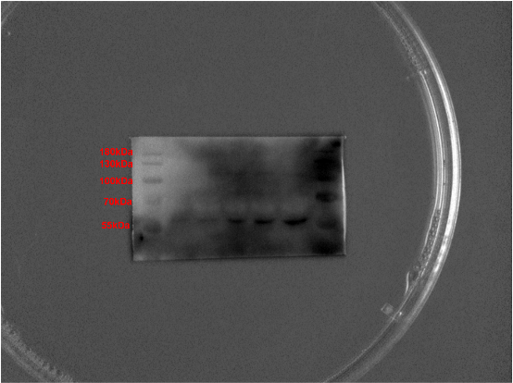
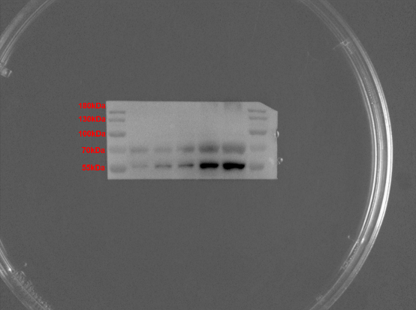
B
A

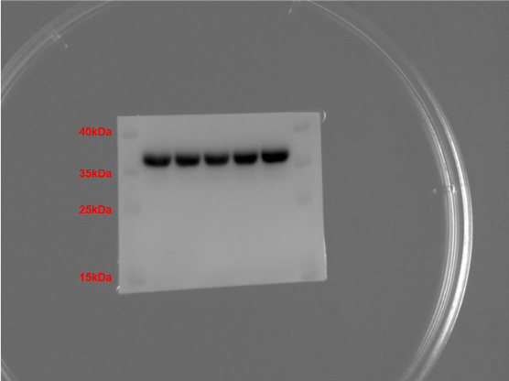
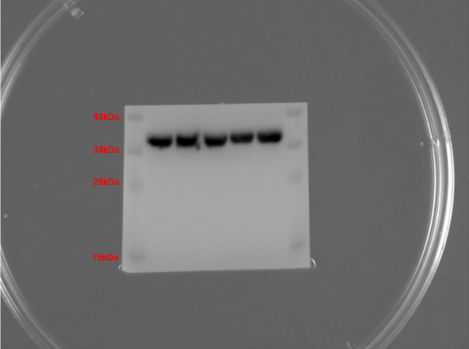
D
C

Supplementary figure 1. Immunoblotting results with protein markers labeled. (A) SOX-9 immunoblotting in accordance with Fig. 5B, top. (B) RUNX2 immunoblotting in accordance with Fig. 5E, top. (C) and (D) are GAPDH immunoblotting in accordance with Fig. 5B, bottom and Fig. 5E, bottom, respectively.

