Supplementary data
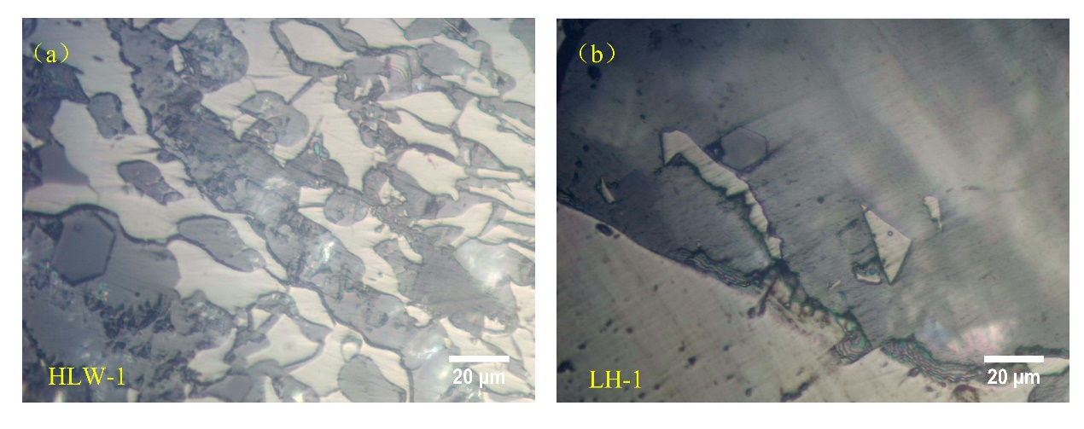
Fig. S1. Microphotographs of volcanic detrital quartz.
Photomicrographs taken in: (a) and (b) plane-polarized light
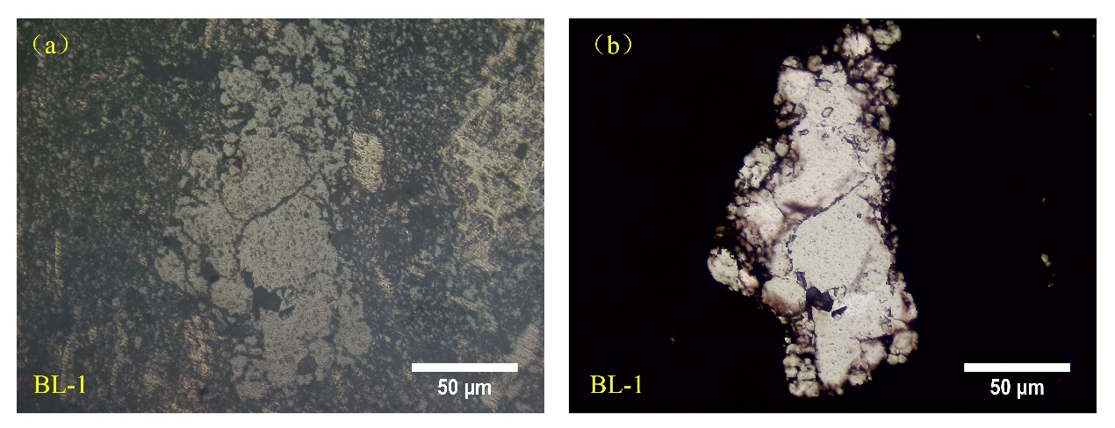
Fig. S2. Microphotographs of terrigenous detrital quartz.
Photomicrographs taken in: (a) reflected light. (b) plane-polarized light, corresponding to (a).
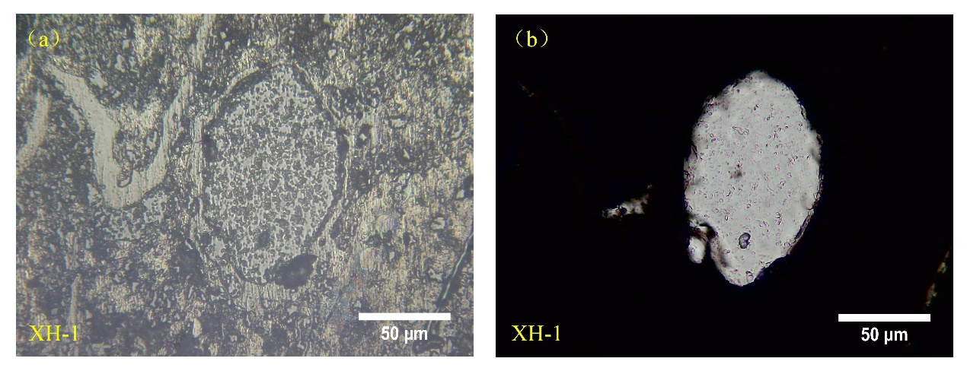
Fig. S3. Microphotographs of diagenetic quartz in pore.
Photomicrographs taken in: (a) reflected light. (b) plane-polarized light, corresponding to (a).
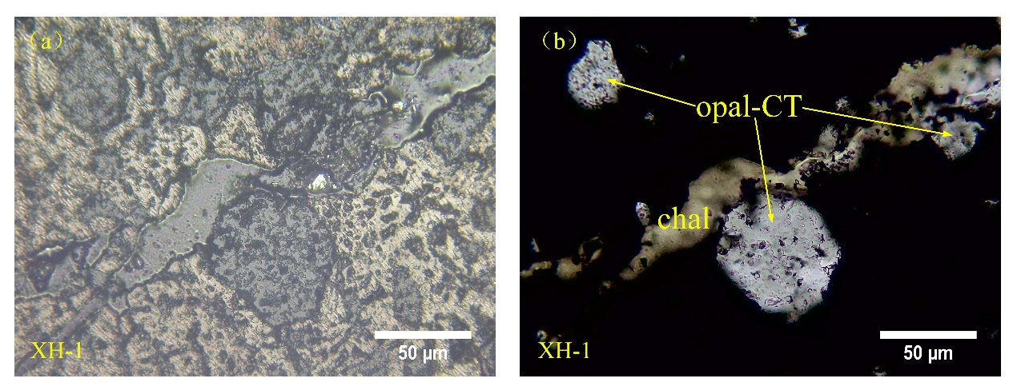
Fig. S4. Microphotographs of diagenetic quartz in pore.
Photomicrographs taken in: (a) reflected light. (b) plane-polarized light, corresponding to (a).
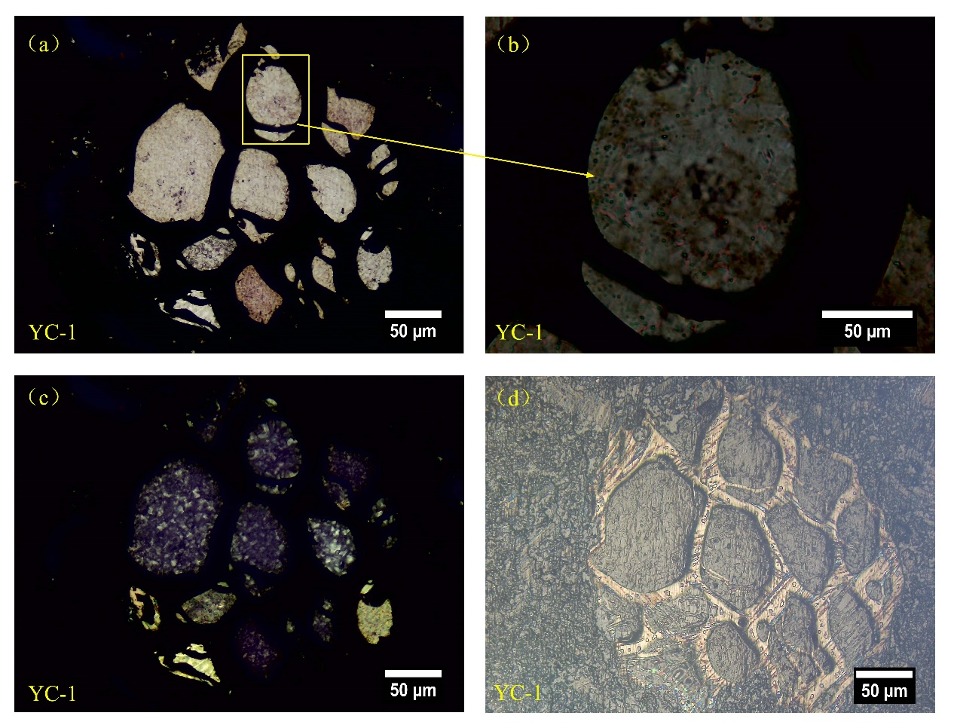
Fig. S5. Microphotographs of diagenetic quartz in plant cell.
Photomicrographs taken in: (a) and (b) plane-polarized light. (c) cross-polarized light. (d) reflected light, corresponding to (a).
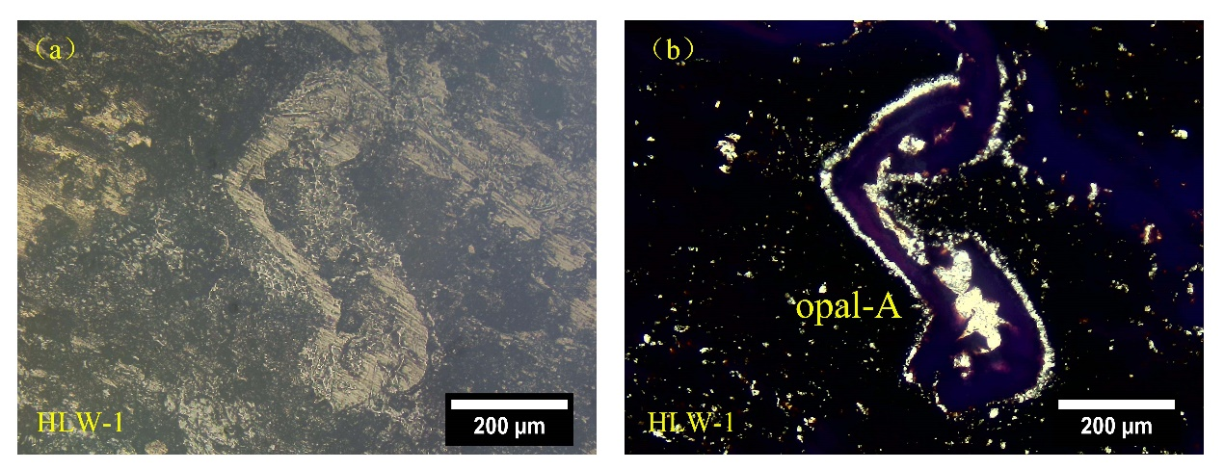
Fig. S6. Microphotographs of amorphous silica around and in the exinite.
Photomicrographs taken in: (a) reflected light. (b) plane-polarized light, corresponding to (a).
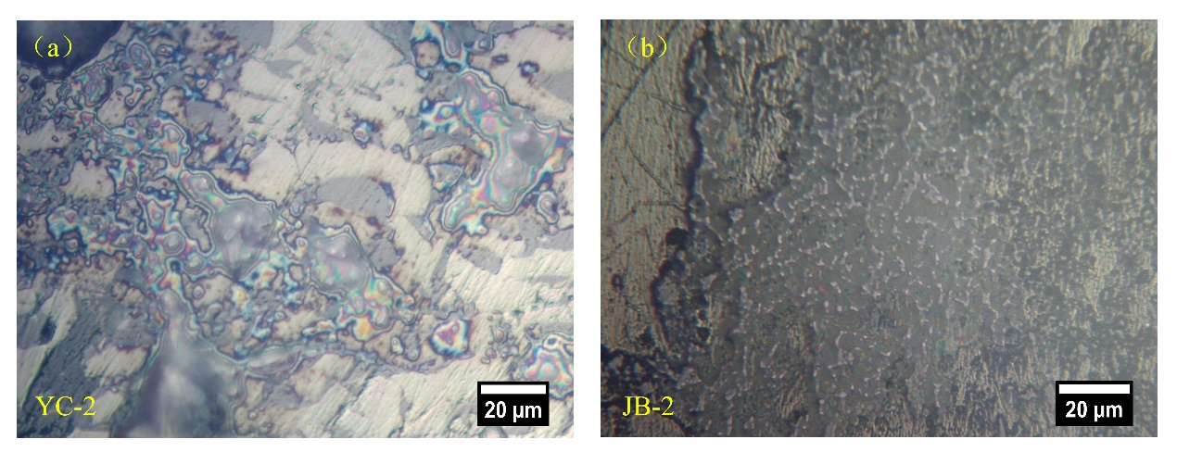
Fig. S7. Microphotographs of amorphous.
Photomicrographs taken in: (a) and (b) reflected light.

Table S1. Geographical location and collected data with the number of samples.

Coal name | East longitude | North latitude | Number of samples | Sources
Xionggou coal mine | 104°19′26″~ 104°20′27″ | 26°28′46″~  26°30′45″ | 2 | This study
Yantang coal mine | 104°07'52"~  104°08'35" | 26°18'17"~  26°19'06" | 2 | This study
Jiubao coal mine | 104°11'33"~  104°12'43" | 26°24'25"~  26°25'56" | 2 | This study
Daqingpo coal mine | 104°19′12″~  104°20′28″ | 26°21′28″~  26°22′45″ | 2 | This study
Laoying coal mine | 104°15′49″~  104°16′27″ | 26°04′10″~  26°05′05″ | 2 | This study
Yongchang coal mine | 104°20'51"~  104°22'04" | 26°02'55"~  26°03'26" | 2 | This study
Bole coal mine | 104°06′15″~ 104°07′48″ | 25°46′53″~  25°48′24″ | 23+2 | This study
Laoniuchang coal mine | 104°18′34″~  104°19′21″ | 25°49′30″~  25°50′17″ | 2 | This study
Longhai coal mine | 104º16′20″~  104º17′03″ | 25º37′45″~  25º38′31″ | 2 | This study
Xinhua Coal Mine | 104°22'47″~  104°23'37" | 25°49'17"~  25°49'44" | 2 | This study
Heilushan coal mine | 104°18′45″~  104°19′45″ | 25°35′03″~  25°35′54″ | 2 | This study
Bumu coal mine | 104°13′06″~  104°14′07″ | 25°28′09″~  25°29′22″ | 3 | This study
Helewu coal mine | 104°12′29″~  104°13′13″ | 25°19′35″~  25°20′17″ | 2 | This study

