Fine mapping and candidate gene analysis of the up locus determining fruit orientation in pepper (Capsicum spp.)
Fang Hu^{1,2}, Jiaowen Cheng^{1,2}, Jichi Dong¹, Jian Zhong¹, Ziyan Zhou¹, Kailin Hu^{1,}*
¹ College of Horticulture, South China Agricultural University/Key Laboratory of Biology and Genetic Improvement of Horticultural Crops (South China), Ministry of Agriculture and Rural Affairs/Guangdong Vegetables Engineering Research Center Guangzhou 510642, China
²These authors contributed equally to this work.
*Corresponding author: Kailin Hu, E-mail: hukailin@scau.edu.cn

Supplementary Information Legends
Supplementary Table S1 Primer sequences used for candidate gene cloning

Supplementary Table S2 Primer sequences used for qPCR analysis

Supplementary Table S3 Details of linked markers on P12 used for preliminary mapping of up
The red labeled markers were anchored to the Scaffold445

Supplementary Table S4 Details of linked markers on P12 used for fine mapping of up

Supplementary Figure S1 Alignment of protein sequences between Capana12g000958 and DGR2 (AT1G72660)

Supplementary Figure S2 Alignment of cDNA sequences of Capana12g000960/66
E and VP represent the erect and vertical pendant fruit orientation phenotype, respectively

Supplementary Figure S3 Transcriptome expression profile of 7 predicted protein-coding genes in 46 samples from different tissue and breeding lines

Supplementary Figure S4 Alignment of cDNA sequences of Capana12g000958

Supplementary Figure S5 Alignment of cDNA sequences of Capana12g000959 in different breeding lines
E and VP represent the erect and vertical pendant fruit orientation phenotype, respectively. The red boxes are two SNP loci in three breeding lines

Supplementary Figure S6 Expression of Capana12g000958 in different tissues of pepper based on qPCR

Supplementary Figure S7 Sequence comparison of the promoter region of Capana12g000958 in different pepper breeding lines
E and VP represent the erect and vertical pendant fruit orientation phenotypes, respectively. The red boxes are SNP loci which consistent with the phenotypes in eight breeding lines

Supplementary Tables
Supplementary Table S1. Primer sequences used for candidate gene cloning
Gene | Forward primer | Reverse primer | Length (bp)
Capana12g000958-cDNA | ATGGGGATCGTAGAAAAGATA | CTATGTCTTAAGTGGAACCTT | 1203
Capana12g000959-cDNA | ATGGGGAGTTCAACAGCTTTATC | TTACAGCACCGATCTCTCTATC | 927
Capana12g000960/66-cDNA | ATGGAAGATGTCACAAGTAATGG | TCAGCTGGACCTAATTCTCTTC | 333
Capana12g000958-promoter | ACCATTTGTAATGCTGTTATTTG | TGACAGTTACCAGTTGCTTT | 1787

Supplementary Table S2. Primer sequences used for qPCR analysis
Gene | Forward primer | Reverse primer | Length (bp)
Capana12g000958 | GGCTCGTACACAGAAGAATA | CCGTCAGCATTGTTAGTAGT | 209
Capana12g000959 | AGAAAACAGGCAGAACAAGA | TACACAGATAAAAGCAGCAT | 174
Capana12g000960/66 | ATAAACCAGAACCACGAGTC | TAGCATTCGTTGATTCACCC | 169
Ca-Actin (GQ339766) | CCCAGATTATGTTTGAGACC | GCAAAGCATAACCCTCATAG | 154

Supplementary Table S3. Details of linked markers on P12 used for preliminary mapping of up
Marker name | Forward primer | Reverse primer | Product Length (bp) | Start position (bp)
FO-505 | TGGTTGCTTTGTAAGAAGTTG | TGGAACATATGGGTCATTTG | 182 | 36620437
FO-578 | AGCATACTGTCACAATGATGA | TGTTAGAAAGGAAAGTTTGAGA | 202 | 36879784
FO-572 | TCTGGCACCTAATAAACTTGA | TTTCCCCTTAAATTAATGTACGG | 149 | 37094409
FO-551 | TGTGCAAGATACATACCTGG | AGACACAACCACTTCATAGG | 175 | 37456686
FO-818 | CCACACGCACAAAACATAAA | ACATATTGTGATTGGGAGGG | 185 | 37640205
FO-771 | GCACCTCAACTAAAACTTGT | TTTTGTATATACGCCGCATG | 165 | 37695341
FO-704 | TCACATACATGGTTTGGAGG | GGTGGAAGGGTTTAGTCAAA | 181 | 38049239
FO-78 | GTCTACGACCTGGAAGTTTT | ATGTGAGGAATCGAGTAAGC | 181 | 38721485
FO-616 | CGCTAGCATATAACTCGAGA | CCCATGGGTATCTTTTATGAC | 211 | 38939069
FO-620 | GGGGTATTTAAGTGTGCGTA | TTTCACCCCAATACCATAGC | 199 | 38984730
FO-61 | CGTTACCTTATAATTGCTTCCA | CGTTAAATTAAGGGACATAAGTGA | 143 | 39000217
FO-364 | AGGGTAAATAGTGGGTGAGT | ACCTCCGTTCGATTTTAAAC | 183 | 39271248
FO-277 | CGCATACACAGACCTTAACT | ACATCTCTCTTTTCCTCTTCA | 195 | 39528011
FO-508 | AGACAAACAGAGAGAAAACCA | TGCAAGTGAACATACGAACT | 208 | 39609108
The red labeled markers were anchored to the Scaffold445

Supplementary Table S4. Details of linked markers on P12 used for fine mapping of up
Primer name | Forward primer | Reverse primer | Product Length (bp) | Start position (bp)
FO-676 | TCCTTAAAGTCAATTCACCAAT | TGTTGCCCTGAATACGTTAA | 154 | 37768901
FO-946 | CATTTGAGTCTGAGTTCCCA | CTGCCATACTTGTCAAGAGT | 209 | 37800443
FO-951 | TTGGTCTTTAACTTGTTAAGGG | AACATACATCAAACTTTCCTCC | 180 | 37809715
FO-691 | ATCCACCGTTTTCAACCAAA | GGACATCTTAGTTCTTCTCTCT | 173 | 37904683
FO-696 | GCCTTCCTCTCTACCTAAGA | TTTAGGTCAGAGTTTGTGGG | 182 | 37983239
FO-958 | TAGTCCAGGCAGTAACTTTG | TTGAGGATGTTGATGTACCA | 190 | 38271111
FO-979 | CATGCAGTACCTCTTTTCCT | ACGTAAAGCATTAGACTAAGAAA | 180 | 38308120
FO-917 | TGTGTATGAAATGTGAACAAATC | TGAGTAAGTGTAAAGGTGAAAA | 205 | 38428897
FO-166 | TGTGTATGACTGTAACGACC | AAAATAAGGTTCCTGCAGCC | 196 | 38926113

Supplementary Figures

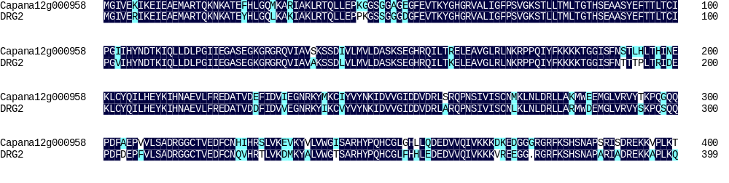

Supplementary Figure S1 Alignment of protein sequences between Capana12g000958 and DGR2 (AT1G72660)

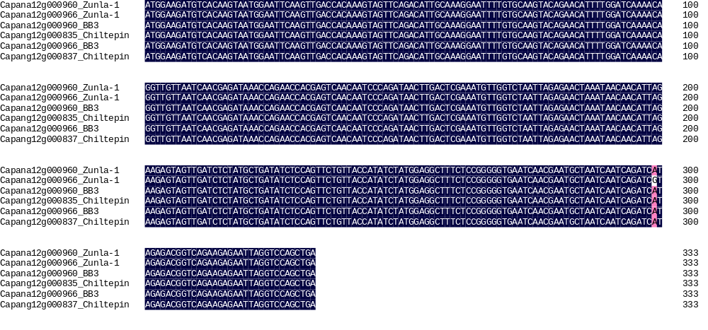

Supplementary Figure S2 Alignment of cDNA sequences of Capana12g000960/66

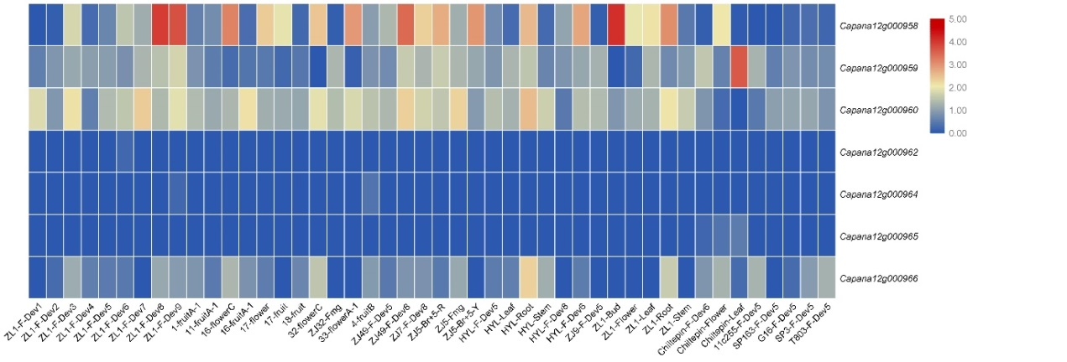

Supplementary Figure S3 Transcriptome expression profile of 7 predicted protein-coding genes in 46 samples from different tissue and breeding lines

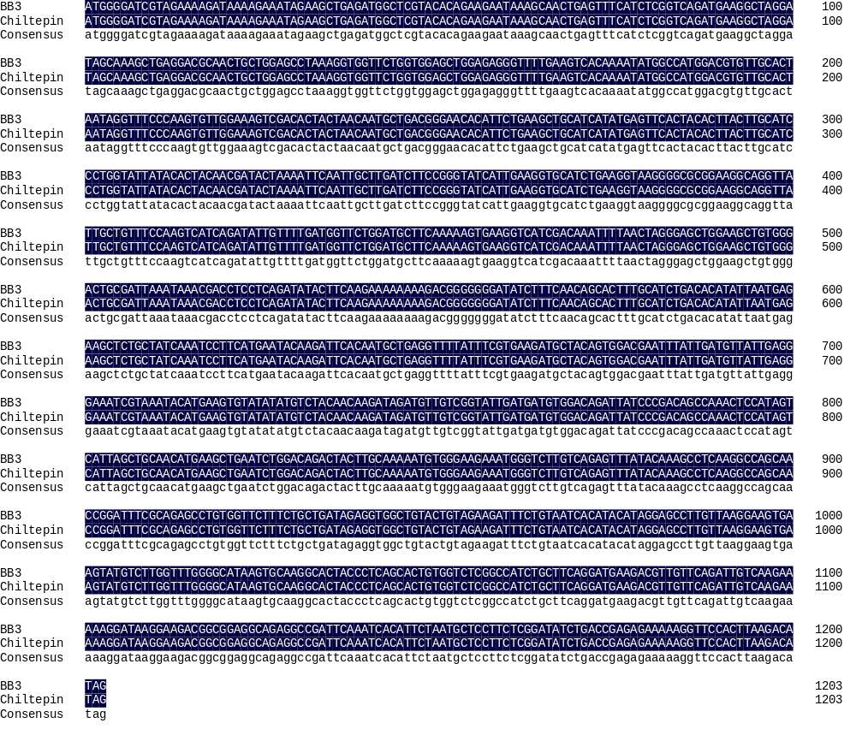

Supplementary Figure S4 Alignment of cDNA sequences of Capana12g000958

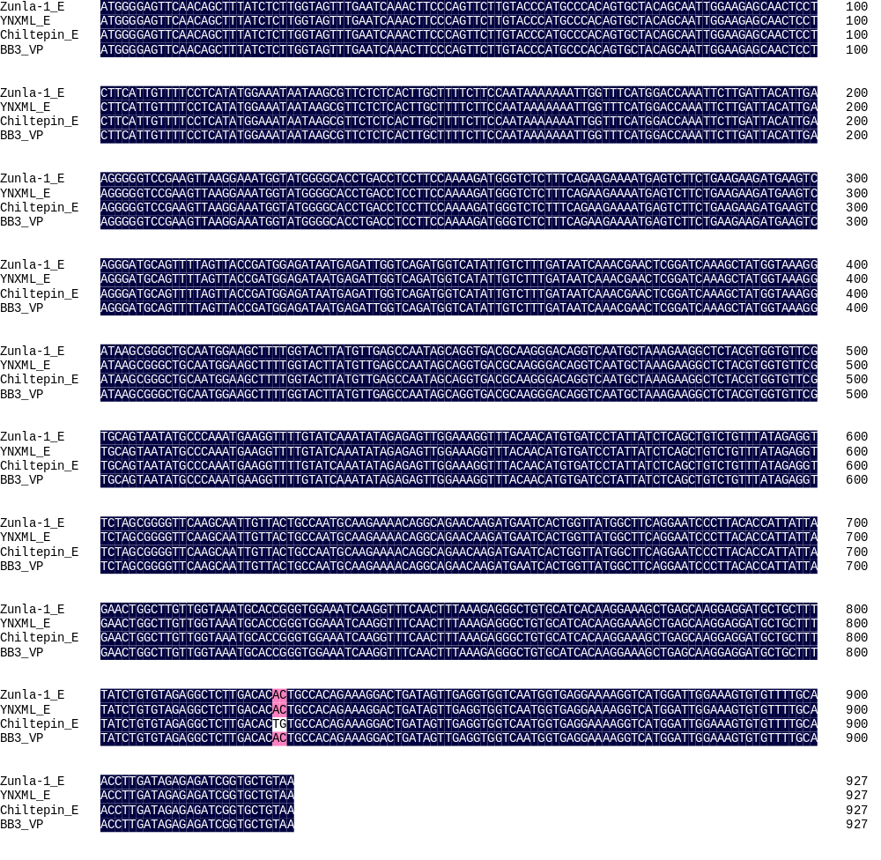

Supplementary Figure S5 Alignment of cDNA sequences of Capana12g000959 in different breeding lines
E and VP represent the erect and vertical pendant fruit orientation phenotype, respectively. The red boxes are two SNP loci in three breeding lines

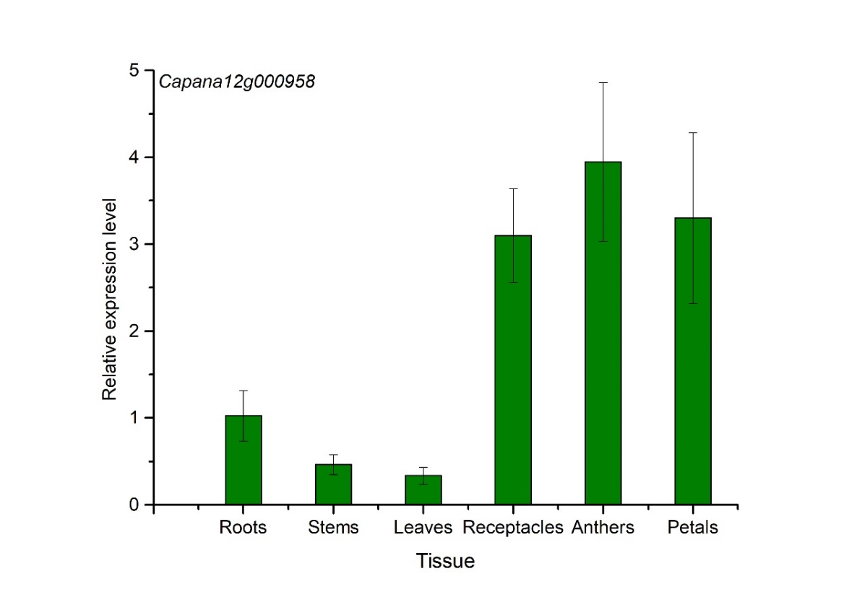

Supplementary Figure S6 Expression of Capana12g000958 in different tissues of pepper based on qPCR

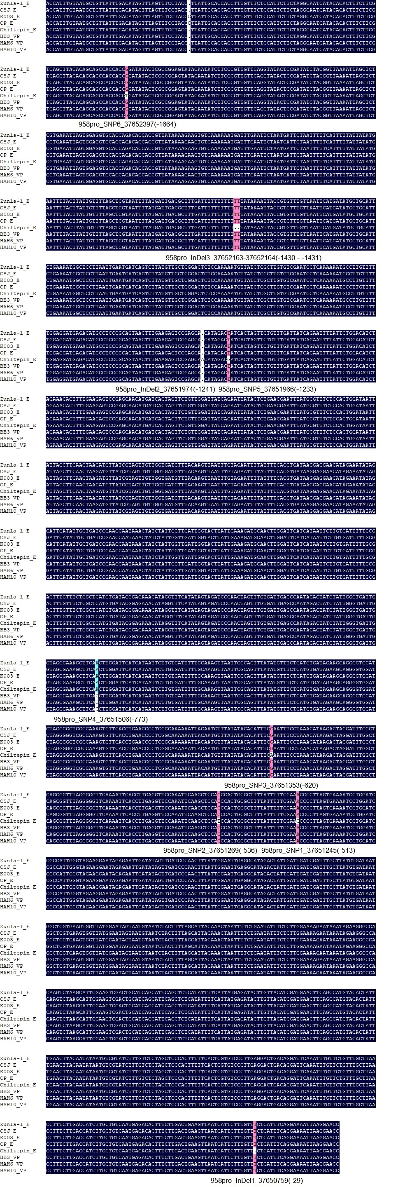

Supplementary Figure S7 Sequence comparison of the promoter region of Capana12g000958 in different pepper breeding lines
E and VP represent the erect and vertical pendant fruit orientation phenotypes, respectively. The red boxes are SNP loci which consistent with the phenotypes in eight breeding lines

