Figure S1. Meta-analysis of total infectious complications. The summary effect estimates odds ratio (OR) for individual randomized controlled trial (RCT) are indicated by blue rectangles (the size of the rectangle is proportional to the study weight), with the black horizontal lines representing 95% confidence interval (CI). The overall summary effect estimate (OR) and 95% CI are shown as the black diamond below. EIN, enteral immunonutrition; SEN, standard enteral nutrition; M-H, Mantel-Haenszel. The pooled results indicated that postoperative EIN was associated with decreased risk of total infectious complications compared to SEN, with a statistical significance (OR=0.47; 95%CI=0.26 to 0.84; p=0.01).

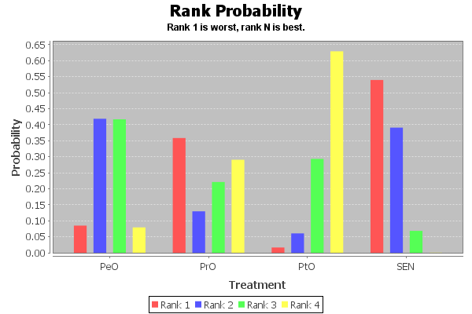
Figure S2. Ranking of all targeted nutritional regimes including PrO, PtO and PeO EIN and SEN in terms of total infectious complications. Pro, preoperation; PtO, postoperation; PeO, perioperation; EIN, enteral immunonutrition; SEN, standard enteral nutrition. Result indicated that postoperative EIN has the highest probability of being optimal option, followed by perioperative EIN, preoperative EIN and SEN.

Figure S3. Meta-analysis of pneumonia. The summary effect estimates odds ratio (OR) for individual randomized controlled trial (RCT) are indicated by blue rectangles (the size of the rectangle is proportional to the study weight), with the black horizontal lines representing 95% confidence interval (CI). The overall summary effect estimate (OR) and 95% CI are indicated by the black diamond below. EIN, enteral immunonutrition; SEN, standard enteral nutrition; M-H, Mantel-Haenszel. Poled results indicated a significant difference between postoperative EIN and SEN in terms of the risk of pneumonia (OR=0.47; 95%CI=0.25 to 0.90; p=0.02).

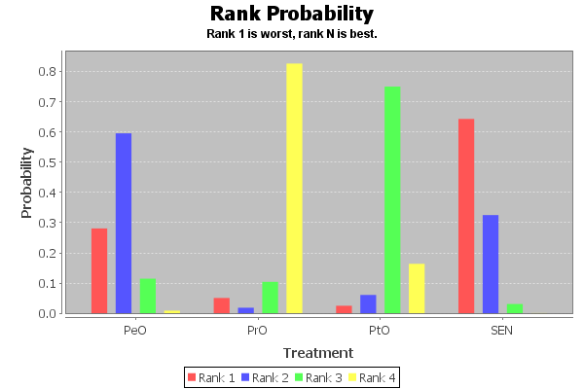
Figure S4. Ranking of all targeted nutritional regimes including PrO, PtO and PeO EIN and SEN in terms of pneumonia. Pro, preoperation; PtO, postoperation; PeO, perioperation; EIN, enteral immunonutrition; SEN, standard enteral nutrition. Result indicated that postoperative EIN has the highest probability of being optimal option, followed by preoperative EIN, perioperative EIN and SEN.

Figure S5. Meta-analysis of wound infection. The summary effect estimates odds ratio (OR) for individual randomized controlled trial (RCT) are indicated by blue rectangles (the size of the rectangle is proportional to the study weight), with the black horizontal lines representing 95% confidence interval (CI). The overall summary effect estimate (OR) and 95% CI are indicated by the black diamond below. EIN, enteral immunonutrition; SEN, standard enteral nutrition; M-H, Mantel-Haenszel.

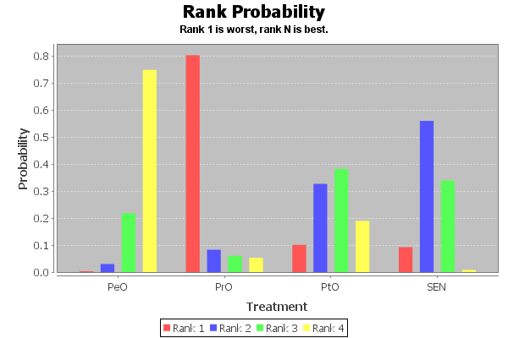
Figure S6. Ranking of all targeted nutritional regimes including PrO, PtO and PeO EIN and SEN in terms of wound infection. Pro, preoperation; PtO, postoperation; PeO, perioperation; EIN, enteral immunonutrition; SEN, standard enteral nutrition. Result indicated that perioperative EIN has the highest probability of being optimal option, followed by SEN, preoperative EIN, and postoperative EIN.
Figure S7. Meta-analysis of sepsis. The summary effect estimates odds ratio (OR) for individual randomized controlled trial (RCT) are indicated by blue rectangles (the size of the rectangle is proportional to the study weight), with the black horizontal lines representing 95% confidence interval (CI). The overall summary effect estimate (OR) and 95% CI are indicated by the black diamond below. EIN, enteral immunonutrition; SEN, standard enteral nutrition; M-H, Mantel-Haenszel.
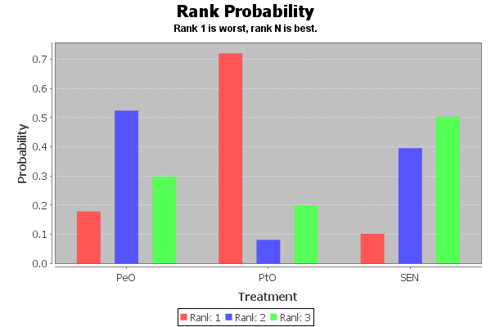
Figure S8. Ranking of all targeted nutritional regimes including PtO and PeO EIN and SEN in terms of sepsis. PtO, postoperation; PeO, perioperation; EIN, enteral immunonutrition; SEN, standard enteral nutrition. Result indicated that SEN has the highest probability of being optimal option, followed by perioperative EIN and postoperative EIN.

Figure S9. Meta-analysis of urinary tract infection. The summary effect estimates odds ratio (OR) for individual randomized controlled trial (RCT) are indicated by blue rectangles (the size of the rectangle is proportional to the study weight), with the black horizontal lines representing 95% confidence interval (CI). The overall summary effect estimate (OR) and 95% CI are indicated by the black diamond below. EIN, enteral immunonutrition; SEN, standard enteral nutrition; M-H, Mantel-Haenszel.
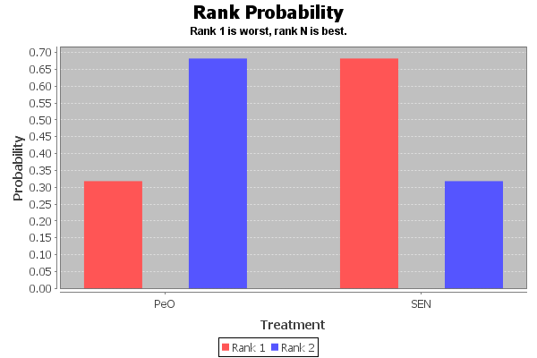
Figure S10. Ranking of all targeted nutritional regimes including PeO EIN and SEN in terms of urinary tract infection. PeO, perioperation; EIN, enteral immunonutrition; SEN, standard enteral nutrition. Result indicated that perioperative EIN has the highest probability of being optimal option, followed by SEN.

Figure S11. Meta-analysis of anastomotic leakage. The summary effect estimates odds ratio (OR) for individual randomized controlled trial (RCT) are indicated by blue rectangles (the size of the rectangle is proportional to the study weight), with the black horizontal lines representing 95% confidence interval (CI). The overall summary effect estimate (OR) and 95% CI are indicated by the black diamond below. EIN, enteral immunonutrition; SEN, standard enteral nutrition; M-H, Mantel-Haenszel. The pooled results indicated that perioperative EIN may be associated with decreased risk of anastomotic leakage compared to SEN, with a nearly statistical significance (OR=0.56; 95%CI=0.31 to 1.00; p=0.05).
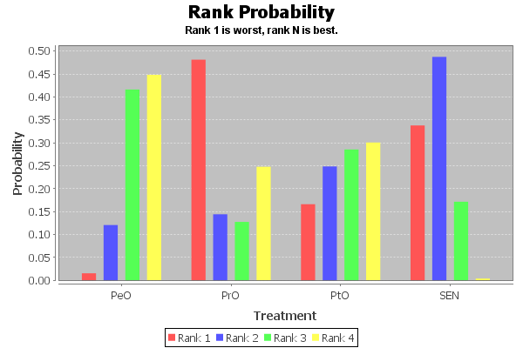
Figure S12. Ranking of all targeted nutritional regimes including PtO and PeO EIN and SEN in terms of anastomotic leakage. PrO, preoperation; PtO, postoperation; PeO, perioperation; EIN, enteral immunonutrition; SEN, standard enteral nutrition. Result indicated that perioperative EIN has the highest probability of being optimal option, followed by postoperative EIN, SEN and preoperative EIN.
Figure S13. Meta-analysis of length of hospitalization (LOH). The summary effect estimates odds ratio (OR) for individual randomized controlled trial (RCT) are indicated by blue rectangles (the size of the rectangle is proportional to the study weight), with the black horizontal lines representing 95% confidence interval (CI). The overall summary effect estimate (OR) and 95% CI are indicated by the black diamond below. EIN, enteral immunonutrition; SEN, standard enteral nutrition; M-H, Mantel-Haenszel. Pooled result indicated that postoperative EIN significantly shorten the length of hospitalization compared to SEN (MD=-1.01; 95%CI=-1.44 to -0.57; p<0.001).

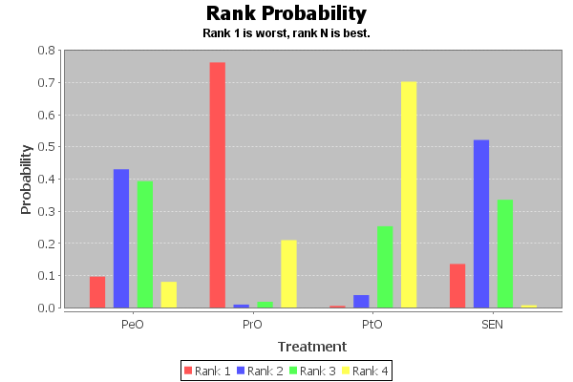
Figure S14. Ranking of all targeted nutritional regimes including PtO and PeO EIN and SEN in terms of length of hospitalization (LOH). PrO, preoperation; PtO, postoperation; PeO, perioperation; EIN, enteral immunonutrition; SEN, standard enteral nutrition. Result indicated that postoperative EIN has the highest probability of being optimal option, followed by perioperative EIN, SEN and preoperative EIN.

Figure S15. Funnel plot of total infectious complications. The vertical axis represented the standard error (SE) of effect size and x axis indicated effect size centred at comparison-specific pooled effect. Symmetrical funnel plot indicated the absence of publication bias. EIN, enteral immunonutrition; SEN, standard enteral nutrition; SE, standard error; OR, odd ratio. A symmetric funnel plot suggested absence of publication bias.

Figure S16. Funnel plot of anastomotic leakage. The vertical axis represented the standard error (SE) of effect size and x axis indicated effect size centred at comparison-specific pooled effect. Symmetrical funnel plot indicated the absence of publication bias. EIN, enteral immunonutrition; SEN, standard enteral nutrition; SE, standard error; OR, odd ratio. A symmetric funnel plot suggested absence of publication bias.

