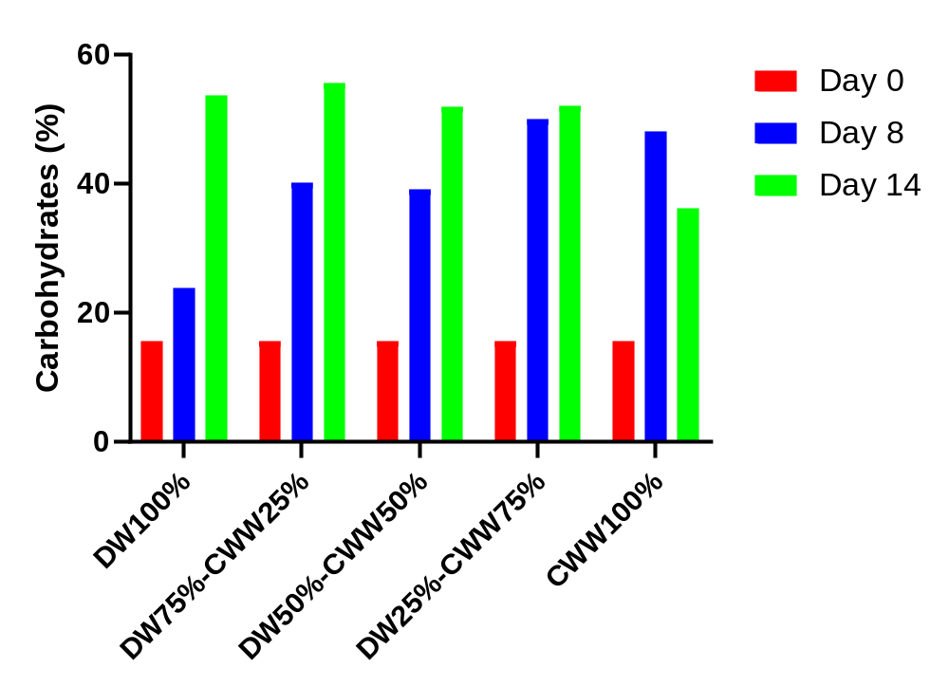
Supplementary material A1. Carbohydrate content in terms of dry cell weight in a batch experiment submitted to different dilutions of domestic wastewater (DW) and cooling water waste (CWW) (v/v) (Ortíz-Sánchez et al., 2022).
Supplementary material A2. Average (standard deviation) of heavy metals in the effluent (mixed liquor) of the photobioreactors.

 | TRH 10  (mg L⁻¹) | Removal (%) | TRH 8  (mg L⁻¹) | Removal (%) | TRH 6  (mg L⁻¹) | Removal (%)
Al | 0.05 (0) | 54.5 | 0.06 (0) | 45.4 | 0.04 (0) | 63.6
Cd | 0.08 (0) | - | 0.26 (0.16) | - | 0.12 (0) | -
Cr | 0.00 (0) | 100 | 0.00 (0) | 100 | 0.00 (0) | 100
Cu | 0.01 (0) | 50 | 0.11 (0) | - | 0.01 (0) | 50
Fe | 1.03 (2.79) | 57.9 | 1.07 (2.53) | 56.3 | 1.06 (3.3) | 56.7
Mn | 0.00 (0) | 100 | 0.00 (0) | 100 | 0.00 (0) | 100
Ni | 0.05 (0) | 16.7 | 0.19 (0) | - | 0.05 (0) | 16.7
Pb | 0.43 (0) | 30.6 | 0.41 (0) | 33.8 | 0.34 (0) | 45.1
Zn | 0 (0) | - | 0.00 (0) | - | 0.00 (0) | -

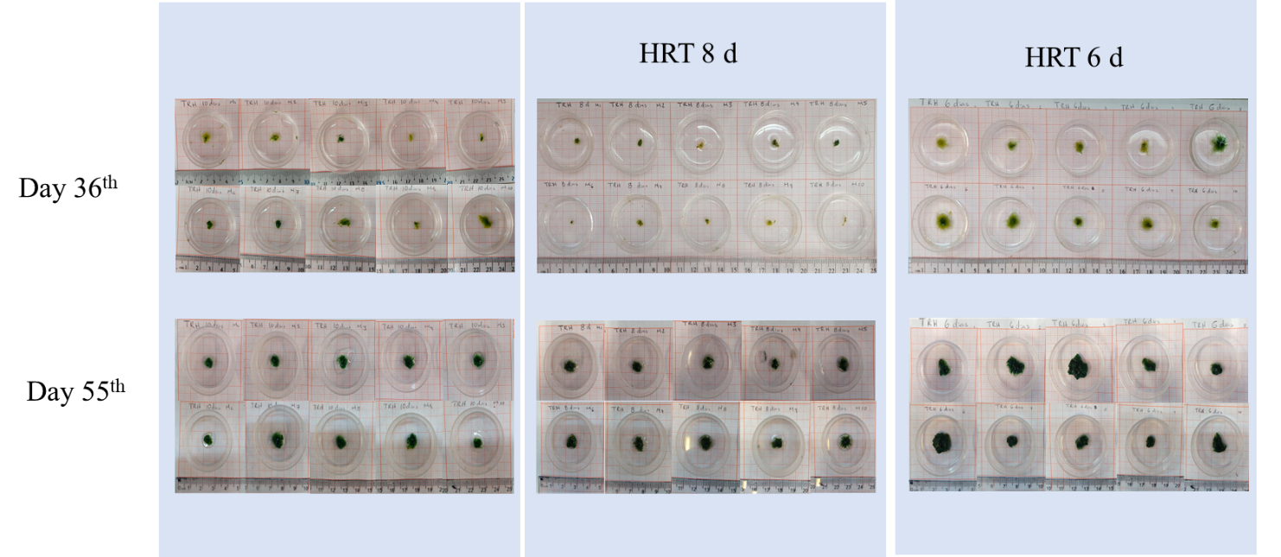

Supplementary material A3. Images illustrating the floc size at 10, 8 and 6 of hydraulic retention time in day 36 and 55 of operation.

