Supplementary information

Solar Driven Agricultural Greenhouse Integrated with Desalination System;
Energy-Water-Food Nexus
Kabir Abdullahiª, Alaa H. Salah^{b}, Hassan Fathª,
ª Environmental Engineering Department, Egypt-Japan University of Science and Technology, Alexandria 21934, Egypt
^{b} Computer Based Engineering Applications Department, Informatics Research Institute, City of Scientific Research and Technological Applications, New Borg El Arab City,
21934 Alexandria, Egypt

2 Figures

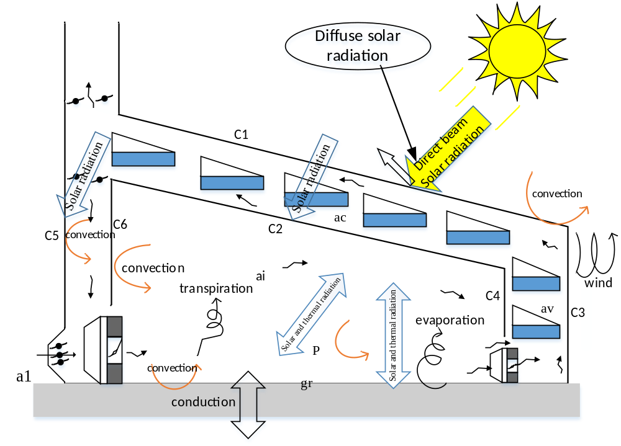
Fig. S1. Energy and water vapor exchanges among the GH components.

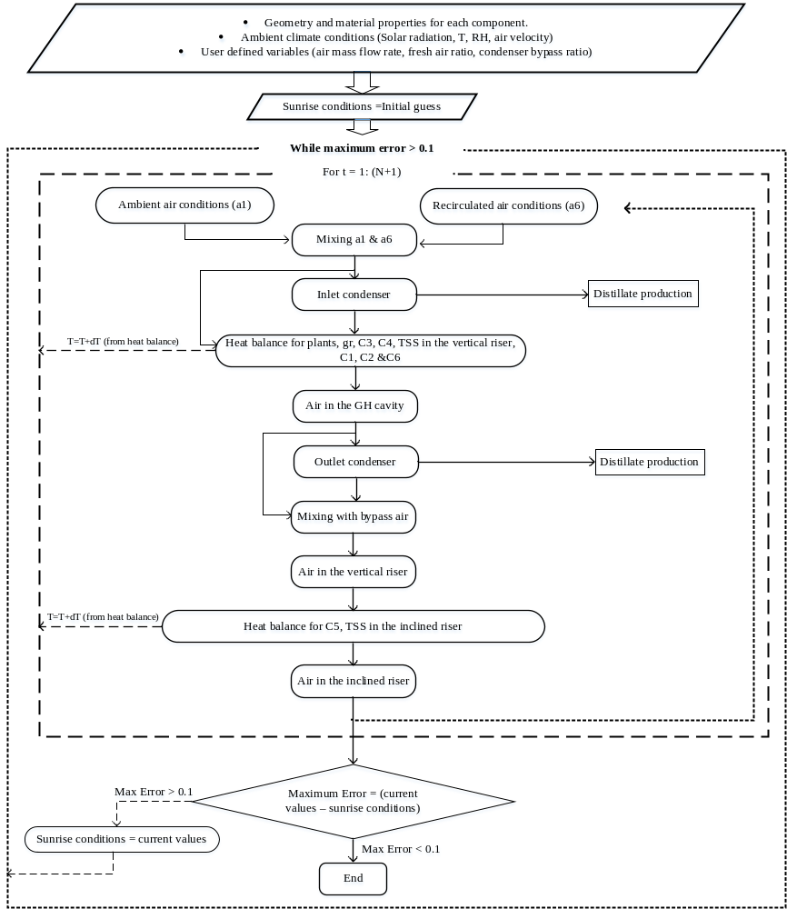
Fig. S2. Mathematical procedure flow chart.

