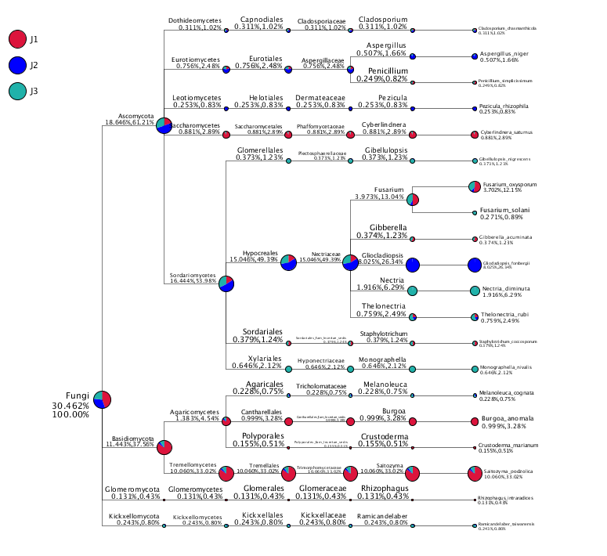
Fig. 1 The taxtree of soil samples

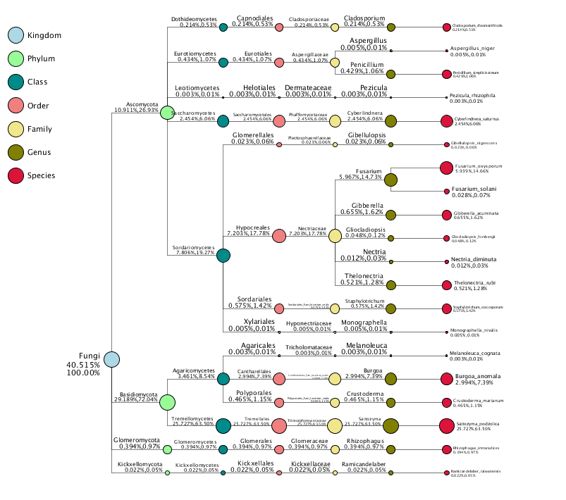
Fig. 2 The taxtree of soil samples at different taxonomic levels

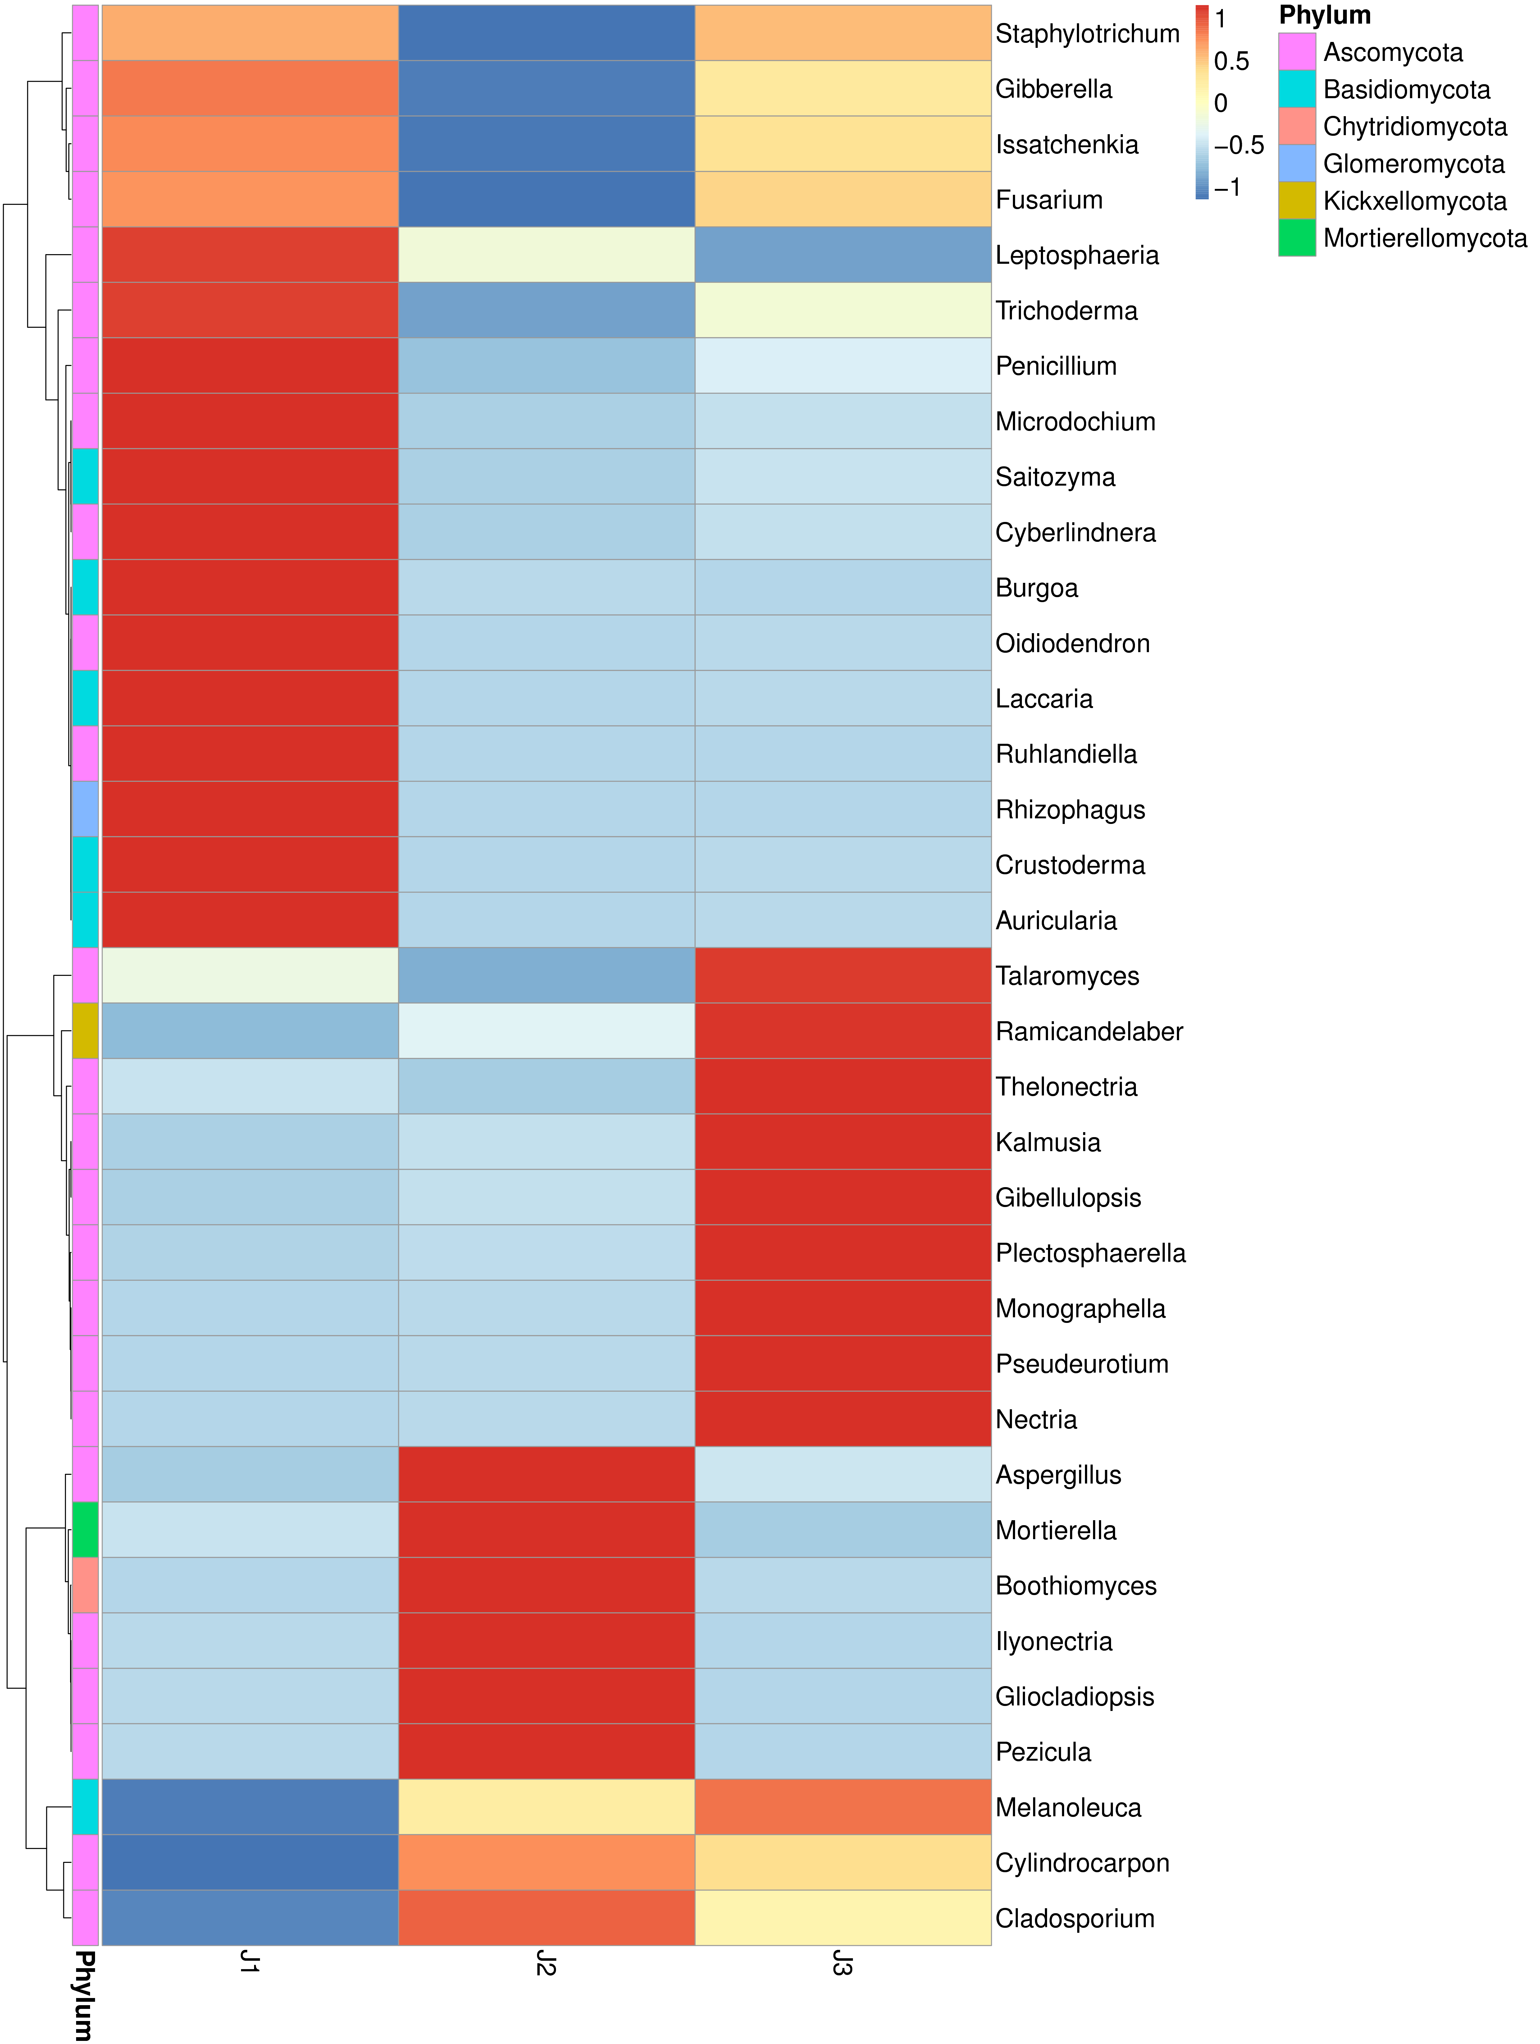
Fig. 3 Heat map of soil samples at the phylum level

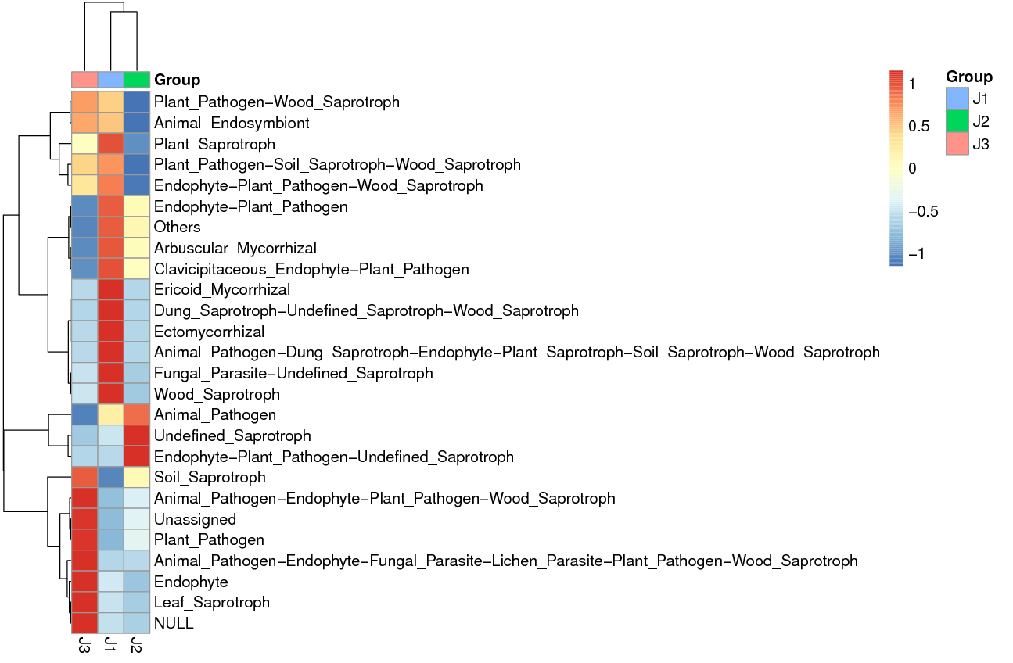
Fig. 4 FunGuild heat map of soil samples

