Additional file 2 | CMV-related test results in CMV-positive pSLE.

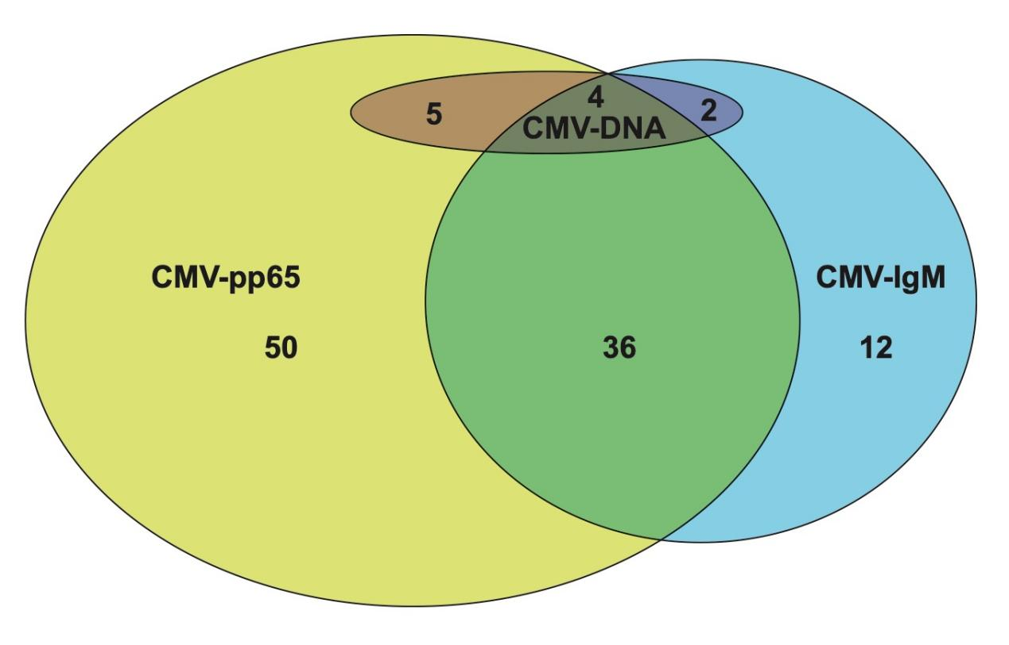
CMV: cytomegalovirus.

