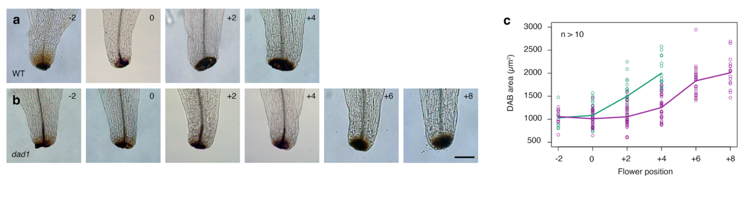

Extended Data Fig. 1 Temporal DAB staining in petals during petal abscission.
a, b, Temporal DAB staining of WT and dad1 petals from position –2 to 4 flowers. Scale bar, 100 µm. c, Quantification of DAB-stained area (µm²). Area averages in WT and dad1 are shown with green and purple lines, respectively, with individual data points.

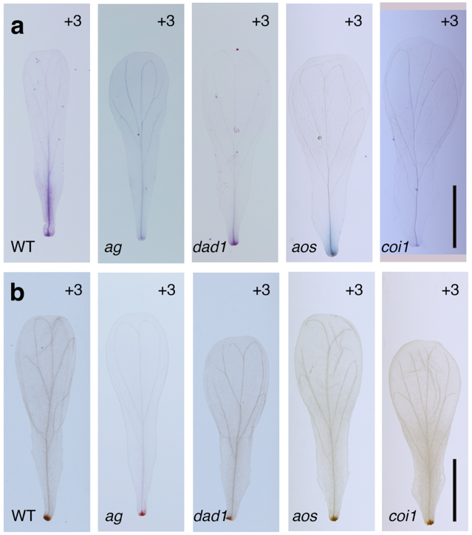

Extended Data Fig. 2 Entire petal images of program cell death and H₂O₂ accumulation during petal abscission.
a, Trypan blue staining of wild-type, ag, dad1, aos, and coi1 petals from position –3 to 4 flowers. Scale bar, 1 mm. b, DAB staining of wild-type, ag, dad1, aos, and coi1 petals from position –3 to 4 flowers. Scale bar, 1 mm.

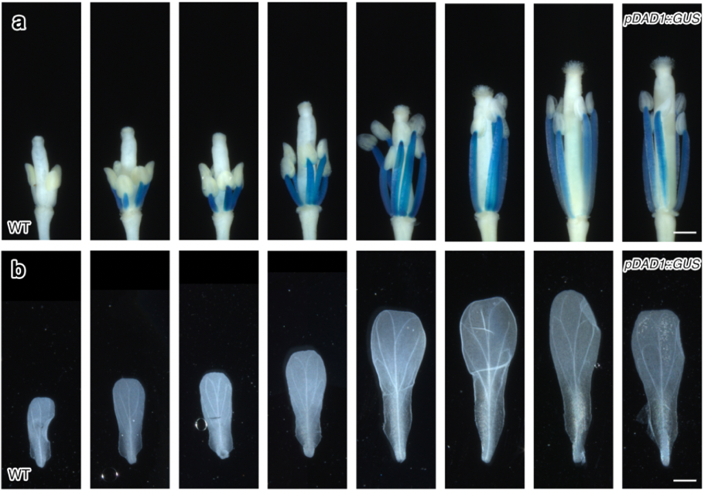

Extended Data Fig. 3 Expression domain of pDAD1::GUS during petal abscission.
a, pDAD1:GUS staining pattern in wild-type stamens from position –3 to 4 flowers. Scale bar, 500 µm. b, pDAD1:GUS staining pattern in wild-type petals (b) from position –3 to 4 flowers. Scale bar, 500 µm.

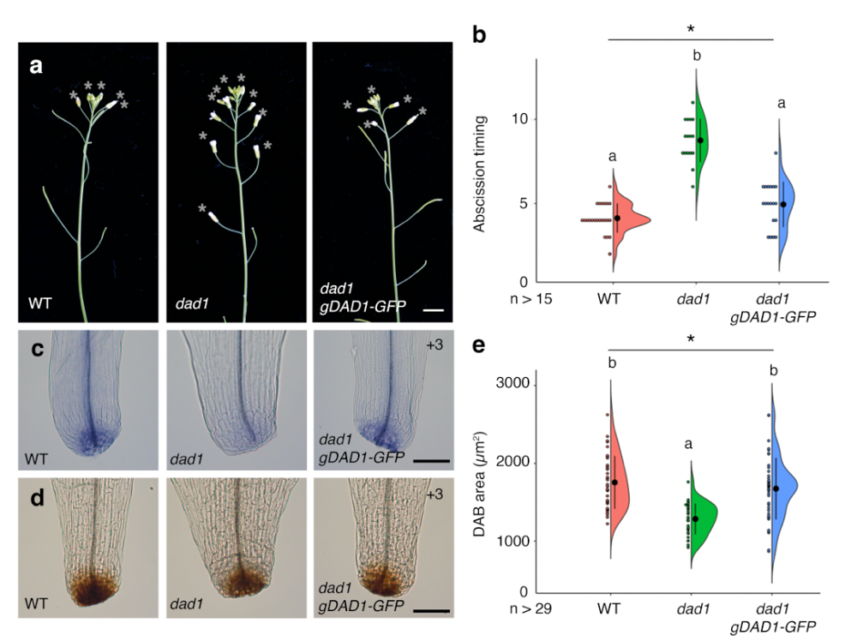
Extended Data Fig. 4 Rescue of the dad1 mutant by introduction of gDAD1-GFP.
a, Profile view of wild-type, dad1, and dad1 gDAD1-GFP inflorescences. Opened flowers with petals are indicated by gray asterisks. Scale bar, 1 cm. b, Quantification of abscission timing, shown as individual data points (left) and Violin plots (right) for each genotype. Black dots and vertical lines indicate average and standard deviation, respectively. n > 15. test, Different letters indicate significant differences, based on one-way ANOVA and post-hoc Tukey’s HSD test (p < 0.05). c, Trypan blue staining of wild type, dad1, and dad1 gDAD1-GFP petals at position 3 flowers. Bar = 100 µm. d, DAB staining of wild type, dad1, and dad1 gDAD1-GFP petals at position 3 flowers. Bar = 100 µm. e, Quantification of DAB-stained area (µm²), shown as individual data points (left) and Violin plots (right) for each genotype. Black dots and vertical lines indicate average and standard deviation, respectively. n > 29. Different letters indicate significant differences, based on one-way ANOVA and post-hoc Tukey’s HSD test (p < 0.05).
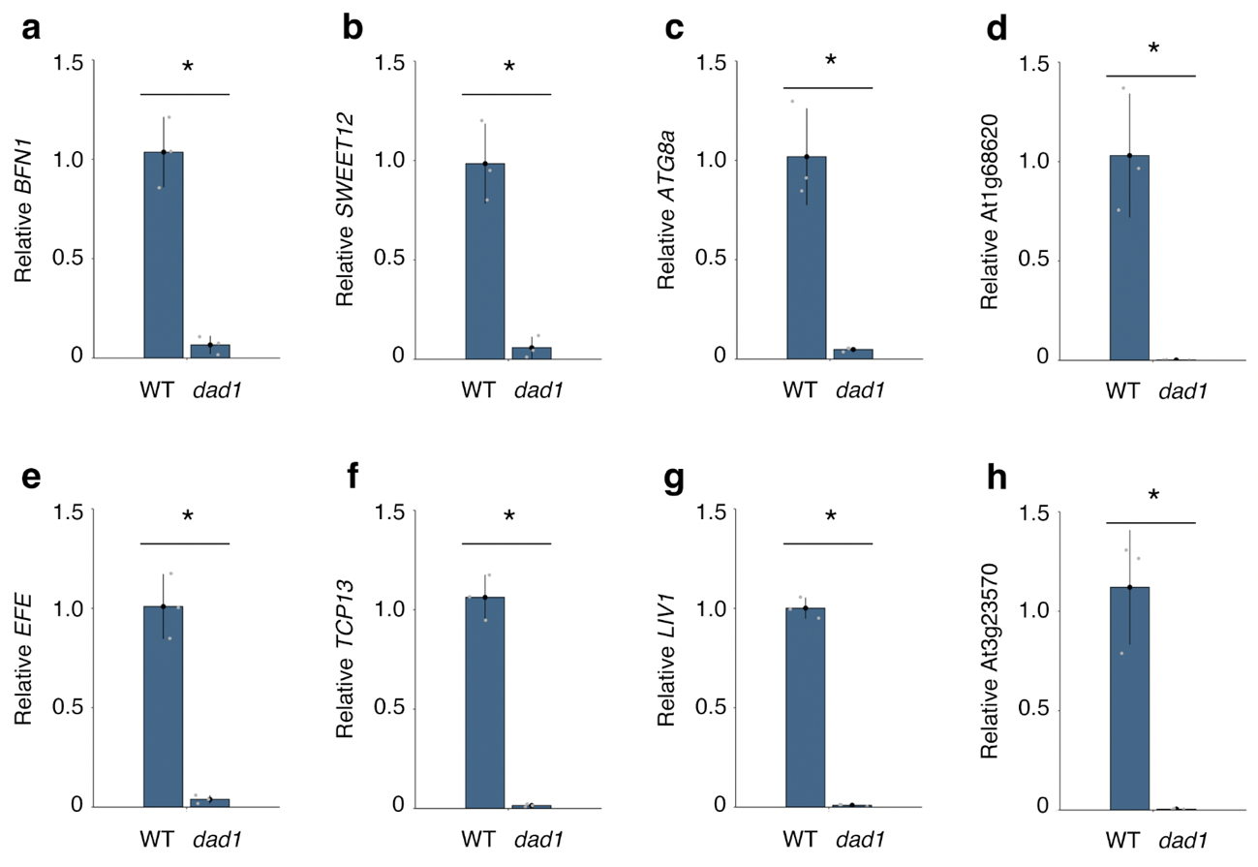
Extended Data Fig. 5 Expression levels of selected DEGs in WT and the dad1 mutant.
a-h, Gene expression levels in wild-type and the dad1 mutant, as determined by RT-qPCR. a, BFN1. b, SWEET12. c, ATG8a, d, At1g68620. e, EFE. f, TCP13. g, LIV1. h. At3g23570. Data are means ± SEM. n = 3. Asterisks indicate significant differences between WT and dad1 based on two-tailed Student’s t-test.
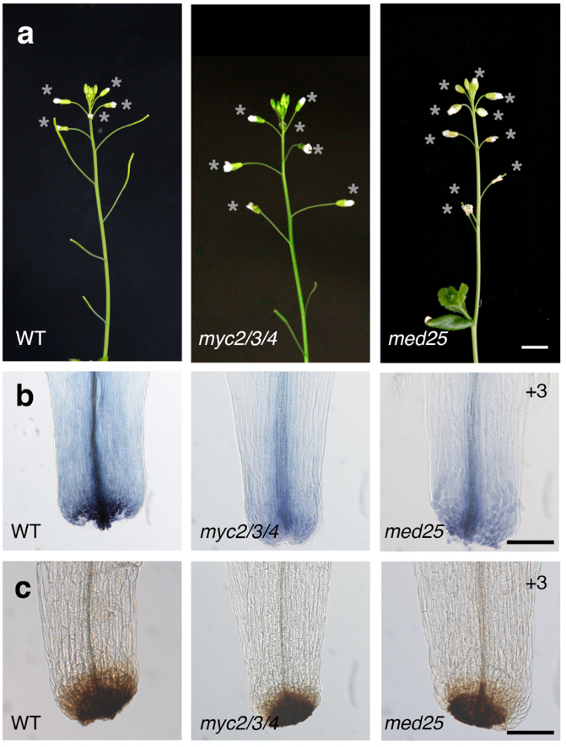

Extended Data Fig. S6 Petal abscission in the myc2 myc3 myc4 and med25 mutants.
a, Profile view of wild-type, myc2 myc3 myc4, and med25 inflorescences. Opened flowers with petals are indicated by asterisks. Scale bar, 1 cm. b, Trypan blue staining of wild type, myc2 myc3 myc4, and med25 petals at position 3 flowers. Scale bar, 100 µm. c, DAB staining of wild type, myc2 myc3 myc4, and med25 petals at position 3 flowers. Scale bar, 100 µm.
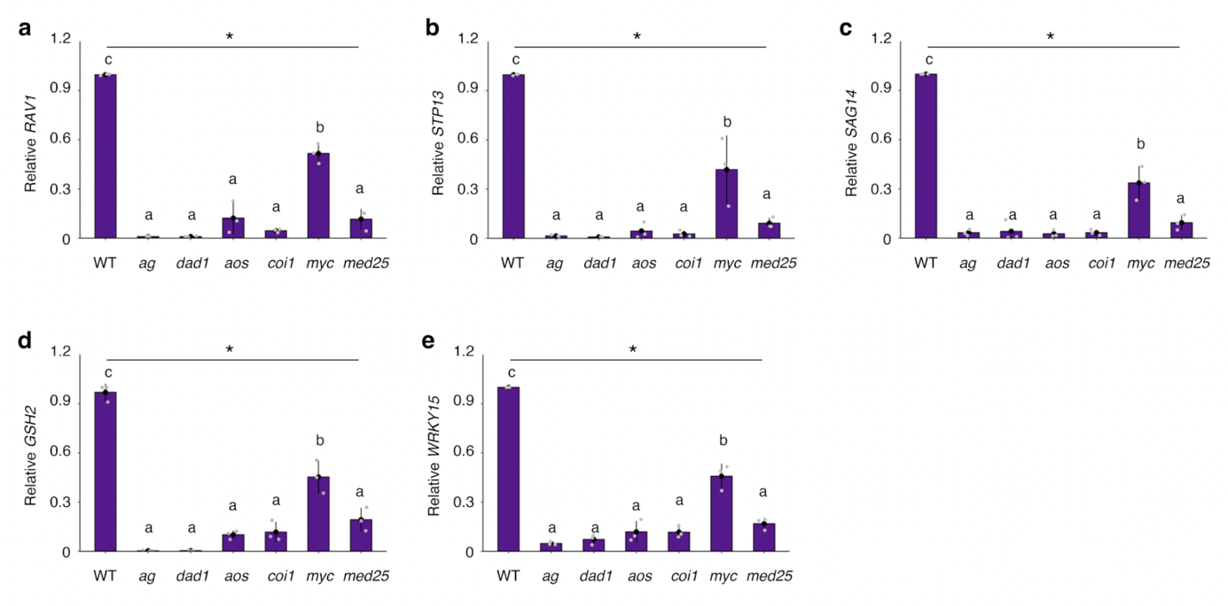
Extended Data Fig. S7 Expression levels of shared direct targets of MYC2 and MED25 in WT and JA-defective mutants.
Gene expression levels in wild-type and JA-defective mutants by RT-qPCR. a, RAV1. b, STP13. c, SAG14, d, GSH2. e, WRKY15. Results are from three independent experiments. Data are means ± SEM. n = 3. Different letters indicate significant differences, based on one-way ANOVA and post-hoc Tukey’s HSD test (p < 0.05).
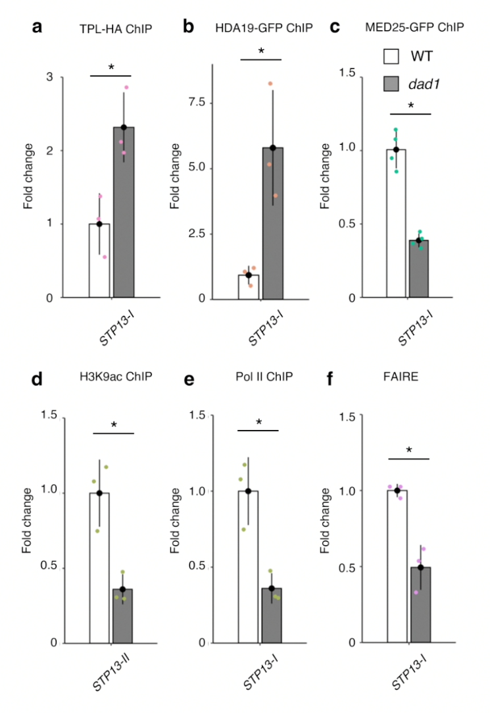
Extended Data Fig. S8 JA-mediated chromatin state switch at the STP13 promoter during petal abscission.
a-e, Binding of TPL-HA (a), HDA19-GFP (b), MED25-GFP (c), H3K9ac (d), and Pol II (e) at the STP13 promoter in wild-type and the dad1 mutant, as determined by ChIP-qPCR. Positions of PCR amplicons for ChIP-qPCR are shown in Fig. 4c. Data are means ± SEM. n = 3. Asterisks indicate significant differences between WT and dad1 based on two-tailed Student’s t-test. f, Chromatin accessibility at the STP13 promoter in wild-type and the dad1 mutant as shown by FAIRE-qPCR. Positions of PCR amplicons for ChIP-qPCR are shown in Fig. 4c. Data are means ± SEM. n = 3. Asterisks indicate significant differences between WT and the dad1 mutant based on two-tailed Student’s t-test.

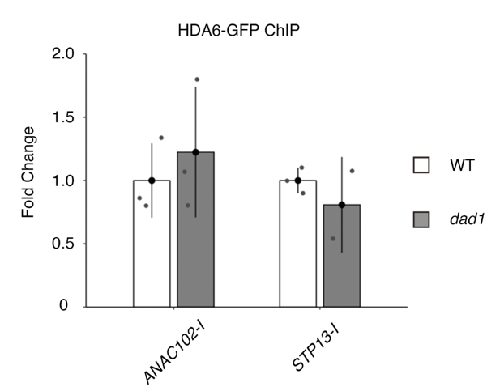

Extended Data Fig. S9 Binding of HDA6-GFP protein to the ANAC102 and STP13 promoters.
Binding of HDA6-GFP at the ANAC102 promoter in wild-type as shown by ChIP-qPCR. Positions of PCR amplicons for ChIP-qPCR are shown in Fig. 4c. Data are means ± SEM. n = 3. No significant differences between WT and the dad1 mutant were observed based on two-tailed Student’s t-test.
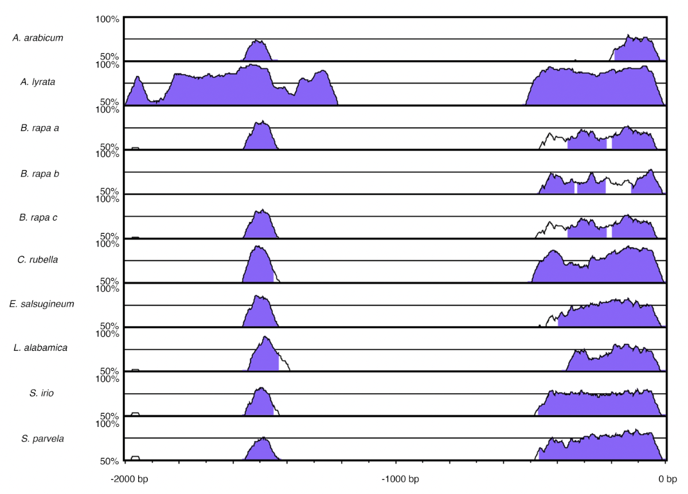

Extended Data Fig. S10 Phylogenetic shadowing across nine Brassicaceae species.
Pairwise alignment created by mVISTA of the 5’ upstream intergenic region of the ANAC102 promoter. 0 bp corresponds to the translation start site.

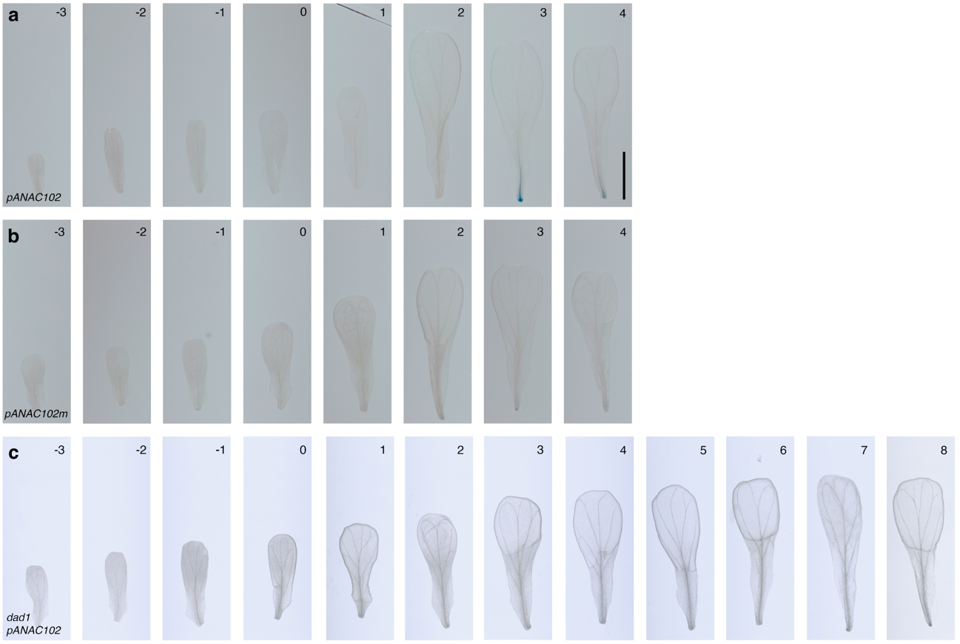
Extended Data Fig. S11 Entire petal images of pANAC102::GUS reporter staining pattern during petal abscission.
a, b, GUS staining pattern for intact pANAC102::GUS (a) and the G-box mutated variant pANAC102m::GUS (b) reporter in petals from position –3 to 4 flowers. Scale bar, 1 mm. c, GUS staining pattern of the ANAC102 promoter in dad1 petals from position –3 to 8 flowers. Scale bar, 1 mm.

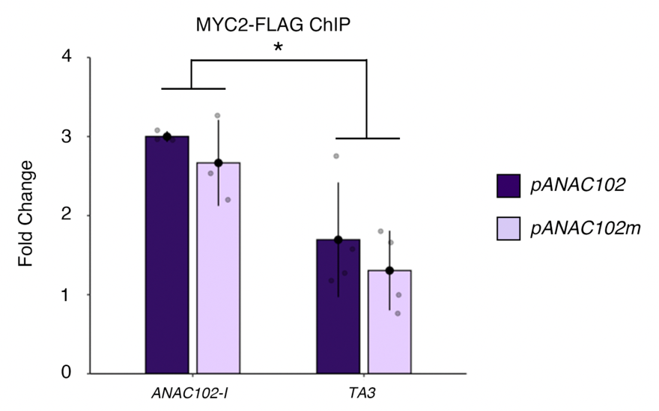
Extended Data Fig. S12 Binding of MYC2-FLAG protein to the endogenous ANAC102 locus.
Binding of MYC2-FLAG protein at the endogenous ANAC102 promoter as shown by ChIP-qPCR. Position of PCR amplicons for ChIP-qPCR are shown in Fig. 5a. Data are means ± SEM. n = 4. Asterisks indicate significant differences of MYC2 binding between the endogenous ANAC102 and TA3 promoters based on two-tailed Student’s t-test.

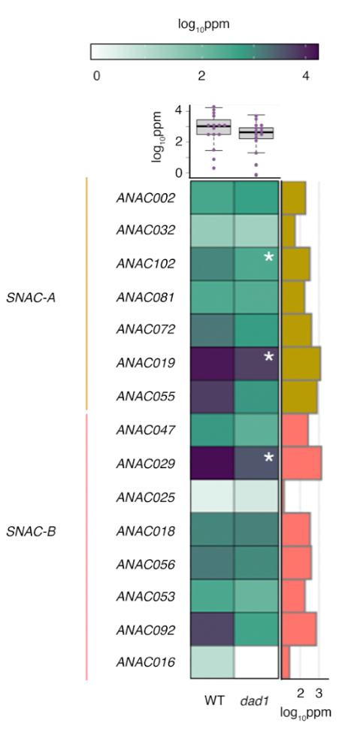
Extended Data Fig. S13 Expression of SNAC family genes in wild type and the dad1 mutant.
Expression levels of seven SNAC-A and eight SNAC-B genes in wild type and dad1 petals from position +3 flowers. The heatmap shows the Log₁₀ ppm based on RNA-seq data. The boxplot graph with individual data points is shown above the heatmap. The bar graph to the right shows expression levels of each gene in wild type.

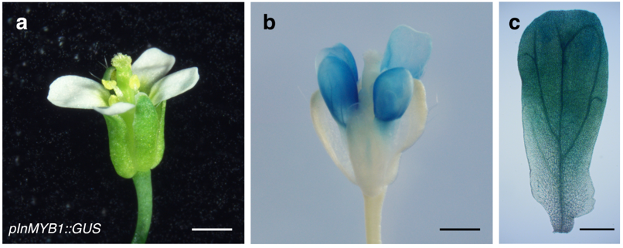
Extended Data Fig. 14 Petal-specific expression of pInMYB1.
a, Flower of the transgenic pInMYB1::GUS line. Scale bar, 1 mm. b, pInMYB1::GUS staining pattern in a wild-type flower at position +1. Scale bar, 1 mm. c, pInMYB1::GUS staining pattern in a wild-type petal from a position –1 flower. Scale bar, 200 µm.

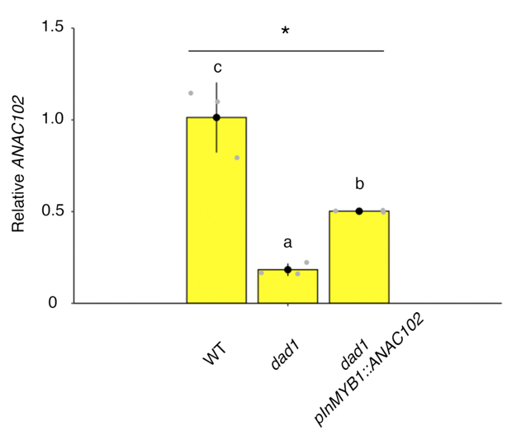
Extended Data Fig. 15 Expression of ANAC102 in pInMYB1::ANAC102 petals from position +3 flowers.
Gene expression levels of ANAC102 in wild type, dad1, and pInMYB1::ANAC102 as determined by RT-qPCR. Data are means ± SEM. n = 3. Different letters indicate significant differences, based on one-way ANOVA and post-hoc Tukey’s HSD test (p < 0.05).

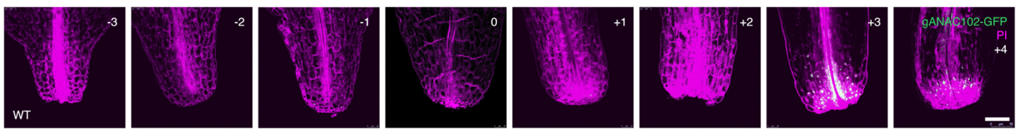
Extended Data Fig. 16 Temporal gANAC102-GFP accumulation in petal bases during petal abscission.
gANAC102-GFP accumulation in petal bases from position –3 to 4 flowers. Scale bar, 50 µm. Green, GFP; purple, propidium iodide (PI).

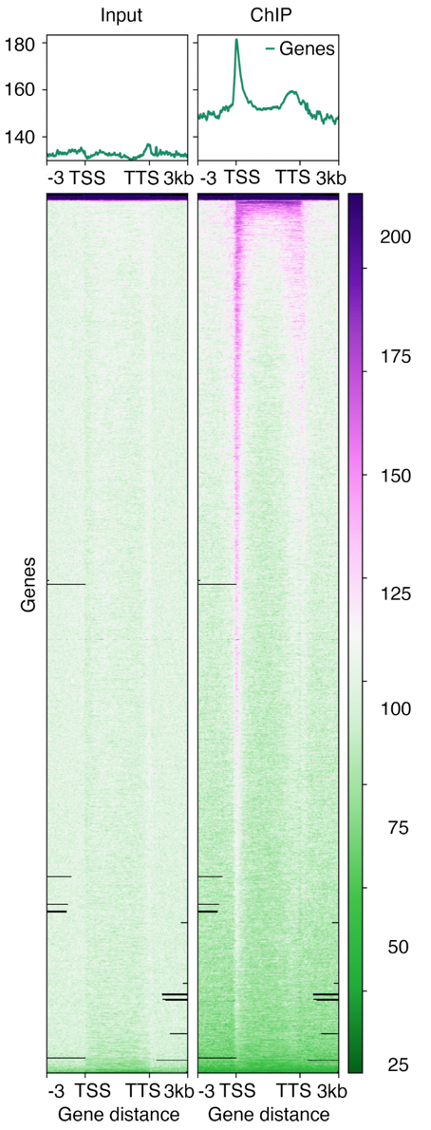
Extended Data Fig. 17 Positional profiles of ANAC102-GFP signal intensity on 4,196 ANAC102-bound genes.
Comparison between ANAC102 input and ChIP data. Left, Input; right, ChIP. The upper panels show the average profile around each peak center. The lower panels show the density heatmaps over the gene body.

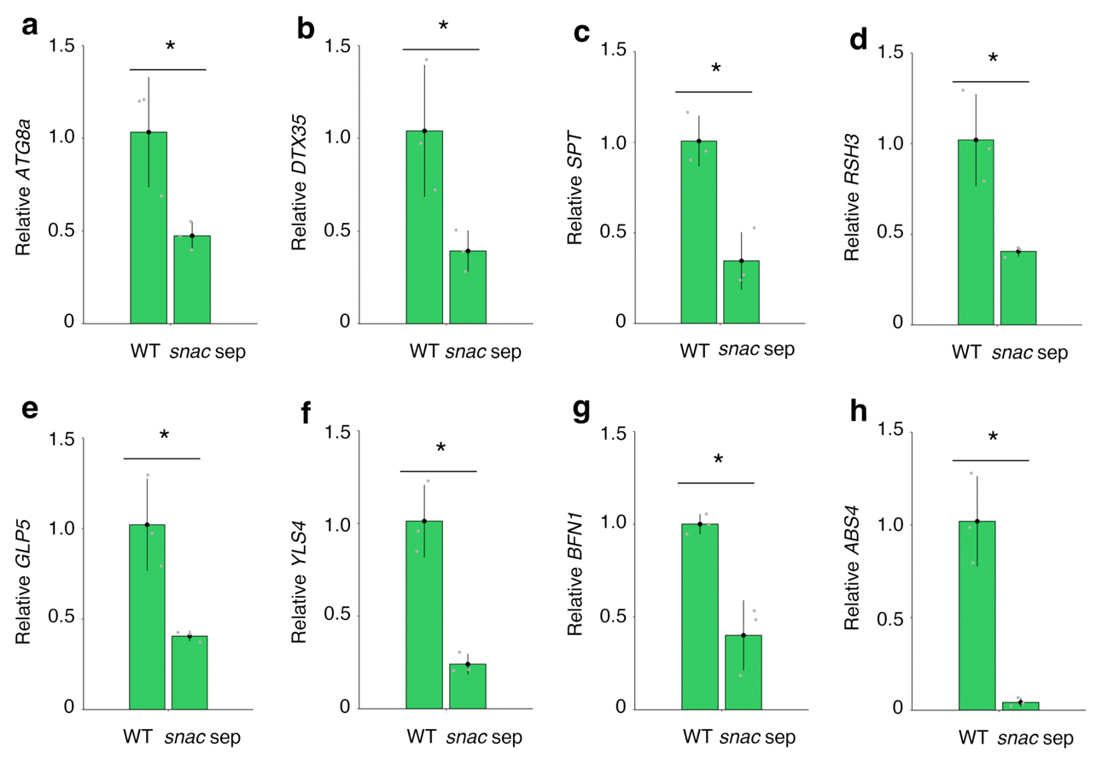

Extended Data Fig. 18 Expression levels of selected DEGs in WT and the snac septuple mutant.
a-h, Gene expression levels in wild type and the dad1 mutant by RT-qPCR. a, ATG8a. b, DTX35. c, SPT, d, RSH3. e, GLP5. f, YLS4. g, BFN1. h. ABS4. Data are means ± SEM. n = 3. Asterisks indicate significant differences between WT and the snac septuple mutant based on two-tailed Student’s t-test.

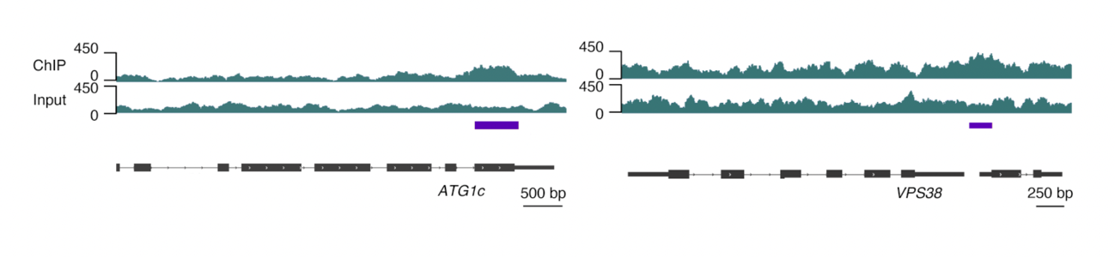
Extended Data Fig. 19 Binding peaks of ANAC102 at the ATG1c and VPS38 loci.
IGV browser view of ANAC102 ChIP and input signals at the ATG1c and VPS38 loci. Purple horizontal bars indicate significant differences between ChIP and input signals. The gene models are shown as black bars and lines at the bottom of each panel.

