Supplementary Information

Therapeutic opportunity of phosphodiesterase 3A modulators in myxoid liposarcomas

Toivanen et al. 2023

Supplementary Table S1. Genes upregulated in liposarcoma subtypes (in their separate sheets) compared to 201 human healthy and cancerous tissue types, and compounds targeting these genes. A. Ranking order number, B. Gene Ensembl code, C. Gene name, D. logFC (fold change), E. logCPM (count per million), F. P Value, G. Drug, identified from drug-gene interaction database (DGIdb), H. Drug type, I. Source of drug-gene interaction, J. PubMed ID.
Supplementary Table S2. Drug sensitivity and resistance test (DSRT) results in 8 liposarcoma cell lines. A. Drug ID used in the Institute for Molecular Medicine Finland (FIMM), B. Drug name, C. Drug target, D. Drug class, E. Drug approval status as of 2020-01-09, F – AK. Half maximal effective concentrations (EC50), Drug Sensitivity Scores (DSS), Selective Drug Sensitivity Scores (sDSS) (where DSS values are compared with normal bone marrow mononuclear cells), and drug response graphs in all 8 liposarcoma cell lines.
Supplementary Table S3. DSRT results in 8 liposarcoma cell lines (D – K) of the drugs (C) that emerged from the DGIdb and were found in the drug panel used in the screening. Some of the drugs targeted multiple genes (B) that were identified in different liposarcoma subtypes (A). The DSS, EC50, and sDSS values are presented in separate sheets.
Supplementary Table S4. Synergy DSRT results in SA4 and GOT3 cell lines. A. Drug name, B. Drug target, C. DSS values of the drugs, D. DSS values of the drugs in combination with 100 nM anagrelide. Drugs for closer synergy examination (highlighted in green) were chosen by subtracting the DSS values of the tested drug and ANA (24.2 in SA4 and 6.4 in GOT3) from the combination DSS value (E). Results of SA4, GOT3, and combination presented in separate sheets.
Supplementary Figure S1. Visual presentation of different PDE3A expressions detected by immunohistochemistry in 9 soft tissue sarcoma (STS) types.
Supplementary Figure S2. PDE3A mRNA results in liposarcoma patient series to validate immunohistochemistry results.
Supplementary Figure S3. Example of the dose-response matrix used to define synergies. ZIP synergy scores were calculated from these experiments.
Supplementary Figure S4. Drug combination responses of (a) anagrelide and A-1155463 in anagrelide insensitive cell lines, and (b) cilostazol and A-1155463 in cell lines of different anagrelide sensitivities.
Supplementary Figure S5. Drug responses in anagrelide sensitive cell lines treated separately and simultaneously with anagrelide and A-1155463 combined.
Supplementary Figure S6. Immunoblotting quantification results of apoptotic markers in cell lines treated with drug combination.
Supplementary Figure S7. Immunoblotting results of antiapoptotic protein expressions in cell lines with and without anagrelide treatment.
Supplementary Figure S8. Drug combination responses of (a) DNMDP and A-1155463, (b) DNMDP and navitoclax, (c) 3’-hydroxy anagrelide and A-1155463, and (d) 3’-hydroxy anagrelide and navitoclax, in anagrelide sensitive cell lines. The same DMSO control and PDE3A modulator treatments are presented in panels a and b, and c and d, as they are from the same experiments, but are presented separately for clarity.

Figure S1. PDE3A staining scores in nine soft tissue sarcoma types. 40X images were acquired from scanned stained TMA slides that were viewed with CaseViewer. * Not all staining intensities appeared. ** In some cases, only gland-like epithelial structures of the tumour were stained.
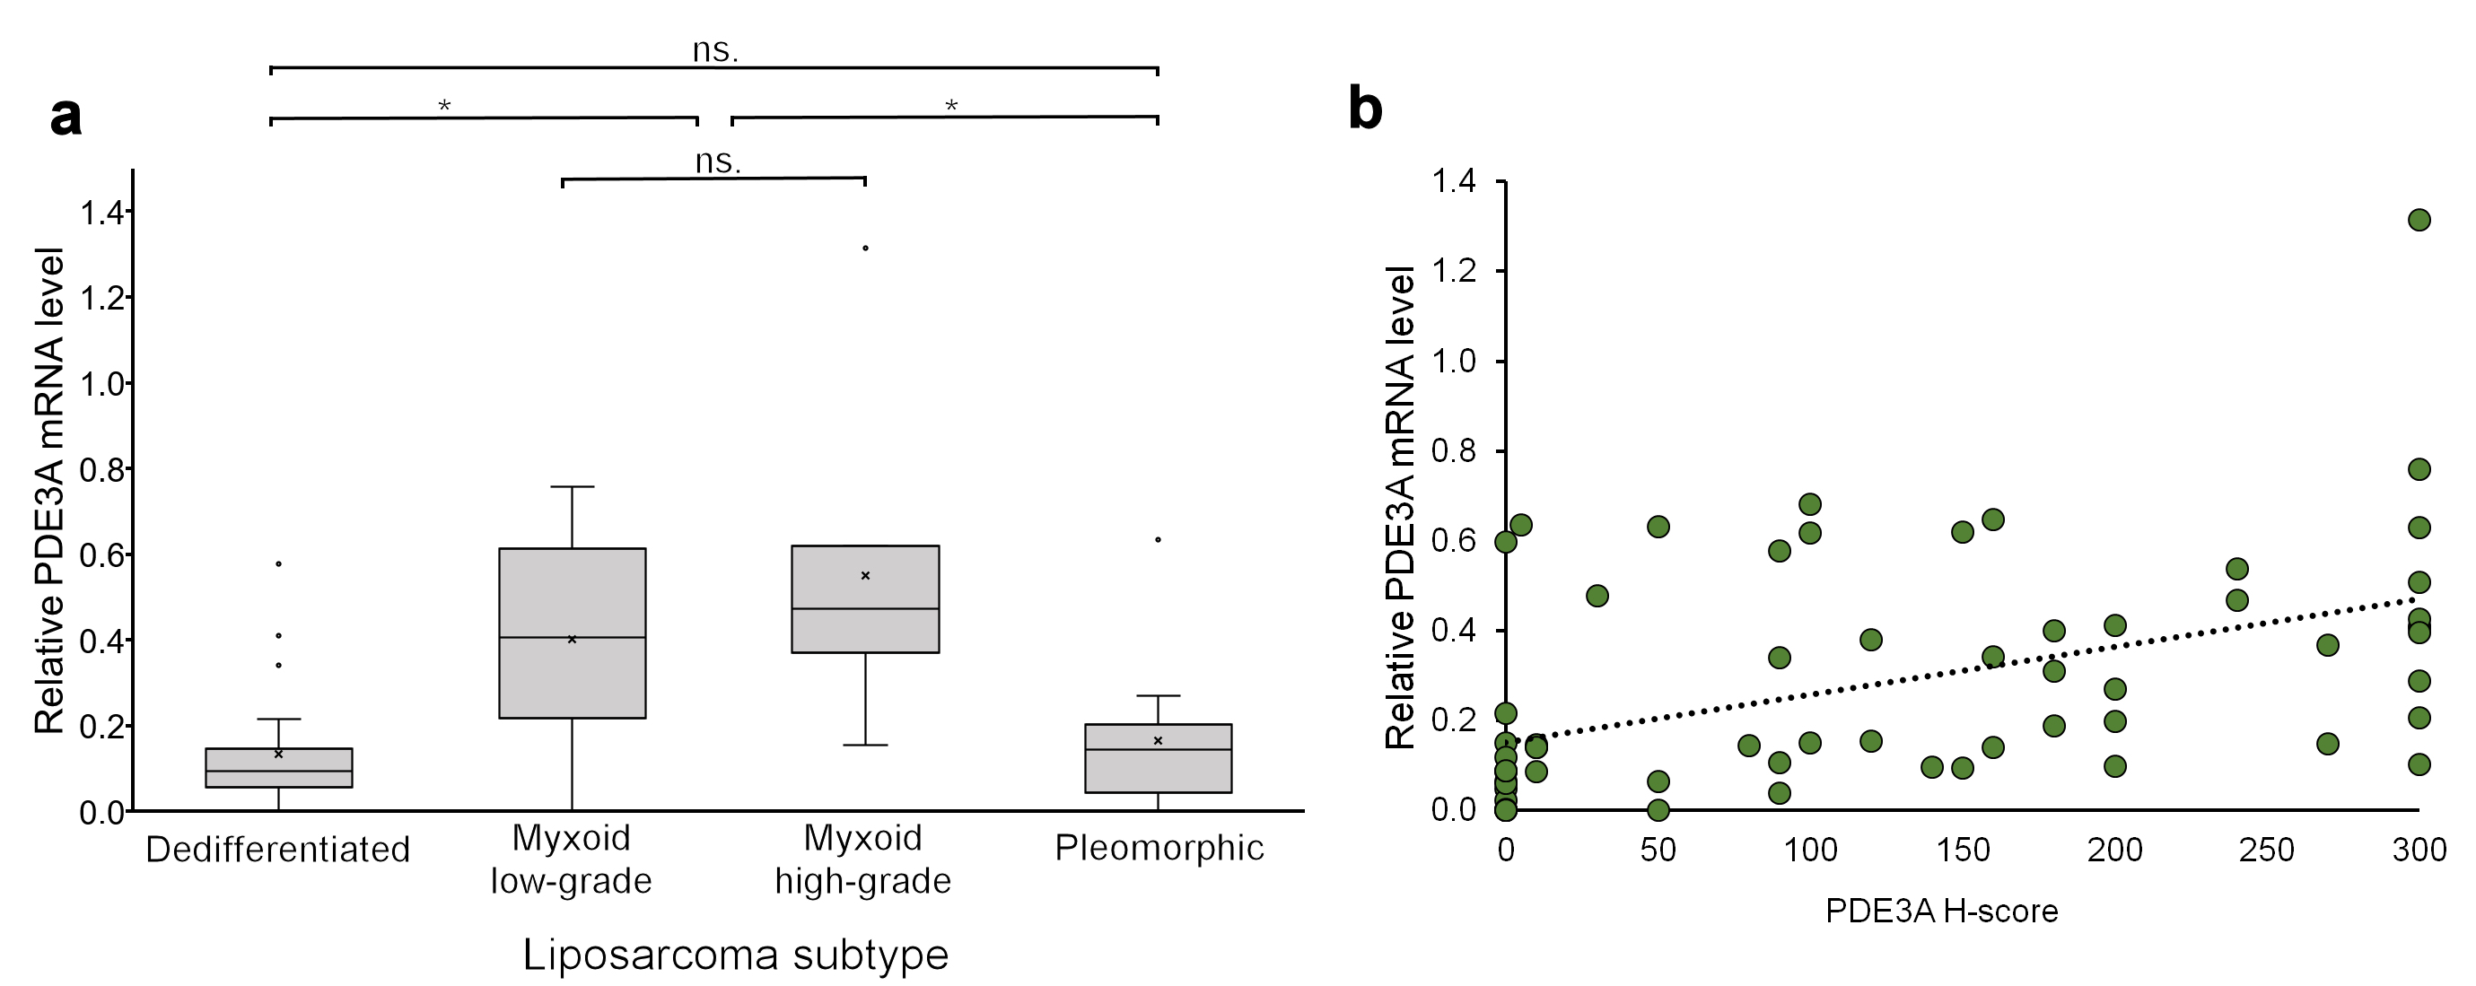
Figure S2. Validating PDE3A immunohistochemical staining in 63 liposarcoma tissue results with RT-qPCR. a, Strong PDE3A expression in myxoid subtype was also observed in mRNA level (Kruskall-Wallis test, P < 0.01). Data are represented as mean ± standard deviation. b, Correlation was observed between PDE3A RT-qPCR and immunohistochemistry results (Spearman’s ρ = 0.573, P < 0.0001).

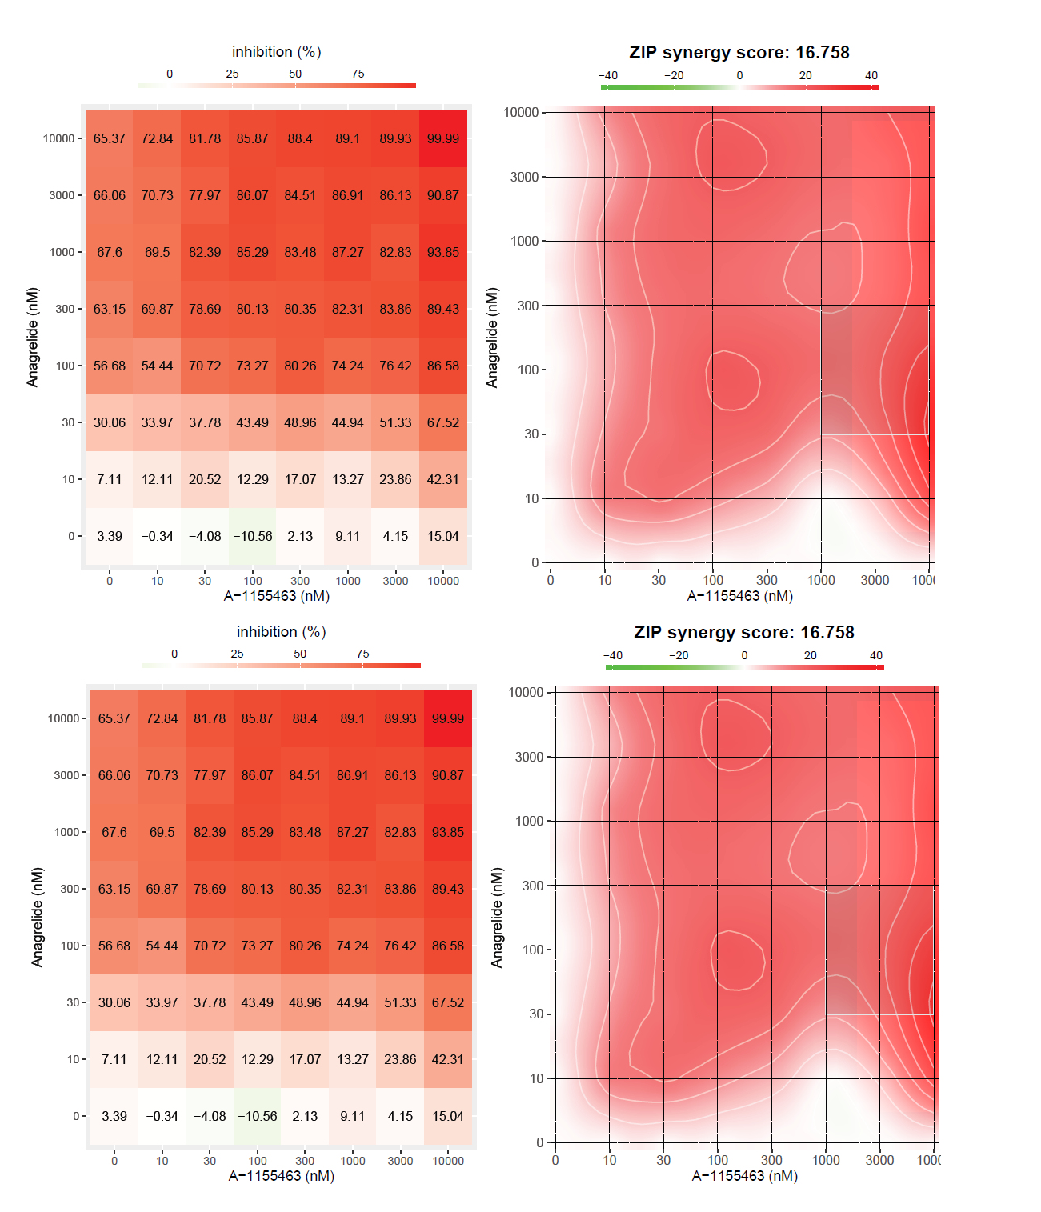
Figure S3. Example DSRT dose-response matrix of anagrelide and A-1155463 in GIST882 from which ZIP synergy scores were calculated. The two representative images are from two separate experiments.

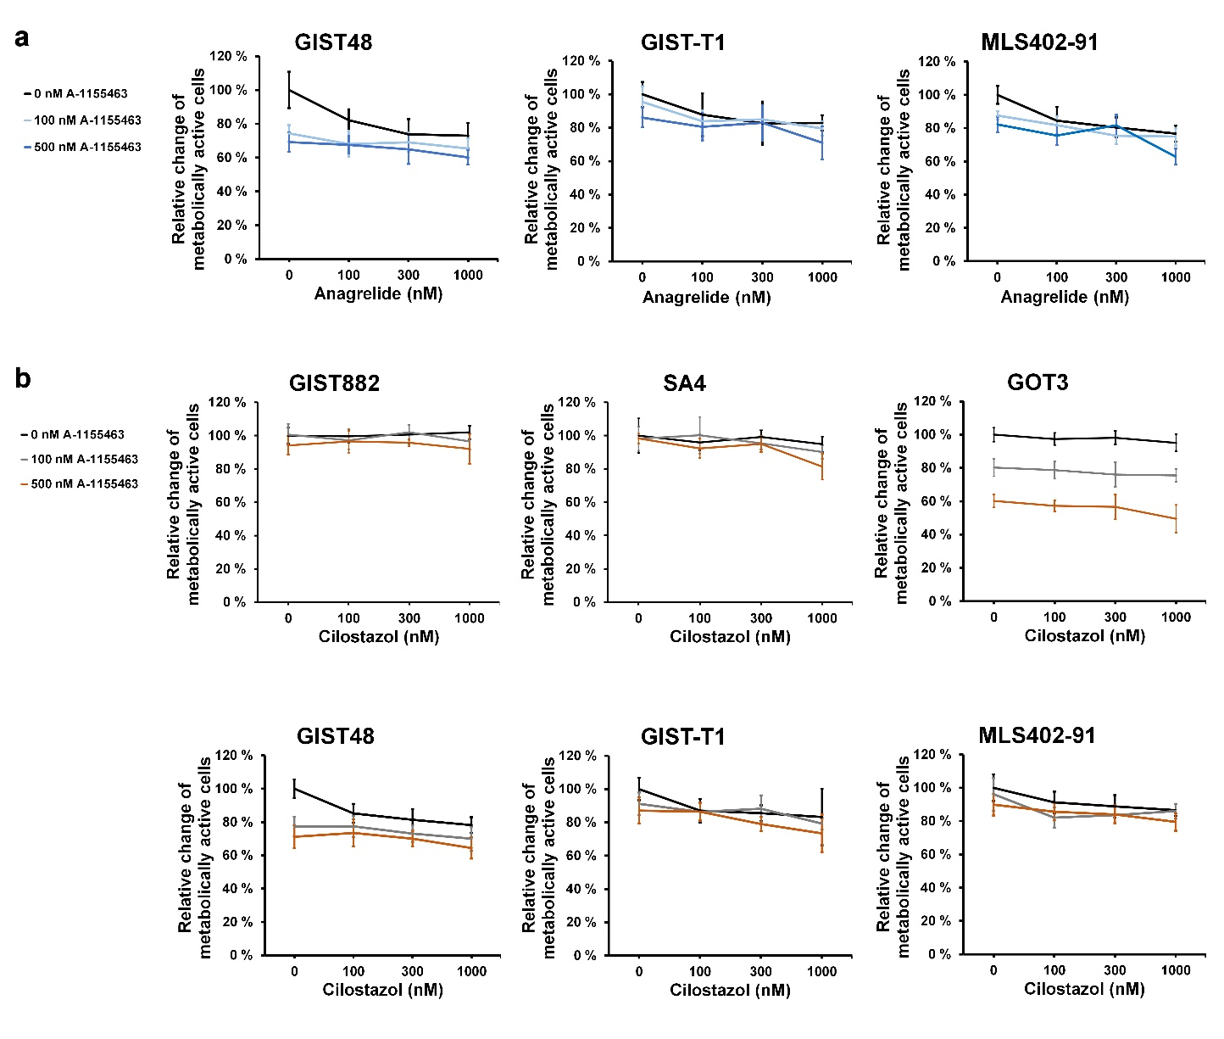
Figure S4. Synergy of anagrelide and cilostazol with Bcl-xL inhibitor assessed in anagrelide-sensitive and –insensitive cell lines. a, Synergy between A-1155463 and anagrelide was not observed in cell lines that do not respond to anagrelide alone. b, Synergy was not observed between A-1155463 and cilostazol in any of the cell lines. Data are represented as mean ± standard deviation of eight replicates from two separate experiments.
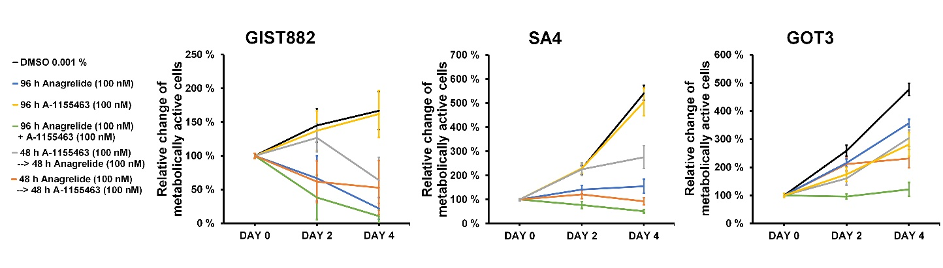
Figure S5. Sequential and combined drug exposures assessed in anagrelide-sensitive cell lines. Combined exposure to anagrelide and A-1155463 was most effective compared to sequential exposures. Data are represented as mean ± standard deviation of eight replicates from two separate experiments.
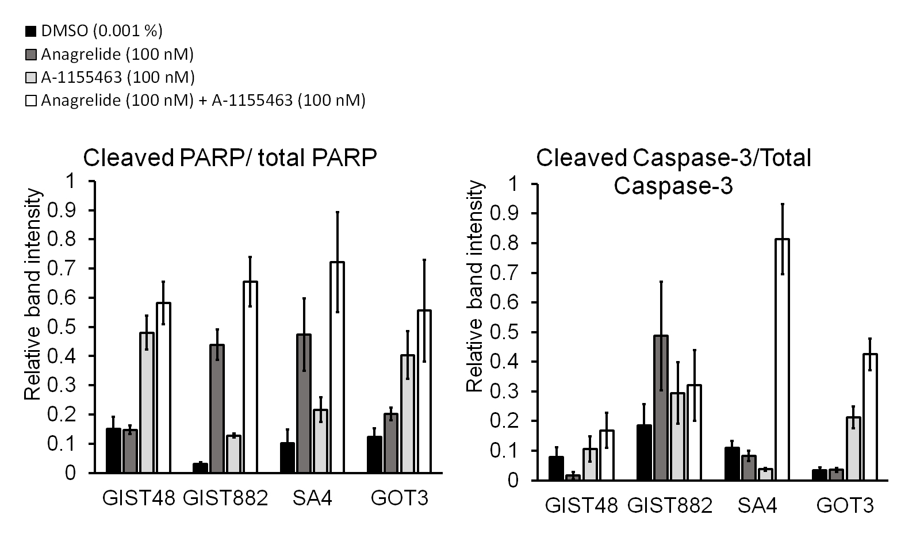
Figure S6. Relative band intensity quantification enabled measuring ratios of the cleaved product to the total protein amount. PARP is highly cleaved in all synergy treated cells, and increased caspase-3 cleavage was detected in synergy treated SA4 and GOT3. Data are represented as mean ± standard deviation of three replicates.
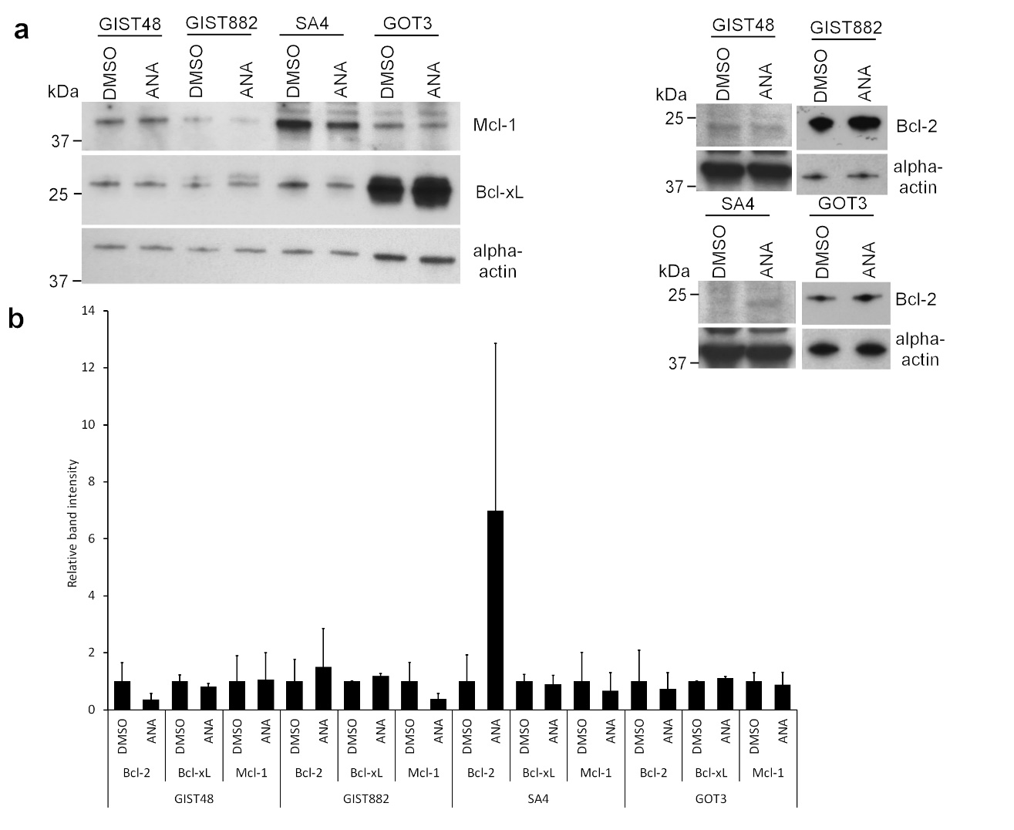
Figure S7. Antiapoptotic protein expression levels in DMSO- and anagrelide-treated cells. a, Immunoblotting revealed reduced Mcl-1 expression in ANA-sensitive cell lines, GIST882, SA4, and GOT3, treated with 100 nM ANA, whereas Bcl-xL expression decreased only slightly in GIST48 and SA4, and Bcl-2 in GIST48 and GOT3. b, Minor expression changes were analysed by relative band intensity quantifications obtained from two independent experiments using DMSO treatment as reference. Data are represented as mean ± standard deviation of three replicates.

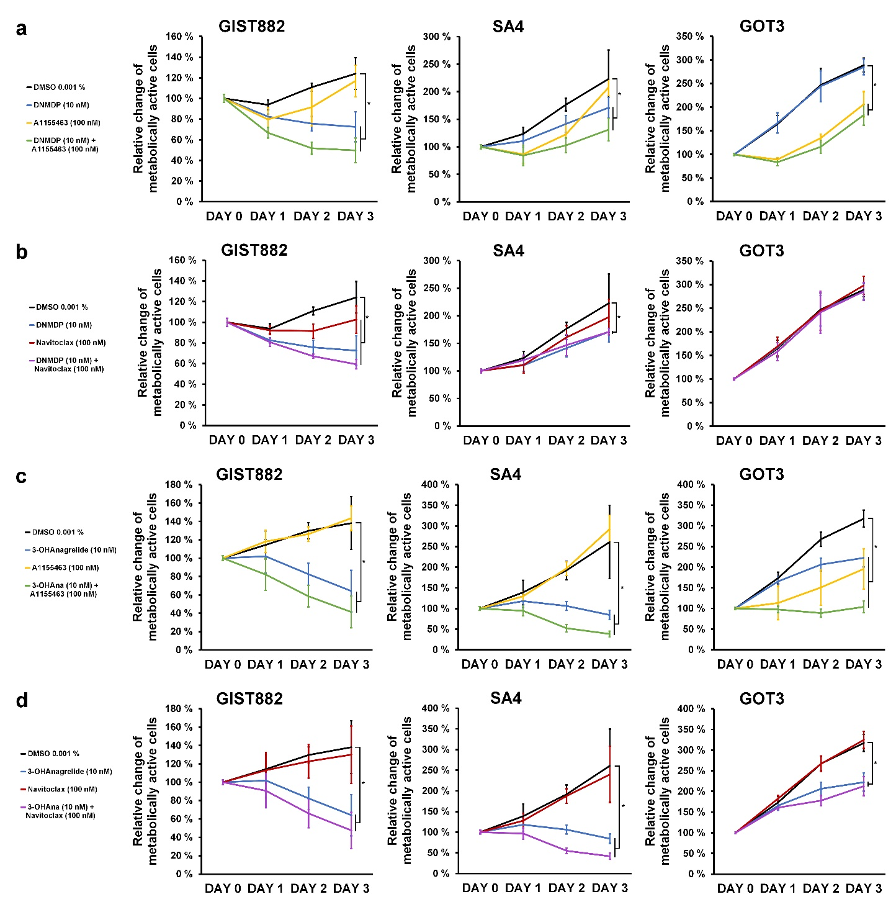
Figure S8. Combinations of PDE3A modulators and Bcl-2/Bcl-xL inhibitors assessed in PDE3A modulator –sensitive cell lines. Drug responses of a, DNMDP and A-1155463; b, DNMDP and navitoclax; c, 3-hydroxy anagrelide and A-1155463; and d, 3-hydroxy anagrelide and navitoclax, in cell lines sensitive to PDE3A modulators. All data are represented as mean ± standard deviation of eight replicates from two separate experiments. With both PDE3A modulators, 10 nM concentration was used since it corresponded to the 100 nM ANA concentration in cell lines. The treatments in panels a and b, and c and d, are from the same dataset, but are presented in separately for clarity. *P < 0.0001, when mean compared to DMSO-treated cells using independent-samples t-test. The combination of DNMDP and A-1155463 was more effective than the combination of DNMDP and navitoclax (GIST882: P = 0.008, SA4: P < 0.0001, GOT3: P < 0.0001). Significant differences between 3-OH + A-1155463 –combination and 3-OH ANA + navitoclax –combination was not observed in GIST882 and SA4. Instead, the combination of A-1155463 and 3-OH ANA resulted in significantly lower cell viabilities (104%) than navitoclax and 3-OH ANA (213%) in GOT3 (P < 0.0001).

