npj | Climate and Atmospheric Science
Supplementary Figures

Linkage between Record Floods in Pakistan and a Severe Heatwave in China in the Boreal Summer of 2022

Chi-Cherng Hong¹, An-Yi Huang¹, Huang-Hsiung Hsu^{2*}, Wan-Ling Tseng^{2,3}, Mong-Ming Lu⁴, Chih-Chun Chang¹

¹Department of Earth and Life Science, University of Taipei, Taipei, Taiwan.
²Anthropogentic Climate Change Center, Research Center for Environmental Changes, Academia Sinica, Taipei, Taiwan.
³International Degree Program in Climate Change and Sustainable Development, National Taiwan University, Taipei, Taiwan.
⁴Department of Atmospheric Sciences, National Taiwan University, Taipei, Taiwan.

*Corresponding author:
Dr. Huang-Hsiung Hsu, Research Center for Environmental Change, Academia Sinica, 128 Academia Road, Section 2, Nankang, Taipei, 115, Taiwan
E-Mail: hhhsu@gate.sinica.edu.tw

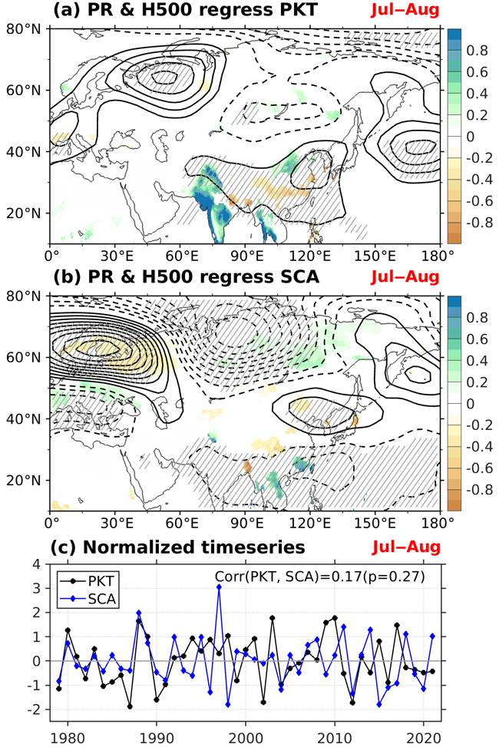
Supplementary Figure 1. Comparisons between PKT related pattern and Scandinavia pattern. (a) Regression of July–August averaged precipitation (shading) and 500 hPa geopotential height (contour; interval: 2.5) on normalized PKT index during 1979–2021. Shadings and hatched regions indicate where regression coefficients exceed 90% confidence level based on Student’s t-test. (b) Same as (a), but on normalized SCA index (Scandinavia pattern index is from https://www.cpc.ncep.noaa.gov/data/teledoc/telecontents.shtml). (c) Normalized timeseries of PKT and SCA indices. Correlation coefficient between PKT and SCA is 0.17 that is not statistically significant.

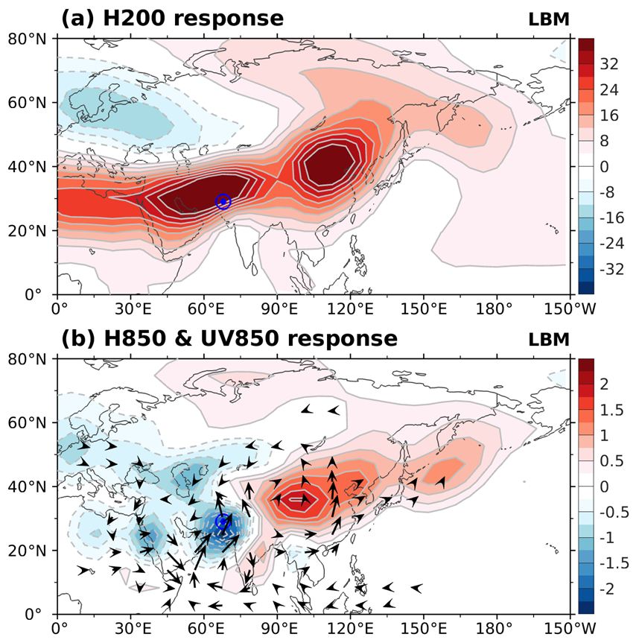
Supplementary Figure 2. Atmospheric response to an idealized heating in Pakistan. (a) Simulated 200-hPa geopotential height derived from the steady response of LBM to a diabatic heating in Pakistan (blue mark) mimicking observed rainfall. (b) Low-level response (850hPa horizontal winds and geopotential height) in the same LBM simulation.

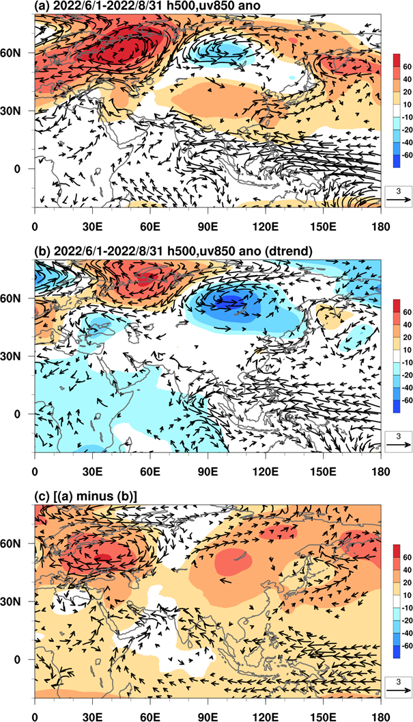
Supplementary Figure 3. Contribution of long-term linear trends on 2022. Spatial distribution of 500hPa geopotential height (shading) and 850hPa wind anomalies in JJA 2022 for (a) total anomaly, (b)linearly detrended anomaly, and (c) contribution long-term (1979–2021) linear trend, i.e., (a) minus (b). Only the wind speed exceeding 0.5 m/s was plotted.

