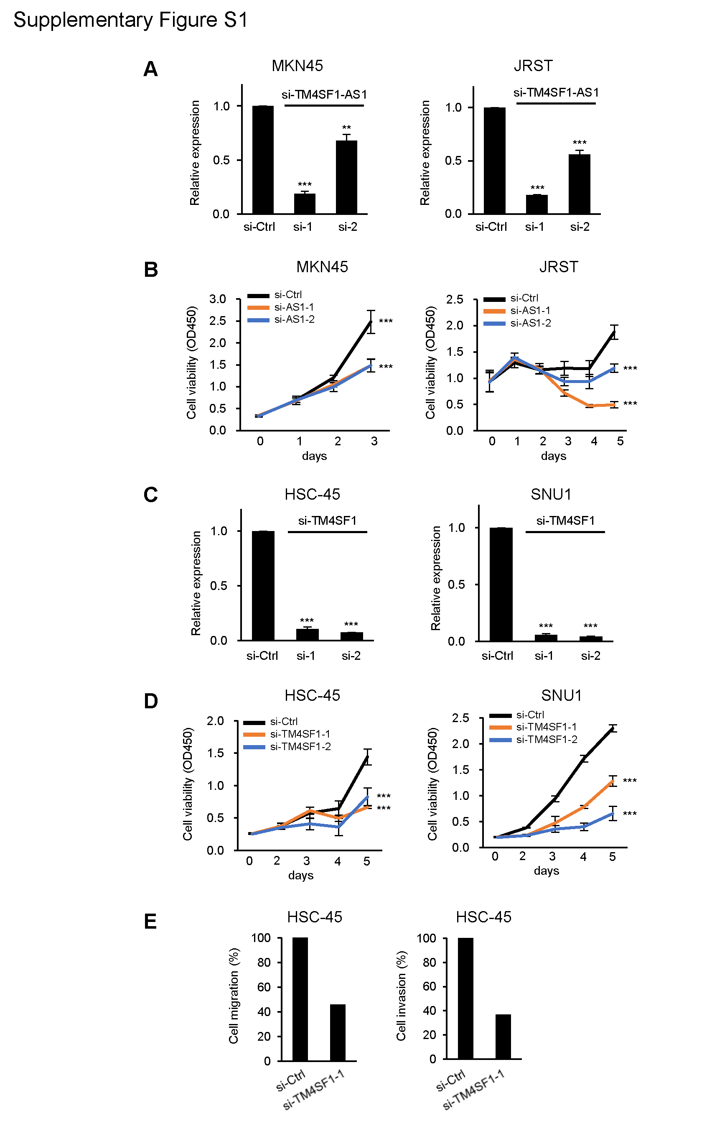
Supplementary Figure S1
Oncogenic functions of TM4SF1-AS1 and TM4SF1 in GC cells. (A) qRT-PCR analysis of TM4SF1-AS1 in the indicated GC cell lines transfected with siRNAs targeting TM4SF1-AS1 (si-1 and -2) or a control siRNA (si-Ctrl). (B) Results of cell viability assays with MKN45 and JRST cells transfected with siRNAs targeting TM4SF1-AS1 or a control siRNA. (C) qRT-PCR analysis of TM4SF1 in HSC-45 and SNU1 cells transfected with a control siRNA or siRNAs targeting TM4SF1 (si-1 and -2). (D) Cell viability assays with MKN45 and JRST cells transfected with siRNAs targeting TM4SF1 or a control siRNA. (E) Results of migration and invasion assays with HSC-45 cells transfected with the indicated siRNAs. Shown are means of eight replications in (B and D); error bars represent SDs. **P<0.0.1, ***P<0.001.

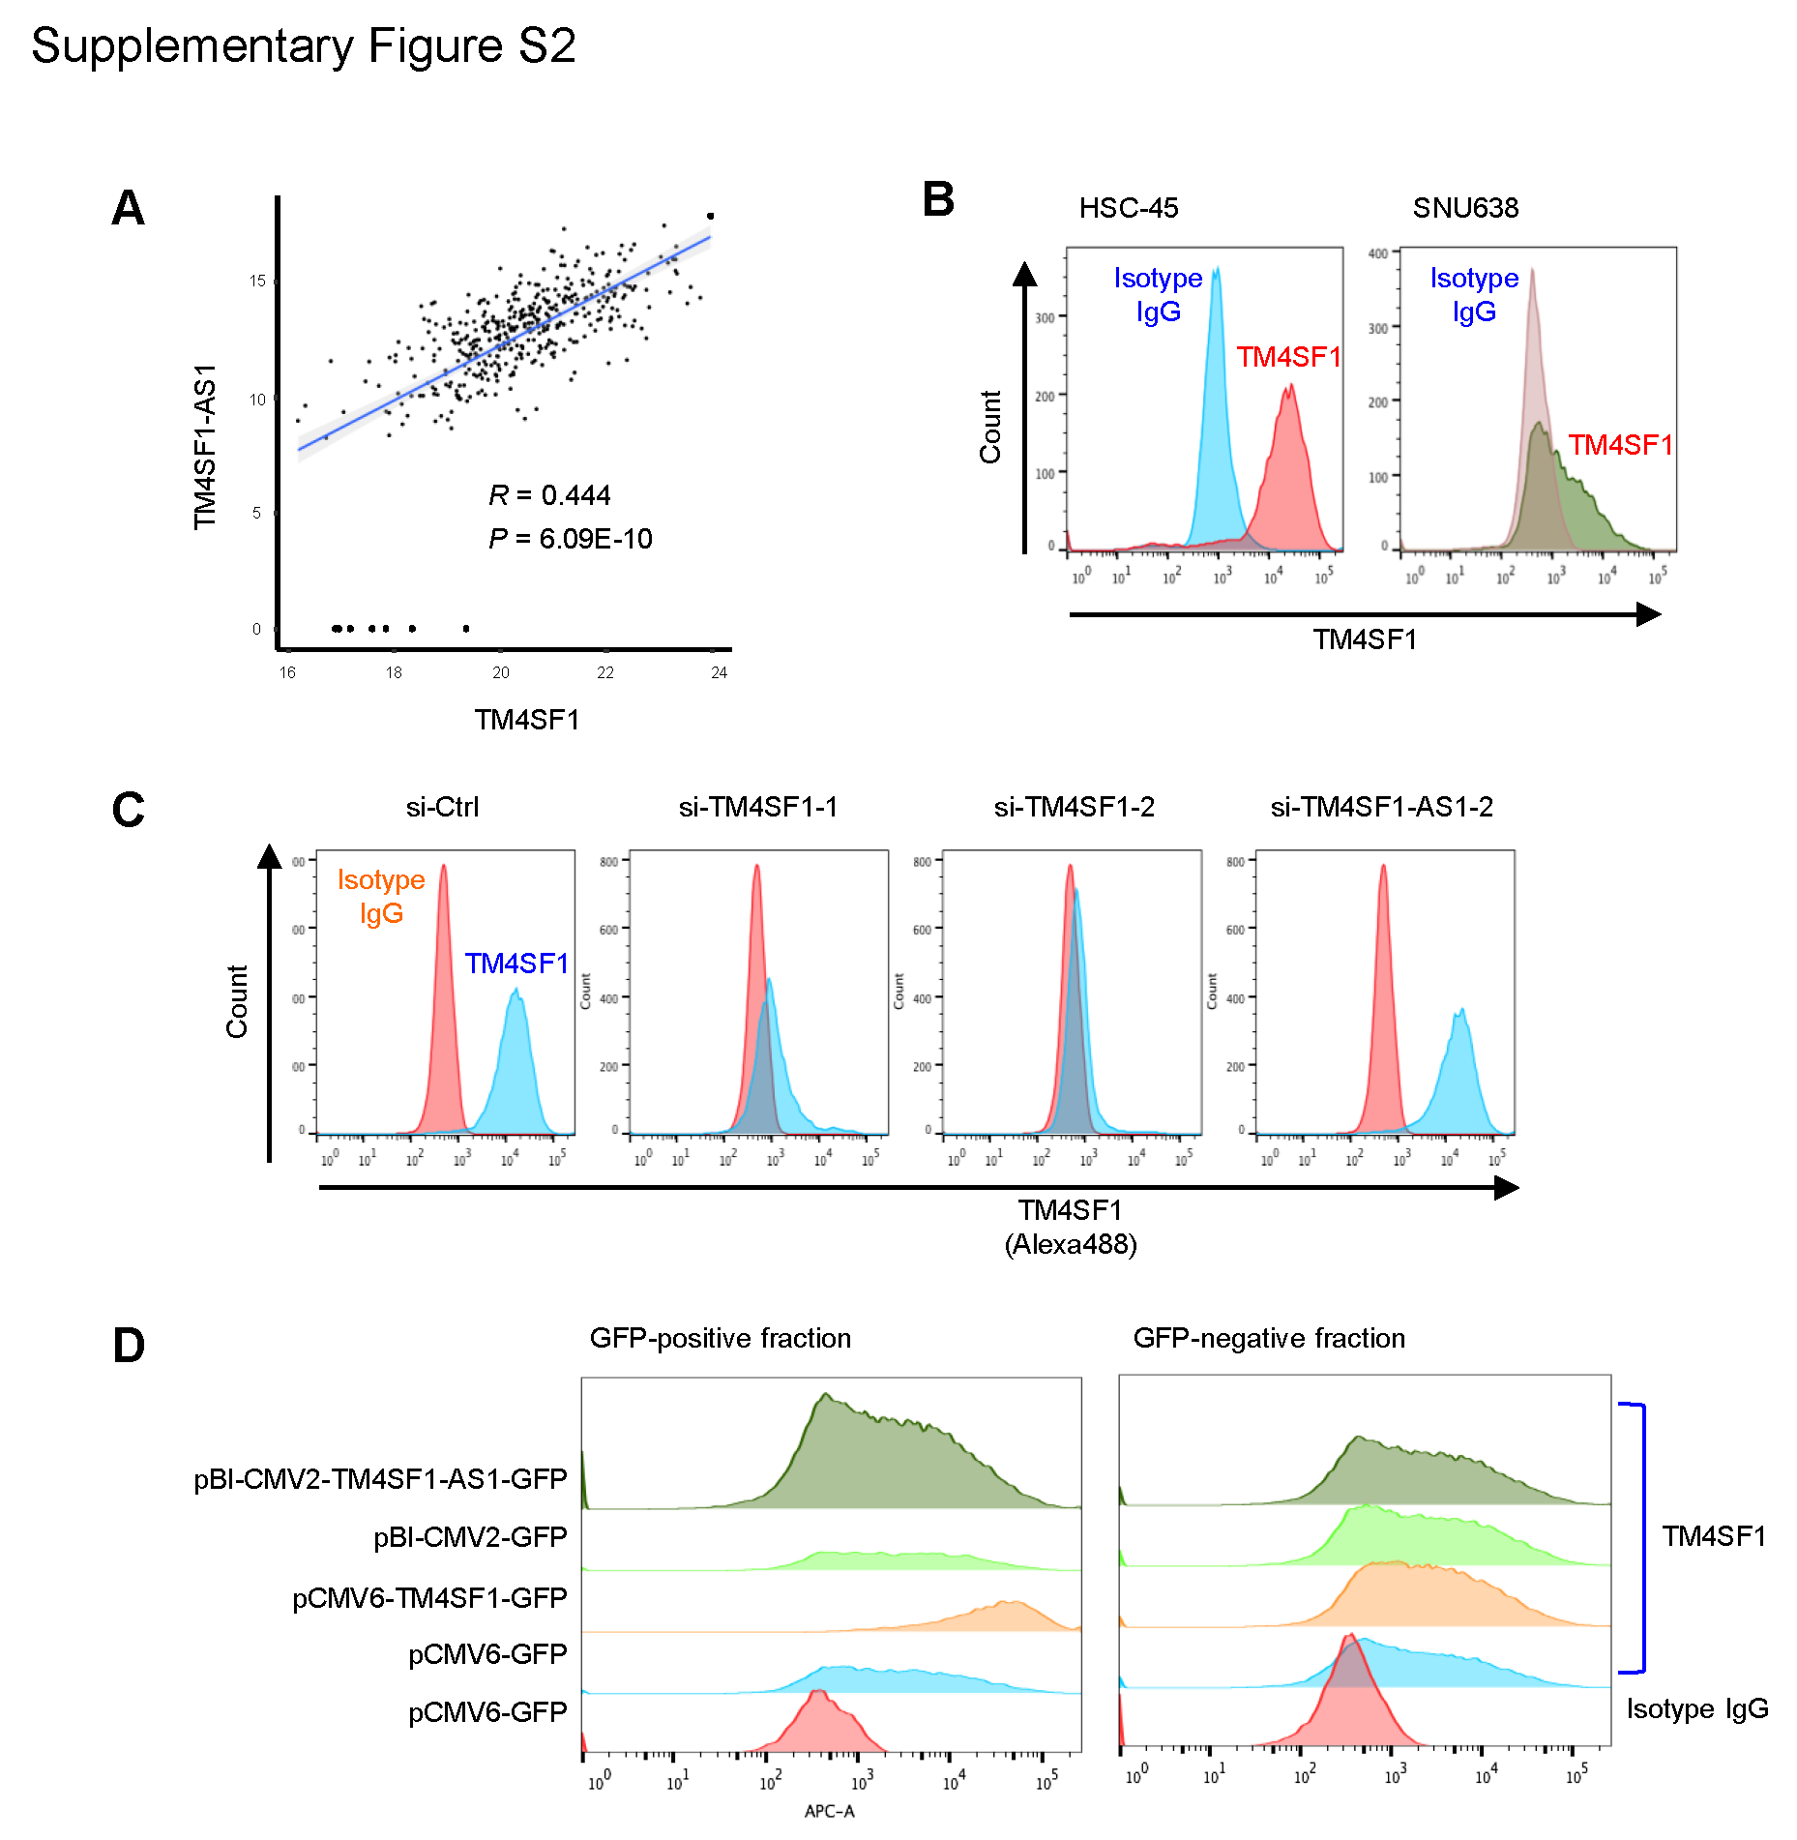

Supplementary Figure S2
TM4SF1 and TM4SF1-AS1 are co-expressed in GC cells, but TM4SF1-AS1 does not affect TM4SF1 expression. (A) Scatter plots showing expression levels of TM4SF1 and TM4SF1-AS1 in indicated datasets from TCGA. The Pearson correlation coefficients and P values are shown. (B) Flow cytometric analysis showing expression of TM4SF1 on the cell surface of the indicated GC cell lines. Isotype IgG served as a negative control. (C) Flow cytometric analysis showing expression of TM4SF1 on the surface of HSC-45 cells transfected with siRNAs targeting TM4SF1 (siTM4SF1-1 and -2) or TM4SF1-AS1 (si-TM4SF1-AS1-2) or a control siRNA. Note that siRNAs targeting TM4SF1 significantly depleted TM4SF1, while TM4SF1-AS1 knockdown did not affect TM4SF1 expression. (D) Flow cytometric analysis of TM4SF1 on the surface of SNU638 cells transfected with TM4SF1 or TM4SF1-AS1 expression vectors (pCMV6-TM4SF1-GFP or pBI-CMV2-TM4SF1-AS1-GFP) or control vectors (pCMV-GFP or pBI-CMV2-GFP). Results obtained with GFP-positive and -negative fractions are shown. Note that TM4SF1 was upregulated in cells transfected with pCMV6-TM4SF1-GFP, while expression of TM4SF1 did not change in cells with ectopic TM4SF1-AS1 expression.

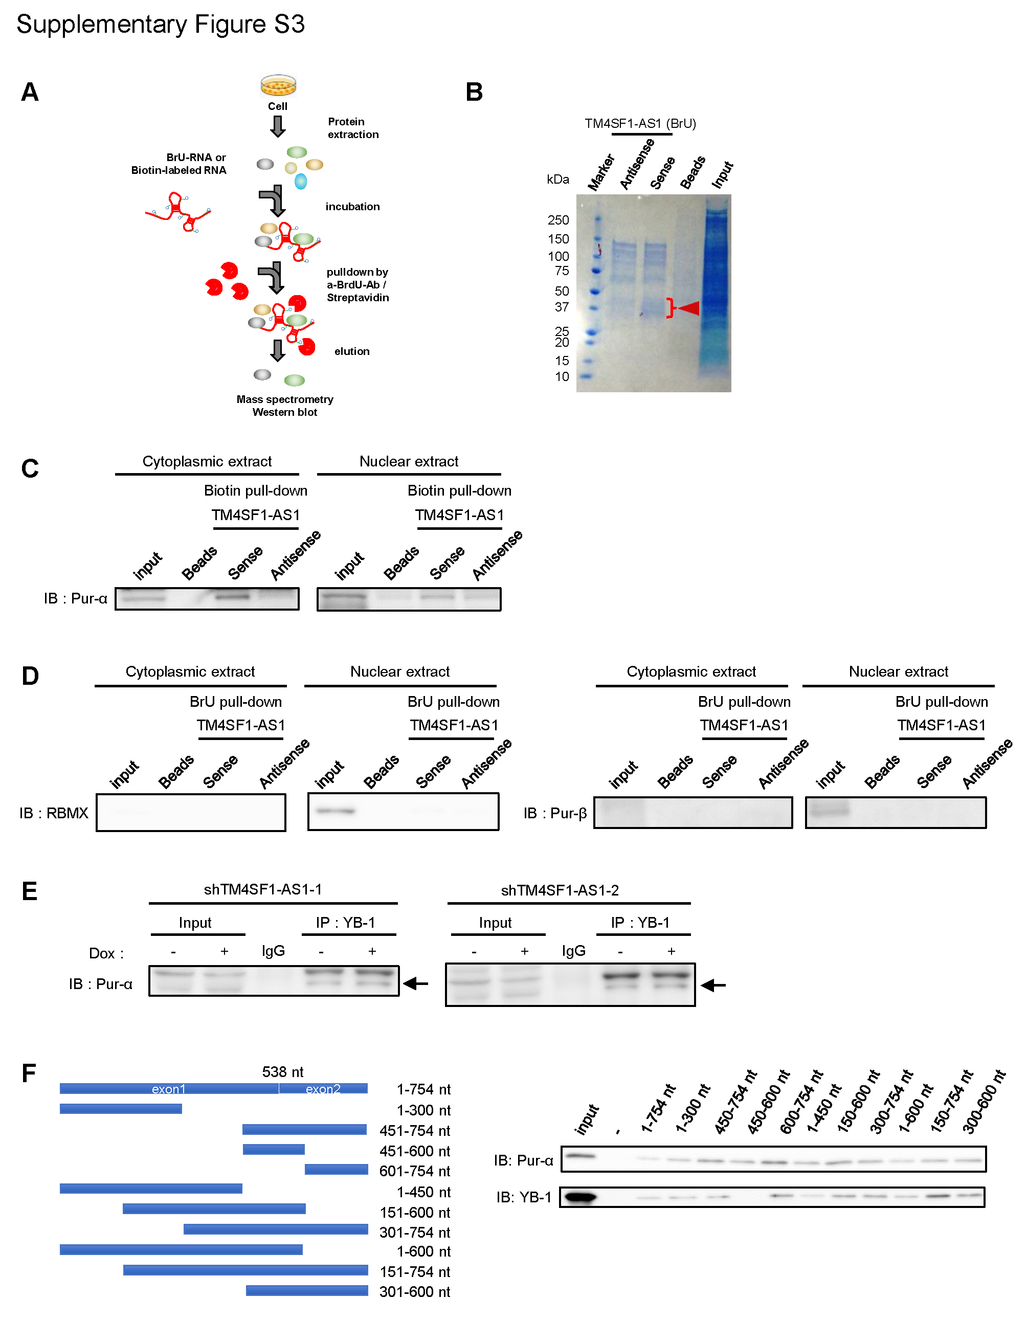

Supplementary Figure S3
Identification of proteins that interact with TM4SF1-AS1 in GC cells. (A) Workflow to identify proteins interacting with TM4SF1-AS1 in GC cells. Extracts from HSC-45 cells were pulled-down with BrU or biotin-labeled RNA, after which mass spectroscopy or western blot analyses were performed. (B) CBB staining of the proteins pull-downed with BrU-labeled TM4SF1-AS1, antisense of TM4SF1-AS1 (a negative control) or beads (mock). Bands specific to TM4SF1-AS1 (indicated by an arrow) were extracted and analyzed by mass spectrometry. (C) Extracts of subcellular fractions from HSC-45 cells were pulled-down with biotinylated TM4SF1-AS1 or its antisense and were probed for Pur-α. (D) Extracts of subcellular fractions of HSC-45 cells were pulled-down with BrU-labeled TM4SF1-AS1 or its antisense and were respectively probed for RBMX (left) or Pur-β (right). (E) Co-immunoprecipitation showing interaction between and YB-1 with TM4SF1-AS1 knockdown. HSC-45 cells were incubated with or without Dox for 8 days and expressed inducible shRNAs (1 and 2) targeting TM4SF1-AS1. YB-1 in the cellular extracts was immunoprecipitated, after which western blotting was used to detect by co-precipitating Pur-α (indicated by arrows). (F) In vitro RNA pull-down showing interactions between deleted TM4SF1-AS1 and Pur-α or YB-1. A series of TM4SF1-AS1 deletion mutants are indicated on the left. Myc-tagged Pur-α or YB-1 were pulled-down with biotin-labeled deletion mutants and were probed for Pur-α or YB-1(right).

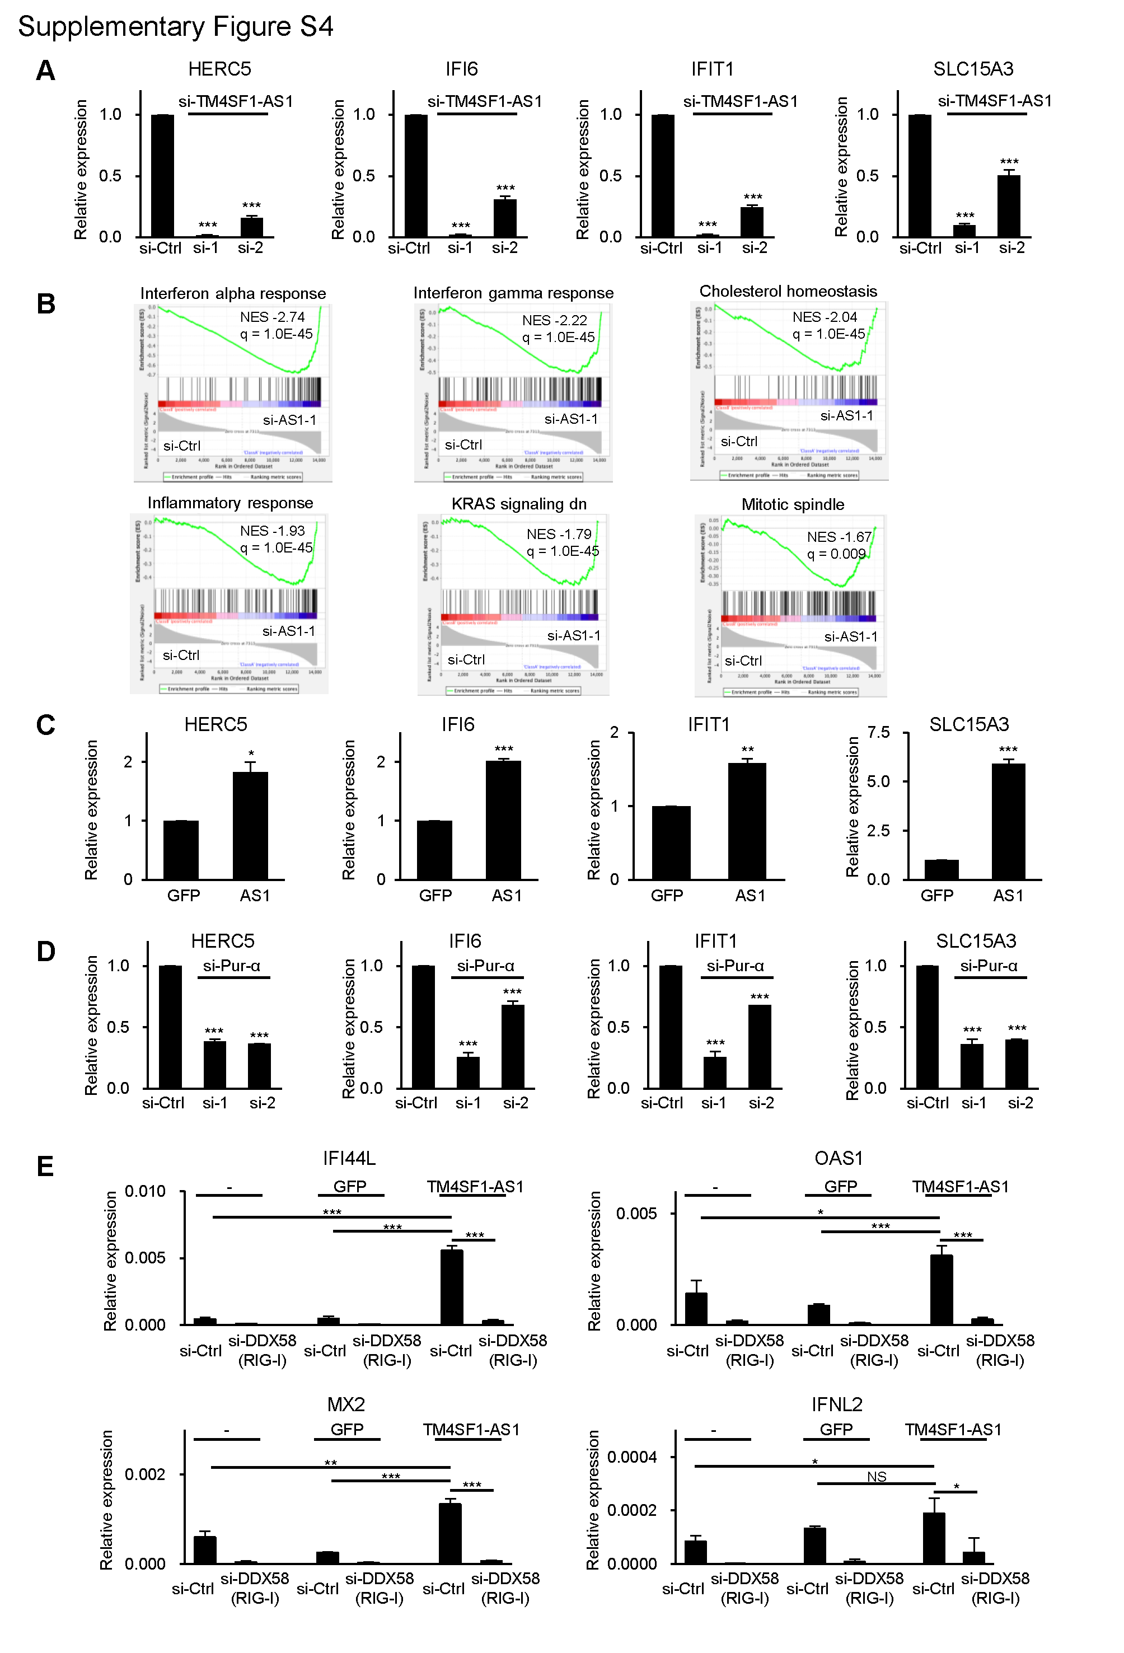
Supplementary Figure S4
TM4SF1-AS1 activates interferon signaling in GC cells. (A) qRT-PCR analysis of the indicated interferon-stimulated genes (ISGs) in HSC-45 cells transfected with a control siRNA or siRNAs targeting TM4SF1-AS1. (B) Results of a GSEA using microarray data obtained from HSC-45 cells after TM4SF1 knockdown. (C) qRT-PCR analysis of the indicated ISGs in SNU638-GFP and SNU638-TM4SF1-AS1 cells. (D) qRT-PCR analysis of the indicated ISGs in SNU638-AS1 cells transfected with a control siRNA or siRNAs targeting Pur-α. (E) qRT-PCR analysis of the indicated IRDS gene in SNU638, SNU638-GFP and SNU638-TM4SF1-AS1 cells transfected with a control siRNA or a siRNA targeting DDX58 (RIG-I). *P<0.05, **P<0.01, ***P<0.001, NS, not significant.

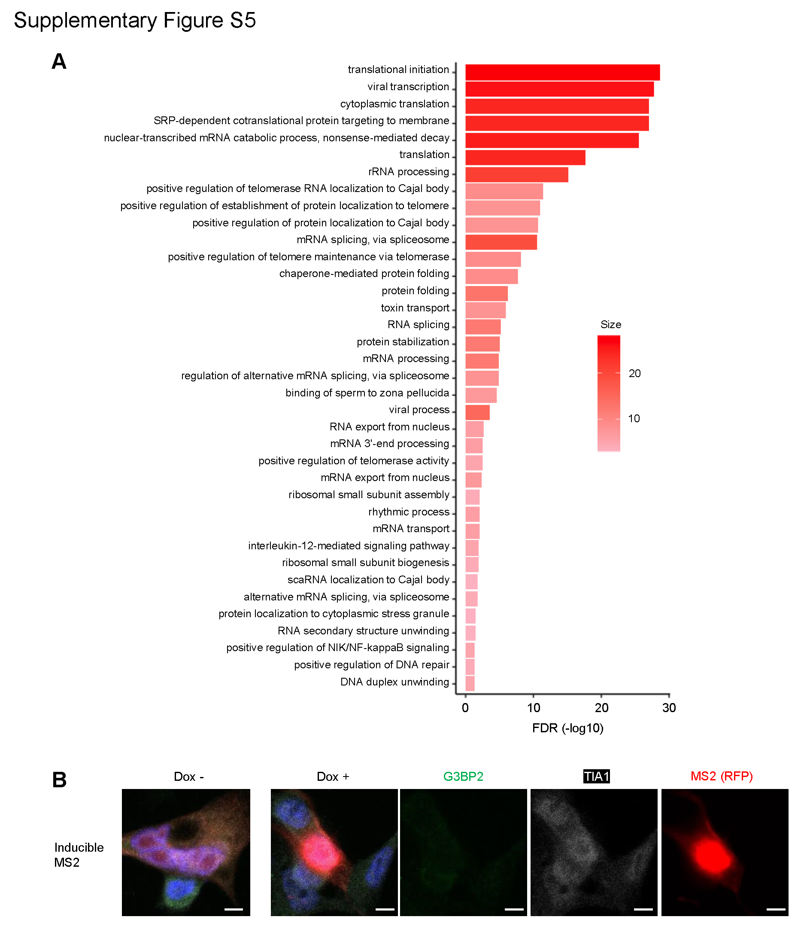
Supplementary Figure S5
TM4SF1-AS1 upregulates SGs in GC cells. (A) GO analysis of proteins identified by ChIRP-MS analysis. (B) Immunofluorescent staining of G3BP2 (green), TIA1 (white) and inducible MS2-tag (red) in SNU638 cells. Cells were transfected with a MS2 coat protein (MCP)-RFP plasmid and incubated for 8 days with or without Dox. Scale bars = 10 μm.

