SUPPORTING INFORMATION

Table S1. List of global maps used for filling missing values of site properties and their sources.
Variable | Resolution of map | Source | URL
Mean annual temperature | 0.0083˚ × 0.0083˚ | Fick and Hijmans (2017) | http://worldclim.org/version2
Mean annual precipitation | 0.0083˚ × 0.0083˚ | Fick and Hijmans (2017) | http://worldclim.org/version2
Aridity index | 0.0083˚ × 0.0083˚ | Zomer et al. (2008) | https://cgiarcsi.community/data/global-aridity-and-pet-database/
Soil pH | 0.0021˚ × 0.0021˚ | Hengl (2018b) | http://doi.org/10.5281/zenodo.2525664
SOC content | 0.0021˚ × 0.0021˚ | Hengl and Wheeler (2018) | https://doi.org/10.5281/zenodo.2525553
Clay content | 0.0021˚ × 0.0021˚ | Hengl (2018a) | http://doi.org/10.5281/zenodo.2525663

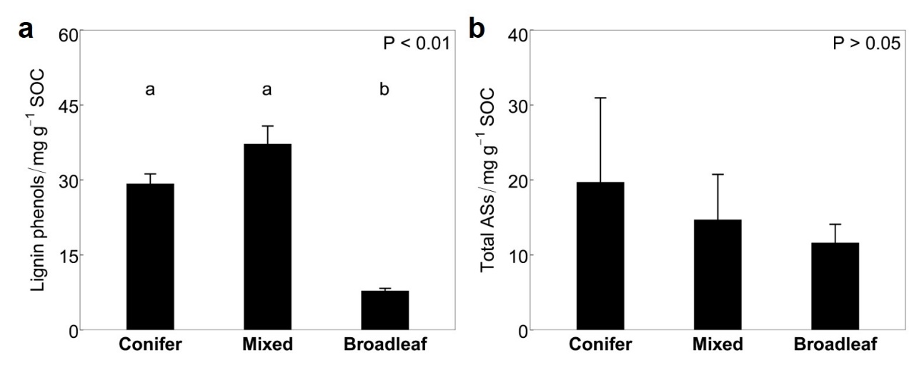
Fig. S1 The SOC-normalized contents of lignin phenols and amino sugars of forest O horizon soil among different forest types. (a) Lignin phenols. (b) Amino sugars (Total Ass). Error bars represent the standard error of the mean (se) and lowercase letters indicate different levels for the same parameter among different forest types (p < 0.05).

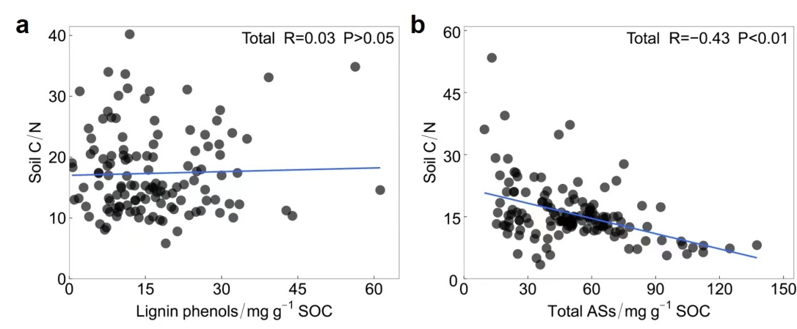
Fig. S2 Relationships of the SOC-normalized contents of lignin phenols or amino sugars with soil C/N among different forest types. (a) Lignin phenols. (b) Amino sugars (Total Ass).

