Extended data figures and tables
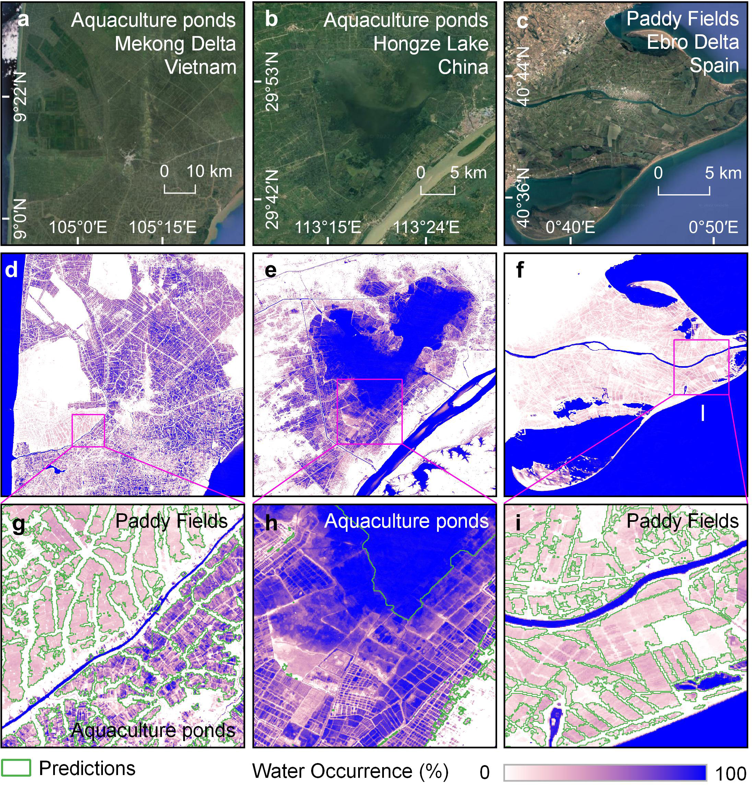
Extended Data Fig. 1 | Mapping human-reclaimed wetlands based on the Global Surface Water Occurrence (GSWO) dataset. The upper panels (a, b, c) show high-resolution Google Earth images. The middle panels (d, e, f) show the corresponding water occurrence images (2011-2020) derived from the GSW dataset (with bluish color indicating permanent waters and purple color representing seasonal waters). The lower panels (g, h, i) show the regions magnified, and the green polygons denote the satellite-detected human-reclaimed wetlands.
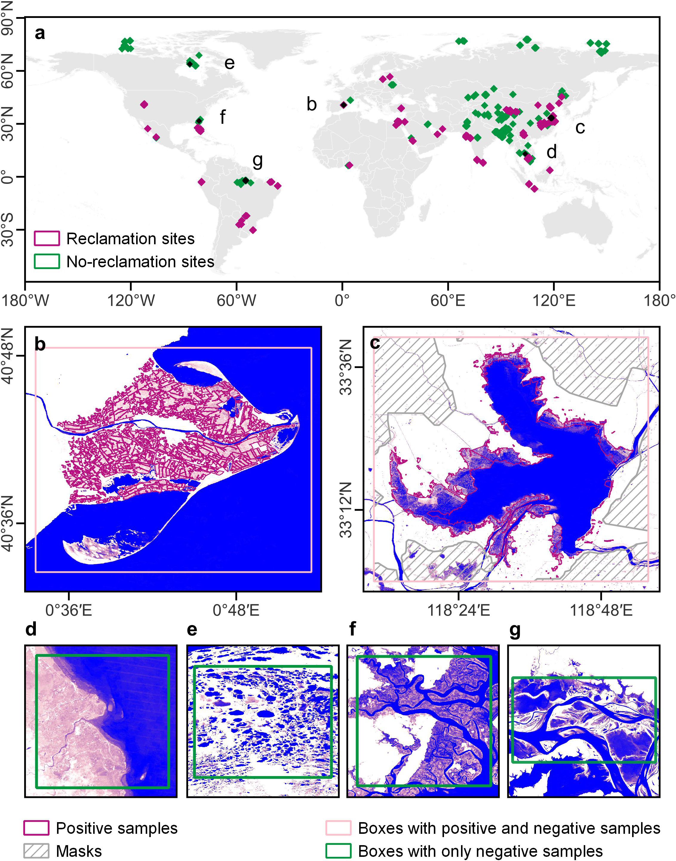
Extended Data Fig. 2 | Preparation of labels for deep learning. (a) The locations of reclamation sites and no-reclamation sites used for training the model. (b-c) Two boxes with both positive (purple polygons) and negative (inside the pink polygons and outside the purple polygons) samples (the hatched regions in c were masked in further training processes because reclaimed wetlands were not labeled). (d-g) Boxes with only negative samples represent tidal flats, densely-distributed lakes, intertidal zones, and floodplains, respectively.
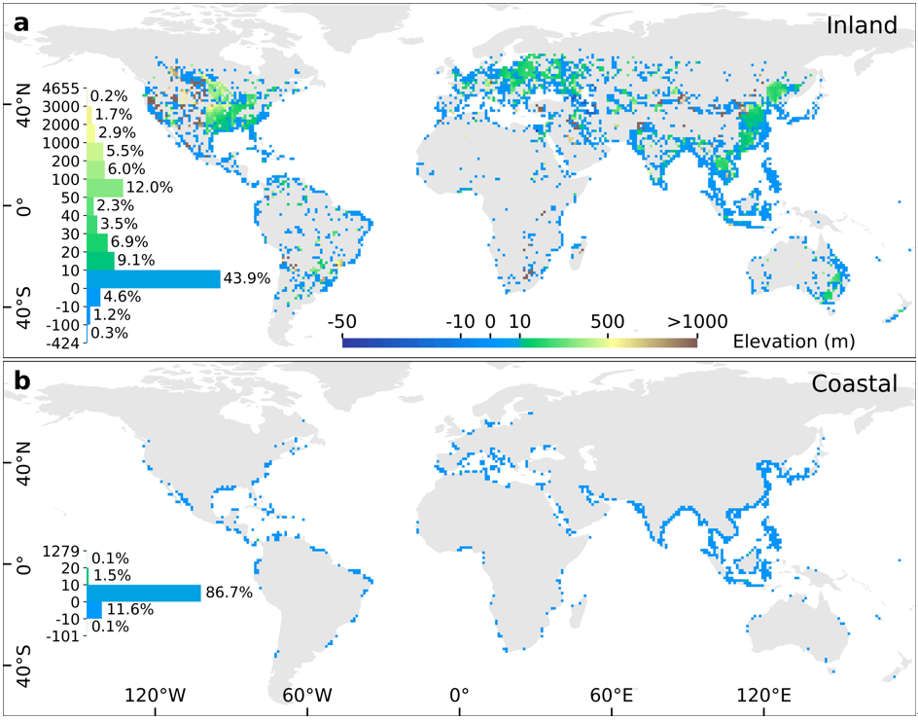
Extended Data Fig. 3 | Elevation distribution of global human-reclaimed wetlands. (a) Inland wetlands. (b) Coastal wetlands. Data are aggregated into 1°×1° grid cells, and the elevation histogram is presented within each panel.
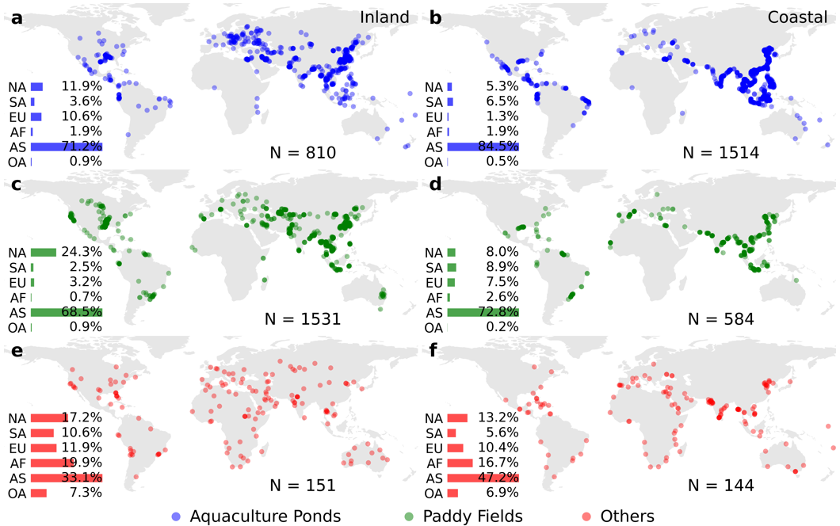
Extended Data Fig. 4 | Global distributions of the probability samples for different reclamation purposes. The left panels (a, c, e) and right panels (b, d, f) show the locations of the probability points in inland and coastal wetlands, respectively. For each reclamation purpose, the proportions of the points for different continents are also displayed in bar charts.

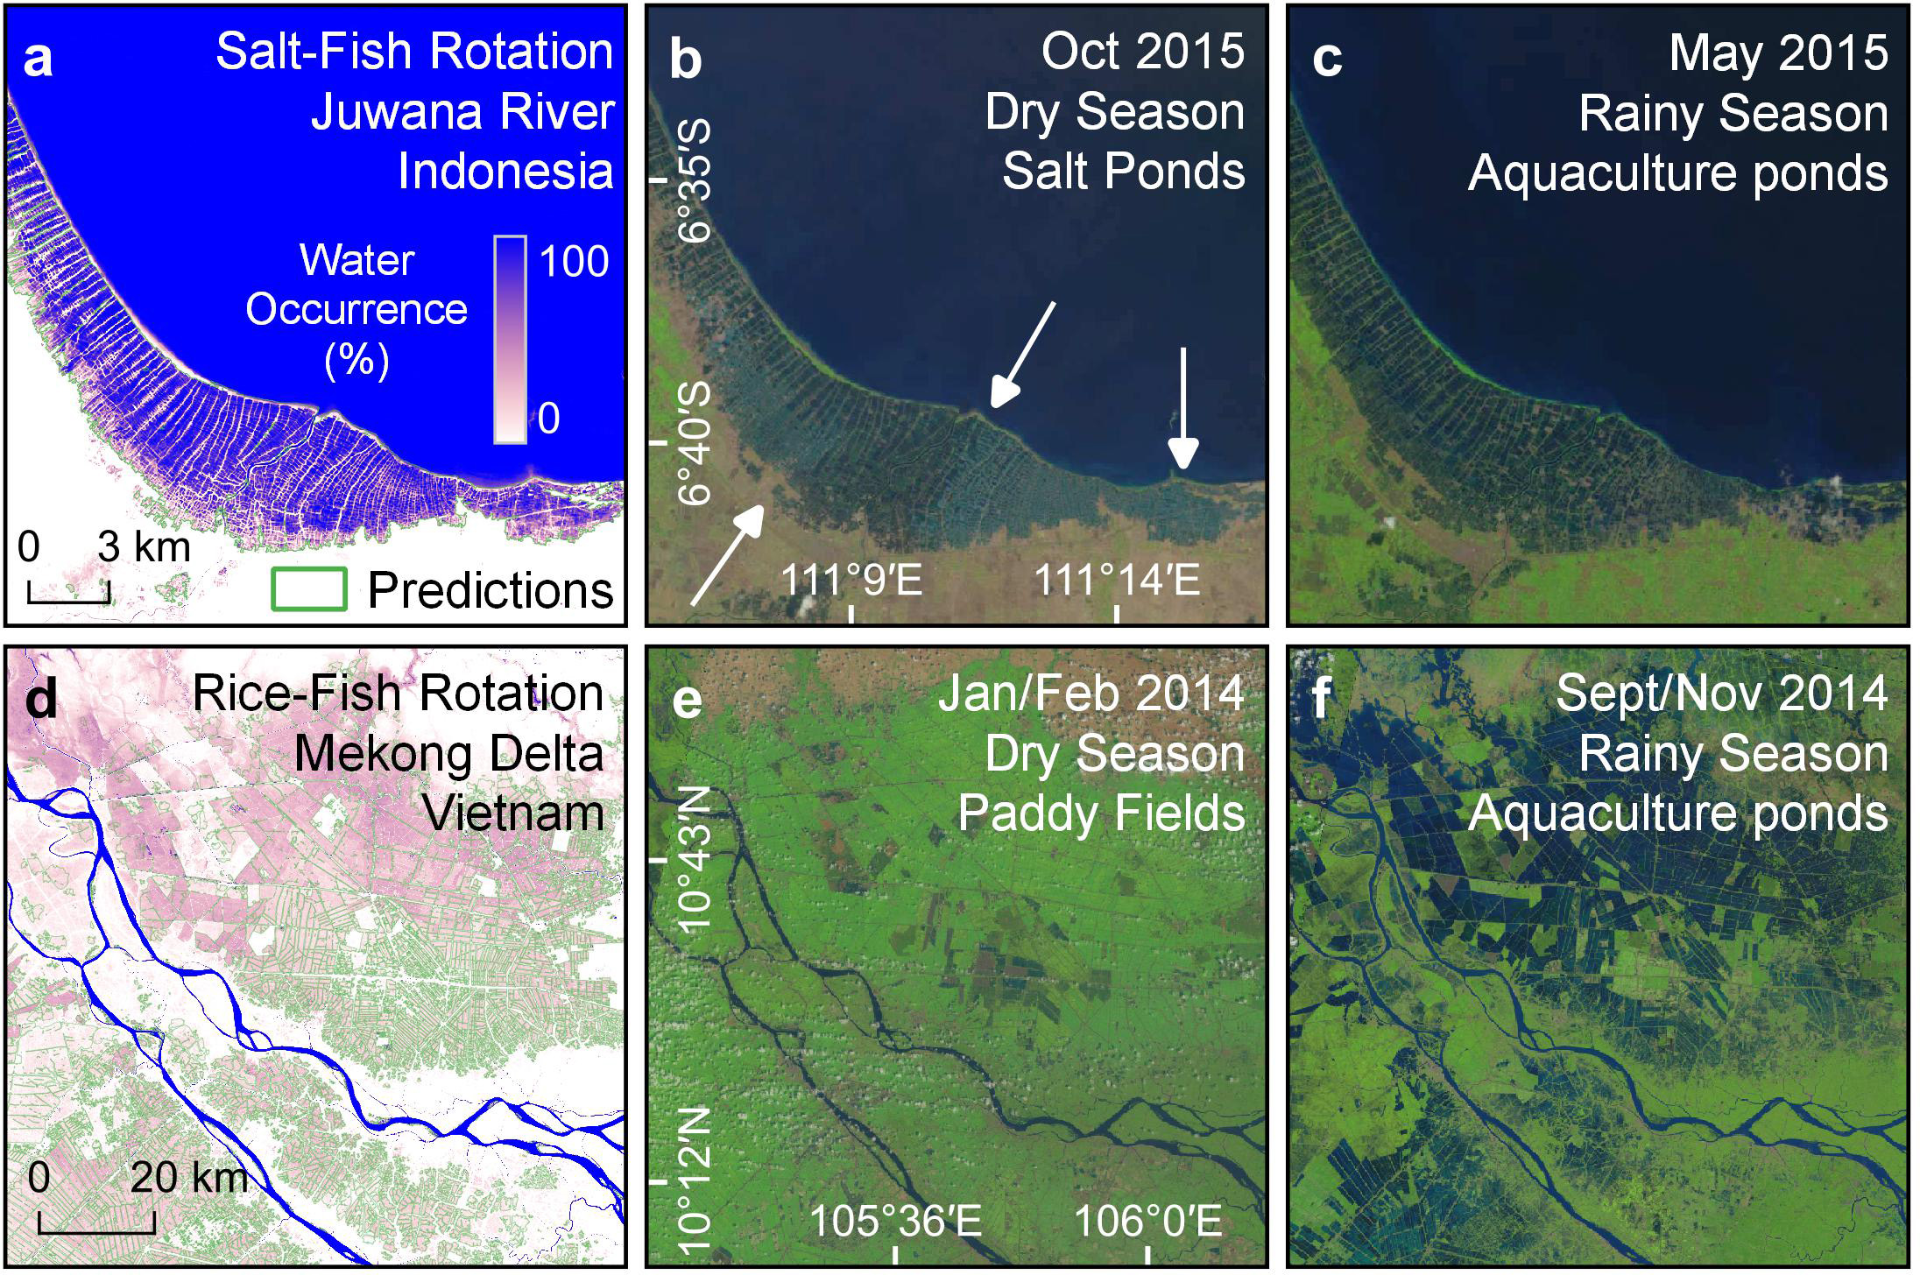
Extended Data Fig. 5 | Examples showing seasonal rotations in human-reclaimed wetlands. (a, d) show water occurrence images (2011-2020) produced by the GSW dataset. The regions delineated by green polygons in the water occurrence images are satellite-detected human-reclaimed wetlands. (b, c, e, f) Show the corresponding true color composites of Landsat images during dry or rainy seasons.
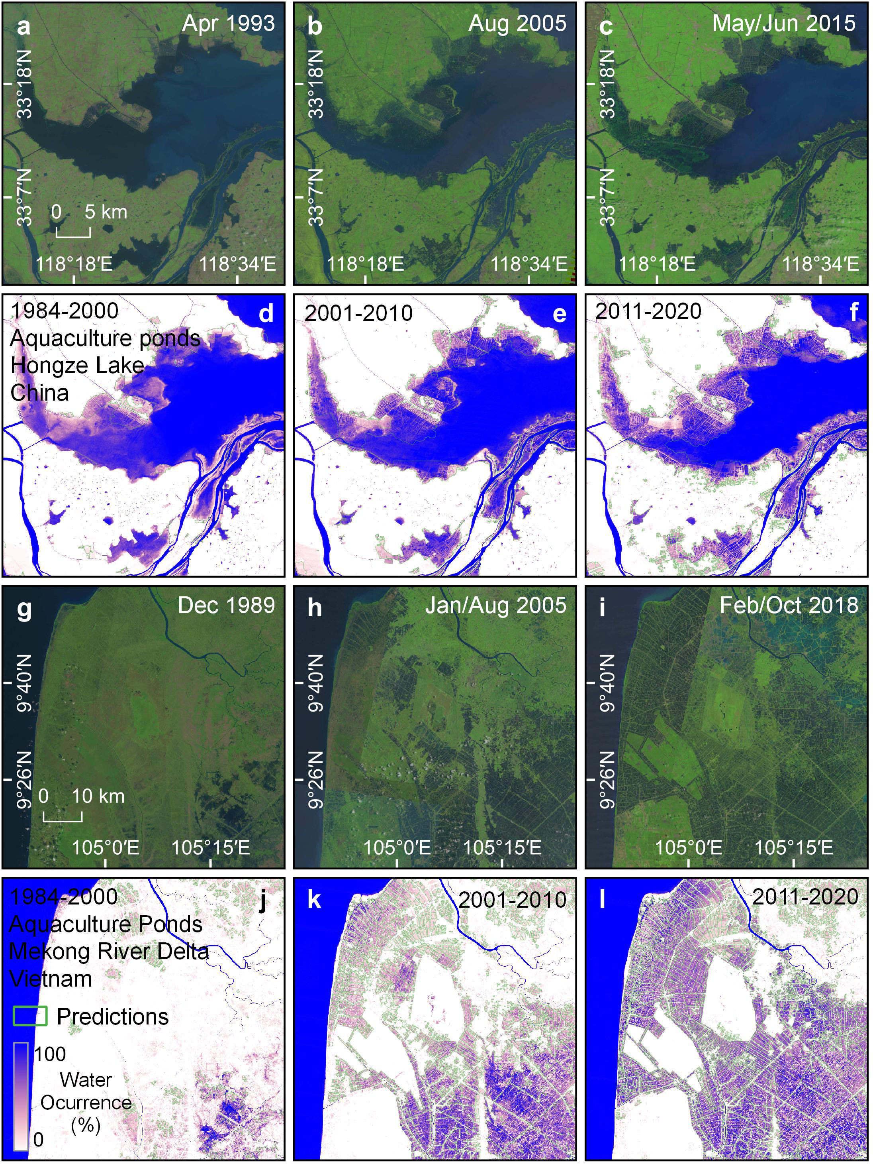
Extended Data Fig. 6 | Examples showing continuous increases in reclaimed wetlands. The upper panels (a, b, c, g, h, i) show true color composites of Landsat images, and the lower panels (d, e, f, j, k, l) show the corresponding water occurrence images produced from the GSW dataset over three time periods (1984-2000, 2001-2010, and 2011-2020). The regions delineated by green polygons in the water occurrence images are satellite-detected human-reclaimed wetlands.
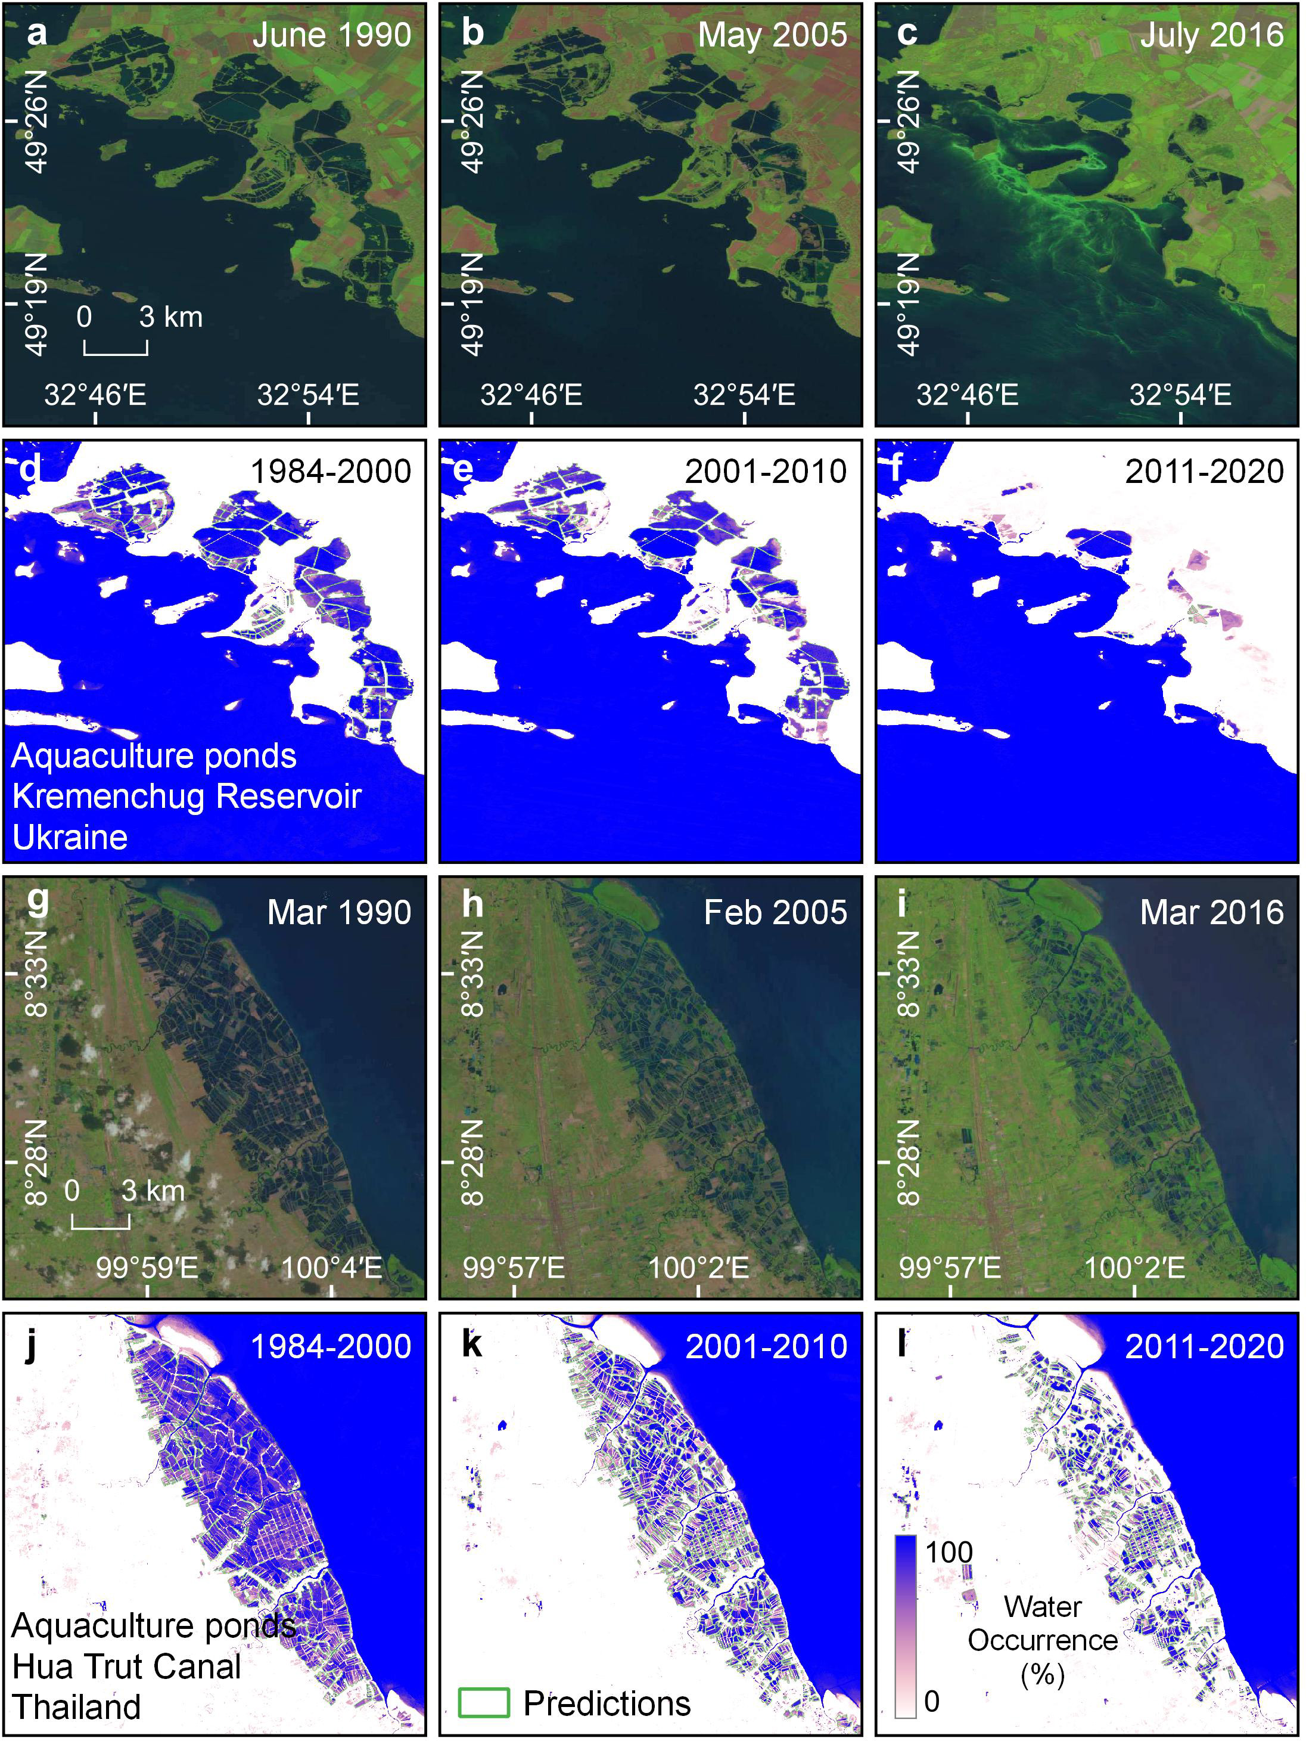
Extended Data Fig. 7 | Examples showing continuous decreases in reclaimed wetlands. The upper panels (a, b, c, g, h, i) show true color composites of Landsat images, and the lower panels (d, e, f, j, k, l) show the corresponding water occurrence images produced from the GSW dataset over three time periods (1984-2000, 2001-2010, and 2011-2020). The regions delineated by green polygons in the water occurrence images are satellite-detected human-reclaimed wetlands.
Extended Data Fig. 8 | Relationship between wetland reclamation and fishery production. (a) Correlation between maximum annual aquaculture production and total area of reclaimed aquaculture ponds between 1984-2020 at the national scale. (b) Correlation between changes in aquaculture production and areal changes in reclaimed aquaculture ponds from 1984-2000 to 2011-2020.
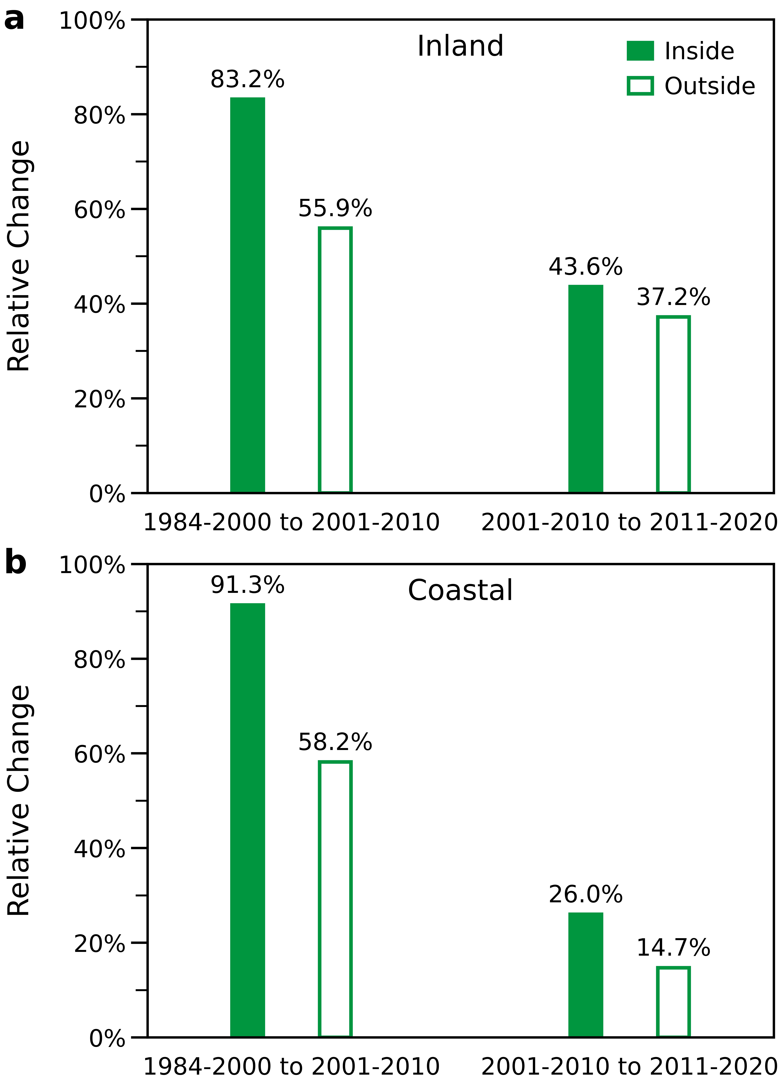
Extended Data Fig. 9 | Comparisons of relative areal change of reclaimed wetlands inside and outside protected areas (defined by the World Database on Protected Areas) across different time periods. (a) Inland wetlands. (b) Coastal wetlands.
Extended Data Table 1 | Error matrices of the mapped human-reclaimed areas gauged by high-resolution Google Earth images for both inland and coastal wetlands.
Inland |  | Reference |  |  | User's Accuracy
 |  | Positive | Negative | Total | User's Accuracy
Map | Positive | 2492 | 273 | 2765 | 90.1%
Map | Negative | 210 | 2555 | 2765 | 92.4%
Map | Total | 2702 | 2828 | 5530
Producer's Accuracy |  | 92.2% | 90.3% | Overall Accuracy | 91.3%
 |  |  |  | F1-Score | 91.2%
Coastal |  | Reference |  |  | User's Accuracy
 |  | Positive | Negative | Total | User's Accuracy
Map | Positive | 2242 | 269 | 2511 | 89.3%
Map | Negative | 196 | 2316 | 2512 | 92.2%
Map | Total | 2438 | 2585 | 5023
Producer's Accuracy |  | 92.0% | 89.6% | Overall Accuracy | 90.7%
 |  |  |  | F1-Score | 90.6%

