Supplementary information
Global mapping reveals more intensively exploited inland than coastal wetlands
Yang Xu, Lian Feng, Hongwei Fang, Xiao-Peng Song, Fabian Gieseke, Ankit Kariryaa, Stefan Oehmcke, Luke Gibson, Xiating Jiang, Ruimin Lin, Wang Xu, Chunmiao Zheng, Martin Brandt, Rasmus Fensholt
Supplementary Figures 1-2
Supplementary Table 1-2

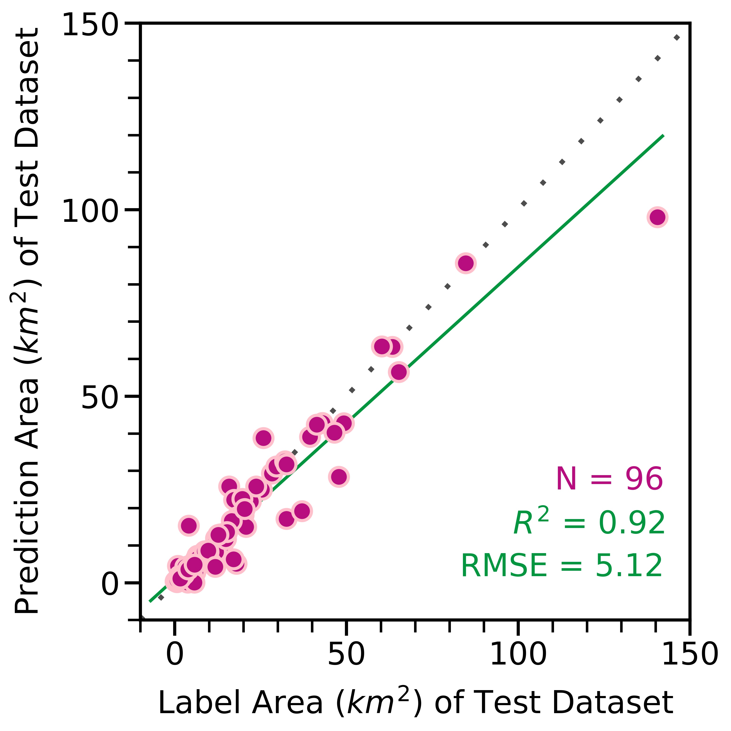
Supplementary Fig. 1 | Comparison between manually labeled areas from the testing dataset and the corresponding prediction on 96 patches. The size of each patch is 512×512 pixels.
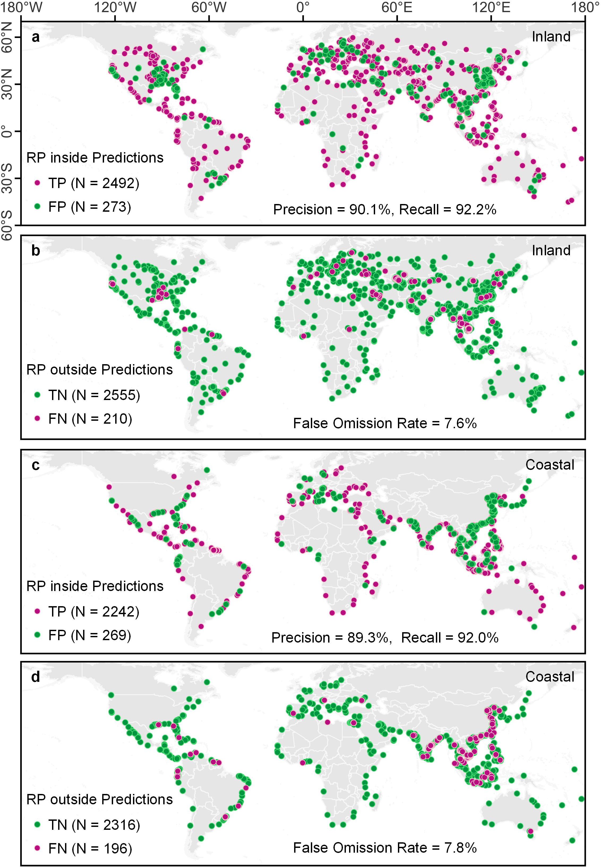
Supplementary Fig. 2 | Global reference points used to assess the accuracy of mapped human-reclaimed wetlands over inland and coastal regions. Random points inside and outside the predicted reclaimed wetlands were selected and used to determine true positives (TP), true negatives (TN), false positives (FP), and false negatives (FN). The numbers of points are shown in brackets. The precision, recall, and false omission rates are also annotated within the panels.

Supplementary Table 1 | Information of samples fed into the U-Net model and the core model settings.
Inputs | Count | Hyperparameters | Setting
Box with positive and negative samples | 133 | Sampling Strategy | Sequential patches with 1/4 overlap
Box with only negative samples | 131 | Patch Size | 512
Box | 264 | Batch Size | 8
Positive Samples (km²) | 15731.7 | Training Steps | 200
Negative Samples (km²) | 85712.0 | Number of Epochs | 400
Training: Validation: Test | 5:3:2 | Ratio in Tversky Loss | 0.6, 0.4

Supplementary Table 2 | Information of training, validation, and testing datasets fed into the training procedure and their performance in the trained model.
 | Number of Boxes with Labels | Number of Boxes without Label | Number of Boxes | Label Areas (km²) | Recall | Precision | F1 Score | MIoU
Training Dataset | 71 | 62 | 133 | 10058.2 | 0.837 | 0.9 | 0.855 | 0.887
Validation Dataset | 33 | 48 | 81 | 4163.3 | 0.831 | 0.919 | 0.865 | 0.889
Test Dataset | 29 | 24 | 53 | 1510.2 | 0.842 | 0.897 | 0.864 | 0.884
Total | 133 | 134 | 267 | 15731.7

