Supplementary Information

Real-time monitoring of fast gas dynamics with a single-molecule resolution
by frequency-comb-referenced plasmonic phase spectroscopy

Nguyen Duy Anh,¹ Geon-Ho Lee,¹ San Kim,^{2,3} Dong-Chel Shin,¹ Dae-Hee Kim,¹ Jongkyoon Park,^{2,3} Hak-Jong Choi,⁵ Seung-Woo Kim,¹ Seungchul Kim,^{2,3,*} and Young-Jin Kim^{1,4,*}

¹Department of Mechanical Engineering, Korea Advanced Institute of Science and Technology (KAIST), Science Town, Daejeon, 34141, South Korea
²Department of Cogno-Mechatronics Engineering, College of Nanoscience and Nanotechnology, Pusan National University, Busan 46241, South Korea
³Department of Optics and Mechatronics Engineering, College of Nanoscience and Nanotechnology, Pusan National University, Busan 46241, South Korea
⁴School of Mechanical and Aerospace Engineering, Nanyang Technological University (NTU), 50 Nanyang Avenue, 639798 Singapore
⁵Nano-Convergence Mechanical Systems Research Division, Korea Institute of Machinery and Materials, 156, Gajeongbuk-Ro, Yuseong-Gu, Daejeon 34103, South Korea

*Correspondence to: s.kim@pusan.ac.kr, yj.kim@kaist.ac.kr

Table S1. The sensitivity and resolution of the available refractive index measurement and single molecule detection
Method | The information parameter | The sensitivity | The resolution
Prism coupling  SPR systems  (Kretschmann) | Intensity [1] | 3100 – 8000 nm/RIU | δn = 10⁻⁶ - 10⁻⁵ RIU
Prism coupling  SPR systems  (Kretschmann) | Phase [2] | 8 400 000 degree/RIU | δn = 4 x 10⁻⁸ RIU
Prism coupling  SPR systems  (Kretschmann) | Incident angle [3] | 155 degree/RIU | δn = 0.016 RIU
Prism coupling  SPR systems  (Kretschmann) | Molecular detection [3] | 1.67x10⁻⁴ degree/pg mm⁻² | 0.6 pg mm⁻²
Nanohole array | Intensity [4] | 400 nm/RIU | δn = 1.1 x 10⁻³ RIU
2 slits SP | Intensity [5] | 4547 nm/RIU
Graphene plasmonic | Intensity [6] | 2480 nm/RIU
Graphene plasmonic | Molecular detection [7] |  | 50 zeptomol/μm²
Photonic Crystal fiber [8] | Phase | 634 500 degree/RIU | δn < 10⁻⁶ RIU
Photonic Crystal fiber [8] | Intensity | 1233 nm/RIU | δn < 10⁻⁶ RIU
Array of Au double-dots [9] | Graphene hydrogenation | 44 degree/pg mm⁻² | 1 x 10⁻⁴ pg mm⁻²
Array of Au double-dots [9] | Streptavidin–biotin affinity | 25 degree/20–100 molecules per nanodot | <1 molecule/nanodot
Silver−Stibnite nanoporous [10] | GH shift interrogation | 4.5x10⁻⁷ RIU/nm
Silver−Stibnite nanoporous [10] | Streptavidin–biotin affinity | 1 fM | 1180 molecules/mm²

Matching the pressure and refractive index
Using the Gladstone-Dale approximation of the Lorentz-Lorenz law, that is, (n-1)/ρ = C (where is ρ the density of the gas and C is a constant for the given wavelength) and the ideal gas equation ρ = MP/RT (where R is the constant of the ideal gas and M is the molar weight) [11], gives:
$n-1=μ\frac{P}{T}$ (3) Table S2. The values of μ for λ = 632.8 nm (288.15 K<T < 322.15 K; 0 < P < 110 kPa) [11]
Gas | μ/10 ⁹K.Pa⁻¹
Ar | 762.0 1.2
N₂ | 808.8 1.2
CO₂ | 1211.1 1.2

Table S3. The calculated refractive index and measured phase corresponding to the pressure change
Case | Pressure change  (kPa) | Δn (RIU) | Phase change  (degree) | The phase changed by EOT only (degree) | Sensitivity  (degree/RIU)
Without EOT sample | 6.89 | 1.7 × 10⁻⁵ | 10 | 30 | ~1.76 × 10⁶
With EOT sample | 6.89 | 1.7 × 10⁻⁵ | 40 | 30 | ~1.76 × 10⁶

The total force F(r) with the AC field
$$F\left(r\right)=\frac{1}{2}Re\left[\frac{ε\left(α-β\right)}{1+iωτ}\left(∇T\left(r\right)∙E\right)E^{*}-\frac{1}{2}εα{\left|E\right|}^{2}∇T\left(r\right)\right]$$
In the x, y, z coordinate, $∇T\left(r\right)= \frac{δT}{δx}+\frac{δT}{δy}+\frac{δT}{δz}$ and E is the external field along Z direction only so $∇T\left(r\right)∙E=\frac{δT}{δz}E_{z}$. Therefore,
$$F\left(r\right)=\frac{1}{2}Re\left[\frac{ε\left(α-β\right)\left(1-iωτ\right)}{1+ω^{2}τ^{2}}\frac{δT}{δz}{\left|E\right|}^{2}-\frac{1}{2}εα{\left|E\right|}^{2}∇T\left(r\right)\right]$$
If we take the real value:
$$F\left(r\right)=\frac{1}{2}\left[\frac{ε\left(α-β\right)}{1+ω^{2}τ^{2}}\frac{δT}{δz}{\left|E\right|}^{2}-\frac{1}{2}εα{\left|E\right|}^{2}∇T\left(r\right)\right]$$
Where α = (1/ε)(δε/δT), β = (1/σ)(δσ/δT), τ = ε/σ then,
$$F\left(r\right)=\frac{1}{2}\left[\frac{σ^{2}\frac{δε}{δz}-εσ\frac{δσ}{δz}}{1+ω^{2}ε^{2}}{\left|E\right|}^{2}-\frac{1}{2}\frac{δε}{δT}{\left|E\right|}^{2}∇T\left(r\right)\right]$$
If we assume z term in $∇T\left(r\right)= \frac{δT}{δx}+\frac{δT}{δy}+\frac{δT}{δz}$ is dominant, we have:
$$F\left(r\right)=\frac{1}{2}\left[\frac{σ^{2}\frac{δε}{δz}-εσ\frac{δσ}{δz}}{1+ω^{2}ε^{2}}{\left|E\right|}^{2}-\frac{1}{2}\frac{δε}{δz}{\left|E\right|}^{2}\right]$$
- If we consider the variation of force at a specific position as a function of ${\left|E\right|}^{2}$ – ε, σ, ω, x, y, and z are constant – $F ≈a{\left|E\right|}^{2}$ is a linear relationship against the ${\left|E\right|}^{2}$ which is matched to the experiment data in Fig. 4i.
- If we consider the variation of force at a specific position as a function of frequency ω – ε, σ, ${\left|E\right|}^{2}$, x, y, and z are constant – $F ≈\frac{b}{1+aω^{2}}+c$ is a non-linear relationship against the frequency ω as shown in Fig. 4j.

Pressure measurement
Because P_{dynamic} is quite small, it cannot escape the chamber by itself; thus, P_{static} was pumped into the chamber. P_{static} acted as a carrier for pushing out P_{dynamic}. To measure P_{dynamic}, we used two different methods and compared their results:

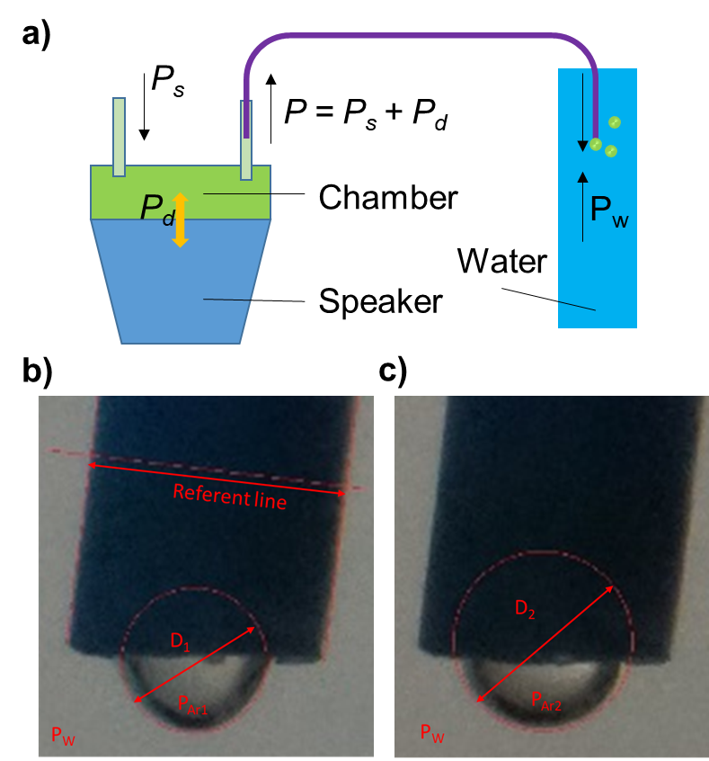
Figure S1. Pressure measurement. a, Manometer principle. b, c, Maximum bubble pressure method. b and c correspond to the pull and push stage of the 200 Hz vibration, respectively.

- Manometer principle (see Fig. S1a): the pressure is calculated by measuring the height of the liquid column. First, the speaker was turned off, then the outlet was immersed in water until the bubble did not tear out, which indicated that P_{static} was the same as the water pressure (P_{W}). After that, the speaker was turned on (20 V – 5 Hz) and the bubble continuously teared out. We slowly immersed the tube until bubbles stopped flowing out. From the distance (d) the tube moved, we could calculate the P_{dynamic}, which is P_{dynamic} = d × ρ (ρ: specific weight of pure water).

Table S4. The measured and converted pressure [12] at 5 Hz when the supplied voltage was changed.
Voltage (V) | Measured pressure  (mm H₂O) | Converted pressure  (Pa) | Refractive index  (Δn × 10⁻⁸) | No. Molecules/hole
10 | 0.83 | 8.14 | 2.05 | 84.33
12 | 3.97 | 38.97 | 9.83 | 403.34
14 | 6.08 | 59.69 | 15.05 | 617.72
16 | 8.91 | 87.47 | 22.06 | 905.24
18 | 9.76 | 95.82 | 24.16 | 991.60
20 | 11.42 | 112.11 | 28.27 | 1160.25
Table S5. The measured and converted pressure when changing the frequency (supplied voltage 20 V)
Frequency  (Hz) | Measured pressure  (mm H₂O) | Converted pressure (Pa) | Refractive index  (Δn × 10⁻⁸) | No. Molecules/hole
1 | 14.05 | 137.93 | 34.78 | 1427.45
5 | 11.42 | 112.11 | 28.27 | 1160.25
10 | 11.63 | 114.18 | 28.80 | 1181.59
20 | 11.4 | 111.92 | 28.23 | 1158.22
30 | 9.50 | 93.26 | 23.52 | 965.18
40 | 8.55 | 83.94 | 21.17 | 868.66
50 | 8.90 | 87.37 | 22.03 | 904.22
80 | 5.93 | 58.22 | 14.68 | 602.48
100 | 3.90 | 38.29 | 9.66 | 396.23
200 | 4.00 | 39.27 | 9.90 | 406.39

- To consider the ability of the phase measurement in the single molecule detection, we also converted the known pressure to the gas density information [13]. With the assumption that the gas in the sample chamber was uniform (Fig. 1a), we can calculate the number of Ar molecules within the sensing area of 1000 × 1000 × 0.15 μm (length × width × height). Then, we divided this amount to the number of holes (~4 million of holes) to derive the No. Molecules/hole in Tables S4 and 5.

- Maximum bubble pressure method: the pressure difference between the inside and outside of a curved surface that forms the boundary between a gas region and a liquid region [14]. The pressure difference is caused by the surface tension of the interface between the liquid and gas [15]. ΔP is the pressure difference between the interior and exterior bubble.
$$∆P=γ\left(\frac{1}{R_{i}}+\frac{1}{R_{i}+d}\right)≈\frac{2γ}{R}$$ | (4)
In Fig. S1b and S1c, the captured bubble corresponded to the pull and push stage of the sound vibration (200 Hz). By measuring their radius, we can calculate the pressure using Equation 4. The reference line is the tube size of 4 mm corresponding to 261 pixels. The measured radius and calculated pressure are shown below (P_{Ar}: the pressure inside the bubble, P_{W}: pressure outside the bubble, γ = 72 mN/m at 25 ^{O}C):

- R₁ = 1.088 mm => ΔP₁ = P_{Ar1} - P_{W} = -132.32 Pa
- R₂ = 1.410 mm => ΔP₂ = P_{Ar2} - P_{W} = -102.12 Pa
- The sound pressure = P_{Ar2} - P_{Ar1} = ΔP₂ - ΔP₁ = -102.12 + 132.32 = 30.2 Pa. This pressure is comparable with the value in Table 6 (red highlight). The difference may be due to the camera's shooting speed (11 fps), which is lower than the sound frequency (200 Hz). Therefore, we could not capture exactly the moment of minimum and maximum pressure vibration.
Table S6. Summary of the experimental data for the high-resolution demonstration
The interested information | The minimum value measured by experiment | Resolution
Refractive index | Δn = 2.7 × 10⁻⁹ | δn = 2.9 × 10⁻¹¹
No.Molecule/hole | ~ 11.2 | 0.12

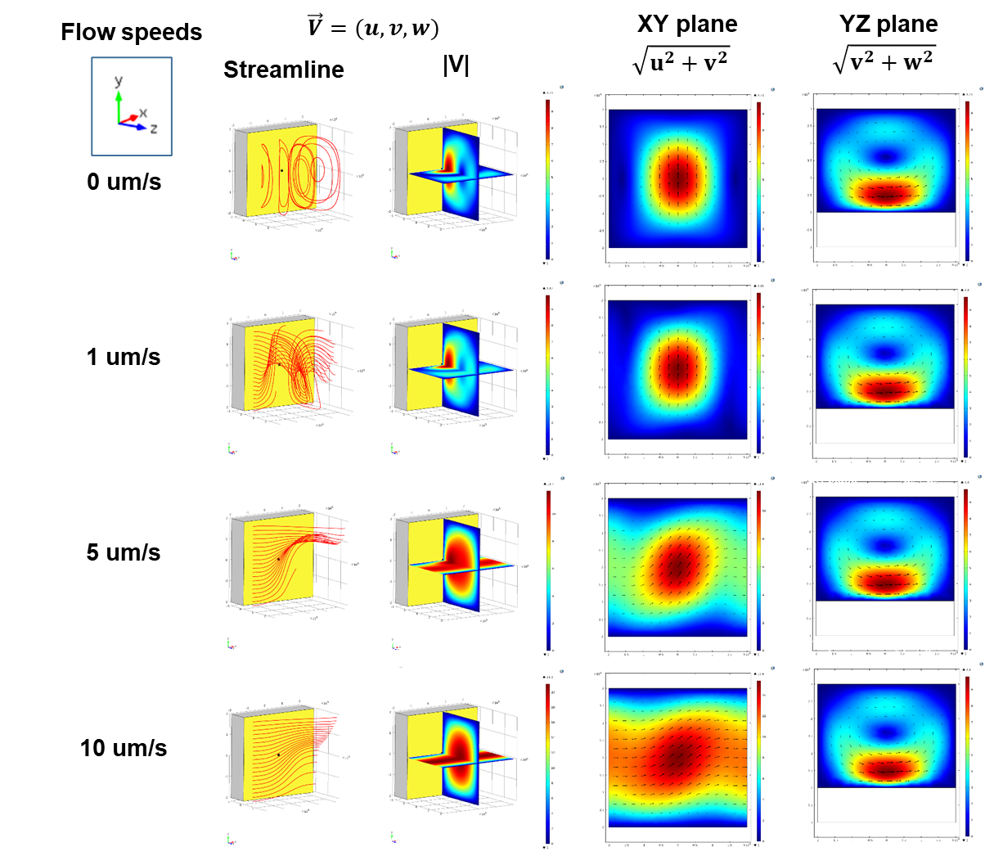
Figure S2. Thermophoresis analysis by FEM simulation. In the “Laminar Flow” module, “Inlet” and “Outlet” boundary conditions were set on the side for Argon flow into the simulation domain with a prescribed velocity and temperature: 0, 1, 5, and 10 μm /s at 293.15 K. The gravitational body force was set to be in the y-direction.

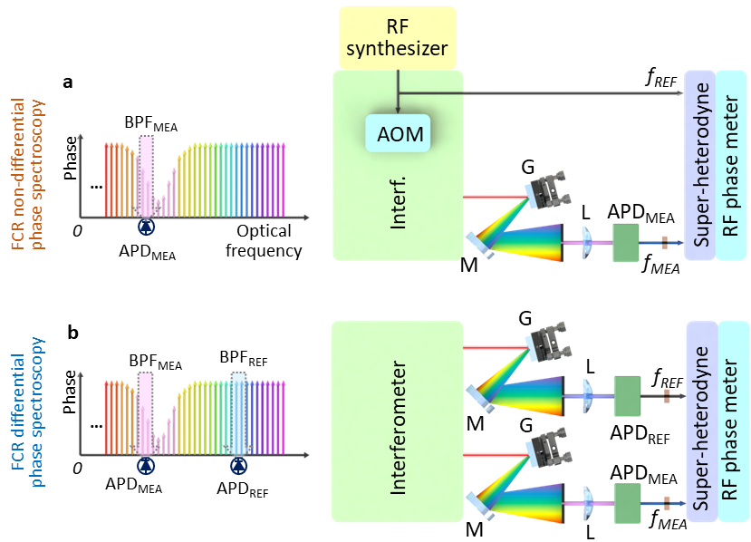
Figure S3. System configuration of the frequency-comb-referenced differential plasmonic phase spectroscopy. a, FCR phase detection using an RF reference signal. b, FCR differential phase detection. The heterodyne RF beat noted detected at the off-resonance wavelength is used as the reference signal for the phase detection.

References

1. Jung, L.S., et al., Quantitative Interpretation of the Response of Surface Plasmon Resonance Sensors to Adsorbed Films. Langmuir, 1998. 14(19): p. 5636-5648.
2. Kabashin, A.V. and P.I. Nikitin, Surface plasmon resonance interferometer for bio- and chemical-sensors. Optics Communications, 1998. 150(1): p. 5-8.
3. http://biosensingusa.com/technical-notes/technical-note-102-spr-sensitivity-detection-limit/.
4. Brolo, A.G., et al., Surface plasmon sensor based on the enhanced light transmission through arrays of nanoholes in gold films. Langmuir, 2004. 20(12): p. 4813-4815.
5. Wu, X., et al., Refractive index sensor based on surface-plasmon interference. Opt Lett, 2009. 34(3): p. 392-4.
6. Wenger, T., et al., High-sensitivity plasmonic refractive index sensing using graphene. 2D Materials, 2017. 4(2): p. 025103.
7. Farmer, D.B., et al., Ultrasensitive Plasmonic Detection of Molecules with Graphene. ACS Photonics, 2016. 3(4): p. 553-557.
8. Andrews, N.L., et al., In-fiber Mach-Zehnder interferometer for gas refractive index measurements based on a hollow-core photonic crystal fiber. Opt Express, 2016. 24(13): p. 14086-99.
9. Kravets, V.G., et al., Singular phase nano-optics in plasmonic metamaterials for label-free single-molecule detection. Nature Materials, 2013. 12: p. 304.
10. Sreekanth, K.V., et al., Large-Area Silver–Stibnite Nanoporous Plasmonic Films for Label-Free Biosensing. ACS Applied Materials & Interfaces, 2018. 10(41): p. 34991-34999.
11. Clergent, Y., C. Durou, and M. Laurens, Refractive Index Variations for Argon, Nitrogen, and Carbon Dioxide at λ = 632.8 nm (He−Ne Laser Light) in the Range 288.15 K ≤ T ≤ 323.15 K, 0 < p < 110 kPa. Journal of Chemical & Engineering Data, 1999. 44(2): p. 197-199.
12. https://www.convertunits.com/from/mmH2O/to/pascal.
13. https://www.ajdesigner.com/idealgas/ideal_gas_law_density.php.
14. Butt, H.-J.G., Karlheinz; Kappl, Michael, Physics and Chemistry of Interfaces. 2006.
15. Gennes, P.-G.d.F.B.-W.D.Q., Capillarity and Wetting Phenomena. Springer, 2004.

