Supplementary material and methods
TSR
RTS,S/AS02A malaria vaccine-induced IgG responses equally recognize native-like fucosylated and non-fucosylated Plasmodium falciparum circumsporozoite proteins
Supplementary Methods
Full-length PfCSP (PfCSP) was expressed and produced at Narum’s lab as described^{1,2}. Purified full-length PfCSP containing O-linked mannosylated and non-mannosylated forms were separated on a Jupiter 5 µm, 300Å, 250 x 10mm column (Phenomenex). Up to 20 mg of protein was injected per run with an elution gradient of A: water + 0.1% TFA (w/w) and B: Acetonitrile + 0.1% TFA (w/w). The mannosylated and non-mannosylated forms of full-length PfCSP eluted as two separate peaks, and the fractions were collected and fully characterised.
The TSR C-terminal domain of PfCSP was produced at Hurtado-Guerrero’s lab, with huPoFUT2 obtained from James M. Rini’s lab. TSR fucosylation reactions were incubated with 150mM NaCl, 20mM Tris pH7.4, 0.2μM huPoFUT, 0.05μM TSR-PfCSP and 150μM of GDP-Fucose (GDP-Fuc) for 24 h at 37ºC. PfCSP fucosylation reactions were performed with 150mM NaCl, 20mM Tris pH7.4, 0.2-0.4μM huPoFUT2, 0.5-1μM PfCSP and 500μM of GDP-Fuc at 37ºC for 24 h. Different time point samples were analysed by LC-MS using an Agilent 6550 Q-TOF mass spectrometer to monitor the reaction (Figure S2).

TABLE S1 | Baseline characteristics of the study population
 | C N=64 | R N=644 | p-value overall
sex: |  |  | 0.398
Female | 33 (51.6%) | 291 (45.2%)
Male | 31 (48.4%) | 353 (54.8%)
Age group: |  |  | 0.811
12<24 months | 14 (21.9%) | 155 (24.1%)
24<60 months | 50 (78.1%) | 489 (75.9%)
Height (cm) [median (IQR)] | 87.0 [80.0;94.6] | 88.0 [80.8;96.0] | 0.687
Weight (kg) [median (IQR)] | 12.8 [11.0;14.5] | 12.6 [10.8;14.7] | 0.872
WHZ score [median (IQR)] | 0.13 [-0.37;0.83] | -0.03 [-0.85;0.65] | 0.186
Hematocrit (%)[median (IQR)] | 34.2 [32.7;35.8] | 34.3 [32.1;36.1] | 0.873
Distance to the health centre (Km) | 1.50 [1.01;2.30] | 1.70 [1.04;2.42] | 0.410
Abbreviations:IQR=Interquartile range; kg=kilograms; cm=centimeters, Km= kilometre, C=comparator, R=RTS,S, WHZ= Weight-for-Height Z-score.

Figure S1. Flowchart of the study population.
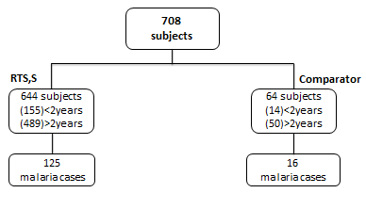

Figure S2. PfCSP TSR and full-length fucosylation by human protein O-fucosyltransferase 2 (huPoFUT2)

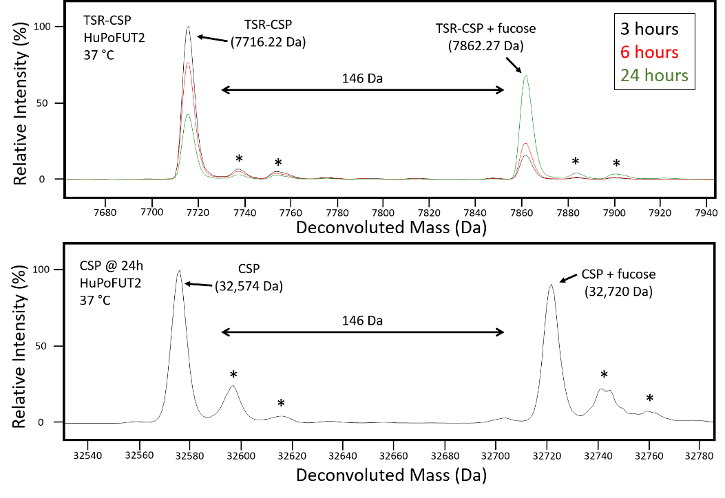
Deconvoluted mass spectra showing non-fucosylated and fucosylated TSR domain from PfCSP (TSR-CSP) (Top panel) and full-length PfCSP (CSP) (Bottom panel). Reactions were performed using huPoFUT2 at 37 °C in the presence of GDP-fucose and analysed by LC-MS using an Agilent 6550 Q-TOF mass spectrometer. In both the TSR-PfCSP and PfCSP full length, a mass shift of 146 Daltons (Da) was observed, correlating to the addition of a fucose residue. For the TSR-PfCSP, three time points were taken over 24 hours, with an increase in the fucosylated protein signal seen as time progressed. The high resolving power of the Q-TOF mass spectrometer enables the differentiation of protein species with 12C (major peaks with labels) from those with a small amount of naturally occurring 13C (denoted with a *).

Figure S3. Comparison of IgG antibody Luminex calibration curves

PfCSP full length PfCSP C-terminal TSR

Calibration curves for a given plate were done using a positive control sample which has been increasingly diluted to cover the whole range of quantification. We used 5 parameter logistic curves to fit the sigmoid trajectories. Lower asymptotes were constrained to correspond to measurements from blank spots for each plate. Only the displacement parameter in the logistic curve was allowed to differ to account for plate variability, but we kept the other parameters fixed for each analyte to avoid overfitting. The top and bottom limits of quantification were determined based on a minimum median fluorescence intensity (MFI) signal fold-change response of 0.2 for a unit fold-change in IgG level. That is 20% of what would be expected if linearity existed (slope of 1 in the log-log scale). Beyond these top and bottom limits, where the curve is too flat for a reliable quantification, no further modelling of the flattening curve was conducted. When measurements happened to occur there, we transformed MFI measurements into levels based on the minimum slope at the quantification limits. Yellow colours correspond to fucosylated antigens and blue to non-fucosylated.

References

1. Herrera, R. et al. Reversible Conformational Change in the Plasmodium falciparum Circumsporozoite Protein Masks Its Adhesion Domains. Infect Immun 83, 3771–3780 (2015).
2. Tsai, C. W., Duggan, P. F., Shimp, R. L., Miller, L. H. & Narum, D. L. Overproduction of Pichia pastoris or Plasmodium falciparum protein disulfide isomerase affects expression, folding and O-linked glycosylation of a malaria vaccine candidate expressed in P. pastoris. Journal of Biotechnology 121, 458–470 (2006).

