Supplementary Figures

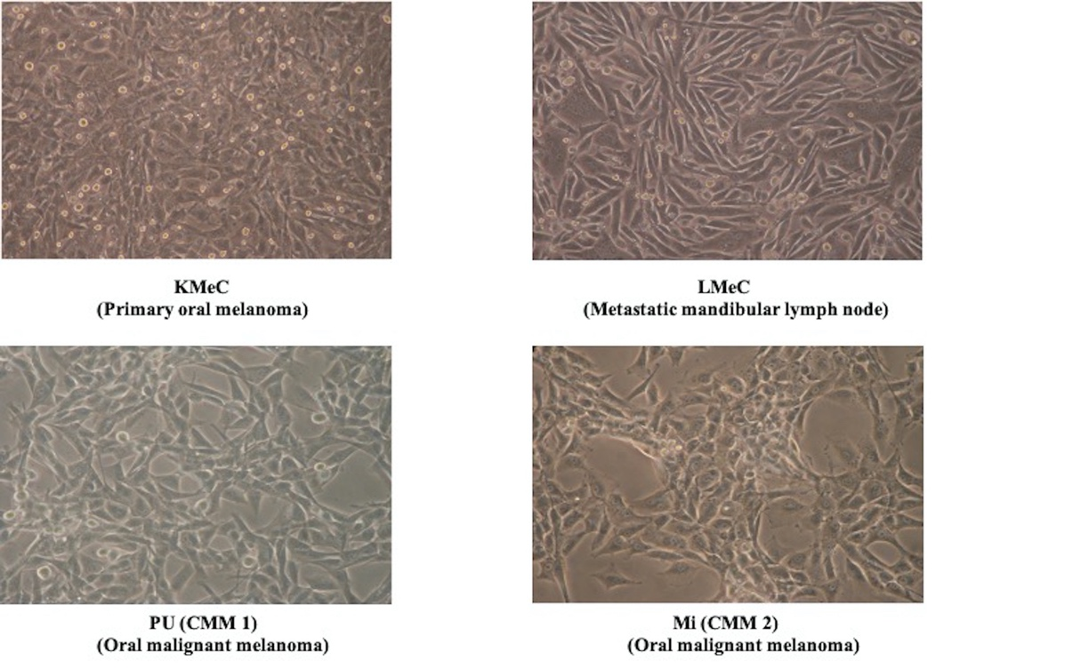
Supplementary Fig. 1

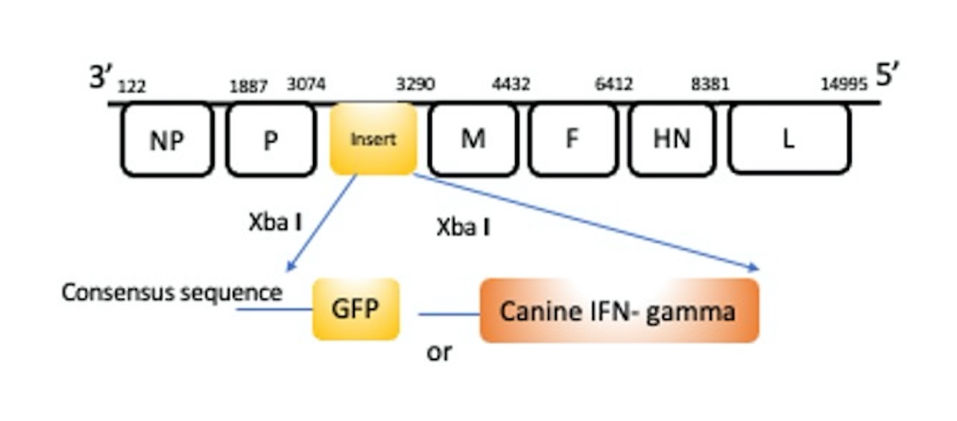
Supplementary Fig. 2

