Supporting Information

Controlled Fabrication of RuO_{x}Se_{y} Composites for Enhanced Acidic Oxygen Evolution
Peng Du^{1,2}, Chaoliang Lin², Xian He², Zhichuan Zheng², Xinyu Xie², Kai Huang^{2,*}, Ming Lei¹，Haolin Tang^{1,*}
¹ State Key Laboratory of Advanced Technology for Materials Synthesis and Processing, Wuhan University of Technology, Wuhan 430070, China
² State Key Laboratory of Information Photonics and Optical Communications, School of Science, Beijing University of Posts and Telecommunications, Beijing 100876, PR China
Email: huang-kai@bupt.edu.cn; thln@whut.edu.cn

Supplementary Figures
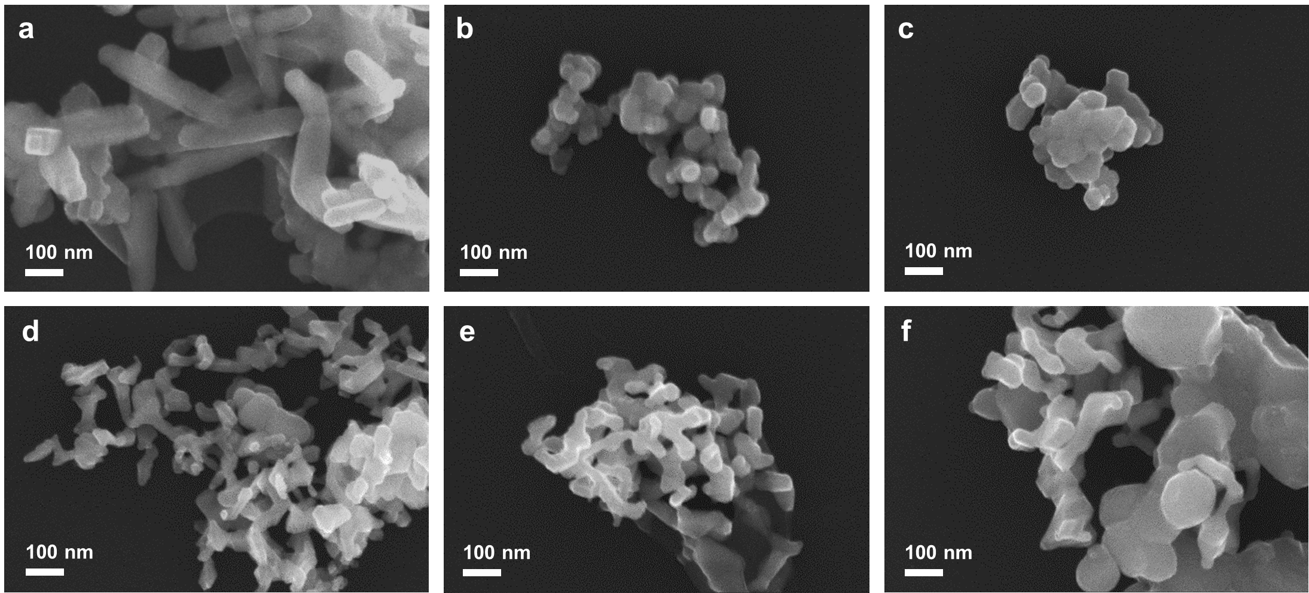

Figure S1. SEM images of (a) RuO₂ (b) RuO_{x}Se_{y}-700 (c) RuO_{x}Se_{y}-750 (d) RuO_{x}Se_{y}-800 (e) RuO_{x}Se_{y}-850 (f) RuO_{x}Se_{y}-900.

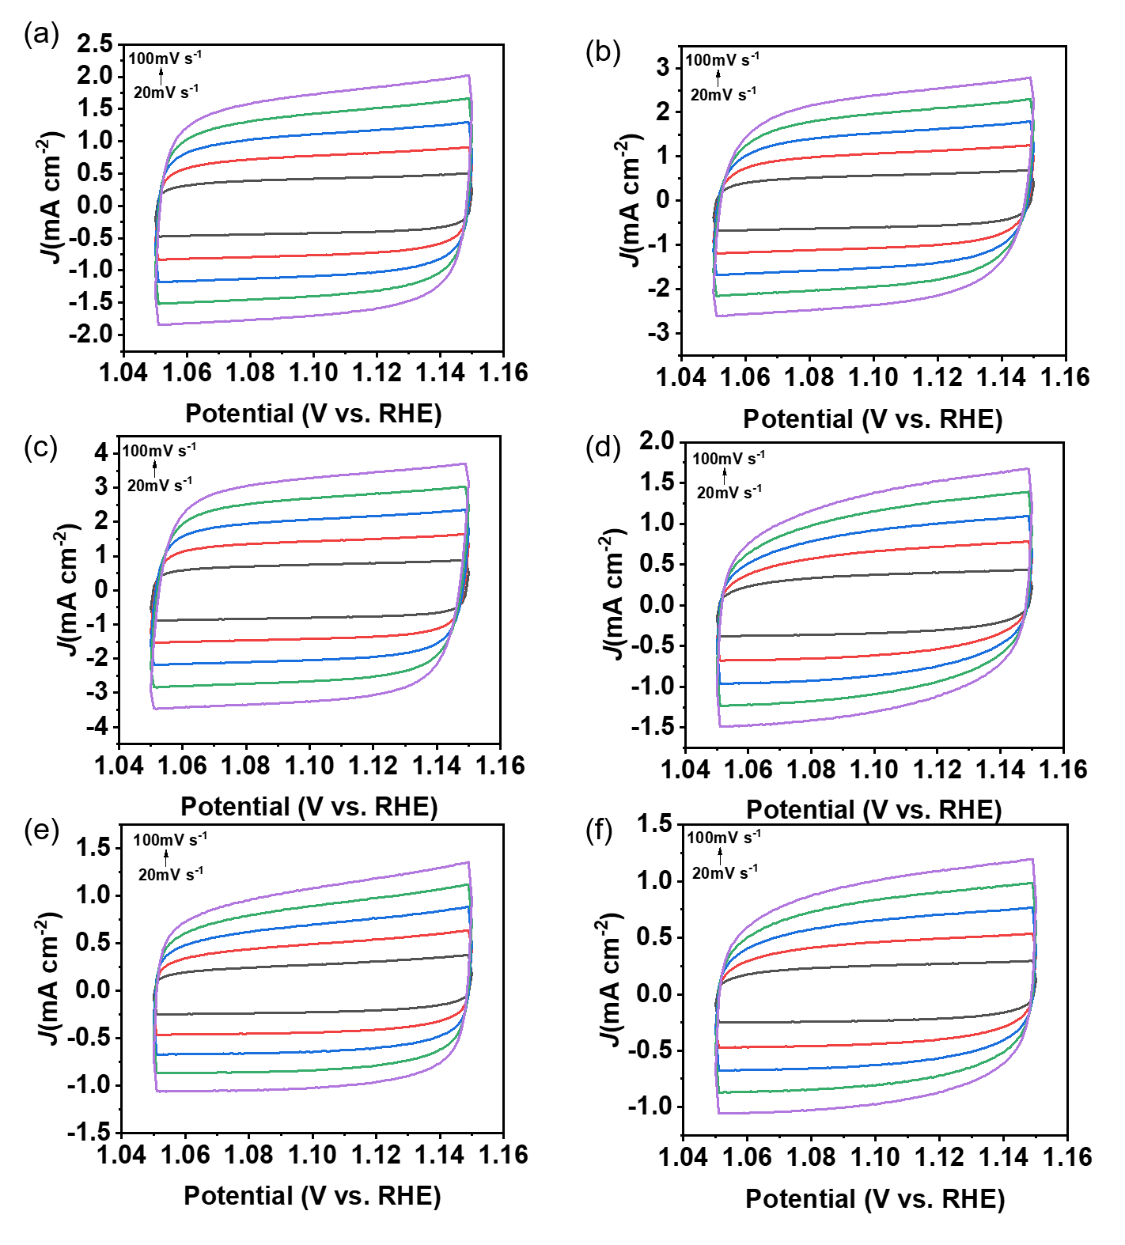

Figure S2. CV curves of (a) RuO_{x}Se_{y}-900 (b) RuO_{x}Se_{y}-850 (c) RuO_{x}Se_{y}-800 (d) RuO_{x}Se_{y}-750 (e) RuO_{x}Se_{y}-700 (f) RuO₂.

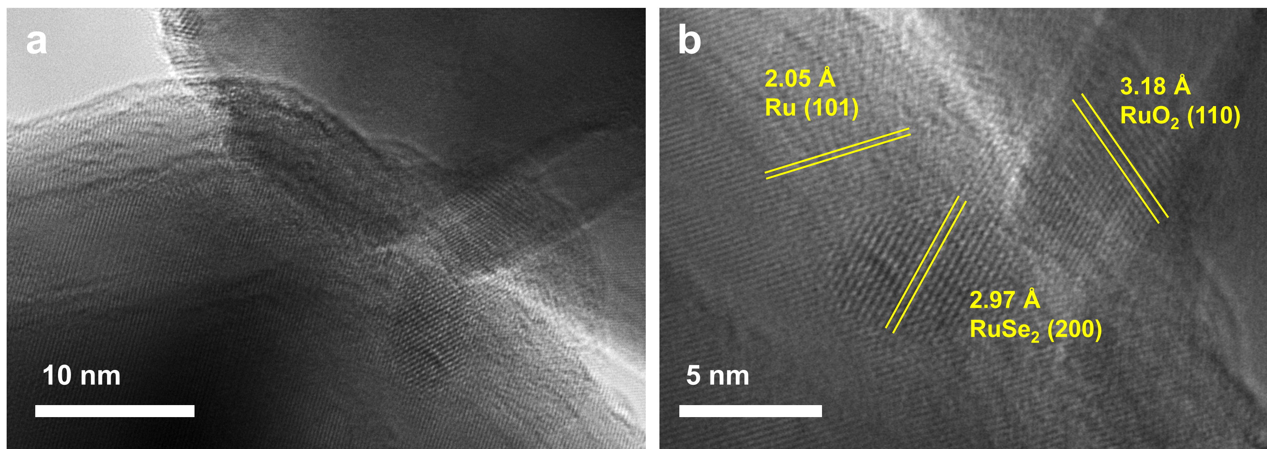

Figure S3. HRTEM images at different magnifications of RuO_{x}Se_{y}-800 sample after stability test for 18 h.
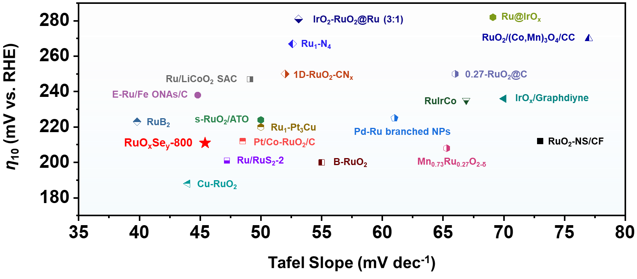

Figure S4. The comparison of RuO_{x}Se_{y}-800 with recently reported catalysts in view of η₁₀ and Tafel slope.

Table S1. EIS fitting results of different RuO₂Se_{x} catalysts.
Catalyst | R_{S} (Ω) | R_{ct1} (Ω) | R₂ (Ω)
RuO_{x}Se_{y}-900 | 3.699 | 2.586 | 8.334
RuO_{x}Se_{y}-850 | 3.162 | 2.29 | 4.426
RuO_{x}Se_{y}-800 | 2.986 | 2.112 | 4.098
RuO_{x}Se_{y}-750 | 3.018 | 2.355 | 18.14
RuO_{x}Se_{y}-700 | 3.549 | 2.422 | 29.53
RuO₂ | 3.745 | 1.982 | 41.2

Table S2. Comparison of electrochemical performances of various catalysts.
Catalyst | Loading  (mg cm⁻²) | Tafel slope  (mV dec⁻¹) | η₁₀  (mV) | Stability (h) | Reference
RuO_{x}Se_{y}-800 | 0.5 | 45.4 | 211 | 18 | This work
Ru/RuS₂-2 | 0.849 | 47.2 | 201 | 24 | [1]
Pt/Co-RuO₂/C | - | 48.5 | 212 | 20 | [2]
IrO₂-RuO₂@Ru(3:1) | 0.379 | 53.1 | 281 | - | [3]
RuIrCo | 0.051 | 66.9 | 235 | 25 | [4]
Cu-RuO₂ | 0.275 | 43.96 | 188 | 8 | [5]
RuB₂ | 0.571 | 39.8 | 223 | 10 | [6]
1D-RuO₂-CN_{x} | 0.171 | 52 | 250 | - | [7]
RuO₂/(Co,Mn)₃O₄/CC | - | 77 | 270 | 24 | [8]
RuO₂-NS/CF | 0.2 | 73 | 212 | 50 | [9]
s-RuO₂/ATO | 0.19 | 50 | 224 | 11.6 | [10]
Ru₁-Pt₃Cu | - | 50 | 220 | 28 | [11]
E-Ru/Fe ONAs/C | - | 44.8 | 238 | 9 | [12]
Ru@IrO_{x} | 0.1 | 69.1 | 282 | 2 | [13]
0.27-RuO₂@C | 0.096 | 66 | 250 | - | [14]
Ru₁-N₄ | 0.28 | 52.6 | 267 | 30 | [15]
IrO_{x}/Graphdiyne | - | 70 | 236 | 20 | [16]
Ru/LiCoO₂ SAC | 1 | 49.1 | 247 | 190 | [17]
B-RuO₂ | - | 55 | 200 | 12 | [18]
Pd-Ru branched NPs | 0.4 | 61 | 225 | - | [19]
Mn_{0.73}Ru_{0.27}O_{2-δ} | - | 65.3 | 208 | 10 | [20]

Reference
[S1] J. Zhu, Y. Guo, F. Liu, H. Xu, L. Gong, W. Shi, D. Chen, P. Wang, Y. Yang, C. Zhang, J. Wu, J. Luo, S. Mu, Regulative Electronic States around Ruthenium/Ruthenium Disulphide Heterointerfaces for Efficient Water Splitting in Acidic Media, Angew. Chem. Int. Ed. Engl., 60 (2021) 12328-12334.
[S2] H. Jin, S. Choi, G.J. Bang, T. Kwon, H.S. Kim, S.J. Lee, Y. Hong, D.W. Lee, H.S. Park, H. Baik, Y. Jung, S.J. Yoo, K. Lee, Safeguarding the RuO₂ phase against lattice oxygen oxidation during acidic water electrooxidation, Energy Environ. Sci., 15 (2022) 1119-1130.
[S3] G. Li, S. Li, J. Ge, C. Liu, W. Xing, Discontinuously covered IrO₂–RuO₂@Ru electrocatalysts for the oxygen evolution reaction: how high activity and long-term durability can be simultaneously realized in the synergistic and hybrid nano-structure, J. Mater. Chem. A, 5 (2017) 17221-17229.
[S4] J. Shan, T. Ling, K. Davey, Y. Zheng, S.Z. Qiao, Transition‐metal‐doped RuIr bifunctional nanocrystals for overall water splitting in acidic environments, Adv. Mater., 31 (2019) 1900510.
[S5] J. Su, R. Ge, K. Jiang, Y. Dong, F. Hao, Z. Tian, G. Chen, L. Chen, Assembling ultrasmall copper‐doped ruthenium oxide nanocrystals into hollow porous polyhedra: highly robust electrocatalysts for oxygen evolution in acidic media, Adv. Mater., 30 (2018) 1801351.
[S6] D. Chen, T. Liu, P. Wang, J. Zhao, C. Zhang, R. Cheng, W. Li, P. Ji, Z. Pu, S. Mu, Ionothermal route to phase-pure RuB₂ catalysts for efficient oxygen evolution and water splitting in acidic media, ACS Energy Lett., 5 (2020) 2909-2915.
[S7] T. Bhowmik, M.K. Kundu, S. Barman, Growth of One-Dimensional RuO₂ Nanowires on g-Carbon Nitride: An Active and Stable Bifunctional Electrocatalyst for Hydrogen and Oxygen Evolution Reactions at All pH Values, ACS Appl. Mater. Interfaces, 8 (2016) 28678-28688.
[S8] S. Niu, X.-P. Kong, S. Li, Y. Zhang, J. Wu, W. Zhao, P. Xu, Low Ru loading RuO2/(Co, Mn) 3O4 nanocomposite with modulated electronic structure for efficient oxygen evolution reaction in acid, Appl. Catal. B-Environ., 297 (2021) 120442.
[S9] H. Huang, H. Kim, A. Lee, S. Kim, W.-G. Lim, C.-Y. Park, S. Kim, S.-K. Kim, J. Lee, Structure engineering defective and mass transfer-enhanced RuO₂ nanosheets for proton exchange membrane water electrolyzer, Nano Energy, 88 (2021).
[S10] B. Huang, H. Xu, N. Jiang, M. Wang, J. Huang, L. Guan, Tensile‐Strained RuO2 Loaded on Antimony‐Tin Oxide by Fast Quenching for Proton‐Exchange Membrane Water Electrolyzer, Adv. Sci., 9 (2022) 2201654.
[S11] Y. Yao, Engineering the electronic structure of single atom Ru sites via compressive strain boosts acidic water oxidation electrocatalysis, Controllable Synthesis and Atomic Scale Regulation of Noble Metal Catalysts, Springer 2022, pp. 55-92.
[S12] Q. Yao, B. Huang, Y. Xu, L. Li, Q. Shao, X. Huang, A chemical etching strategy to improve and stabilize RuO₂-based nanoassemblies for acidic oxygen evolution, Nano Energy, 84 (2021) 105909.
[S13] J. Shan, C. Guo, Y. Zhu, S. Chen, L. Song, M. Jaroniec, Y. Zheng, S. Z. Qiao, Charge-redistribution-enhanced nanocrystalline Ru@IrO_{x} electrocatalysts for oxygen evolution in acidic media, Chem, 5 (2019) 445-459.
[S14] H. S. Park, J. Yang, M.K. Cho, Y. Lee, S. Cho, S. D. Yim, B. S. Kim, J.H. Jang, H. K. Song, RuO₂ nanocluster as a 4-in-1 electrocatalyst for hydrogen and oxygen electrochemistry, Nano Energy, 55 (2019) 49-58.
[S15] L. Cao, Q. Luo, J. Chen, L. Wang, Y. Lin, H. Wang, X. Liu, X. Shen, W. Zhang, W. Liu, Z. Qi, Z. Jiang, J. Yang, T. Yao, Dynamic oxygen adsorption on single-atomic Ruthenium catalyst with high performance for acidic oxygen evolution reaction, Nat. Commun., 10 (2019) 4849.
[S16] Z. Wang, Z. Zheng, Y. Xue, F. He, Y. Li, Acidic water oxidation on quantum dots of IrO_{x}/graphdiyne, Adv. Energy Mater., 11 (2021) 2101138.
[S17] X. Zheng, J. Yang, Z. Xu, Q. Wang, J. Wu, E. Zhang, S. Dou, W. Sun, D. Wang, Y. Li, Ru–Co Pair Sites Catalyst Boosts the Energetics for the Oxygen Evolution Reaction, Angew. Chem. Int. Ed., 61 (2022) e202205946.
[S18] C. Liu, B. Sheng, Q. Zhou, D. Cao, H. Ding, S. Chen, P. Zhang, Y. Xia, X. Wu, L. Song, Motivating Ru-bri site of RuO₂ by boron doping toward high performance acidic and neutral oxygen evolution, Nano Res., (2022) 1-8.
[S19] L. Gloag, T.M. Benedetti, S. Cheong, C.E. Marjo, J.J. Gooding, R.D. Tilley, Cubic-Core Hexagonal-Branch Mechanism To Synthesize Bimetallic Branched and Faceted Pd-Ru Nanoparticles for Oxygen Evolution Reaction Electrocatalysis, J. Am. Chem. Soc., 140 (2018) 12760-12764.
[S20] K. Wang, Y. Wang, B. Yang, Z. Li, X. Qin, Q. Zhang, L. Lei, M. Qiu, G. Wu, Y. Hou, Highly active ruthenium sites stabilized by modulating electron-feeding for sustainable acidic oxygen-evolution electrocatalysis, Energ. Environ. Sci., (2022).

