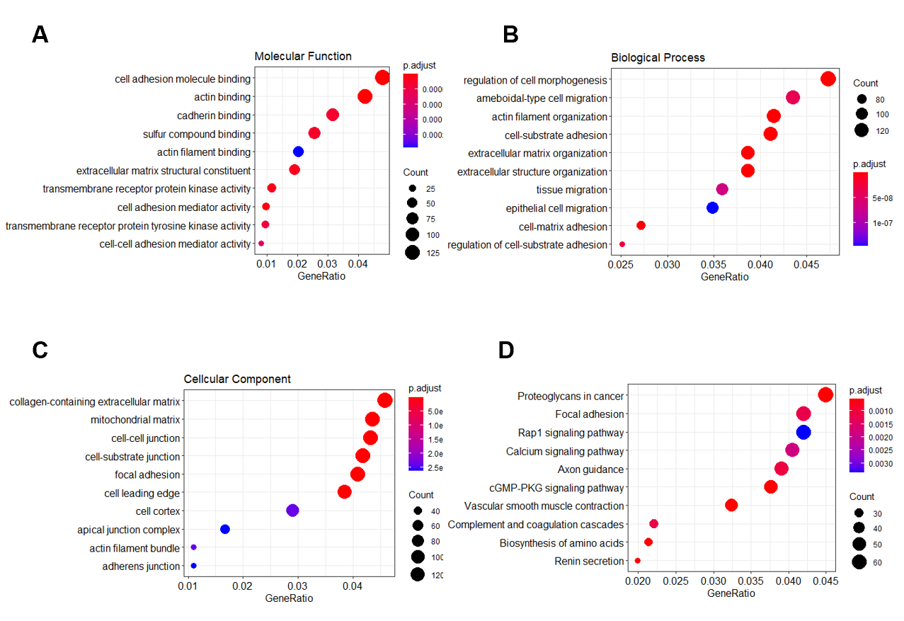
Supplementary Figure 1. Functional enrichment analysis of all the genes in the turquoise module.
(A). GO analysis for molecular function.
(B). GO analysis for biological process.
(C). GO analysis for cellular component.
(D). KEGG pathway enrichment analysis.

Supplementary Figure2. GSEA.
(A). The ‘‘HEPARIN_BINDING’’ gene set was enriched in the TCGA with high expression of RNF150.
(B). PPI of RNF150 based on the STRING database.
(C). Pearson correlation analysis between RNF150 and eight HEPARIN_BINDING pathway-associated member genes in MSI samples.
R, Pearson correlation coefficient.

Supplementary Figure3. Spearrman correlation analysis between RNF150 and four MSI related genes in TCGA GC samples.
R, Pearson correlation coefficient.

