Temporal associations of the COVID-19 related border restrictions and respiratory viral infections in New Zealand
Huang et al
Supplementary Information
BorderRestrictionImpactOnFluRSV Consortium: A full list of members and their affliations
Shirley Laurence⁴, Alicia Stanley⁵, Gail Spence⁴, Maricar Maminta⁴, Renee Clark⁴, Amanda Retter⁴, Roxanne Buchanan⁵, Kristie Yorston⁵, Kristie Yorston⁵, Claire Tarring⁵, Shelley Coetzer⁵,
Srushti Utekar¹, Jason Smith¹, Helen Johnston¹, Georgia Mantziou¹, Ana Claasen¹, Leah Kemp¹,
Akeena Raphael¹, Danielle Currin¹, Erin Signal⁷, Mary Ryan⁷, Sasha Aizpuru⁷, Leigh Emmerton⁷, Donna-Marie Ammundsen⁷, Ginna Alston⁹

¹Institute of Environmental Science and Research, Wellington, New Zealand

⁴Te Whatu Ora – Health New Zealand Counties Manukau, Auckland, New Zealand
⁵Te Whatu Ora – Health New Zealand Te Toka Tumai Auckland, Auckland, New Zealand

⁷Regional Public Health, Te Whatu Ora – Health New Zealand Capital, Coast and Hutt Valley, Wellington, New Zealand
⁹Te Whatu Ora – Health New Zealand Waitaha Canterbury, Christchurch, New Zealand

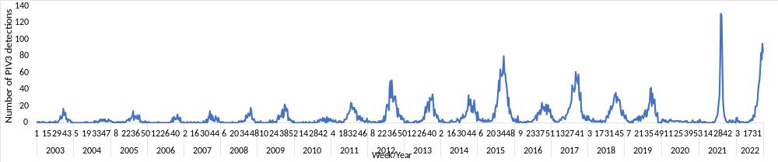
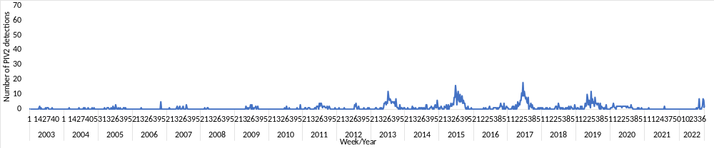
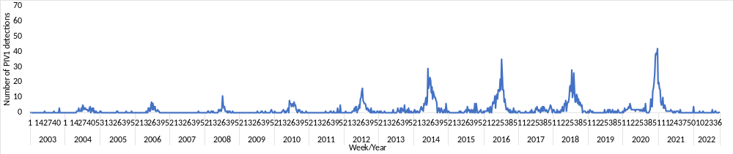
Supplementary Figure. Laboratory-based positive parainfluenza virus (PIV) types 1-3 reported to the Institute of Environmental Science and Research (ESR) during 2003-2022


Supplementary Table. Accession numbers of global RSV full genomes obtained from GISAID during January 2012 and September 2022

