Supporting information
for

A distance-based paper sensor for rapid detection of blood lactate concentration using gold nanoparticles synthesized by Satureja hortensis
Younes Mirzaei¹, Ali Gholami^{1,*}, Mohammad Mahdi Bordbar²
¹Department of Analytical Chemistry, Faculty of Chemistry, University of Kashan, Kashan, 87317−51167, Iran
² Independent researcher, Personal laboratory, Fasa, 74614, Iran.

* Email address: agholami@kashanu.ac.ir

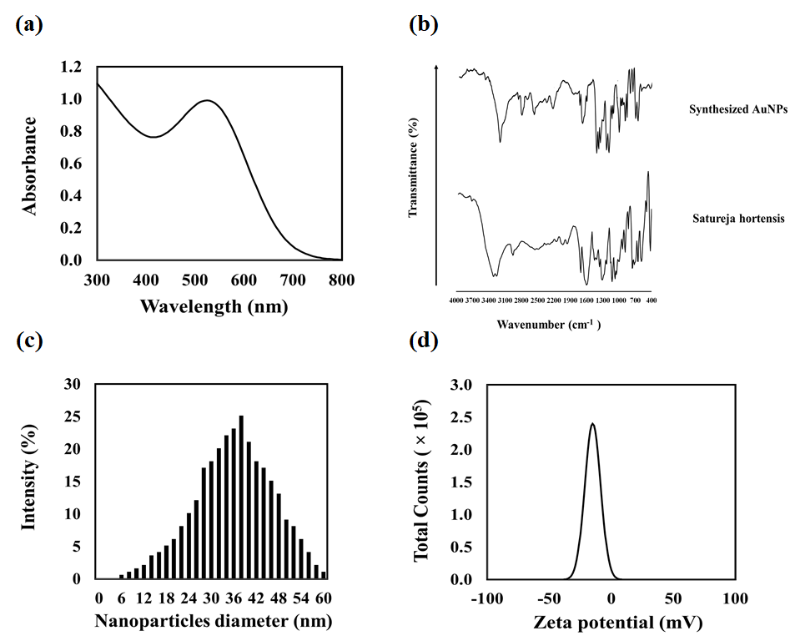
Figure S1. Characterization of synthesized nanoparticles: (a) absorption spectrum, (b) FT-IR spectrum, (c) hydrodynamic size distribution, (d) surface electrical charge.

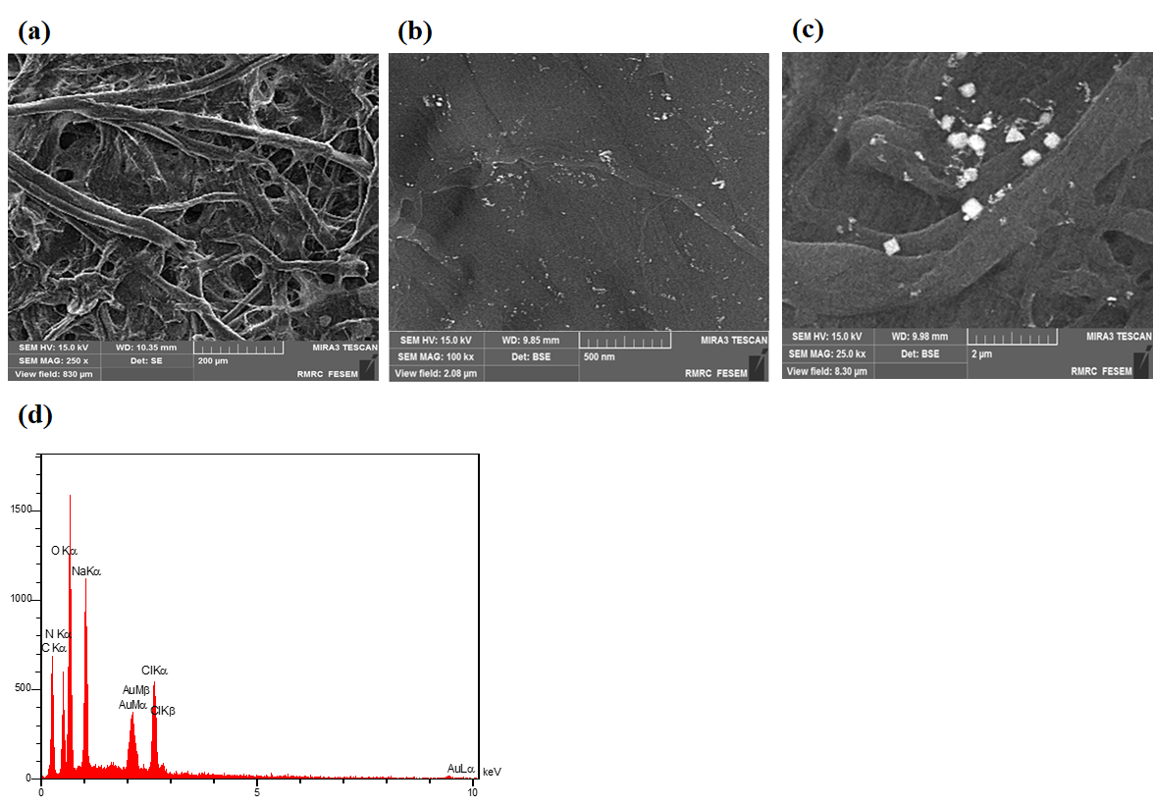
Figure S2. Characterization of paper based sensor: (a) the structure of filter paper before immersing in the AuNPs solution, (b) distribution of AuNPs on the surface of paper, (c) aggregation of AuNPs after exposing to lactate (4.0 mM), (d) the EDX spectrum of synthesized AuNPs.

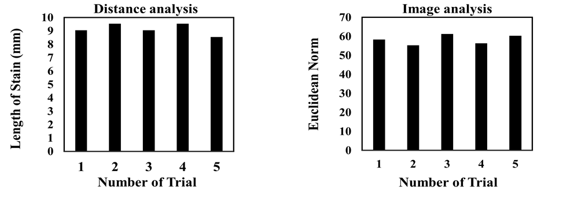
Figure S3. The reproducibility of sensor responses after exposing to lactate (4.0 mM). The results obtained by distance and image analyses. The sensor was fabricated by mixing 8.0 μL of NPs by 10.0 μL of Britton-Robinson buffer (pH 8.0, 0.05 M) and 2.0 μL double-distilled water. The results were collected after 1.5 min.

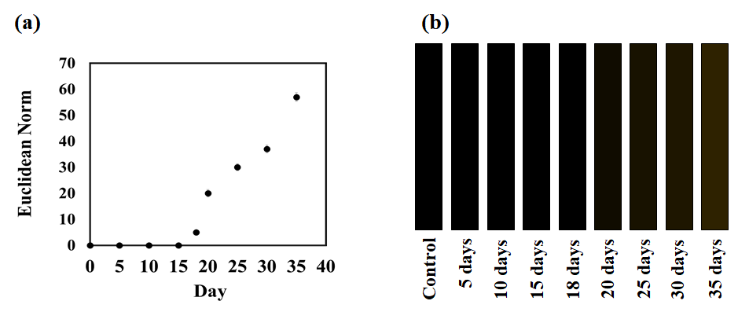
Figure S4. The stability of sensor before exposing to lactate: (a) numerical plot, (b) color maps. The results were obtained by image analysis.

Table S1. Evaluating the repeatability of sensor fabrication procedure.
Color element | Sensor 1 | Sensor 2 | Sensor 3 | Sensor 4 | Sensor 5 | RSD %
R | 223 | 225 | 220 | 226 | 223 | 1.03
G | 84 | 84 | 81 | 82 | 81 | 1.36
B | 110 | 108 | 112 | 111 | 108 | 1.63

Table S2. Comparison of the sensor responses in the presence of lactate immediately or 15 days after sensor fabrication.
Method | Analysis after fabricating the sensor | Analysis after  15 days | t_experimental²
Distance analysis | 9¹ (±0.4) | 8.5 (±0.46) | 1.42
Image analysis | 58 (±2.5) | 55 (±1.9) | 1.65
¹ average of 3 measurements
² t_critical (4, 0.05) = 2.78

Table S3. Comparison between the analytical information of some lactate sensors.
Method | Receptor | Linear range (mM) | Detection limit (mM) | Media | Ref.
Colorimetric | Enzyme+Organic dye | 0.5–8.0 | - | Blood | ¹
Colorimetric | Enzyme+Organic dye | 0.0-25.0 | - | Sweat | ²
Amperometric | Enzyme+Indium tin oxide | 0.1 - 5.5 | 0.1 | Serum | ³
Colorimetric | Enzyme+ Organic dye | 0.039-5.0 | 0.047 | - | ⁴
Colorimetric | Universal pH indicator | 1.0–25.0 | 1.0 | Sweat | ⁵
Fluorimetric | fluorescein-Fe (III) complex | 1.0-12.5 | 0.4 | Sweat | ⁶
Distance | Nanoparticles | 1.0-30.0 | 0.6 | Plasma | This work
Colorimetric | Nanoparticles | 0.5-30.0 | 0.4 | Plasma | This work

References
1. Dai, G., Hu, J., Zhao, X. & Wang, P. A colorimetric paper sensor for lactate assay using a cellulose-Binding recombinant enzyme. Sensors Actuators, B Chem. 238, 138–144 (2017).
2. Promphet, N. et al. Non-invasive textile based colorimetric sensor for the simultaneous detection of sweat pH and lactate. Talanta 192, 424–430 (2019).
3. Suman, S., Singhal, R., Sharma, A. L., Malthotra, B. D. & Pundir, C. S. Development of a lactate biosensor based on conducting copolymer bound lactate oxidase. Sensors Actuators, B Chem. 107, 768–772 (2005).
4. Kan, S. C. et al. Development of an enzymatic chromatography strip with nicotinamide adenine dinucleotide-tetrazolium coupling reactions for quantitative L-lactate analysis. Anal. Biochem. 471, 61–66 (2015).
5. Xiao, G. et al. Facile and Low-Cost Fabrication of a Thread/Paper-Based Wearable System for Simultaneous Detection of Lactate and pH in Human Sweat. Adv. Fiber Mater. 2, 265–278 (2020).
6. Ardalan, S., Hosseinifard, M., Vosough, M. & Golmohammadi, H. Towards smart personalized perspiration analysis: An IoT-integrated cellulose-based microfluidic wearable patch for smartphone fluorimetric multi-sensing of sweat biomarkers. Biosens. Bioelectron. 168, (2020).

