Supporting Information
Injectable bioactive copper-based metal organic framework embedded dual-crosslinked alginate hydrogel for potential antimicrobial applications
Kihak Gwon¹, Seonhwa Lee¹, Youngmee Kim², Jun Choi2, Sujin Kim², Sung-Jin Kim², Hye Jin Hong³, Youngmin Hwang⁴, Munemasa Mori⁴ and Do Nam Lee^{1*}
¹ Ingenium College of Liberal Arts (Chemistry), Kwangwoon University, Seoul 01897, Republic of Korea
² Department of Chemistry and Nano Science, NanoBio-Energy Materials Center, Ewha Womans Universiry, Seoul 03760, Republic of Korea
³ Department of Physiology and Biomedical Engineering, Mayo Clinic, Rochester, MN, 55902, USA
⁴ Columbia Center for Human Development (CCHD), Pulmonary Allergy & Critical Care Medicine, Department of Medicine, Columbia University Irving Medical Center, New York, NY 10032, USA

Corresponding Author: D.N. Lee.
E-mail addresses: donamlee@hanmail.net. ¹ Ingenium College of Liberal Arts (Chemistry), Kwangwoon University, Seoul 01897, Republic of Korea
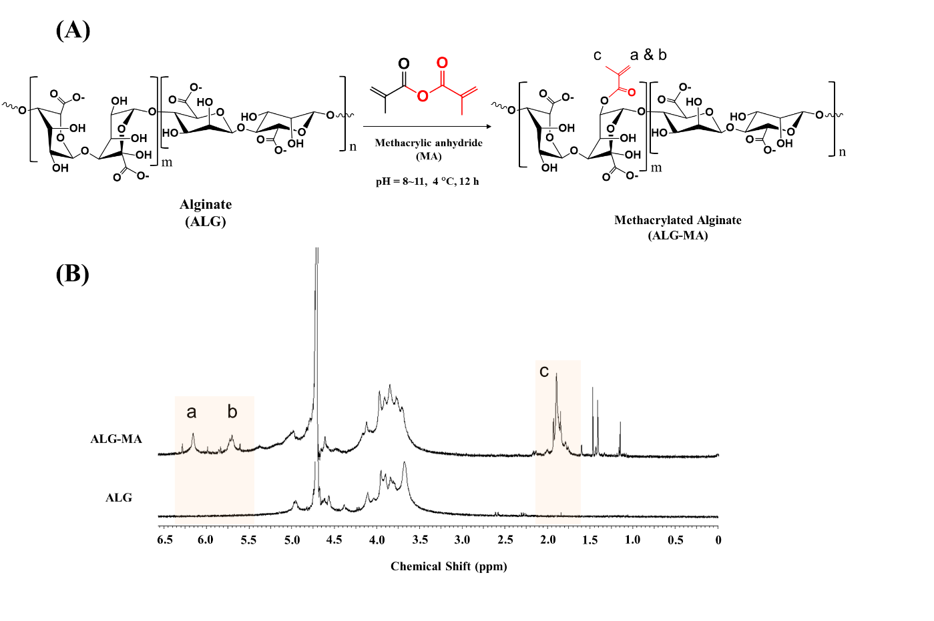
Figure S1. Synthesis and characterization of methacrylated alginate (ALG-MA). (A) Synthesis of ALG-MA via transesterification reaction between alginate and methacrylic anhydride. (B) The ¹H nuclear magnetic resonance (NMR) spectra of HA-MA. The degree of methacrylation was calculated by comparing the methacrylate peaks of MA at −5.6 (Peak b) and −6.1 ppm (Peak a) and methyl protons peak at 1.9 ppm (Peak c).

Table S1. Crystallographic data for Cu(AZPY)-MOF.
 | Cu(AZPY)-MOF
Chemical formula | C₂₀H₂₀Cu₂N₄O₁₀
Formula weight | 603.48
Wavelength (Å) | 0.71073
Space group | C 2/c
a (Å) | 24.679 (11)
b (Å) | 13.156 (5)
c (Å) | 8.534 (3)
α (°) | 90
β (°) | 93.86 (3)
γ (°) | 90.00
Volume (Å³) | 2766.5 (18)
Z | 4

Table S2. Antibacterial and antifungal activities of Cu(AZPY)-MOF (Cu(AZPY)), alginate hydrogel (Dual-ALG), and Cu(AZPY)-MOF encapsulated alginate hydrogel (Cu(AZPY)@Dual-ALG) against MRSA, C. albicans, and S. mutans.
Test strain | Test sample | Test results^{a, b}
Test strain | Test sample | Early conc.  (CFU·mL⁻¹) | After 24 h, conc.  (CFU·mL⁻¹) | Reduction rate of bacteria (%)
MRSA | Blank | 1.7 × 10⁴ | 1.0 × 10⁵ | -
MRSA | Cu(AZPY) | 1.7 × 10⁴ | <10 | 99.9
MRSA | Blank | 2.1× 10⁵ | 2.8 × 10⁶ | -
MRSA | Dual-ALG | 2.1 × 10⁵ | 1.7× 10⁵ | 93.9
MRSA | Blank | 2.1 × 10⁵ | 2.8 × 10⁶ | -
MRSA | Cu(AZPY)@Dual-ALG | 2.1 × 10⁵ | <10 | 99.9
S. mutans | Blank | 2.5 × 10⁴ | 2.8 × 10⁵ | -
S. mutans | Cu(AZPY) | 2.5 × 10⁴ | 2.7 × 10⁴ | 90.3
S. mutans | Blank | 2.5 × 10⁵ | 5.3 × 10⁶ | -
S. mutans | Dual-ALG | 2.5 × 10⁵ | 8.2 × 10⁴ | 98.4
S. mutans | Blank | 2.5 × 10⁵ | 5.3 × 10⁶ | -
S. mutans | Cu(AZPY)@Dual-ALG | 2.5 × 10⁵ | <10 | 99.9
C. albicans | Blank | 1.3 × 10⁴ | 2.2 × 10⁵ | -
C. albicans | Cu(AZPY) | 1.3 × 10⁴ | <10 | 99.9
C. albicans | Blank | 3.5 × 10⁵ | 4.7 × 10⁶ | -
C. albicans | Dual-ALG | 3.5 × 10⁵ | 4.1 × 10⁶ | 12.7
C. albicans | Blank | 3.5 × 10⁵ | 4.7 × 10⁶ | -
C. albicans | Cu(AZPY)@Dual-ALG | 3.5 × 10⁵ | 1.0 × 10⁶ | 78.7
ªTest method: KCL-FIR1002: 2021 for Cu-Azpy and KCL-FIR1003: 2018 for Dual-ALG and Cu(AZPY)@Dual-ALG
^{b}Test environment: (37.0 ± 0.2) °C, Conc. 20 μg·mL⁻¹ of Cu(AZPY), 2 mg·mL⁻¹ of Dual-ALG and Cu(AZPY)@Dual-ALG

