Extended Data
Contents of this file
Extended Data Figures 1–2
Extended Data Tables 1–3

1. Experimental setup
The experiments were conducted by using a VX-3 Paris-Edinburgh (PE) press at the High-Pressure Collaborative Access Team (HPCAT 16-BM-B) at the Advanced Photon Source, Argonne National Laboratory, USA. The schematic of the PE cell assembly is shown in Extended Data Fig. 1. The sample was placed between the Al₂O₃ buffer rod and the backing. Ultrasonic signals were reflected between the interfaces of buffer/sample (R1) and sample/backing (R2). An MgO ring surrounding the sample was used to calibrate the pressure.

The compressional (V_{P}) and shear (V_{S}) wave velocities were obtained by the pulse-echo overlap technique. Electrical sine waves were generated by a waveform generator (Tektronix AFG3251) from 12 to 45 MHz with a step of 1 MHz. The waves were reflected at the buffer-rod/sample and sample/backing interfaces, which were R₁ and R₂ for both P-wave and S-wave. The travel time (t) of the elastic waves through the sample could be determined by R₁ and R₂. The sample length (l) was delimited by white X-ray radiography measurements. The acoustic velocity can be calculated by
$V=\frac{2l}{t}$ (1)
where V corresponds to the V_{P} or V_{S}, l is the thickness of the sample, and t is the travel time of ultrasonic signals determined by R₁ and R₂, respectively. The detailed method can be found in Kono, et al. ¹.
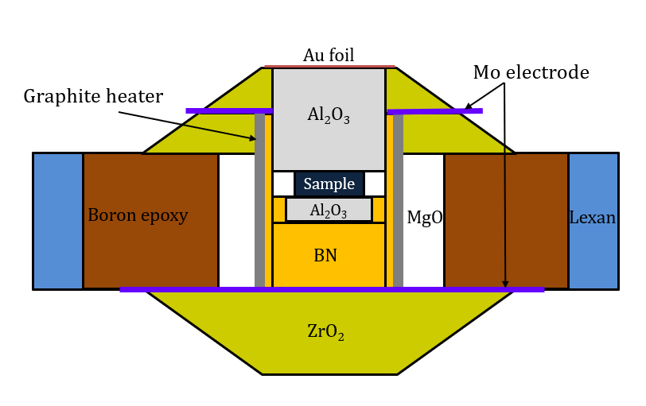
Extended Data Fig. 1. High-pressure and high-temperature PE cell assembly for the acoustic velocity measurements of CaCO₃.

2. In-situ energy dispersive X-ray diffraction
The incident X-ray beam with a size of 0.1×0.3 mm² was white synchrotron radiation (0–120 keV) from a bending magnet. The energy-dispersive X-ray diffraction (EDXRD) patterns of the sample were collected using a Ge solid state detector. The typical collection time was 20 mins. Representative EDXRD patterns for current experiments are presented in Extended Data Fig. 2 and 3.
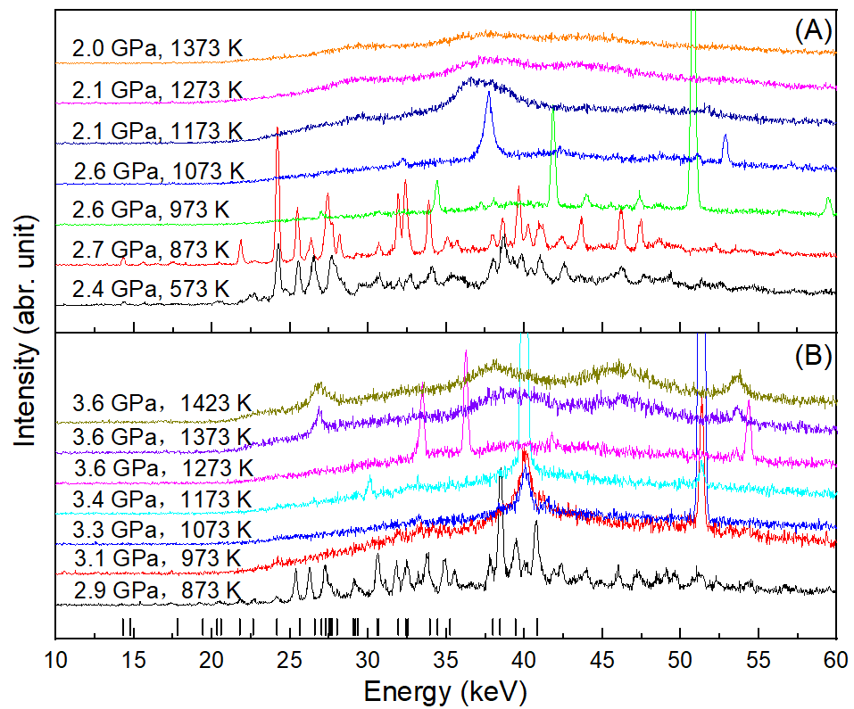
Extended Data Fig. 2. Representative EDXRD patterns of aragonite and amorphous CaCO₃ at high P-T in two heating cycles (A and B). The black bar denote the peaks of aragonite.

3. Seismic velocities of pyrolite + 5 vol.% CaCO₃
We modeled the profile of the low-velocity layers (LVLs) at the top of the subducting slabs with the mixture of pyrolite and 5 vol.% CaCO₃. The density (ρ), compressional (V_{P}), and shear (V_{S}) wave velocities of pyrolite are from Xu, et al. ². The density of aragonite was calculated according to its thermal equation of state (EOS)³. The density of amorphous CaCO₃ is presumably 84% of that of aragonite⁴. The total uncertainties of the literature data from ref. 3. and the density of aragonite are about 0.5%. For the calculated seismic parameters of pyrolite + 5 vol.% CaCO₃, the uncertainties are about 1%.
Extended Data Table 1. Acoustic velocities and densities of pyrolite, aragonite, and amorphous CaCO₃ along the craton geotherm with surface heat flux of 45 mW/m².

P (GPa) | 1.4 | 1.7 | 2.0 | 2.3 | 2.6 | 2.9 | 3.2 | 3.5 | 4.0 | 4.5 | 5.0
Depth(km) | 41 | 50 | 59 | 68 | 77 | 87 | 97 | 406 | 121 | 134 | 150
T (K) | 656 | 728 | 793 | 861 | 923 | 986 | 1044 | 1101 | 1176 | 1240 | 1309
Pyrolite
V_{P} (km/s) | 7.69 | 7.73 | 7.79 | 7.85 | 7.98 | 8.06 | 8.13 | 8.18 | 8.26 | 8.27 | 8.35
V_{S} (km/s) | 4.57 | 4.59 | 4.60 | 4.61 | 4.63 | 4.67 | 4.69 | 4.71 | 4.72 | 4.74 | 4.75
ρ (g/cm³) | 3.24 | 3.25 | 3.26 | 3.27 | 3.30 | 3.32 | 3.33 | 3.34 | 3.36 | 3.37 | 3.39
K_{S} (GPa) | 101.2 | 102.8 | 105.7 | 109.0 | 115.7 | 119.0 | 122.5 | 124.8 | 129.4 | 129.6 | 134.2
G (GPa) | 67.6 | 68.4 | 68.9 | 69.6 | 70.7 | 72.3 | 73.3 | 74.1 | 74.8 | 75.7 | 76.4
Aragonite
V_{P} (km/s) | 5.71 | 5.75 | 5.79 | 5.83 | 5.87 | 5.91 | / | / | / | / | /
V_{S} (km/s) | 2.98 | 3.01 | 3.04 | 3.07 | 3.09 | 3.12 | / | / | / | / | /
ρ (g/cm³) | 3.01 | 3.01 | 3.01 | 3.01 | 3.02 | 3.02 | / | / | / | / | /
K_{S} (GPa) | 63.4 | 64.4 | 65.4 | 66.4 | 67.6 | 68.8 | / | / | / | / | /
G (GPa) | 27.3 | 27.9 | 28.5 | 29.1 | 29.8 | 30.5 | / | / | / | / | /
Amorphous CaCO₃*
V_{P} (km/s) | / | / | / | / | / | / | 3.99 | 4.03 | 4.11 | 4.17 | 4.25
V_{S} (km/s) | / | / | / | / | / | / | 1.33 | 1.37 | 1.45 | 1.52 | 1.59
ρ (g/cm³) | / | / | / | / | / | / | 2.63 | 2.63 | 2.63 | 2.64 | 2.64
K_{S} (GPa) | / | / | / | / | / | / | 41.1 | 41.6 | 42.7 | 43.5 | 44.5
G (GPa) | / | / | / | / | / | / | 5.3 | 5.7 | 6.4 | 7.0 | 7.7
*: The density of amorphous of CaCO₃ is assumed to be 0.87 times of the density of aragonite.

Extended Data Table 2. Acoustic velocities of pyrolite + 5 vol.% aragonite averaged by Voigt, Reuss, and VRH algorithms.
P (GPa) | 1.4 | 1.7 | 2.0 | 2.3 | 2.6 | 2.9
Depth (km) | 41 | 50 | 59 | 68 | 77 | 87
T (K) | 656 | 728 | 793 | 861 | 923 | 986
Pyrolite + 5vol.% aragonite, Voigt
V_{P} (km/s) | 7.61 | 7.65 | 7.71 | 7.76 | 7.89 | 7.97
V_{S} (km/s) | 4.51 | 4.53 | 4.54 | 4.55 | 4.56 | 4.61
Pyrolite + 5vol.% aragonite, Reuss
V_{P} (km/s) | 7.51 | 7.59 | 7.65 | 7.71 | 7.83 | 7.91
V_{S} (km/s) | 4.41 | 4.49 | 4.50 | 4.51 | 4.53 | 4.57
Pyrolite + 5vol.% aragonite, VRH
V_{P} (km/s) | 7.56 | 7.62 | 7.68 | 7.74 | 7.86 | 7.94
V_{S} (km/s) | 4.46 | 4.51 | 4.52 | 4.53 | 4.55 | 4.59

Extended Data Table 3. Acoustic velocities of pyrolite + 5 vol.% amorphous CaCO₃ averaged by Voigt, Reuss, and VRH algorithms.

P (GPa) | 3.2 | 3.5 | 4.0 | 4.5 | 5.0
Depth (km) | 97 | 406 | 121 | 134 | 150
T (K) | 1044 | 1101 | 1176 | 1240 | 1309
Pyrolite + 5vol.% amorphous CaCO₃, Voigt
V_{P} (km/s) | 7.99 | 8.04 | 8.12 | 8.13 | 8.21
V_{S} (km/s) | 4.59 | 4.61 | 4.62 | 4.64 | 4.65
Pyrolite + 5vol.% amorphous CaCO₃, Reuss
V_{P} (km/s) | 7.18 | 7.26 | 7.39 | 7.44 | 7.56
V_{S} (km/s) | 3.67 | 3.73 | 3.82 | 3.89 | 3.96
Pyrolite + 5vol.% amorphous CaCO₃, VRH
V_{P} (km/s) | 7.60 | 7.66 | 7.76 | 7.79 | 7.89
V_{S} (km/s) | 4.16 | 4.19 | 4.24 | 4.28 | 4.32

Reference
1 Kono, Y., Park, C., Kenney-Benson, C., Shen, G. & Wang, Y. Toward comprehensive studies of liquids at high pressures and high temperatures: Combined structure, elastic wave velocity, and viscosity measurements in the Paris–Edinburgh cell. Phys. Earth Planet. Inter. 228, 269-280 (2014).
2 Xu, W., Lithgow-Bertelloni, C., Stixrude, L. & Ritsema, J. The effect of bulk composition and temperature on mantle seismic structure. Earth Planet. Sci. Lett. 275, 70-79 (2008).
3 Litasov, K. D. et al. PVT equation of state of CaCO3 aragonite to 29 GPa and 1673 K: In situ X-ray diffraction study. Phys. Earth Planet. Inter. 265, 82-91 (2017).
4 Hou, M. et al. Temperature-induced amorphization in CaCO 3 at high pressure and implications for recycled CaCO 3 in subduction zones. Nat. Commun. 10, 1963 (2019).

