Supplementary data

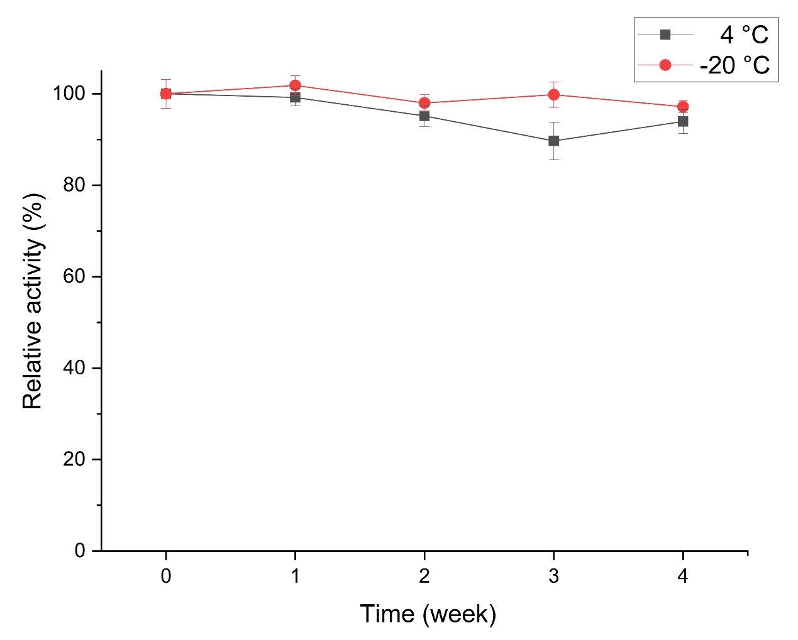
Figure S1. Stablity of the crude enzyme of halolysin Hly176B at 4 °C and -20 °C. The crude enzyme of the strain Haloarchaeobius sp. FL176 was prepared through tangential flow concentration with a molecular weight cut-off of 10 kDa. The concentrated supernatants of the strain Haloarchaeobius sp. FL176 was taken as the crude enzyme of halolysin Hly176B. The proteolytic activity was measured by azocaseinolytic assay with a interval of 7 days after a storation at 4 °C (black line) and -20 °C (red line). Three parallel tests were taken.

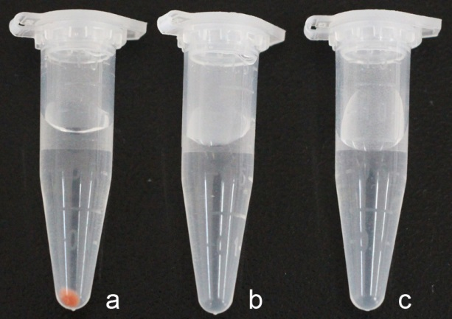
Figure S2. Cells of Haloarchaeobius sp. strain FL176 lyse in distilled water. Cells of strain FL176 suspended in 20% NaCl (a) or distilled water (b), then harvested by centrifugation. (c) Distilled water without cells.

