Table 1. A sample of tests containing multiple choice questions on theoretical and applied anatomy of the brain stem. Correct answers in bold italic font.

- Which of the following correctly represents the parts of the brain stem?  - Midbrain  - Internal capsule  - Pons  - Medulla oblongata  - Cerebellum | a) I, II, III, IV  b) II, III, V  c) I, III, IV  d) I, III, IV, V  e) II, IV, V
- Which of the following has the highest number of dopaminergic neurons? | a) Area pretectalis  b) Tectum mesencephali  c) Tegmentum mesencephali  d) Substantia nigra  e) Nucleus ruber
- Which nucleus is located between the substantia nigra and aquaduct of midbrain? | a) Nucleus of oculomotor nerve  b) Nucleus of trochlear nerve  c) Red nucleus  d) Pontine nuclei  e) Edinger-Westphal nucleus
- Which center has a role in reflex movements of the head, neck and eyes against sudden auditory, somatic and visual stimuli? | a) Inferior colliculus  b) Superior colliculus  c) Pretectal area  d) Tectum of midbrain  e) Substantia nigra
- Which of the information about medulla oblongata is false? | a) It is the most caudal part of the brain stem.  b) Connected to the cerebellum with the inferior cerebellar peduncle.  c) The last 4 cranial nerves leave the brain stem from the medulla oblongata.  d) The basilar artery sits on the basilar groove on its anterior surface.  e) It is separated from the pons with bulbopontin groove.
- Which cranial nerve gets out from the bulbopontin groove? | a) IX. cranial nerve  b) X. cranial nerve  c) V. cranial nerve  d) VI. cranial nerve  e) XI. cranial nerve
- Which of the statements about the pons is false? | a) It is adjacent to the cerebellum through the 4th ventricle.  b) It is adjacent to the clivus through the cisterna pontis.  c) It is separated from the bulbus by the sulcus bulbopontinus.  d) Inferior cerebellar pedincle is connected with the cerebellum.  e) The basilar artery sits on the basilar groove on its anterior surface.
- Write the name of the indicated structure.  Oculomotor nerve | 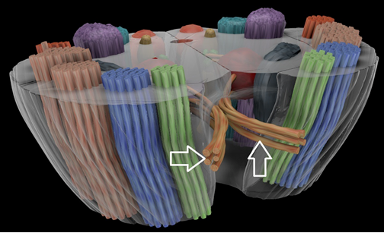
- Write the name of the indicated structure.  Inferior colliculus | 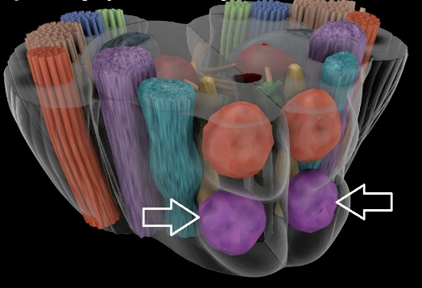
- Write the name of the indicated structure.  Medial lemniscus | 