Supplementary material

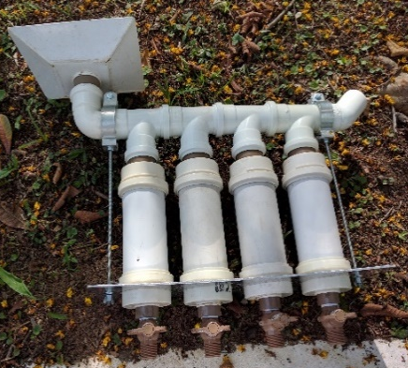 | 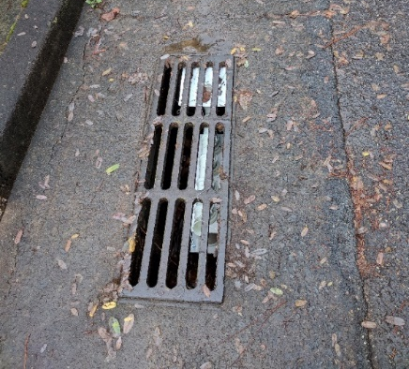
Figure S1 - Integrated Collector assembled with PVC tubes(a) installed(b)

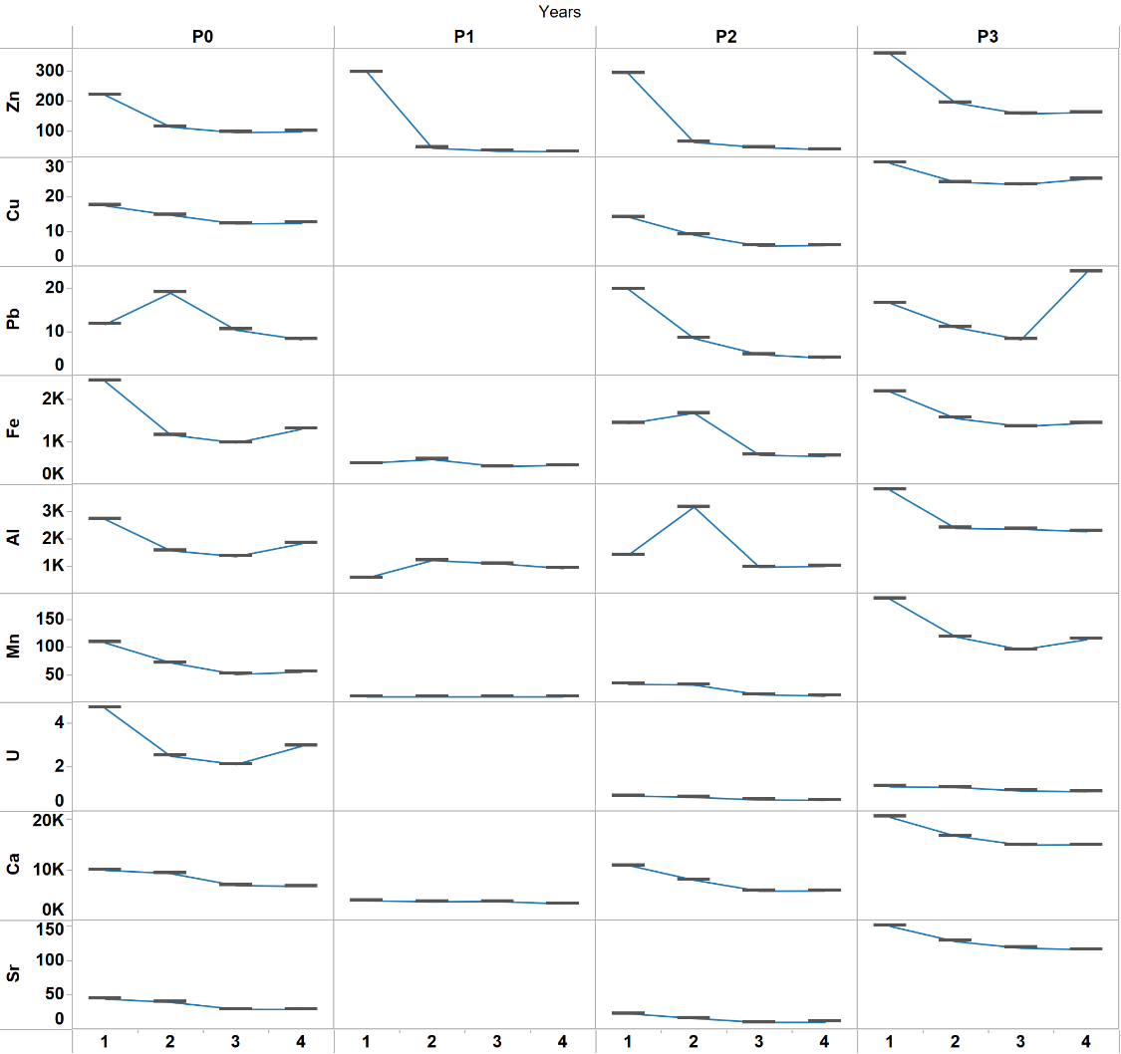
Figure S2 – Elemental variability by collector chamberand by sampling point.

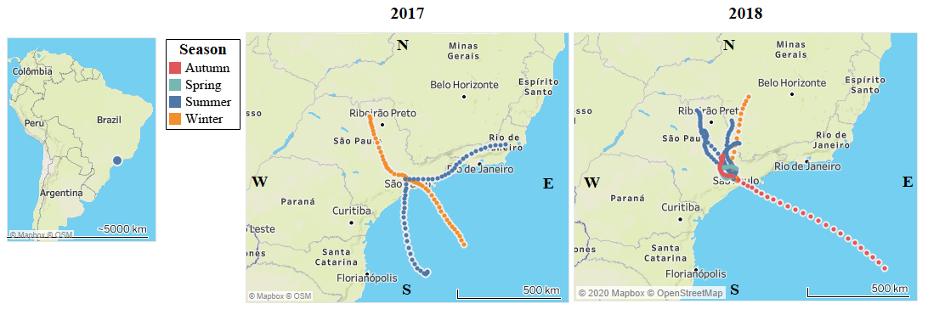
Figure S3 Atmospheric trajectory by season in 2017 and 2018.

