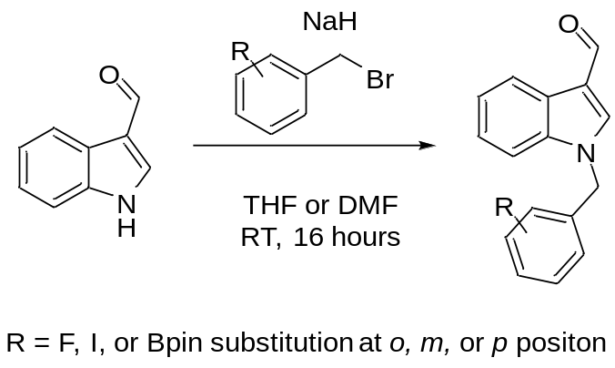
Scheme 1: Standard coupling conditions for indole-3-carbaldehyde and various benzyl bromides.
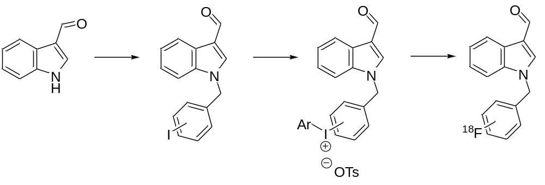
Scheme 2: Proposed synthetic route for iodonium salt synthesis and subsequent labelling
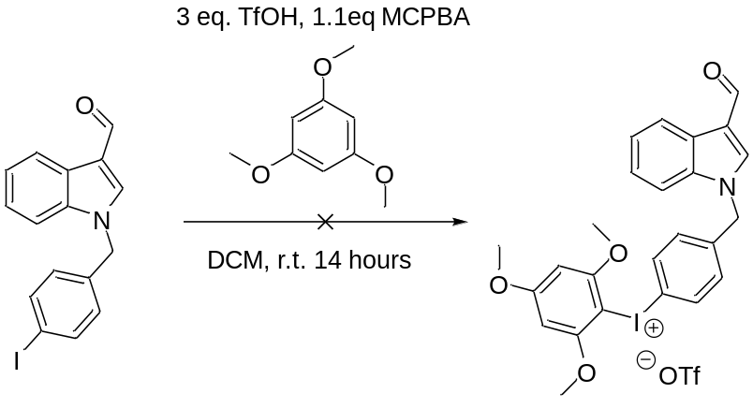
Scheme 3: Attempted initial iodonium salt synthesis
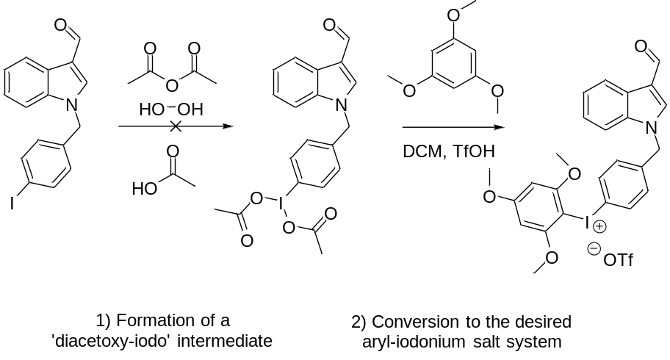
Scheme 4: A 2-step approach to iodonium salt synthesis.
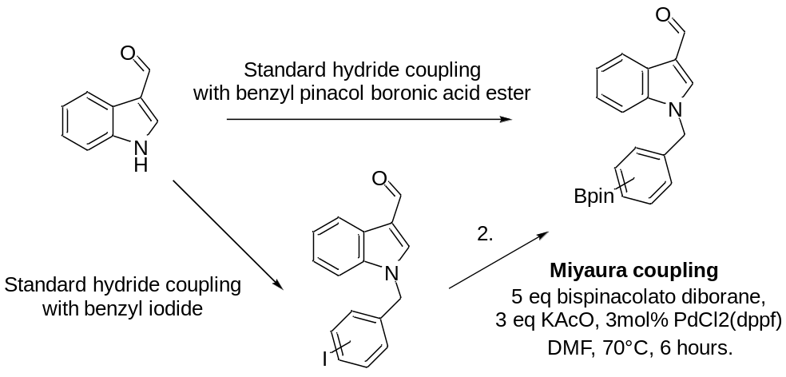
Scheme 5: Synthesis of boronic ester precursors via two routes
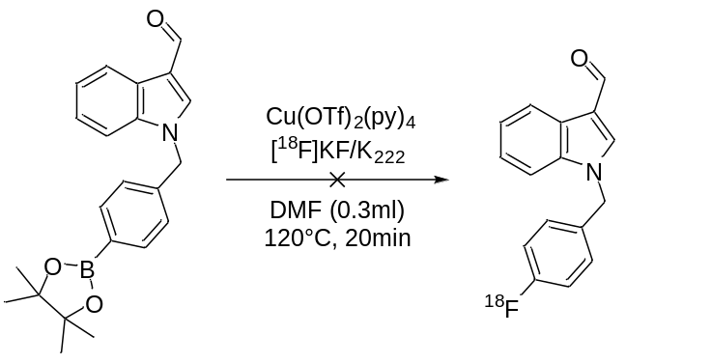
Scheme 6: Initial radiolabelling trial conditions utilizing Treadwell conditions.
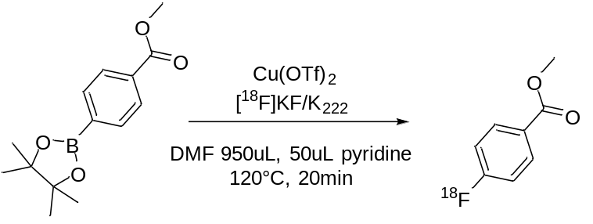
Scheme 7: Radiolabelling conditions used for labelling of model system
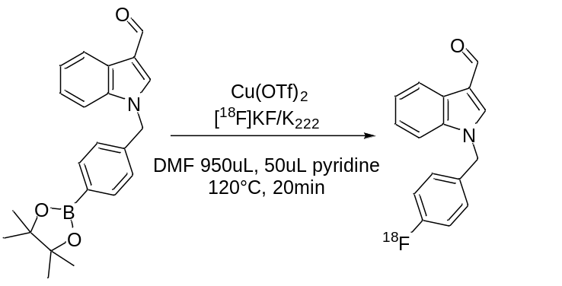
Scheme 8: Radiolabelling conditions for KAM001

