Supplementary data

General
Solvents and reagents other than boron containing compounds were purchased from Sigma Aldrich and used without further purification. Boron compounds were purchased from Advanced Molecular Technologies and used without further purification.
NMR experiments
Nuclear magnetic resonance (NMR) spectra for ¹H and ¹³C nuclei were recorded using a Varian Inova-600 NMR operating at 600 and 150 MHz respectively. Unless otherwise specified, 1H NMR were obtained in deuterochloroform solution (CDCl₃) at ambient temperature with residual chloroform of δ7.26 ppm as internal reference. ¹H NMR chemical shifts are reported in parts per million (ppm) and are followed by integration, multiplicity (singlet (s), doublet (d), triplet (t), multiplet (m), doublet doublet (dd), triplet doublet (td), broad singlet (b.s.)), coupling constant (J) given in Hertz (Hz). Proton decoupled ¹³C NMR chemical shifts were referenced on the centre peak of CDCl₃ (δ77.0 ppm) and the signals are reported as chemical shift in ppm.
Mass Spectrometry
High Resolution Mass Spectrometry (HRMS) was carried out in the positive ion mode on either a Finnigan LTQ-FT hybrid linear ion trap fitted with an electrospray ionization (ESI) source and Fourier Transform Ion Cyclotron Resonance (FT-ICR) or a Thermo NanoLC/ OrbiTRAP ELITE ETD mass spectrometer. All values are represented in a mass to charge ratio (m/z).
Characterization of compounds
Structure
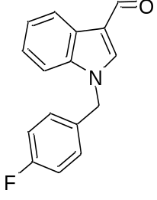
Identifier - KAM001
Mass Spec
Chemical Formula: C16H12FNO
Exact Mass: 253.09029
Molecular Weight: 253.27098

Calculated Mass (M +H) 254.09757
Observed Mass (M +H) 254.09747
¹H NMR (CDCl₃, 600 MHz) δ 5.34 (s, 2 H), 7.05 (t, J = 8.64 Hz, 2 H), 7.17 (dd, J = 8.57, 5.20 Hz, 2 H), 7.29 - 7.37 (m, 3 H), 7.71 (s, 1 H), 8.27 - 8.42 (m, 1 H), 10.02 (s, 1 H)
¹³C NMR: CDCl₃, 600 MHz 50.3, 110.2, 116.1, 116.2, 122.2, 123.1, 124.2, 128.9, 129.0, 138.1, 184.5

Melting Point 114.1-116.3 °C
High Resolution Mass Spectrometry of KAM001
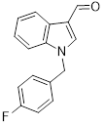
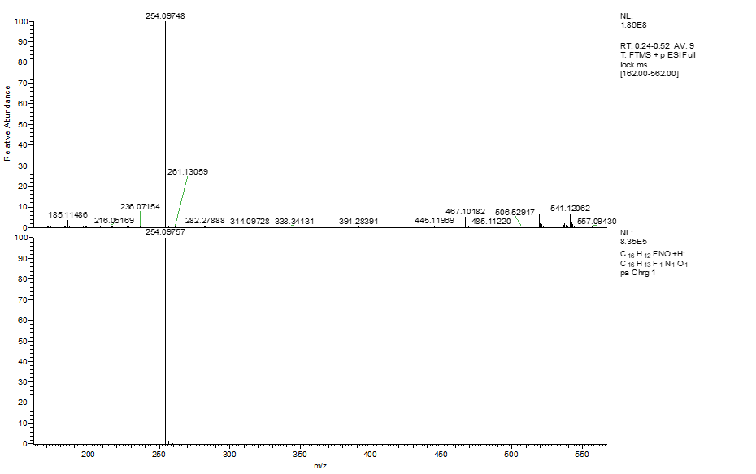

¹H NMR of KAM001

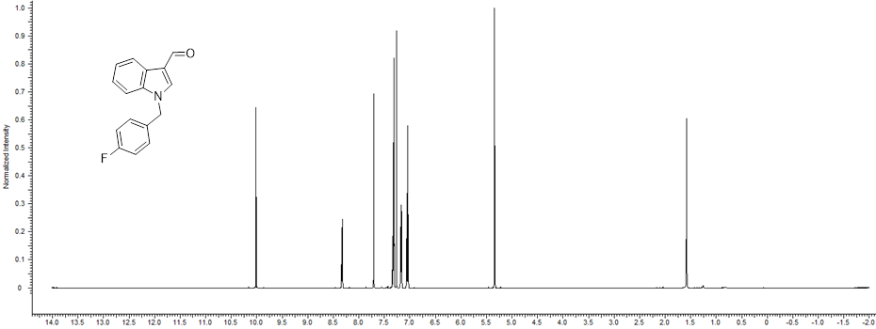

¹³C NMR of KAM001

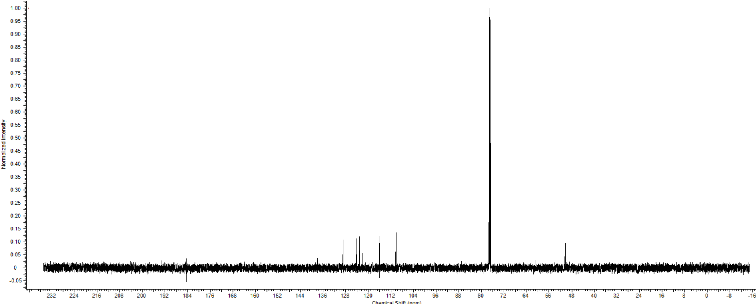
Structure
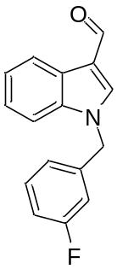
Identifier - KAM002
Mass Spec
Chemical Formula: C16H12FNO
Exact Mass: 253.09029
Molecular Weight: 253.27098

Calculated Mass (M +H) 254.09757
Observed Mass (M +H) 254.09747

¹H NMR (CDCl₃, 600 MHz) δ 10.03 (s, 1H), 8.15 - 8.55 (m, 1H), 7.74 (s, 1H), 7.23 - 7.45 (m, 5H), 6.70 - 7.12 (m, 3H), 5.37 (s, 2H)

¹³C NMR δ: 50.4, 110.2, 114.0, 114.1, 115.3, 115.5, 118.7, 122.2, 122.6, 123.2, 124.3, 125.5, 130.7, 130.8, 137.3, 137.9, 138.3, 162.3, 163.9, 184.6

Melting Point 109.4-112.3 °C
Crystal Structure
Link: DOI: 10.5517/ccdc.csd.cc23sy95
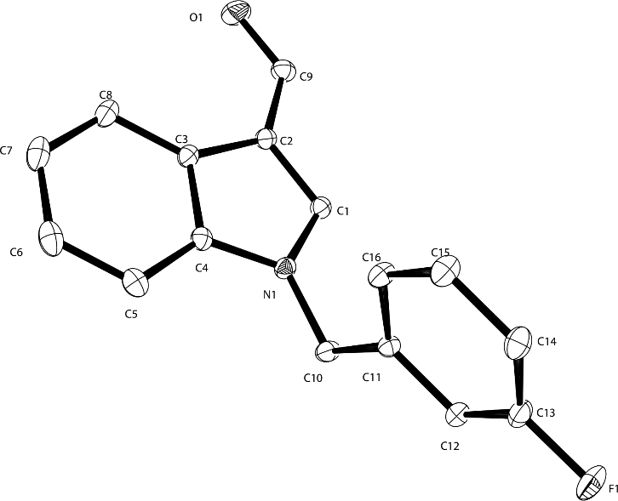

High Resolution Mass Spectrometry of KAM002
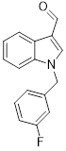
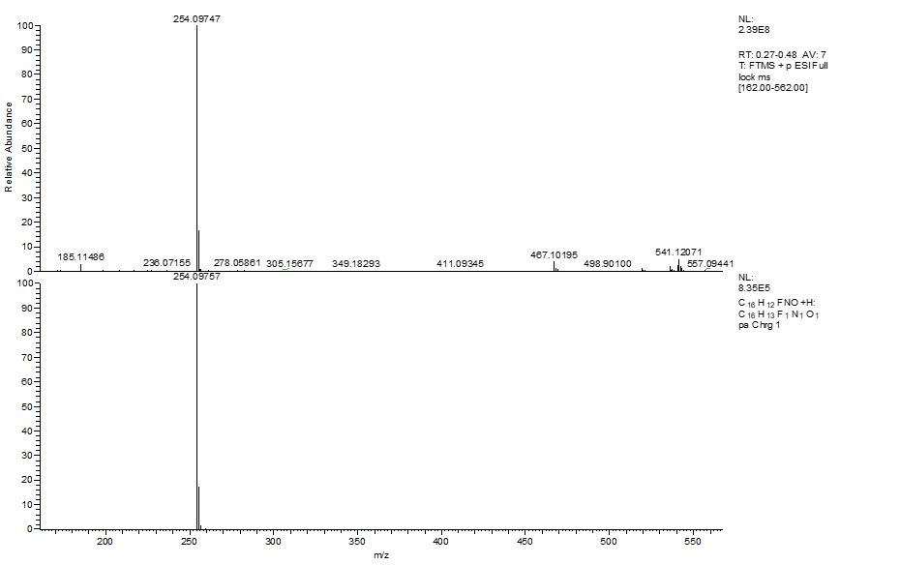

¹H NMR of KAM002

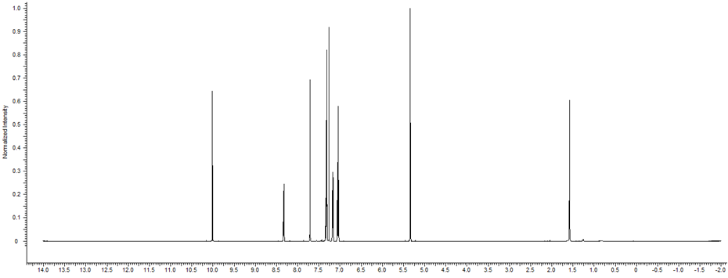

¹³C NMR of KAM002

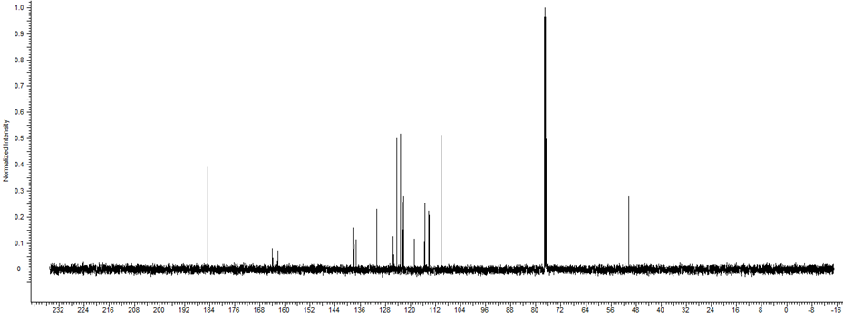

Structure
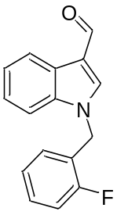
Identifier - KAM003
Mass Spec
Chemical Formula: C16H12FNO
Exact Mass: 253.09029
Molecular Weight: 253.27098

Calculated Mass (M + H) 254.09029
Observed Mass (M + H ) 254.09753
¹H NMR δ:
(CDCl₃, 400 MHz) δ 9.88 - 10.08 (m, 1H), 8.20 - 8.45 (m, 1H), 7.77 (s, 1H), 7.36 - 7.44 (m, 1H), 7.28 - 7.36 (m, 3H), 7.00 - 7.18 (m, 3H), 5.41 (s, 2H)
¹³C NMR δ:
(101 MHz, cdcl₃) δ 184.6, 161.8, 159.3, 138.4, 137.3, 130.4, 129.4, 125.4, 124.7, 124.2, 123.1, 122.6, 122.2, 118.7, 115.9, 110.1, 44.7
Melting Point 98.0-100.5°C
Crystal Structure:
Link: DOI: 10.5517/ccdc.csd.cc23syb6

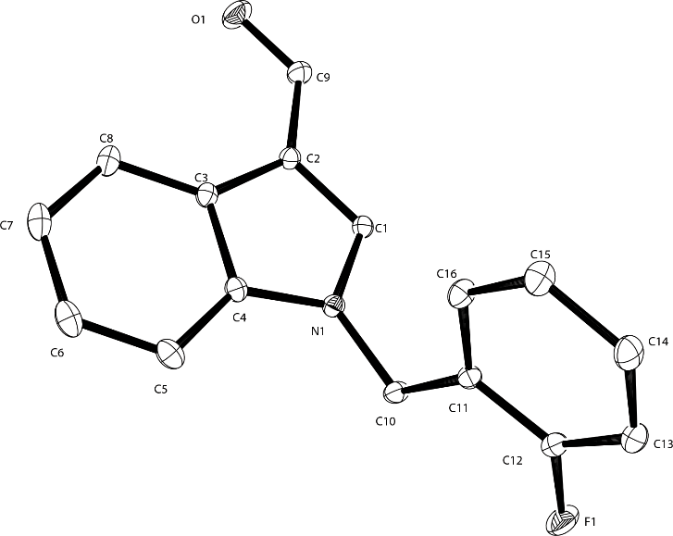

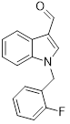
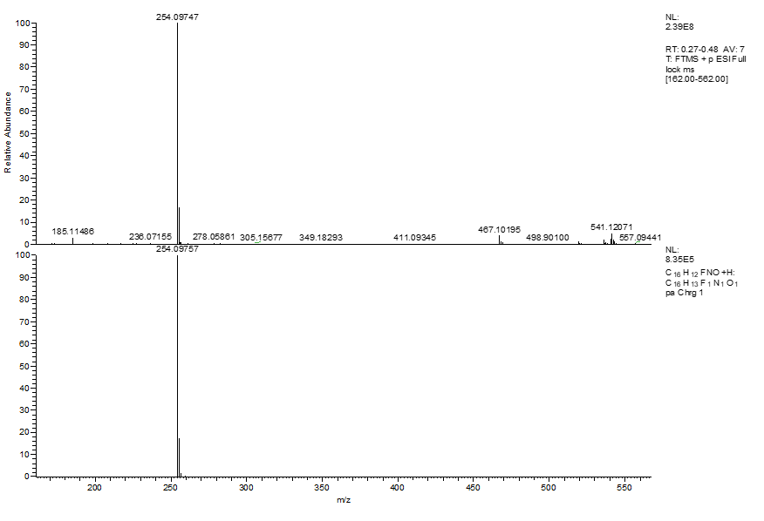

¹H NMR of KAM003

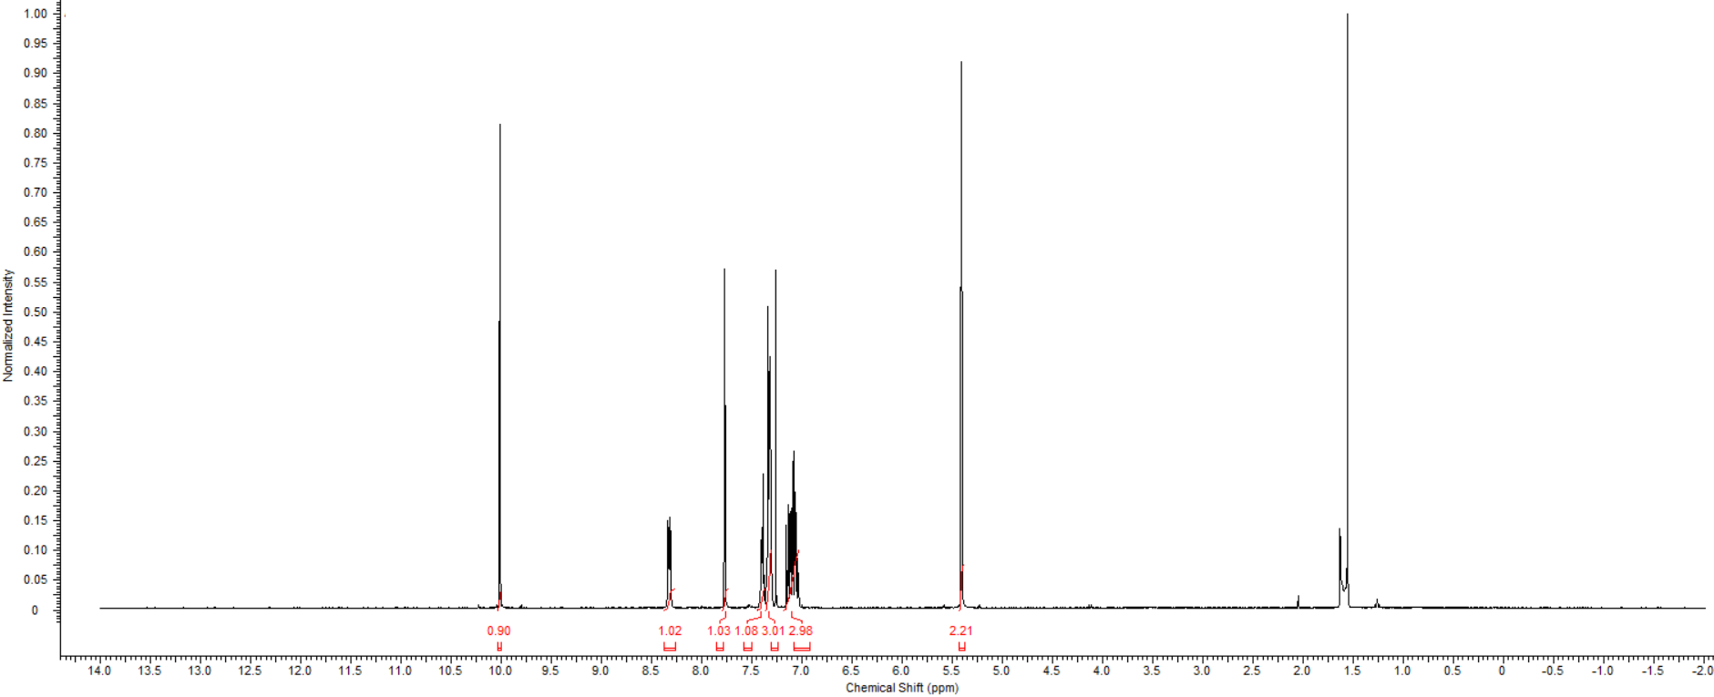

¹³C NMR of KAM003
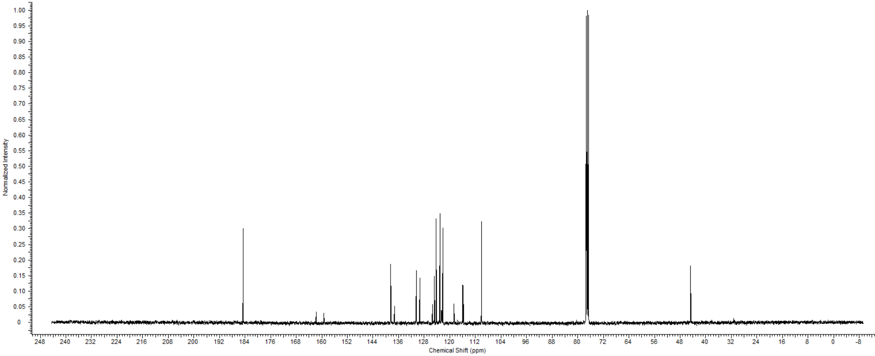
Structure
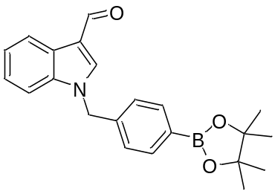
Identifier – BpinKAM001
1-(4-(4,4,5,5-tetramethyl-1,3,2-dioxaborolan-2-yl)benzyl)-1H-indole-3-carbaldehyde

Mass Spec
Chemical Formula: C22H24BNO3
Exact Mass: 361.24186
Molecular Weight: 361.18492

Observed Mass (M + H )
¹H NMR :
(CDCl₃, 400 MHz) δ 10.00 (s, 1H), 8.33 (d, J = 6.65 Hz, 1H), 7.79 (d, J = 7.83 Hz, 2H), 7.70 (s, 1H), 7.27 - 7.35 (m, 3H), 7.19 (d, J = 7.83 Hz, 2H), 5.37 (s, 2H), 1.33 (s, 12H)
¹³C NMR:
(CDCl₃, 101 MHz) δ 184.6, 138.4, 138.2, 137.4, 135.5, 126.5, 125.5, 124.2, 123.1, 122.2, 110.3, 84.0, 51.1, 30.9, 24.8

Crystal structure:
Link: DOI: 10.5517/ccdc.csd.cc23syc7

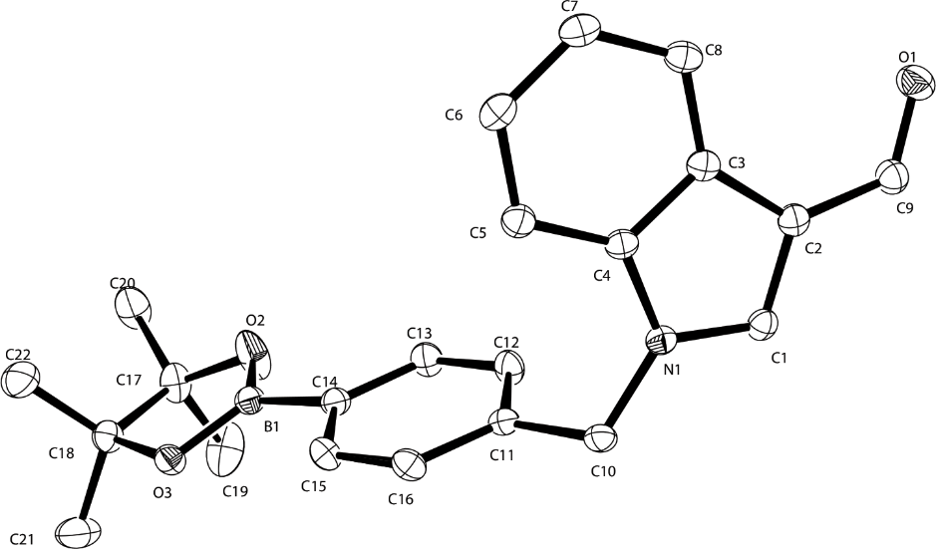

¹H NMR of BpinKAM001

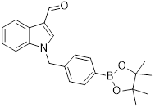
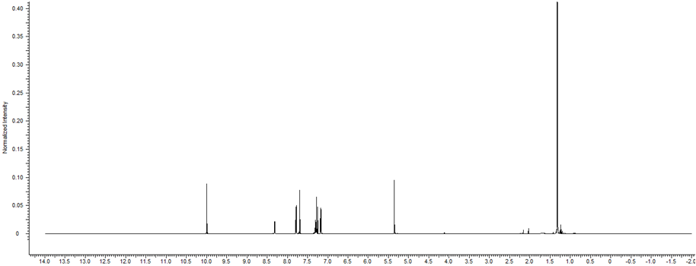

¹³C NMR of BpinKAM001

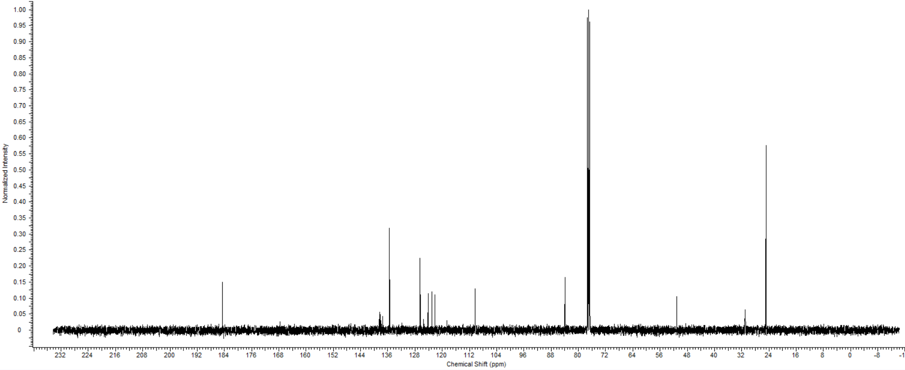

Structure
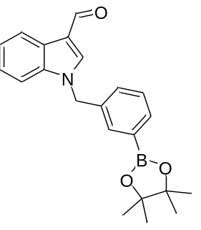
Identifier – BpinKAM002
1-(3-(4,4,5,5-tetramethyl-1,3,2-dioxaborolan-2-yl)benzyl)-1H-indole-3-carbaldehyde

Mass Spec
Chemical Formula: C22H24BNO3
Exact Mass: 361.24186
Molecular Weight: 361.18492

Observed Mass (M + H )
¹H NMR :
(CDCl₃, 400 MHz) δ 10.00 (s, 1 H), 8.31 (s, 1 H), 7.82 - 7.74 (m, 2 H), 7.41 - 7.27 (m, 4 H), 7.21 (s, 1 H), 5.34 (s, 2 H), 1.35 (s, 12 H)
¹³C NMR:
(CDCl₃, 101 MHz) δ 184.96, 138.42, 137.47, 134.90, 134.46, 133.88, 130.20, 128.59, 125.53, 124.10, 123.04, 122.12, 118.45, 110.36, 84.09, 50.94

Crystal Structure
Link: DOI: 10.5517/ccdc.csd.cc23syhc
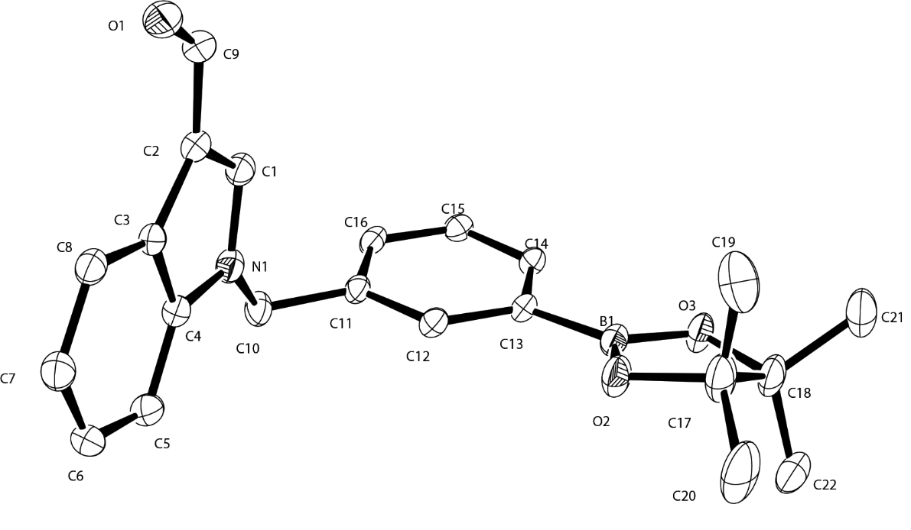

¹H NMR of BpinKAM002

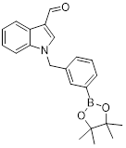
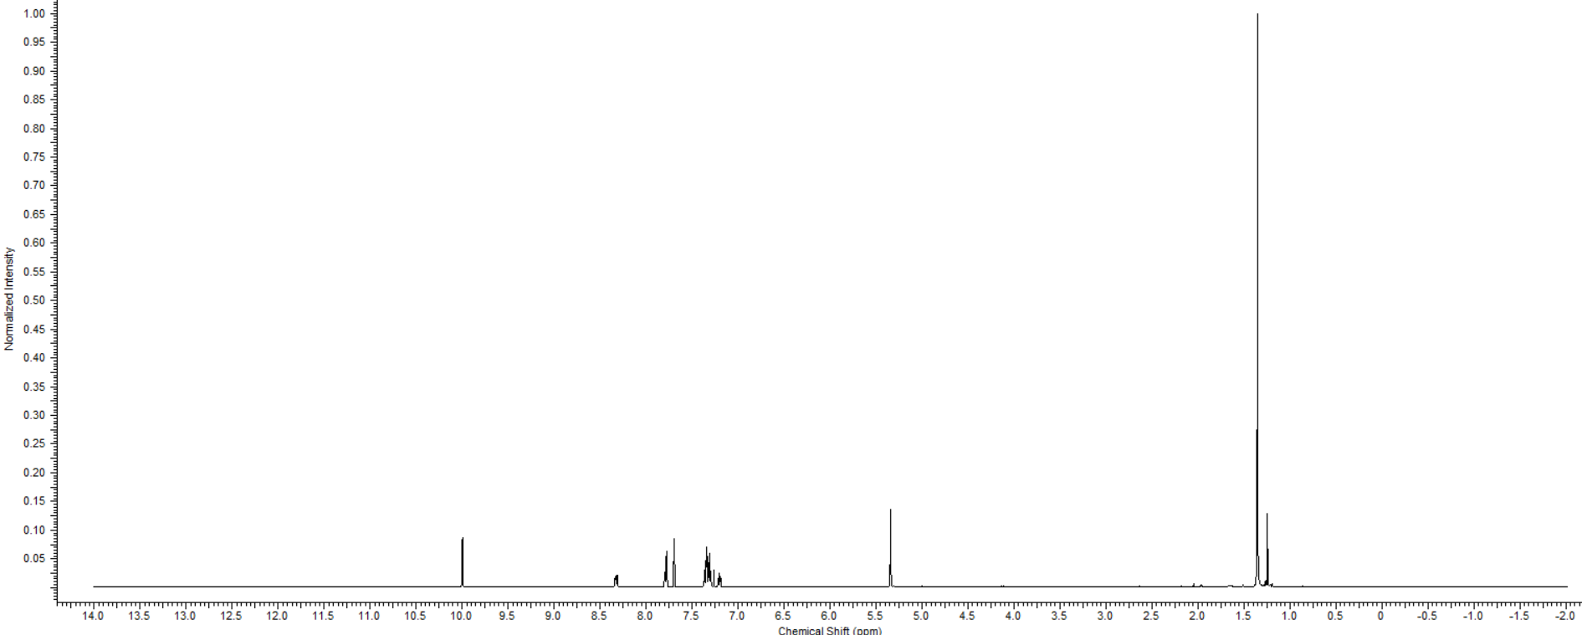

¹³C NMR of BpinKAM002

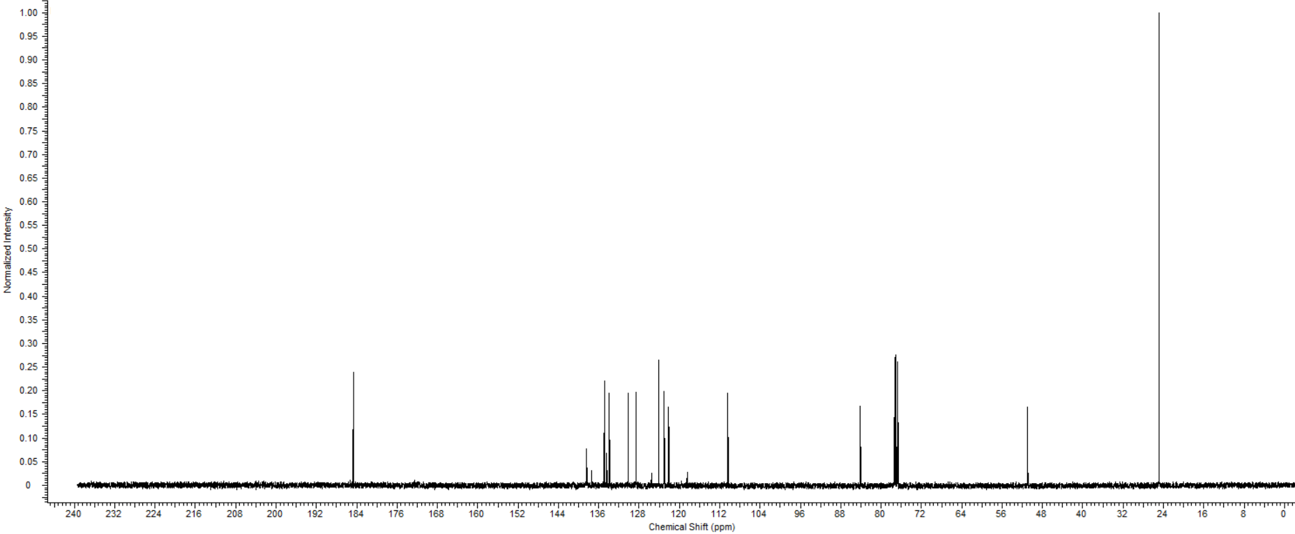

Structure
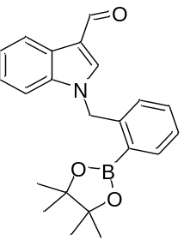
Identifier – BpinKAM003
1-(2-(4,4,5,5-tetramethyl-1,3,2-dioxaborolan-2-yl)benzyl)-1H-indole-3-carbaldehyde
Mass Spec
Chemical Formula: C22H24BNO3
Exact Mass: 361.24186
Molecular Weight: 361.18492

Observed Mass (M + H )
¹H NMR :
(CDCl₃, 400 MHz) δ 9.94 (s, 2 H), 8.39 - 8.28 (m, 2 H), 7.96 (d, J = 6.7 Hz, 2 H), 7.59 (s, 2 H), 7.47 - 7.24 (m, 11 H), 7.01 (d, J = 7.0 Hz, 2 H), 1.23 (s, 12 H)
¹³C NMR:
(CDCl₃, 101 MHz) δ 184.6, 141.3, 137.9, 131.8, 128.1, 127.7, 125.4, 123.4, 122.0, 118.1, 110.7, 84.0, 77.3, 77.0, 76.7, 50.3, 24.7

Crystal Structure
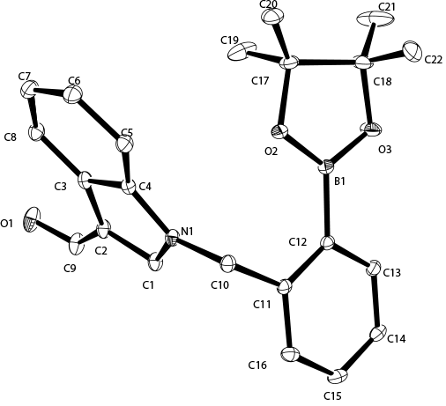
Link: DOI: 10.5517/ccdc.csd.cc23sygb

¹H NMR of BpinKAM003

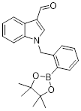
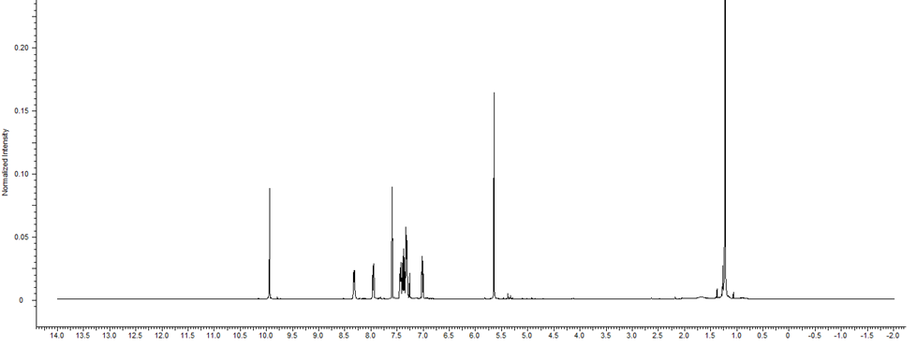

¹³C NMR of BpinKAM003

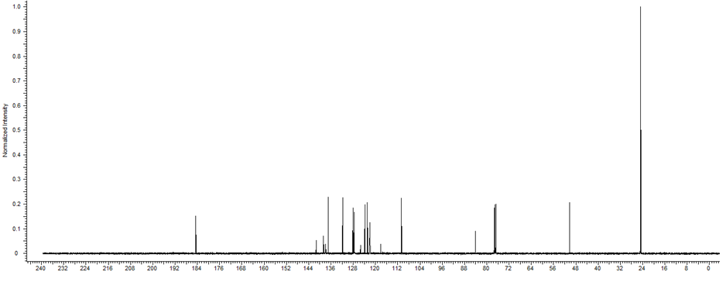

Characterization of radiolabelled compounds
¹⁸F KAM001
Radiolabeling of BpinKAM001
Cold Standard Profile:
Total Ion Count (Mass selected in pink for 254)
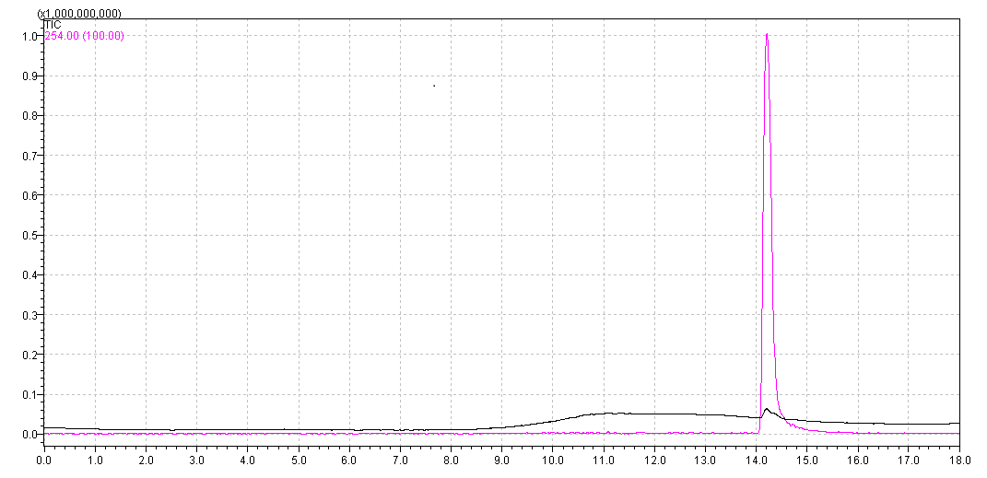
Mass Spectrum
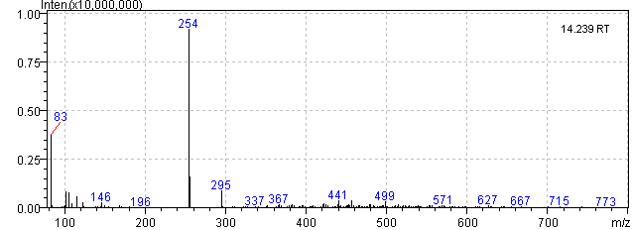
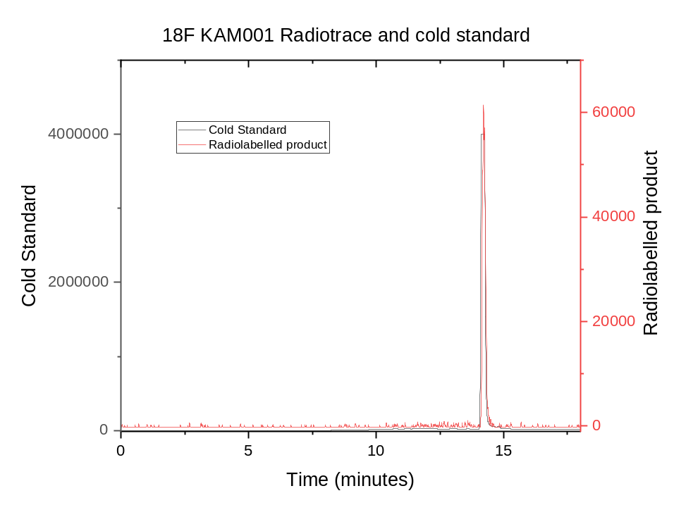
Example of separation radiochromatogram of ¹⁸F KAM001
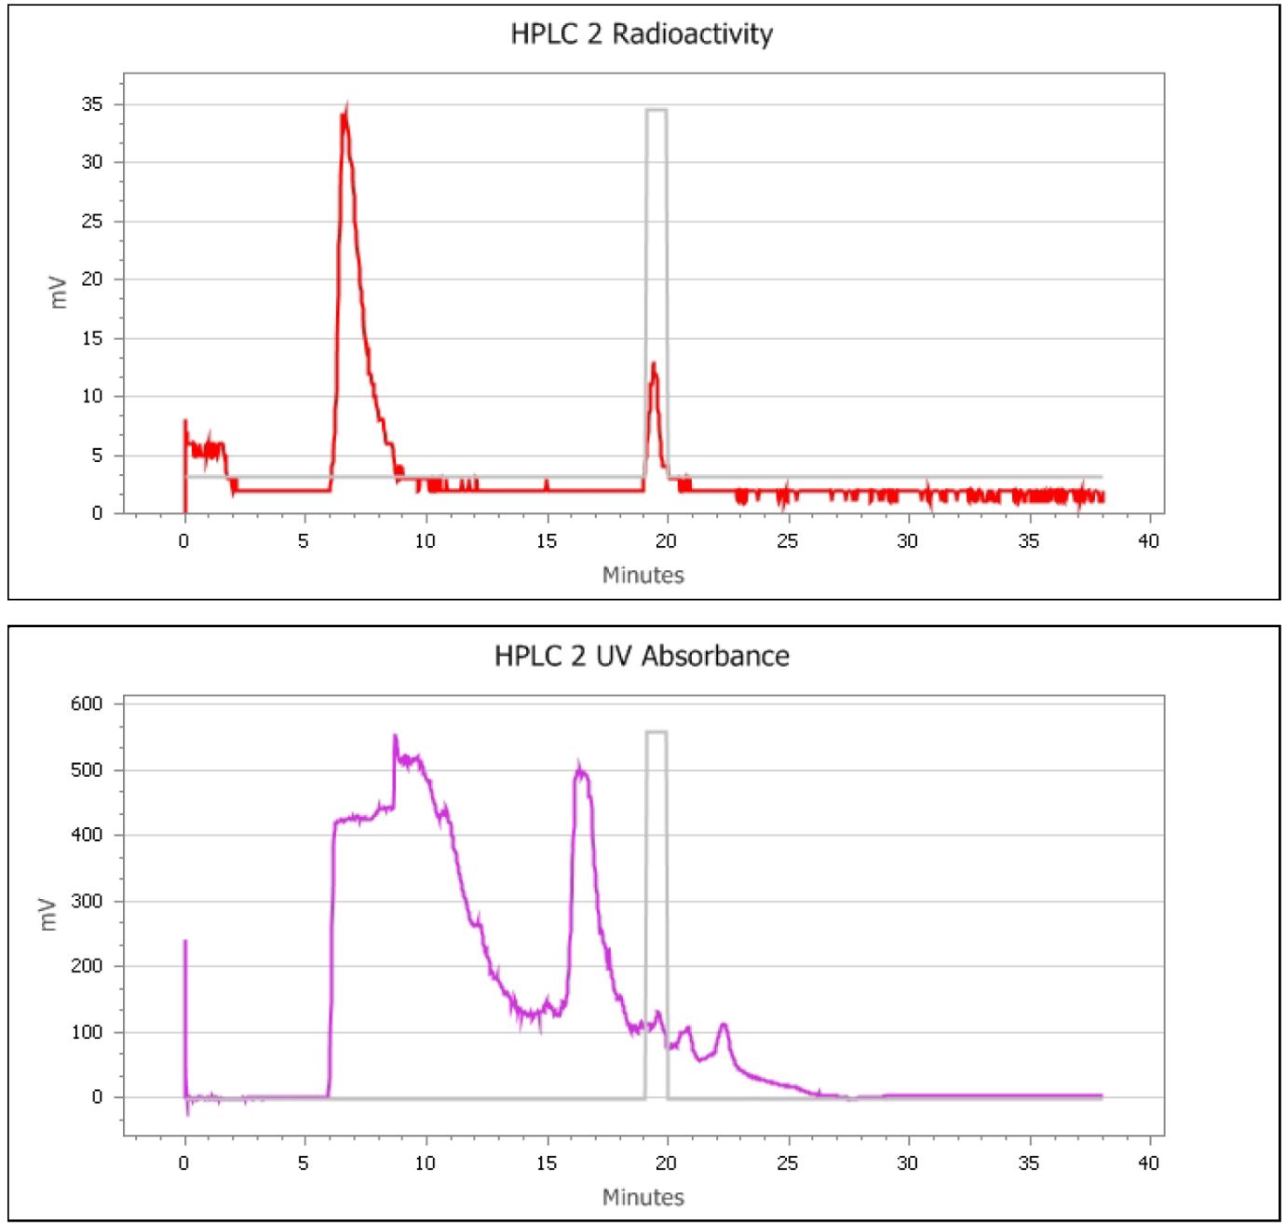

Radiolabelling of BpinKAM002
Cold Standard Profile:
Total Ion Count (Mass selected in pink for 254)
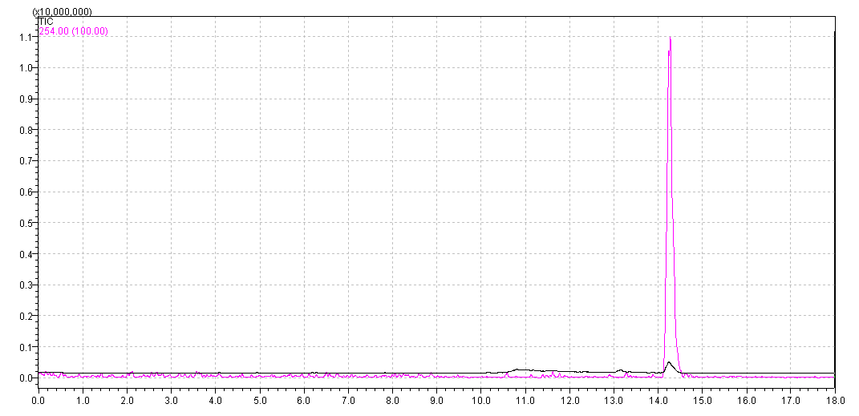
Mass spectrum
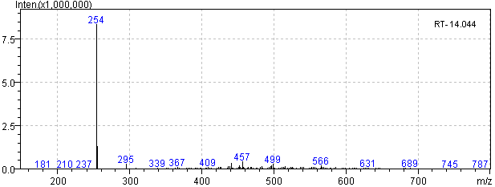

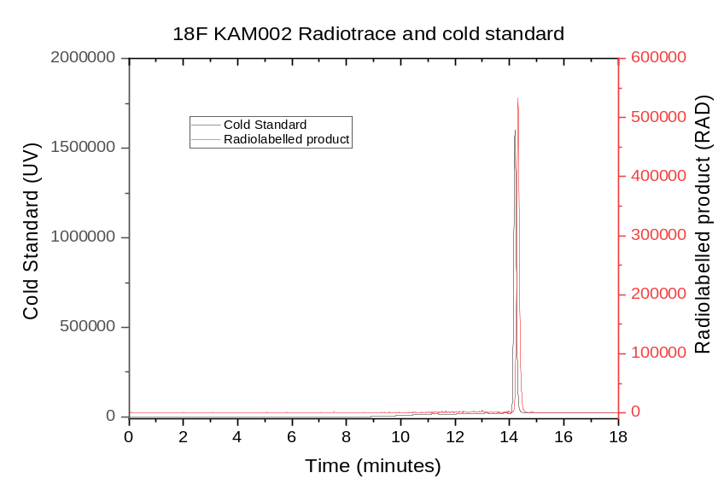

Example of separation radiochromatogram of ¹⁸F KAM002
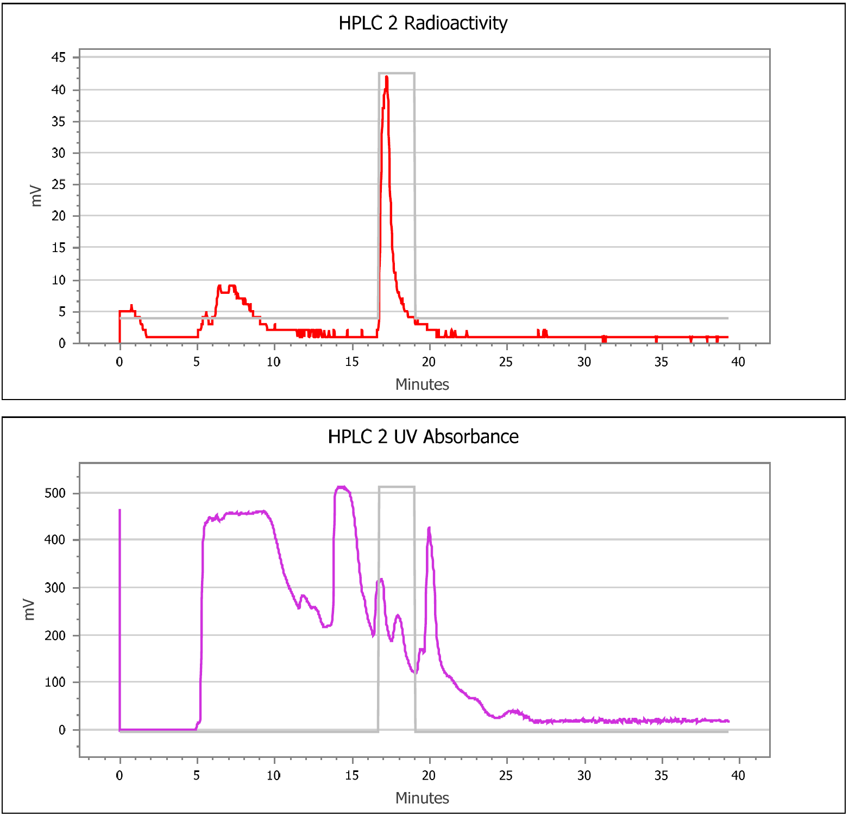
Molar activity of isolated radioactive products.
Molar activity was determined by measurement of the UV absorbance of a known amount of radioactivity under identical analytical HPLC conditions used to generate a calibration curve for the corresponding nonradioactive standard.

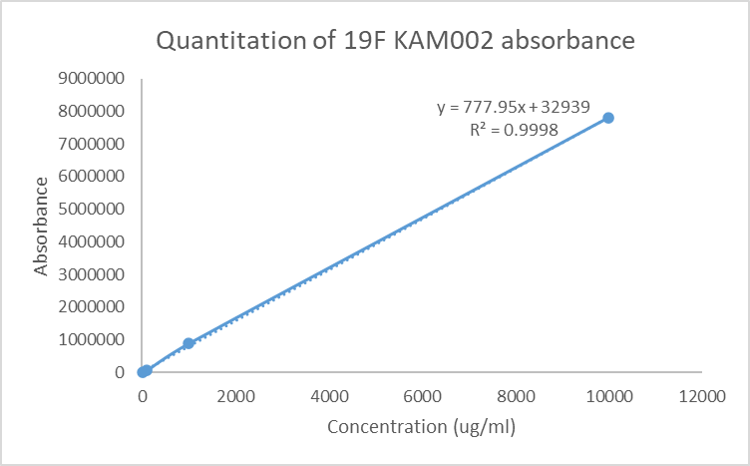

Radiolabelling of BpinKAM003
Cold Standard Prolfile:
Total Ion Count (Mass selected in pink for 254)
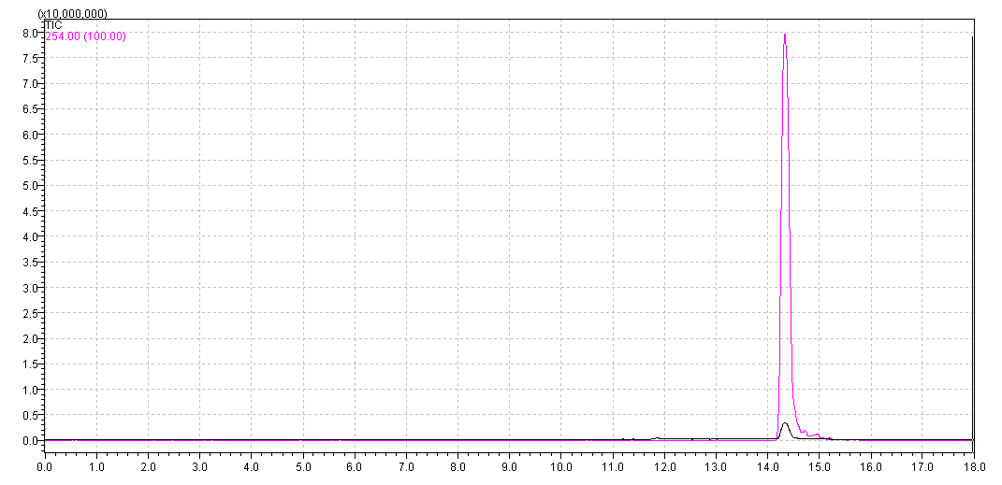
Mass spectrum
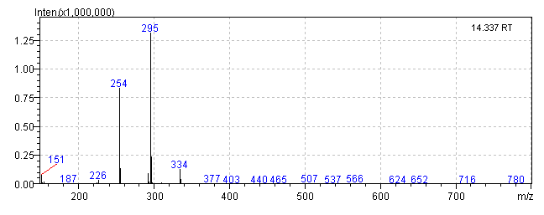
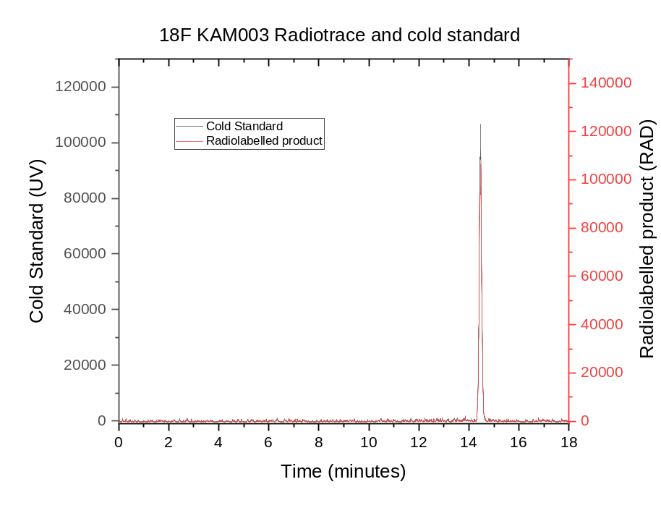

Example of separation radiochromatogram of ¹⁸F KAM003
