Supplementary data

General
Solvents and reagents other than boron containing compounds were purchased from Sigma Aldrich and used without further purification. Boron compounds were purchased from Advanced Molecular Technologies and used without further purification.
Sodium hydride coupling reaction
Sodium hydride (60%, 97mg, 2.4mmol) was washed with petroleum spirits (20ml) twice before addition of a chilled solution of indole 3 carboxaldehyde (200mg, 1.37 mmol) in THF (20ml) to afford a pink coloured solution. The desired benzyl bromide (1.57 mmol) was added to the solution, with the ice bath being removed 5 minutes after this addition. This reaction mixture was stirred at room temperature overnight before termination of the reaction by removal of solvent under vacuum. The resultant residue was then redissolved in 30ml of diethyl ether and washed with saturated sodium bicarbonate (2x 50ml) and distilled water (2x 50ml). The organic layer was then dried onto silica for column chromatography. Fractions were combined and concentrated under reduced pressure to afford the product. Crystals were grown either through evaporation from dicholormethane or vapour diffusion methods from either ethyl acetate, ethanol, or methanol with petroleum spirits.
Yields of compounds using

Miyarua borylation
A flask was charged with N-(4-iodobenzyl)-indole-3-carbaldehyde (500mg, 1.38mmol), potassium acetate (407mg, 4.14 mmol), bispinacolato diborane (1.75g, 6.9mmol) and palladium dichloride diphenyl phosphine ferrocene catalyst (30mg, 0.04mmol). The mixture was dissolved in 20ml of DMF and heated to 70°C for 3 hours before being diluted into 300ml of water and extracted 3 times with dichloromethane. The organics were combined and then dried onto silica for column chromatography. Fractions were combined and concentrated under reduced pressure to yield a mass of 360mg (72%)

Characterization of compounds
Structure
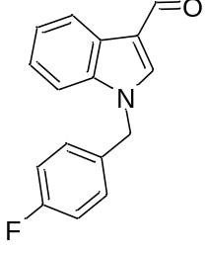
Identifier - KAM001
Mass Spec
Chemical Formula: C16H12FNO
Exact Mass: 253.09029
Molecular Weight: 253.27098

Calculated Mass (M +H) 254.09757
Observed Mass (M +H) 254.09747
¹H NMR (CDCl₃, 600 MHz) δ 5.34 (s, 2 H), 7.05 (t, J = 8.64 Hz, 2 H), 7.17 (dd, J = 8.57, 5.20 Hz, 2 H), 7.29 - 7.37 (m, 3 H), 7.71 (s, 1 H), 8.27 - 8.42 (m, 1 H), 10.02 (s, 1 H)
¹³C NMR: CDCl₃, 600 MHz 50.3, 110.2, 116.1, 116.2, 122.2, 123.1, 124.2, 128.9, 129.0, 138.1, 184.5

Melting Point 114.1-116.3 °C
Crystal Structure:
Link:

High Resolution Mass Spectrometry of KAM001
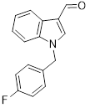
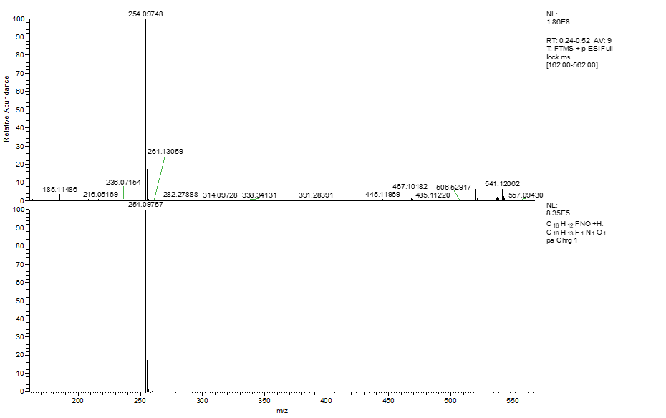

¹H NMR of KAM001

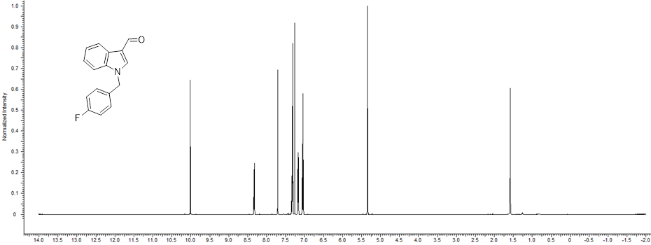

¹³C NMR of KAM001

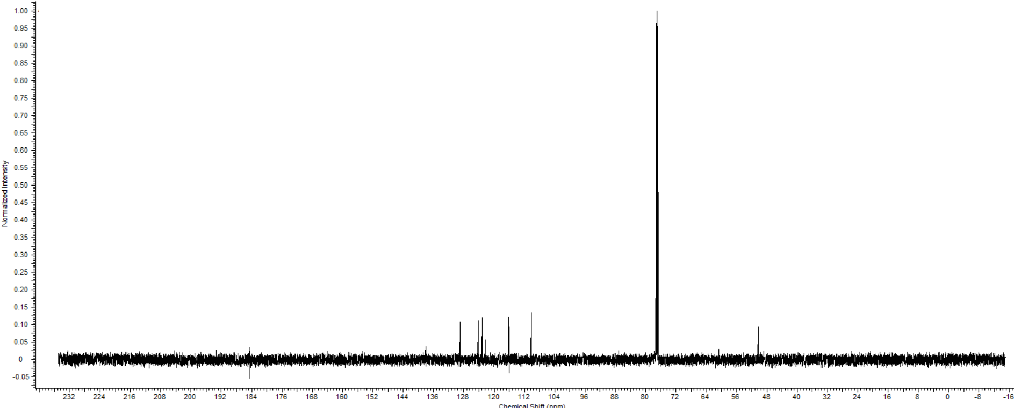
Structure
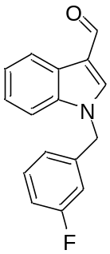
Identifier - KAM002
Mass Spec
Chemical Formula: C16H12FNO
Exact Mass: 253.09029
Molecular Weight: 253.27098

Calculated Mass (M +H) 254.09757
Observed Mass (M +H) 254.09747

¹H NMR (CDCl₃, 600 MHz) δ 10.03 (s, 1H), 8.15 - 8.55 (m, 1H), 7.74 (s, 1H), 7.23 - 7.45 (m, 5H), 6.70 - 7.12 (m, 3H), 5.37 (s, 2H)

¹³C NMR: δ: 50.4, 110.2, 114.0, 114.1, 115.3, 115.5, 118.7, 122.2, 122.6, 123.2, 124.3, 125.5, 130.7, 130.8, 137.3, 137.9, 138.3, 162.3, 163.9, 184.6

Melting Point 109.4-112.3 °C
Crystal Structure
Link:
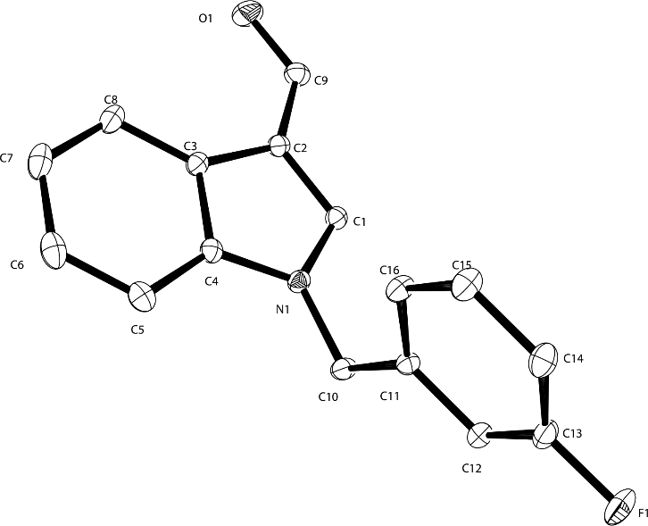

High Resolution Mass Spectrometry of KAM002
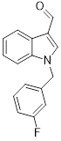
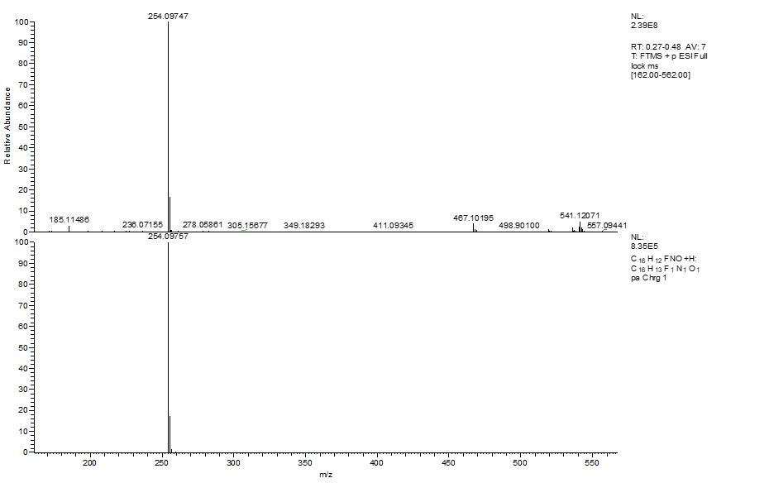

¹H NMR of KAM002

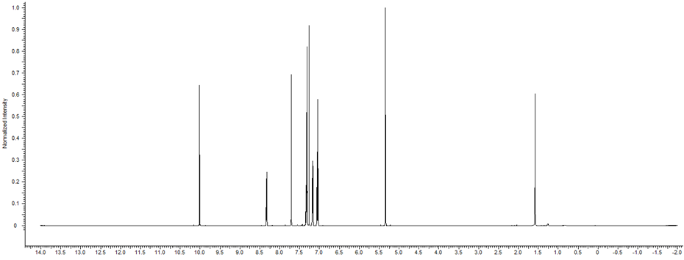

¹³C NMR of KAM002

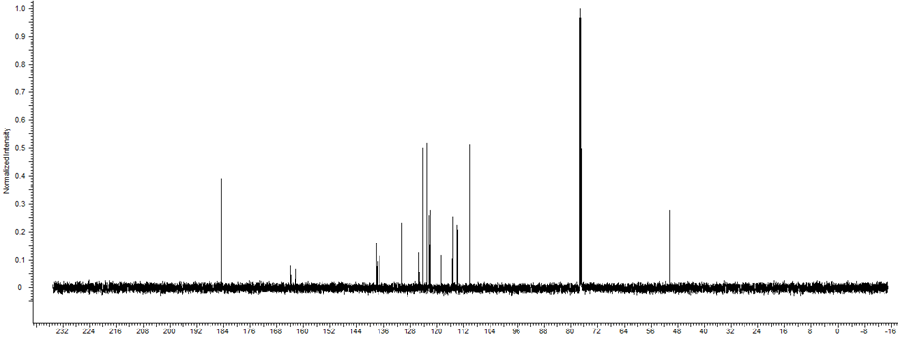

Structure
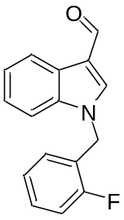
Identifier - KAM003
Mass Spec
Chemical Formula: C16H12FNO
Exact Mass: 253.09029
Molecular Weight: 253.27098

Calculated Mass (M + H) 254.09029
Observed Mass (M + H ) 254.09753
¹H NMR
(CDCl₃, 400 MHz) δ 9.88 - 10.08 (m, 1H), 8.20 - 8.45 (m, 1H), 7.77 (s, 1H), 7.36 - 7.44 (m, 1H), 7.28 - 7.36 (m, 3H), 7.00 - 7.18 (m, 3H), 5.41 (s, 2H)
¹³C NMR: δ:

Melting Point 98.0-100.5°C
Crystal Structure:
Link:

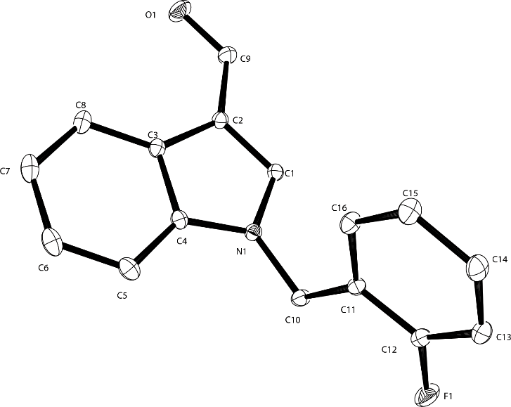

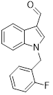
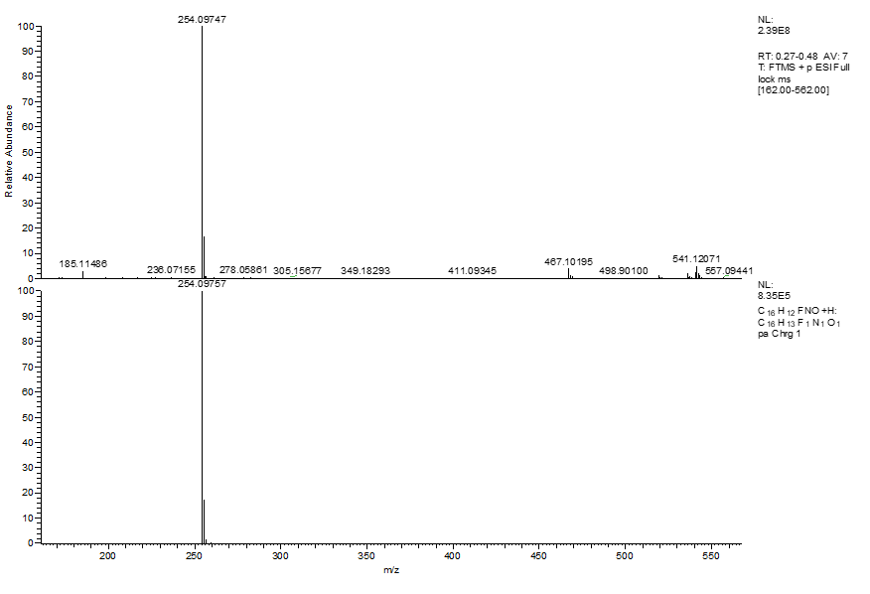

¹H NMR of KAM003

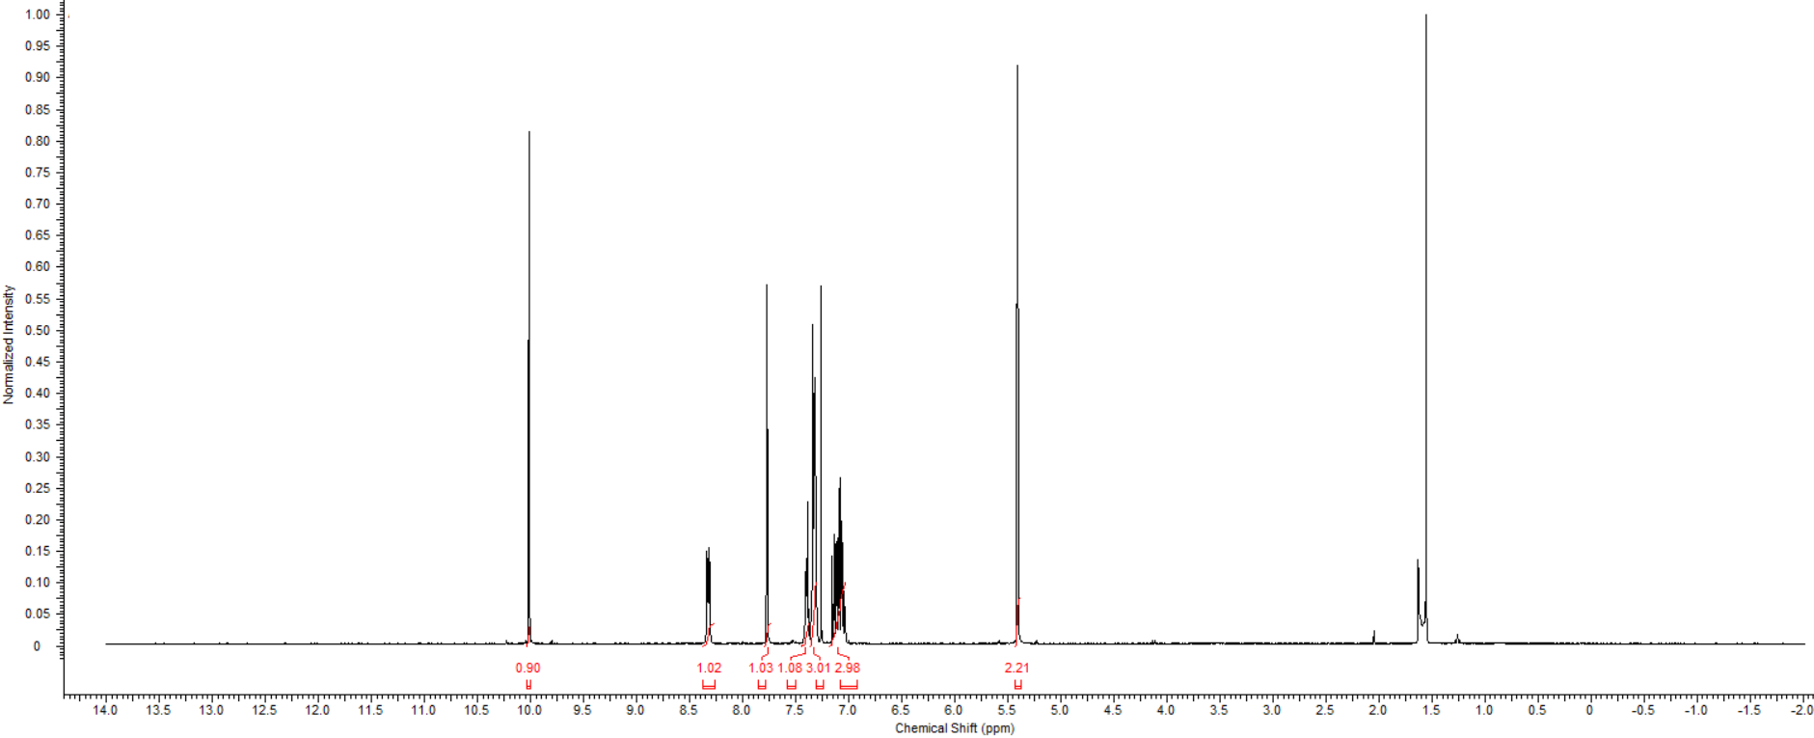

¹³C NMR of KAM003
Structure
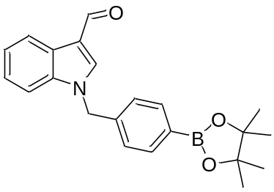
Identifier – BpinKAM001
1-(4-(4,4,5,5-tetramethyl-1,3,2-dioxaborolan-2-yl)benzyl)-1H-indole-3-carbaldehyde

Mass Spec
Chemical Formula: C22H24BNO3
Exact Mass: 361.24186
Molecular Weight: 361.18492

Observed Mass (M + H )
¹H NMR :
(CDCl₃, 400 MHz) δ 10.00 (s, 1H), 8.33 (d, J = 6.65 Hz, 1H), 7.79 (d, J = 7.83 Hz, 2H), 7.70 (s, 1H), 7.27 - 7.35 (m, 3H), 7.19 (d, J = 7.83 Hz, 2H), 5.37 (s, 2H), 1.33 (s, 12H)
¹³C NMR:
(CDCl₃, 101 MHz) δ 184.6, 138.4, 138.2, 137.4, 135.5, 126.5, 125.5, 124.2, 123.1, 122.2, 110.3, 84.0, 51.1, 30.9, 24.8

Crystal structure:
Link:

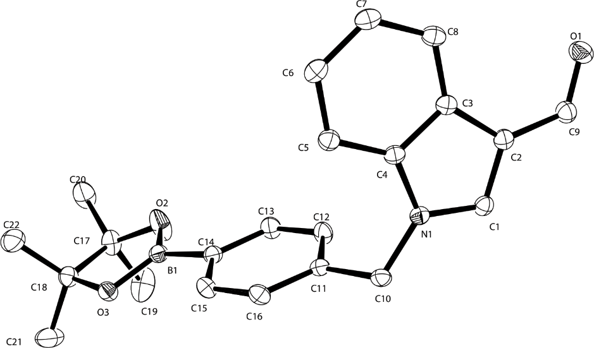

¹H NMR of BpinKAM001

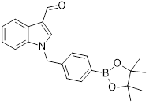
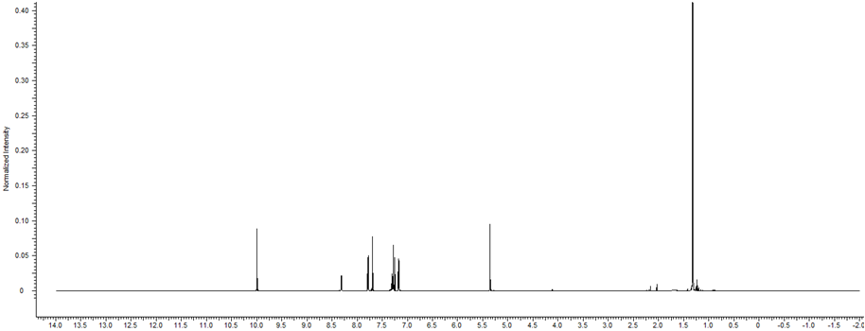

¹³C NMR of BpinKAM001

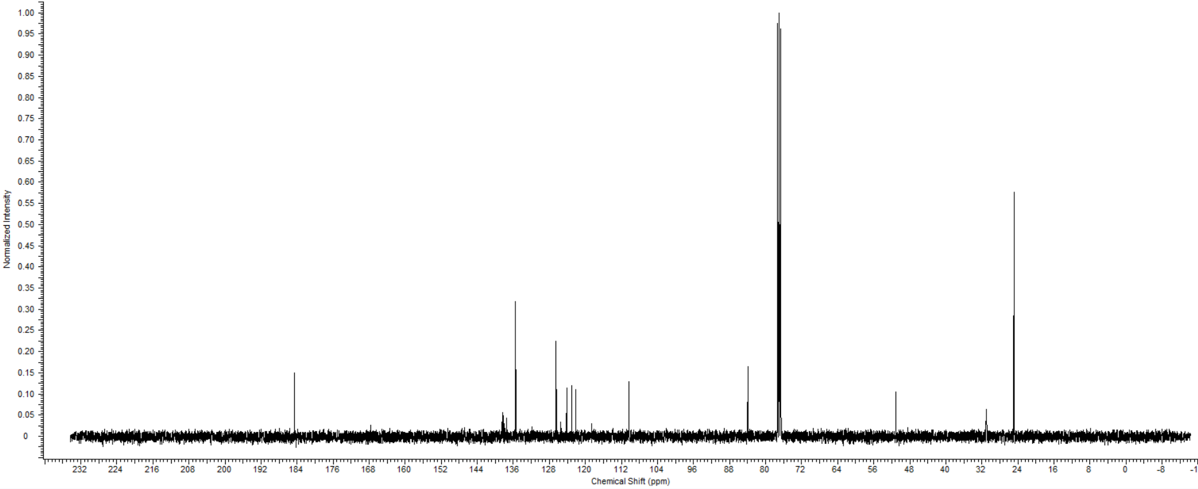

Structure
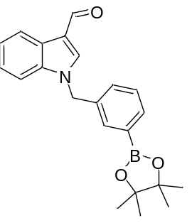
Identifier – BpinKAM002
1-(3-(4,4,5,5-tetramethyl-1,3,2-dioxaborolan-2-yl)benzyl)-1H-indole-3-carbaldehyde

Mass Spec
Chemical Formula: C22H24BNO3
Exact Mass: 361.24186
Molecular Weight: 361.18492

Observed Mass (M + H )
¹H NMR :
(CDCl₃, 400 MHz) δ 10.00 (s, 1 H), 8.31 (s, 1 H), 7.82 - 7.74 (m, 2 H), 7.41 - 7.27 (m, 4 H), 7.21 (s, 1 H), 5.34 (s, 2 H), 1.35 (s, 12 H)
¹³C NMR:
(CDCl₃, 101 MHz) δ 184.96, 138.42, 137.47, 134.90, 134.46, 133.88, 130.20, 128.59, 125.53, 124.10, 123.04, 122.12, 118.45, 110.36, 84.09, 50.94

Crystal Structure
Link:
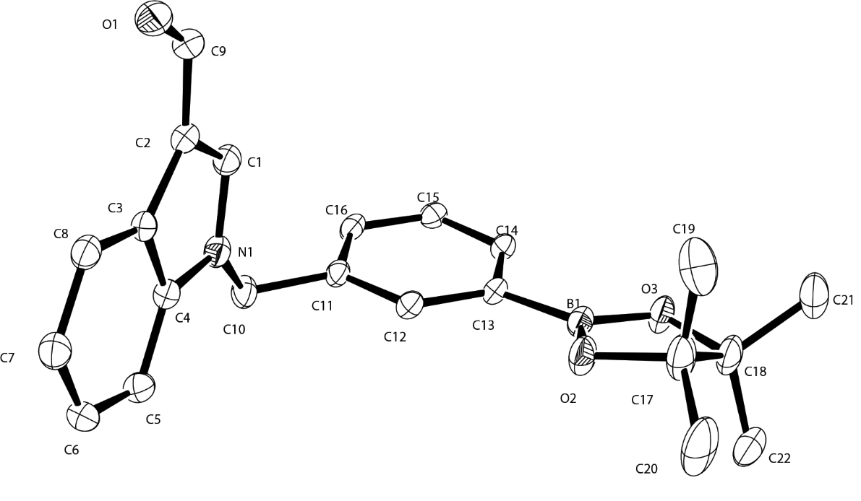

¹H NMR of BpinKAM002

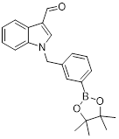
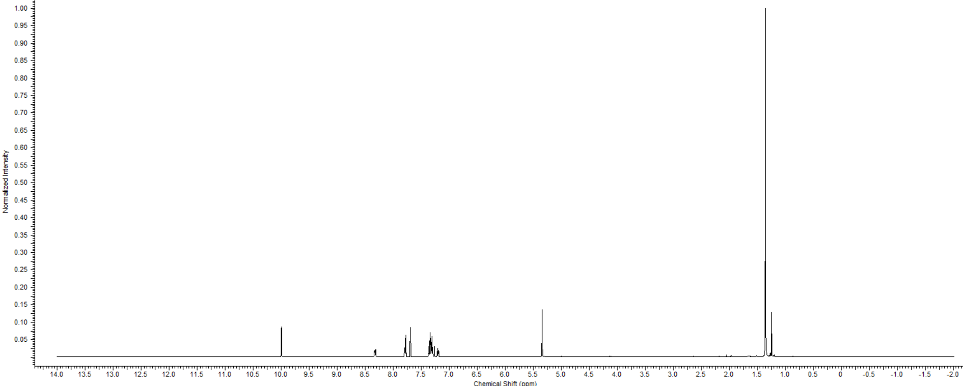

¹³C NMR of BpinKAM002

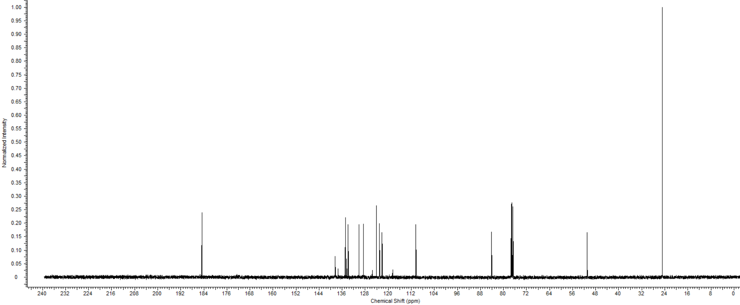

Structure
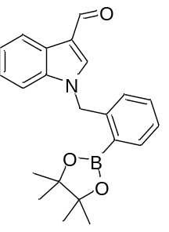
Identifier – BpinKAM003
1-(2-(4,4,5,5-tetramethyl-1,3,2-dioxaborolan-2-yl)benzyl)-1H-indole-3-carbaldehyde
Mass Spec
Chemical Formula: C22H24BNO3
Exact Mass: 361.24186
Molecular Weight: 361.18492

Observed Mass (M + H )
¹H NMR :
(CDCl₃, 400 MHz) δ 9.94 (s, 2 H), 8.39 - 8.28 (m, 2 H), 7.96 (d, J = 6.7 Hz, 2 H), 7.59 (s, 2 H), 7.47 - 7.24 (m, 11 H), 7.01 (d, J = 7.0 Hz, 2 H), 1.23 (s, 12 H)
¹³C NMR:
(CDCl₃, 101 MHz) δ 184.6, 141.3, 137.9, 131.8, 128.1, 127.7, 125.4, 123.4, 122.0, 118.1, 110.7, 84.0, 77.3, 77.0, 76.7, 50.3, 24.7

Crystal Structure
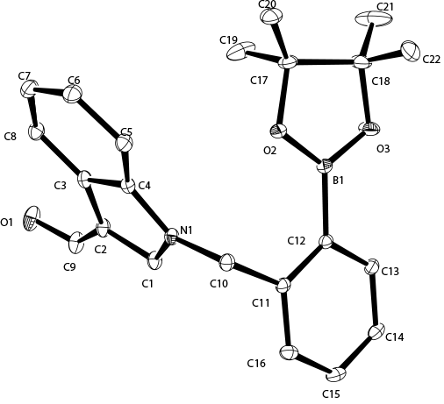
Link:

¹H NMR of BpinKAM003

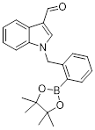
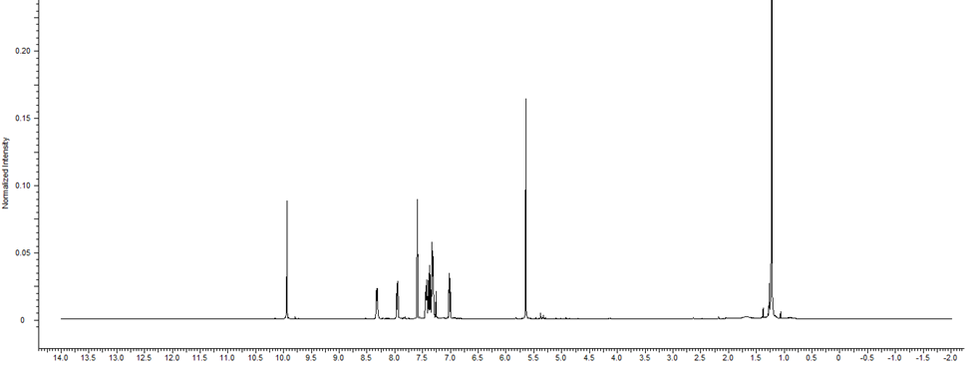

¹³C NMR of BpinKAM003

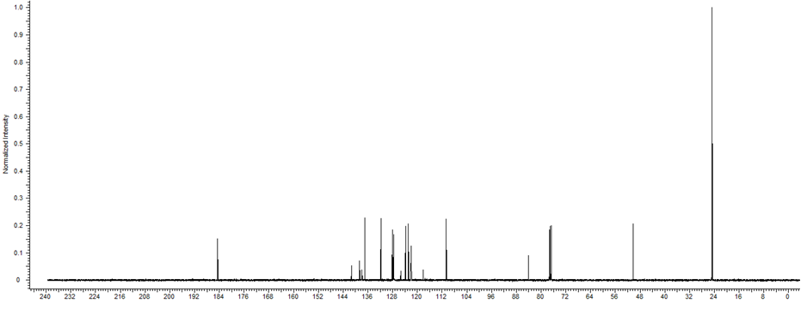

Characterization of radiolabelled compounds
¹⁸F KAM001
Radiolabeling of BpinKAM001
Cold Standard Profile:
Total Ion Count (Mass selected in pink for 254)
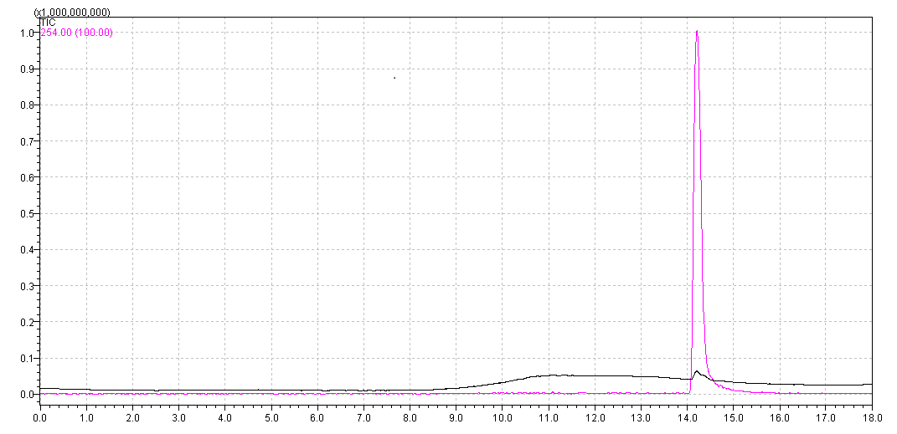
Mass Spectrum
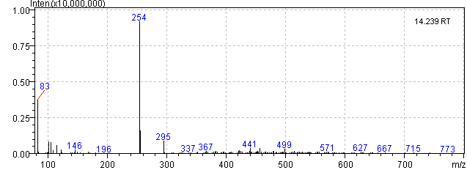
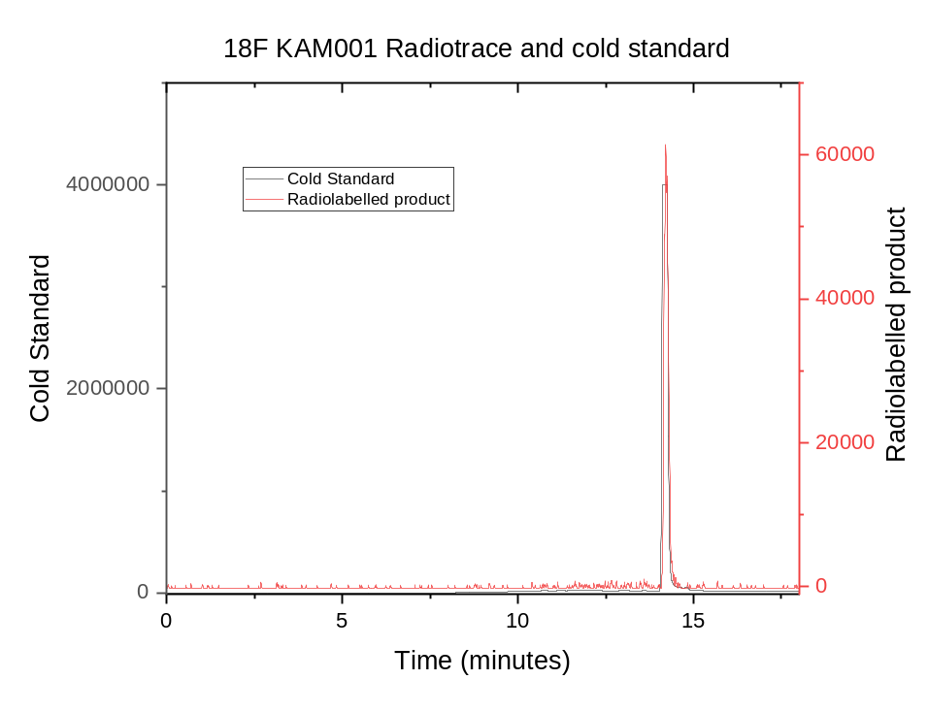
Radiolabelling of BpinKAM002
Cold Standard Profile:
Total Ion Count (Mass selected in pink for 254)
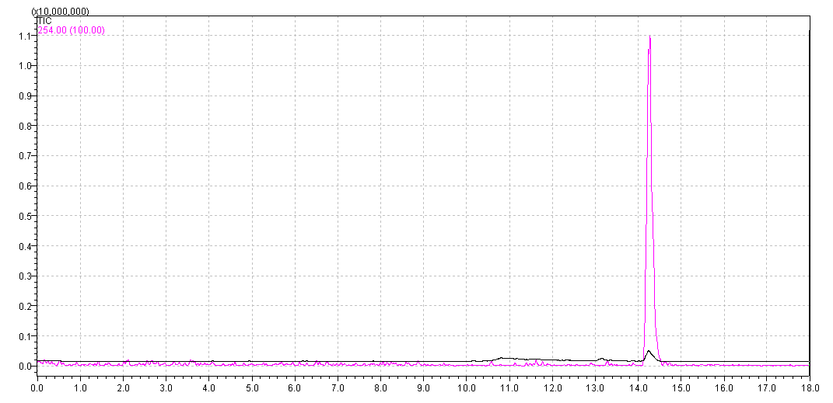
Mass spectrum
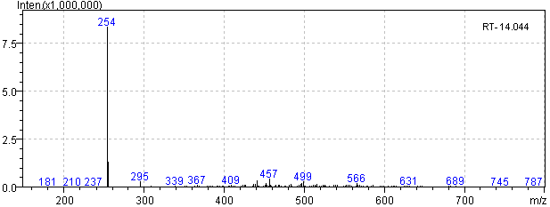

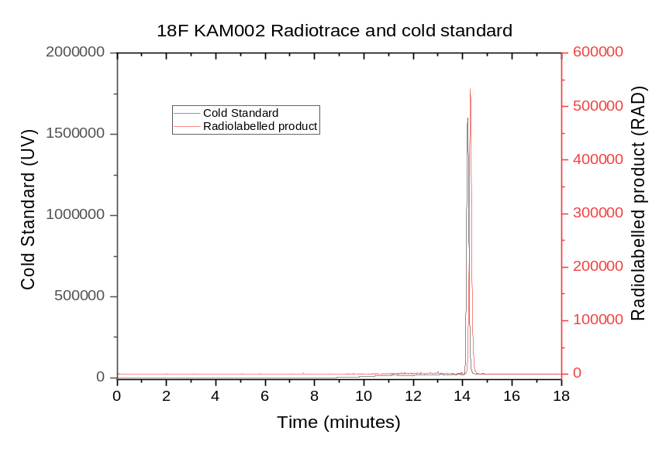

Radiolabelling of BpinKAM003
Cold Standard Prolfile:
Total Ion Count (Mass selected in pink for 254)
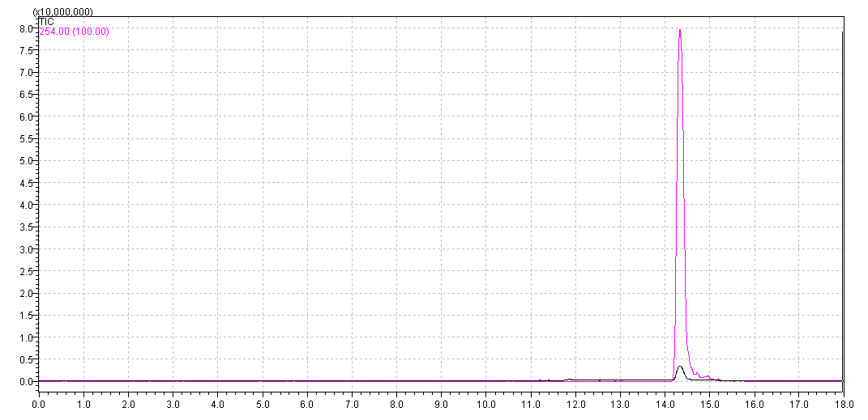
Mass spectrum
