Supplementary Table 1: Characteristics of data entries separated by cognitive status
Characteristic | Dementia severity
Characteristic | Normal cognition | Impaired-not-MCI | MCI | Dementia
Number of Entries | 76502 | 7302 | 28385 | 51593
Age (years old), mean (SD) | 74 (10) | 74 (10) | 76 (10) | 76 (11)
Female, n (%) | 49944 (65.3%) | 4123 (56.5%) | 14475 (51.0%) | 26221 (50.8%)
Education (years), mean (SD) | 16 (6) | 15 (5) | 16 (6) | 15 (8)
Race, n (%)
White | 62443 (81.6%) | 5654 (77.4%) | 22745 (80.1%) | 44099 (85.5%)
Black/African American | 11005 (14.4%) | 1200 (16.4%) | 4164 (14.7%) | 4742 (9.2%)
American Indian/Alaskan Native | 418 (0.5%) | 43 (0.6%) | 180 (0.6%) | 339 (0.7%)
Native Hawaiian/Pacific Islander | 44 (0.1%) | 7 (0.1%) | 15 (0.1%) | 64 (0.1%)
Asian | 1939 (2.5%) | 163 (2.2%) | 812 (2.9%) | 1054 (2.0%)
Other/multiracial/unknown | 653 (0.9%) | 235 (3.2%) | 469 (1.7%) | 1295 (2.5%)
Hispanic ethnicity, n (%) | 4191 (5.5%) | 711 (9.7%) | 2161 (7.6%) | 3975 (7.7%)
>= 1 APOE e4 allele, n (%) | 20236 (29.6%) | 1894 (25.9%) | 9473 (33.4%) | 22427 (43.5%)

Supplementary Table 2: Predictive performance of the two-feature models (age + standard global CDR)
AUC-ROC  (95% CI) | AUC-PR  (95% CI) | Accuracy  (95% CI) | AUC-ROC  (95% CI) | AUC-PR  (95% CI)
0.804  (0.799-0.824) | 0.240  (0.215-0.264) | 0.785 | 0.853 | 0.277
0.787  (0.778-0.795) | 0.494  (0.475-0.518) | 0.777 | 0.808 | 0.482
0.774  (0.764-0.781) | 0.643  (0.627-0.658) | 0.732 | 0.772 | 0.577
0.768  (0.750-0.770) | 0.865  (0.854-0.875) | 0.656 | 0.714 | 0.636

Supplementary Table 3: Variables and their descriptors. Variable names and their corresponding descriptors according to the NACC UDS Researcher’s Data Dictionary.
Variable Name | Descriptor
ANIMALS | Animals — Total number of animals named in 60 seconds
BPDIAS | Subject blood pressure (sitting), diastolic
CDRGLOB | Global CDR
CDRLANG | Language
CDRSUM | Standard CDR sum of boxes
COGVIS | Indicate whether the subject currently is meaningfully impaired, relative to previously attained abilities, in visuospatial function
COMMUN | Community affairs
CVCHF | Congestive heart failure
EDUC | Years of education
ENERGY | Do you feel full of energy?
HEIGHT | Subject’s height (inches)
HISPANIC | Hispanic/Latino ethnicity
HOMEHOBB | Home and hobbies
HRATE | Subject resting heart rate (pulse)
HYPERCHO | Hypercholesterolemia
HYPERTEN | Hypertension
INCONTU | Incontinence — urinary
INDEPEND | Level of independence
MMSELAN | Language of MMSE administration
MOMODE | Mode of onset of motor symptoms
MOSLOW | Indicate whether the subject currently has meaningful changes in motor function — Slowness
NACCADC | ADC at which subject was seen
NACCAGE | Subject’s age at visit
NACCBMI | Body mass index (BMI)
NACCETPR | Primary etiologic diagnosis (MCI; impaired, not MCI; or dementia)
NACCGDS | Total GDS Score
NACCMMSE | Total MMSE score (using D-L-R-O-W)
NACCMOTF | Indicate the predominant symptom that was first recognized as a decline in the subject’s motor function
NACCNIHR | Derived NIH race definitions
ORIENT | Orientation
PERSCARE | Personal care
RESIDENC | Type of residence
SEX | Subject’s sex
SHOPPING | In the past four weeks, did the subject have any difficulty or need help with: Shopping alone for clothes, household necessities, or groceries
SMOKYRS | Total years smoked cigarettes
STOVE | In the past four weeks, did the subject have any difficulty or need help with: Heating water, making a cup of coffee, turning off the stove
TOBAC100 | Smoked more than 100 cigarettes in life
TRAILA | Trail Making Test Part A — Total number of seconds to complete
TRAILB | Trail Making Test Part B — Total number of seconds to complete
TRAILBRR | Part B — Number of commission errors
TRAVEL | In the past four weeks, did the subject have any difficulty or need help with: Traveling out of the neighborhood, driving, or arranging to take public transportation
VEG | Vegetables — Total number of vegetables named in 60 seconds
WEIGHT | Subject’s weight (lbs)

Supplementary Table 4: List of final hyperparameters. Hyperparameters used in (A) the two-feature models (age + standard global CDR), (B) the multi-factorial models, and (C) the dementia type models. All hyperparameters were selected through fifty rounds of Bayesian optimization with five-fold cross validation, with the exception of the ‘scale_pos_weight’ parameter, which was manually set to the ratio between the number of samples in the negative class (survival) and the number of samples in the positive class (mortality) for the given dataset. All other unspecified values were initialized to the default values of the XGBoost algorithm.
A)
Hyperparameter | One-Year Survival Model | Three-Year Survival Model | Five-Year Survival Model | Ten-Year Survival Model
Number of trees (n_estimators) | 211 | 214 | 146 | 234
Maximum depth (max_depth) | 2 | 2 | 2 | 2
Learning rate (learning_rate) | 0.2 | 0.143 | 0.030 | 0.106
Percentage of features used per tree (colsample_bytree) | 1.0 | 0.796 | 0.913 | 1.0
Percentage of samples used per tree (subsample) | 1.0 | 0.344 | 0.377 | 0.2
Minimum sum of instance weight needed per child (min_child_weight) | 25 | 17 | 16 | 8
Gamma regularization parameter (gamma) | 0.01 | 1.623 | 0.596 | 0.01
Balance between positive and negative weights (scale_pos_weight) | 15.081 | 3.862 | 1.872 | 0.476

B)
Hyperparameter | One-Year Survival Model | Three-Year Survival Model | Five-Year Survival Model | Ten-Year Survival Model
Number of trees (n_estimators) | 101 | 226 | 264 | 299
Maximum depth (max_depth) | 3 | 5 | 9 | 8
Learning rate (learning_rate) | 0.019 | 0.022 | 0.012 | 0.046
Percentage of features used per tree (colsample_bytree) | 0.470 | 0.824 | 0.815 | 0.619
Percentage of samples used per tree (subsample) | 0.325 | 0.865 | 0.764 | 0.665
Minimum sum of instance weight needed per child (min_child_weight) | 11 | 20 | 20 | 7
Gamma regularization parameter (gamma) | 3.492 | 0.398 | 1.947 | 1.075
Balance between positive and negative weights (scale_pos_weight) | 15.081 | 3.862 | 1.872 | 0.476

C)
Hyperparameter | No Dementia | AD | Unknown | FTLD | LBD | VBI | Other | Dep
Number of trees (n_estimators) | 78 | 107 | 214 | 148 | 141 | 218 | 126 | 146
Maximum depth (max_depth) | 10 | 7 | 3 | 10 | 10 | 10 | 2 | 8
Learning rate (learning_rate) | 0.043 | 0.065 | 0.054 | 0.01 | 0.01 | 0.01 | 0.100 | 0.019
Percentage of features used per tree (colsample_bytree) | 0.219 | 0.561 | 0.650 | 0.2 | 0.2 | 1.0 | 0.218 | 0.735
Percentage of samples used per tree (subsample) | 0.968 | 0.914 | 0.838 | 1.0 | 1.0 | 1.0 | 0.522 | 0.538
Minimum sum of instance weight needed per child (min_child_weight) | 24 | 9 | 13 | 8 | 25 | 22 | 15 | 16
Gamma regularization parameter (gamma) | 1.009 | 0.163 | 1.640 | 0.01 | 0.01 | 0.01 | 0.751 | 5.691
Balance between positive and negative weights (scale_pos_weight) | 8.609 | 1.748 | 6.715 | 1.061 | 1.038 | 2.05 | 3.862 | 10.4

Supplementary Figure 1: Survival analysis of other diseases by standard global CDR. Kaplan-Meier estimator curves separated by standard global CDR and stratified by disease
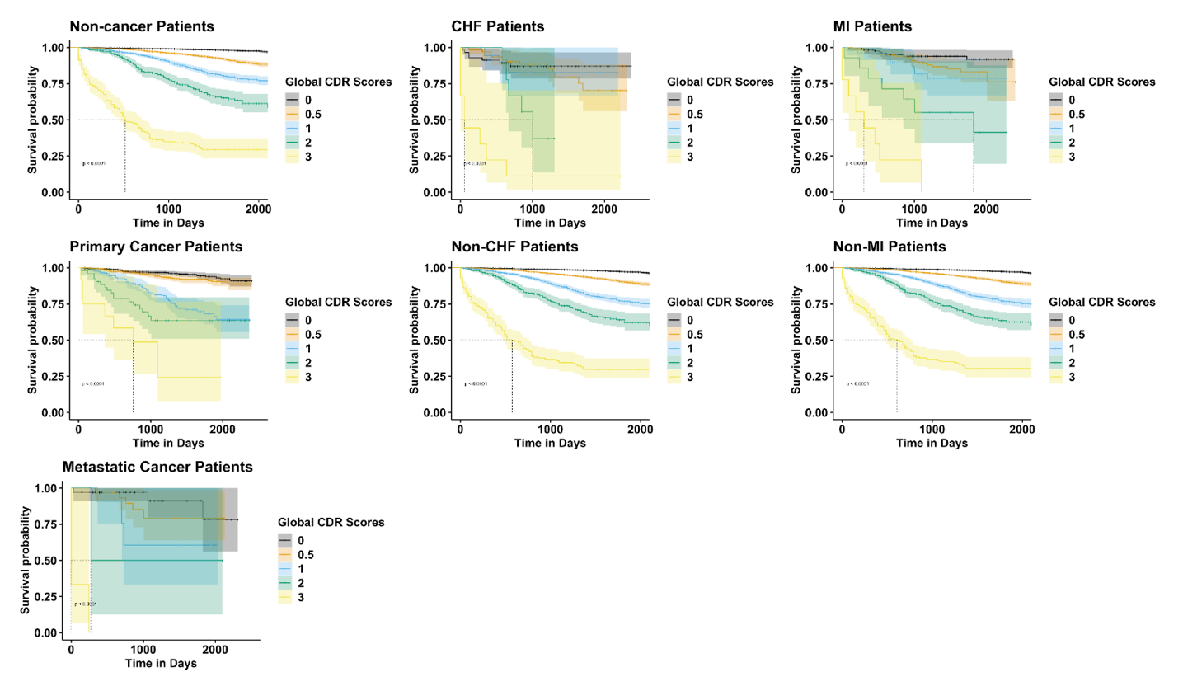

Supplementary Figure 2: Flowchart of data splitting. The diagram illustrates how the train/test set and validation set were split based on the setting of survival year.
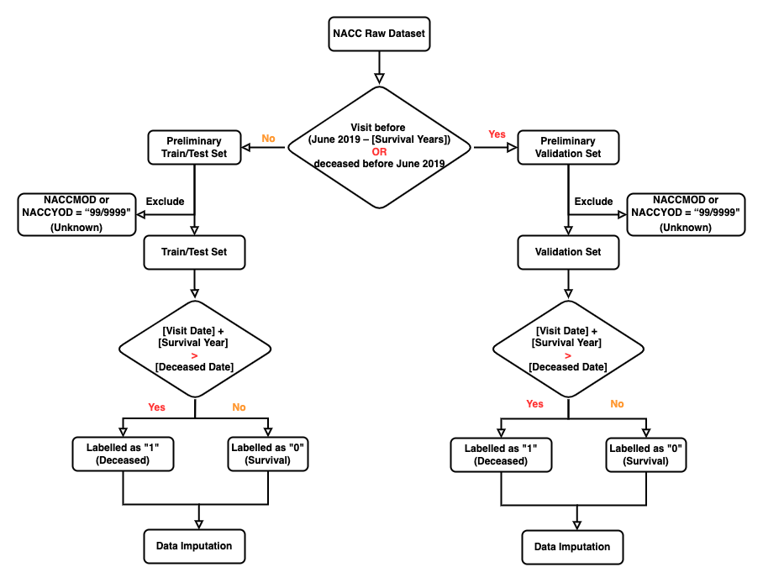

Supplementary Figure 3: Receiver operating characteristic curves of the two-feature models (age + standard global CDR). Receiver operating characteristic curves of (A) the one-year survival model, (B) the three-year survival model, (C) the five-year survival model, and (D) the ten-year survival model.
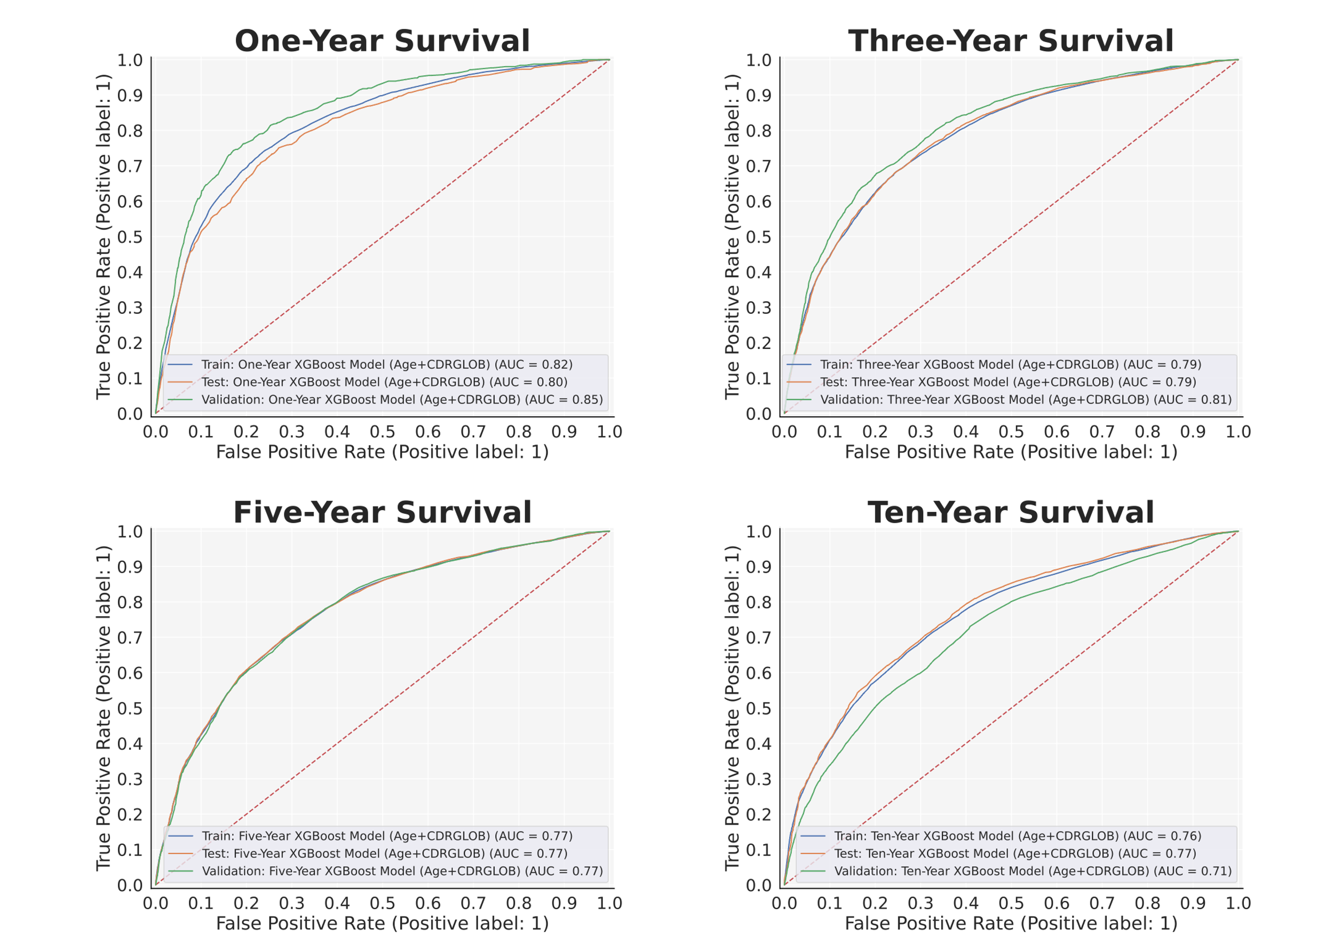

Supplementary Figure 4: Feature selection bar plots. SHapley Additive exPlanations (SHAP) bar plots of (A) the one-year survival model, (B) the three-year survival model, (C) the five-year survival model, and (D) the ten-year survival model in the training set. Features are ranked by mean absolute SHAP value. The top five features of each of the four models are shown.
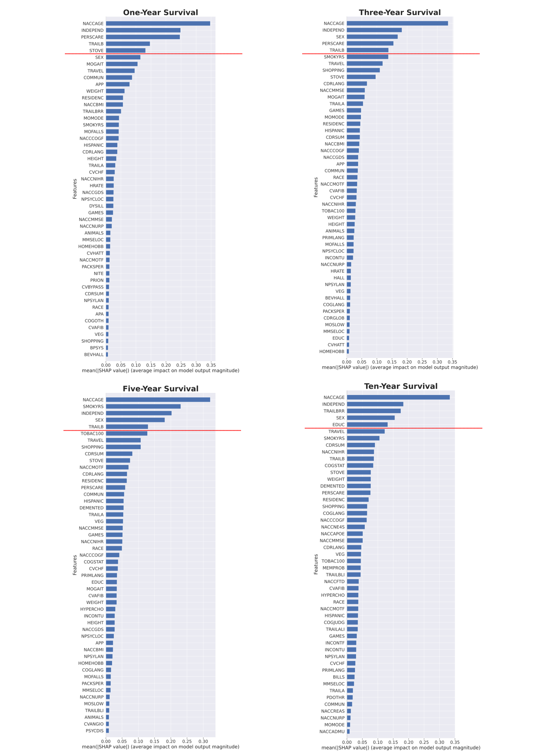

Supplementary Figure 5: Receiver operating characteristic curves of the multi-factorial models separated by Alzheimer’s disease center. Receiver operating characteristic curves stratified by Alzheimer’s disease center of (A) the one-year survival model, (B) the three-year survival model, (C) the five-year survival model, and (D) the ten-year survival model. The code corresponding to each Alzheimer’s disease center (ADC) is a randomly generated ID that replaces the actual ADC ID.
