Title
High quality long-read genomes produced from single MinION flow cells clarify polyploid and demographic histories of critically endangered ash species (Fraxinus: Oleaceae)

Authors
Steven J. Fleck^{1,*}, Crystal M. Tomlin¹, Flavio Augusto da Silva Coelho¹, Michaela Richter¹, Erik S. Danielsen², Nathan J C Backenstose¹, Trevor J Krabbenhoft¹, Charlotte Lindqvist¹, Victor A. Albert^{1,*}

1. Department of Biological Sciences, University at Buffalo, Buffalo, New York 14260, USA
2. Western New York Land Conservancy, East Aurora, NY 14052, USA
* Co-corresponding authors: sjfleck@buffalo.edu, vaalbert@buffalo.edu

Supplementary figures
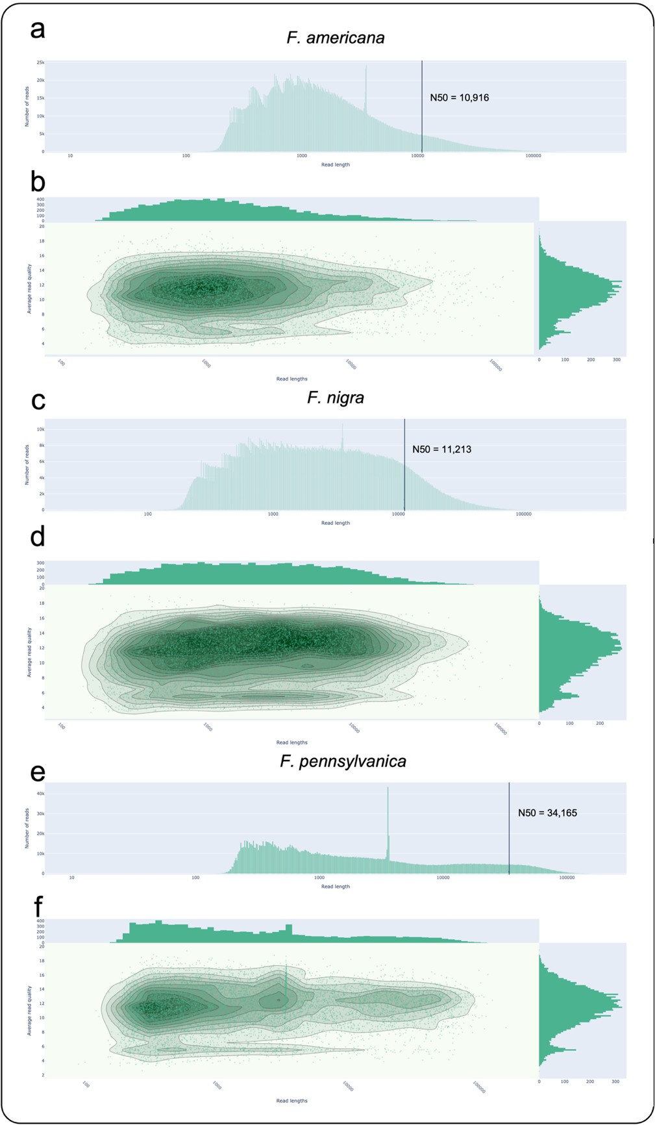
Figure S1: Raw read length and quality distributions for Fraxinus spp.. Histogram of read length after log transformation for Fraxinus americana (a), F. nigra (c), and F. pennsylvanica (e). Read N50 is marked on each histogram. Read length vs. average read quality using a kernel density estimation after log transformation of read lengths for F. americana (b), F. nigra (d), and F. pennsylvanica (f). Read length plot above and average quality score histogram to the right of the kernel density estimation plot.

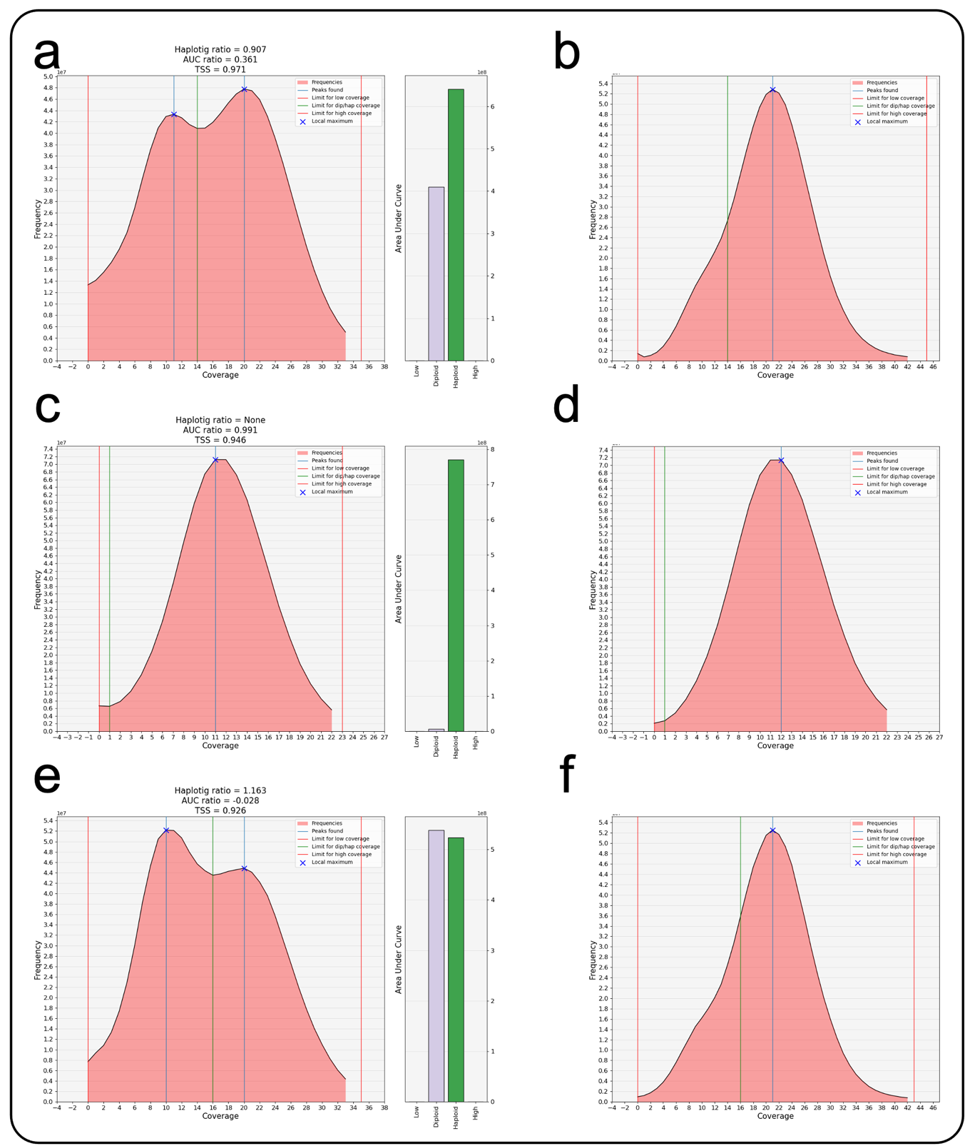
Figure S2: Haploidy assessment of Fraxinus genome assemblies before and after running Purge Haplotigs. F. americana before (a) and after Purge Haplotigs (b). F. nigra before (c) and after Purge Haplotigs (d). F. pennsylvanica before (e) and after Purge Haplotigs (f). AUC ratio = 1 - (D/H); TSS = 1 - (abs(G - (H + D/2)) / G ). Abbreviations: AUC = area under curve, D = diploid area under curve, H = haploid area under curve, TSS = total size score, G = estimated genome size.

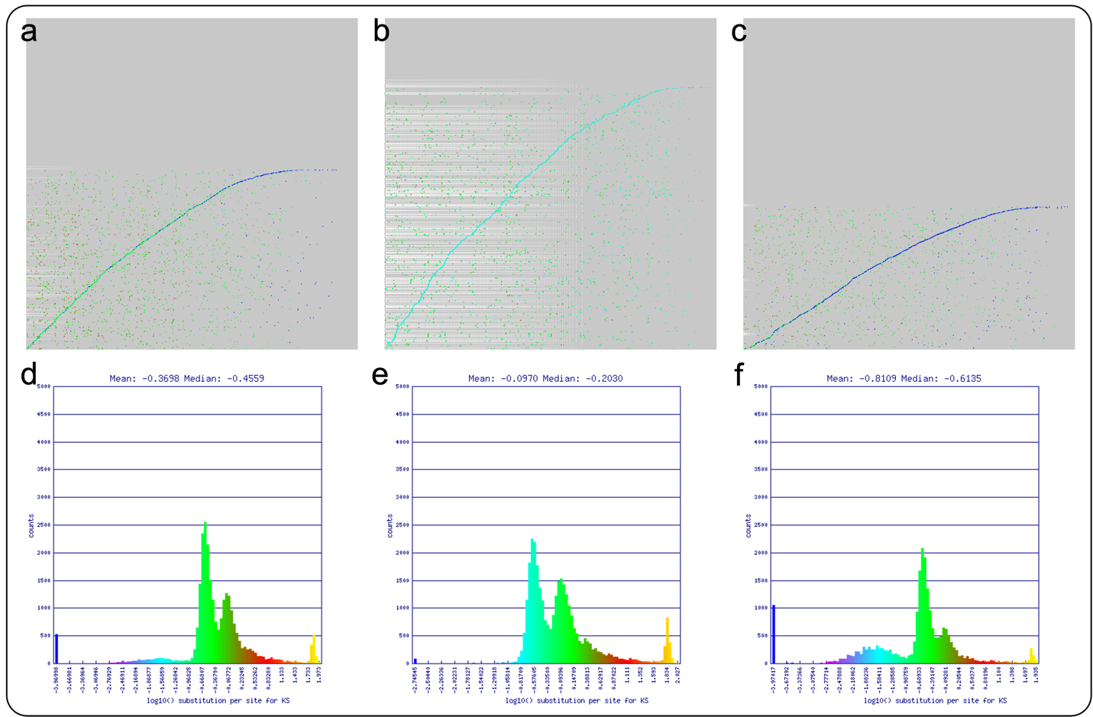
Figure S3: Syntenic regions and frequency plots for synonymous substitution rates (Ks) between syntenic CDS pairs for each partially diploid Fraxinus assembly and itself. Self-vs-self syntenic dot plots for F. americana (a&d), F. nigra (b&e), and F. pennsylvanica (c&f). Colors in Ks histograms correspond with colors of each point in the dot plots.

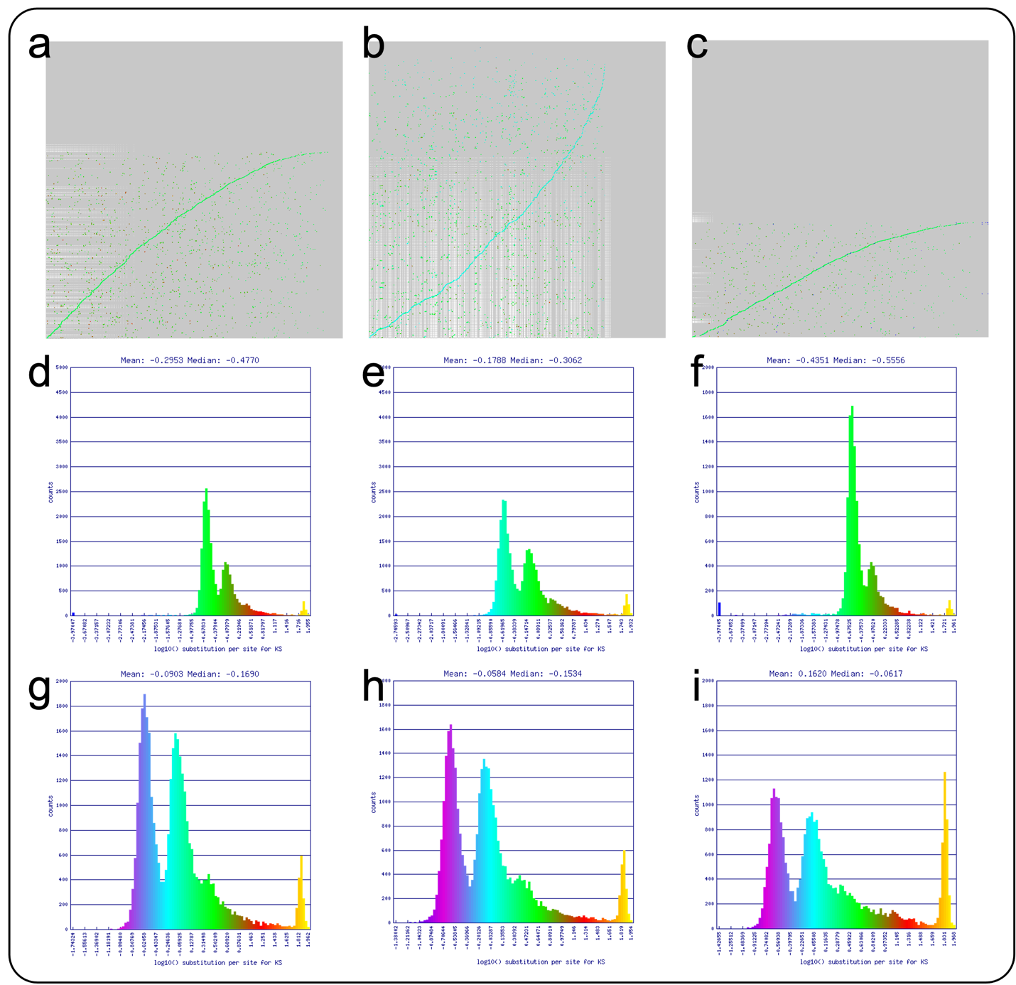
Figure S4: Syntenic regions and frequency plots for synonymous substitution rates (Ks) between syntenic CDS pairs for each haploid Fraxinus assembly and itself. Self-self syntenic dot plots for F. americana (a&d), F. nigra (b&e), and F. pennsylvanica (c&f). Colors in Ks histograms correspond with colors of each point in the dot plots. Ks frequency plots for Huff et al. assemblies are also included for comparison: F. americana-v0.21 (g), F. nigra-v0.21 (h), and F. pennsylvanica-v1.4 (i).

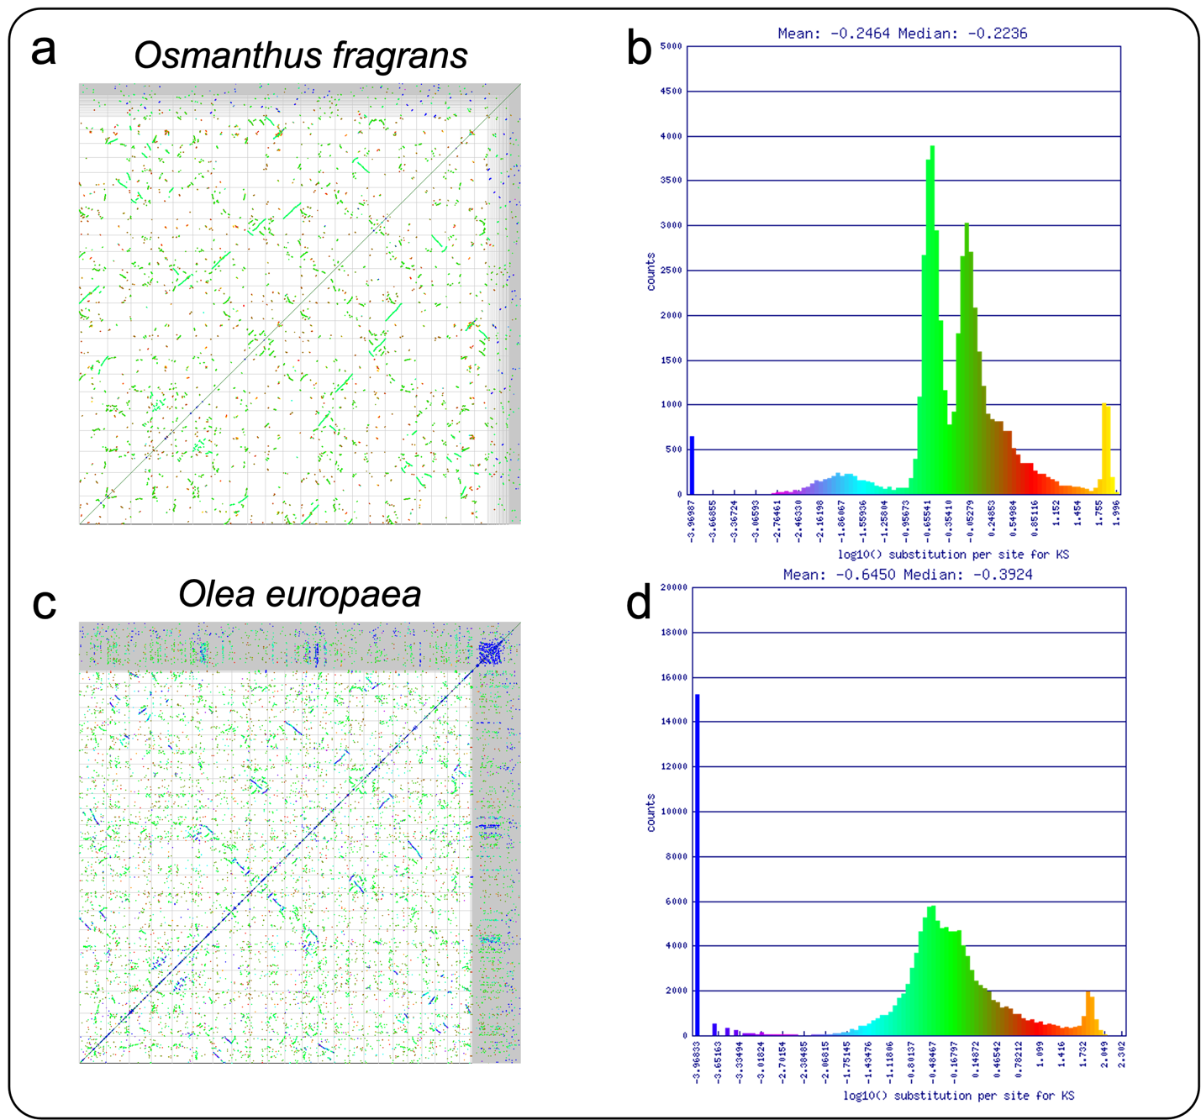
Figure S5: Unpurged heterozygosity in previously published Osmanthus fragrans and Olea europaea assemblies. Self-vs-self syntenic dot plot for O. fragrans (a) and O. europaea (c). Full genome runs along x and y-axis. Each dot represents a syntenic gene pair between paralogs within each genome. Dot color correlates with synonymous substitution rate (Ks) values (in log₁₀) in accompanying histograms: O. fragrans (b) and O. europaea (d).

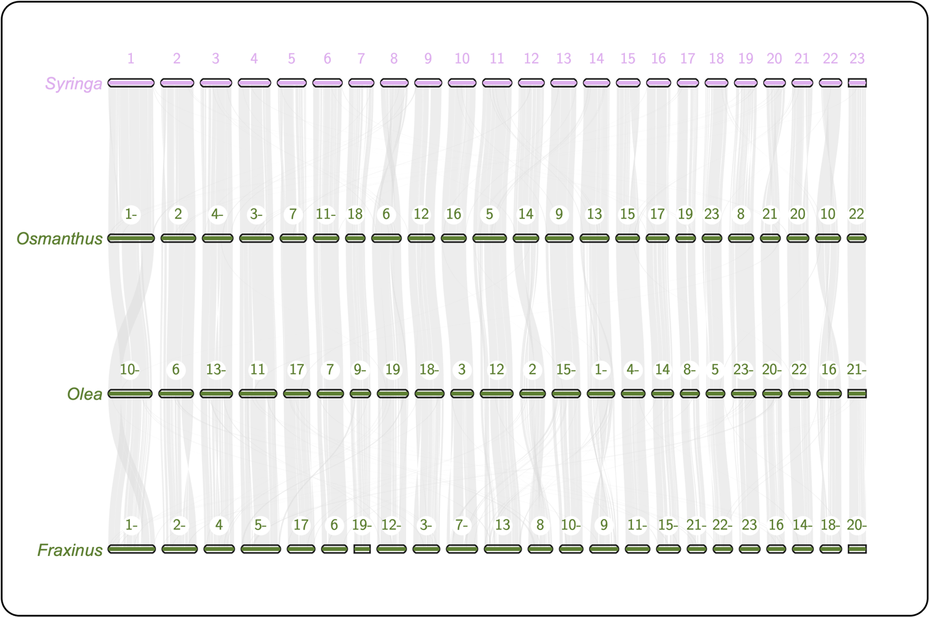
Figure S6: One-to-one macrosynteny relationships among members of the Oleeae tribe. Macrosynteny on a chromosome-scale between Syringa oblata, Osmanthus fragrans, Olea europaea, and Fraxinus nigra. Numbers above chromosomes indicate chromosome number and reversed sequences are followed by “-”. Syntenic blocks between Syringa, Osmanthus, Olea, and Fraxinus chromosomes are connected by light grey lines.

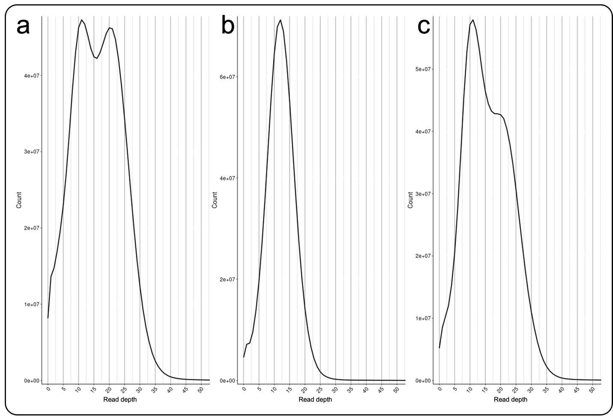
Read depth
Read depth
Read depth
Figure S7: Coverage histograms produced by Purge Haplotigs. F. americana (a), F. nigra (b), and F. pensylvanica (c). Values on the x-axis Read depth is on the x-axis and frequency is on the y-axis.

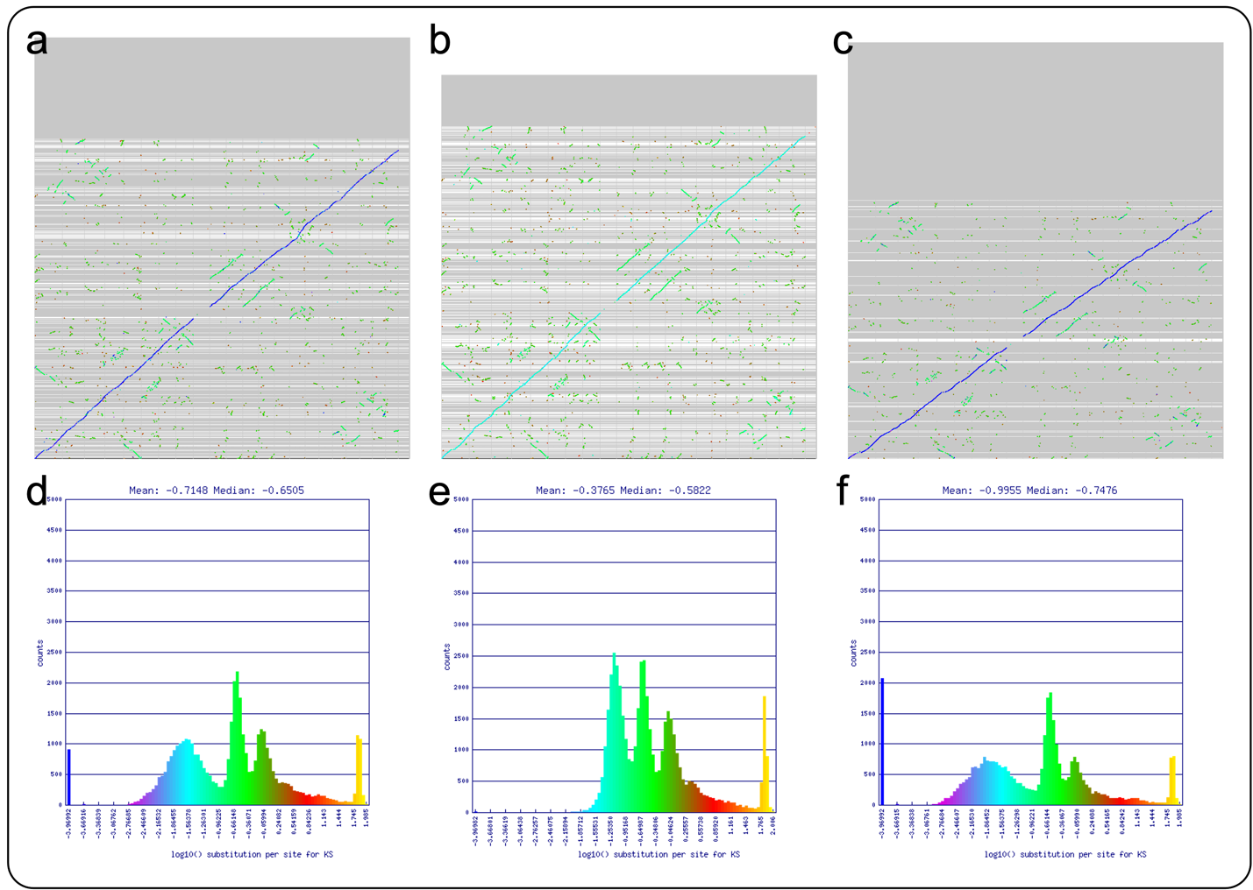
Figure S8: Syntenic regions and frequency plots for synonymous substitution rates (Ks) between syntenic CDS pairs for each haploid Fraxinus assembly and the F. pennsylvanica reference assembly. Syntenic dot plots for F. pennsylvanica against F. americana (a&d), F. nigra (b&e), and F. pennsylvanica (c&f).

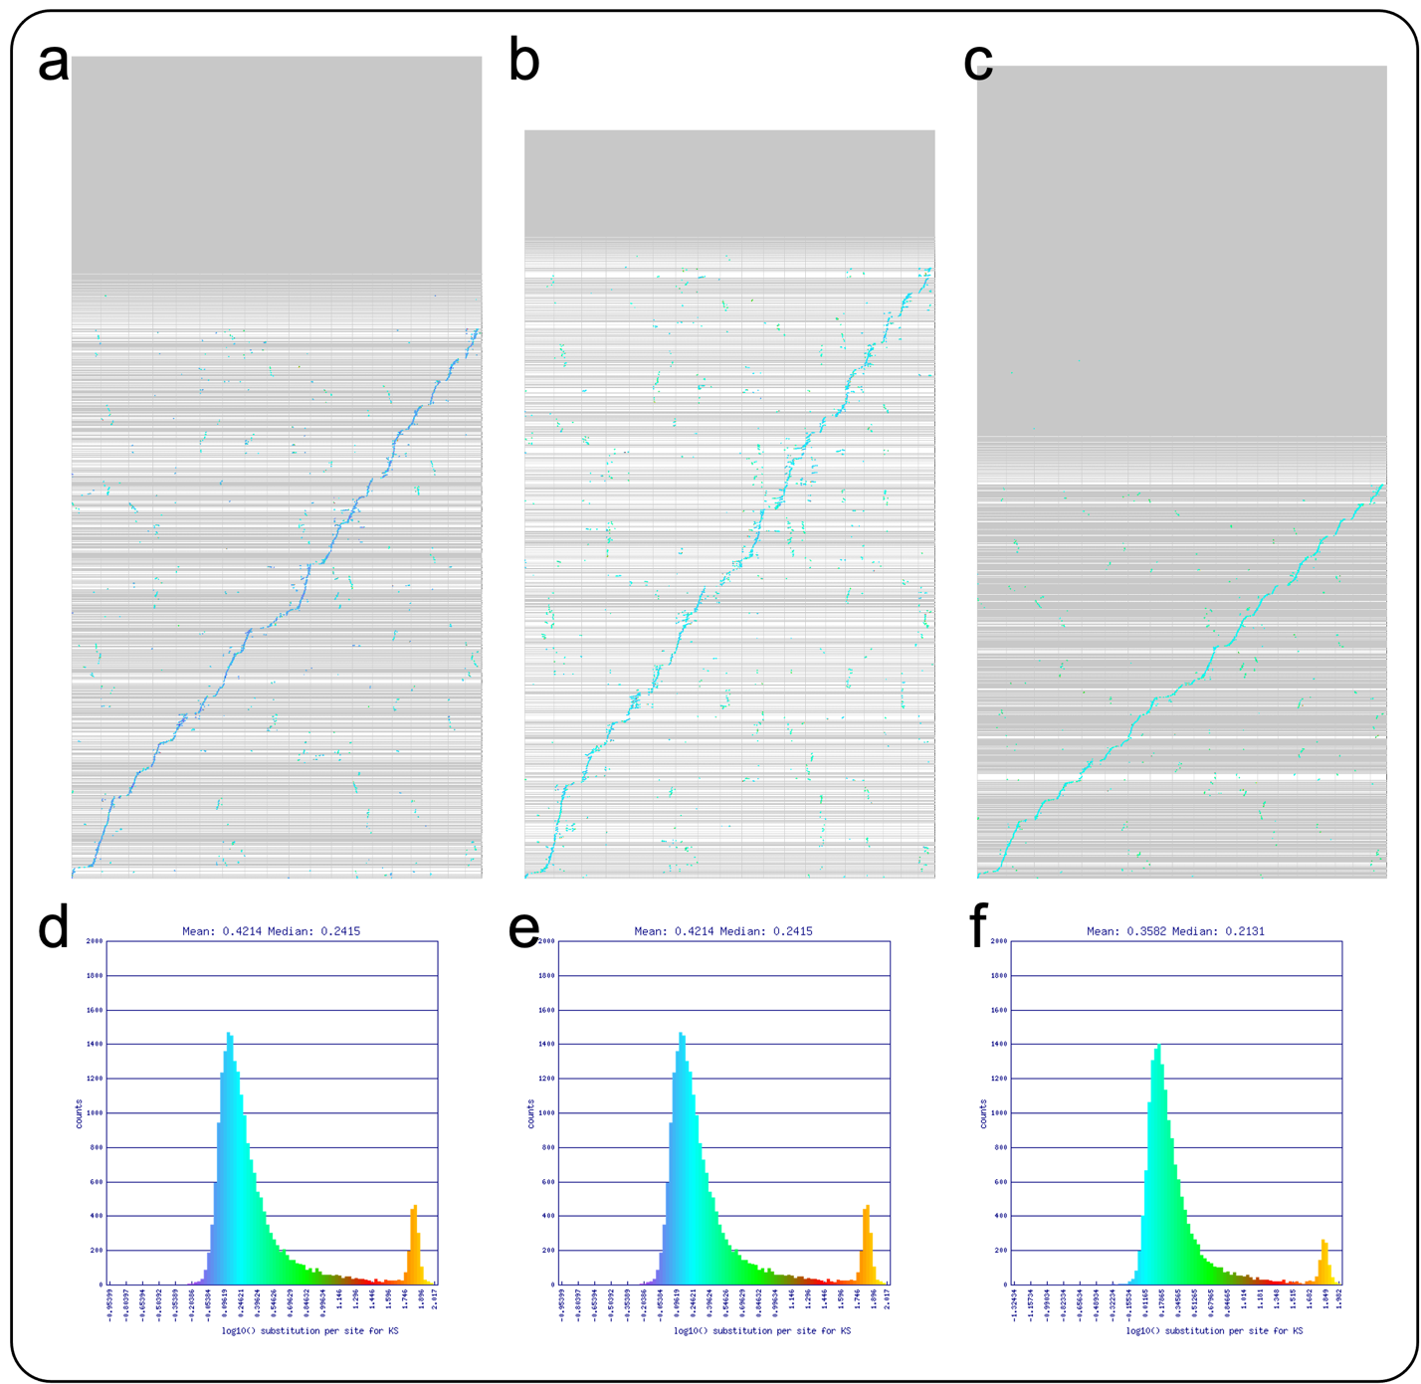
Figure S9: Syntenic regions and frequency plots for synonymous substitution rates (Ks) between syntenic CDS pairs for each haploid Fraxinus assembly and Vitis vinifera.
Syntenic dot plots for V. vinifera against F. americana (a&d), F. nigra (b&e), and F. pennsylvanica (c&f).

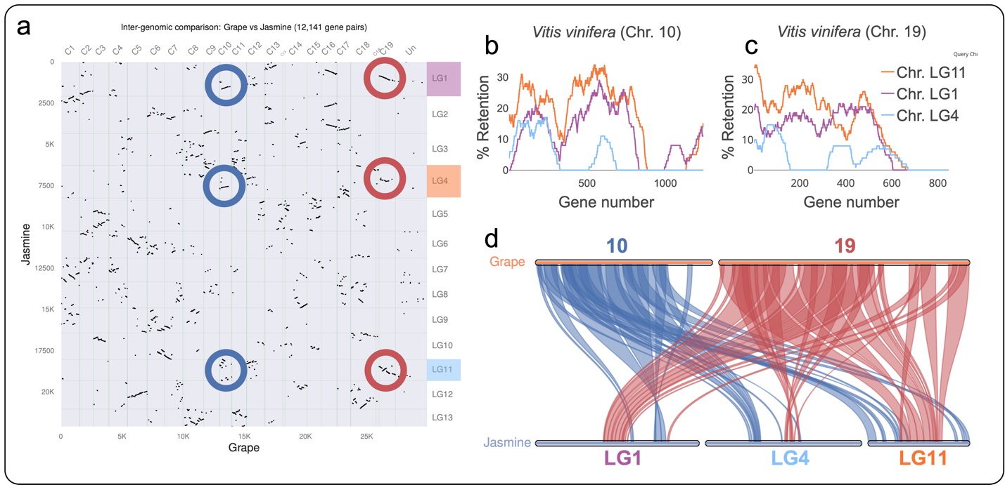
Figure S10. Syntenic dot plot, fractionation bias, and macrosynteny between jasmine and grapevine. (a) Syntenic dot plot with grapevine on the x-axis and jasmine on the y-axis. Each dot represents a syntenic gene pair between the two assemblies. Blue circles highlight the syntenic dots between grapevine chromosomes 10 and jasmine chromosomes 1, 4, and 11. Red circles highlight the syntenic dots between grapevine chromosomes 19 and jasmine chromosomes 1, 4, and 11. (b&c) Gene retention of syntenic gene blocks between grapevine and jasmine. Y-axis represents the percent of gene retention of each jasmine syntenic block compared with windows of genes on grapevine chromosomes 10 and 19. Line color correlates with query chromosome number in the key and the highlighted chromosome names in (a). (d) Macrosyntenic blocks between grapevine chromosomes 10 and 19 and jasmine chromosome 1, 4, and 11. The colors of the connecting lines correlate to the circled syntenic dots in (a).

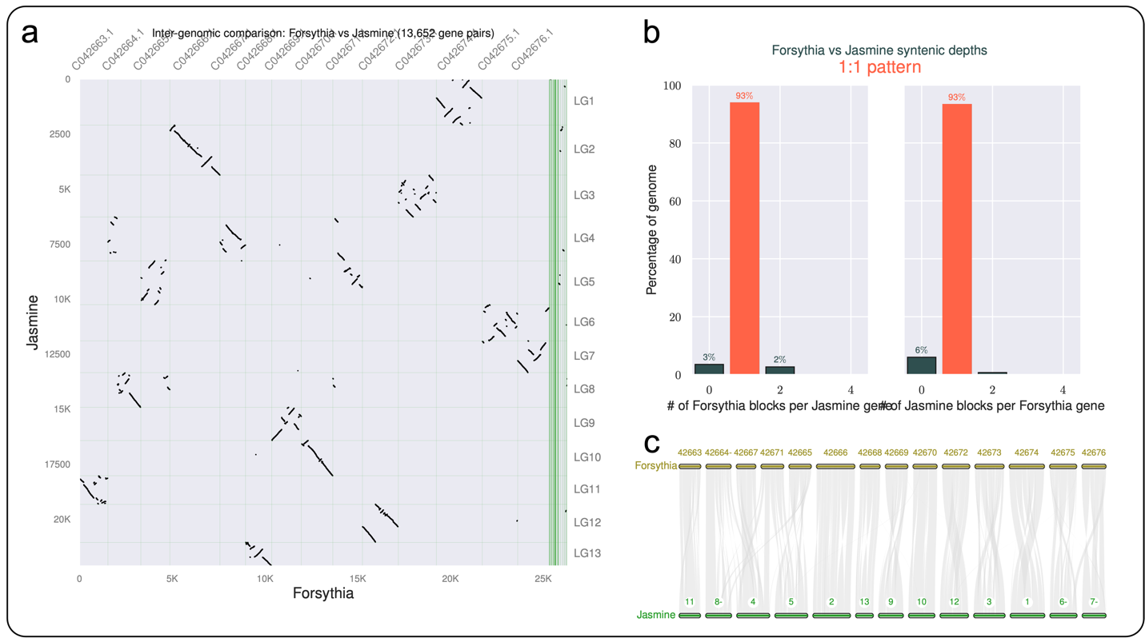
Figure S11. Syntenic dot plot, syntenic depth, and macrosynteny between jasmine and forsythia. (a) Syntenic dot plot with forsythia on the x-axis and jasmine on the y-axis. Each block dot represents a syntenic gene pair between the two assemblies. (b) 1:1 syntenic depth between forsythia and jasmine. (c) The fourteen chromosomes of forsythia show a 1:1 ratio with jasmine’s thirteen chromosomes. Grey connectors join syntenic blocks between the two assemblies. Numbers above chromosomes indicate chromosome name.
d
c
b
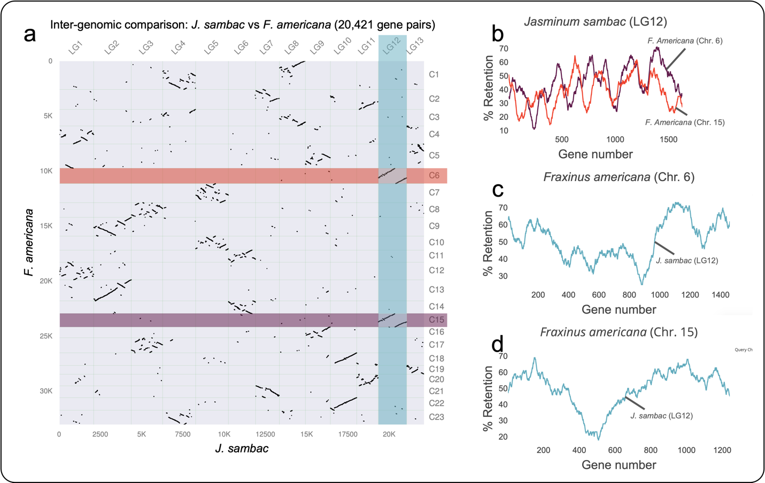
Figure S12. Syntenic dot plot and fractionation bias between F. americana and J. sambac. (a) Syntenic dot plot with jasmine on the x-axis and F. americana pseudoassembly on the y-axis. Each block dot represents a syntenic gene pair between the two assemblies. Colored rectangles highlight the syntenic dots between Jasmine chromosome 12 and F. americana chromosomes 6 and 15. Colors of rectangles correlate with line color in (b), (c), and (d). (b) Fractionation bias plot showing two F. americana chromosomes (chr. 6 and 15) with similar patterns of gene retention when compared to one J. sambac chromosome (LG12). (c&d) One J. sambac chromosome (LG12) showing high gene retention with two F. americana chromosomes (chr. 6 and 15). Lines representing F. americana chromosome 6 and 15 and J. sambac chromosome 12 are labeled.

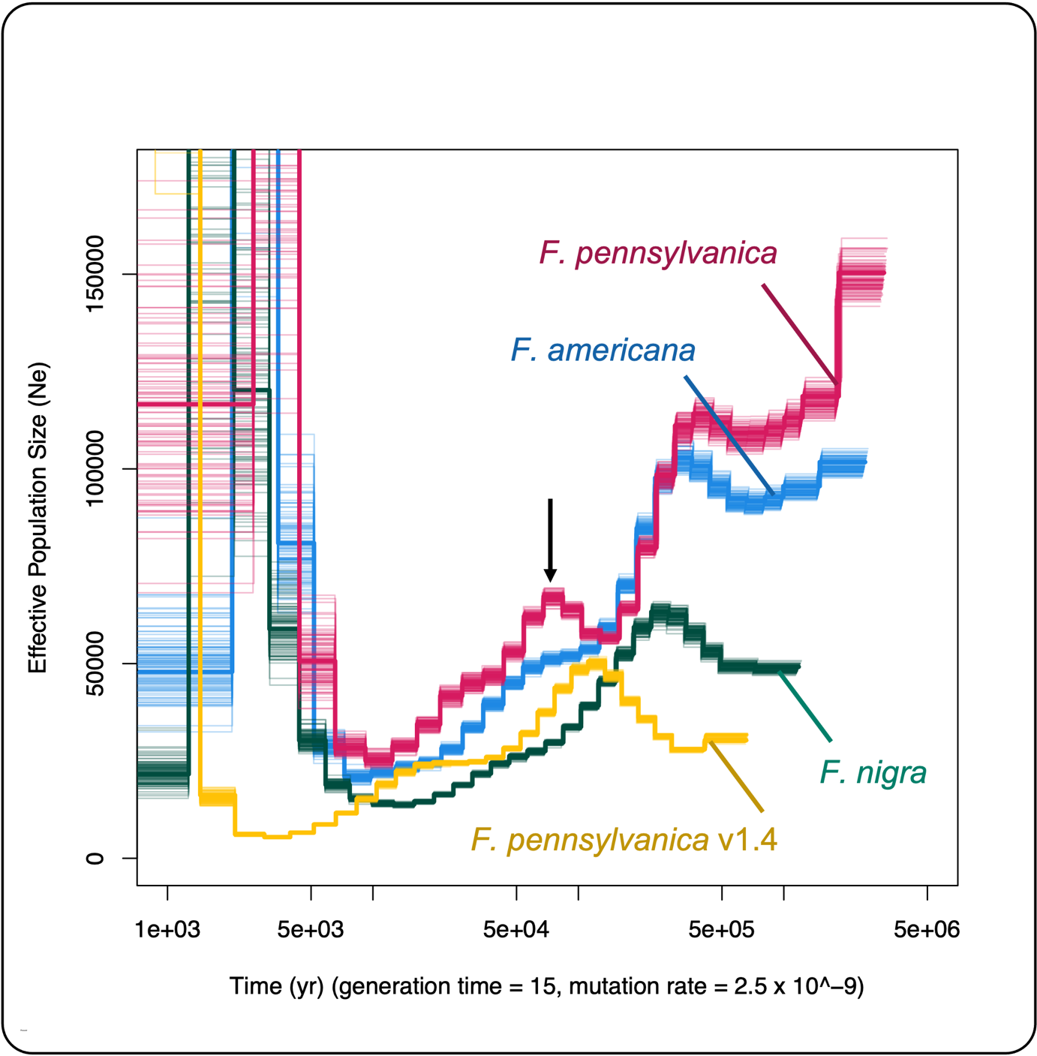
Figure S13: Pairwise Sequentially Markovian Coalescent with R (PSMCR) paleodemographic analyses for Fraxinus species. Demographic curve colors represent the following genome assemblies: blue: F. americana; green: F. nigra; pink: F. pennsylvanica; yellow: F. pennsylvanica reference assembly (v1.4). PSMCR plots were generated by mapping F. americana, F. nigra, and F. pennsylvanica against their own ONT long-reads and the F. pennsylvanica reference assembly mapped against its Illumina short-reads and filtered to the same coverage as the others. All curves assume a mutation rate of 2.5e-9 and a generation time of 15 years. The original bcftools variant calling model was used and maxt was set to 15 for PSMCR. Thin black arrow points to the “hump” in our F. pennsylvanica’s demographic curve.

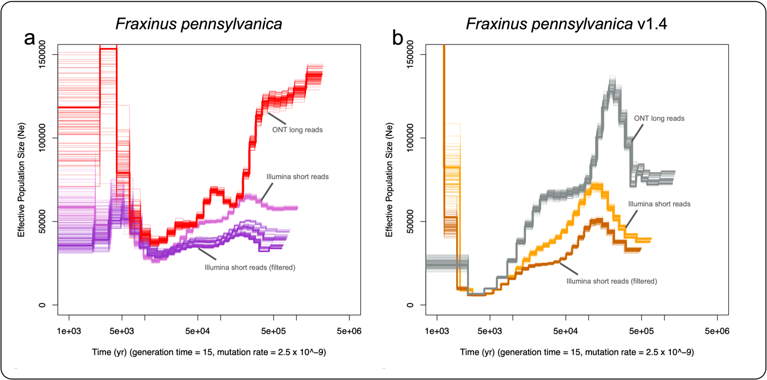
Figure S14: Pairwise sequentially markovian coalescent with R (PSMCR) for Fraxinus pennsylvanica. (a) PSMCRs created using our F. pennsylvanica assembly and ONT long reads (red), Illumina short reads from the F. pennsylvanica reference assembly (light purple), and Illumina short reads from the F. pennsylvanica reference assembly that has been filtered to match the depth of coverage of the long-read mapping (dark purple). (b) PSMCs created using the F. pennsylvanica reference assembly and its own Illumina short reads (orange), its own Illumina short reads that have been filtered to match the depth of coverage of the long-read mapping (dark orange), and the ONT long reads from our F. pennsylvanica sample (grey). Effective population size (Ne) is on the y-axis and time in years is on the x-axis. The bcftools multiallelic and rare-variant calling model was used and maxt was set to 10 for PSMCR.
b

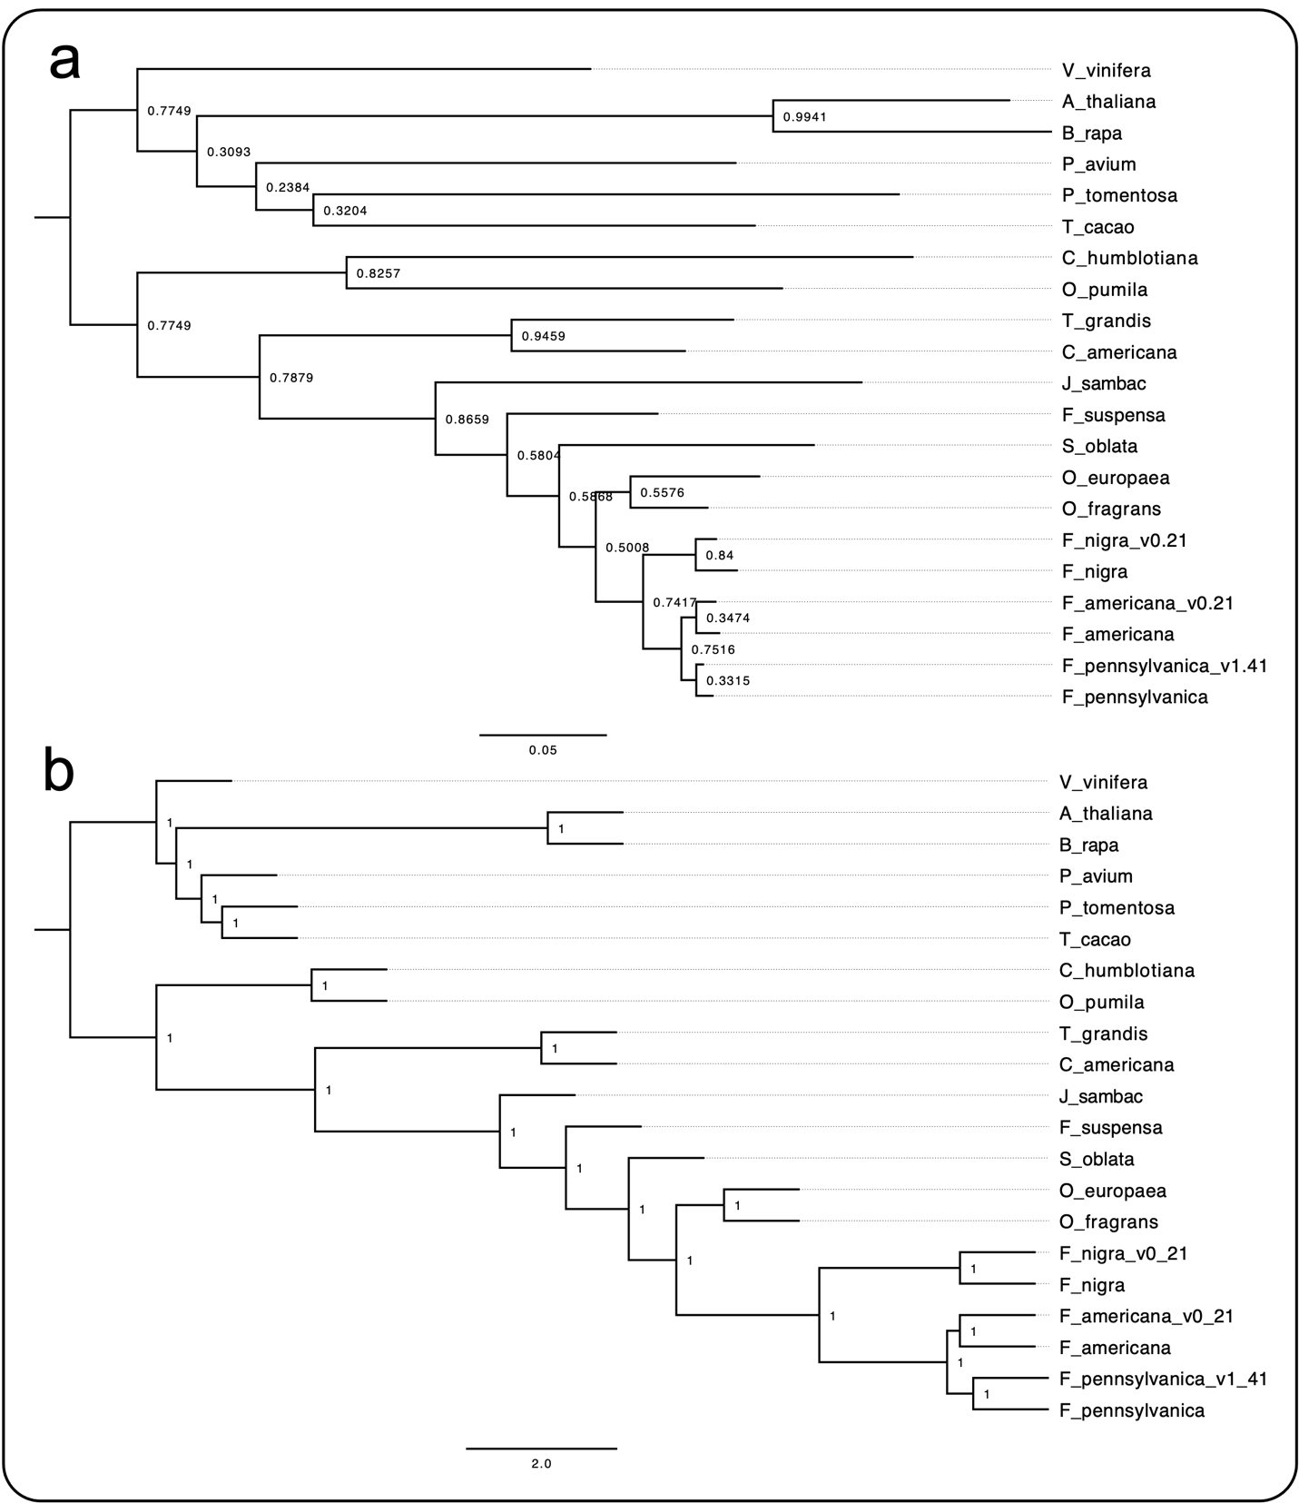
Figure S15: Species trees based on OrthoFinder data. (a) OrthoFinder species tree. Branch support is derived from the proportion of species trees derived from single-locus gene trees supporting each bipartition using STAG. Branch lengths of the STAG tree represent average substitutions per site among orthogroup input trees. (b) ASTRAL tree generated using single-copy gene trees from OrthoFinder. Internal branch lengths are in coalescent units and branch support is measured as local posterior probabilities. Tip labels are as follows: (Lamiales, Oleaceae) F_pennsylvanica: Fraxinus pennsylvanica; F_pennsylvanica_v1.4: F. pennsylvanica reference assembly (Huff et al.); F_americana: Fraxinus americana; F_americana_v0.21: Fraxinus americana (Huff et al.); F_nigra: Fraxinus nigra; F_nigra_v0.21: Fraxinus nigra (Huff et al.); O_fragrans: Osmanthus fragrans; O_europaea: Olea europaea; S_oblata: Syringia oblata; F_suspensa: Forsythia suspensa; J_sambac: Jasminum sambac; (other Lamiales) C_amerciana: Callicarpa americana; T_grandis: Tectona grandis; (Gentianales) C_humblotiana: Coffea humblotiana; O_pumila: Ophiorrhiza pumila; (Rosids) T_cacao: Theobroma cacao; P_tomentosa: Populus tomentosa; P_avium: Prunus avium; B_rapa: Brassica rapa; A_thaliana: Arabidopsis thaliana; V_vinifera: Vitis vinifera.

