Supplementary Information for
A global analysis of coral reef conservation preferences
- Survey questions
Our study embedded the discrete choice experiment (DCE) in an online survey that derived socio-demographic characteristics and preferences, beliefs about climate change, experiences with coral reefs, and included several questions that aimed to extract how the DCE choices were made. We included these dimensions of the survey to permit a detailed exploration of the drivers of conservation behaviour.
Concerning preferences, respondents’ political preferences and time preferences were elicited with widely adopted questions modified to incorporate sliding scales. The former question asked respondents to state their political ideology between “strongly liberal” and “strongly conservative” (e.g. Brandt et al., 2015; Jenkins-Smith et al., 2020; Jost et al., 2008; Kahan et al., 2012). Political ideology has been shown to impact how individuals think about a range of environmental issues (Dunlap et al., 2001) that may include their conservation choices. The latter question asked respondents to rate their willingness to give up something beneficial today in order to obtain more benefits in the future (e.g. Falk et al., 2018; de Grip et al., 2020; Potrafke, 2019). We expect time preferences to be influential in our setting, since conservation decisions amount to a choice of whether to incur certain costs now in return for uncertain benefits in the future (Bernedo and Ferraro, 2017).
Beliefs about climate change, which is overall the largest threat to coral reefs globally (Hughes et al., 2017; Ceccarelli et al., 2020), were extracted with a measure that has been demonstrated to have the best predictive validity related to several criterion variables often applied in climate change research, including pro-environmental behaviour, compared to other measures of climate change beliefs (Greenhill et al., 2014; Devine-Wright et al., 2015).
According to the availability heuristic, individuals evaluate topics and make decisions based on the immediacy with which similar examples come to mind (Tversky and Kahneman, 1973). It follows that previous experiences and/or prior awareness of salient issues for coral reefs, may influence conservation choices. Furthermore, anecdotal evidence acquired from comments in the pre-tests suggested that individuals’ previous experiences may have altered their stated conservation behaviour. Several questions were asked to gauge whether respondents dived or snorkeled on a coral reef before, watched documentaries recently related to sustainability issues in oceans and donated money to an environmental cause in the last 12 months.
Using Internet Protocol (IP) based geolocation data, we were able to obtain a reasonable proxy for distance in kilometers (km) of each respondent to a tropical coral reef in most of the sampled countries. This value was measured as the Euclidean distance from each longitude and latitude point to the outside edge of a tropical coral reef polygon in Geographic Information Systems (GIS). Note that network connectivity in developing countries tends to be poor, which impacts the accuracy of IP-based geolocation techniques (Li et al., 2012). IP geolocation databases cannot accurately determine city-level location estimates in many developing regions like Africa, only country-level data (Ding et al., 2015). Therefore, we only examine the effect of distance on coral reef conservation preferences within countries other than Ghana and Kenya.
- Descriptive statistics
Table 1 displays descriptive statistics for variables of interest by sampled region. Table 2 details the questions used to derive these variables and the specific coding structures utilized for data analysis. Across all countries, there is a fairly similar pattern of climate change beliefs. The majority think that climate change is largely caused by humans (between 53% and 86% of respondents in each country). A lower proportion (between 11% and 32%) of individuals believe that climate change is a natural fluctuation in Earth’s temperatures. The smallest percentage of individuals think that climate change is not happening (between 1% and 7%). A low fraction of respondents also appears unsure as to whether climate change is happening or not (between 2% and 13%). On the whole, there are more climate change believers, regardless of the specified cause, in lower-income countries that are more vulnerable to the harmful impacts of climate change (Ravindranath and Sathaye, 2002; Mertz et al., 2009). In the six wealthiest countries, less than 87% of individuals in each country think that climate change is happening. More than 90% of individuals in every other country with a relatively lower-income believes in the occurrence of climate change.
The previous experience variables reveal obvious results. On the one hand, unsurprisingly the highest proportions of individuals who have dived or snorkeled before come from countries where there is a tropical coral reef present. More than 38% of respondents have dived or snorkeled in Australia, China, Colombia, Indonesia, Kenya and the United States. On the other hand, less than 28% have done so in Chile, Ghana, the Netherlands and the United Kingdom. Exceptions are New Zealand, a non-tropical coral reef country, where 42% of respondents have dived or snorkeled before, and Japan, a country that has a tropical coral reef, where 21% of respondents have dived or snorkeled before.
There is also some between-country variability in the other experience related variables, namely whether in the last 12 months, individuals have watched any documentaries related to sustainability issues in oceans, and donated money to an environmental cause. More than half of respondents in Chile, China, Colombia, Ghana, Indonesia and Kenya have watched ocean sustainability documentaries. Whereas, less than half have watched documentaries in the six comparatively higher-income countries. Moreover, the incidence of donations to an environmental cause is particularly high (in excess of 62%) in China, Indonesia and Kenya. In all other countries, less than half of respondents have donated. Japan stands out as the country with the lowest proportion of individuals who have donated, watched documentaries and dived or snorkeled.
Although the sampling strategy was aimed to obtain a similar socio-demographic characteristics profile in each country, natural differences across countries in access to online panel respondents, life expectancies and years of schooling made this a challenge. Nevertheless, this objective has to a large extent been achieved within countries of a similar income. In Australia, Japan, the Netherlands, New Zealand, the United Kingdom and the United States, average age varies between 43.05 and 47.93 years. In Chile, China, Colombia and Indonesia, this range is between 35.84 and 38.81 years. Individuals who reside in Ghana and Kenya have a similar average age of 30.22 and 31.49, respectively. There is a tendency for either more females than males or an equal distribution in the six highest-income countries. In Chile, China, Colombia and Indonesia, slightly more females participated than males. However, in Ghana and Kenya, participation is more male dominated. The median income range for the six highest-income countries is US$30,000 to US$94,999 in total per household for 2020 (or the income-adjusted equivalent), before taxes. In the lower-income countries (apart from China), this median range is US$10,000 to US$29,999. In China, the median range is US$95,000 to US$154,999. The proportion of individuals who are highly educated is on aggregate larger in lower-income countries, even though there are some irregularities to this observation. More than 56% of individuals residing within China, Colombia, Ghana, Japan and Kenya have higher education. Less than half of those in Australia, Chile, Indonesia, the Netherlands, New Zealand, the United Kingdom and the United States are highly educated. Additionally, the majority of respondents specified that their main nationality is the same as the sampled country. Yet, in Australia, Chile, New Zealand, the United Kingdom and the United States, a somewhat large percentage of more than 10% of residents are foreign nationals.
In terms of political preferences, there is a conservative leaning in ten of the twelve sampled countries. China and the Netherlands lean slightly liberal. Furthermore, in all countries except Japan, individuals are generally patient since they are by majority willing to give up something that is beneficial today in order to extract more future benefits.
Note that country fixed effects are used to control for (unobserved) country-level heterogeneity when examining the influence of individual-specific variables of interest on willingness to contribute to coral reef conservation. These fixed effects are replaced by country income and tropical coral reef proximity variables in additional models, since these variables pick up to a large extent the between-country variation. Moreover, a regression analysis of DCE choice behaviour controls for and examines the influence of the individual- and country-specific variables of interest on willingness-to-pay (WTP) for conservation. Further analyses group countries of a similar income, to test the robustness of the effects of scarcity of coral reef attributes and tropical reef proximity on conservation behaviour.

Table 1: Descriptive statistics
 | Australia | Chile | China | Colombia | Ghana | Indonesia | Japan | Kenya | Netherlands | New Zealand | United Kingdom | United States
Willing to contribute | 0.69  N = 583 | 0.89  N = 508 | 0.93  N = 716 | 0.93  N = 567 | 0.94  N = 642 | 0.96  N = 692 | 0.41  N = 610 | 0.97  N = 772 | 0.59  N = 535 | 0.67  N = 528 | 0.64  N = 558 | 0.77  N = 616
Distance (km) from reef | 380.38  (370.26)  N = 792 | 3562.21  (243.76)  N = 777 | 775.56  (480.69)  N = 801 | 301.61  (149.76)  N = 785 | / | 42.32  (36.67)  N = 784 | 837.76  (297.20)  N = 780 | / | 3327.66  (44.67)  N = 795 | 1739.46  (95.88)  N = 809 | 3739.76  (147.52)  N = 772 | 358.96  (425.37)  N = 818
Socio-demographic characteristics and preferences
Age | 44.74  (14.15)  N = 790 | 38.79  (13.03)  N = 766 | 37.61  (10.90)  N = 792 | 38.81  (13.06)  N = 771 | 30.22  (8.21)  N = 705 | 35.84  (10.92)  N = 776 | 47.93  (12.62)  N = 791 | 31.49  (9.12)  N = 767 | 44.94  (14.26)  N = 788 | 43.05  (14.55)  N = 775 | 44.57  (13.92)  N = 786 | 47.25  (15.14)  N = 808
Male | 0.41  N = 811 | 0.48  N = 803 | 0.49  N = 800 | 0.48  N = 802 | 0.73  N = 825 | 0.49  N = 818 | 0.50  N = 800 | 0.55  N = 814 | 0.49  N = 804 | 0.45  N = 813 | 0.50  N = 805 | 0.45  N = 822
Higher education | 0.43  N = 800 | 0.49  N = 794 | 0.88  N = 801 | 0.57  N = 803 | 0.65  N = 818 | 0.42  N = 815 | 0.62  N = 796 | 0.71  N = 814 | 0.35  N = 789 | 0.48  N = 780 | 0.45  N = 789 | 0.45  N = 822
Income | 3.64  (1.32)  N = 733 | 2.11  (1.36)  N = 643 | 4.56  (1.17)  N = 798 | 2.36  (1.42)  N = 694 | 2.05  (1.28)  N = 694 | 2.50  (1.38)  N = 744 | 3.81  (1.34)  N = 724 | 2.42  (1.58)  N = 757 | 3.37  (1.14)  N = 665 | 3.84  (1.33)  N = 707 | 3.64  (1.27)  N = 723 | 3.35  (1.31)  N = 795
Foreign | 0.15  N = 797 | 0.15  N = 795 | 0.02  N = 790 | 0.06  N = 803 | 0.04  N = 822 | 0.00  N = 808 | 0.02  N = 799 | 0.01  N = 812 | 0.05  N = 790 | 0.25  N = 786 | 0.11  N = 793 | 0.13  N = 798
Patience | 63.01  (21.43)  N = 817 | 69.04  (24.46)  N = 810 | 72.34  (19.10)  N = 801 | 72.14  (22.03)  N = 806 | 78.23  (22.94)  N = 834 | 79.40  (18.56)  N = 819 | 48.84  (21.62)  N = 802 | 81.92  (20.16)  N = 817 | 58.89  (21.07)  N = 808 | 61.97  (22.42)  N = 826 | 62.96  (21.24)  N = 805 | 67.93  (22.45)  N = 826
Conservative | 52.43  (24.57)  N = 639 | 54.69  (27.49)  N = 574 | 48.86  (19.40)  N = 713 | 54.82  (26.39)  N = 579 | 58.83  (30.03)  N = 658 | 65.01  (25.00)  N = 658 | 53.04  (19.74)  N = 641 | 57.64  (31.90)  N = 725 | 48.71  (22.00)  N = 622 | 52.94  (24.86)  N = 658 | 54.93  (26.99)  N = 640 | 57.30  (29.22)  N = 725
Climate change beliefs
Climate change not happening | 0.07  N = 817 | 0.02  N = 810 | 0.03  N = 801 | 0.01  N = 806 | 0.01  N = 834 | 0.04  N = 819 | 0.02  N = 802 | 0.02  N = 817 | 0.04  N = 808 | 0.06  N = 826 | 0.05  N = 805 | 0.07  N = 826
Climate change don’t know | 0.12  N = 817 | 0.04  N = 810 | 0.06  N = 801 | 0.02  N = 806 | 0.04  N = 834 | 0.03  N = 819 | 0.13  N = 802 | 0.02  N = 817 | 0.10  N = 808 | 0.11  N = 826 | 0.09  N = 805 | 0.10  N = 826
Climate change natural | 0.28  N = 817 | 0.15  N = 810 | 0.23  N = 801 | 0.11  N = 806 | 0.25  N = 834 | 0.32  N = 819 | 0.18  N = 802 | 0.15  N = 817 | 0.29  N = 808 | 0.27  N = 826 | 0.20  N = 805 | 0.26  N = 826
Climate change human caused | 0.53  N = 817 | 0.79  N = 810 | 0.68  N = 801 | 0.86  N = 806 | 0.70  N = 834 | 0.61  N = 819 | 0.67  N = 802 | 0.81  N = 817 | 0.57  N = 808 | 0.57  N = 826 | 0.66  N = 805 | 0.57  N = 826
Previous experience
Dived or snorkeled | 0.44  N = 817 | 0.25  N = 810 | 0.52  N = 801 | 0.41  N = 806 | 0.22  N = 834 | 0.52  N = 819 | 0.21  N = 802 | 0.50  N = 817 | 0.27  N = 808 | 0.42  N = 826 | 0.25  N = 805 | 0.39  N = 826
Donated | 0.29  N = 817 | 0.41  N = 810 | 0.63  N = 801 | 0.35  N = 806 | 0.43  N = 834 | 0.74  N = 819 | 0.11  N = 802 | 0.63  N = 817 | 0.34  N = 808 | 0.29  N = 826 | 0.32  N = 805 | 0.32  N = 826
Watched documentaries | 0.39  N = 739 | 0.56  N = 752 | 0.53  N = 766 | 0.64  N = 770 | 0.64  N = 809 | 0.82  N = 776 | 0.17  N = 774 | 0.80  N = 802 | 0.32  N = 713 | 0.42  N = 742 | 0.38  N = 740 | 0.39  N = 764
Country-specific characteristics
GDP per capita | 52,397 | 25,068 | 17,204 | 14,570 | 5,742 | 12,068 | 41,733 | 4,576 | 59,334 | 44,213 | 45,853 | 63,414
Tropical reef | Yes | No | Yes | Yes | No | Yes | Yes | Yes | No | No | No | Yes
Notes: The mean or proportion is provided with the standard deviation in parentheses.

Table 2: Elicitation of variables of interest and variable coding
Variable | Elicitation | Coding
Willing to contribute | In principle, would you be willing to contribute money to support coral reef and reef fish conservation? | 1 = yes; 0 = no; missing = don’t know
Distance (km) from reef | Euclidean distance in km from each geolocation longitude and latitude point to the outside edge of a tropical coral reef polygon in Geographic Information Systems (GIS) | Distance in km
Socio-demographic characteristics and preferences
Age | How old are you, in years (if you prefer not to say then leave blank)? | Age in years; missing = prefer not to say
Male | What is your gender? | 1 = male; 0 = female; missing = other, or prefer not to say
Higher education | What is your highest completed level of education? | 1 = university/college graduate, or post graduate; 0 = some high school, or high school graduate, or some university/college, or other; missing = prefer not to say
Income | Which of the following ranges best describes your total household income for 2020 before taxes? | 1 = Less than US$10,000; 2 = US$10,000 to US$29,999; 3 = US$30,000 to US$54,999; 4 = US$55,000 to US$94,999; 5 = US$95,000 to US$154,999; 6 = US$155,000 or more; missing = don’t know, or prefer not to say
Foreign | What is your primary/main nationality? | 1 = primary/main nationality is not the same as the sampled country; 0 = primary/main nationality is the same as the sampled country; missing = rather not say
Patience | How willing are you to give up something that is beneficial for you today in order to benefit more from that in the future? Please use a scale from 0 to 10, where a 0 means you are “completely unwilling to do so”, and a 10 means you are “very willing to do so”. You can also answer values in-between to indicate where you fall on the scale. | 100 = very willing to do so; …; 0 = completely unwilling to do so (sliding scale values)
Conservative | How would you describe your political ideology (please use the sliding scale)? | 100 = strongly conservative; …; 0 = strongly liberal; missing = prefer not to describe my political ideology
Climate change beliefs
Climate change not happening | Which of the following statements best describes your thoughts on climate change? | 1 = I don’t think that climate change is happening; 0 = I have no idea whether climate change is happening or not, or I think that climate change is happening, but it’s just a natural fluctuation in Earth’s temperatures, or I think that climate change is happening, and I think that humans are largely causing it
Climate change don’t know | Which of the following statements best describes your thoughts on climate change? | 1 = I have no idea whether climate change is happening or not; 0 = otherwise
Climate change natural | Which of the following statements best describes your thoughts on climate change? | 1 = I think that climate change is happening, but it’s just a natural fluctuation in Earth’s temperatures; 0 = otherwise
Climate change human caused | Which of the following statements best describes your thoughts on climate change? | 1 = I think that climate change is happening, and I think that humans are largely causing it; 0 = otherwise
Previous experience
Dived or snorkeled | Have you ever dived or snorkeled before on a coral reef? | 1 = yes; 0 = no
Donated | Have you ever donated money to an environmental cause in the last 12 months? | 1 = yes; 0 = no
Watched documentaries | In the last 12 months, did you watch any documentaries related to sustainability issues in oceans, e.g. about coral reefs and/or fish? | 1 = yes; 0 = no; missing = don’t know
Country-specific characteristics
GDP per capita | GDP per capita at the time of the survey based on Purchasing Power Parity (PPP) figures from https://data.worldbank.org/. | GDP per capita in US$
Tropical reef | Visual inspection of whether a country has a tropical coral reef according to GIS data taken from UNEP-WCMC, WorldFish Centre, WRI, TNC (2021). | 1 = country has a tropical coral reef; 0 = country does not have a tropical coral reef
Notes:
The answer options for the income question were corrected for country-level income by making similar adjustments as the contribution per year in the DCE.

- Econometric method
We predict two types of behaviour, namely: willingness to contribute a positive amount of money to support coral reef and reef fish conservation, and DCE choice behaviour. The former amounts to a binary choice, where respondent $i$ derives a positive level of utility from choosing to contribute money if utility associated with contributing ($U_{1i}^{*}$) is greater than utility of not contributing ($U_{0i}^{*}$), which is normalized to equal zero:
$U_{i}^{*}=U_{1i}^{*}-U_{0i}^{*}=β_{0}+β_{1}X_{i}+e_{i}>0$ (1)
Utility is a function of a systematic component, $β_{0}+β_{1}X_{i}$, where $X_{i}$ is a vector of observed regressors, and a random unobserved component, $e_{i}$. Therefore, $U_{i}^{*}$ is a latent (unobserved) variable. In our survey, we observe ${Willing to contribute}_{i}$, which is coded as follows:
${Willing to contribute}_{i}\left\{\begin{aligned}1 if U_{i}^{*}≥0 \\ 0 if U_{i}^{*}<0\end{aligned}\right.$ (2)
The likelihood that ${Willing to contribute}_{i}=1$, conditional on $X_{i}$ is given by:
$\operatorname{Pr}\left(U_{i}^{*}≥0|X_{i}\right)=\operatorname{Pr}\left(β_{0}+β_{1}X_{i}+e_{i}≥0|X_{i}\right)=\operatorname{Pr}\left(e_{i}≥-β_{0}-β_{1}X_{i})|X_{i}\right)$ (3)
$=\operatorname{Pr}\left(e_{i}<β_{0}+β_{1}X_{i})|X_{i}\right)$
$=F(β_{0}+β_{1}X_{i})$
For our analysis, we assume $e_{i}$ follows a type-1 extreme value distribution, which yields the Logit model. The marginal effects are calculated by taking the derivative of equation 3 and applying chain rule:
$\frac{δ\operatorname{Pr}\left({Willing to contribute}_{i}=1|X_{i}\right)}{δX_{i}}=F^{'}\left(β_{0}+β_{1}X_{i}\right)\frac{δ\left(β_{0}+β_{1}X_{i}\right)}{δX_{i}}$ (4)
$=f\left(β_{0}+β_{1}X_{i}\right)β_{1}$
Our preference for the Logit model over the Linear Probability model is based on the known problem that the latter may predict probabilities that fall outside the unit interval (Horowitz and Savin, 2001). Moreover, the decision to use another commonly applied binary choice model, i.e. the Probit model, is ultimately based on the assumption of the error distribution, which is unobserved (Cameron and Trivedi, 2005). However, predicted probabilities derived from both the Logit and Probit models tend to be almost the same (Wooldridge, 2010) and applying either model to our data results in nearly identical findings with respect to the marginal effect estimates.
To account for potential heterogeneity in DCE choice behaviour across individuals, we estimate a series of Panel Mixed Logit (ML) models, where coefficients of interest are allowed to vary over respondents. The coefficient vector $γ_{i}$ is the sum of the population mean variable weights, $b$, and an individual deviation from the mean, $η_{i}$. This deviation can take any distributional assumption, and is measured by its standard deviation. According to random utility maximization theory (McFadden, 1974), the utility of a choice alternative $j$ for individual $i$ can be expressed as:
$V_{ij}=bZ_{ij}+{η_{i}Z}_{ij}+ε_{ij}$ (5)
$Z_{ij}$ is a vector of observed variables, including the choice attributes, and $ε_{ij}$ is the random error component of utility that is independent and identically distributed with a type-1 extreme value distribution. Furthermore, the independence of irrelevant alternatives assumption of the standard Multinomial Logit model is relaxed here, because the unobserved portion of utility is correlated across alternatives due to the common influence of $η_{i}$ (Train, 1998).
Decision making within DCEs is based on utility maximization (Louviere et al., 2010), where the likelihood that individual $i$ chooses alternative $j$ from a choice set $C$, with $q$ other options is:
$P_{ij}=\operatorname{Pr}\left(V_{ij}>V_{iq}, ∀q∈C\right)$ (6)
For the ML models we apply that include the choice attributes only, the following utility function is specified:
$V_{ij}=ASC+β_{1}{Funding restoration}_{ij}+β_{2}{Strengthen legislation}_{ij}+β_{3}{10 pp. coral cover}_{ij}+β_{4}{25 pp. coral cover}_{ij}+β_{5}{40 pp. coral cover}_{ij}+β_{6}{10 pp. coral cover}_{ij}×best case+β_{7}{25 pp. coral cover}_{ij}×best case+β_{8}{40 pp. coral cover}_{ij}×best case+β_{9}{10 pp. reef fish}_{ij}+β_{10}{25 pp. reef fish}_{ij}+β_{11}{40 pp. reef fish}_{ij}+β_{12}{10 pp. reef fish}_{ij}×best case+β_{13}{25 pp. reef fish}_{ij}×best case+β_{14}{40 pp. reef fish}_{ij}×best case+β_{15}{Contribution}_{ij}+ε_{ij}$ (7)
ASC is the alternative-specific constant, where the no additional conservation effort alternative is coded as 1. The conservation measure, global coral coverage remaining and reef fish species at risk of extinction in 50 years attributes are dummy coded to test for non-linear effects of percentage point changes (pp.) in the attribute levels on utility. A uniform distribution for the random parameters on all dummy variables is used as suggested by Hensher et al. (2005). To test whether individuals respond to scarcity according to the future scenario without conservation, we interact the coral coverage and reef fish attributes with a dummy variable that indicates whether this is the best-case scenario. The contribution per year attribute is assumed to have a linear fixed effect on utility to permit the calculation of welfare estimates (Hensher et al., 2001). Table 3 lists the attributes and their corresponding levels within the DCE. The ML models are estimated using 1,000 Halton draws to ensure high statistical efficiency of the estimation (Bhat, 2001).

Table 3: List of attributes and their corresponding levels within the discrete choice experiment
Attributes | Levels
Conservation measure | Expansion of marine protected areas; funding of coral and reef fish restoration projects; strengthening of legislation on climate change, pollution and overfishing; or no additional conservation effortª
Global coral coverage remaining in 50 years | 90%; 75%; 60%; 50%; 35%; 20%; or 10% of current coral coverage remaining^{b}
Reef fish species at risk of extinction in 50 years | 10%; 25%; 40%; 50%; 65%; 80%; or 90% of reef fish species at risk of extinction (vulnerable, endangered or critically endangered)^{c}
Contribution per year^{d} | Australia: AU$0; AU$15; AU$30; AU$60; AU$80; AU$140; AU$190; or AU$280  Chile: CLP$0; CLP$4.200; CLP$8.300; CLP$17.000; CLP$25.000; CLP$42.000; CLP$58.000; or CLP$83.000  China: ¥0; ¥20; ¥40; ¥80; ¥120; ¥200; ¥290; or ¥410  Colombia: COL$0; COL$12.000; COL$24.000; COL$48.000; COL$71.000; COL$120.000; COL$170.000; or COL$240.000  Ghana: GH₵0; GH₵5; GH₵15; GH₵25; GH₵40; GH₵60; GH₵90; or GH₵130  Indonesia: Rp 0; Rp 33.000; Rp 67.000; Rp 130.000; Rp 200.000; Rp 330.000; Rp 470.000; or Rp 670.000  Japan: ¥0; ¥910; ¥1,800; ¥3,600; ¥5,500; ¥9,100; ¥13,000; or ¥18,000  Kenya: Ksh 0; Ksh 100; Ksh 190; Ksh 380; Ksh 570; Ksh 960; Ksh 1,300; or Ksh 1,900  Netherlands: €0; €10; €20; €40; €60; €100; €140; or €200  New Zealand: NZ$0; NZ$10; NZ$25; NZ$50; NZ$70; NZ$120; NZ$170; or NZ$250  United Kingdom: £0; £5; £15; £30; £40; £70; £100; or £140  United States: US$0; US$10; US$25; US$50; US$70; US$120; US$170; or US$250
Notes:
ª The “business-as-usual” scenario (option C) was always assigned no additional conservation effort.
^{b} Option C is either 50% or 10%. The additional conservation measures scenarios (options A and B) are either 10-, 25- or 40-percentage point improvements in current coral coverage remaining, compared to option C.
^{c} Option C is either 50% or 90%. The additional conservation measures scenarios (options A and B) are either 10-, 25- or 40-percentage point improvements in reef fish species at risk of extinction, compared to option C.
^{d} Thousand and decimal separators adopted in the discrete choice experiment were altered based on what is most commonly used in each country.

- Regression analysis of willingness to contribute
Table 1 of the manuscript displays average marginal effects derived from Logit regressions of predictors of willingness to contribute a positive amount of money towards the conservation of coral reefs and reef fish. Model 1 contains socio-demographic characteristics and preferences variables, as well as the country fixed effects. Models 2 and 3 add, respectively, climate change beliefs and relevant previous experiences. Model 4 substitutes the country fixed effects for the natural logarithm of country-level GDP per capita and a dummy coded indicator of whether a country has a tropical coral reef. Model 5 replaces the tropical coral reef dummy variable with the distance of each respondents’ geolocation from a tropical reef in 1,000 km. The latter regression excludes data from the African countries due to inaccurate geolocation data there. It also excludes data that indicates respondents’ geolocations are different from the sampled country, which might be the case if respondents are using a Virtual Private Network.
Socio-demographic characteristics reveal various levels of covariance. First, age negatively predicts willingness to contribute. Depending on the inclusion of control variables, a one-year increase in age lowers the likelihood of contributing by between 0.2 and 0.3 percentage points. Second, a unit change in the categorical income variable raises the likelihood of contributing by between 0.7 and 2 percentage points. Third, Models 1 and 2 show that compared to individuals who do not hold a higher education degree, university/college graduates or post graduates are between 2.2 and 2.7 percentage points more likely to contribute. However, this education effect is not robust to the inclusion of previous experiences in the regression model. Finally, there is also no significant effect of gender and foreign national status on willingness to contribute.
Our self-reported measure of patience positively predicts willingness to contribute. A unit change in this variable increases the contribution likelihood by between 0.2 and 0.4 percentage points. Interestingly, of all the factors included in Model 1, patience accounts for the largest proportion of the variation in contribution willingness. Removal of this variable decreases the Pseudo-R² value by 0.061. Moreover, according to Model 1, conservative leaning individuals are less likely to contribute (a unit change lowers the likelihood by 0.04 percentage points). Nevertheless, this effect is not significant at the 5% level once climate change beliefs are controlled for. The variable does regain significance in Model 5, which excludes data from African countries, which may suggest that political preferences are more influential among the higher-income countries.
Regarding the various beliefs about climate change, compared to a belief that climate change is happening and human caused, individuals who don’t think that climate change is happening are between 7.5 and 8.8 percentage points less likely to contribute. Relative to the same reference category, an unsure belief as to whether climate change is happening or not also predicts a lower contribution likelihood by 5.2 to 8.7 percentage points. Individuals who think that climate change is happening, but attribute it to a natural fluctuation in Earth’s temperatures are less likely to contribute as well by 5.4 to 6.4 percentage points.
With respect to previous experiences, individuals who have dived or snorkeled before on a coral reef are between 6.4 and 7.2 percentage points more likely to contribute. In addition, if in the last 12 months, individuals have donated money to an environmental cause, and watched documentaries related to sustainability issues in oceans, they have a higher contribution probability of between 15 and 19.6 percentage points and 7.9 and 9.4 percentage points, respectively.
- Regression analysis of discrete choice experiment behaviour
Table 4 displays the choice modelling results of the DCE data based on ML specifications. To examine the influence of percentage point rises (declines) in global coral coverage remaining (in reef fish species at risk of extinction) in 50 years on utility, no change in these attributes between the business-as-usual and additional conservation options is adopted as the reference category. Scarcity effects are modelled by interacting the coral coverage and reef fish attributes with a dummy variable that indicates whether the business-as-usual option is the best-case scenario, or alternatively the worst-case scenario. Furthermore, the expansion of marine protected areas is incorporated as the reference category for the conservation measure attribute.
Model 1 is a pooled model that includes data from all sampled countries, for respondents who indicated that in principle they would be willing to contribute money to support coral reef and reef fish conservation, and that they did not make random choices in the DCE tasks. Model 2 adds country-specific interaction terms, namely: between GDP per capita as well as whether a country has a tropical coral reef and the contribution level. Models 3, 5 and 7 conduct the same regression analysis as Model 1 separately for countries with GDP per capita greater than $41,732, between $25,068 and $12,067, and equal to or less than $5,742, respectively. Models 4, 6 and 8 integrate interaction terms between whether a country from these respective income groups has a tropical coral reef and the contribution level, in order to explore whether the effects of scarcity and tropical reef proximity on conservation behaviour are the same across high- and relatively low-income countries. Individual-specific interaction terms between socio-demographic characteristics and preferences, climate change beliefs, previous experiences, and the contribution level are also included in Models 2, 4, 6 and 8 if the coefficients on these interaction terms are significant in at least one of these models. Choice attributes with statistically significant randomized coefficient estimates (at the 5% level) are emboldened in Table 4.
The results of Model 1 suggest that on aggregate, percentage point improvements in both the coral coverage remaining and reef fish at risk of extinction attributes induce positive changes to utility. Since coefficient estimates on all interaction terms between these attributes and the best-case scenario are negative and significant, it can be concluded that individuals prefer gains to coral reef conditions from the worst-case scenario, compared to the best-case scenario. On average, individuals also dislike paying higher contributions in the DCE, but the ASC term is negative and significant, so overall options with additional conservation measures were selected more often than the business-as-usual option. Regarding the conservation measures, respondents prefer funding coral and reef fish restoration projects to expanding marine protected areas. In contrast, there is no significant difference in preferences between strengthening of legislation and marine protected area expansion.
The addition of country-specific interactions to the pooled specification in Model 2 provides two more insights. First, there is no significant effect of GDP per capita on WTP higher contribution amounts when individual-specific variables are controlled for. Second, countries with a tropical coral reef favor paying high contributions, relative to countries without a reef.
Concerning Models 3, 5 and 7, which disaggregate the pooled analysis by country income, there is some heterogeneity in the effect of the coral coverage remaining and reef fish at risk of extinction attributes, as well as the conservation measures on choice behaviour. Most notably, there is a stronger preference for improvements to future levels of coral coverage remaining, in the worst-case scenario in countries with GDP per capita greater than $41,732, than among lower-income countries. That is, interaction effects between coral cover and the best-case scenario are most prominent among high-income countries, implying that respondents in these countries respond more to coral coverage scarcity. A similar, although somewhat less salient, pattern of findings emerges for the reef fish species at risk of extinction attribute.
The ASC is highest for countries with GDP per capita greater than $41,732, and lowest for countries with GDP per capita between $25,068 and $12,067, suggesting that dislike for the business-as-usual scenario is strongest in countries from the middle-income category. Moreover, even though coefficient estimates attached to the funding of restoration projects are consistently positive across all models, there is only a significant preference for restoration in countries with GDP per capita between $25,068 and $12,067. For countries with GDP per capita greater than $41,732, there is a significant dislike of funding of legislation compared to marine protected area expansion, once country- and individual-specific variables are controlled for.
The individual-specific interactions indicate that on average, WTP for conservation is positively predicted by being a male respondent, household income, patience, diving or snorkeling experience on a coral reef, previous donations to an environmental cause, and watching documentaries related to sustainability issues in oceans. Older individuals have lower WTP and those who believe that climate change is caused by a natural fluctuation in Earth’s temperatures, rather than human caused, are less willing to pay higher contribution amounts. These individual-specific variables are stronger WTP determinants among high-income countries, however age, household income and patience come out as significant across all interaction models.
Lastly, significant preference heterogeneity is found in the ASC term in all choice models. Therefore, individuals vary in their preferences towards conservation more generally. Preference heterogeneity is also found in certain choice attribute levels in particular. Specifically, there are heterogeneous preferences for 25- and 40-percentage point increases to coral coverage, as well as 10-, 25- and 40-percentage point reductions to reef fish species at risk of extinction, in a large proportion of the regression models. Some models find heterogeneous preferences for funding restoration projects and strengthening legislation as well.

Table 4: Panel Mixed Logit models
 | Pooled (Model 1) | Pooled country interactions (Model 2) | GDP per capita > $41,732 (Model 3) | GDP per capita > $41,732 reef interaction (Model 4) | $25,068 ≥ GDP per capita > $12,067 (Model 5) | $25,068 ≥ GDP per capita > $12,067 reef interaction (Model 6) | $5,742 ≥ GDP per capita (Model 7) | $5,742 ≥ GDP per capita reef interaction (Model 8)
Alternative Specific Constant (ASC) | -6.842***  (0.280) | -5.446***  (0.225) | -4.508***  (0.280) | -4.178***  (0.250) | -10.037***  (0.717) | -8.172***  (0.628) | -7.560***  (0.656) | -6.232***  (0.589)
Funding restoration | 0.060***  (0.019) | 0.093***  (0.027) | 0.026  (0.032) | 0.034  (0.046) | 0.099***  (0.031) | 0.178***  (0.045) | 0.049  (0.040) | 0.053  (0.057)
Strengthen legislation | 0.006  (0.019) | -0.040  (0.027) | -0.041  (0.031) | -0.129***  (0.045) | 0.038  (0.030) | 0.030  (0.043) | 0.020  (0.039) | -0.027  (0.055)
10 pp. coral cover | 0.136***  (0.043) | 0.153***  (0.056) | 0.165**  (0.071) | 0.177*  (0.092) | 0.136*  (0.070) | 0.133  (0.093) | 0.088  (0.090) | 0.130  (0.119)
25 pp. coral cover | 0.526***  (0.053) | 0.702***  (0.071) | 0.680***  (0.087) | 0.925***  (0.116) | 0.485***  (0.085) | 0.639***  (0.116) | 0.363***  (0.111) | 0.490***  (0.148)
40 pp. coral cover | 0.944***  (0.054) | 1.097***  (0.072) | 1.137***  (0.090) | 1.335***  (0.122) | 0.919***  (0.086) | 1.115***  (0.117) | 0.671***  (0.111) | 0.784***  (0.148)
10 pp. coral cover × best case | -0.134**  (0.054) | -0.157**  (0.069) | -0.174**  (0.087) | -0.182*  (0.110) | -0.085  (0.090) | -0.055  (0.117) | -0.130  (0.114) | -0.248*  (0.148)
25 pp. coral cover × best case | -0.256***  (0.054) | -0.359***  (0.070) | -0.351***  (0.086) | -0.469***  (0.110) | -0.161*  (0.089) | -0.199*  (0.119) | -0.270**  (0.113) | -0.450***  (0.151)
40 pp. coral cover × best case | -0.287***  (0.039) | -0.429***  (0.056) | -0.341***  (0.064) | -0.521***  (0.096) | -0.274***  (0.062) | -0.420***  (0.090) | -0.209***  (0.079) | -0.350***  (0.117)
10 pp. reef fish | 0.097**  (0.045) | 0.128**  (0.058) | 0.122*  (0.072) | 0.156*  (0.092) | 0.152**  (0.073) | 0.193**  (0.096) | -0.004  (0.093) | 0.047  (0.120)
25 pp. reef fish | 0.662***  (0.050) | 0.829***  (0.065) | 0.774***  (0.082) | 1.000***  (0.106) | 0.684***  (0.082) | 0.896***  (0.109) | 0.476***  (0.104) | 0.538***  (0.135)
40 pp. reef fish | 0.921***  (0.054) | 1.115***  (0.072) | 1.010***  (0.089) | 1.218***  (0.120) | 0.934***  (0.087) | 1.154***  (0.117) | 0.764***  (0.113) | 0.925***  (0.150)
10 pp. reef fish × best case | -0.124**  (0.057) | -0.117  (0.072) | -0.203**  (0.093) | -0.154  (0.114) | -0.127  (0.093) | -0.099  (0.122) | -0.036  (0.121) | -0.085  (0.154)
25 pp. reef fish × best case | -0.200***  (0.054) | -0.267***  (0.067) | -0.358***  (0.086) | -0.485***  (0.107) | -0.205**  (0.089) | -0.270**  (0.116) | 0.047  (0.112) | 0.081  (0.146)
40 pp. reef fish × best case | -0.314***  (0.038) | -0.487***  (0.056) | -0.287***  (0.063) | -0.498***  (0.094) | -0.343***  (0.063) | -0.497***  (0.091) | -0.324***  (0.079) | -0.453***  (0.115)
Contribution | -0.004***  (0.000) | -0.023***  (0.004) | -0.006***  (0.000) | -0.035***  (0.003) | -0.004***  (0.000) | -0.023***  (0.003) | -0.002***  (0.000) | -0.018***  (0.003)
Individual-specific interactions
Contribution × age |  | > -0.001***  (0.000) |  | > -0.001***  (0.000) |  | > -0.001***  (0.000) |  | > -0.001***  (0.000)
Contribution × male |  | 0.002***  (0.001) |  | 0.004***  (0.001) |  | 0.001  (0.001) |  | 0.002*  (0.001)
Contribution × income |  | 0.001***  (0.000) |  | 0.001***  (0.000) |  | 0.002***  (0.000) |  | 0.001***  (0.000)
Contribution × patience |  | < 0.001***  (0.000) |  | < 0.001***  (0.000) |  | < 0.001***  (0.000) |  | < 0.001***  (0.000)
Contribution × climate change not happening |  | -0.001  (0.002) |  | -0.003  (0.003) |  | -0.001  (0.003) |  | -0.001  (0.004)
Contribution × climate change don’t know |  | -0.002  (0.001) |  | -0.002  (0.002) |  | -0.003  (0.002) |  | 0.002  (0.003)
Contribution × climate change natural |  | -0.001** (0.001) |  | -0.004**  (0.001) |  | -0.001  (0.001) |  | 0.001  (0.001)
Contribution × dived or snorkeled |  | 0.002***  (0.001) |  | 0.004***  (0.001) |  | 0.001  (0.001) |  | 0.001  (0.001)
Contribution × donated |  | 0.003***  (0.001) |  | 0.004***  (0.001) |  | 0.001  (0.001) |  | 0.003***  (0.001)
Contribution × watched documentaries |  | 0.004***  (0.001) |  | 0.008***  (0.001) |  | 0.003***  (0.001) |  | 0.002*  (0.001)
Country-specific interactions
Contribution × ln(GDP per capita) |  | > -0.001  (0.000)
Contribution × tropical reef (dummy coded) |  | 0.001**  (0.001) |  | 0.001  (0.001) |  | < 0.001  (0.001) |  | 0.004***  (0.001)
Summary statistics
Pseudo-R² | 0.254 | 0.322 | 0.242 | 0.328 | 0.278 | 0.336 | 0.252 | 0.304
Number of respondents | 5,620 | 5,390 | 2,112 | 2,062 | 2,229 | 2,159 | 1,279 | 1,169
Notes: ***, **, *: Significance at 1%, 5%, 10% level, respectively. Standard errors are in parentheses. Significant standard deviations at the 5% level on random terms are emboldened.

- Welfare estimates
In Table 2 of the manuscript, we measure welfare based on Models 1, 3, 5 and 7 of Table 4. Mean WTP (US$) per year is calculated for marginal changes in the attribute levels relative to their reference categories. Statistical significance is derived using the Krinsky and Robb (1986) bootstrapping method with 1,000 random draws. Figures 1, 2 and 3 display Kernel density estimations of the individual WTP values elicited according to the choice modelling results, by countries with GDP per capita greater than $41,732, between $25,068 and $12,067, and equal to or less than $5,742, respectively. To examine whether there are significant mean differences in WTP between the worst- and best-case future state scenarios, Poe et al. (1997; 2005) dependent samples combinatorial tests are applied.

Figure 1: Distribution of marginal WTP (US$) for 10-, 25- and 40-percentage point rise (decline) in global coral coverage remaining (in reef fish species at risk of extinction) in 50 years for countries with GDP per capita > $41,732
Notes: ***, ** and *: Distributions of marginal WTP between worst- and best-case future state scenarios significantly different at 1%, 5% and 10% levels, respectively, based on two-sided Poe et al. (1997; 2005) dependent samples combinatorial tests.
Figure 2: Distribution of marginal WTP (US$) for 10-, 25- and 40-percentage point rise (decline) in global coral coverage remaining (in reef fish species at risk of extinction) in 50 years for countries with $25,068 ≥ GDP per capita > $12,067
Notes: ***, ** and *: Distributions of marginal WTP between worst- and best-case future state scenarios significantly different at 1%, 5% and 10% levels, respectively, based on two-sided Poe et al. (1997; 2005) dependent samples combinatorial tests.
Figure 3: Distribution of marginal WTP (US$) for 10-, 25- and 40-percentage point rise (decline) in global coral coverage remaining (in reef fish species at risk of extinction) in 50 years for countries with $5,742 ≥ GDP per capita
Notes: ***, ** and *: Distributions of marginal WTP between worst- and best-case future state scenarios significantly different at 1%, 5% and 10% levels, respectively, based on two-sided Poe et al. (1997; 2005) dependent samples combinatorial tests.

- Discussion of individual-specific variables
On average, individuals who are younger and have higher incomes are more inclined to spend money on conservation. The impact of age on environmental preservation and attitudes has been shown to be mixed in a range of other contexts (Wiernik et al., 2013). One possible explanation for our result is a natural difference in individuals’ perceived remaining life expectancies, which can change the pursuit of social goals (Carstensen et al., 1999). Older individuals may prioritize short-term environmental goals, whereas the benefits of coral reef conservation are likely to accrue in the far future. Relatedly, self-reported time preferences account for a large proportion of the variation in conservation contribution willingness as well as WTP. That is, patient individuals appear to be more likely to protect coral reefs, in line with other studies on sustainable investment decisions with uncertain future benefits, e.g. the planting of mangroves (Boonmanunt et al., 2020), energy efficiency investments (Fuerst and Singh, 2018; Newell and Siikamäki, 2015) and the protection of common-pool resources (Fehr and Leibbrandt, 2011).
Concerning beliefs about climate change, relative to individuals who think climate change is happening and human caused, those who either attribute climate change to natural fluctuations, have no idea whether climate change is occurring, or don’t think that climate change is happening, are significantly less likely to contribute to conservation. Another recent study also found that climate change beliefs shape coral reef management when non-use values are salient (Robinson et al., 2022). As an aside, our descriptive analyses display some between-country variability in climate beliefs, i.e. a higher proportion of residents of low-income countries are climate change believers than residents of high-income countries, the latter of which are less susceptible to the adverse impacts of climate change (Mirza, 2003).
Lastly, our results are consistent with theoretical and empirical research on the availability heuristic and Bayesian learning, regarding the effect of prior experience in forming risk perceptions and beliefs (Tversky and Kahneman, 1973; Smith and Johnson, 1988). Respondents who have dived or snorkeled on a coral reef before and have watched documentaries recently related to sustainability issues in oceans, are more likely to contribute towards conservation. Those who recently donated money to an environmental cause, and who may hold a general concern for and willingness to preserve environmental values, demand more conservation as well.

- Translated survey texts
Page 1 (if respondent selects 2nd option end survey)
English
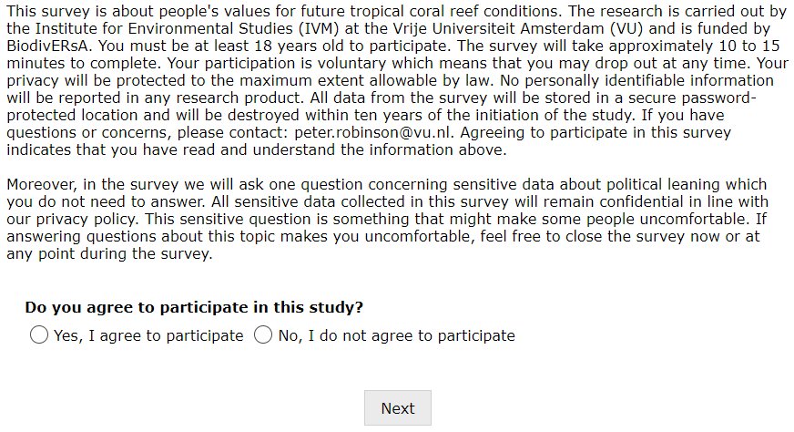
Spanish
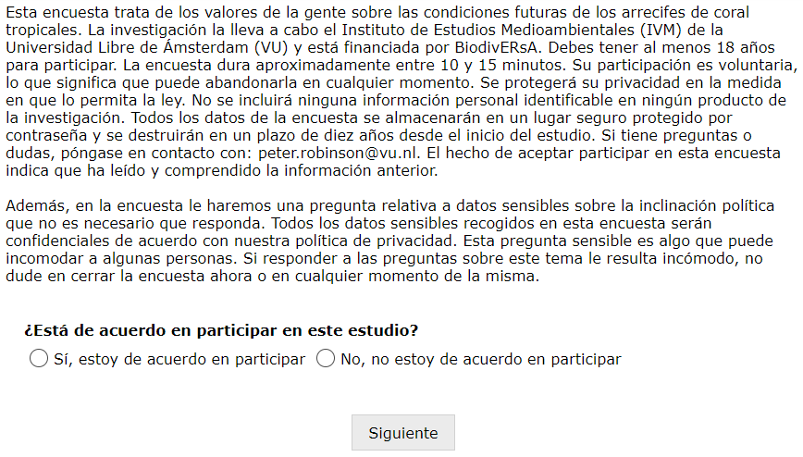

Standard Chinese
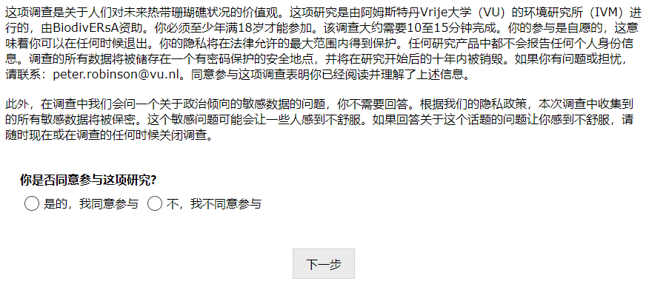
Indonesian
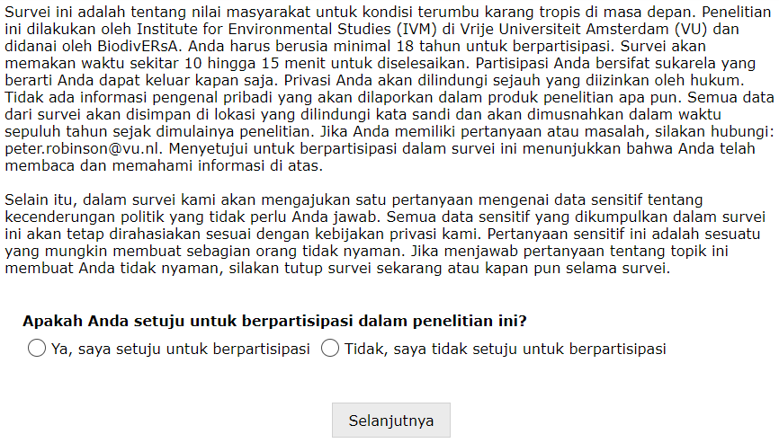

Japanese
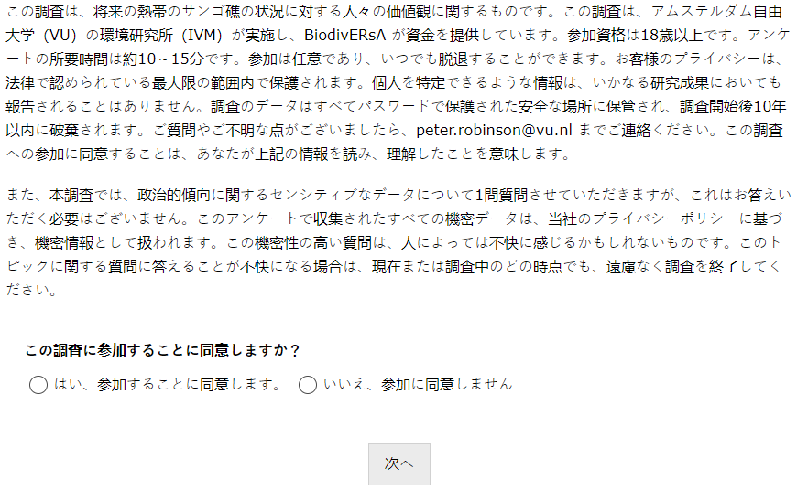
Dutch
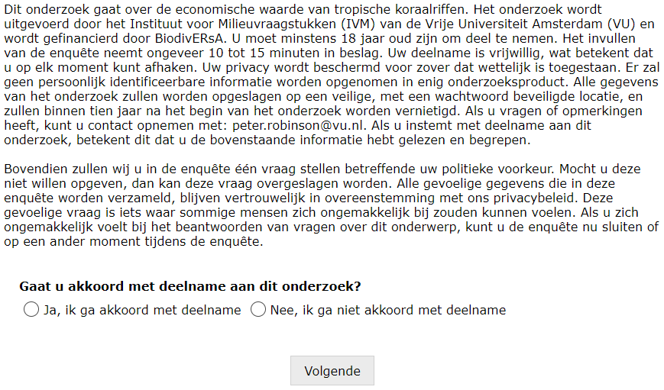

Page 2
English
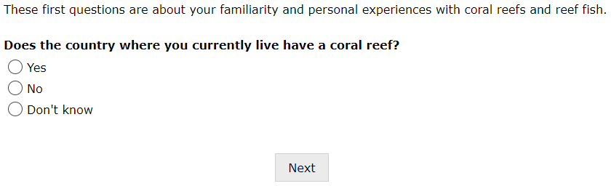
Spanish
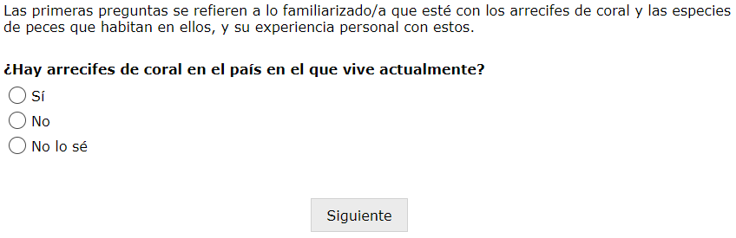
Standard Chinese
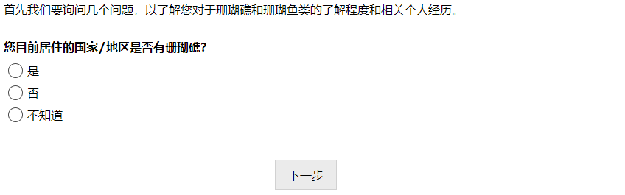

Indonesian
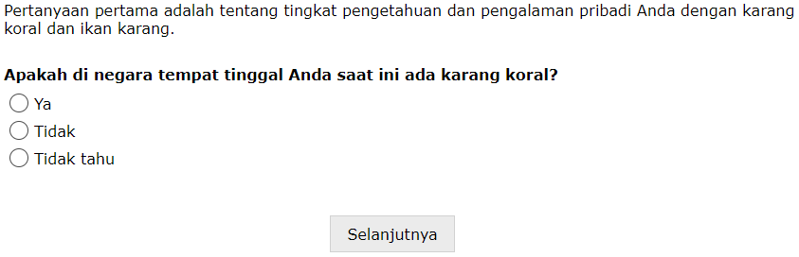
Japanese
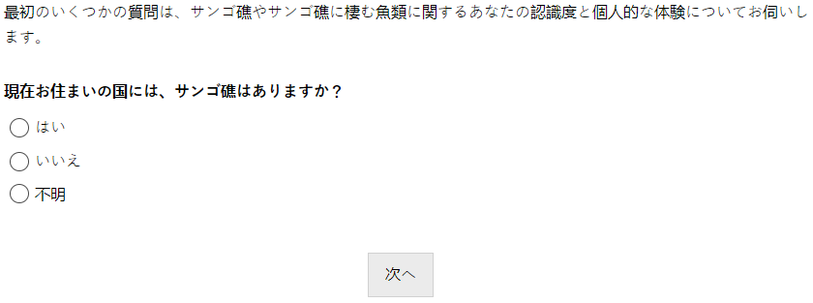
Dutch
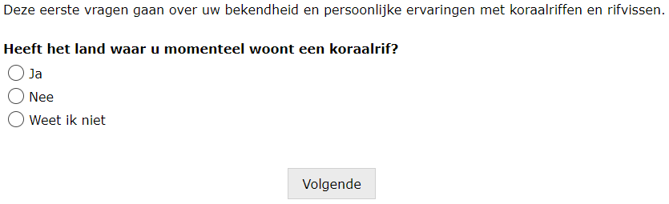

Page 3 (if respondent selects 2nd option skip to page 5)
English

Spanish
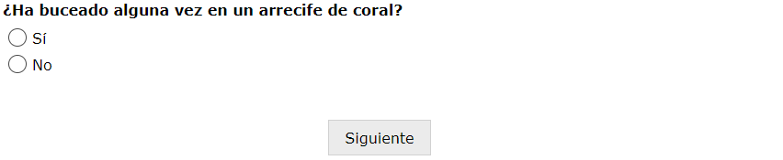
Standard Chinese

Indonesian


Japanese
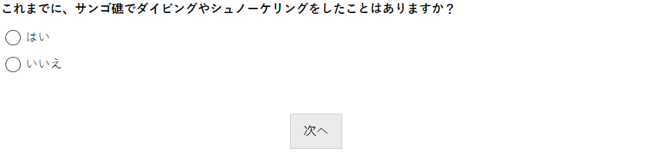

Dutch
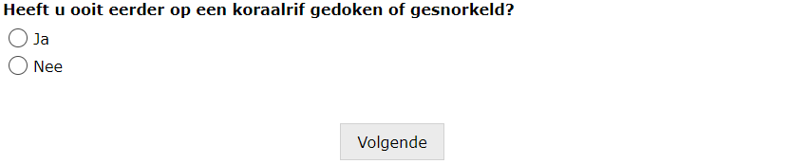
Page 4
English
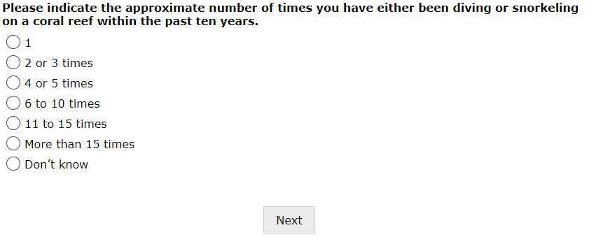

Spanish
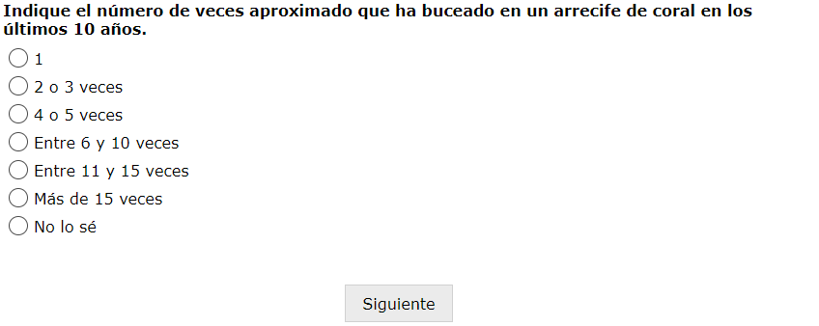
Standard Chinese
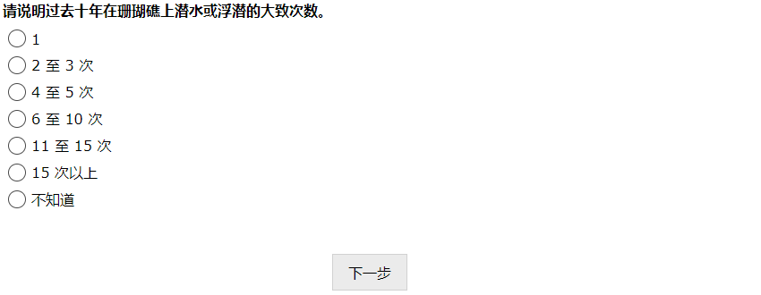
Indonesian
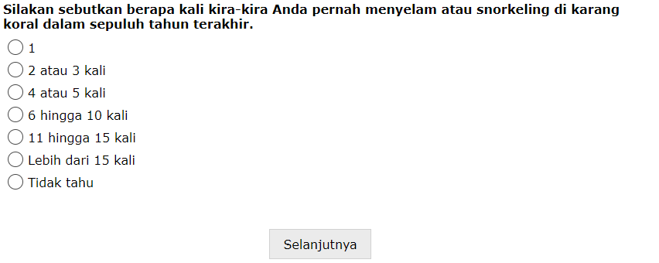

Japanese
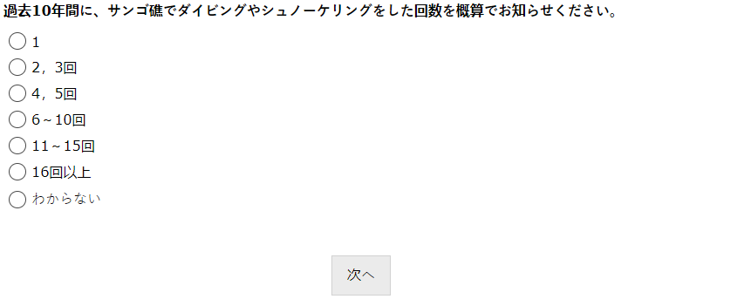
Dutch
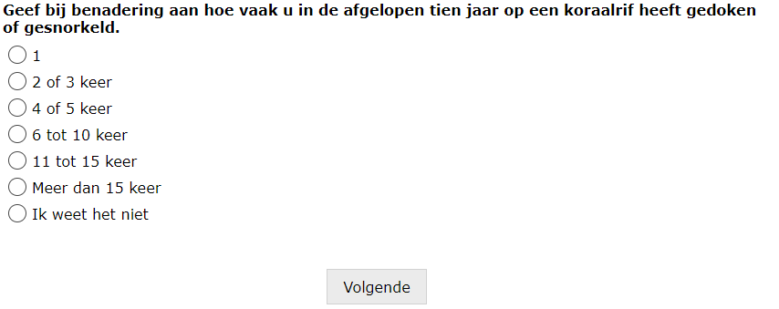
Page 5
English
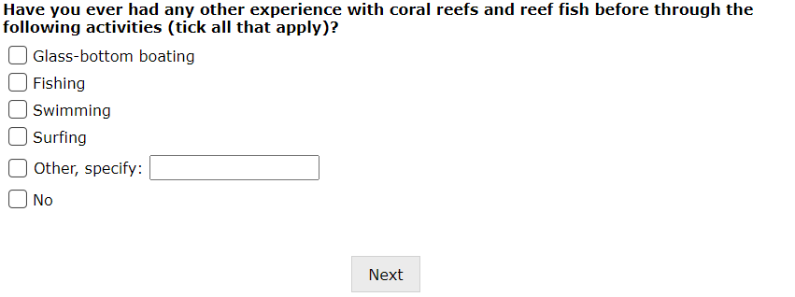
Spanish
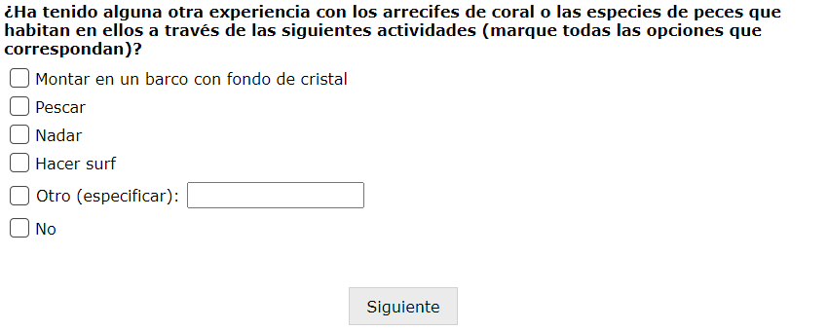
Standard Chinese
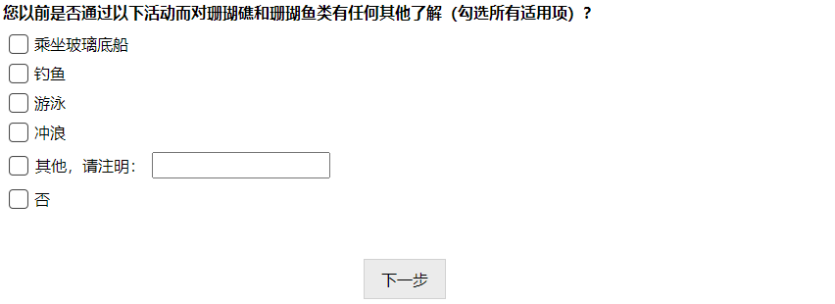
Indonesian
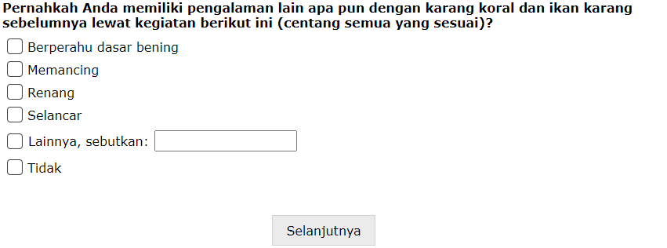

Japanese
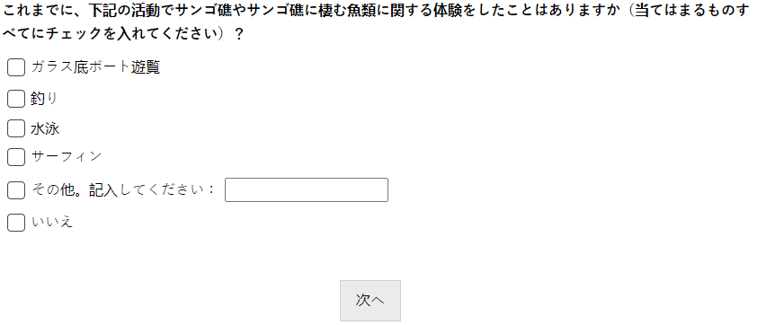
Dutch
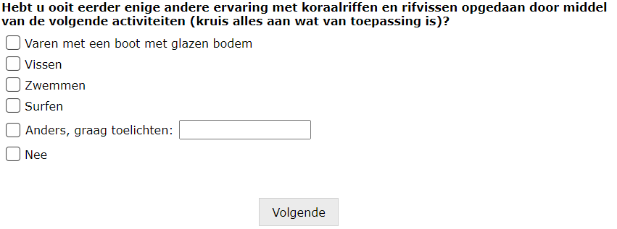
Page 6 (if respondent selects 1st or 2nd option skip to page 8)
English
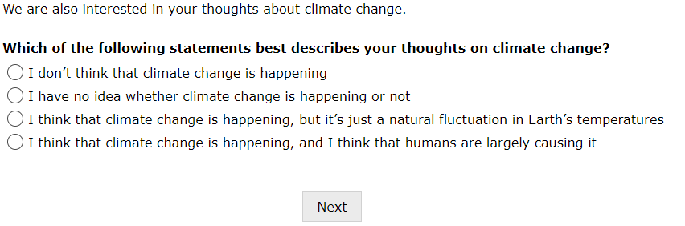

Spanish
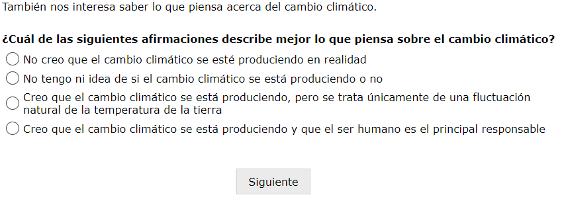
Standard Chinese
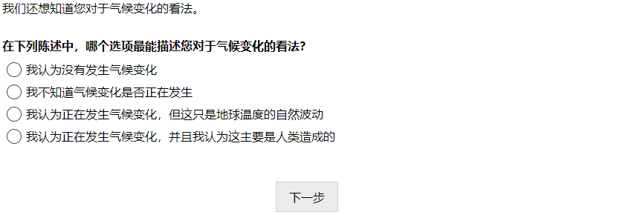
Indonesian
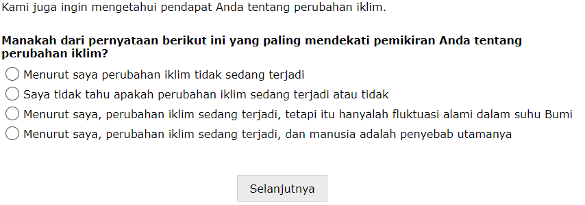

Japanese
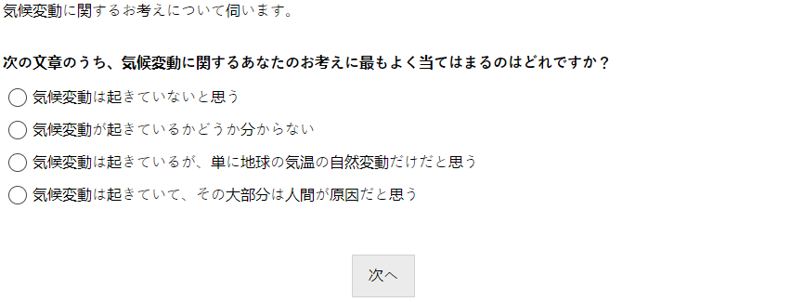
Dutch
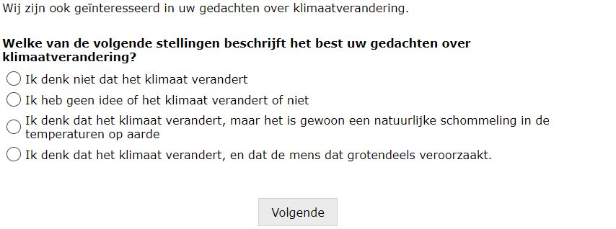
Page 7
English
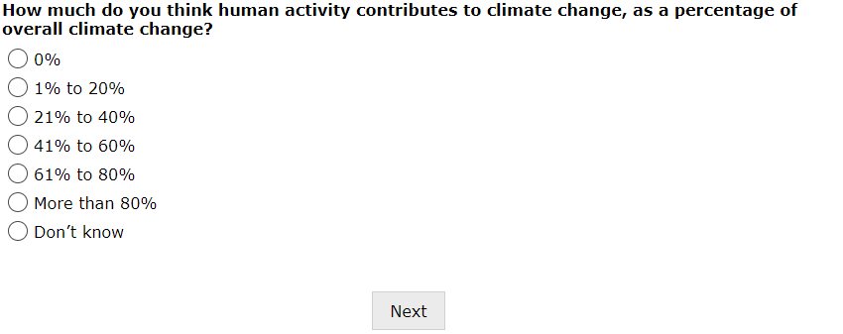

Spanish
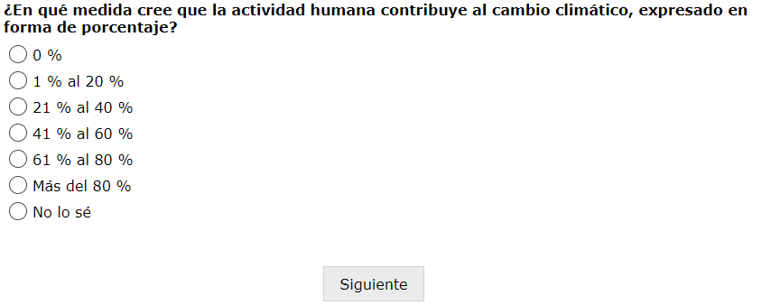
Standard Chinese
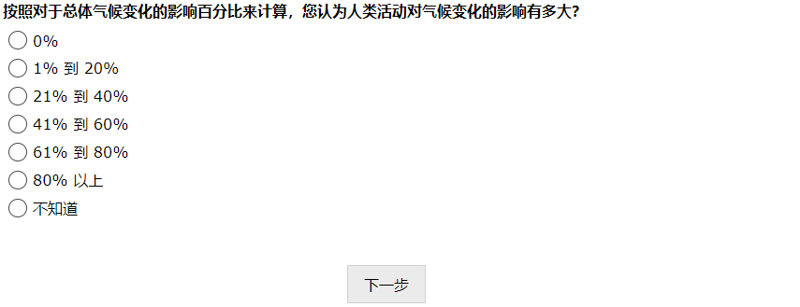
Indonesian
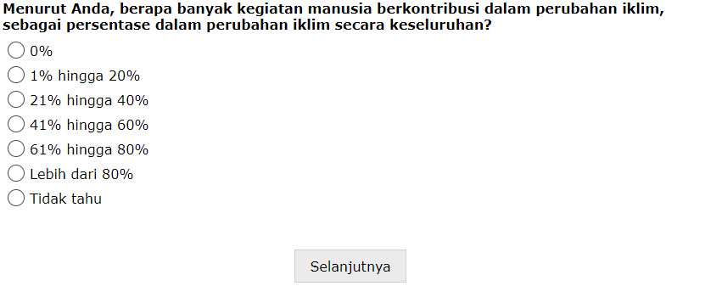

Japanese
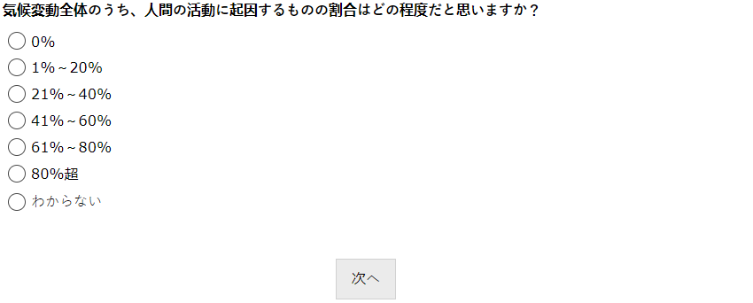
Dutch
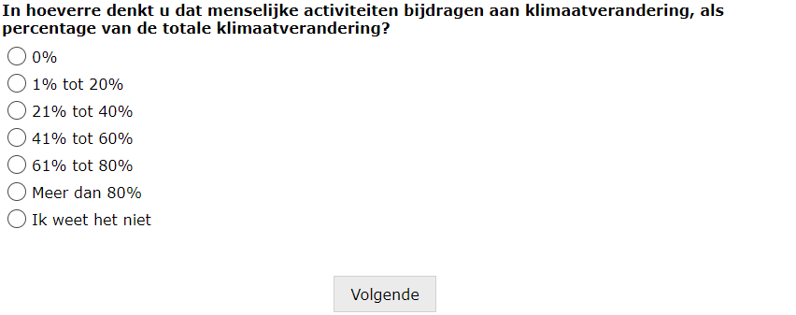
Page 8 (if respondent selects 2nd option skip to page 10)
English
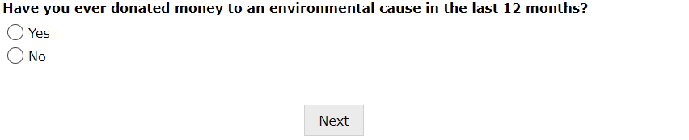

Spanish
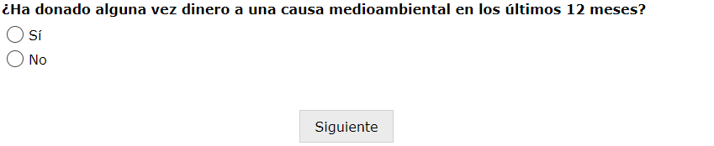
Standard Chinese
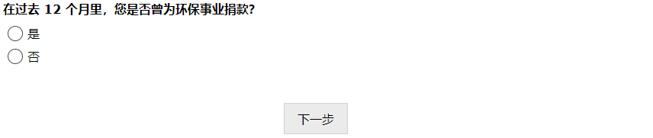
Indonesian
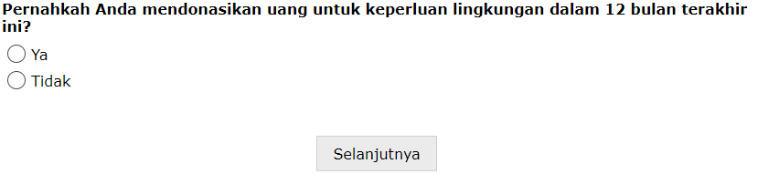
Japanese
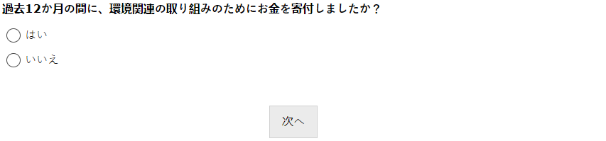
Dutch
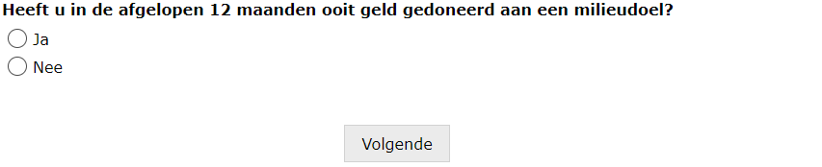
Page 9
English
Australia
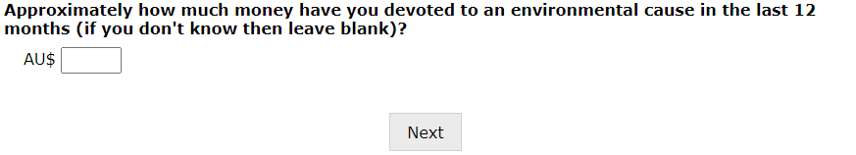
Ghana
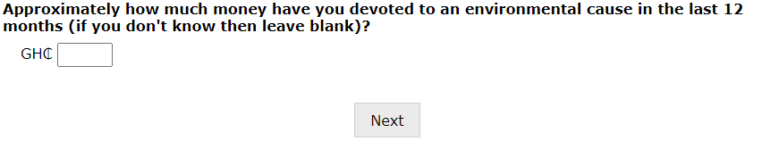
Kenya
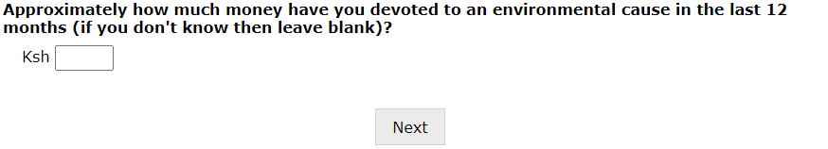
New Zealand
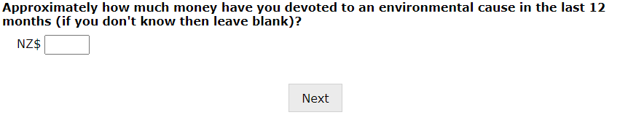
United Kingdom
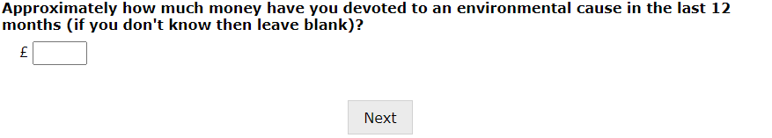
United States
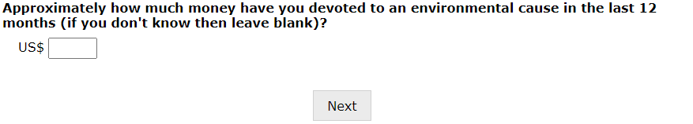
Spanish
Chile
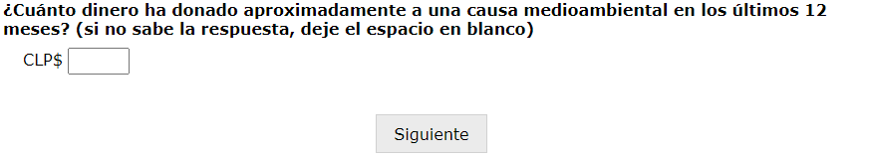
Colombia
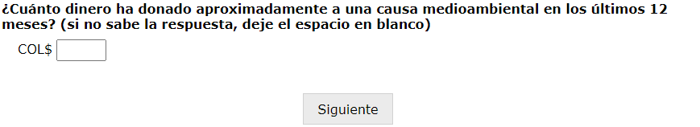
Standard Chinese
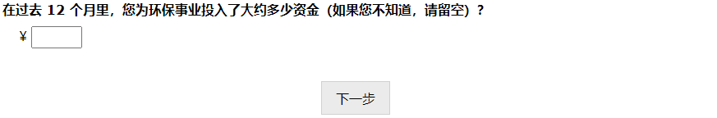
Indonesian
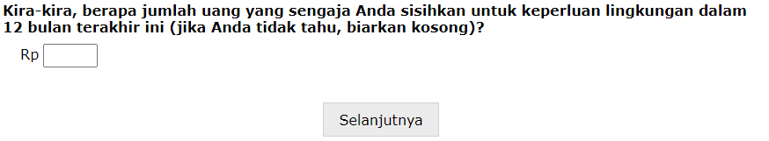

Japanese
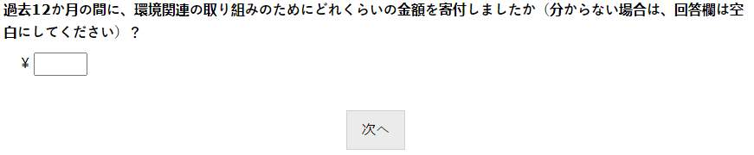
Dutch
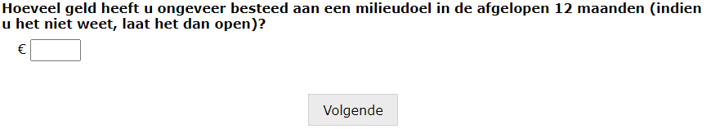
Page 10 (if respondent selects 2nd or 3rd option skip to page 28)
English
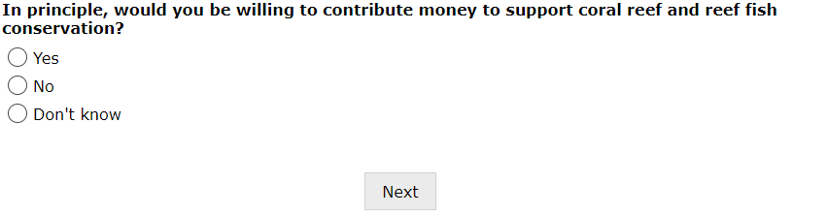
Spanish
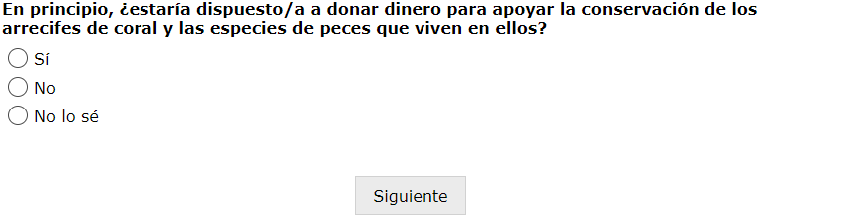

Standard Chinese
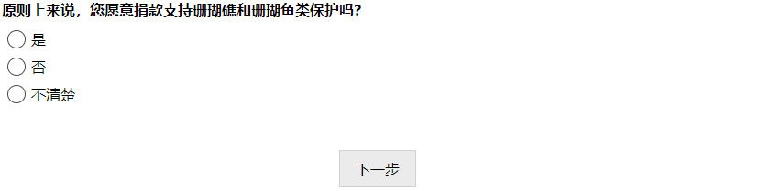
Indonesian
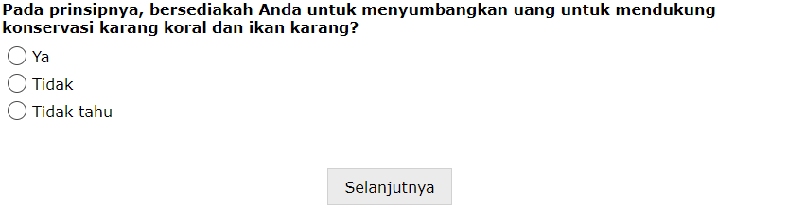
Japanese
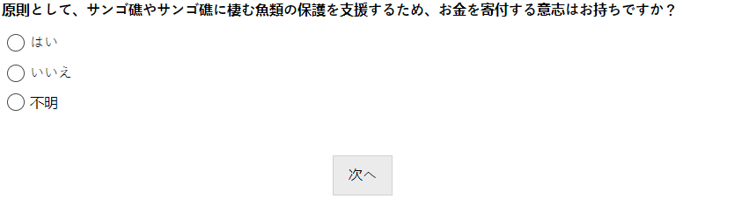
Dutch
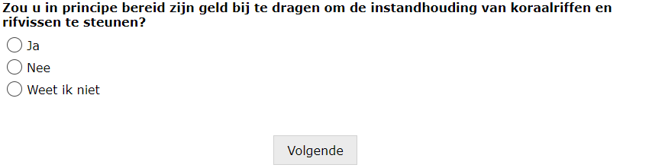

Page 11
English
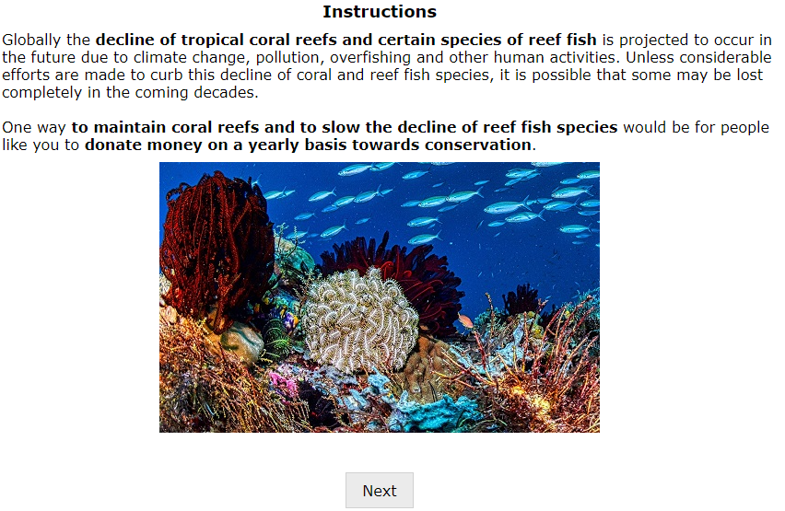

Spanish
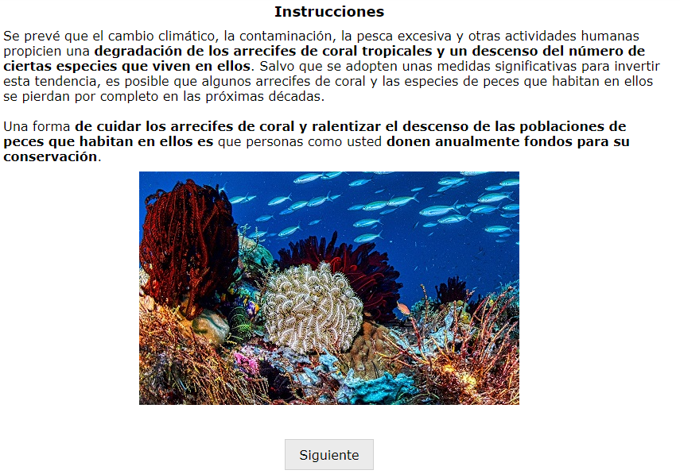
Standard Chinese
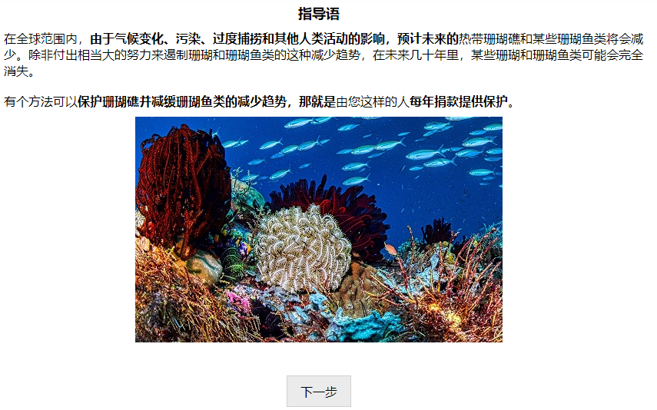
Indonesian
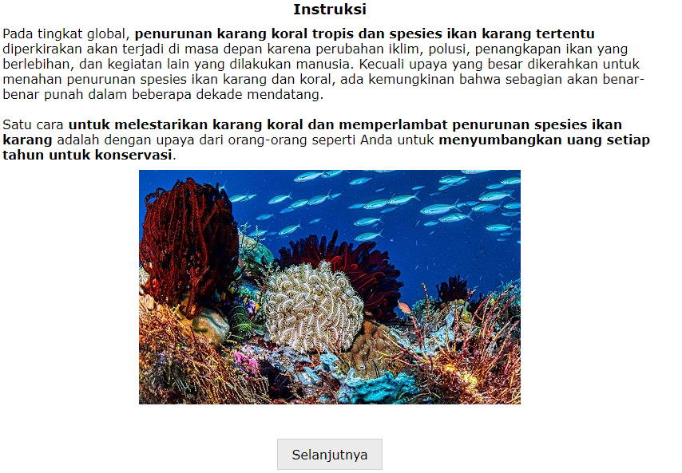
Japanese
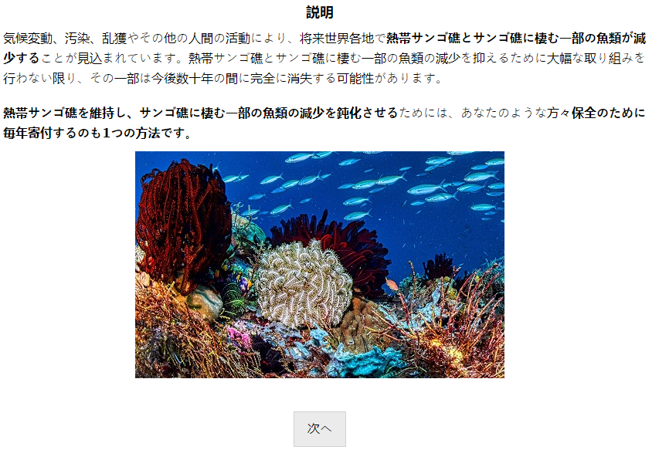
Dutch
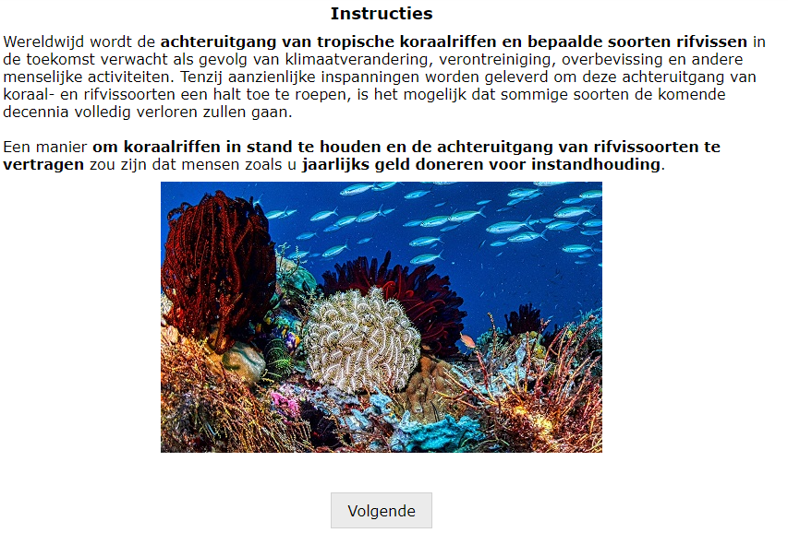

Page 12
English
Australia
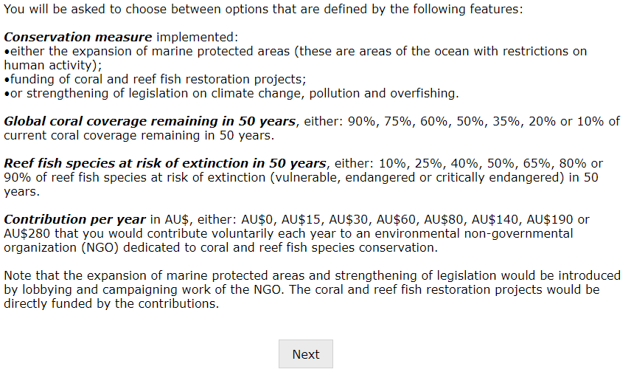
Ghana
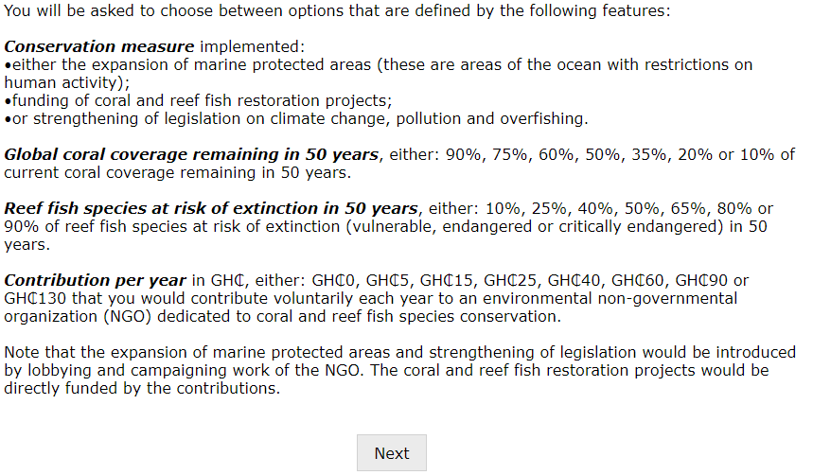

Kenya
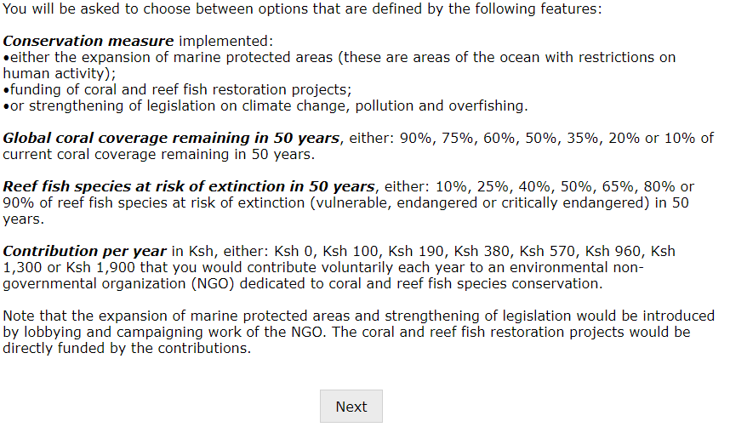
New Zealand
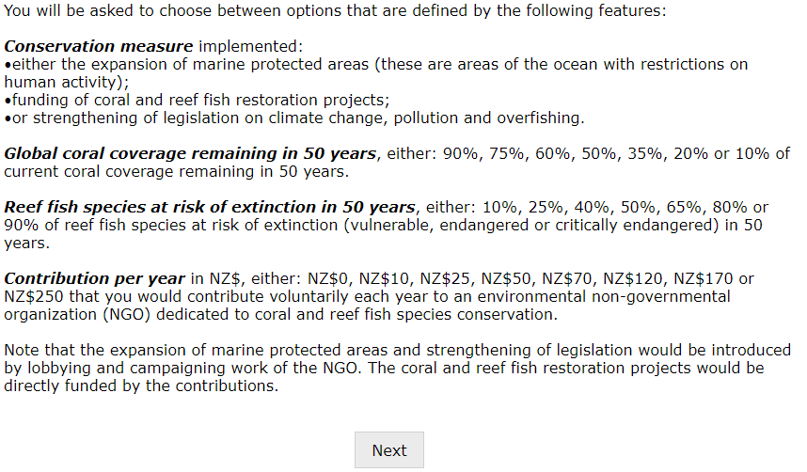

United Kingdom
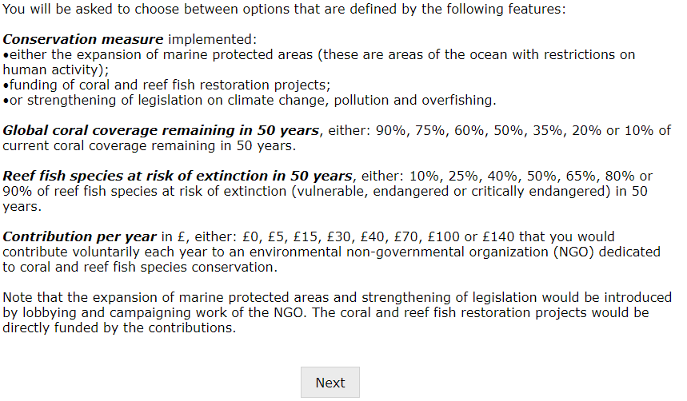
United States
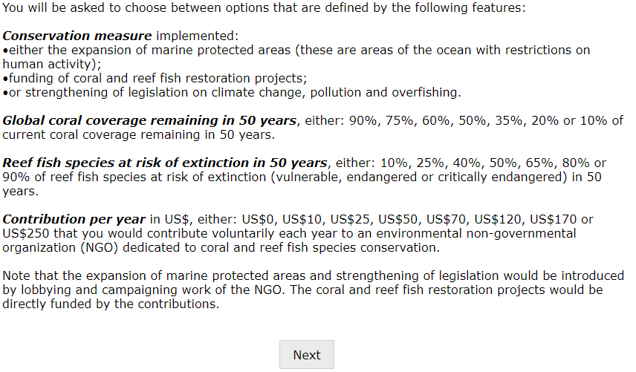

Spanish
Chile
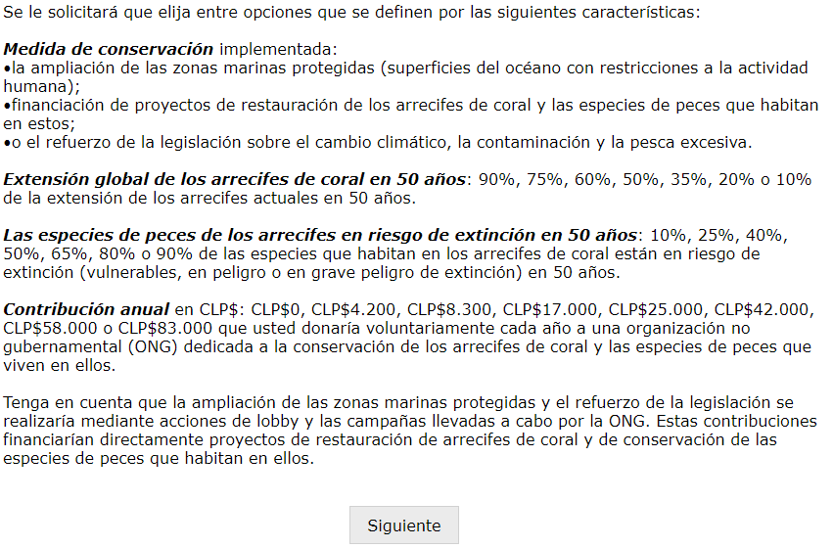
Colombia
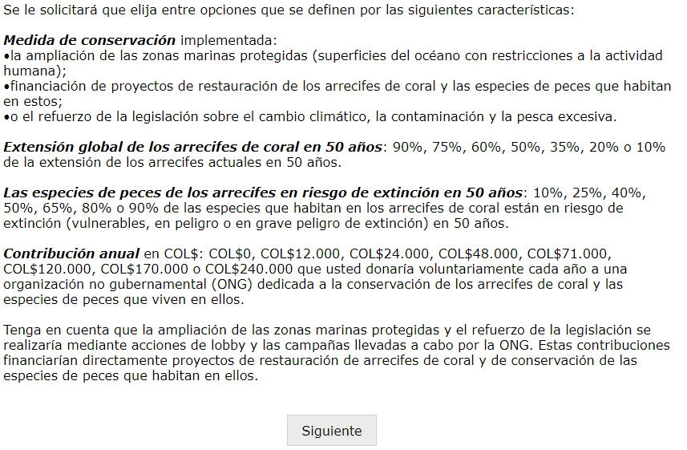
Standard Chinese
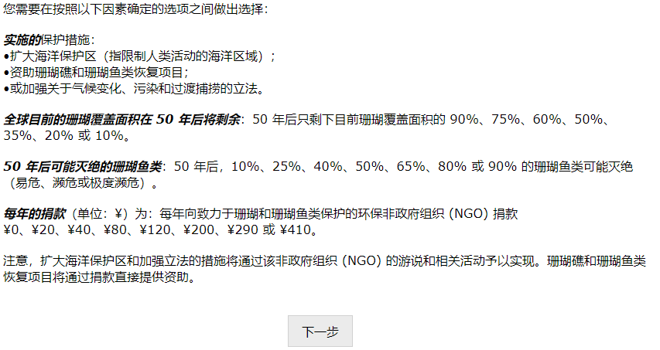
Indonesian
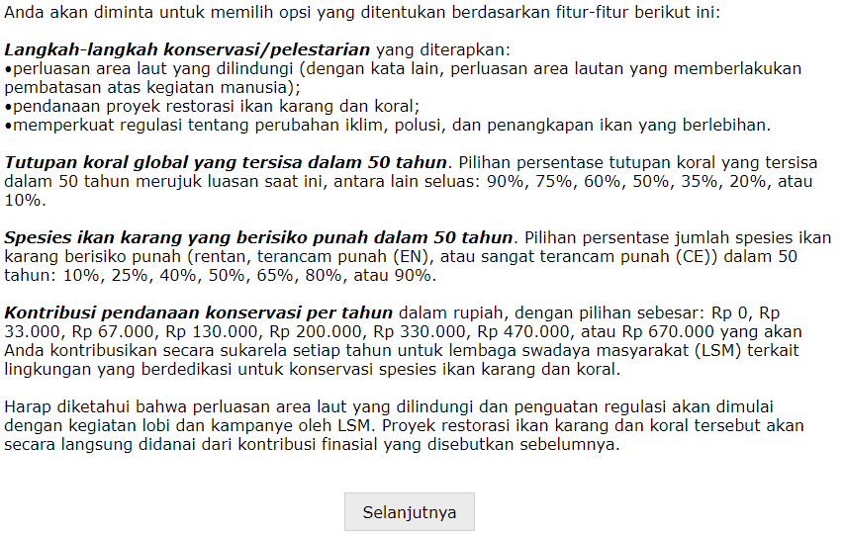

Japanese
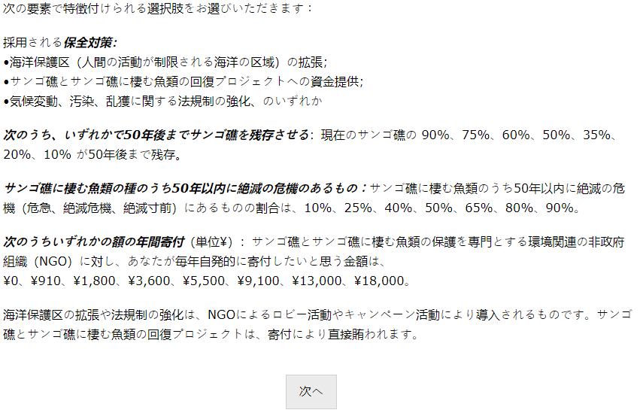
Dutch
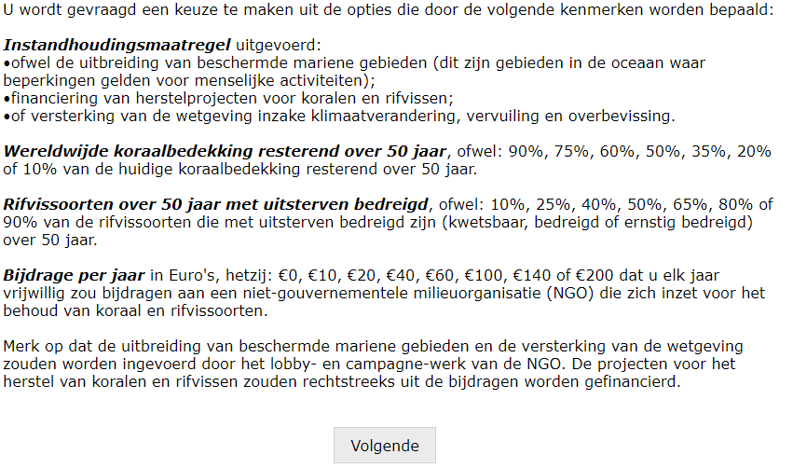

Page 13
English
Australia
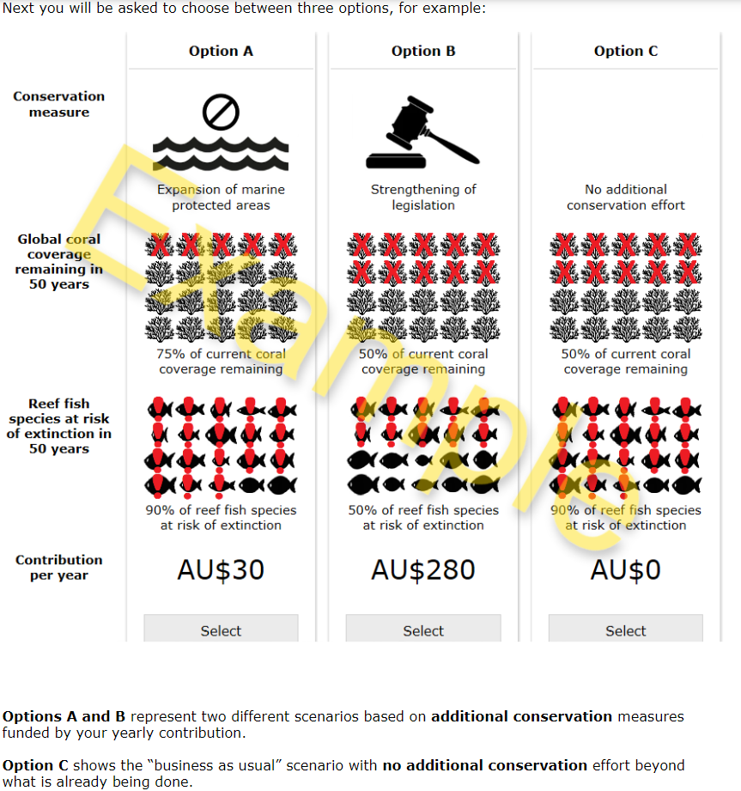
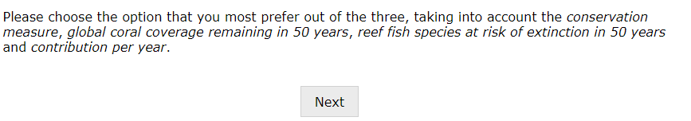

Ghana
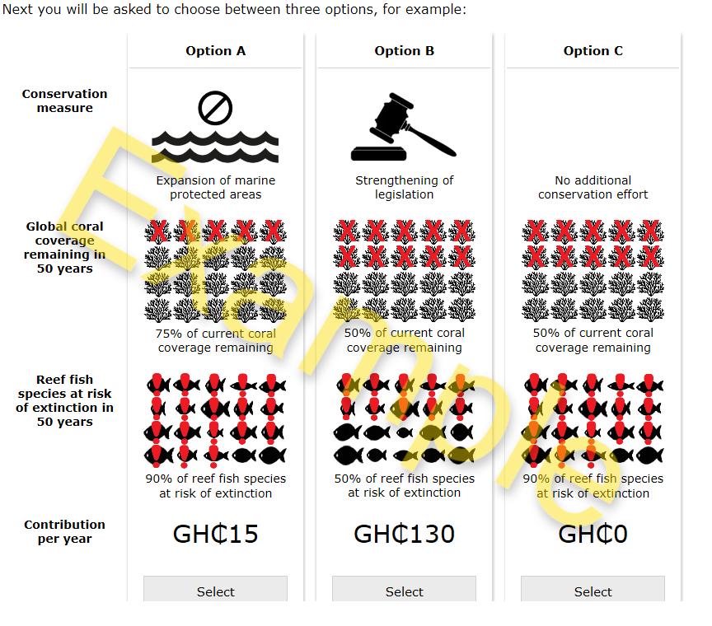
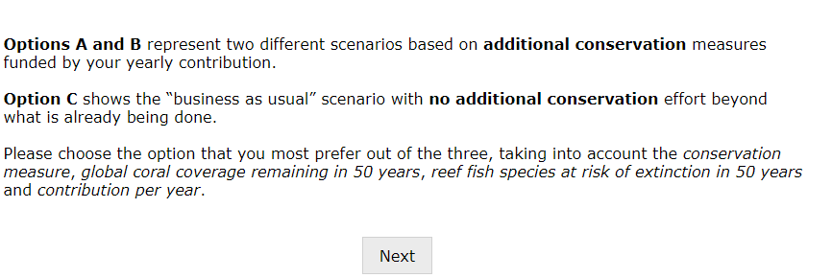

Kenya
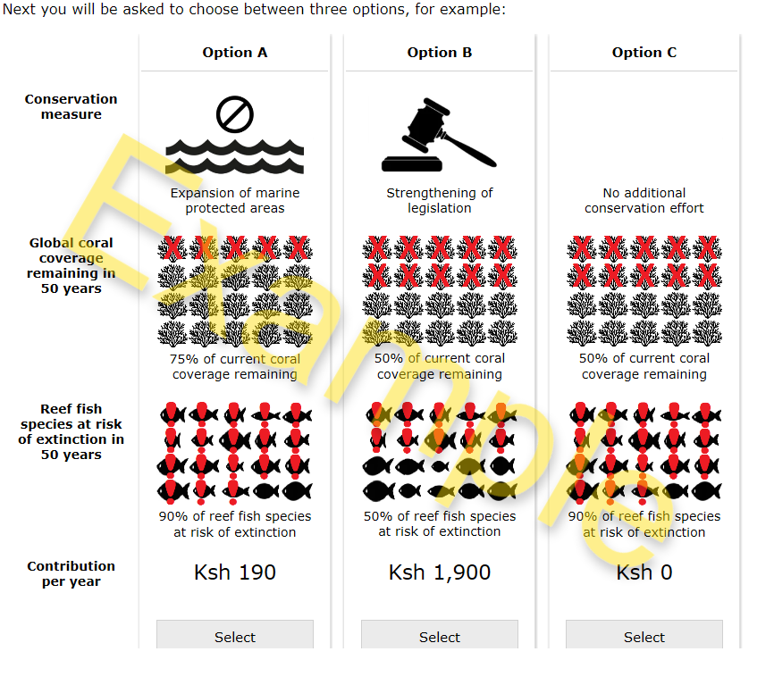

New Zealand
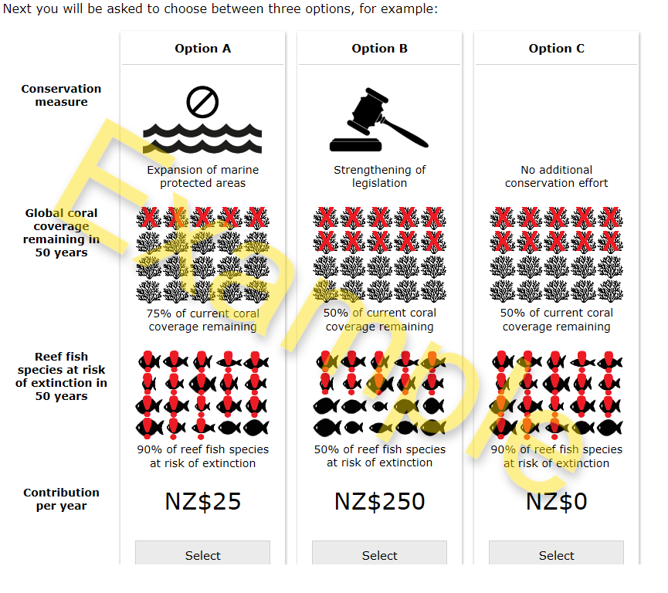

United Kingdom
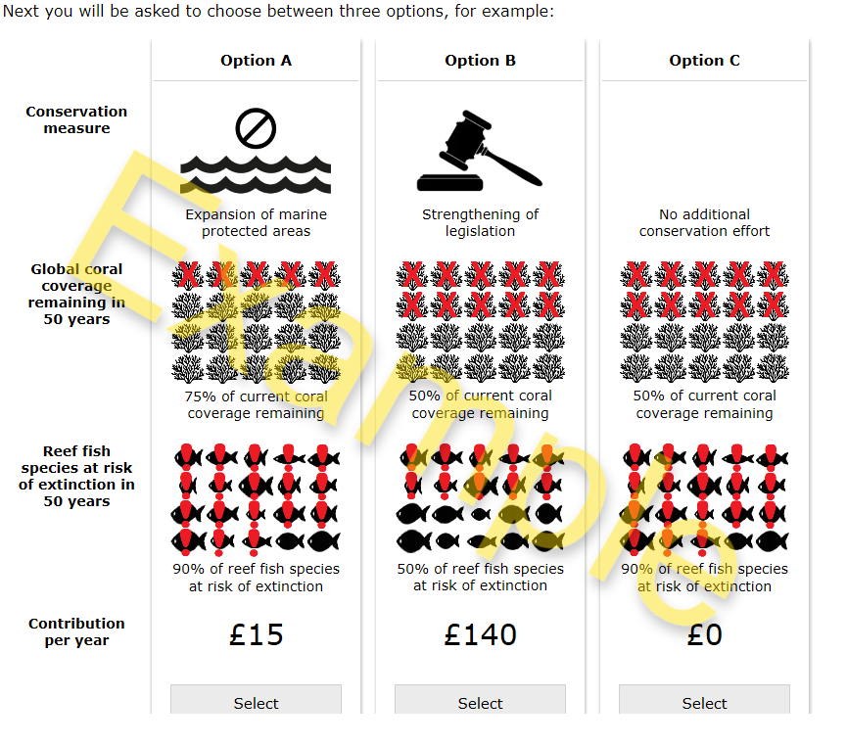

United States
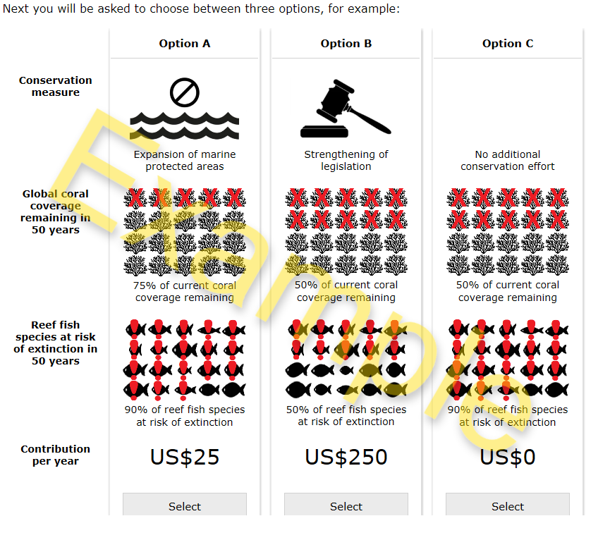

Spanish
Chile
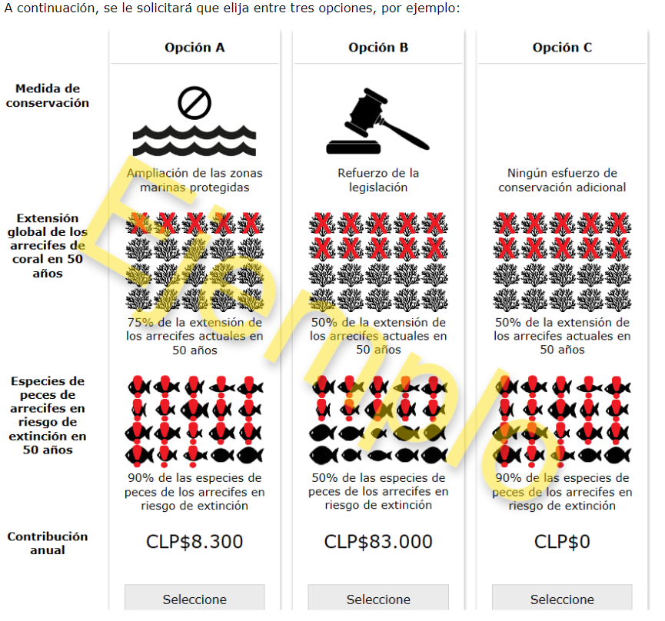
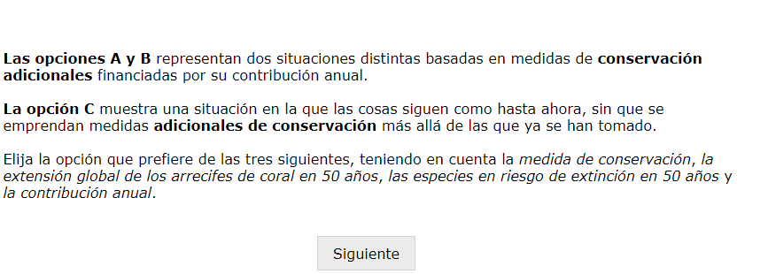

Colombia
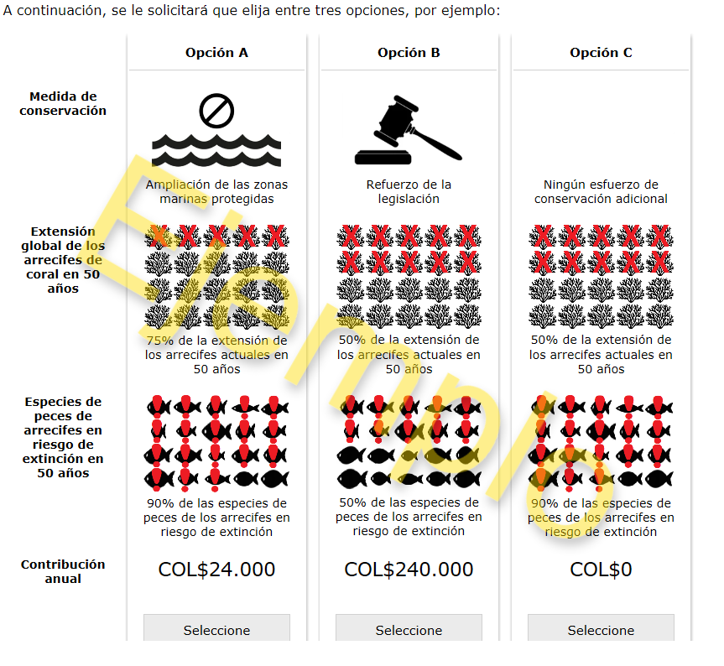

Standard Chinese
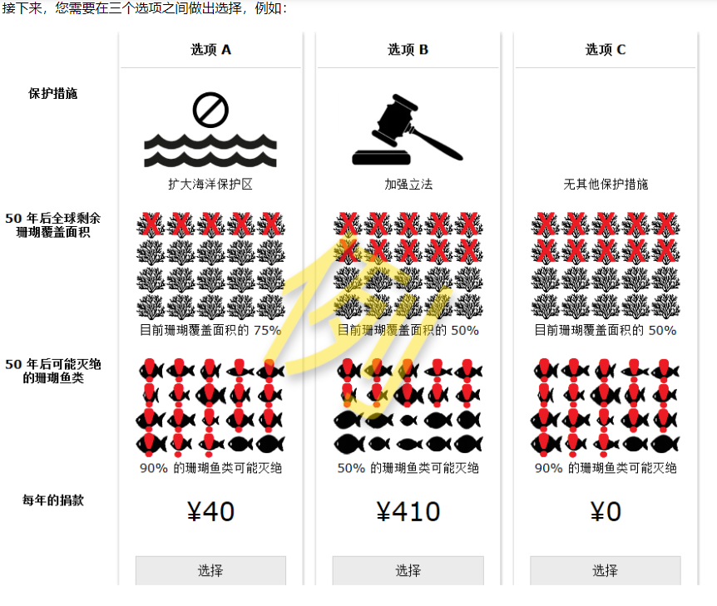
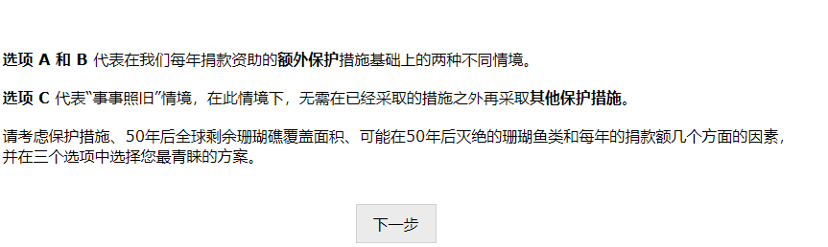

Indonesian
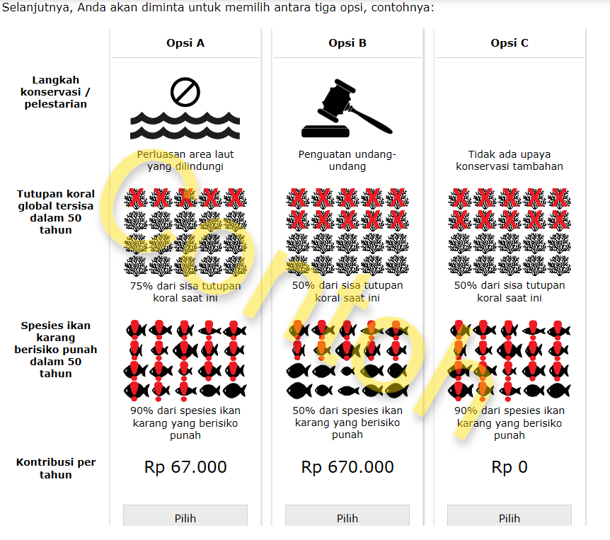
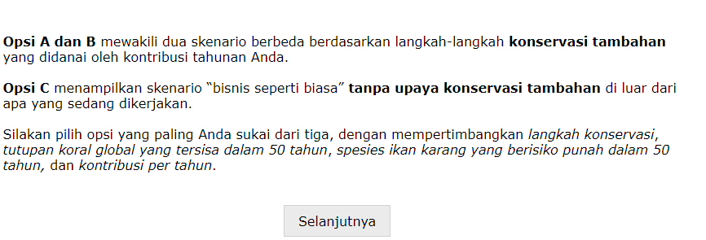

Japanese
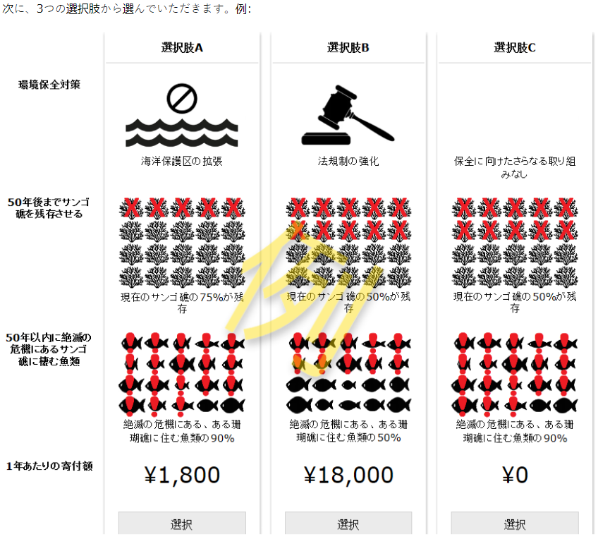
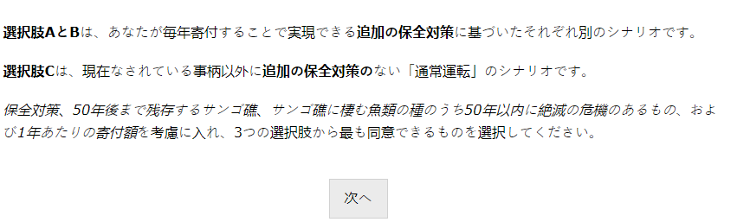

Dutch
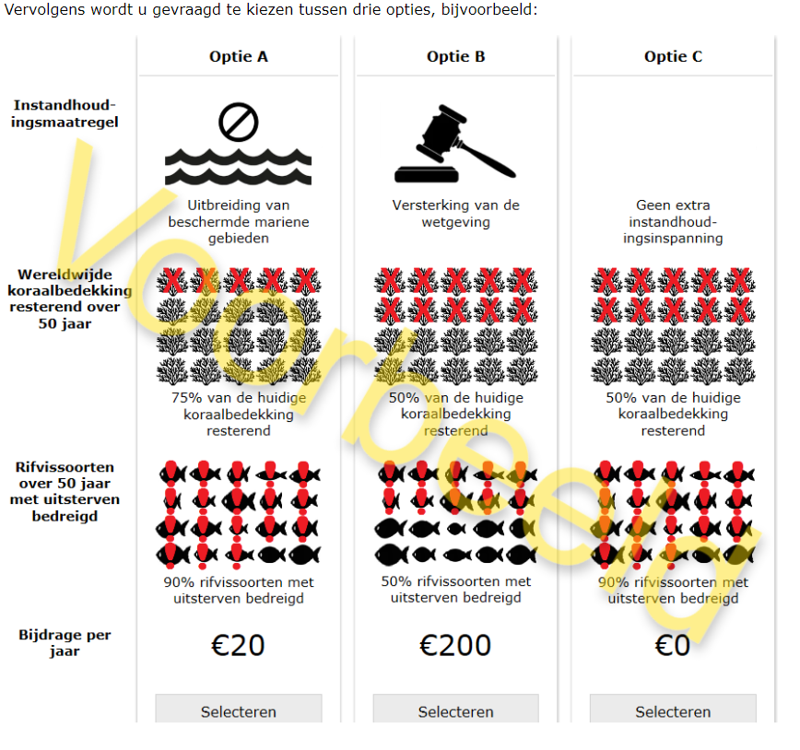
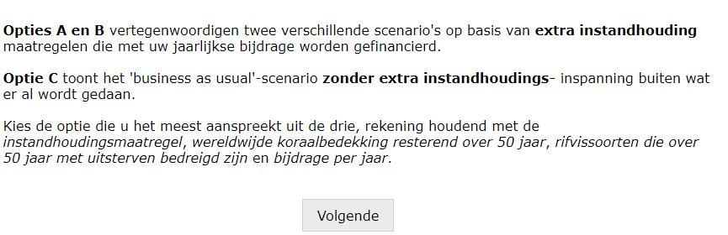

Page 14
English
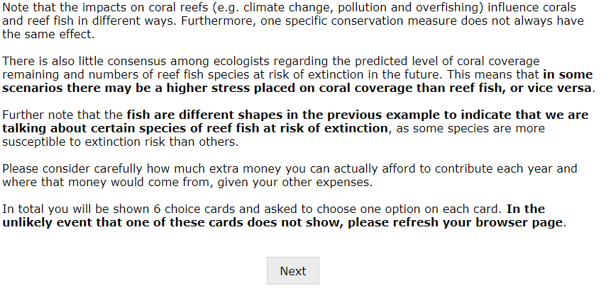
Spanish
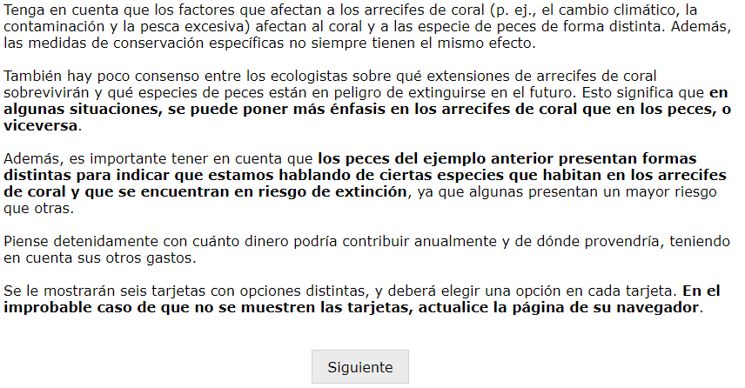

Standard Chinese
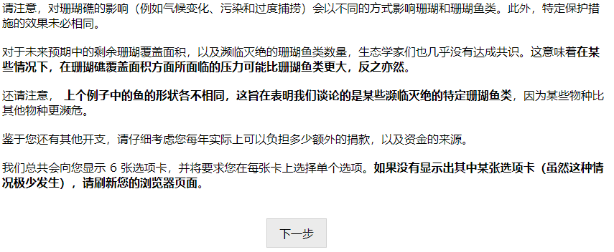
Indonesian
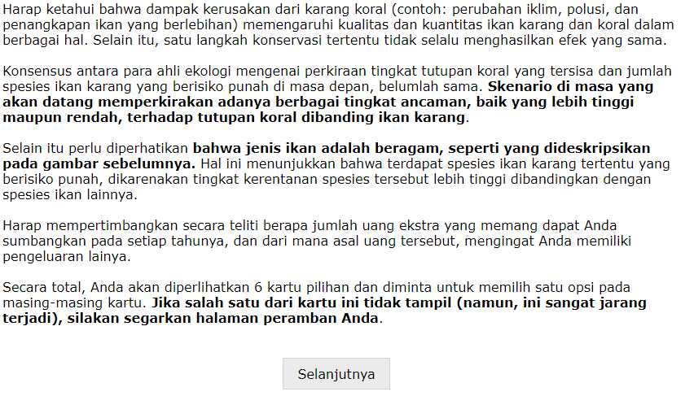

Japanese
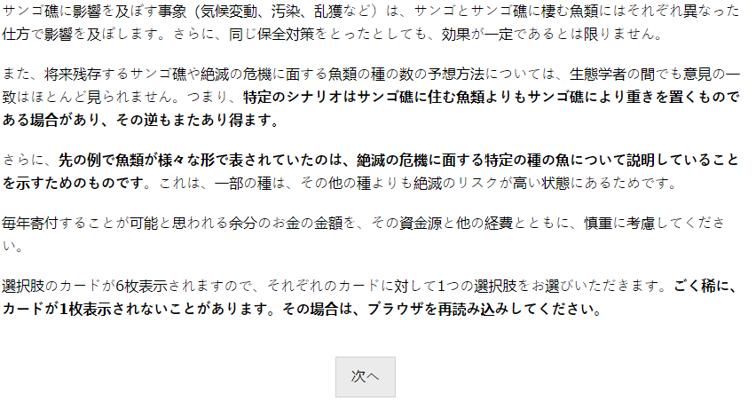
Dutch
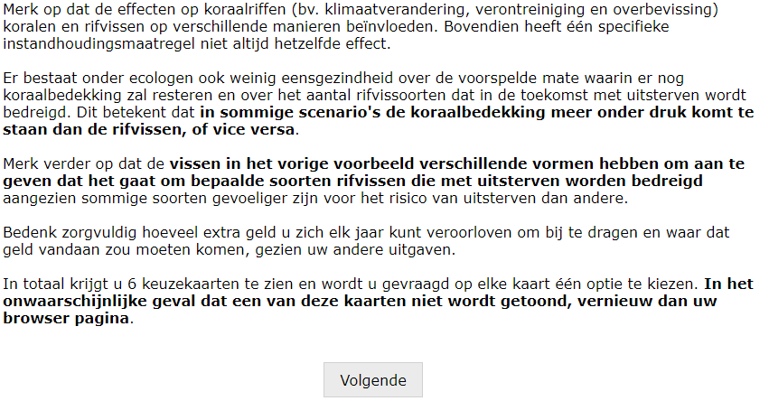

Pages 15, 16, 17, 18, 19 and 20 are discrete choice experiment tasks
English
{Insert choice set}
Spanish
{Insert choice card}
Standard Chinese
{Insert choice card}
Indonesian
{Insert choice card}

Japanese
{Insert choice card}
Dutch
{Insert choice card}
Page 21
English
Australia
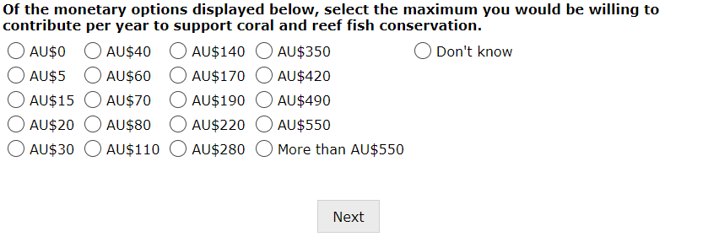

Ghana
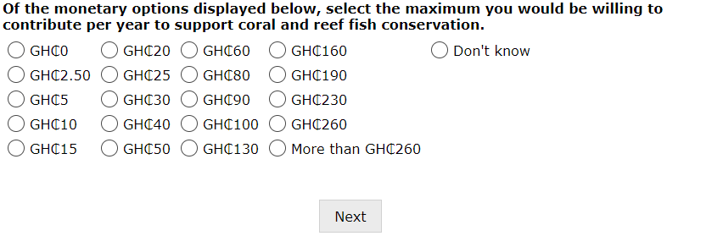
Kenya
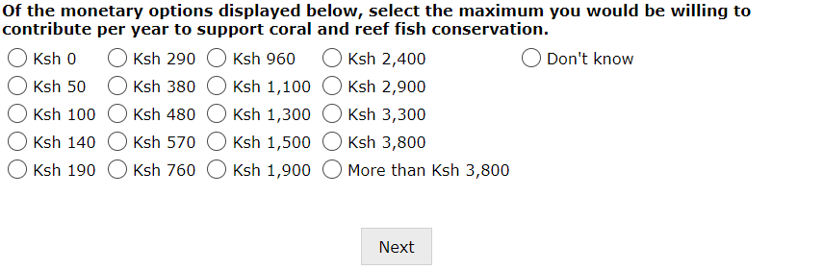
New Zealand
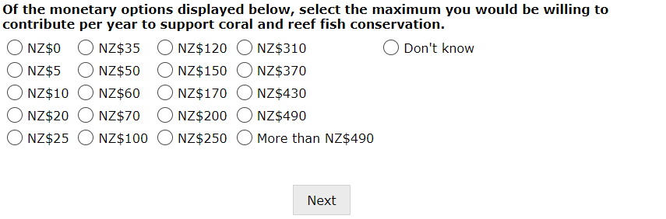

United Kingdom
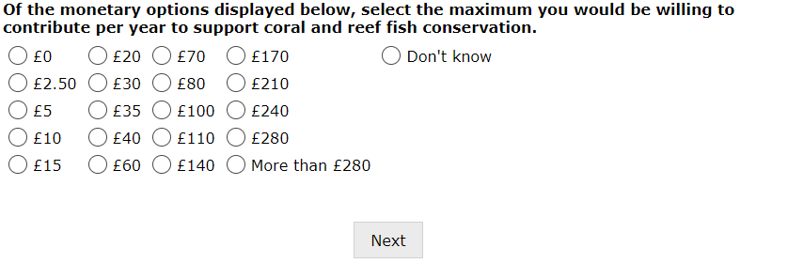
United States
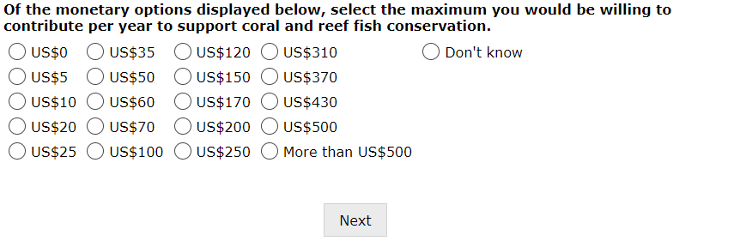
Spanish
Chile
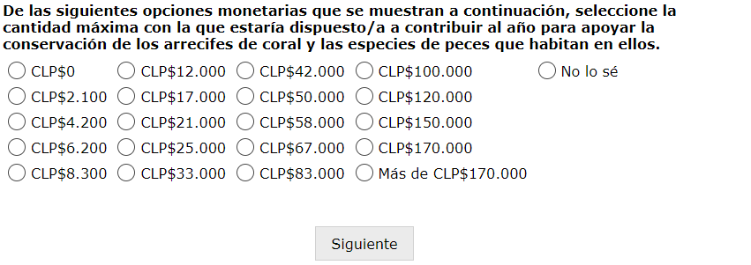

Colombia
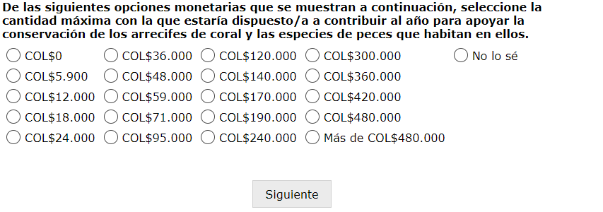
Standard Chinese
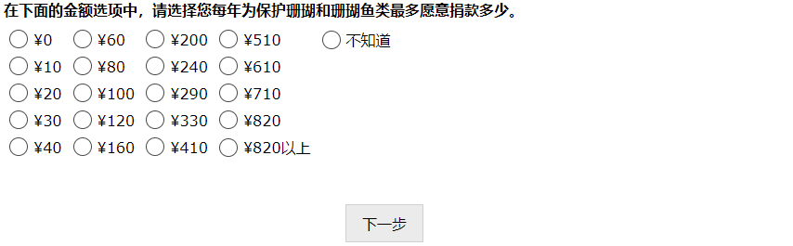
Indonesian
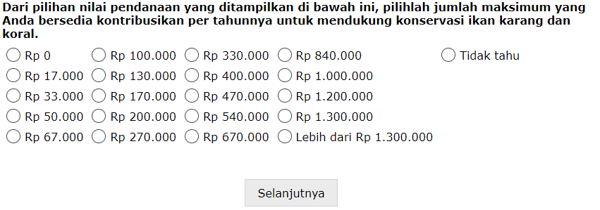

Japanese
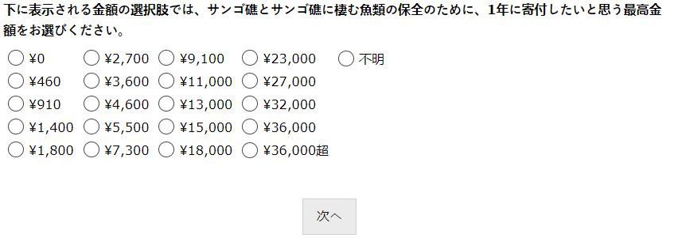
Dutch
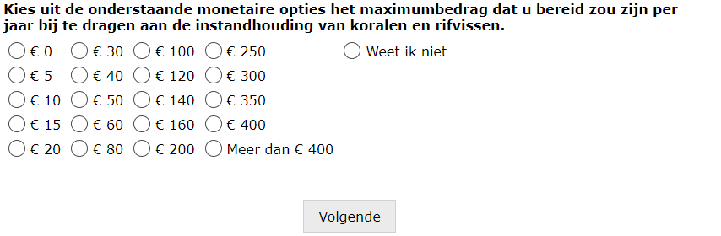
Page 22
English
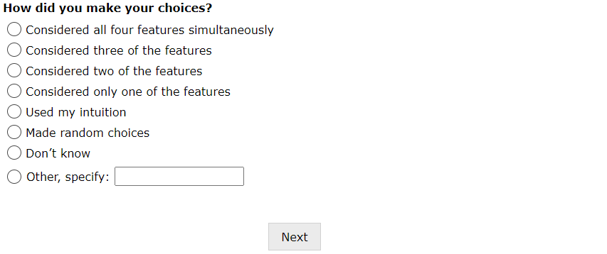

Spanish
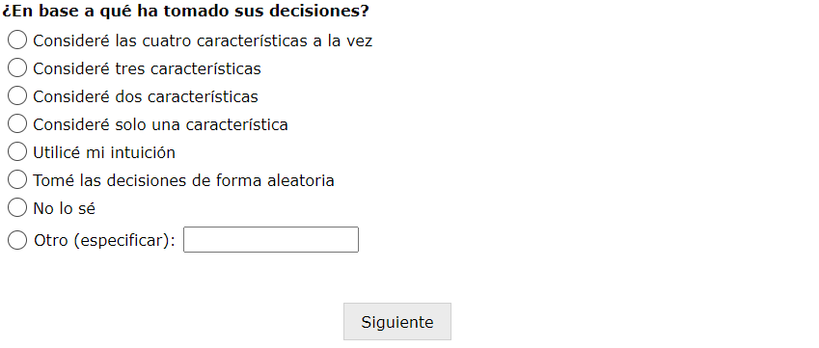
Standard Chinese

Indonesian
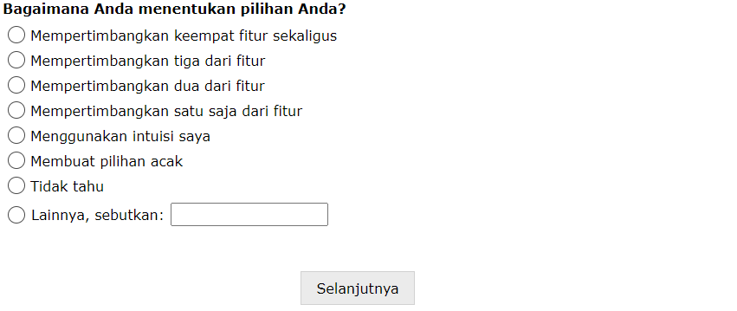
Japanese
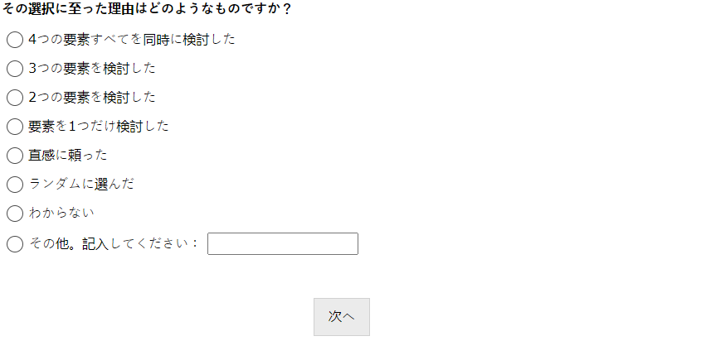
Dutch
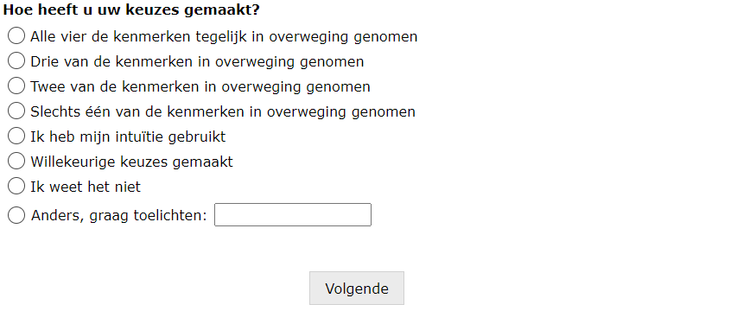
Page 23
English
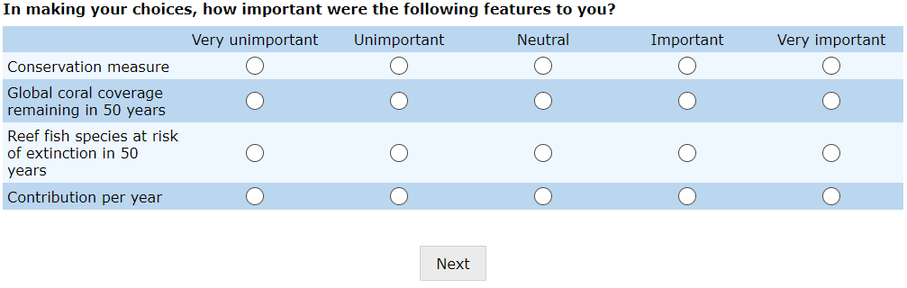
Spanish
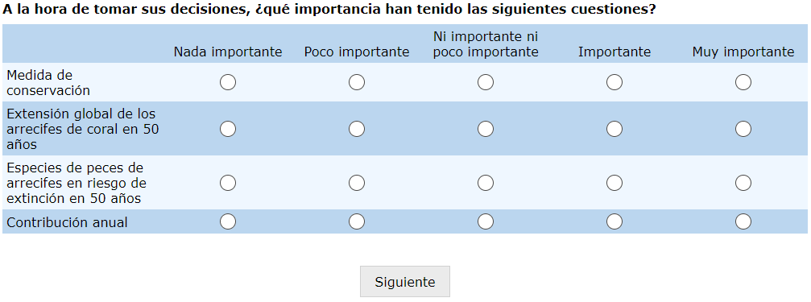
Standard Chinese
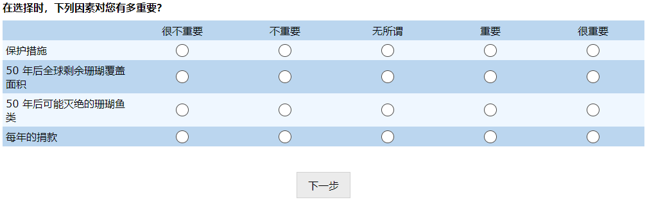
Indonesian
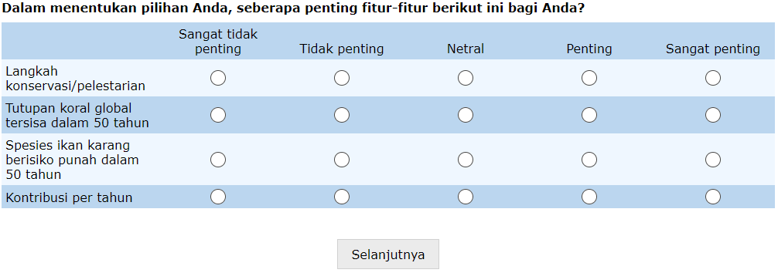

Japanese
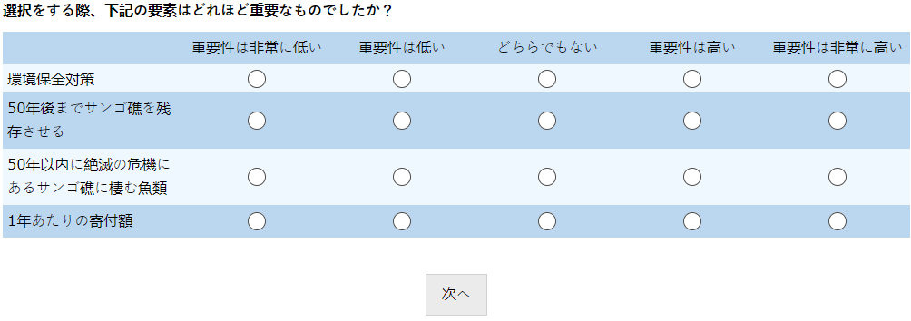
Dutch
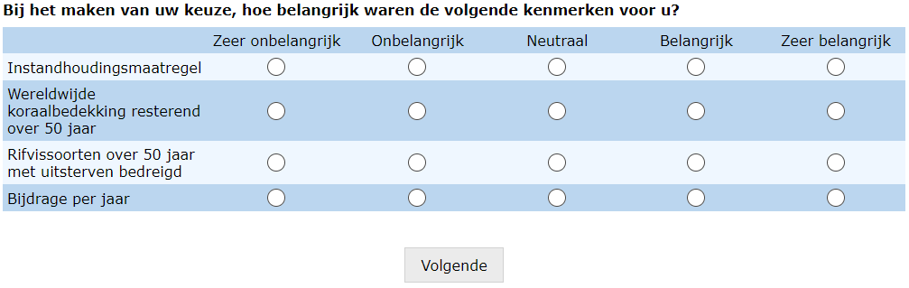
Page 24
English
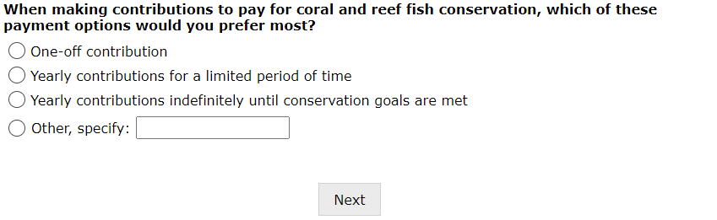

Spanish
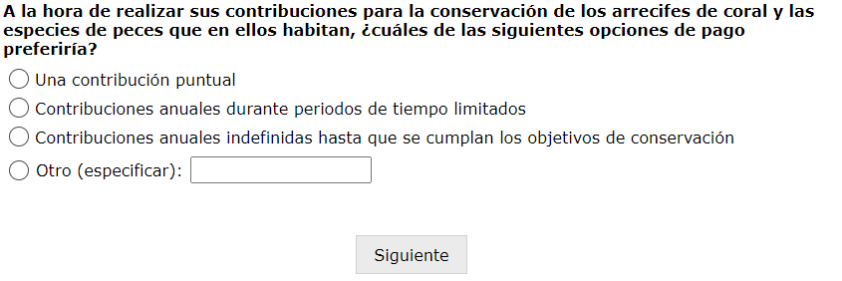
Standard Chinese

Indonesian
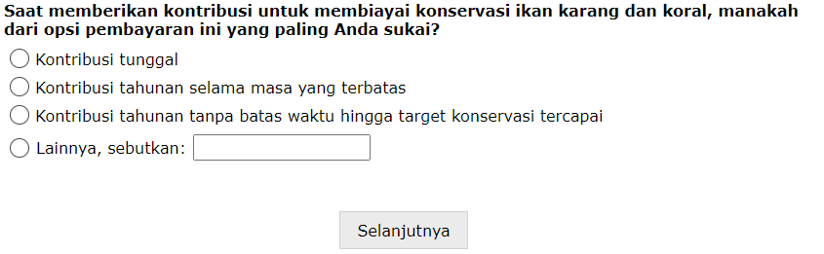

Japanese
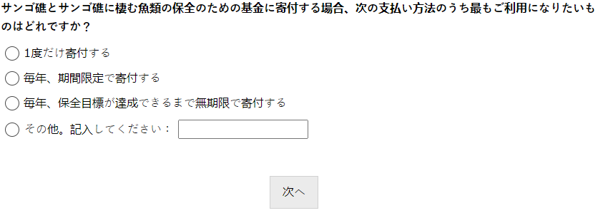
Dutch
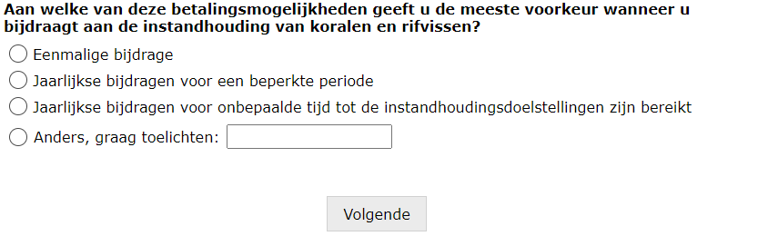
Page 25
English
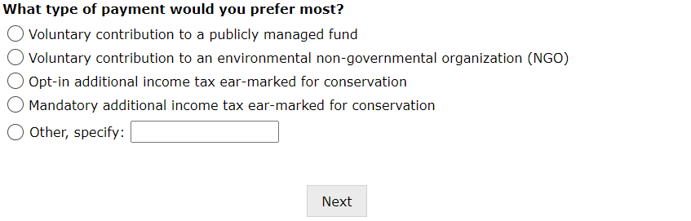

Spanish
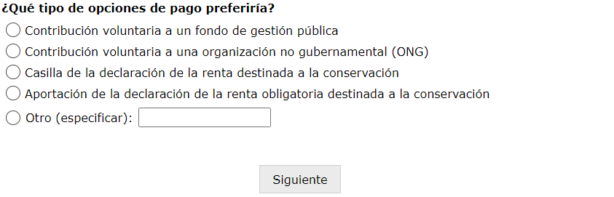
Standard Chinese
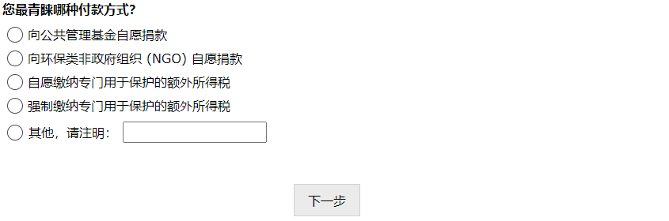
Indonesian
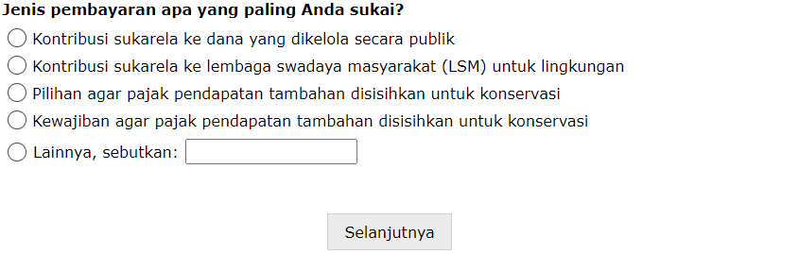

Japanese
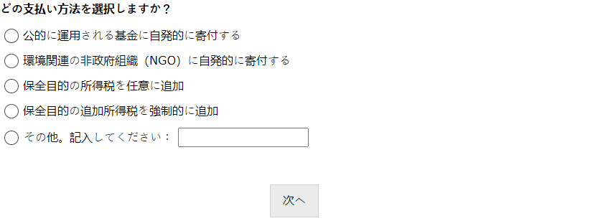
Dutch
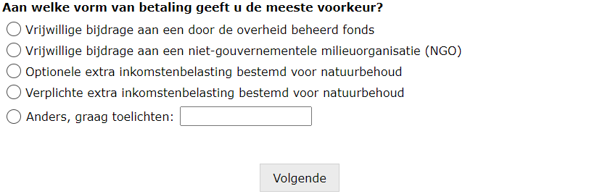

Page 26
English
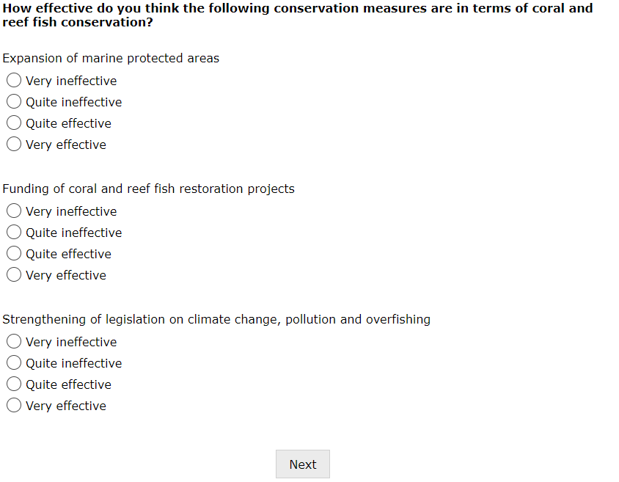

Spanish
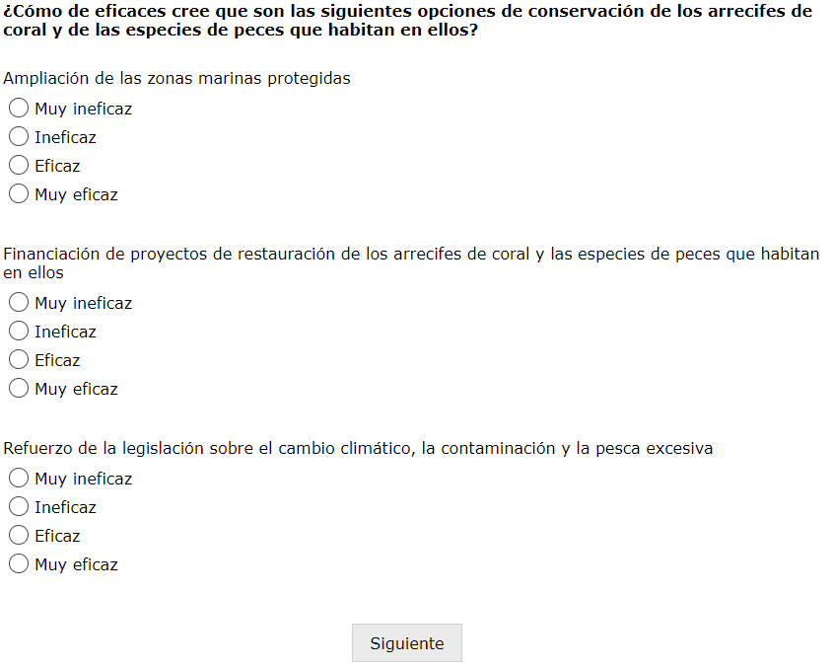

Standard Chinese
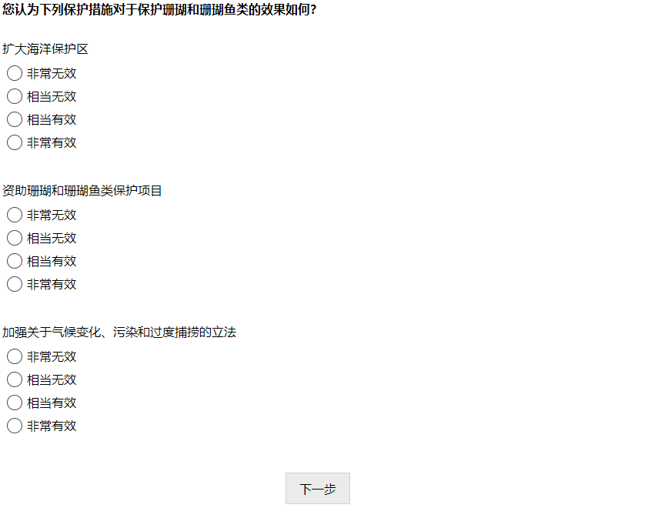

Indonesian
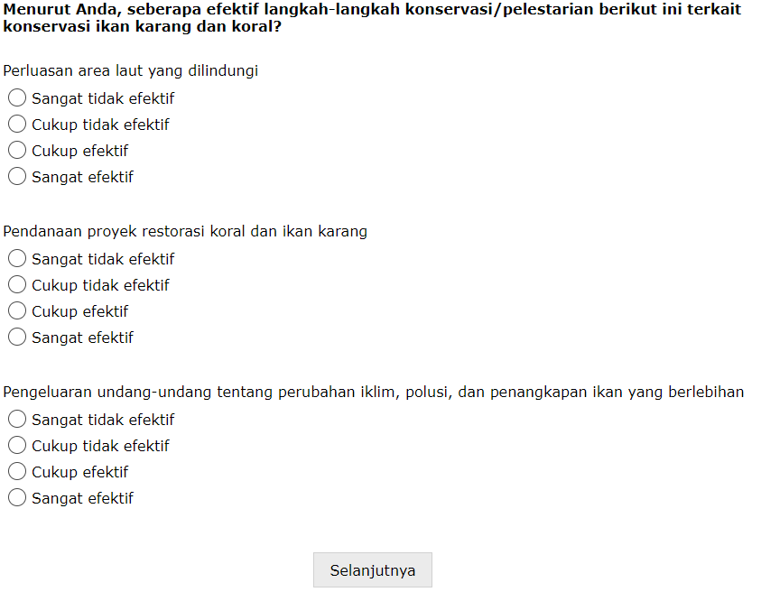

Japanese
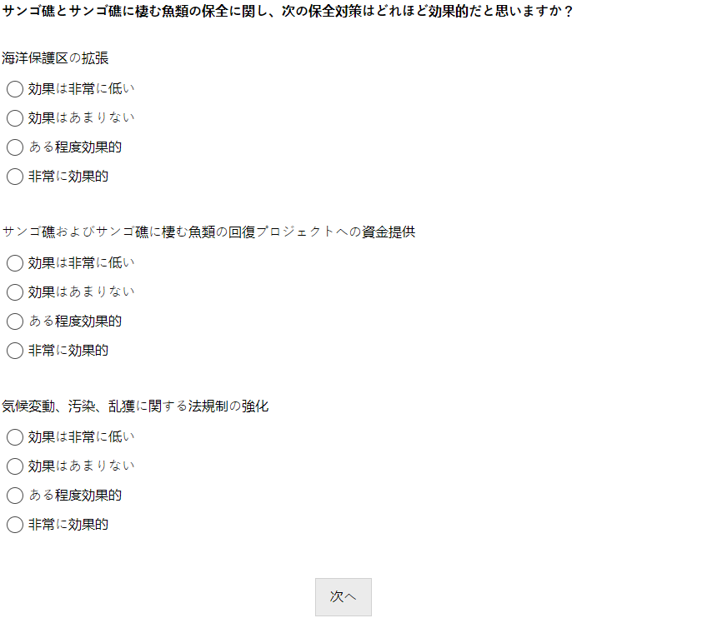

Dutch
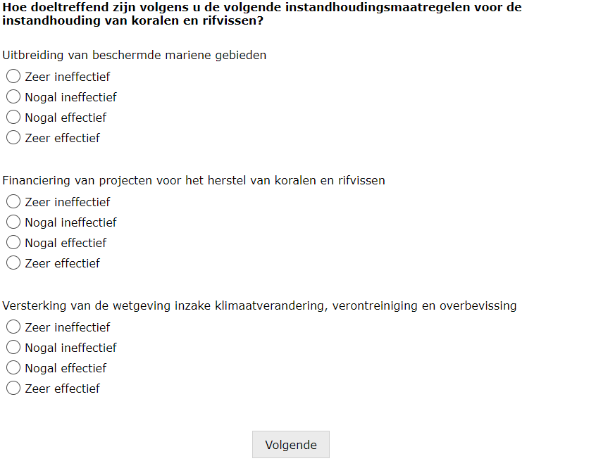
Page 27
English
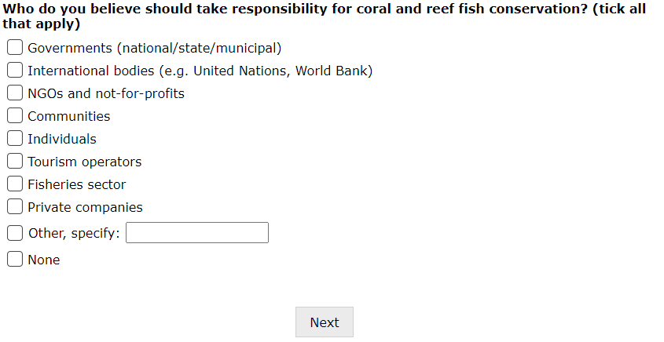
Spanish
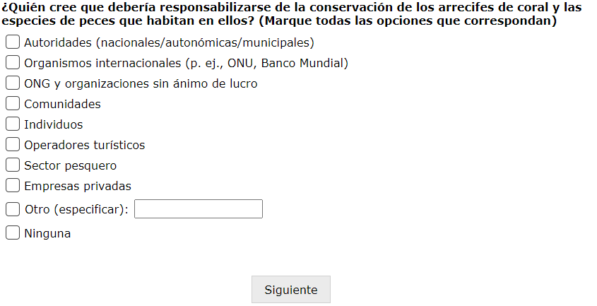
Standard Chinese
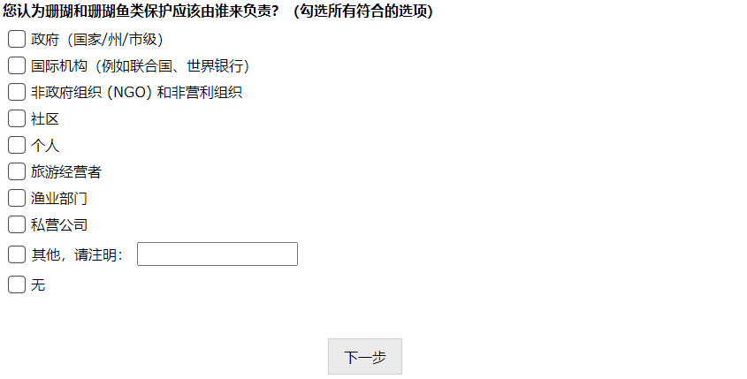

Indonesian
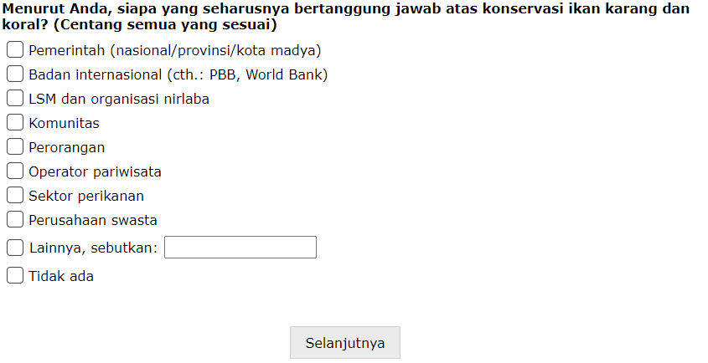
Japanese
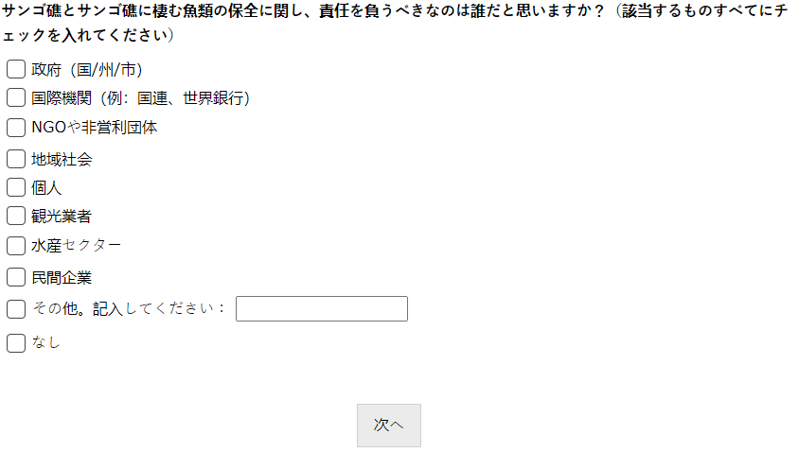

Dutch
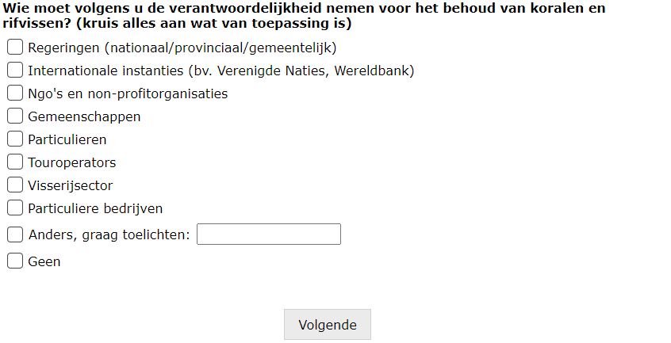

Page 28
English
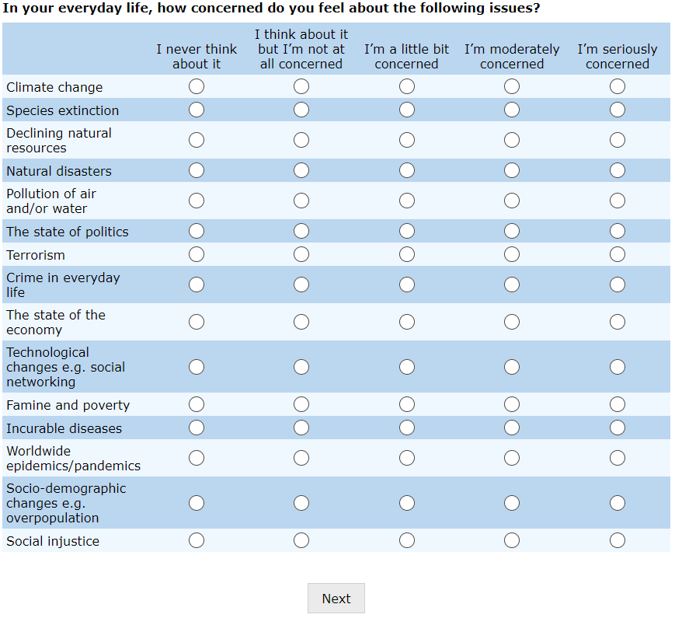

Spanish
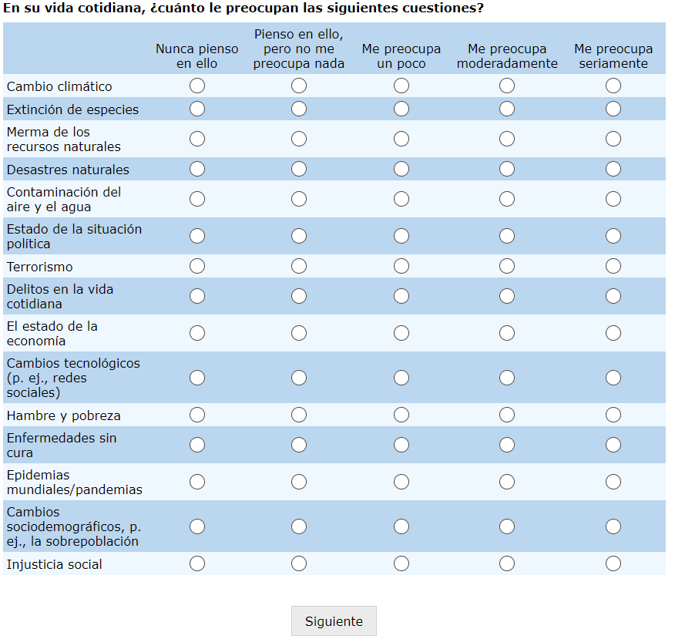

Standard Chinese
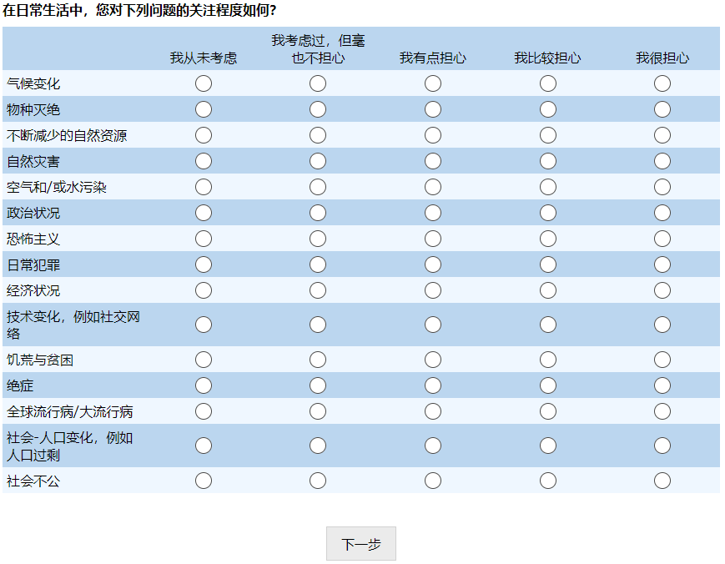

Indonesian
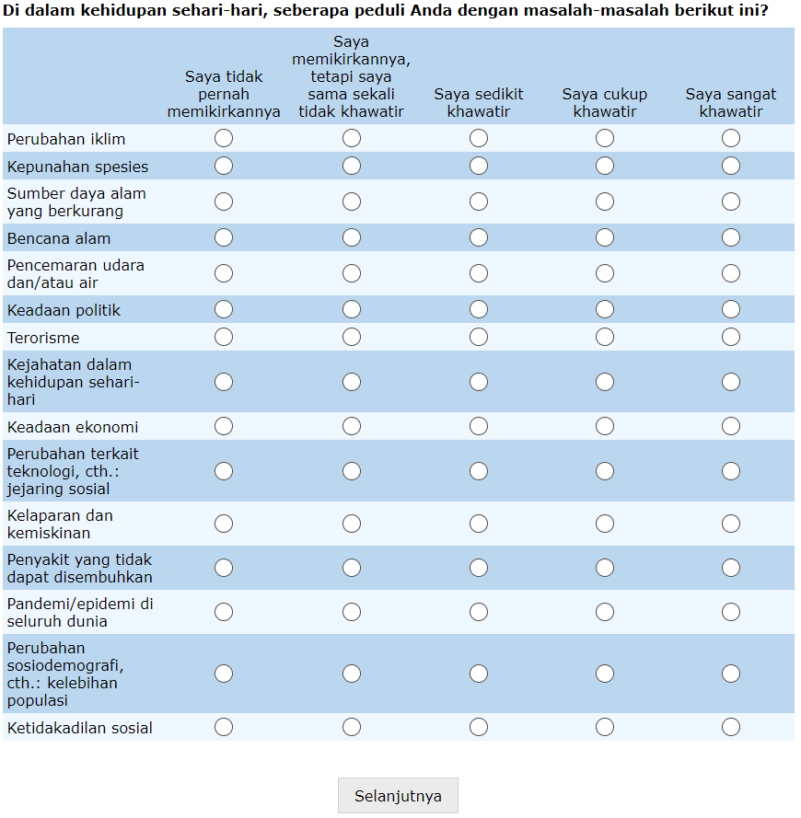

Japanese
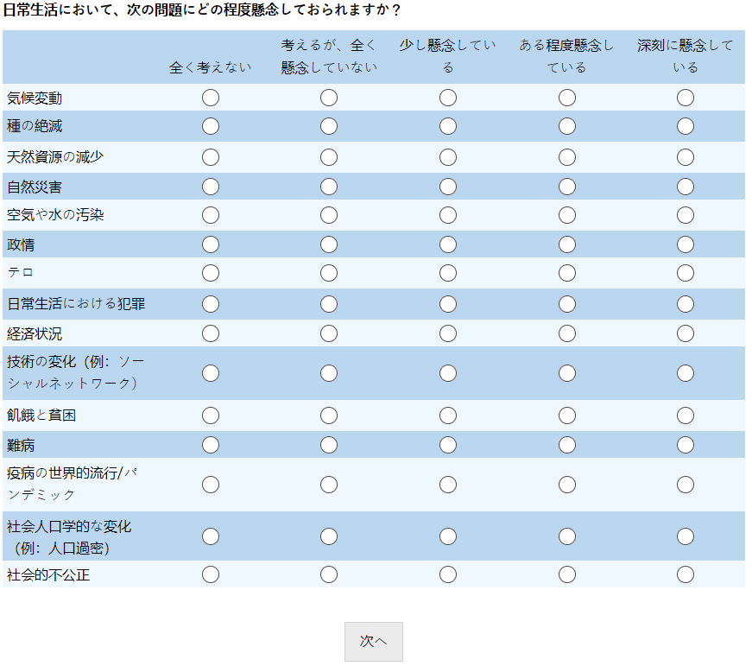

Dutch
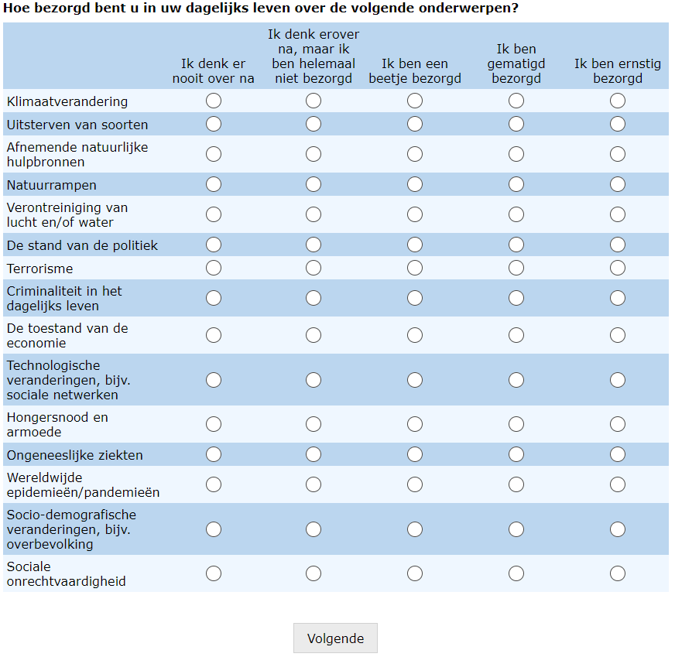

Page 29
English
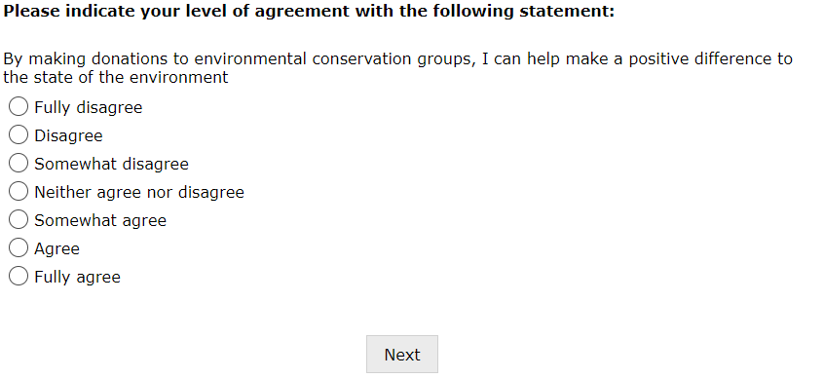
Spanish
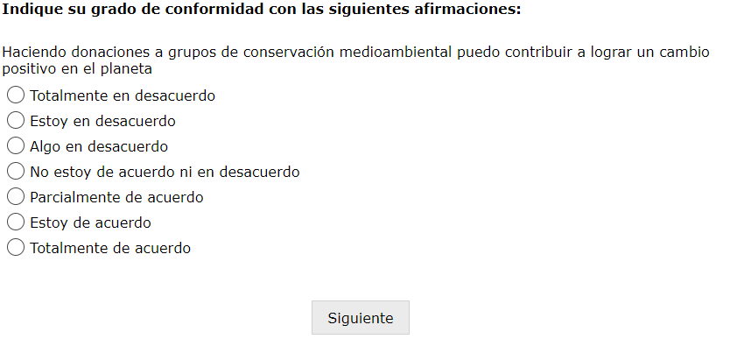

Standard Chinese
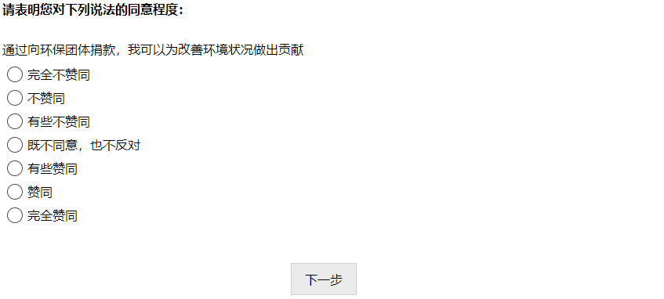
Indonesian
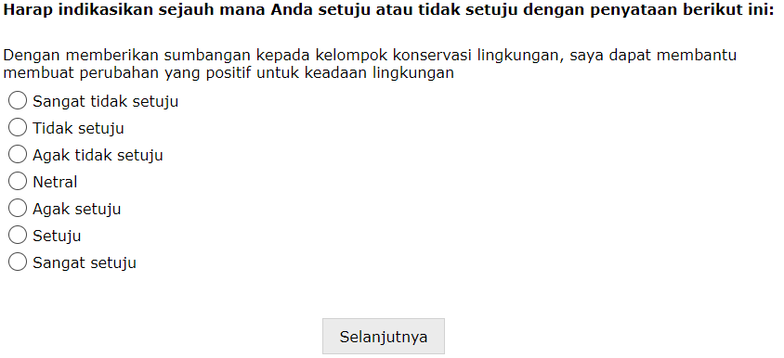

Japanese
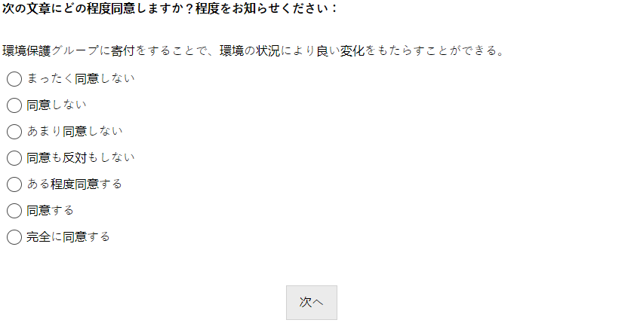
Dutch
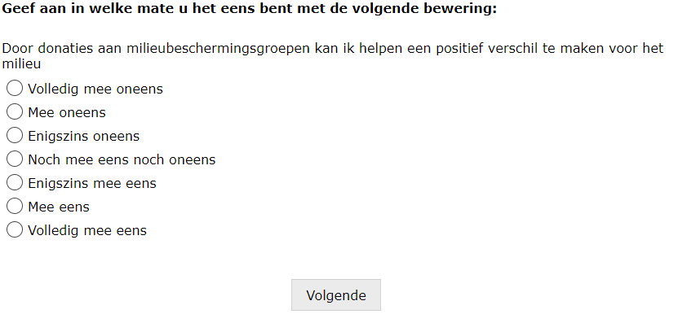

Page 30
English
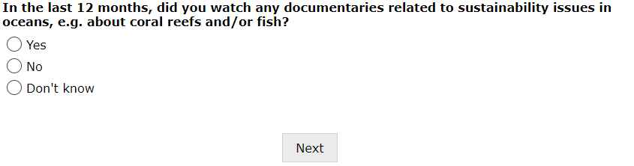

Spanish
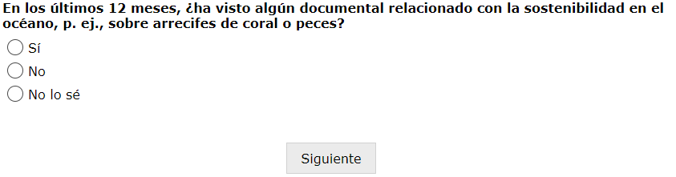
Standard Chinese
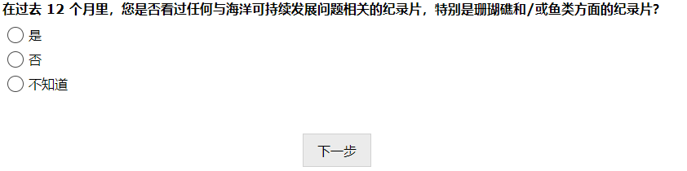
Indonesian
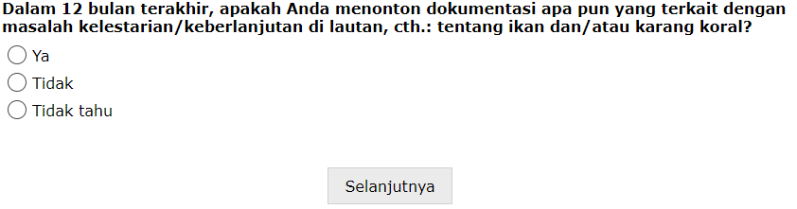
Japanese
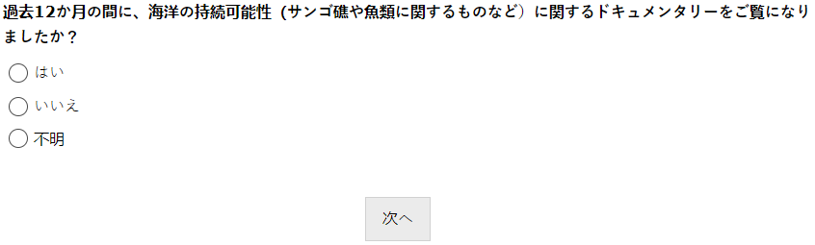
Dutch
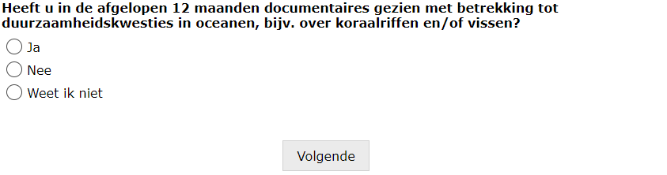
Page 31
English
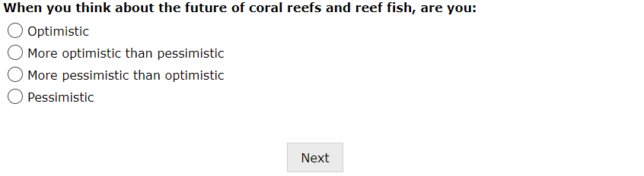

Spanish
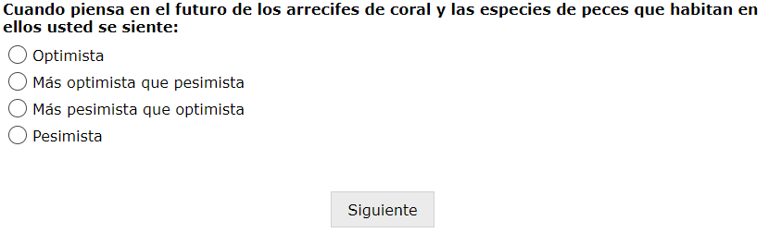
Standard Chinese
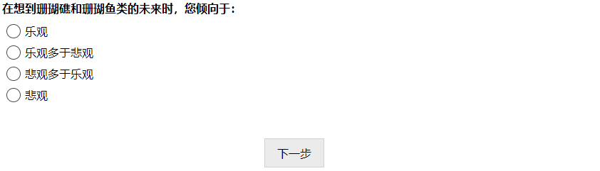
Indonesian
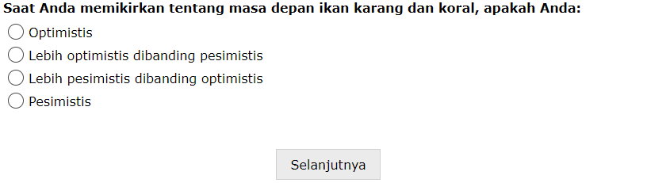
Japanese
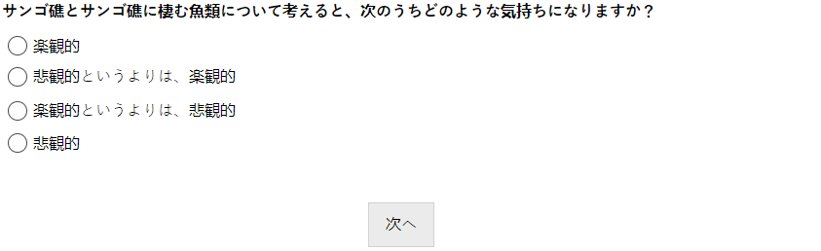
Dutch
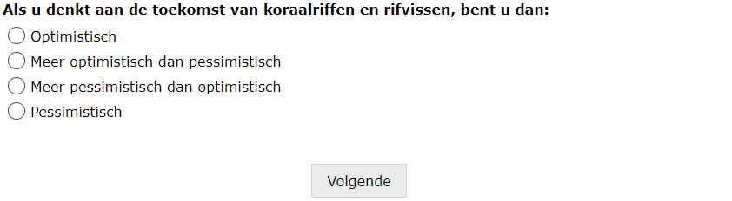
Page 32
English
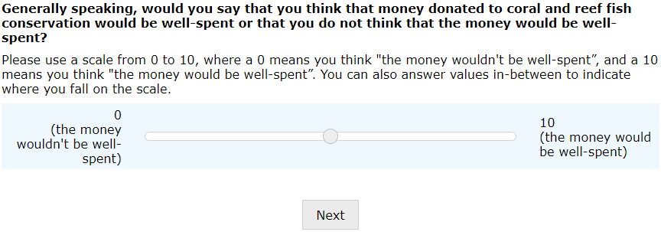
Spanish
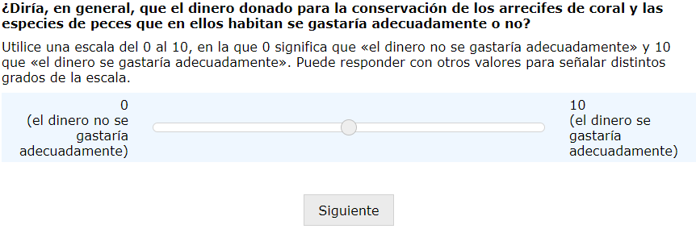

Standard Chinese
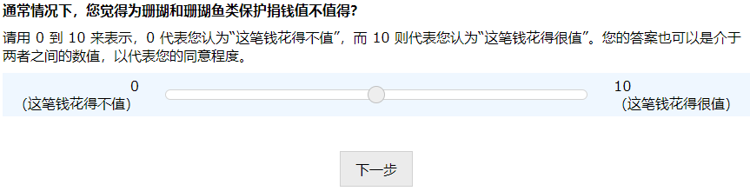
Indonesian
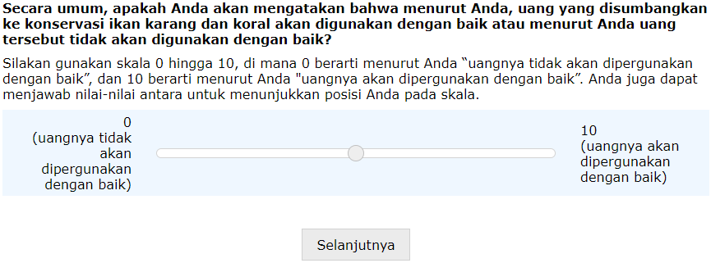
Japanese
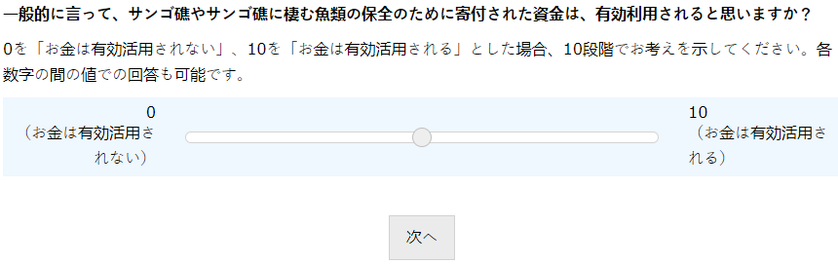

Dutch
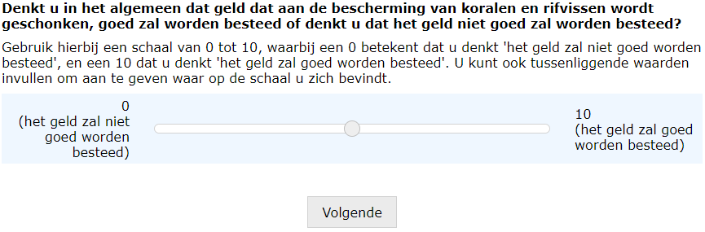
Page 33
English
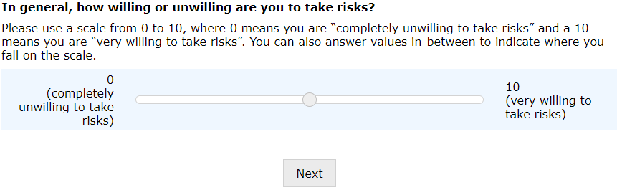
Spanish
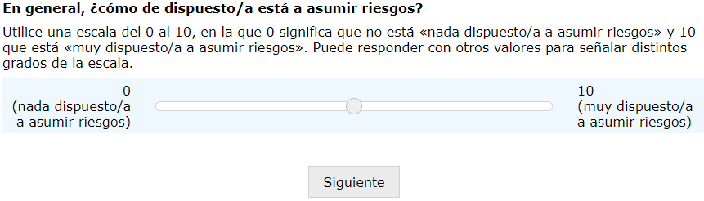

Standard Chinese
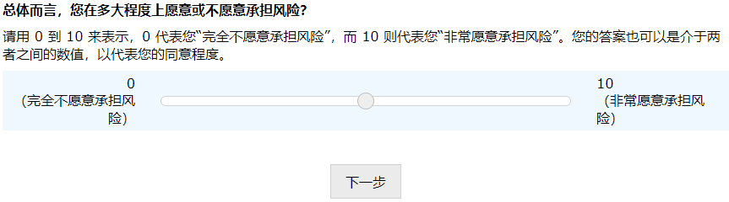
Indonesian
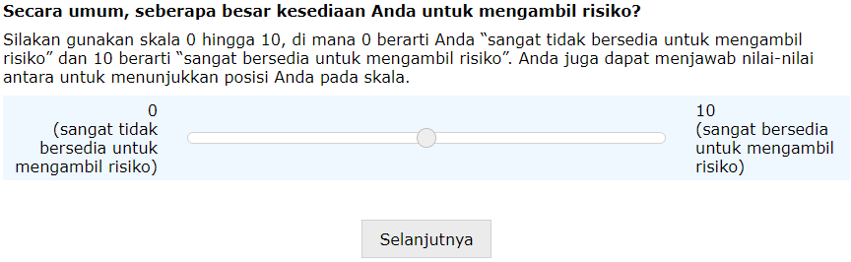
Japanese
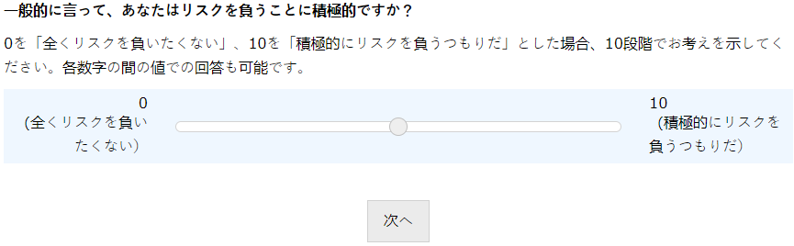

Dutch
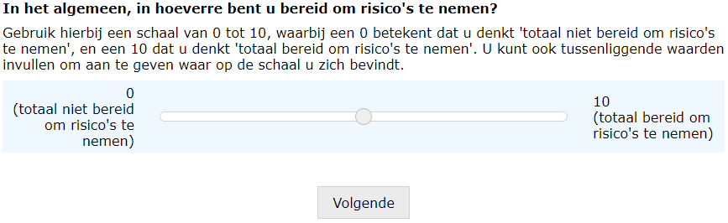
Page 34
English
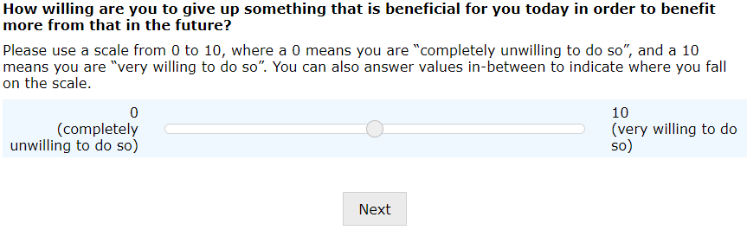
Spanish
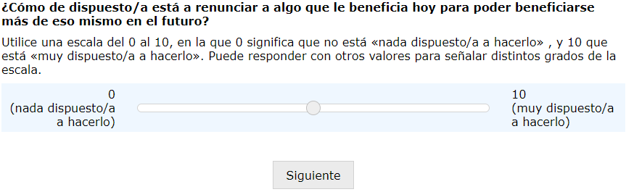

Standard Chinese
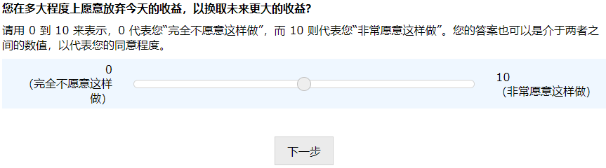
Indonesian
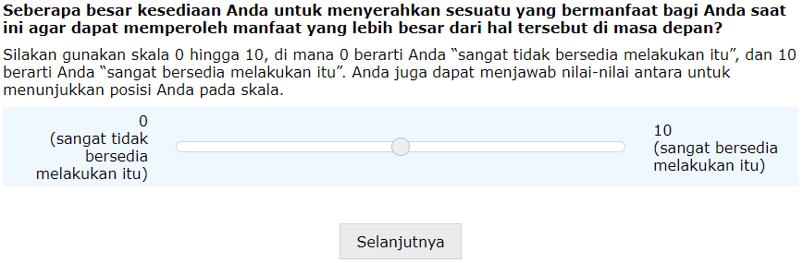
Japanese
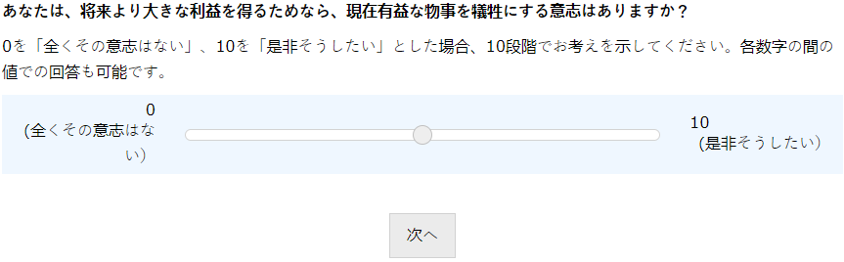

Dutch
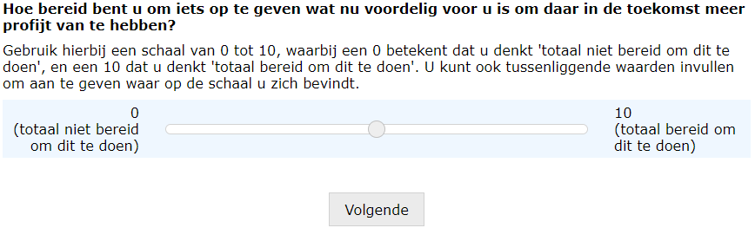
Page 35
English
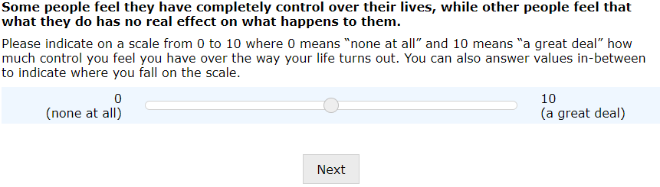
Spanish
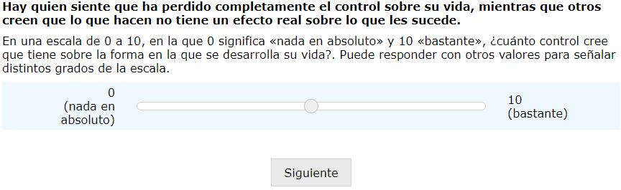

Standard Chinese
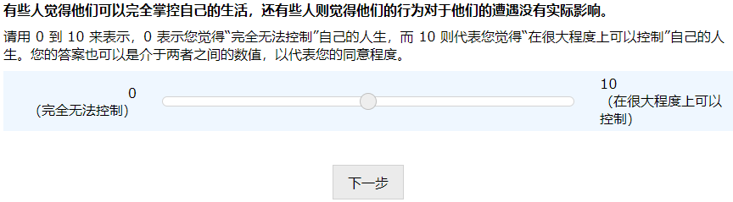
Indonesian
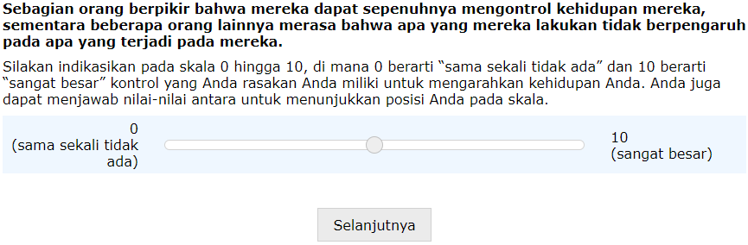
Japanese
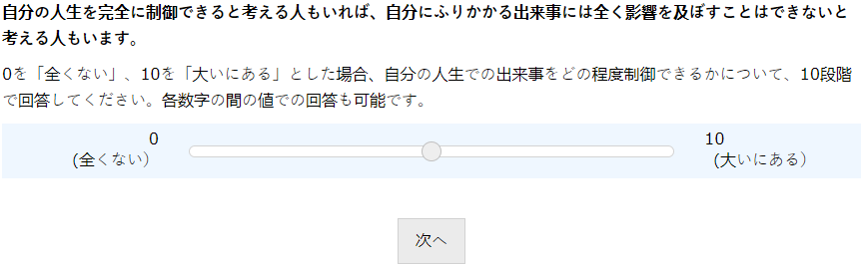

Dutch
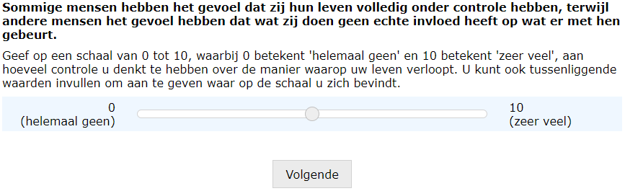
Page 36
English
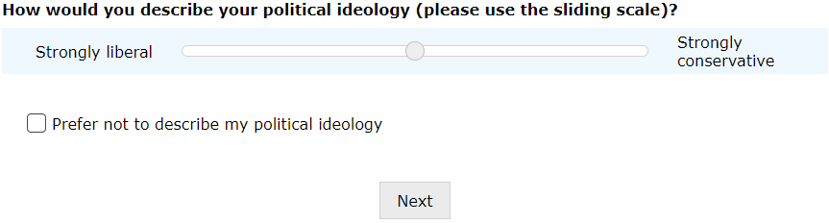
Spanish
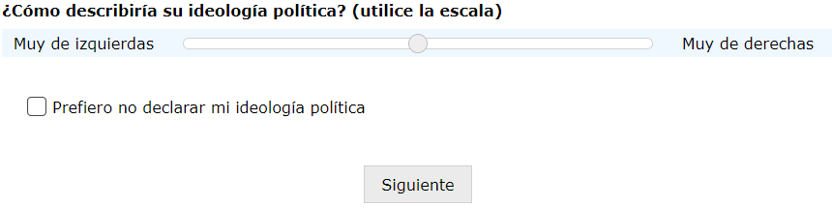
Standard Chinese
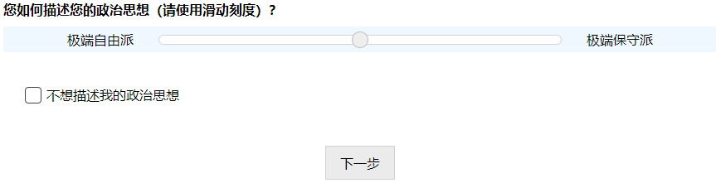
Indonesian
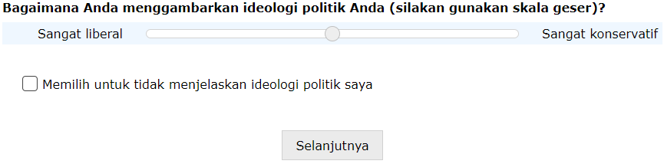
Japanese
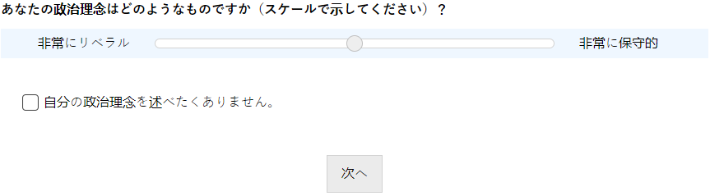
Dutch
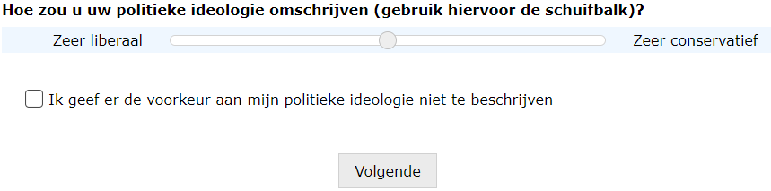
Page 37
English
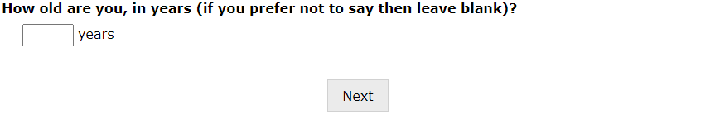

Spanish
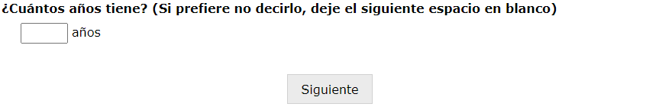
Standard Chinese

Indonesian
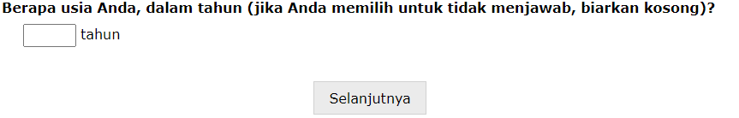
Japanese

Dutch
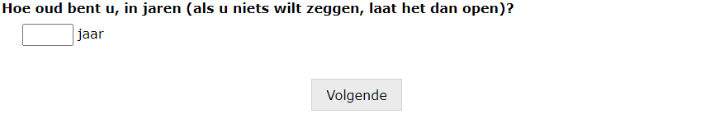

Page 38
English
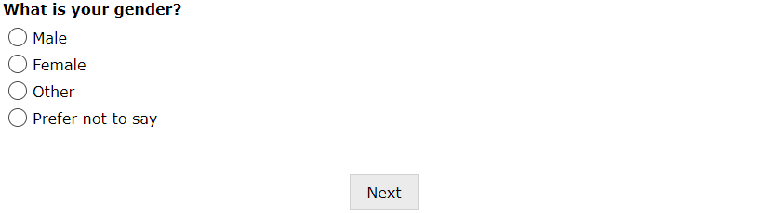
Spanish

Standard Chinese

Indonesian
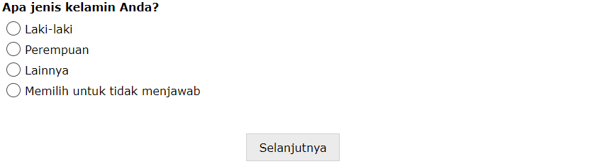
Japanese

Dutch
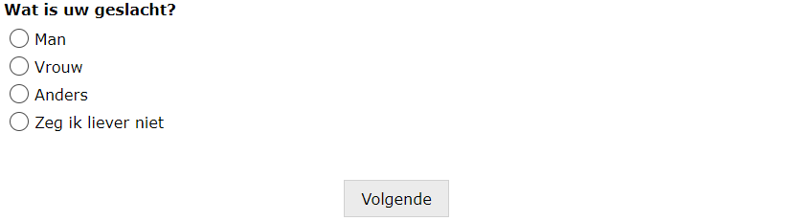
Page 39
English
Australia
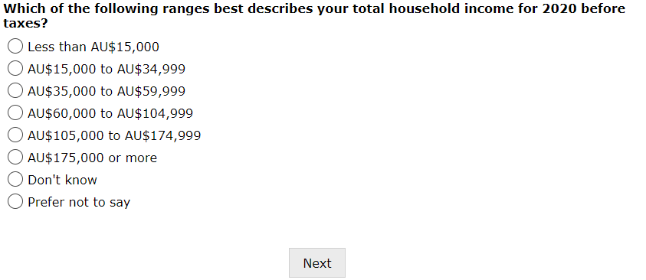

Ghana
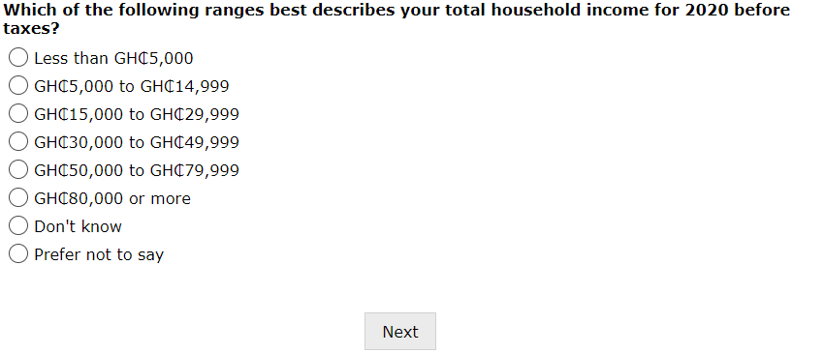
Kenya
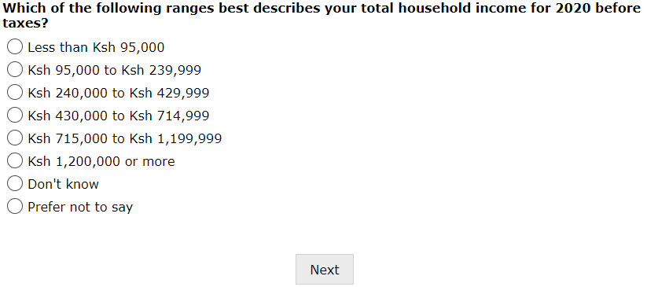
New Zealand
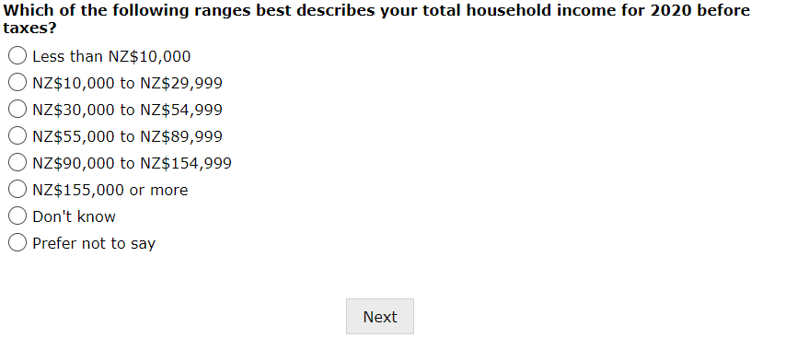
United Kingdom
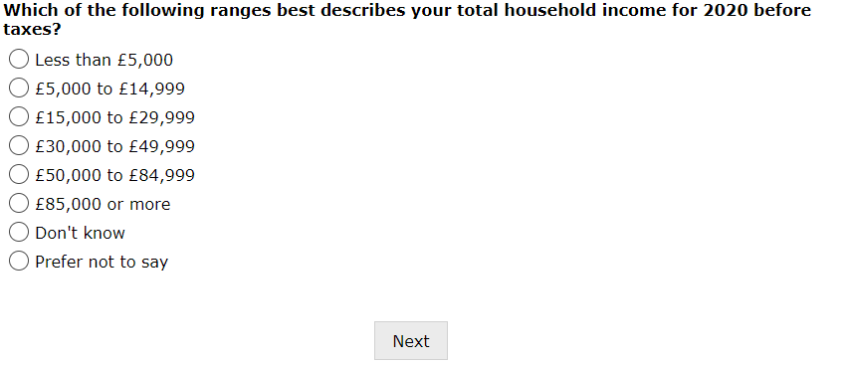
United States
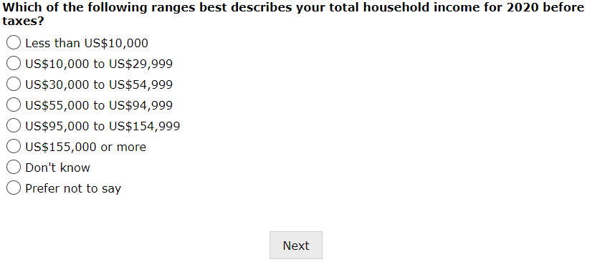

Spanish
Chile
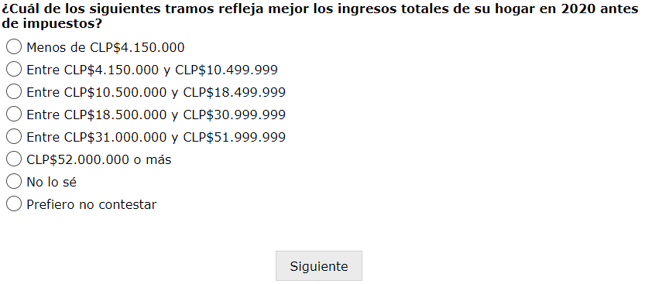
Colombia
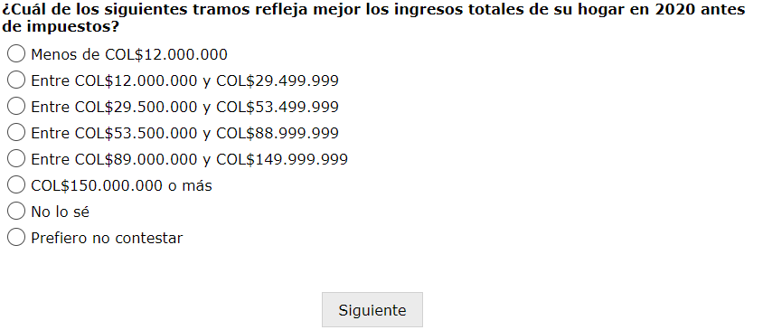

Standard Chinese
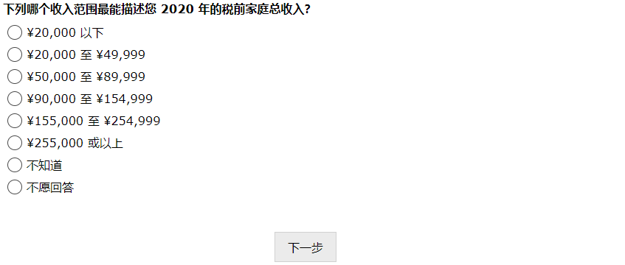
Indonesian
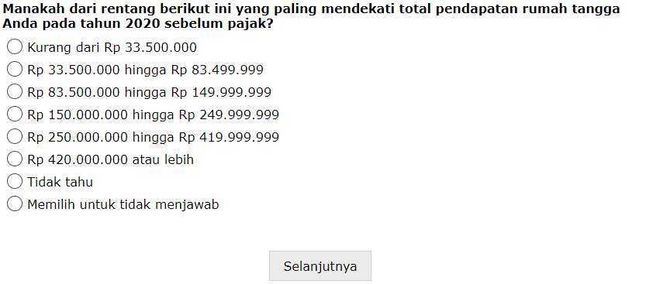

Japanese
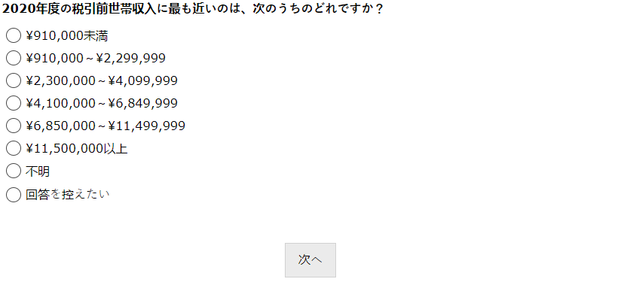
Dutch
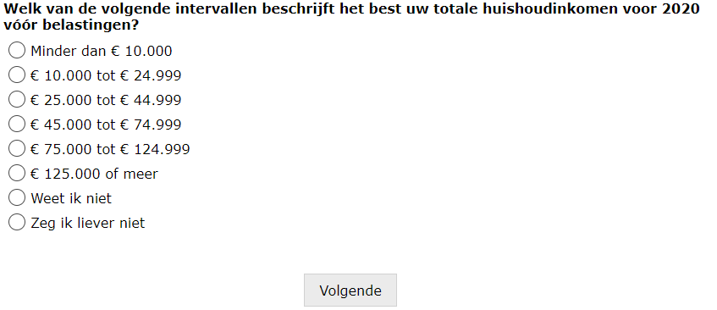

Page 40
English

Spanish
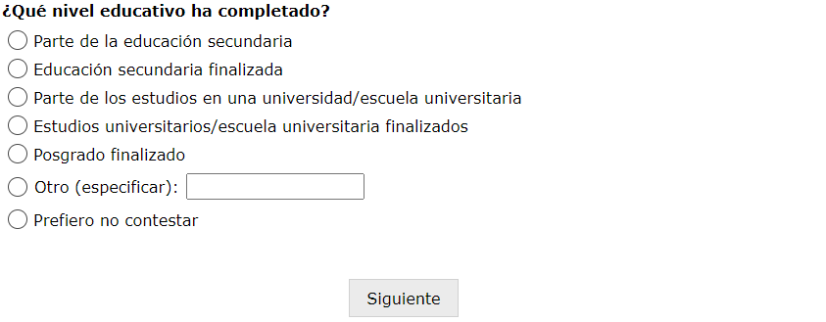
Standard Chinese

Indonesian

Japanese
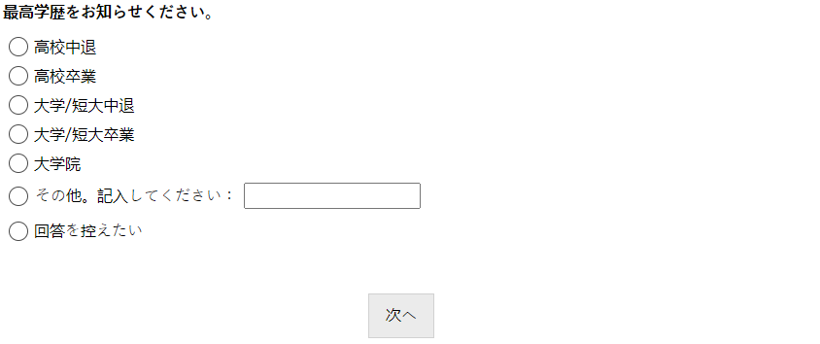
Dutch


Page 41
English
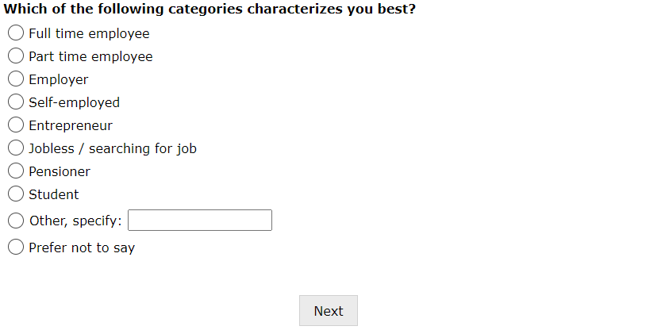
Spanish
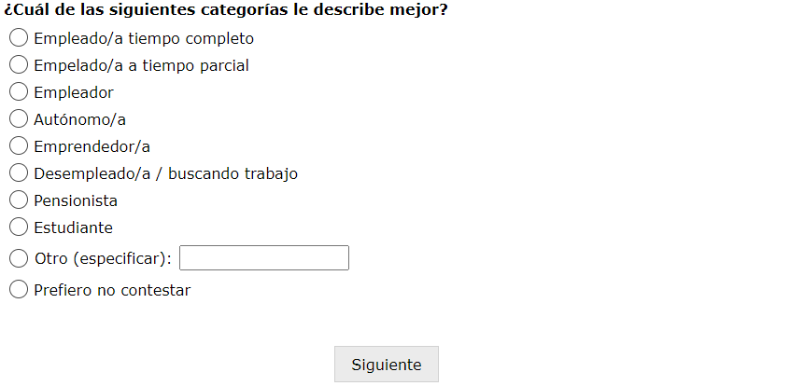

Standard Chinese
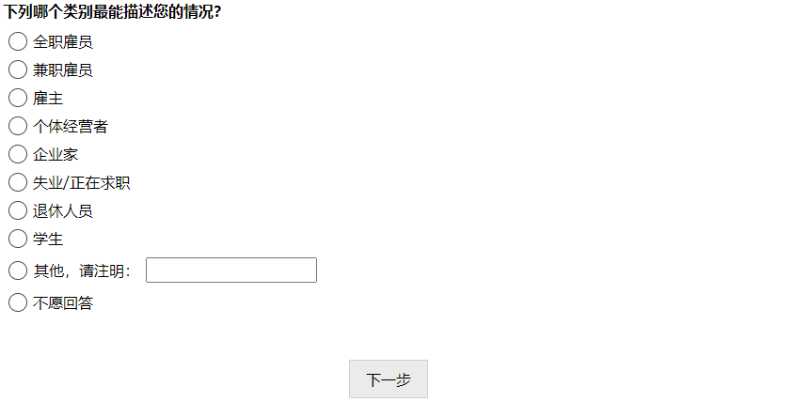
Indonesian
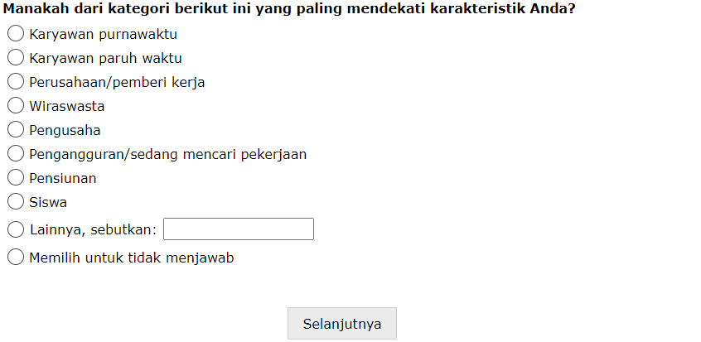

Japanese
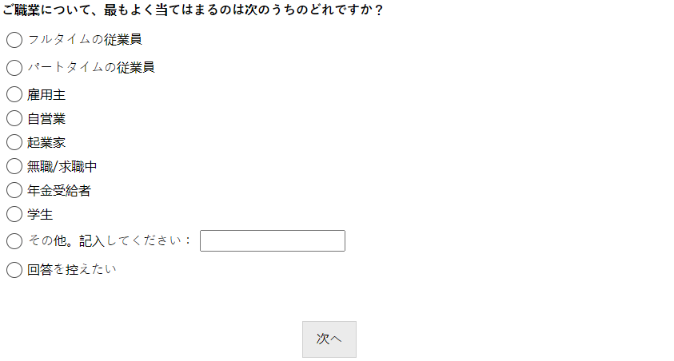
Dutch
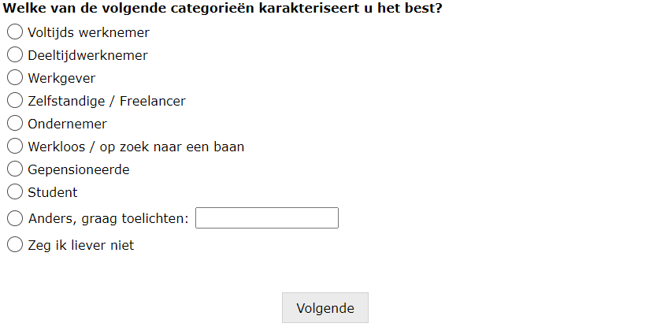
Page 42
English
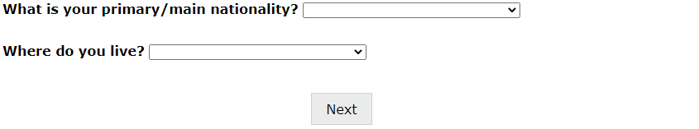
Spanish
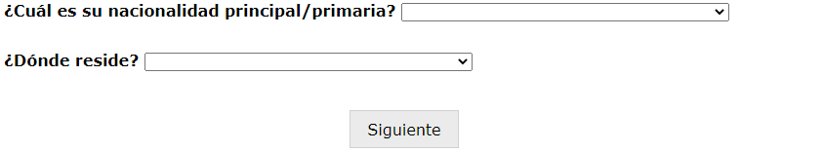
Standard Chinese

Indonesian
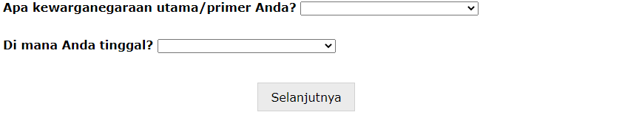
Japanese
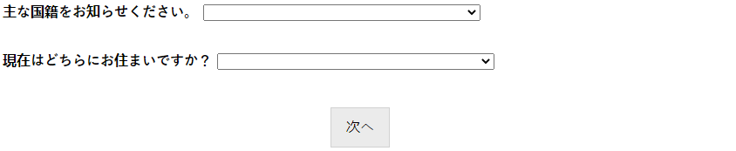
Dutch
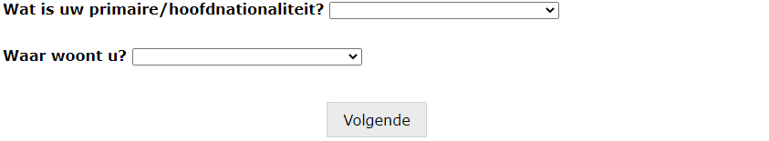

Page 43
English

Spanish
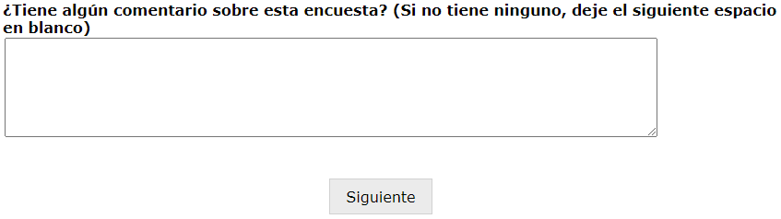
Standard Chinese

Indonesian
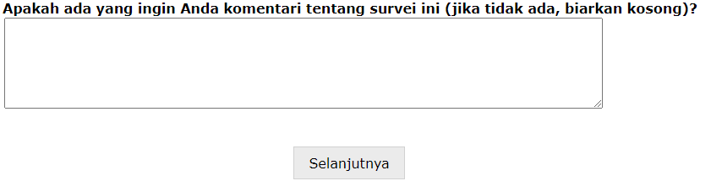

Japanese
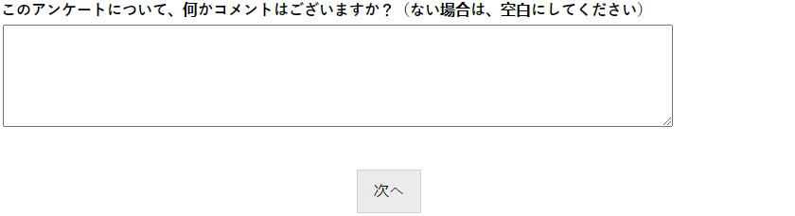
Dutch
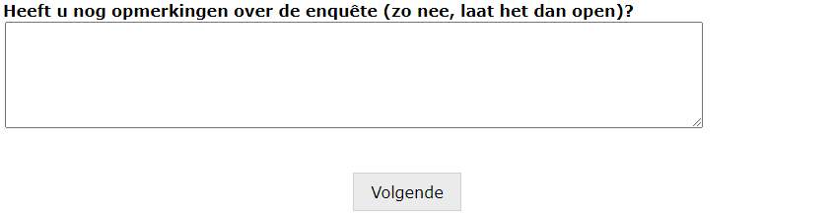

References (not in the manuscript)
Bernedo, M. and Ferraro, P.J., 2017. Behavioral economics and climate change adaptation: Insights from experimental economics on the role of risk and time preferences. In World scientific reference on natural resources and environmental policy in the era of global change.
Bhat, C.R., 2001. Quasi-random maximum simulated likelihood estimation of the mixed multinomial logit model. Transportation Research Part B: Methodological, 35(7), pp.677-693.
Boonmanunt, S., Lauer, T., Rockenbach, B. and Weiss, A., 2020. Field evidence on the role of time preferences in conservation behavior. Journal of Environmental Economics and Management, 104.
Brandt, M.J., Evans, A.M. and Crawford, J.T., 2015. The unthinking or confident extremist? Political extremists are more likely than moderates to reject experimenter-generated anchors. Psychological Science, 26(2), pp.189-202.
Cameron, A.C. and Trivedi, P.K., 2005. Microeconometrics: Methods and applications. Cambridge University Press.
Carstensen, L.L., Isaacowitz, D.M. and Charles, S.T., 1999. Taking time seriously: A theory of socioemotional selectivity. American Psychologist, 54(3).
Ceccarelli, D.M., Evans, R.D., Logan, M., Mantel, P., Puotinen, M., Petus, C., Russ, G.R. and Williamson, D.H., 2020. Long‐term dynamics and drivers of coral and macroalgal cover on inshore reefs of the Great Barrier Reef Marine Park. Ecological Applications, 30(1).
de Grip, A., Fouarge, D. and Montizaan, R., 2020. Redistribution of individual pension wealth to survivor pensions: Evidence from a stated preferences analysis. Journal of Economic Behavior & Organization, 173, pp.402-421.
Devine-Wright, P., Price, J. and Leviston, Z., 2015. My country or my planet? Exploring the influence of multiple place attachments and ideological beliefs upon climate change attitudes and opinions. Global Environmental Change, 30, pp.68-79.
Ding, S., Luo, X., Yin, M., Liu, Y. and Liu, F., 2015. An ip geolocation method based on rich-connected sub-networks. In 2015 17th International Conference on Advanced Communication Technology (ICACT) (pp. 176-181). IEEE.
Dunlap, R.E., Xiao, C. and McCright, A.M., 2001. Politics and environment in America: Partisan and ideological cleavages in public support for environmentalism. Environmental Politics, 10(4), pp.23-48.
Falk, A., Becker, A., Dohmen, T., Enke, B., Huffman, D. and Sunde, U., 2018. Global evidence on economic preferences. The Quarterly Journal of Economics, 133(4), pp.1645-1692.
Fehr, E. and Leibbrandt, A., 2011. A field study on cooperativeness and impatience in the tragedy of the commons. Journal of Public Economics, 95(9-10), pp.1144-1155.
Fuerst, F. and Singh, R., 2018. How present bias forestalls energy efficiency upgrades: A study of household appliance purchases in India. Journal of Cleaner Production, 186, pp.558-569.
Greenhill, M., Leviston, Z., Leonard, R. and Walker, I., 2014. Assessing climate change beliefs: Response effects of question wording and response alternatives. Public Understanding of Science, 23(8), pp.947-965.
Hensher, D.A., Stopher, P.R. and Louviere, J.J., 2001. An exploratory analysis of the effect of numbers of choice sets in designed choice experiments: An airline choice application. Journal of Air Transport Management, 7(6), pp.373-379.
Horowitz, J.L. and Savin, N.E., 2001. Binary response models: Logits, probits and semiparametrics. Journal of Economic Perspectives, 15(4), pp.43-56.
Hughes, T.P., Barnes, M.L., Bellwood, D.R., Cinner, J.E., Cumming, G.S., Jackson, J.B., Kleypas, J., van de Leemput, I.A., Lough, J.M., Morrison, T.H., Palumbi, S.R., van Nes, E.H. and Scheffer, M., 2017. Coral reefs in the Anthropocene. Nature, 546(7656), pp.82-90.
Irwin, J.R. and McClelland, G.H., 2001. Misleading heuristics and moderated multiple regression models. Journal of Marketing Research, 38, pp.100-109.
Jenkins-Smith, H.C., Ripberger, J.T., Silva, C.L., Carlson, D.E., Gupta, K., Carlson, N., Ter-Mkrtchyan, A. and Dunlap, R.E., 2020. Partisan asymmetry in temporal stability of climate change beliefs. Nature Climate Change, 10(4), pp.322-328.
Jost, J.T., Nosek, B.A. and Gosling, S.D., 2008. Ideology: Its resurgence in social, personality, and political psychology. Perspectives on Psychological Science, 3(2), pp.126-136.
Kahan, D.M., Peters, E., Wittlin, M., Slovic, P., Ouellette, L.L., Braman, D. and Mandel, G., 2012. The polarizing impact of science literacy and numeracy on perceived climate change risks. Nature Climate Change, 2(10), pp.732-735.
Li, D., Chen, J., Guo, C., Liu, Y., Zhang, J., Zhang, Z. and Zhang, Y., 2012. IP-geolocation mapping for moderately connected Internet regions. IEEE Transactions on Parallel and Distributed Systems, 24(2), pp.381-391.
Louviere, J.J., Flynn, T.N. and Carson, R.T., 2010. Discrete choice experiments are not conjoint analysis. Journal of Choice Modelling, 3(3), pp.57-72.
McFadden, D., 1974. Conditional logit analysis of qualitative choice behavior. In Zarembka, P. (Ed.), Frontiers in Econometrics. Academic Press, New York.
Mertz, O., Halsnæs, K., Olesen, J.E. and Rasmussen, K., 2009. Adaptation to climate change in developing countries. Environmental Management, 43(5), pp.743-752.
Mirza, M.M.Q., 2003. Climate change and extreme weather events: Can developing countries adapt?. Climate Policy, 3(3), pp.233-248.
Newell, R.G. and Siikamäki, J., 2015. Individual time preferences and energy efficiency. American Economic Review, 105(5), pp.196-200.
Poe G.L., Giraud K.L. and Loomis J.B., 2005. Computational methods for measuring the difference of empirical distributions. American Journal of Agricultural Economics, 87, pp.353-365.
Poe G.L., Welsh M.P. and Champ P.A., 1997. Measuring the difference in mean willingness to pay when dichotomous choice contingent valuation responses are not independent. Land Economics, 73, pp.255-267.
Potrafke, N., 2019. Risk aversion, patience and intelligence: Evidence based on macro data. Economics Letters, 178, pp.116-120.
Ravindranath, N.H. and Sathaye, J.A., 2002. Climate change and developing countries. Springer, Dordrecht.
Robinson, P.J., van Beukering, P., Brander, L., Brouwer, R., Haider, W., Taylor, M. and Mau, P., 2022. Understanding the determinants of biodiversity non-use values in the context of climate change: Stated preferences for the Hawaiian coral reefs. Ecosystem Services, In press. https://doi.org/10.1016/j.ecoser.2021.101393
Smith, V.K. and Johnson, F.R., 1988. How do risk perceptions respond to information? The case of radon. The Review of Economics and Statistics, 70(1), pp.1-8.
Train, K.E., 1998. Recreation demand models with taste differences over people. Land Economics, 74(2), pp.230-239.
Tversky, A. and Kahneman, D., 1973. Availability: A heuristic for judging frequency and probability. Cognitive Psychology, 5(2), pp.207-232.
UNEP-WCMC, WorldFish Centre, WRI, TNC, 2021. Global distribution of warm-water coral reefs, compiled from multiple sources including the Millennium Coral Reef Mapping Project. Version 4.1. Cambridge (UK): UN Environment World Conservation Monitoring Centre. https://doi.org/10.34892/t2wk-5t34
Wiernik, B.M., Ones, D.S. and Dilchert, S., 2013. Age and environmental sustainability: A meta-analysis. Journal of Managerial Psychology, 28(7-8), pp.826-856.
Wooldridge, J.M., 2010. Econometric analysis of cross section and panel data. MIT press.

GIS data has been taken from UNEP-WCMC, WorldFish Centre, WRI, TNC (2021).
The time subscript is suppressed here.
The fixed effects and country-level indicators cannot be included in the model together due to multicollinearity.
Conservative ideology and a belief that climate change is happening and largely human caused is negatively correlated (Spearman’s rho = -0.216, p-value < 0.001), which may shed some light on the non-significance of political ideology once climate change beliefs are controlled for.
This was asked with a follow-up question to the DCE.
We opt for statistical parsimony here to avoid problems associated with multicollinearity when many interaction terms are incorporated (Irwin and McClelland, 2001).
In models with country- and individual-specific interaction terms, the contribution attribute is added as a random parameter with a normal distribution since these models are not used in the calculation of welfare estimates.
WTP for marginal changes from the worst-case scenario is extracted by taking the negative ratio between the coefficient of a specific attribute level and the contribution coefficient ($β_{15}$). For marginal changes compared to the best-case scenario, WTP is based on the negative ratio between the coefficient of a specific attribute level plus the coefficient on its interaction with the best-case variable, and the contribution coefficient.

