Supplementary Materials for

Going beyond SARS-CoV-2: genomic surveillance of monkeypox in German wastewater
Authors: Shelesh Agrawal¹*, Laura Orschler¹, Sofie Wangler¹, Robert Greither², Sindy Böttcher³, Annika Brinkmann⁴, Andreas Nitsche⁵, Joachim J. Bugert⁶, Martin Hölzer⁷, Susanne Lackner¹
Affiliations

¹Department of Water and Environmental Biotechnology, Institute IWAR, Technical University of Darmstadt; Darmstadt, 64287, Germany.
²Life Technologies; Darmstadt 64287, Germany.
³National Reference Center for Poliomyelitis and Enteroviruses, Robert Koch Institute; Berlin 13353, Germany.
⁴Highly Pathogenic Viruses, Centre for Biological Threats and Special Pathogens, WHO Reference Laboratory for SARS-CoV-2 and WHO Collaborating Centre for Emerging Infections and Biological Threats, Robert Koch Institute; Berlin 13353, Germany.
⁵German Consultant Laboratory for Poxviruses, Robert Koch Institute; Berlin 13353, Germany.
⁶Bundeswehr Institute of Microbiology; Munich 80937, Germany
⁷Methodology and Research Infrastructure, Bioinformatics and Systems Biology, Robert Koch Institute; Berlin 13353, Germany.

Correspondence to: s.agrawal@iwar.tu-darmstadt.de

This PDF file includes:

Supplementary Text
Figs. S1 to S6
Tables S1

Supplementary Text
Information about the wastewater treatment plants (WWTP) sampled

According to the information provided by the sewage treatment plant operators, a total of 2,230,322 residents are connected to all the tested sewage treatment plants (S.table 1). Since 6,293,154 inhabitants live in Hesse in 2020 (Statista, 2021), the 10 sampled sewage treatment plants cover around 36% of the Hessian inhabitants.

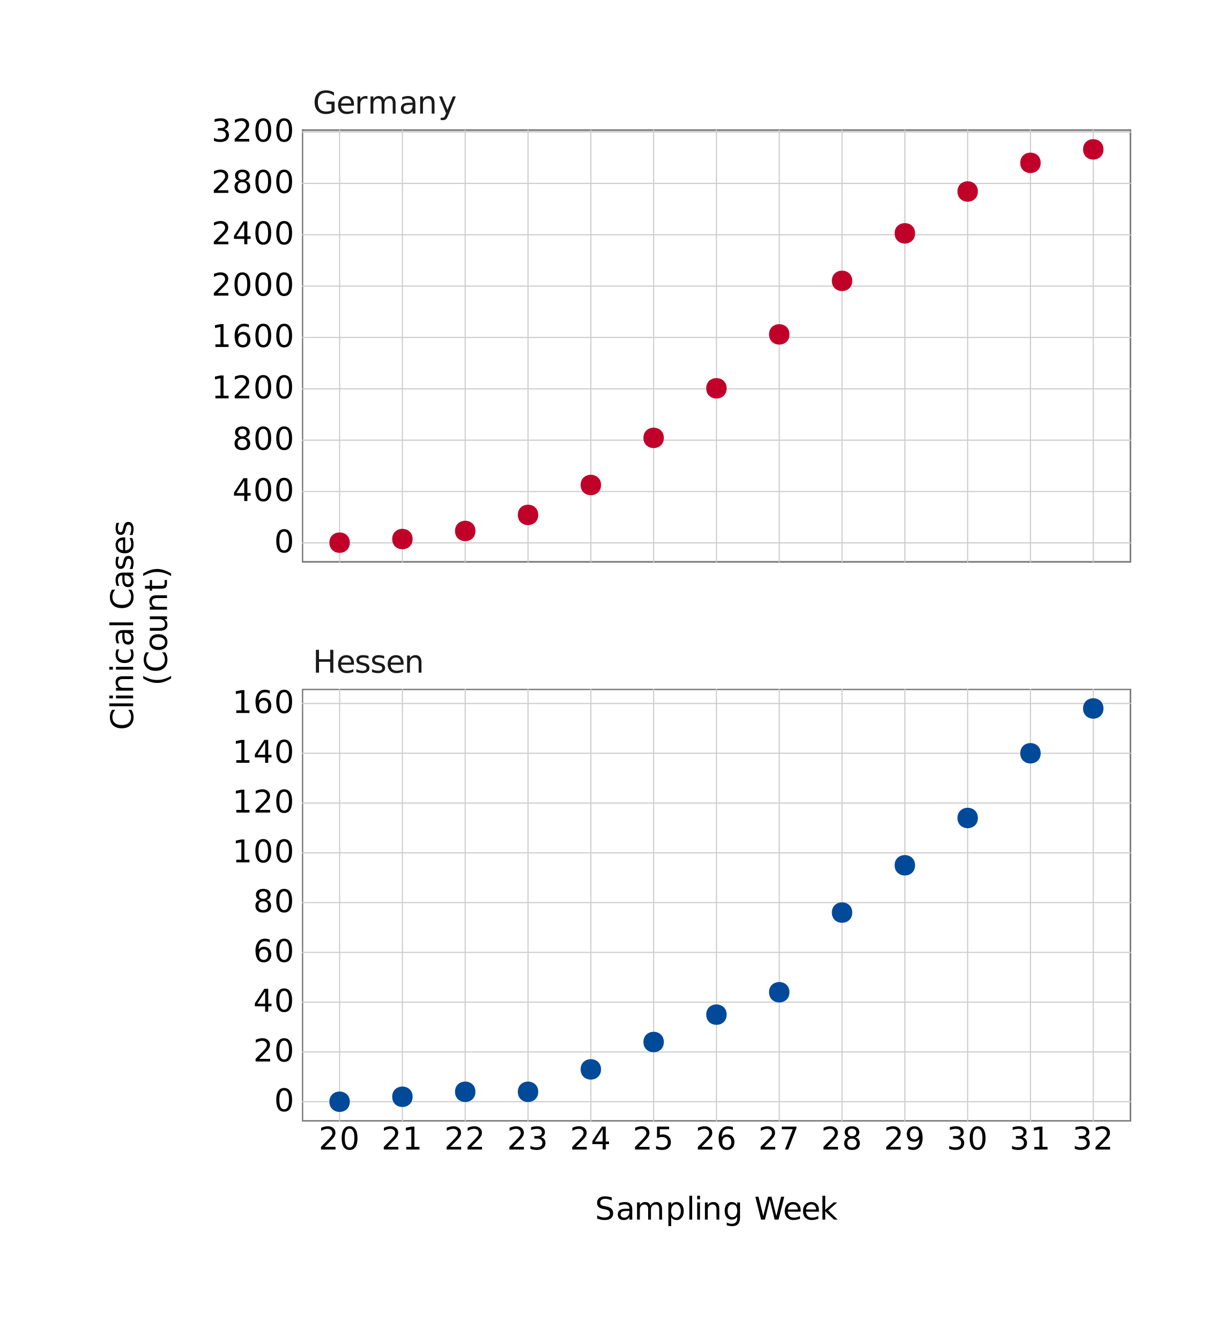

Fig. S1.Clinical cases reported in Germany and state Hessen. The figure shows the number of cases reported in state of Hessen, where sampled WWTPs are located, in comparison to the clinical cases known in Germany.

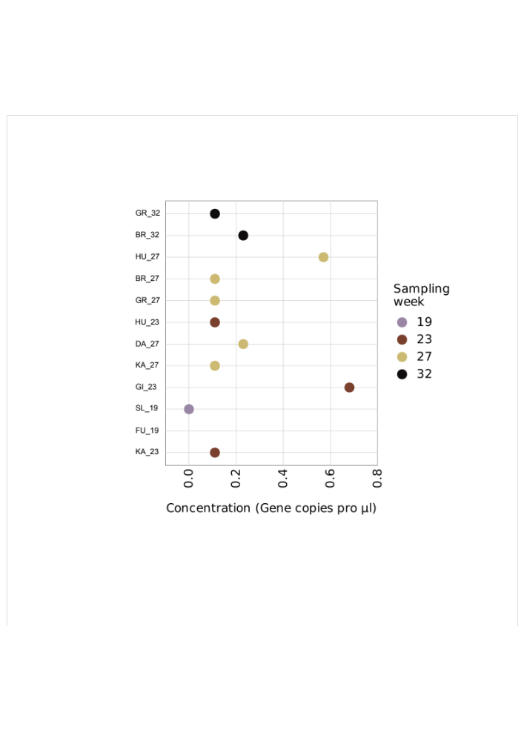

Fig. S2. MPXV concentration in sequenced wastewater samples. Concentration of the MPXV was measured using dPCR analysis. Sampling week corresponds to the weeks in year 2022.

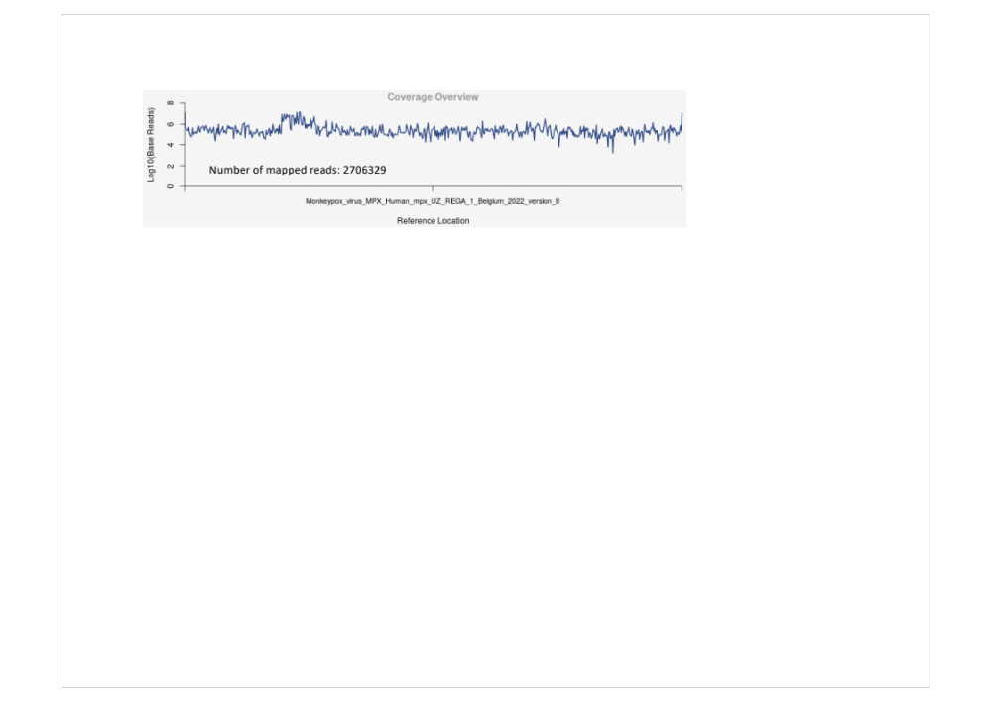

Fig. S3. Genome coverage of clinical sample obtained using P4Mpox22 panel. This shows the coverage of MPXV genome achieved using the NGS panel designed for monitoring the MPXV in wastewater samples. The DNA sample used as control was obtained from virus isolated from skin pustules of the first German case in Munich (2). We used hMpxV/Belgium/UZ_Rega_1/2022 (GISAID accessionID - EPI_ISL_13052282) as reference genome. The x-axis represents the length of 198010 bp of the reference genome.
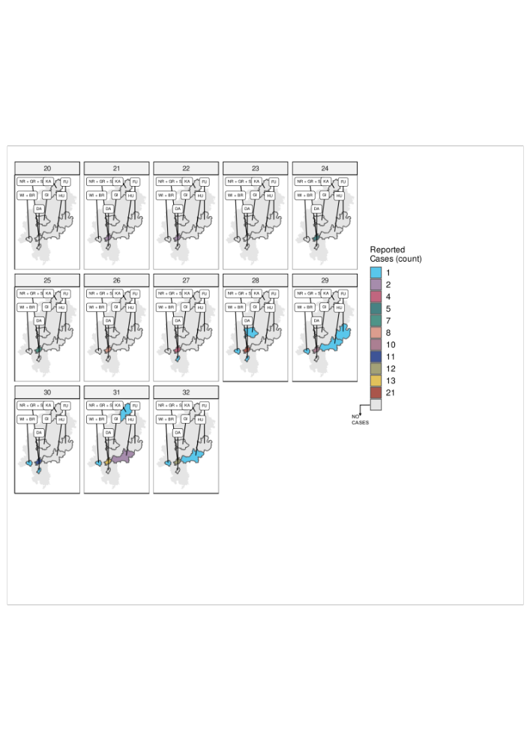
Fig. S4. Number of clinical cases reported in each city district. This map shows the location of each city district along with the count of clinical cases that have been reported to the health authorities from week 20 to 32 in year 2022. BR – Wiesbaden Biebrich, DA – Darmstadt, FU – Fulda, GI – Giessen, GR – Griesheim, HU – Hanau, KA – Kassel, NR – Niederrad, SL – Sindlingen, and WI – Wiesbaden.

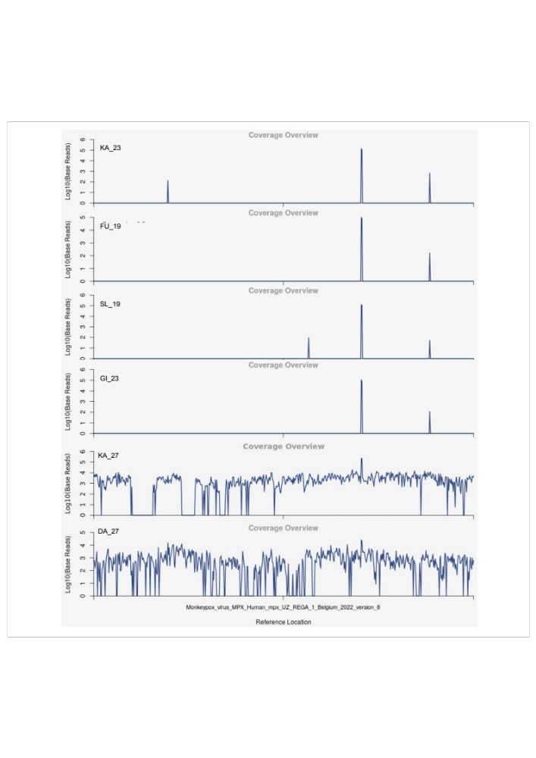
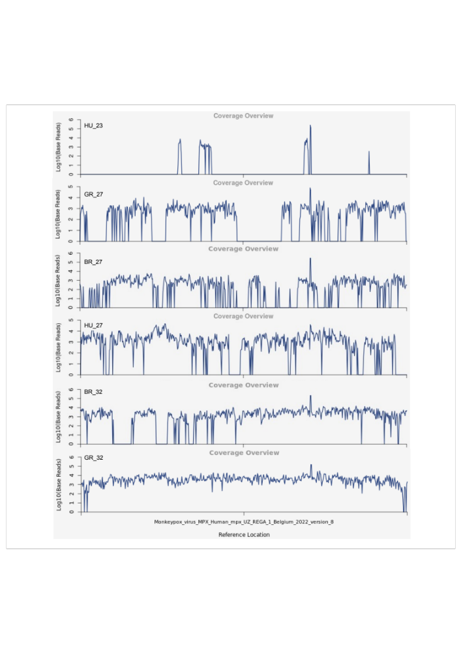

Fig. S5. Percentage of target base coverage in wastewater samples sequences. Each panel show the coverage of 2022-outbreak monkeypox virus achieved for each wastewater sample. We used hMpxV/Belgium/UZ_Rega_1/2022 (GISAID accessionID - EPI_ISL_13052282) as reference genome. The x-axis represents the length of 198010 bp of the reference genome.

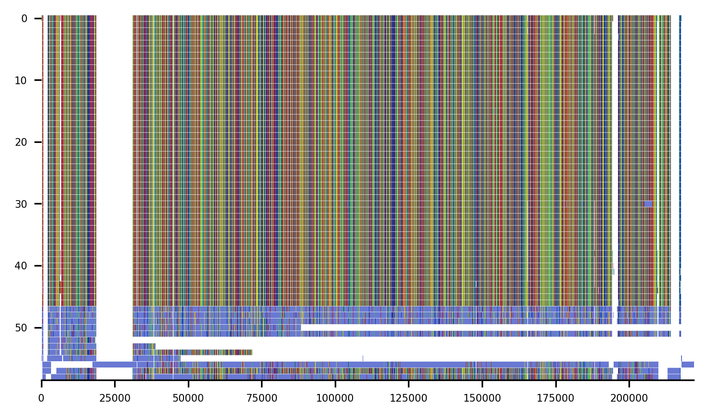

Fig. S6. Multiple sequence alignment of wastewater sample sequences and clinical sequences. The genome sequences obtained from wastewater sequences were aligned against the clinical MPXV sequences. Sewage-derived consensus sequences are based at the bottom of the alignment. The blue vertical bars represent ambiguous N bases in the wastewater –based genomes while all rows above represent MPXV genomes from clinical sampling.

Nr.* | Wastewater Treatment Plant (City) | Population equivalents | Connected inhabitants
1 | Darmstadt (DA) | 240.000 | 130.811
2 | Frankfurt Griesheim (GR)#
3 | Frankfurt Niederrad (NR) | 1.350.000 | 895.355
4 | Frankfurt Sindlingen (SL) | 470.000 | 244.032
5 | Fulda / Gläserzell (FU) | 150.000 | 92.920
6 | Gießen (GI) | 300.000 | 186.943
7 | Hanau (HU) | 200.000 | 140.000
8 | Kassel (KA) | 340.000 | 266.669
9 | Wiesbaden Biebrich (BR) | 130.000 | 99.722
10 | Wiesbaden main Wastewater treatment plant (WSB) | 330.000 | 173.870
 |  | ∑ | 2.230.322

Table S1. Overview of all sampled WWTP and the respective population values. This table lists the sampled WWTPs, the population values for which the respective WWTP is designed, and the residents connected. (#) Not available.

