Supplementary Information for
Giant Modulation of Magnetoresistance in van der Waals Magnet by In-Plane Current Injection
Kwangsu Kim^{1,2,†}, Hyo-bin Ahn^{3,†}, Munsu Jin⁴, Seyeob Jeong¹, Donghyeon Lee¹, Dohee Kwon¹, Seong Been Kim^{2,5}, Sung Jong Kim^{2,5}, Jungmin Park⁴, Nyun Jong Lee^{1,6}, Hyun Cheol Koo^{2,5}, Kyongmo An⁷, Kyoung-Woong Moon⁷, Bongjae Kim⁸, Kyoo Kim⁹, Kab-Jin Kim⁴, Changgu Lee¹⁰, Kyoung-Whan Kim^{2*}, Se Kwon Kim^{4,*}, Tae-Eon Park^{2,*}, Sanghoon Kim^{1,*}

¹Department of Physics, University of Ulsan, Ulsan 44619, Korea.
²Center for Spintronics, Korea Institute of Science and Technology, Seoul 02792, Korea.
³SKKU Advanced Institute of Nanotechnology, Sungkyunkwan University, Suwon 16419, Korea.
⁴Department of Physics, Korea Advanced Institute of Science and Technology, Daejeon 34141, Korea.
⁵KU-KIST Graduate School of Converging Science and Technology, Korea University, Seoul 02841, Korea.
⁶Energy Harvest Storage Research Center, University of Ulsan, Ulsan 44619, Korea.
⁷Spin Convergence Research Team, Korea Research Institute of Standards and Science, Daejeon 34113, Korea.
⁸ Department of Physics, Kunsan National University, Gunsan 54150, Korea
⁹ Korea Atomic Energy Research Institute (KAERI), 111 Daedeok-daero, Daejeon 34057, Korea
¹⁰School of Mechanical Engineering, Sungkyunkwan University, Suwon 16419, Korea.

† These Authors equally contributes to this work.
* Corresponding authors: kwk@kist.re.kr, sekwonkim@kaist.ac.kr, tepark@kist.re.kr, sanghoon.kim@ulsan.ac.kr
This Supplementary Information file includes:
1. Supplementary Notes 1-4
2. Extended Data Figures 1-9
3. Supplementary Table 1
4. Supplementary References

Table of Contents

Supplementary Notes 1. Extraction of AHE signals from the Hall voltage loops.
Supplementary Notes 2. Thermal effect and contact issues.
Supplementary Notes 3. Simulation model.
Supplementary Notes 4. Macroscopic dynamics of the current-induced FM-to-AFM transition.

Extended Data Fig. 1. Structural analysis of Fe₅GeTe₂ nanoflake
Extended Data Fig. 2. Magnetic properties of bulk Fe₅GeTe₂
Extended Data Fig. 3. SEM EDS analysis of Fe₅GeTe²
Extended Data Fig. 4. Fabrication of the encapsulated device
Extended Data Fig. 5. Schematic configuration of the Hall Measurement
Extended Data Fig. 6. I-R curve from the 2-probe and 4-probe measurements with the Fe₅GeTe₂ Hall device
Extended Data Fig. 7. Simulation of micromagnetic dynamics based on the current distribution
Extended Data Fig. 8. Confirmation of simulation with the estimated R
Extended Data Fig. 9. Interfacial conditions of encapsulated device (h-BN/Fe₅GeTe₂/h-BN)
Supplementary Table 1. Element Composition from SEM EDS

Supplementary Notes 1. Extraction of AHE signals from the Hall voltage loops
The Hall effect is a crucial factor for understanding transport properties of materials. For example, anomalous Hall effect (AHE) shows spin polarization near the Fermi energy in conductive magnetic materials. Even though the anomalous Hall conductivity ($σ_{xy}^{AHE}$) is proportional to magnetization, in general, due to relatively small magnetoresistance (MR), Hall voltage is approximately proportional to $σ_{xy}^{AHE}$. However, in our measurement, MR is no longer negligible; $σ_{xy}^{AHE}$ should be extracted from Hall signal. In this section, we explain how to extract $σ_{xy}^{AHE}$ from measured data in our system.
S1.1 Extraction of Hall signal from the measurement
Even though we try to fabricate Hall geometry as precisely as we can to measure the Hall voltage, MR from misalignment can be included in the signal ($V$). Therefore, using reversal symmetry of measurement, we will obtain Hall voltage ($V_{xy}^{Hall}$) from $V$.
When we measure the Hall voltage, we apply current and magnetic field (not external magnetic field in general). Thus, we can have two kinds of reversal symmetry (current and magnetic field) to categorize the voltage components. We denote each basis as $V_{++}$, $V_{-+}$, $V_{+-}$, and $V_{--}$, where the basis is even (+) or odd (-) component with respect to current and magnetic field reversal symmetry. When we measure the voltage in Extended Data Fig. 5 configuration, we define $V=|\left.+,+\right\rangle = V_{++}+ V_{-+}+V_{+-}+V_{--}$. When current or magnetic field are reversed, the notation will be $|\left.-,+\right\rangle$ or $|\left.+,-\right\rangle$, respectively. In this manner, we can write the equation as a matrix form as below.
 | $$\left(\begin{matrix}\begin{matrix}|\left.+,+\right\rangle \\ |\left.-,+\right\rangle \end{matrix} \\ \begin{matrix}|\left.+,-\right\rangle \\ |\left.-,-\right\rangle \end{matrix}\end{matrix}\right)=\left(\begin{matrix}\begin{matrix}1 & 1 \\ 1 & -1\end{matrix} & \begin{matrix}1 & 1 \\ 1 & -1\end{matrix} \\ \begin{matrix}1 & 1 \\ 1 & -1\end{matrix} & \begin{matrix}-1 & -1 \\ -1 & 1\end{matrix}\end{matrix}\right)\left(\begin{matrix}\begin{matrix}V_{++} \\ V_{-+}\end{matrix} \\ \begin{matrix}V_{+-} \\ V_{—}\end{matrix}\end{matrix}\right)$$ | (S1)
Each vector component of $V_{++}$, $V_{-+}$, $V_{+-}$, and $V_{--}$ has their own related phenomena. $V_{++}$ is generally called offset in Hall measurement coming from current meter, voltmeter, and thermoelectric voltages. $V_{-+}$ is $V_{xx}$ (often called misalignment in Hall measurement configuration). $V_{+-}$ is related to Nernst effect and Righi-Leduc effect. Finally, $V_{--}$ consists of Ettingshausen effect and Hall effect. Thermoelectric voltage, Nernst effect, Righi-Leduc effect, and Ettingshausen effect are all related to thermal gradient in the sample (Seebeck effect). If we assume that the Ettingshausen effect is small enough to be ignored, we can obtain the Hall voltage
 | $$V_{xy}^{Hall}=V_{(--)}=\frac{|\left.+,+\right\rangle -|\left.-,+\right\rangle -|\left.+,-\right\rangle +|\left.-,-\right\rangle }{4} .$$ | (S2)
S1.2 Estimation of resistivity and conductivity from $V_{xy}$
Resistivity and conductivity $ρ_{xx}$, $ρ_{xy}^{Hall}$, and $σ_{xy}^{Hall}$ are
 | $$ρ_{xx}=\frac{V_{xx}}{I}\frac{wt}{L} , ρ_{xy}^{Hall}=\frac{V_{xy}^{Hall}}{I}\frac{t}{1} ,$$ | (S3)
 | $$σ_{xy}^{Hall}=-\frac{ρ_{xy}^{Hall}}{ρ_{xx}^{2}+{ρ_{xy}^{Hall}}^{2}} ,$$ | (S4)
where L, w, and t are the length, width, and thickness of device, respectively. Here, $σ_{xy}^{Hall}$ has linear contributions from both ordinary Hall effect ($σ_{xy}^{OH}$) and anomalous Hall effect ($σ_{xy}^{AH}$). Thus, we can separate $σ_{xy}^{OH}$ and $σ_{xy}^{AH}$:
 | $$σ_{xy}^{Hall}=σ_{xy}^{OH}+σ_{xy}^{AH} .$$ | (S5)
As we know, $σ_{xy}^{OH}$ is linear to $B=μ_{0}(H_{ext}+M)$. By subtracting the linear component from high field regime, we can extract $σ_{xy}^{AH}$.

Supplementary Notes 2. Thermal effect and contact issues
We measured temperature-dependent R_{xx} and anomalous Hall conductivity ($σ_{xy}^{AH}$) to clarify the origin of giant LMR that we observed with I = 0.2 mA in all measurements. In Extended Data Fig. 6, as we increase the temperature, R_{xx} gradually increases in the temperature range from 10 K to 70 K, but abruptly increases from 80 K to 100 K. The sudden increase and the butterfly-shape of R_{xx} were already reported as due to the disordering of Fe1 site and resultant magnetic fluctuation near 100 K ¹. In Fig. 2c, R_{2P} increases as I increases from 0.2 mA to 2.3 mA. The increase of R_{2P} in this current range can originate from Joule heating. When I = 2.35 mA, however, the giant LMR whose magnetoresistance (MR) ratio is ~170%, cannot be observed in Extended Data Fig. 6, in all temperature region, even in 80 ~ 100 K. The amount of increase of R_{2P} may be assisted by thermal effect, the revelation of giant LMR cannot only be explained with thermal effect.
We conducted 2-probe and 4-probe I-R measurements. In 2-probe measurement, we flew current from source to drain electrodes and measured resistance in the same electrodes (R_{2p}). In 4-probe measurement, we flew current from source to drain electrodes and measured resistance in other electrodes that are placed between source and drain electrodes (R_{4p}) (Extended Data Fig. 6) at 10 K, without external magnetic field (H_{ext}). In Extended Data Fig. 6, the magnitude of Rs is different from each other because of contact resistance and different channel lengths. When we increase I, both R_{2p} and R_{4p} gradually increase, which may be due to Joule heating. When I reaches 1.26 mA, both R_{2p} and R_{4p} abruptly increase. When I decreases, they abruptly decrease when I = 1.23 mA, which can be explained by phase transition between FM-to-AFM in our study. For the abrupt increase and decrease of Rs in R_{2p} and R_{4p} that appear at I = 1.26 mA, I = 1.23 mA, respectively, we assert that the phase transition occurs in the whole channel including contact regions within very short time scale which cannot be detected in our measurement system.

Supplementary Notes 3. Simulation model
In main text, we demonstrate that the giant longitudinal magnetoresistance (LMR) is originated from antiferromagnetic (AFM) coupling between layers induced by voltage difference. In that case, the total resistance is determined by magnetization and applied voltage. Therefore, simulation model for our result should contain two information at the same time: voltage and magnetization. Unfortunately, such resistance model has not been developed yet; we should build original simulation model. The simulation calculated voltage and magnetization distribution based on Ohm’s law and magnetic couplings in Ising model.
Firstly, we divide the system (or device) into equally divided unit cells, and the cells are expressed by the capacitance matrix ($V^{(i,j)}$). If we set voltage ($±ΔV/2$) to each contact which are on the left and right top side, the voltage difference generates current (See also Extended Data Fig. 7a). Current changes electric charges in cell and affects to $V^{(i,j)}$. During the simulation process, $V^{(i,j)}$ is continuously updated after a short time. Theoretical description will be right after.
$eV^{(i,j)}$ represents the energy difference from Fermi energy ($E_{F}$), where $e$ is the charge of electron. If the density of states near the Fermi energy is almost constant ($D\left(E_{F}+eV\right)≅D\left(E_{F}\right)$) and the temperature is ~0 K, the non-equilibrium charge density ($Δn$) can be written as
 | $$Δn≅D\left(E_{F}\right)eV-n_{E_{F}} ,$$ | (S6)
where $n_{E_{F}}$ is the carrier density at $E_{F}$. By substituting (S1) to the definition of current ($I=dQ/dt$), we obtain
 | $$I=\frac{dQ}{dt}=ev_{unit}\frac{dΔn}{dt}≅e^{2}v_{unit}D\left(E_{F}\right)\frac{dV}{dt}≡\frac{dV}{dt^{'}} ,$$ | (S7)
where $e$, $v_{unit}$ and $t^{'}$ are elementary charge, the volume of the unit cell, and normalized time, respectively. By using definition of current and Ohm’s law ($I=R/V$), the current of cell is expressed by a matrix:
 | $$I^{\left(i,j\right)}=\frac{dQ^{\left(i,j\right)}}{dt}=\sum{\frac{ΔV}{R}}=\sum{\frac{ΔV⋅A_{⊥}}{ρL}}=\frac{dV^{\left(i,j\right)}}{dt^{'}} ,$$ | (S8)
where $ΔV$, $R$, $ρ$, $L$, and $A_{⊥}$ are voltage difference between neighboring cell, resistance, resistivity, and the length & area between the cells, respectively. After infinitesimal normalized time ($δt^{'}$), $V^{(i,j)}$ can be updated:
 | $$V^{(i,j)}\left(t^{'}+δt^{'}\right)=V^{(i,j)}\left(t^{'}\right)+\frac{dV^{\left(i,j\right)}}{dt^{'}}⋅δt^{'}=V^{\left(i,j\right)}\left(t^{'}\right)+I^{\left(i,j\right)}⋅δt^{'} .$$ | (S9)
If entering and exiting current of cell is same, time derivative $V^{(i,j)}$ will be zero,
 | $$I^{\left(i,j\right)}=\frac{dV^{\left(i,j\right)}}{dt^{'}}=\sum{\frac{ΔV⋅A_{⊥}}{ρL}}=0 ,$$ | (S10)
and the system will become equilibrium state.
To estimate the resistance of device, we should get the constant current at equilibrium state. Furthermore, based on continuity theorem, the current at the contact should be completely the same with the total current at channel.
We set the system size as 5 μm × 2 μm × 15 nm, (length (L) × width (w) × depth (d)) and divide the system into the unit cells whose size are 10 nm × 2 μm × 1 nm. According to the resistance of ferromagnetic state (250 Ω) in Extended Data Fig. 8a, We set the resistivity as $ρ=ρ_{intra}=1.5×{10}^{6} Ω ⋅m$. If interlayer resistivity is small enough ($ρ_{intra}⋅L^{2}≫ρ_{inter}⋅d^{2}$), the resistance goes to 250 Ω ($ρ_{intra}L/wd=250 Ω)$. If $ρ_{inter}$ is $\sim ρ_{intra}⋅L^{2}/d^{2}$ region, the resistance can be varied significantly. (See also Extended Data Fig. 8b) As a result, the simulation calculates time dependent voltage distribution.
Second, this simulation should consider not only voltage difference, but also magnetization. Thus, we set the magnetization matrix as well. (See also Extended Data Fig. 7a) In the program, the magnetization should be considered based on 3 terms: exchange coupling, RKKY coupling and magnetic anisotropy. The magnetic energy of unit cell $M^{2,2}$ is
 | $$E=\left[\begin{aligned}A_{ex,IP}\left(M^{1,2}+M^{3,2}\right)+A_{ex,OOP}\left(M^{2,1}+M^{2,3}\right) \\ +A_{ex,RKKY}\left(M^{2,1}+M^{2,3}\right)+K_{u}M^{2,2}\end{aligned}\right]⋅M^{2,2} ,$$ | (S11)
where $A_{ex,IP}$, $A_{ex,OOP}$, $A_{ex,RKKY}$, and $K_{u}$ are exchange stiffness constant along in-plane & OOP directions, RKKY coupling strength, and uniaxial anisotropy, respectively. If we consider the system as the Ising model, what we only have to care about is the sign of equation. Dividing $A_{ex,IP}$ and substituting RKKY interaction, quadratic function of $ΔV$, gives
 | $$Γ≡\left(M^{1,2}+M^{3,2}\right)+A^{'}\left(M^{2,1}+M^{2,3}\right)+A_{RKKY}^{'}⋅ΔV^{2}\left(M^{2,1}+M^{2,3}\right)+K_{u}^{'}M^{2,2} ,$$ | (S12)
 | $$M^{2,2}=\left\{\begin{aligned}1, &Γ<0 \\ -1, &Γ>0\end{aligned}\right. .$$ | (S13)
With simplified equation above, we are able to update voltage and magnetization information after $δt^{'}$. When vertically neighboring magnetization is antiparallel, additional resistance ($Δρ$) is induced. The resistivity of vertical direction for this case is represented as below.
 | $$ρ_{inter}=\left\{\begin{aligned}ρ_{inter}, FM \\ ρ_{inter}+Δρ, AFM\end{aligned}\right.$$ | (S14)
As a result, the simulation program gives electric (voltage, current, and resistance) and magnetic (magnetization) properties at the same time.

Supplementary Notes 4. Macroscopic dynamics of the current-induced FM-to-AFM transition
The current-induced FM-to-AFM transition can be explained based on the bias-induced change of the exchange coupling across junctions as introduced in the theoretical study. ² The study suggests that the bias voltage ΔV applied across a magnetic tunnelling junction changes the interlayer exchange coupling (J_{inter}) as δJ_{inter} $∝$ ΔV² between FM layers. To apply the proposed model to our case, it is required to explain how ΔV is built across the layers under an in-plane bias. Considering the geometry depicted in Extended Data Fig. 7a, one can clearly see that a nonzero amount of current can flow perpendicularly to the layer, implying that perpendicular ΔV can be induced near the contacts. While the total ΔV between two layers should be cancelled out, δJ_{inter} $∝$ ΔV² is not cancelled. It should be noted that the interlayer voltage drop is negligible near the center. However, J_{intra}, which is much stronger than J_{inter}, can allow for the interlayer AFM states developed near the contacts to propagate over the entire sample as demonstrated in our simulations below.
In order to confirm that the above scenario can explain the FM-to-AFM transition and its impact on a large LMR, we developed a numerical circuit model based on a modified Ohm’s law and the Ising model. The simulation scheme is illustrated in Extended Data Fig. 7. We discretize the spatial degree of freedom and each of the cell includes the information of the local electric potential $V^{(i,j)}$ and magnetization $M^{(i,j)}$. At each time step, we compute the coupled time evolution of $V^{(i,j)}$ and $M^{(i,j)}$: (i) The evolution of $V^{(i,j)}$ follows the Ohm’s law, where the out-of-plane resistance is dependent on the difference of $M^{(i,j)}$, (ii) that of $M^{(i,j)}$ follows the Ising model where the out-of-plane exchange interaction has a contribution $∝$ ΔV². Our simulation not only allows a computation of the steady state of magnetization and the spatial potential profile but also enables its time-dependent computations. ³
Extended Data Fig. 7b shows the simulation results for the magnetization switching process of the F₅GT under a ΔV_{R-L} between the two contacts (V_{R} and V_{L}), which is fixed during the time evolution. We had sufficiently large time steps (t_{step} > 10⁵) for obtaining the steady-state profile. The steady-state magnetization of the F₅GT can be driven into three types as a function of V: a Fully FM state composed of 15 layers (FM), a partial FM state with 3 AFM (up-down-up) coupled layers (FM+3AFM), a partial FM state with 4 AFM (down-up-down-up) coupled layers (FM+4AFM). When the FM+3AFM state developed with V = 2 V, we find that the 2nd layer starts being flipped at first in contrast to the naïve expectation that the magnetization flipping occurs from the top 1st layer where the direct contact is present. When voltage increases up to 3V, the 1st and the 3rd layers are switched (FM+4AFM). The reason of this trend is that magnetization state of the 1st layer is only influenced by one underneath layer ($i=2$), while the 2nd layer is subject to the AFM coupling with the two adjacent layers ($i=1,3$) as illustrated in Extended Data Fig. 7a. While this behavior may depend on the detailed parameters for the magnetic anisotropy and exchange interaction, our simulations clearly reproduce our microscopic conjecture explained with Extended Data Fig. 7.
In the time-dependent simulations in Extended Data Fig. 7b, we observed that the reversed magnetization propagates from edge to center. Since δJ_{inter} is the largest near the lead contacts (see Extended Data Fig. 7a), the AFM states appear near the edge first, and then the domain nucleation arising from the intralayer exchange interaction makes the whole layer switched in the steady state. This intuitively explains why the whole layer may be switched even though there is no voltage drop near the center of the layer. There are two side remarks. First, in Extended Data Fig. 7b, there is instability near the domain walls (t_{step} = 3000) because we use the Ising model where $M_{i,j}$ can have discrete values ±1. Second, we attribute the finite width of the step-wise jump of Δ$R$ in Fig. S8c (0.9 – 1.1 V and 2.2 – 2.3 V) to partial switching of layers due to incomplete domain wall propagation.
Now we confirm that the voltage-dependent steady-state profile can reproduce our experimental results for LMR and Hall conductivities. Since our simulation is based on the Ohm’s law, it is straightforward to calculate the current at each time step. The LMR is then given by ΔV divided by the total current flow in the steady state. In Extended Data Fig. 7c, we explicitly show that there are clearly abrupt jumps in ΔR as a function of ΔV where ΔR = R – R(ΔV=0). Furthermore, we calculated the anomalous Hall conductivity $σ_{xy}^{AH}$ by the weighted average of $M_{i}$ with the locally flowing current ($σ_{xy}^{AH}∝\sum_{i=1}^{15}{M_{i}⋅\frac{I_{i}}{I_{tot}}}$). If we assume that the magnitude of magnetization is constant regardless of layer, then we can rewrite equation as below.
 | $$σ_{xy}^{AH}/σ_{xy,FM}^{AH} =\sum_{i=1}^{15}{sign\left(M_{i}\right)⋅\frac{I_{i}}{I_{tot}}}$$ | (S2)
The notation i indicate that the local values in i-th layer. It is shown that the abrupt jumps of the resistance occur at the transition voltages where $σ_{xy}$ reduces due to the FM-to-AFM transitions. Therefore, we conclude that our simulations well reproduce our experimental observations shown in Figs. 3 and 4 as well as provide useful insights on our experimental observation.

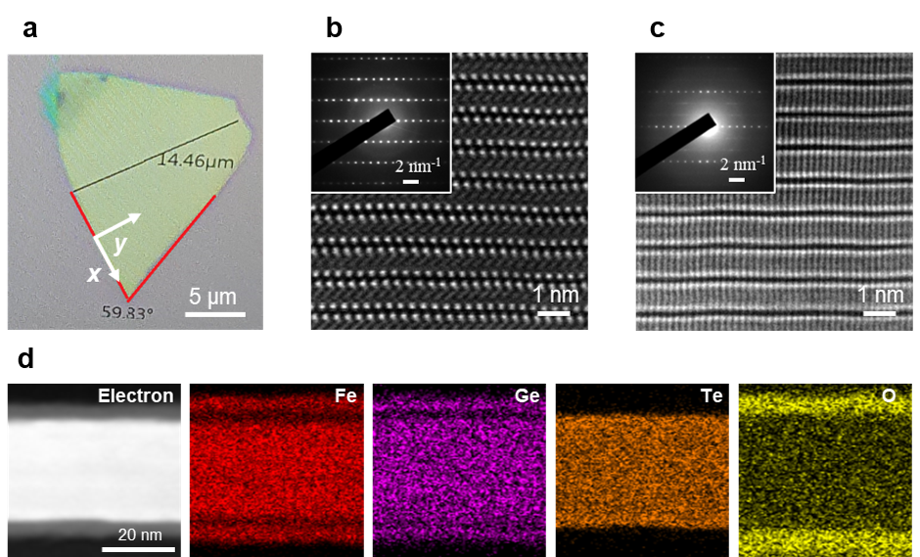
Extended Data Fig. 1│ Structural analysis of Fe₅GeTe₂ nanoflake. a, The optical image of exfoliated Fe₅GeTe₂. Axes indicate the direction of focused ion beam milled TEM samples. x axis is parallel to crystal edge and y axis is orthogonal to crystal edge. b-c, The high angle annular dark field (HAADF) scanning transmission electron microscopy (STEM) cross sectional image of x, y axis sample, respectively. inset images are selected area diffraction (SAED) pattern of each axis sample. d, The energy dispersive spectroscopy (EDS) results obtained from TEM EDS at high magnification. Fe, Ge, and O-rich area at the top and bottom region is oxidized layers which are formed during sample preparation.

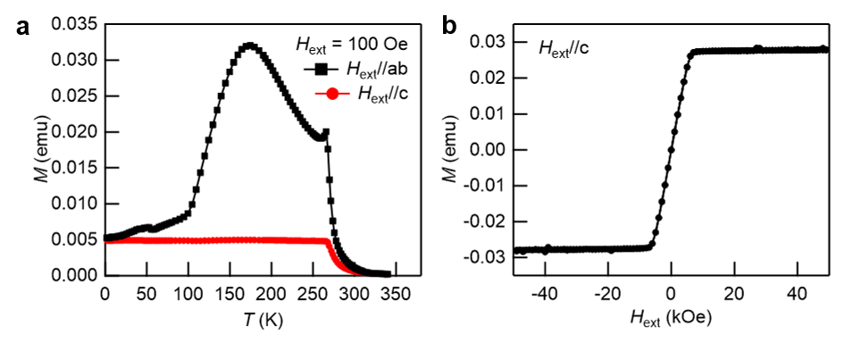
Extended Data Fig. 2│ Magnetic properties of bulk Fe₅GeTe₂. a. M-T curve of bulk Fe₅GeTe₂. Helimagnetism-induced sharp peak is at ~270K, which is consistent with previous reports. b. M-H curve of bulk crystal at 2K with H_{ext}//c.

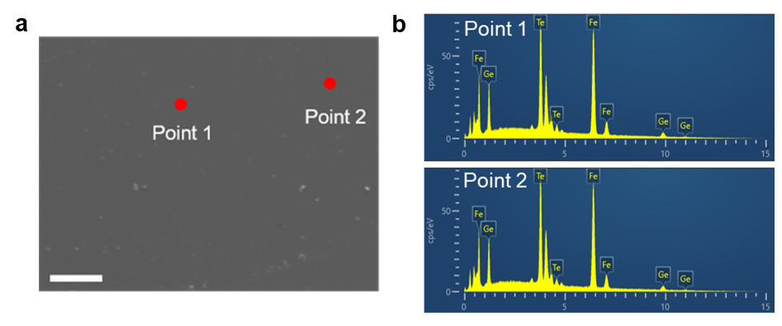
Extended Data Fig. 3│ SEM EDS analysis of Fe₅GeTe₂. a. The SEM image of bulk Fe₅GeTe₂. The length of scale bar is 20µm. b. EDS spectrum of Fe, Ge, Te elements.

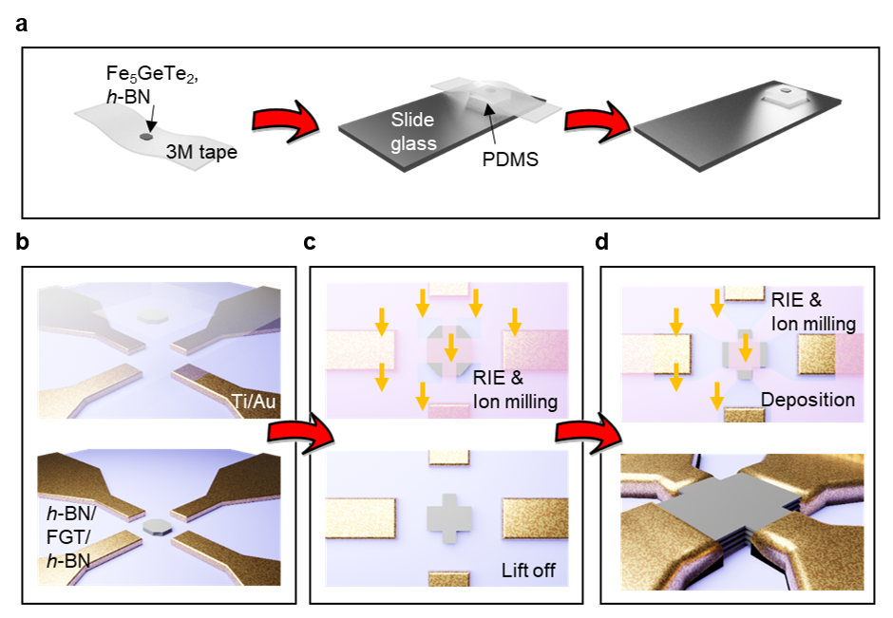
Extended Data Fig. 4│ Fabrication of the encapsulated device. a, Schematic of the exfoliated Fe₅GeTe₂ and h-BN crystals on PDMS. b, Schematic of a dry transfer method for transferring Fe₅GeTe₂ on a substrate. The transfer was performed 3 times in one device (2 h-BN and 1 Fe₅GeTe₂) for making an encapsulated structure. c, Schematic of a process to define a channel for transport measurement by RIE and ion milling. d, Schematic of a process to deposition of electrode with etching process. h-BN is etched by RIE and oxide layers on surface is etched by ion milling before the deposition. The last figure is Fe₅GeTe₂ device after whole fabrication.
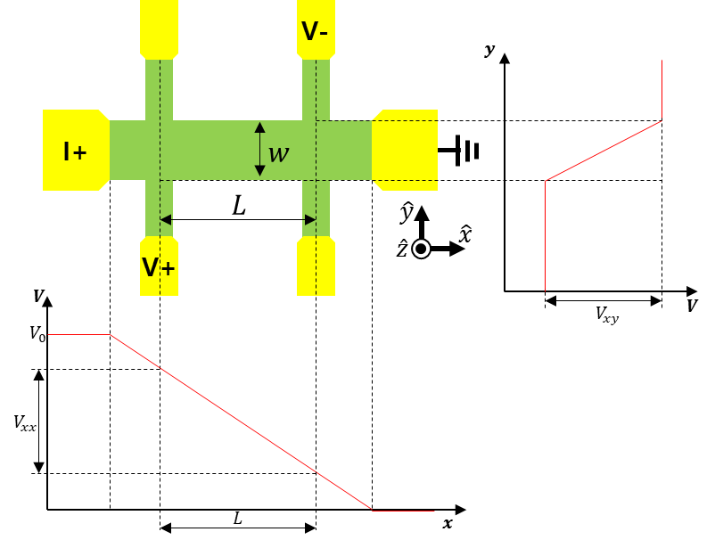
Extended Data Fig. 5│Schematic configuration of the Hall measurement. To describe a general condition for voltage measurement, probes of voltmeter are placed on diagonal direction. When the contacts are placed like figure, we can define voltage as $V=V_{xx}+V_{xy}$.

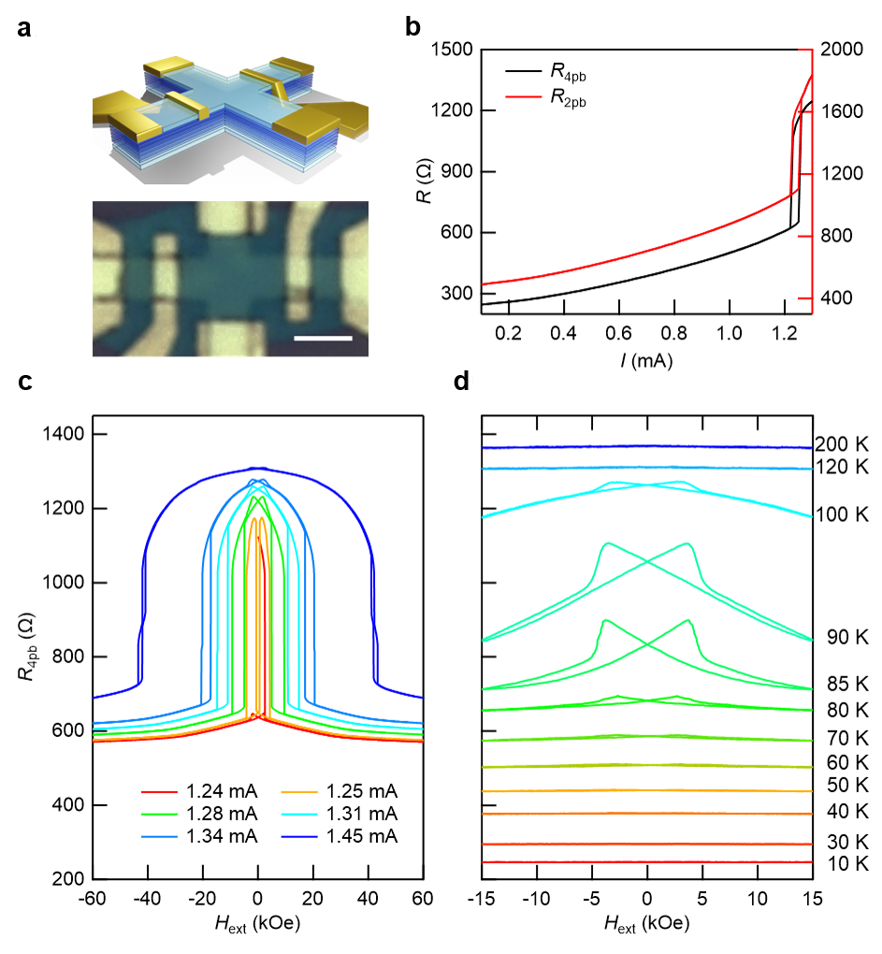
Extended Data Fig. 6│ I-R curve from the 2-probe and 4-probe measurements with the Fe₅GeTe₂ hall device. a, Device optical and schematic images for 4-probe measurement. b, I-R curve 2-probe and 4-probe measurement of Fe₅GeTe₂ Hall device at 10K without H_{ext}. R_{2p}, R_{4p} refer to the resistance between source and drain electrodes, resistance between other two electrodes which are placed between source and drain, respectively. c, In 4-probe measurement, the giant LMR is observed. d, R_{4p} of Fe₅GeTe₂ Hall device at various temperature range from 10 K to 250 K with H_{ext}//c, I = 0.2 mA.
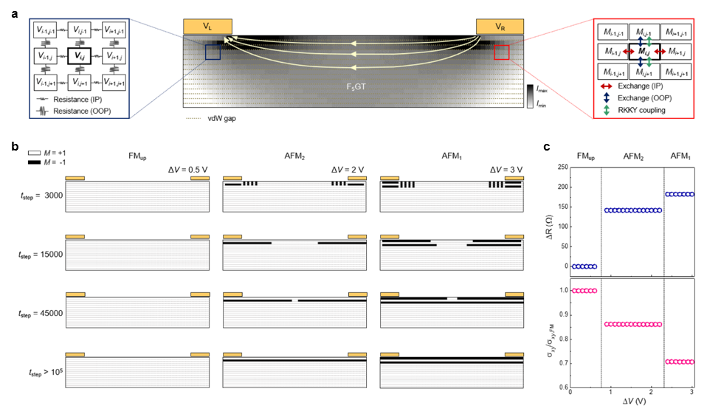
Extended Data Fig. 7│Simulation of micromagnetic dynamics based on the current distribution. a, Schematic of the Fe₅GeTe₂ device with two electrodes showing the current distribution. Current is injected from the right electrode to the left electrode due to the voltage difference (ΔV_{R-L} = V_{R} – V_{L}) and also induces the voltage gradient near the electrodes (expressed with yellow arrows as current direction and color gradient as current distribution). Dash lines depict van der Waals gaps in Fe₅GeTe₂. Numerical circuit models were carried out based on a modified Ohm’s law (enlarged image of blue box in left) and Ising model (enlarged image of red box in right). b, Time dependences of micromagnetic simulations as a function of ΔV_{R-L} represent the magnetization switching process, showing three representative steady-state magnetization states with calculated spin configurations (FM_{up}, AFM₁, and AFM₂). Bright and dark contrast correspond to magnetization of Fe₅GeTe₂ oriented up (M = +1) and down (M = –1), respectively. c, Calculated resistance difference (ΔR = R – R_{FM}; upper panel) and ratio of Hall conductivity (σ_{xy} / σ_{xy, FM}; bottom panel) are plotted as ΔV_{R-L}. FM_{up}-to-AFM₂ and AFM₂ -to-AFM₁ transitions occur at the critical values of ΔV_{R-L}, in good agreement with experiments.
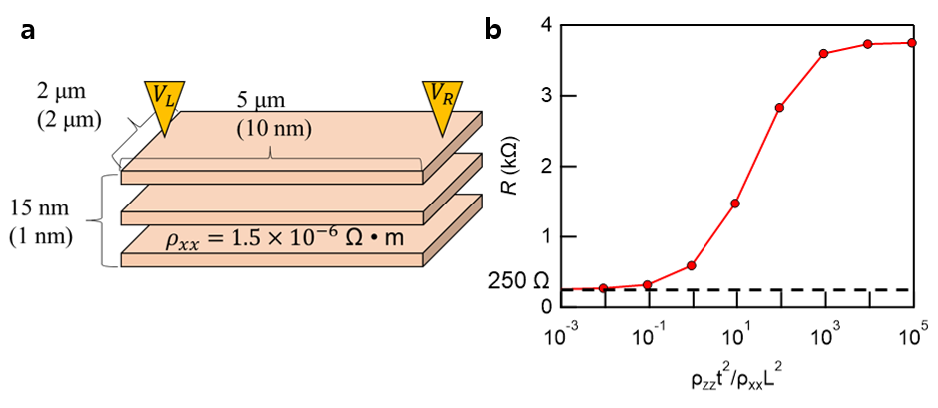
Extended Data Fig. 8│ Confirmation of simulation with the estimated R. a, Designed template for the simulation. b, Estimated R values in terms of the ratio between ρ_{zz} and ρ_{xx}.

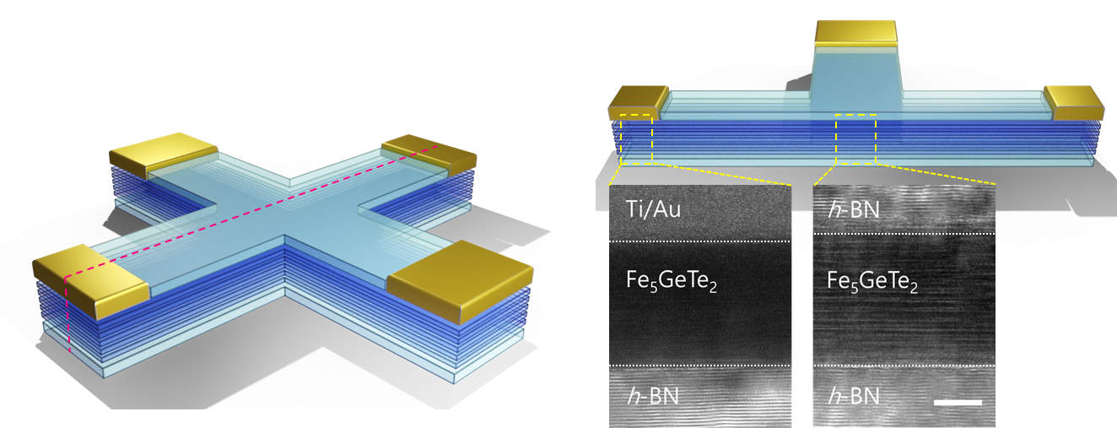
Extended Data Fig. 9│Interfacial conditions of encapsulated device (h-BN/Fe₅GeTe₂/h-BN). The right side of TEM image is the encapsulated Fe₅GeTe₂ after the device fabrication. The crystal was not damaged during the fabrication with the use of RIE and ion milling. The left side TEM image at the lead part. The contact interface was flat without any h-BN residue or damages (scale bars: 5 nm).

Supplementary Table 1. SEM EDS results
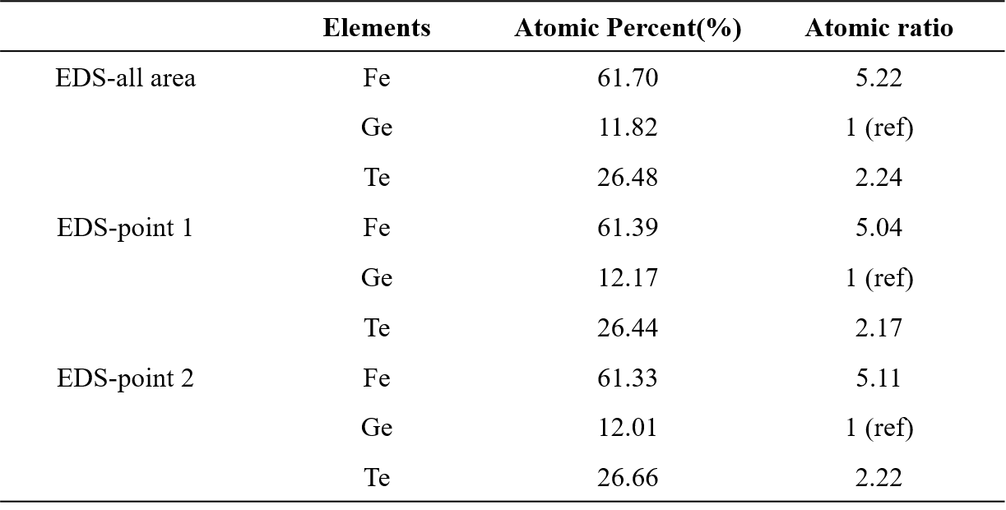

References
1 Ohta, T. et al. Butterfly-shaped magnetoresistance in van der Waals ferromagnet Fe5GeTe2. Aip Adv 11 (2021). https://doi.org:10.1063/9.0000067
2 Haney, P. M., Heiliger, C. & Stiles, M. D. Bias dependence of magnetic exchange interactions: Application to interlayer exchange coupling in spin valves. Physical Review B 79, 054405 (2009). https://doi.org:10.1103/PhysRevB.79.054405
3 Kim, K., Kwon, H. Y., Park, T.-E., Kim, S. & Kim, K.-W. Simulation on dynamics of voltage distribution regarding van der Waals tunneling gap. Journal of the Korean Magnetics Society 32, 123-129 (2022). https://doi.org:10.4283/JKMS.2022.32.3.123

