A prior knowledge-informed traceable Neutral Network modeling only using regular laboratory results to assist early diagnosis for tuberculosis: a multiple-center study in China

Yu-fang Liang¹ † , Hua-rong Zheng² † , Da-wei Huang¹ † , Jing Nai³, Yan Wang⁴, Wei-qun Cui⁵, Li-na Feng⁶, Xu-sheng Li⁷, Meng-guang Fan⁸，Yi-fei Luo⁹, Chao Chen¹⁰, Qing-tao Wang^{1,11*}，Rui Zhou^{1,11*}

Supplementary materials and methods
- Support Vector Machine （SVM）
SVM is a learning algorithm applied in many areas as it can be used to classify both linear and nonlinear data. In this study, the radial basis function (rbf) kernel was used and two hyperparameters were optimized, including the regularization parameter (C, from 2⁻⁵ to 2¹⁵, num = 100, equally spaced on a log scale), and the Kernel coefficient (gamma, from 2⁻⁹ to 2³, num = 100, equally spaced on a log scale)
- Logistic regression（LR）
LR is like linear regression, that is, a straight line fitted from existing data is used for prediction. The L2 penalty was used to specify the norm used in the penalization, and inverse of regularization strength was optimized
- K nearest neighbor（KNN）
KNN is classified according to the distance between different features and determines the category of samples to be distinguished according to the category of K samples closest to them. Number of n_neighbors used by default for model optimization (1 to 11, interval =1)
- Random Forest（RF）
RF is an ensemble classifier formed by a family of T decision trees. The predictions of all individual trees are combined by using the majority-voting mechanism. A node is partitioned using the best possible binary split. Another important feature of RF is its ability to measure the importance of each feature based on the Gini impurity index. Gini impurity is the likelihood of an incorrect classification of a randomly selected case if it was randomly labeled according to the distribution of the data.
Here three key hyperparameters were optimized, including the number of trees in the forest (estimators, from 50 to 100, interval = 1), the maximum depth of the tree (adept, from 10 to 70, interval = 1), and the function to measure the quality of a split (criterion,[entropy, gain]) and the randomness of the bootstrapping of the samples used when building trees (random state, from 1 to 100, interval = 1).
- Neutral Network（NN）
NN consists of input layer, hidden layer, and output layer, which is composed of neuron basic units. Each neuron is connected to the neuron of the previous layer, receives the output of the previous layer, and outputs to the next layer. In this study, the NN model has 5-6 hidden layers except the input and output layers, and the number of neurons in each layer varies from 32 to 256. Relu is selected as the activation function of the hidden layer, binary-Cross entropy is used as the loss function of the classifier, and RMSprop is used as the optimization algorithm. Both L1_L2 regularization and Dropout methods are used to reduce overfitting and improve model generalization.

Table 1. Different performance of 5 machine learning algorithms in disease screening process

Algorithm | Performance indicator (Mean;95%CI; SD)
 | AUC | SEN | SPE | ACC
RF | 0.9904  (0.9898-0.9909) 0.0003 | 0.9397  (0.9358-0.9435) 0.0019 | 0.9350  (0.9330-0.9370) 0.0010 | 0.9359  (0.9339-0.9380) 0.0010
SVM | 0.9811  (0.9791-0.9831) 0.0010 | 0.9053  (0.9011-0.9096) 0.0021 | 0.9769  (0.9758-0.9780) 0.0006 | 0.9623  (0.9610-0.9636) 0.0006
NN | 0.9913  (0.9905-0.9921) 0.0004 | 0.9600  (0.9543-0.9656) 0.0028 | 0.9635  (0.9610-0.9659) 0.0012 | 0.9628  (0.9616-0.9640) 0.0006
LR | 0.9361  (0.9339-0.9383) 0.0011 | 0.9256  (0.9216-0.9297) 0.0020 | 0.7494  (0.7462-0.7526) 0.0016 | 0.7853  (0.7825-0.7881) 0 .0014
K-NN | 0.9577  (0.9556-0.9597) 0.0010 | 0.9194  (0.9142-0.9245) 0.0026 | 0.9195  (0.9078-0.9312) 0.0058 | 0.9195  (0.9103-0.9287) 0.0046

Table 2. The prediction results of TB&nonTB screening Model from real-world independently external test samples
Clinical diagnosis | Target results | Model prediction results | Positive probability | Negative probability
Tuberculosis | positive | negative | 0.4931 | 0.5069
Tuberculosis | positive | negative | 0.4251 | 0.5749
Tuberculosis | positive | positive | 0.5523 | 0.4477
Tuberculosis | positive | negative | 0.4056 | 0.5944
Tuberculosis | positive | positive | 0.8348 | 0.1652
Tuberculosis | positive | positive | 0.6136 | 0.3864
Tuberculosis | positive | negative | 0.4109 | 0.5891
Tuberculosis | positive | negative | 0.4189 | 0.5811
Tuberculosis | positive | positive | 0.6564 | 0.3436
Tuberculosis | positive | positive | 0.7770 | 0.2230
Tuberculosis | positive | positive | 0.7185 | 0.2815
Tuberculosis | positive | positive | 0.8277 | 0.1723
Tuberculosis | positive | negative | 0.2737 | 0.7263
Tuberculosis | positive | negative | 0.4056 | 0.5944
Tuberculosis | positive | positive | 0.8348 | 0.1652
Tuberculosis | positive | negative | 0.4631 | 0.5369
Tuberculosis | positive | positive | 0.6529 | 0.3471
Tuberculosis | positive | positive | 0.9277 | 0.0723
Gestational Diabetes Mellitus | negative | positive | 0.5588 | 0.4412
Gestational Diabetes Mellitus | negative | negative | 0.4317 | 0.5683
Acute Abdominalgia | negative | positive | 0.5418 | 0.4582
Embryo Damage | negative | negative | 0.3251 | 0.6749
Infection After Appendicitis | negative | negative | 0.3845 | 0.6155
Ovarian Cancer | negative | negative | 0.2308 | 0.7692
Gastroesophageal Reflux Disease | negative | negative | 0.4427 | 0.5573
Oropharyngeal Cancer | negative | positive | 0.6764 | 0.3236
Gallstones With Chronic Cholecystitis | negative | negative | 0.3092 | 0.6908
Polyneuropathy | negative | negative | 0.1673 | 0.8327
Gastric Dysfunction | negative | negative | 0.2729 | 0.7271
Epilepsy | negative | negative | 0.4329 | 0.5671
Vertigo | negative | negative | 0.4458 | 0.5542
Acute Abdomen | negative | negative | 0.2902 | 0.7098
Coronary Heart Disease | negative | negative | 0.4088 | 0.5912
Coronary Heart Disease | negative | negative | 0.4391 | 0.5609
Acute Abdomen | negative | negative | 0.3598 | 0.6402
Pneumonia | negative | positive | 0.7269 | 0.2731

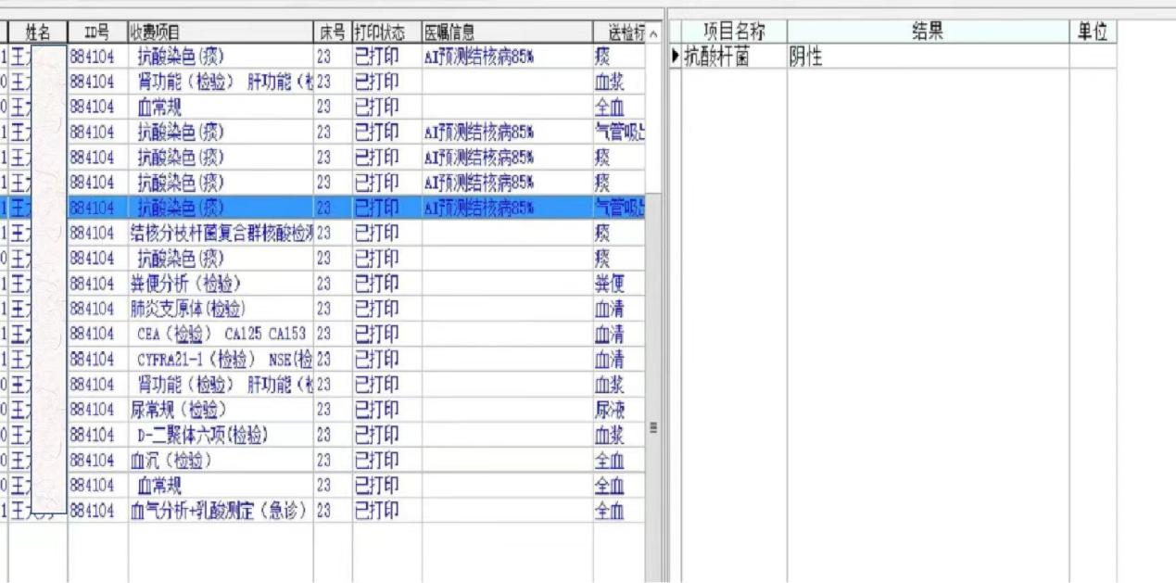
Fig.1a. AI-TB model predicted to be TB first time while acid fast staining method was negative.

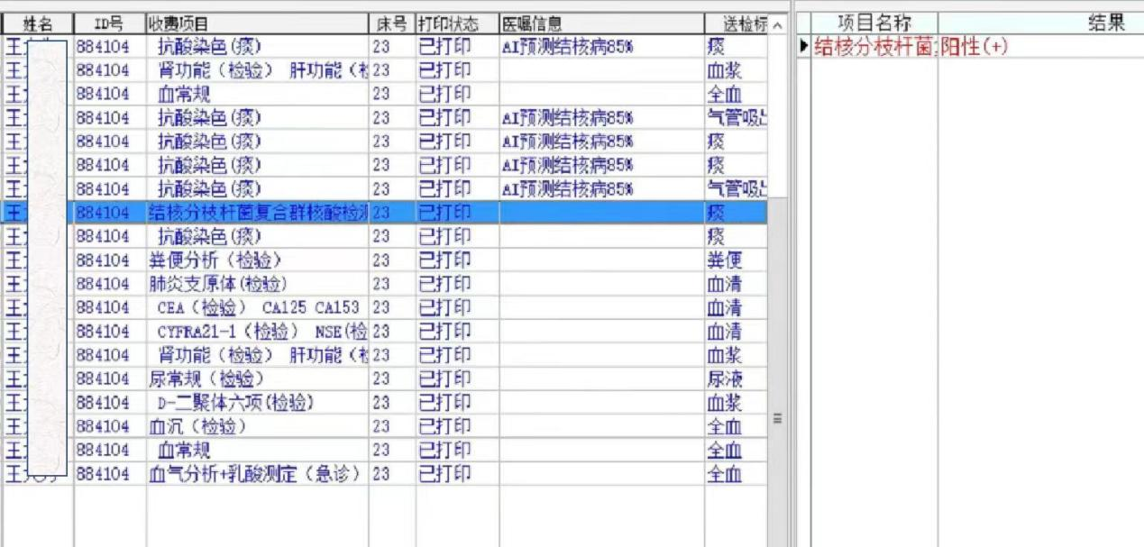
Fig.1b. AI-TB model predicted to be TB second time while Xpert MTB/RIF assay was positive.
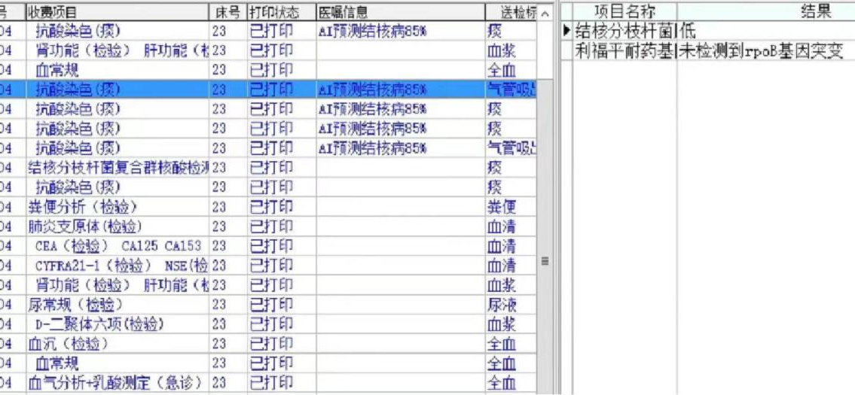
Fig.1c. AI-TB model predicted to be TB third time while Xpert MTB/RIF assay recovered to negative after treatment.

Table 3. A summary of institutions for clinical validation of TB model

Number | Names of institutions for clinical validation of TB model | Number of participations
1 | Baoding No.2 Central Hospital，Hebei, China | 1
2 | Changchun Infectious Disease Hospital, Jilin, China | 10
3 | Jilin Provincial Hospital for Tuberculosis, Jilin, China | 10
4 | Comprehensive Disease Control and Prevention Center of Inner Mongolia Autonomous Region, Inner Mongolia, China | 10
5 | Hohhot Municipal Health Commission，Inner Mongolia, China | 1
6 | Changchun Center For Disease Control and Prevention，Jilin, China | 1
7 | Health Commission Of Baishan City，Jilin, China | 1
8 | Health Commission Of Liaoyuan City， Jilin, China | 1
9 | Hohhot Second Hospital, Hohhot Infectious Diseases Hospital, Inner Mongolia, China | 1
10 | People's Hospital of Helingeer County，Inner Mongolia, China | 1

