Supplementary materials
Contents
Table S1: Basic demographics by country in percentages or means and standard deviations (SD) 2
Table S2: Fixed effects analyses with multiple imputations (fully adjusted) 4
Table S3: Fixed effects analyses for older adults when extending the sample to those aged 55 and above (fully adjusted) 5
Table S4: Subgroup analyses in meta-analysis 6
Table S5: Hobbies and mental health/wellbeing measures across 5 cohort studies 7
Figures S1a-S5d: Meta-regression 9
Figures S6a-S9b: Hobbies and outcomes by gender 14

Table S1: Basic demographics by country in percentages or means and standard deviations (SD)
 | Austria | Belgium | China | Czech Republic | Denmark | England | Estonia | France | Germany | Italy | Japan | Slovenia | Spain | Sweden | Switzerland | US
Hobby
With hobby | 90.0% | 88.9% | 37.6% | 89.1% | 96.0% | 78.1% | 88.3% | 82.5% | 91.0% | 54.0% | 90.0% | 70.5% | 51.0% | 95.8% | 94.4% | 56.2%
Without hobby | 9.1% | 11.1% | 62.4% | 10.9% | 4.0% | 21.9% | 11.7% | 17.5% | 9.0% | 46.0% | 10.0% | 29.5% | 49.0% | 4.20% | 5.60% | 43.8%
N | 2,524 | 2,304 | 1,611 | 2,664 | 1,006 | 4,267 | 3,584 | 2,705 | 966 | 1,915 | 57,051 | 1,272 | 2,099 | 1,315 | 1,776 | 6,204
Gender
Female | 58.1% | 55.8% | 45.5% | 57.6% | 54.2% | 53.7% | 61.6% | 58.0% | 48.7% | 51.4% | 45.1% | 56.6% | 54.3% | 52.8% | 53.0% | 58.4%
Male | 41.9% | 44.2% | 54.5% | 42.4% | 45.8% | 46.3% | 38.4% | 42.0% | 51.3% | 48.6% | 54.9% | 43.4% | 45.7% | 47.2% | 47.0% | 41.6%
N | 2,524 | 2,304 | 1,611 | 2,664 | 1,006 | 4,267 | 3,584 | 2,705 | 966 | 1,915 | 57,051 | 1,272 | 2,099 | 1,315 | 1,776 | 6,204
Education levels
Degree or above | 28.0% | 24.8% | 2.70% | 16.2% | 31.0% | 18.8% | 32.6% | 84.2% | 68.8% | 6.4% | 31.1% | 14.9% | 4.8% | 30.6% | 27.1% | 28.5%
Below degree | 71.5% | 74.8% | 97.3% | 82.8% | 68.8% | 81.2% | 67.4% | 14.6% | 30.9% | 93.3% | 68.9% | 85.0% | 94.6% | 68.2% | 72.1% | 71.5%
N | 2,492 | 2,289 | 1,611 | 2,635 | 996 | 4,237 | 3,583 | 2,662 | 940 | 1,894 | 56,885 | 1,267 | 2,014 | 1,276 | 1,751 | 6,195
Age | 74.2 (6.53) | 75.5 (7.25) | 71.7 (4.98) | 73.5 (6.52) | 74.8 (7.42) | 73.8 (6.65) | 74.6 (6.16) | 75.8 (7.17) | 74.0 (6.33) | 74.1 (6.46) | 73.5 (5.60) | 74.7 (6.41) | 75.9 (7.16) | 74.7 (7.22) | 74.2 (6.82) | 72.6 (6.06)
Range | 65-98 | 65-101 | 65-92 | 65-98.9 | 65-99 | 65-99 | 65–101 | 65-103 | 65-100 | 65-100 | 65-99 | 65-99 | 65-101 | 65-99 | 65-101 | 65-101
N | 2,524 | 2,304 | 1,611 | 2,664 | 1,006 | 4,267 | 3,584 | 2,705 | 966 | 1,915 | 57,051 | 1,272 | 2,099 | 1,315 | 1,776 | 6,204
Employment status
Working | 1.5% | 1.0% | 42.9% | 1.0% | 4.3% | 11.2% | 9.6% | 0.9% | 3.2% | 1.6% | 27.6% | 0.5% | 1.0% | 4.4% | 5.2% | 14.6%
Not working | 13.5% | 16.3% | 0.9% | 0.2% | 3.2% | 4.27% | 1.2% | 7.1% | 6.4% | 23.1% | 6.5% | 10.5% | 37.6% | 0.2% | 8.6% | 7.0%
Retired | 85.0% | 82.7% | 56.2% | 98.8% | 92.5% | 84.5% | 89.2% | 92.0% | 90.4% | 75.3% | 66.0% | 89.0% | 61.4% | 95.4% | 86.2% | 78.3%
N | 2,458 | 2,216 | 1,611 | 2,612 | 973 | 4,267 | 3,568 | 2,620 | 950 | 1,906 | 57,051 | 1,259 | 2,073 | 1,293 | 1,742 | 6,204
Long-standing mental/physical health conditions
Yes | 73.7% | 77.0% | 84.1% | 83.8% | 68.4% | 60.2% | 83.0% | 75.9% | 75.1% | 74.9% | 81.4% | 76.7% | 78.0% | 67.3% | 66.1% | 93.6%
No | 26.3% | 23.0% | 15.9% | 16.2% | 31.6% | 39.8% | 17.0% | 24.1% | 24.9% | 25.1% | 18.6% | 23.3% | 22.0% | 32.7% | 33.9% | 6.4%
N | 2,504 | 2,295 | 1,611 | 2,643 | 1,004 | 4,267 | 3,576 | 2,665 | 966 | 1,912 | 57,051 | 1,260 | 2,091 | 1,313 | 1,770 | 6,204

Table S2: Fixed effects analyses with multiple imputations (fully adjusted)
 | Depressive symptoms | Self-reported health | Happiness | Life satisfaction
 | Coef (95%CI) | Coef (95%CI) | Coef (95%CI) | Coef (95%CI)
Austria (N=3,178) | -0.27 | 0.11 | 0.11 | 0.18
 | (-0.40, -0.14) | (0.01, 0.21) | (-0.01, 0.25) | (0.05, 0.30)
Belgium (N=3,814) | -0.11 | 0.09 | 0.03 | 0.04
 | (-0.21, -0.01) | (0.01, 0.18) | (-0.09, 0.15) | (-0.04, 0.12)
China (N=5,316) | -0.20 | -0.01 | 0.29 | 0.01
 | (-0.30,-0.10) | (-0.08,0.06) | (0.20,0.39) | (-0.11,0.13)
Czech Republic (N=4,086) | -0.04 | 0.04 | 0.06 | 0.19
 | (-0.16, 0.80) | (-0.03, 0.12) | (-0.07, 0.19) | (0.07, 0.31)
Denmark (N=2,317) | -0.22 | -0.07 | 0.09 | 0.41
 | (-0.49, 0.05) | (-0.28, 0.13) | (-0.07, 0.24) | (0.22, 0.61)
England (N=5,026) | -0.02 | 0.02 | 0.08 | 0.06
 | (-0.08, 0.03) | (-0.02, 0.07) | (0.02, 0.14) | (0.01, 0.12)
Estonia (N=4,528) | -0.17 | 0.01 | 0.05 | 0.17
 | (-0.26, -0.08) | (-0.05, 0.06) | (-0.05, 0.14) | (0.06, 0.28)
France (N=3,431) | -0.21 | 0.01 | 0.02 | 0.09
 | (-0.32, -0.10) | (-0.49, 0.60) | (-0.08, 0.12) | (0.01, 0.17)
Germany (N=3,128) | -0.05 | 0.07 | 0.13 | -0.02
 | (-0.17, 0.07) | (-0.05, 0.18) | (-0.02, 0.28) | (-0.17, 0.14)
Italy (N=3,932) | -0.11 | 0.05 | 0.23 | 0.09
 | (-0.19, 0.03) | (-0.01, 0.11) | (0.15, 0.31) | (0.01, 0.18)
Japan (N=124,057) | -0.13 | 0.10 | 0.09 | 0.09
 | (-0.15, -0.11) | (0.08, 0.12) | (0.07, 0.10) | (0.07, 0.11)
Slovenia (N=2,816) | -0.11 | 0.10 | 0.08 | 0.11
 | (-0.21, -0.02) | (0.02, 0.18) | (-0.03, 0.19) | (-0.01, 0.22)
Spain (N=4,547) | -0.11 | 0.12 | -0.12 | 0.13
 | (-0.18, -0.03) | (0.07, 0.17) | (-0.20, -0.04) | (0.05, 0.20)
Sweden (N=3,508) | -0.12 | 0.16 | 0.24 | 0.10
 | (-0.26, 0.03) | (0.01, 0.31) | (0.07, 0.42) | (-0.05, 0.24)
Switzerland (N=2,201) | 0.02 | 0.20 | -0.02 | 0.19
 | (-0.10, 0.15) | (0.08, 0.32) | (-0.16, 0.13) | (0.08, 0.31)
United States (N=7,362) | -0.07 | 0.03 | 0.09 | 0.10
 | (-0.13, -0.02) | (-0.01, 0.07) | (0.04, 0.14) | (0.03, 0.16)

Table S3: Fixed effects analyses for older adults when extending the sample to those aged 55 and above (fully adjusted)

 | Depressive symptoms | Self-reported health | Happiness | Life satisfaction
 | Coef (95%CI) | Coef (95%CI) | Coef (95%CI) | Coef (95%CI)
Austria (N=4,838) | -0.15 | 0.13 | 0.14 | 0.17
 | (-0.23, -0.06) | (0.05, 0.21) | (0.05, 0.23) | (0.08, 0.26)
Belgium (N=6,428) | -0.08 | 0.07 | 0.07 | 0.06
 | (-0.15, -0.001) | (0.004, 0.13) | (-0.02, 0.16) | (0.004, 0.12)
China (N= 4,875) | -0.03 | 0.02 | 0.22 | 0.03
 | (-0.09,0.02) | (-0.04,0.09) | (0.15,0.30) | (-0.04,0.10)
Czech Republic (N=6,412) | -0.10 | 0.03 | 0.06 | 0.09
 | (-0.17, -0.03) | (-0.03, 0.09) | (-0.03, 0.14) | (0.01, 0.17)
Denmark (N=3,862) | -0.15 | -0.07 | 0.06 | 0.14
 | (-0.29, -0.02) | (-0.23, 0.08) | (-0.06, 0.17) | (0.01, 0.28)
England (N=6,657) | -0.05 | 0.03 | 0.09 | 0.06
 | (-0.10, -0.00) | (-0.01, 0.07) | (0.04, 0.14) | (0.02, 0.10)
Estonia (N=6,657) | -0.14 | 0.03 | 0.13 | 0.12
 | (-0.20, -0.07) | (-0.02, 0.07) | (0.04, 0.21) | (0.03, 0.20)
France (N=5,576) | -0.17 | 0.04 | 0.02 | 0.13
 | (-0.23, -0.10) | (-0.02, 0.09) | (-0.05, 0.10) | (0.07, 0.19)
Germany (N=5,212) | -0.08 | 0.05 | 0.03 | 0.04
 | (-0.18, 0.02) | (-0.04, 0.14) | (-0.09, 0.14) | (-0.06, 0.14)
Italy (N=5,933) | -0.07 | 0.03 | 0.17 | 0.06
 | (-0.13, -0.02) | (-0.01, 0.08) | (0.11, 0.23) | (0.01, 0.11)
Slovenia (N=4,616) | -0.08 | 0.07 | 0.02 | 0.14
 | (-0.14, -0.01) | (0.004, 0.13) | (-0.06, 0.10) | (0.07, 0.21)
Spain (N=6,694) | -0.10 | 0.07 | -0.02 | 0.15
 | (-0.15, -0.05) | (0.03, 0.11) | (-0.08, 0.04) | (0.10, 0.20)
Sweden (N=4,822) | -0.20 | 0.18 | 0.27 | 0.14
 | (-0.32, -0.07) | (0.04, 0.32) | (0.12, 0.43) | (0.02, 0.26)
Switzerland (N=3,487) | 0.04 | 0.20 | -0.04 | 0.16
 | (-0.05, 0.14) | (0.11, 0.29) | (-0.15, 0.08) | (0.07, 0.24)
United States (N=10,746) | -0.10 | 0.04 | 0.09 | 0.09
 | (-0.13, -0.06) | (0.01, 0.06) | (0.06, 0.13) | (0.06, 0.12)

Table S4: Subgroup analyses in meta-analysis
 | Effect size | 95%CI | I² | τ² | H² | P_{subgroup}
Depressive symptoms
Hobbies measures |  |  |  |  |  | 0.645
Listed | -0.10 | -0.15, -0.06 | 61.6% | 0.004 | 2.60
Binary | -0.09 | -0.14, -0.03 | 83.8% | 0.002 | 6.17
Self-reported health
Hobbies measures |  |  |  |  |  | 0.818
Listed | 0.06 | 0.03, 0.09 | 32.3% | 0.001 | 1.48
Binary | 0.05 | 0.00, 0.10 | 81.8% | 0.002 | 5.50
Happiness
Hobbies measures |  |  |  |  |  | 0.578
Listed | 0.09 | 0.04, 0.14 | 61.3% | 0.005 | 2.58
Binary | 0.10 | 0.08, 0.12 | 0.00% | 0.000 | 1.00
Life satisfaction
Hobbies measures |  |  |  |  |  | 0.433
Listed | 0.11 | 0.07, 0.15 | 49.0% | 0.002 | 1.96
Binary | 0.09 | 0.07, 0.11 | 0.23% | 0.000 | 1.00
Note: I² indicates the percentage of variability in the effect size that is caused by between-study heterogeneity, rather than by sampling error. τ² indicates the variance of the true effect sizes underlying our data. H² statistics describe the ratio of the observed variation and the expected variance due to sampling error. A value of H² greater than 1 indicates the presence of between-study heterogeneity. P_{subgroup} presents the p-value of the test for subgroup differences to test whether the difference between subgroups is statistically significant.

Table S5: Hobbies and mental health/wellbeing measures across 5 cohort studies
Data | Survey questions | Coding
Hobby
ELSA | ‘I have a hobby or past-time’ | 1=yes; 0=no
JAGES | ‘Do you have hobbies?’ | 1=yes; 0=no
HRS | ‘How often do you work on a hobby or project?’ | 1=any frequency; 0=not in the last month/never
SHARE | ‘Which of the activities listed on this card – if any – have you done in the past twelve months?’  1. Done voluntary or charity work  2. Attended an educational or training course  3. Gone to a sport, social or other kind of club  4. Taken part in a political or community-related organization  5. Read books, magazines or newspapers  6. Did word or number games such as crossword puzzles or Sudoku 10. Played cards or games such as chess.  0. None of these | 1=any of the activities; 0=none
CHARLS | ‘Which of the social activities listed on this card – if any – have you done in the past month?’  1. Played ma-jong, played chess, played cards or went to a community club  2. Went to a sport, social or other kind of club  3. Took part in a community-related organisation  4. Did voluntary or charity work  5. Attended an educational or training course  0. None of these | 1=any of the activities; 0=none
Depressive symptoms
ELSA | Center for Epidemiologic Studies Depression Scale (CES-D)¹ | 8 items
JAGES | Geriatric Depression Scale (GDS)² | 15 items
HRS | CES-D | 8 items
SHARE | EURO-D scale³ | 12 items
CHARLS | CED-D⁴ | 10 items
Self-reported health
ELSA | ‘Would you say your health is excellent, very good, good, fair, or poor?’ | 5-point scale; reverse-coded & standardised
JAGES | ‘How is your health condition now?’ | 4-point, ranging in excellent, good, fair, or poor; reverse-coded & standardised
HRS | ‘Would you say your health is excellent, very good, good, fair, or poor?’ | 5-point scale; reverse-coded & standardised
SHARE | ‘Would you say your health is excellent, very good, good, fair, or poor?’ | 5-point scale; reverse-coded & standardised
CHARLS | ‘Would you say your health is very good, good, fair, poor or very poor?’ | 5-point scale; reverse-coded & standardised
Happiness
ELSA | ‘Overall, how happy did you feel yesterday?’ | 11-point scale, ranging from not at all to very; standardised
JAGES | ‘How happy are you now?’ | 11-point scale (a 10-point scale for Wave 2 only), ranging from very unhappy to very happy; standardised
HRS | ‘During the past 30 days, to what degree did you feel happy?’ | 5-point scale, ranging from not at all to very much; standardised
SHARE | ‘How often, on balance, do you look back on your life with a sense of happiness?’ | 4-point scale, ranging from never to often
CHARLS | ‘How have you felt and behaved during the last week? - I was happy.’ | 4-point scale, ranging from rare to most; standardised
Life satisfaction
ELSA | ‘I am satisfied with my life’ | 7-point scale, ranging from strongly disagree to strongly agree; standardised
JAGES | ‘Are you satisfised with your present life?’ | 1=yes, 2=no; standardised
HRS | ‘I am satisfied with my life’ | 7-point scale, ranging from strongly disagree to strongly agree; standardised
SHARE | H’ow satisfied are you with your life?’ | 10-point scale, randing from 0 completelty dissatisfied to 10 completelty satisfied.
CHARLS | How satisfied are you with it? | 5-point scale, ranging from completely satisfied to not at all satisfied; standardised
Note: ELSA refers to the English Longitudinal Study of Ageing.
JAGES refers to the Japan Gerontological Evaluation Study.
HRS refers to the Health and Retirement Study.
SHARE refers to the Survey of Health, Ageing and Retirement in Europe.
CHARLS refers to the China Health and Retirement Longitudinal Study.
¹CES-D consists of 8 items assessing depression, everything is an effort, sleep is restless, felt alone, felt sad, could not get going, felt happy, and enjoyed life.
²GDS consists of 15 items assessing life satisfaction, felt little meaning in life, low motivation, felt empty, felt bored, felt good, mood, bad feeling, felt happy, felt helpless, homebound, felt forgetful, enjoyed life, vitality, hopeless, and felt poverty.
³EURO-D scale consists of 12 items assessing depression, pessimism, suicidality, guilt, sleep, interest, irritability, appetite, fatigue, concentration, enjoyment, and tearfulness.
⁴CES-D consists of 10 items assessing depression, everything is an effort, sleep is restless, felt happy, felt lonely, bored by little things, could not get going, had trouble keeping mind on what is doing, felt hopeful about the future, and felt fearful.

Figures S1a-S5d: Meta-regression
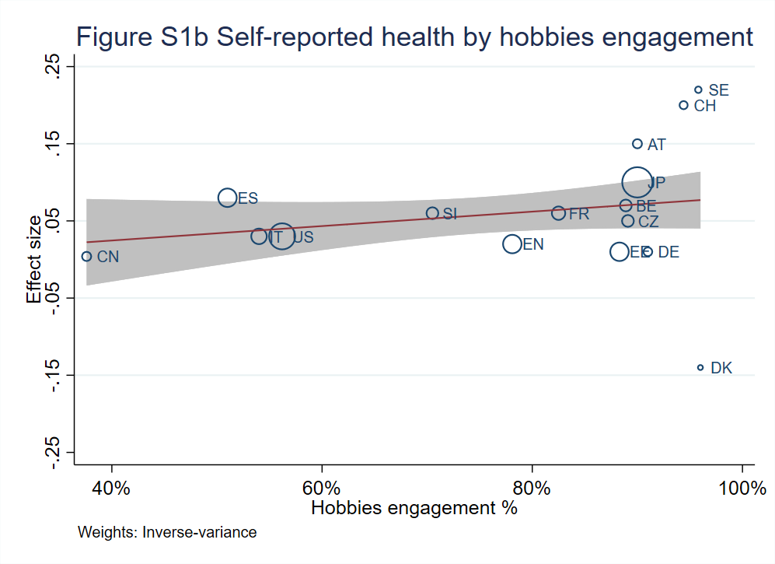
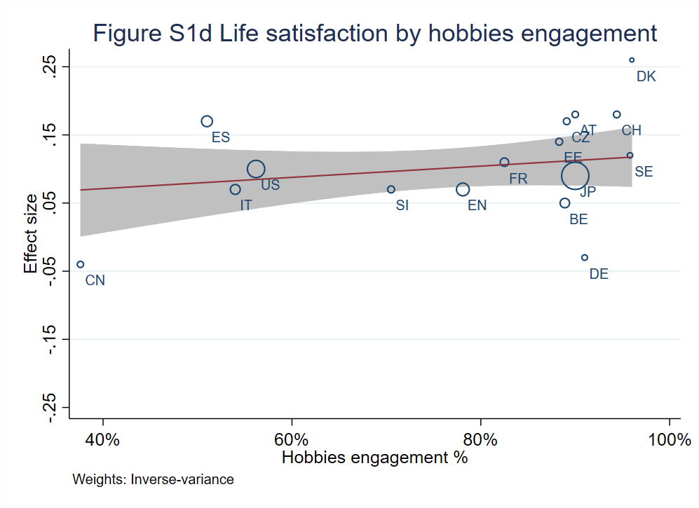
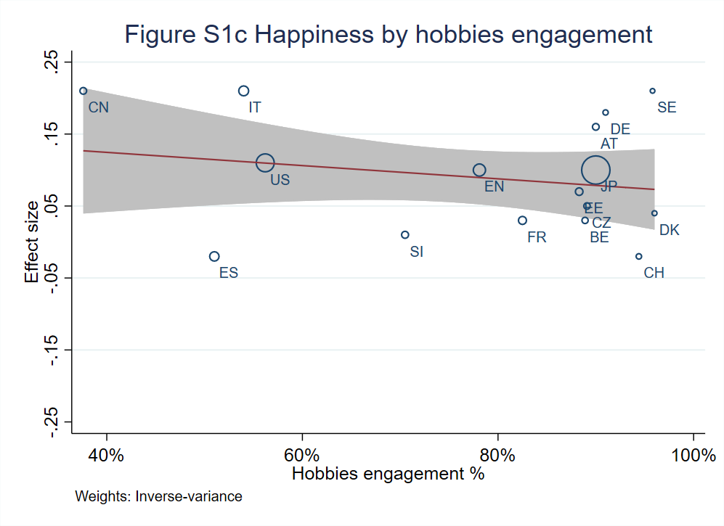
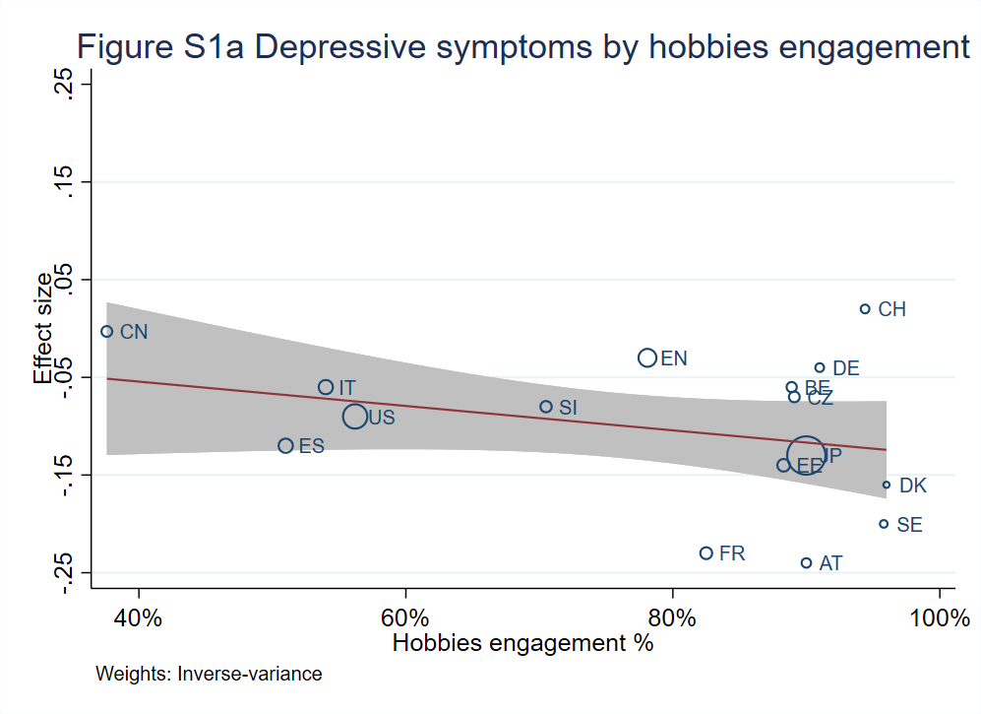
For Figures S2a-S5d, bubble plots with fitted meta-regression line and 95% confidence intervals (shaded area) are presented. Circles are sized according to the precision of each estimate with larger bubbles for more precise estimates. Figures S1a-S1d present bubble plots of the effect size for four outcomes and the percentage of hobbies engagement. Figures S2a-2d present the effect size and country wealth. Figures S3a-3d present the effect size and the Gini index. Figures 4a-4d present the effect size and the world happiness index score. Figures 5a-5d present the effect size and life expectancy. Country abbreviations were used: AT=Austria, BE=Belgium, CN=China, CZ=Czech Republic, DK=Denmark, EN=England, EE=Estonia, FR=France, DE=Germany, IT=Italy, JP=Japan, SI=Slovenia, ES=Spain, SE=Sweden, CH=Switzerland, and US=United States.
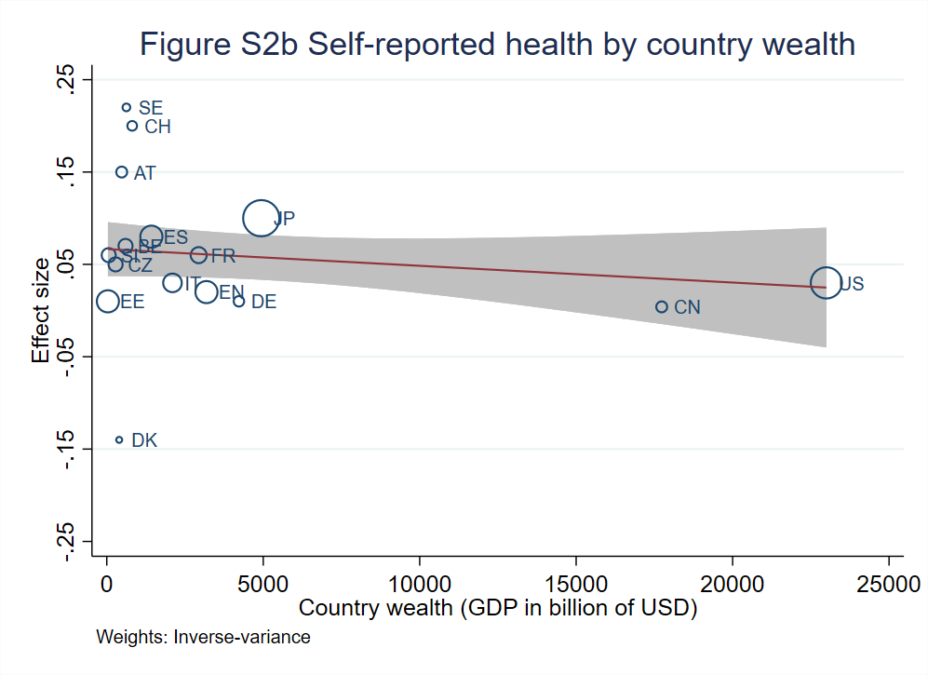
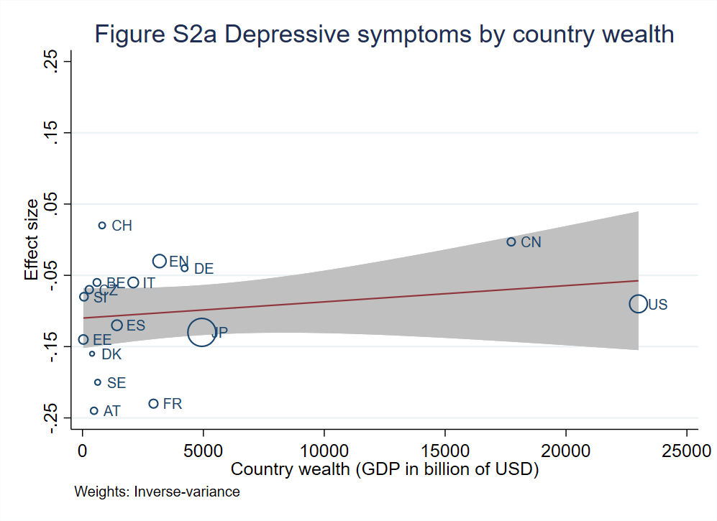
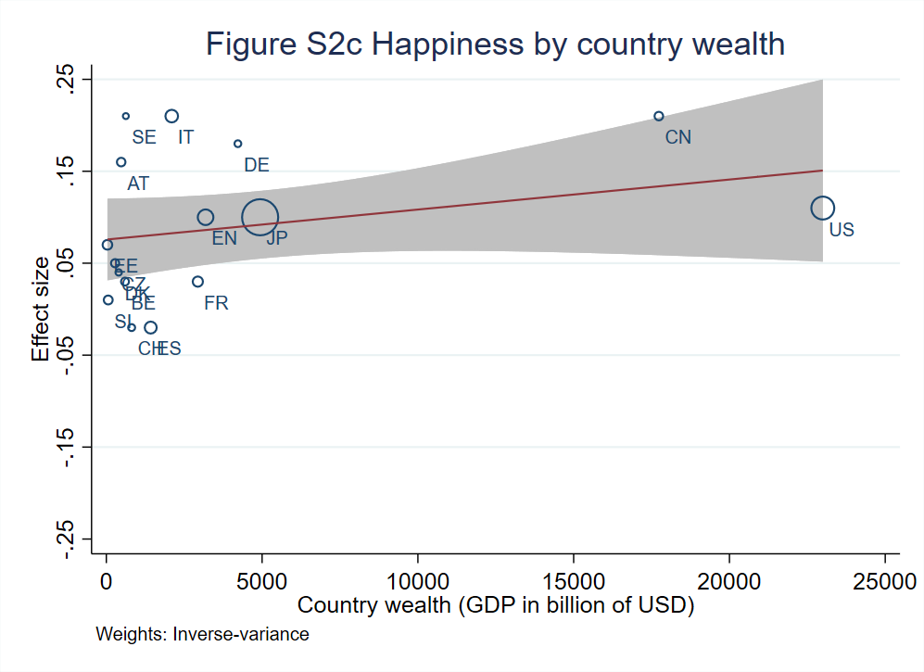
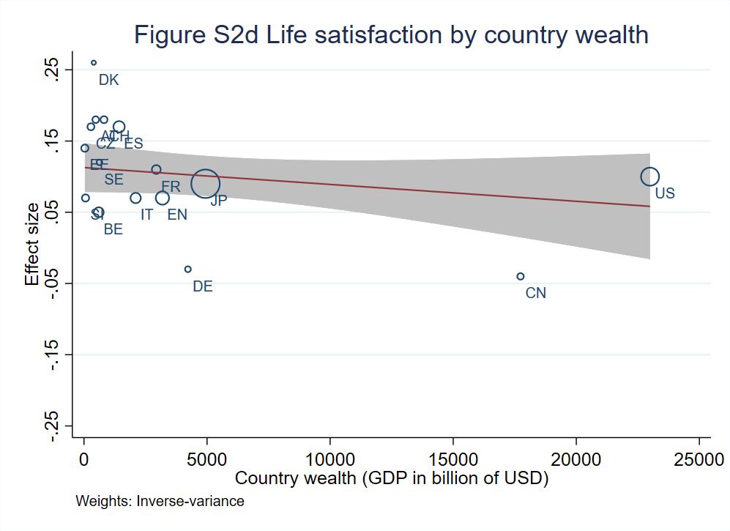
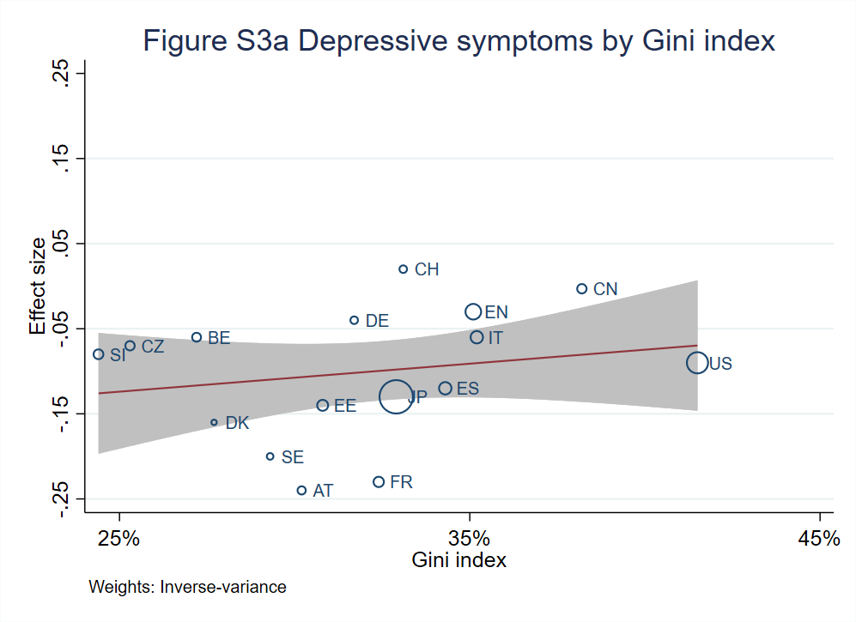
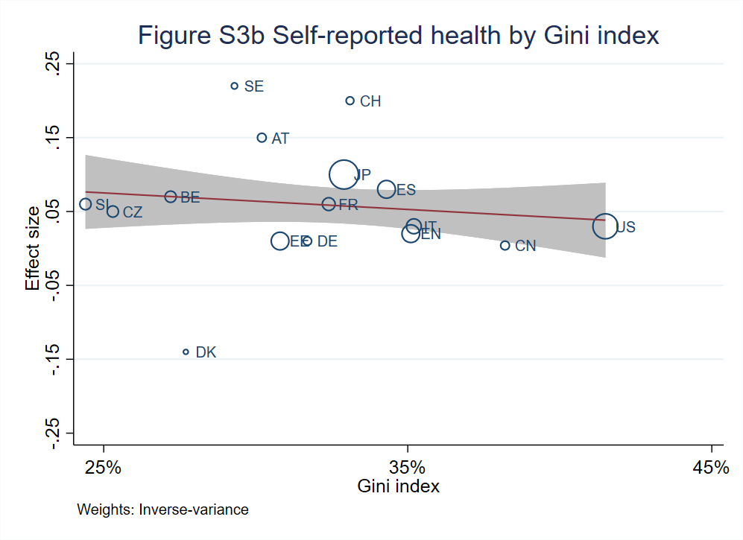
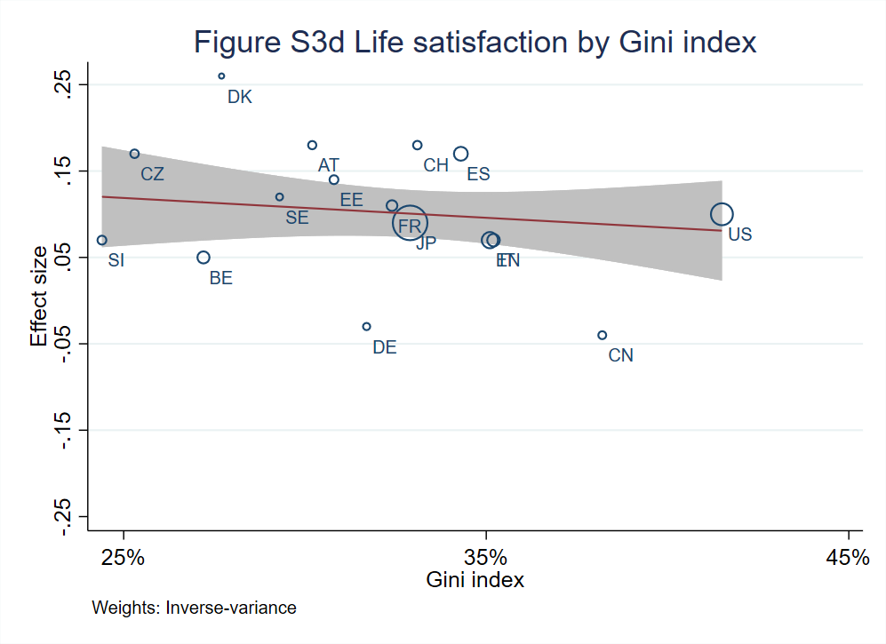
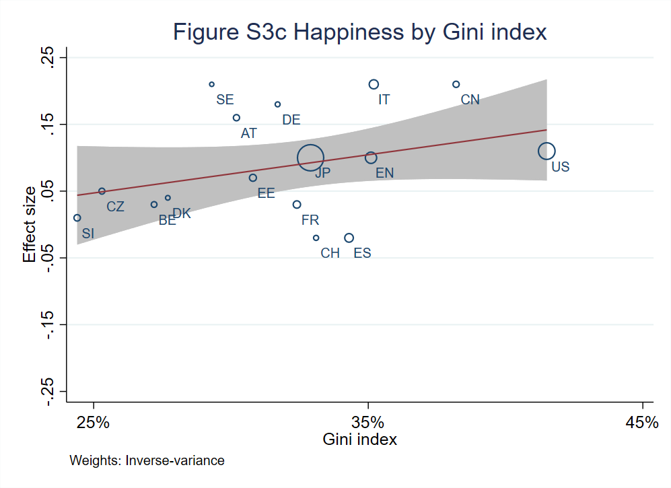
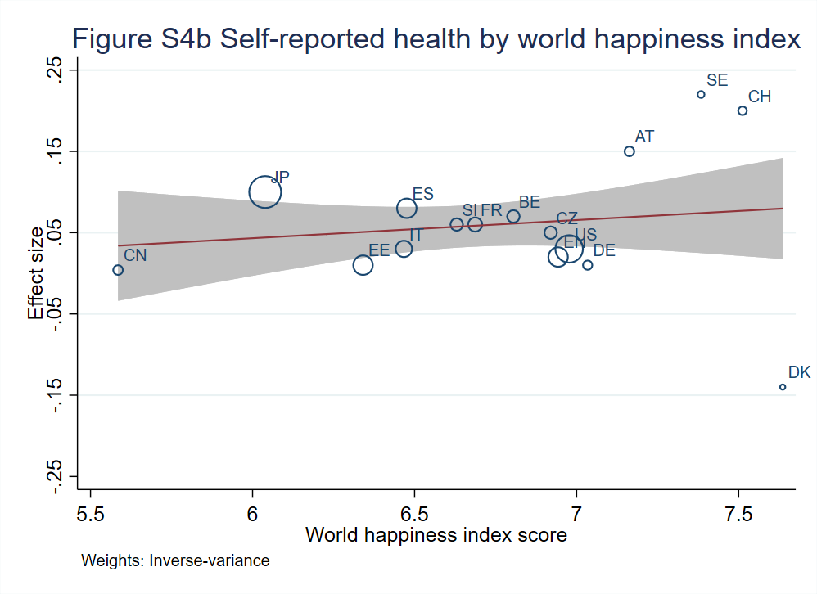
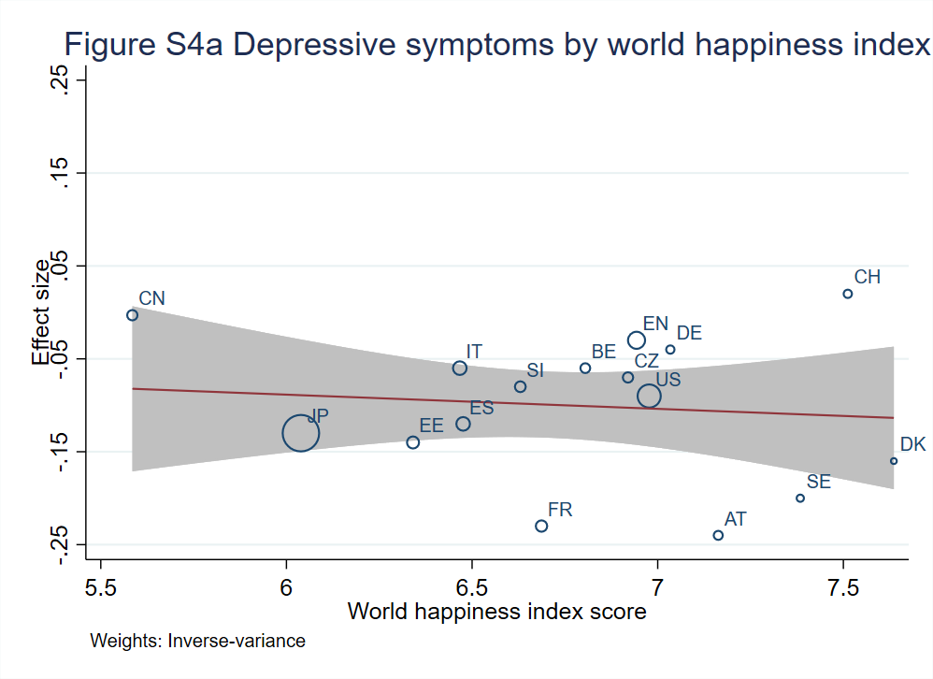
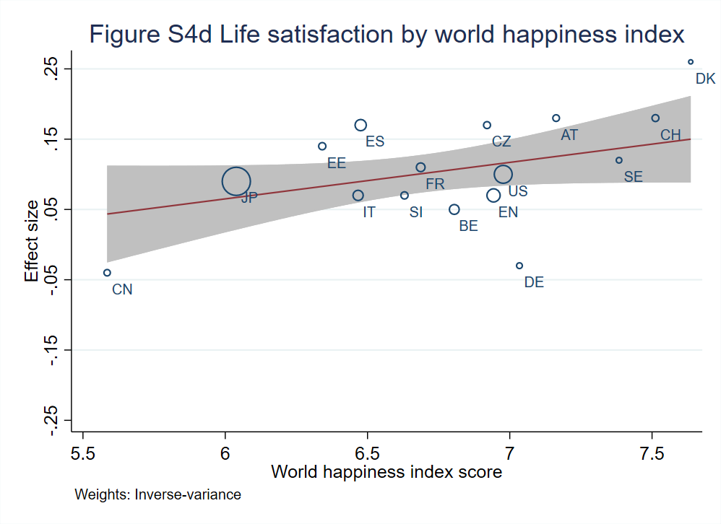
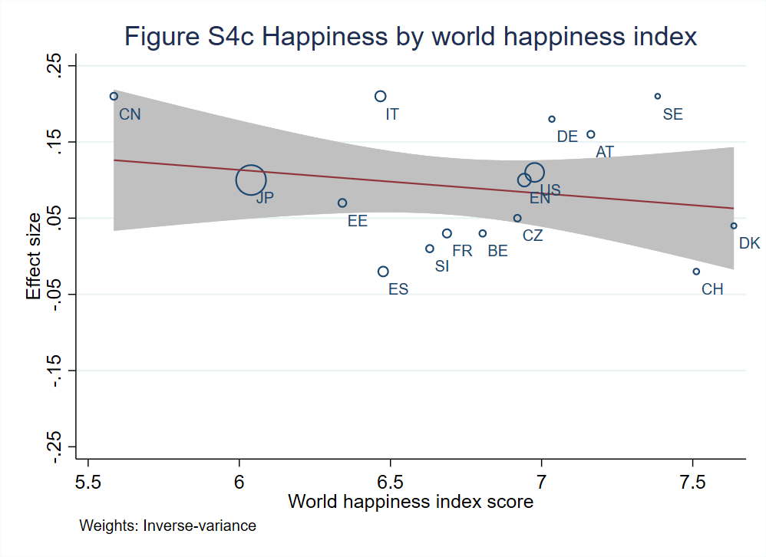
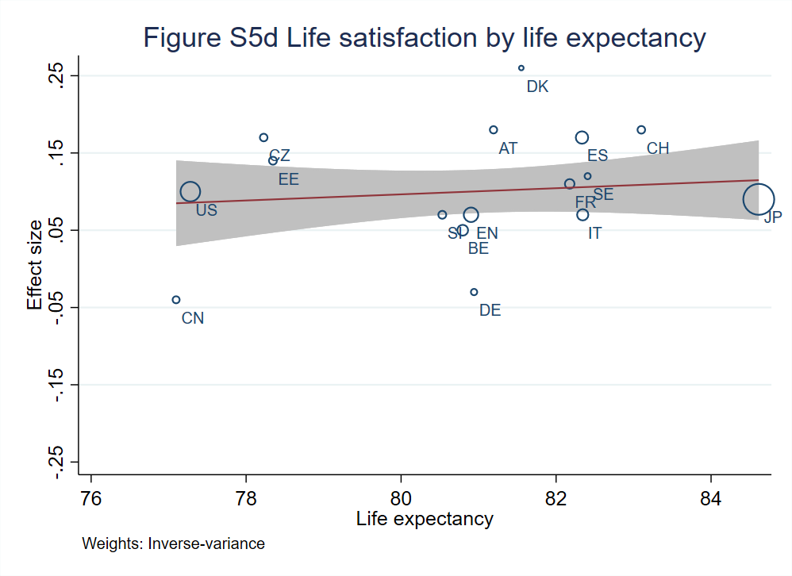
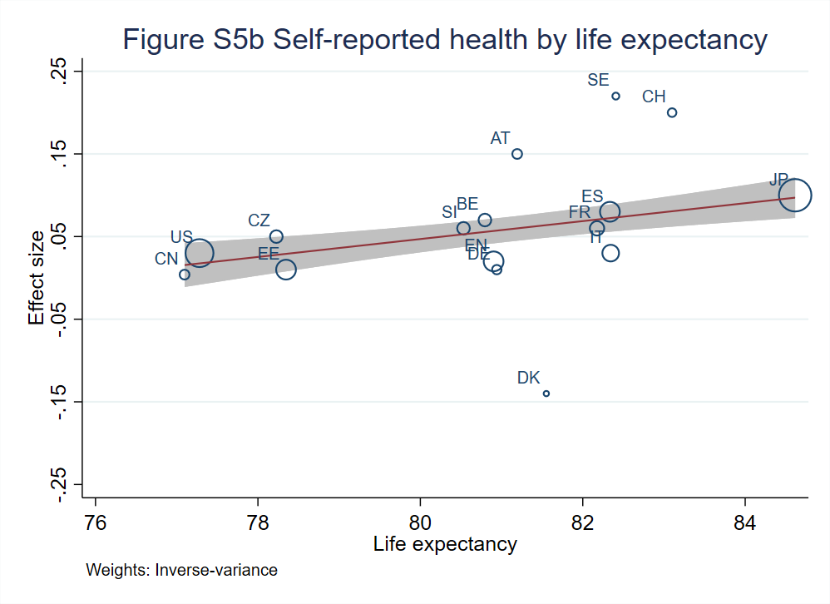
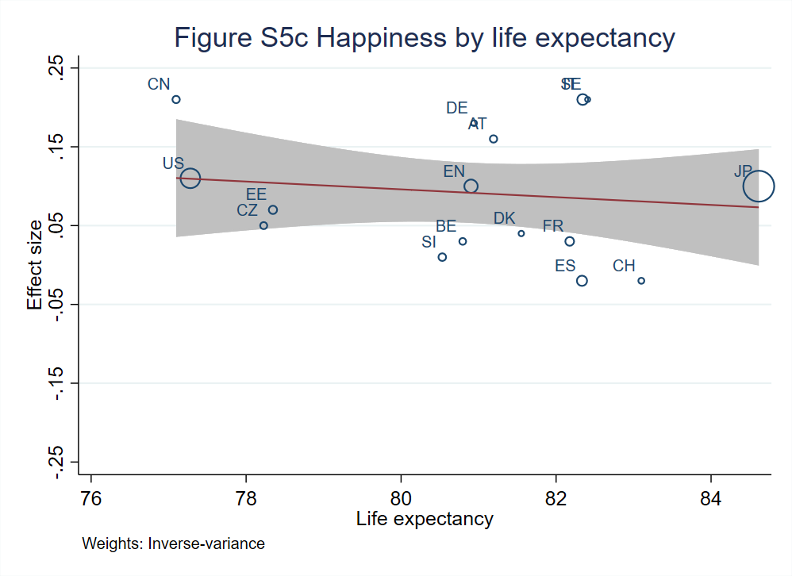
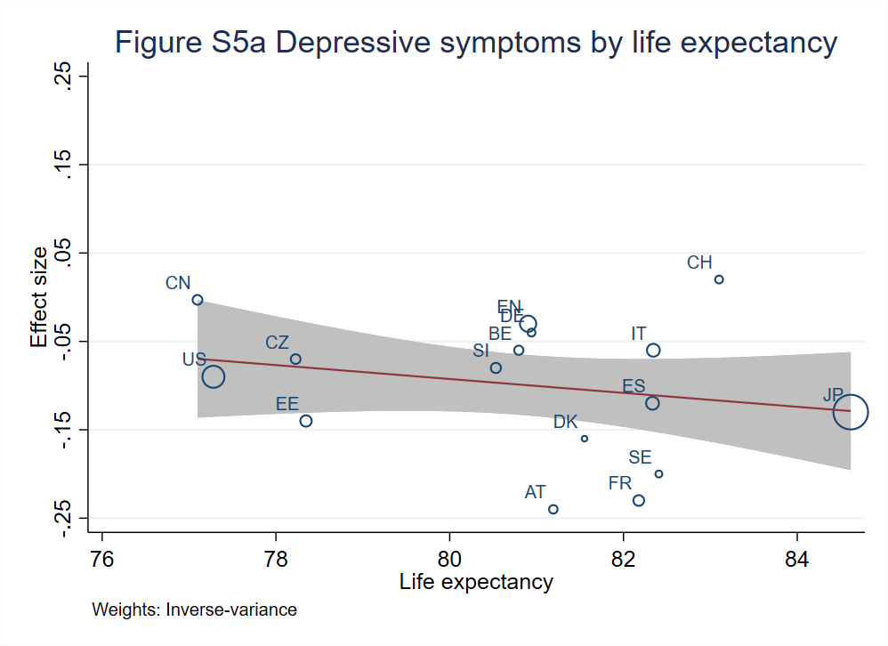

Figures S6a-S9b: Hobbies and outcomes by gender
