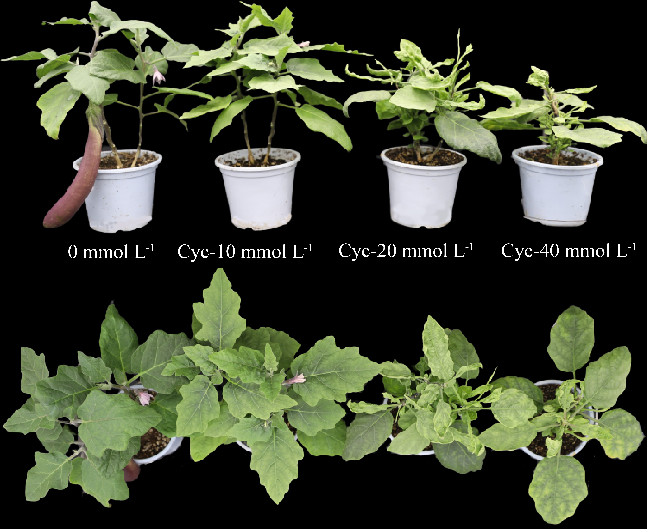
Figure S1. Effects of exogenous cyclic leucine spraying on growth and development of eggplant (day 30 after the end of spraying)

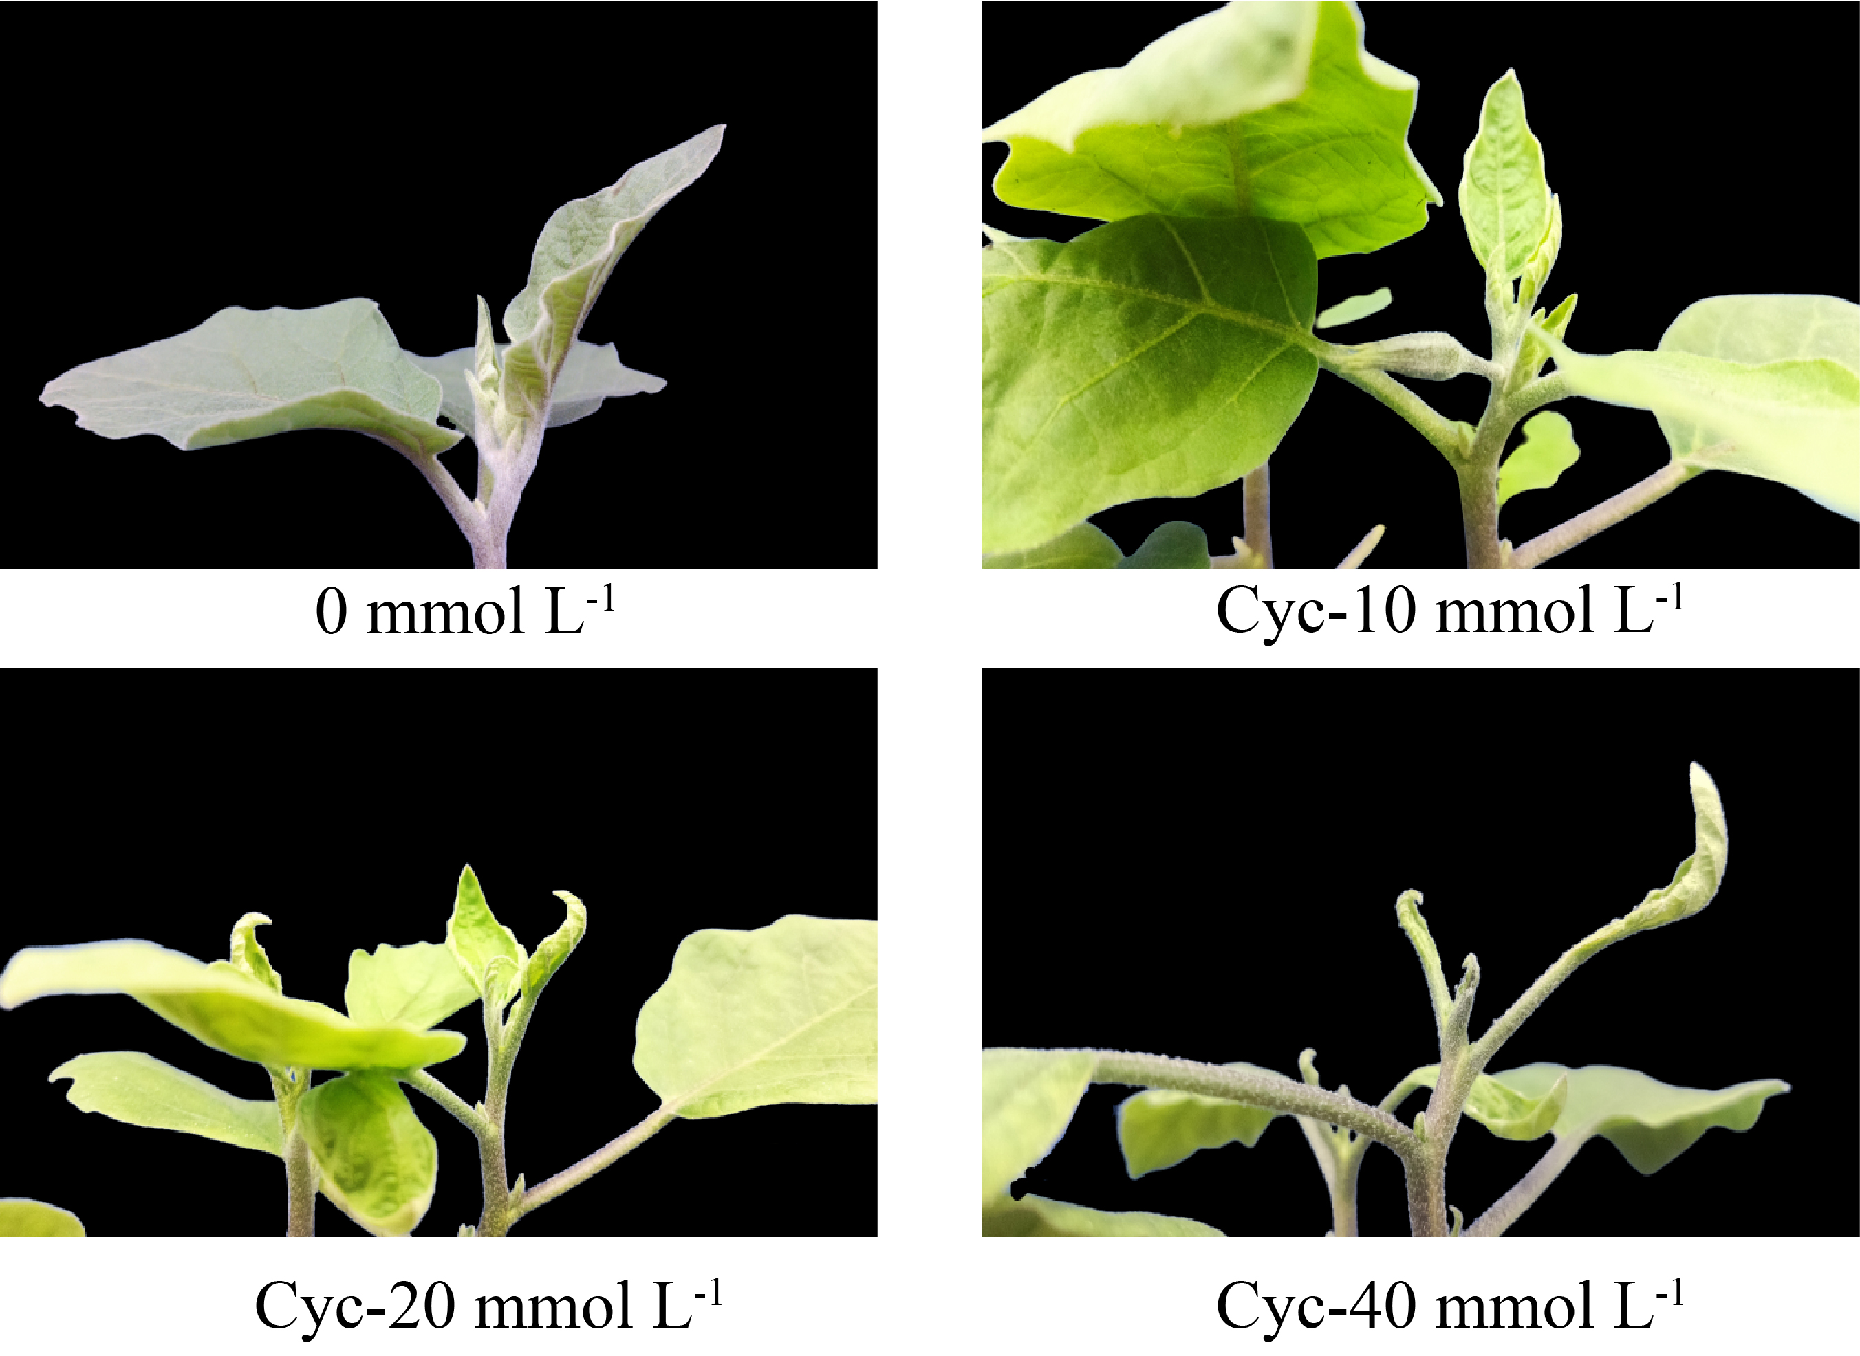
Figure S2. Changes in growth points of eggplant plants after spraying with different concentrations of exogenous cyclic leucine (14th day after the end of spraying)

