Legends of supplementary Figures.

Fig. S1 LD decay (r²) in a full-sib progeny population (F1-generation, n=904 from 49 parents based on the original pedigree) based on Norway spruce 50k SNP array. The Vertical dashed line represents LD decay distance when r²=0.2.

Fig. S2 Population structure for the 904 clones coloured based on the family identities.

Fig. S3 A mating design of 49 parents constructed into 32 full-sib families. Each circle in the top level represents a parent and the number is the identity of the parent. Each square at the bottom represents a full-sib family. The number within each square represents the number of clones per family genotyped. The families whose squares are framed in red colour, were selected to test the effect of family size on predictive ability. If the parents only cross once, then dark goldenrod means male and dark skyblue means female. Otherwise, the colour of the parents could be any of both colours.

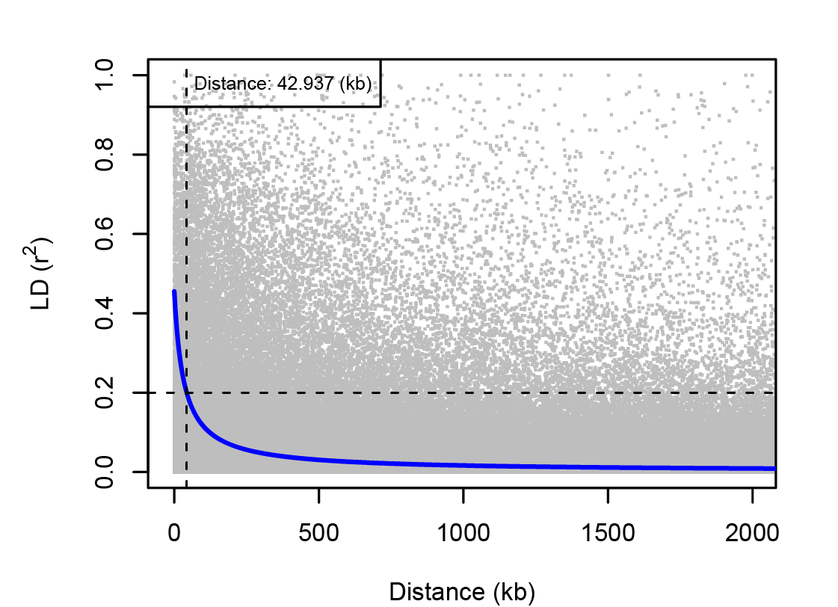
Fig. S1 LD decay (r²) in a full-sib progeny population (F1-generation, n=904 from 49 parents based on the original pedigree) based on Norway spruce 50k SNP array. The Vertical dashed line represents LD decay distance when r²=0.2.

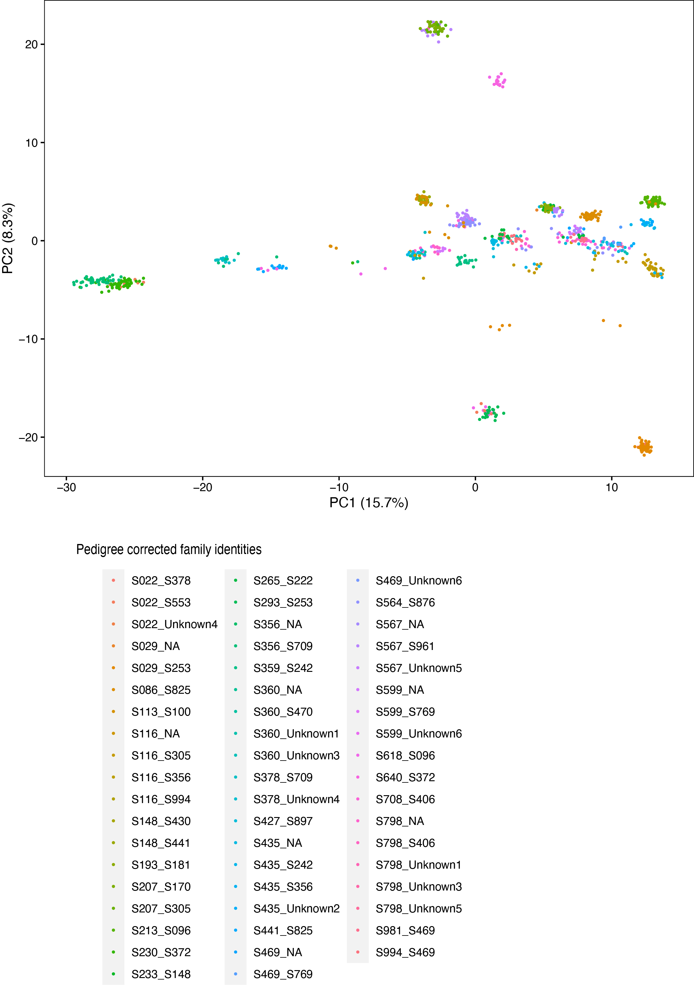
Fig. S2 Population structure for the 904 clones coloured based on the family identities.

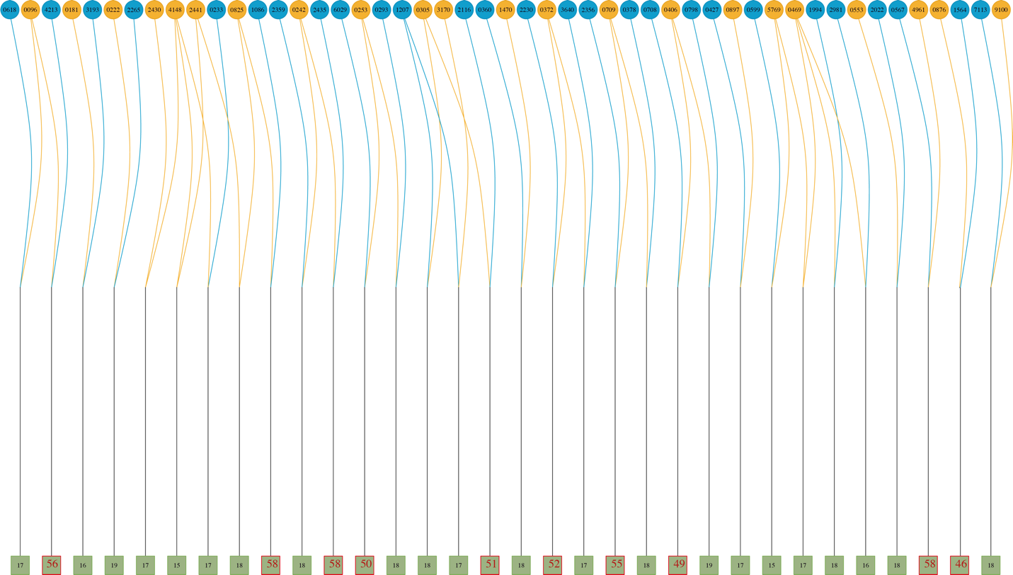
Fig. S3 A mating design of 49 parents constructed into 32 full-sib families. Each circle in the top level represents a parent and the number is the identity of the parent. Each square at the bottom represents a full-sib family. The number within each square represents the number of clones per family genotyped. The families whose squares are framed in red colour, were selected to test the effect of family size on predictive ability. If the parents only cross once, then dark goldenrod means male and dark skyblue means female. Otherwise, the colour of the parents could be any of both colours.

