Supporting Information

Sub-nanometric high entropy alloy cluster: hydrogen spillover-driven synthesis on CeO₂ and structural reversibility

Naoki Hashimoto¹, Kohsuke Mori^{1,2}*, Shuichiro Matsuzaki¹, Kazuki Iwama¹,
Naoto Kamiuchi³, Hideto Yoshida³, and Hiromi Yamashita^{1,2}*

¹ Division of Materials and Manufacturing Science, Graduate School of Engineering, Osaka University, 2-1 Yamada-oka, Suita, Osaka 565-0871, Japan.
Tel & FAX: +81-6-6879-7457, +81-6-6879-7457,
E-mail: mori@mat.eng.osaka-u.ac.jp, yamashita@mat.eng.osaka-u.ac.jp
² Innovative Catalysis Science Division, Institute for Open and Transdisciplinary Research Initiatives (ICS-OTRI), Osaka University, Suita, Osaka 565-0871, Japan.
³ The institute of Scientific and Industrial Research, Osaka University, 8-1 Mihogaoka, Ibaraki, Osaka 567-0047, Japan.

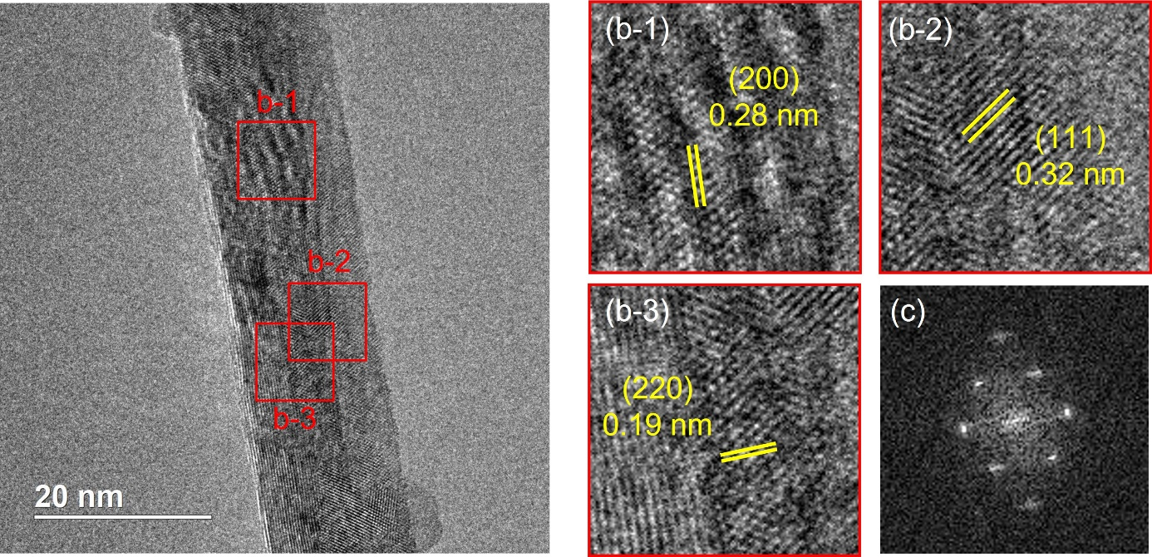

Figure S1. (a,b) HR-TEM images and (c) SAED of CeO₂-NRs.

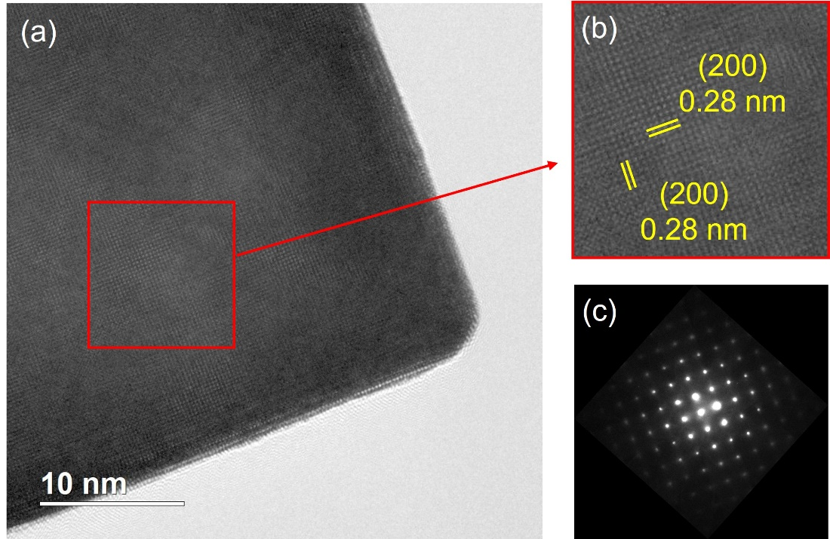

Figure S2. (a,b) HR-TEM images and (c) SAED of CeO₂-NCs.

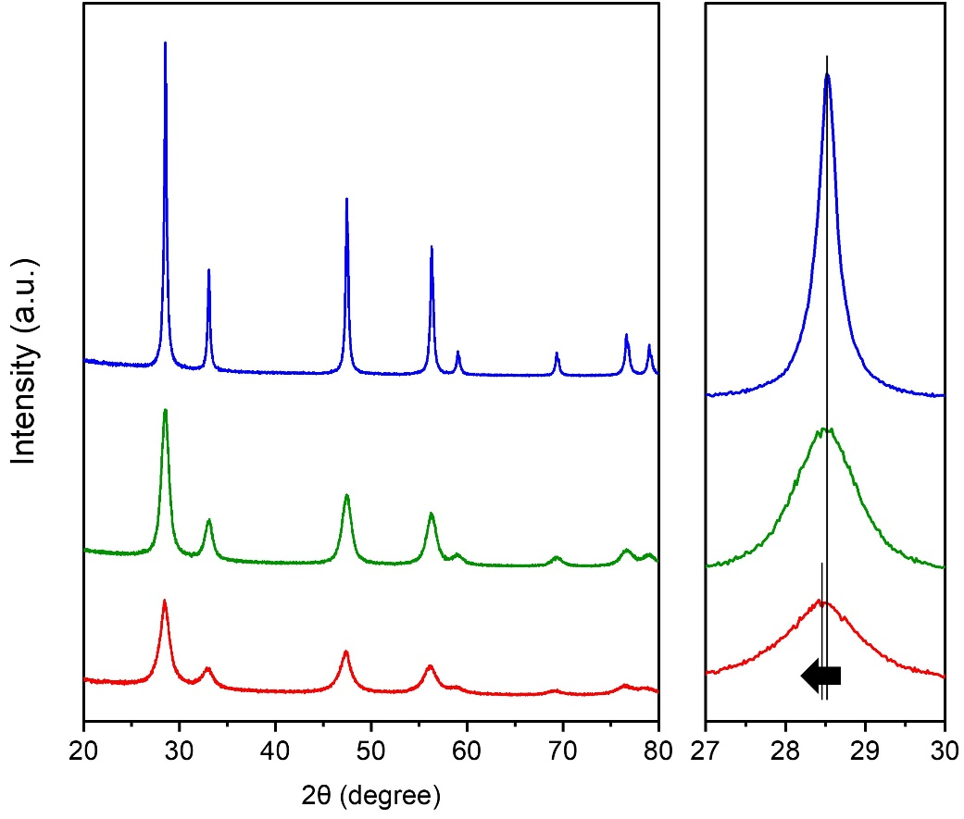

Figure S3. XRD patterns of CeO₂-NRs, CeO₂-NPs and CeO₂-NCs.

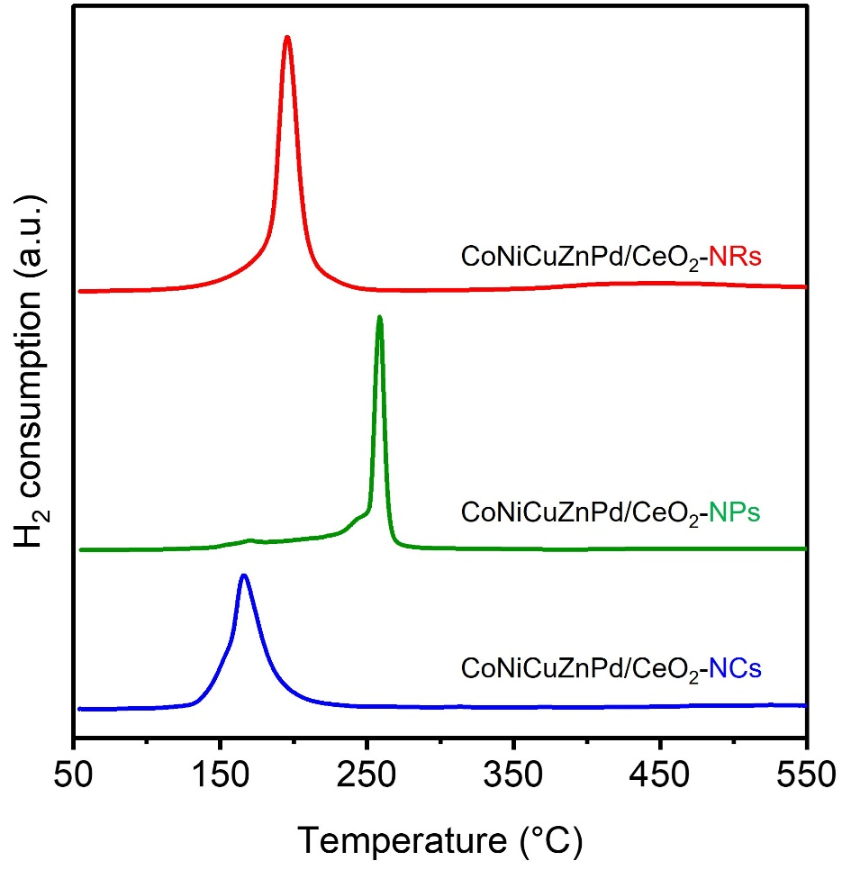

Figure S4. H₂-TPR profiles of quinary CoNiCuZnPd specimens deposited on various CeO₂ supports.

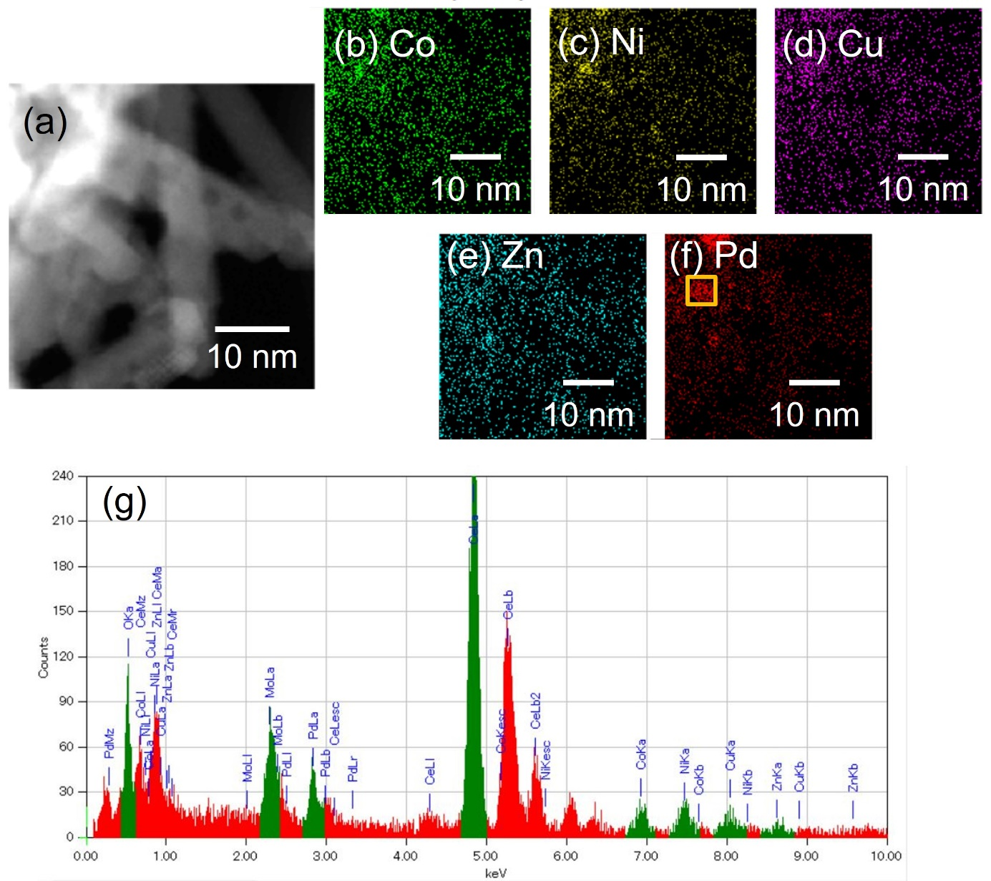

Figure S5. (a) A HAADF-STEM image and (b)-(f) EDX-mappings of CoNiCuZnPd/CeO₂-NRs. (g) EDX analysis in the indicated region.

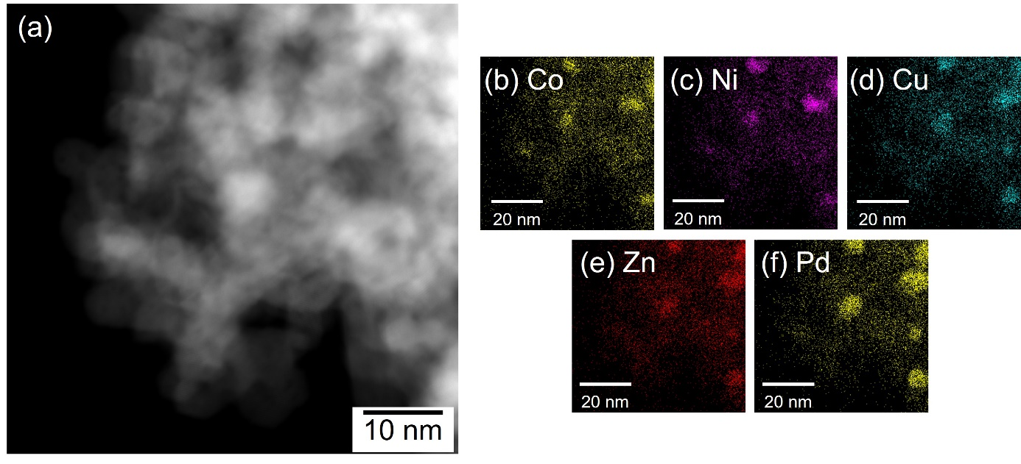

Figure S6. (a) A HAADF-STEM image and (b)-(f) EDX-mappings of CoNiCuZnPd/CeO₂-NPs.

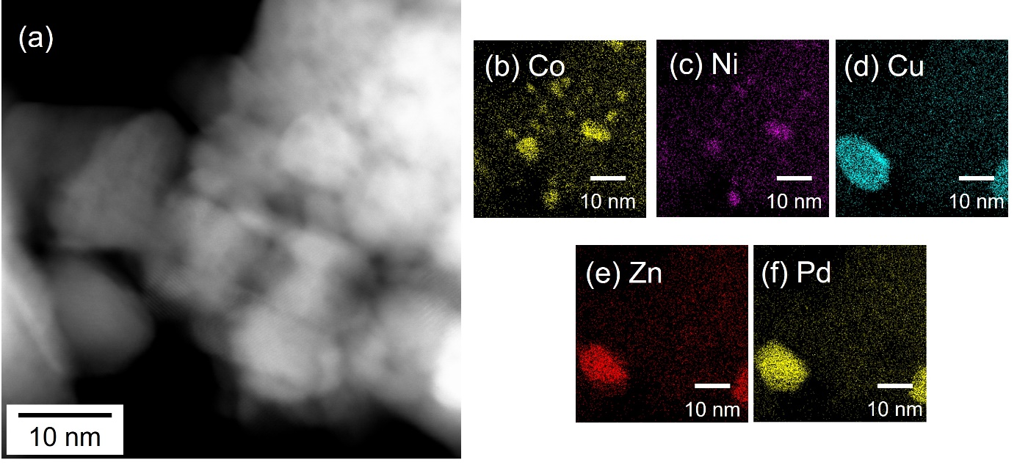

Figure S7. (a) A HAADF-STEM image and (b)-(f) EDX-mappings of CoNiCuZnPd/CeO₂-NCs.

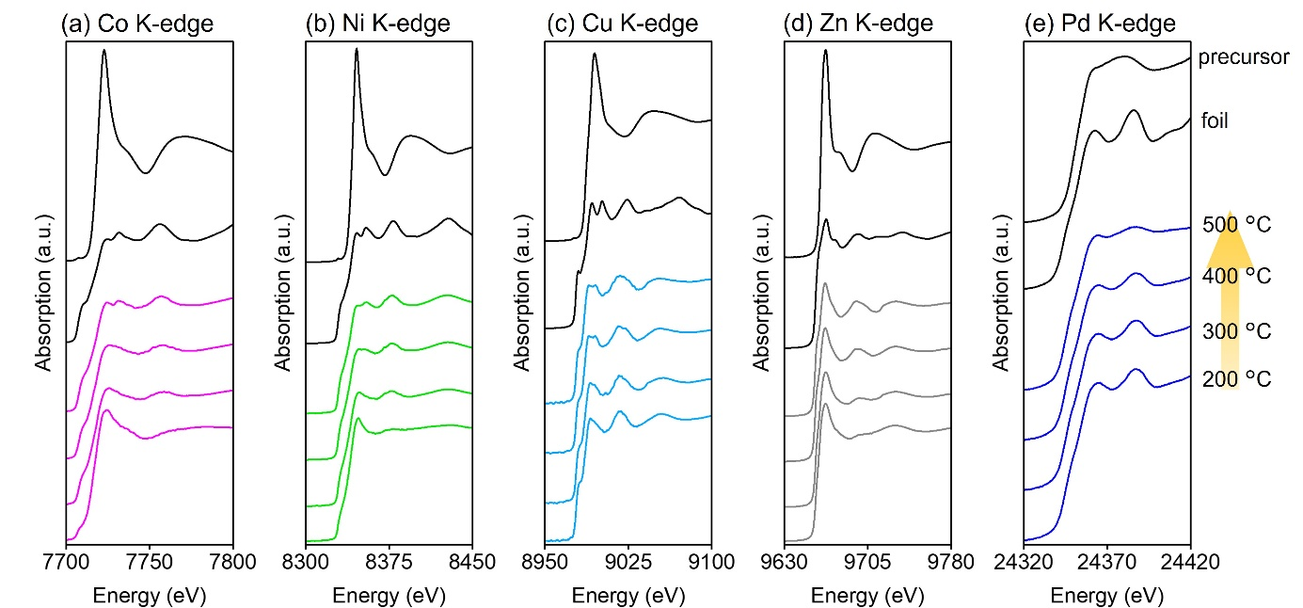

Figure S8 In situ XANES spectra at the (a) Co, (b) Ni, (c) Cu, (d) Zn and (e) Pd K-edge of CoNiCuZnPd/CeO₂-NPs under H₂ condition with elevated temperature from 200 to 400 °C.

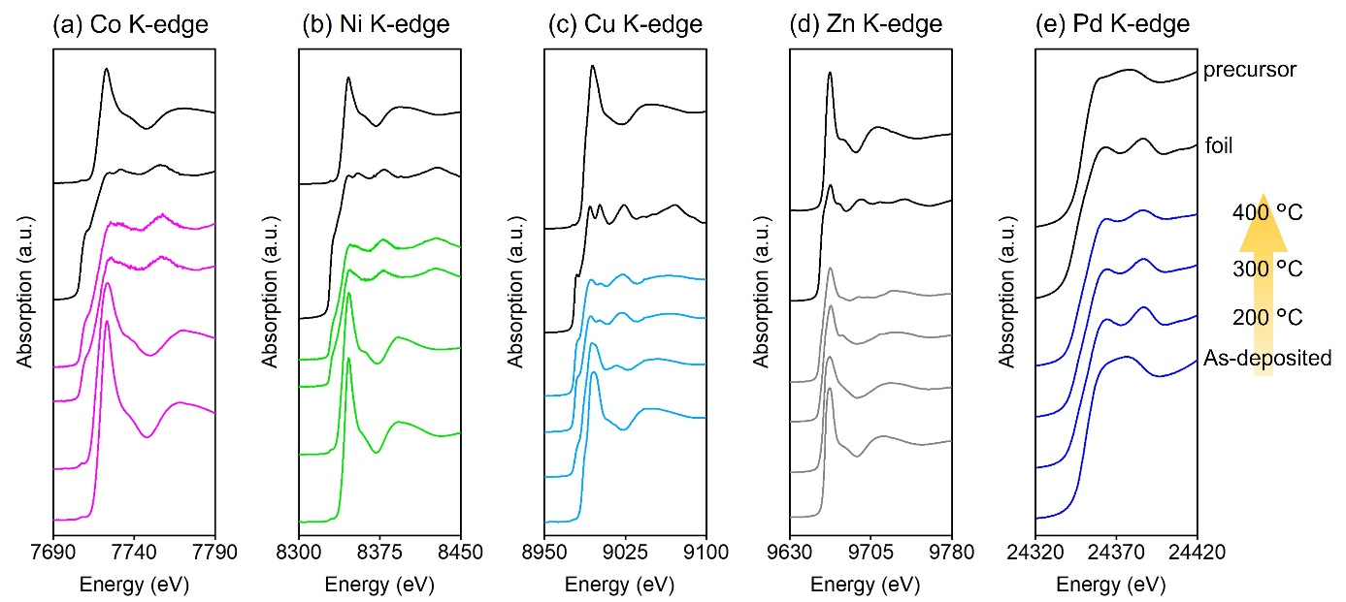

Figure S9. In situ XANES spectra at the (a) Co, (b) Ni, (c) Cu, (d) Zn and (e) Pd K-edge of CoNiCuZnPd/CeO₂-NCs under H₂ condition with elevated temperature from room temperature to 400 °C.

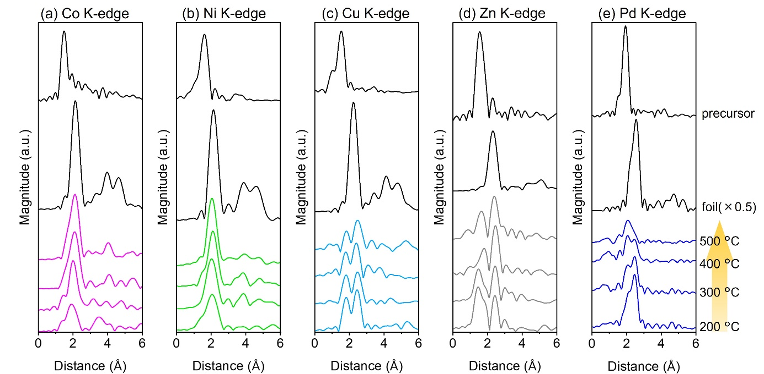

Figure S10. In situ FT-EXAFS spectra at the (a) Co, (b) Ni, (c) Cu, (d) Zn and (e) Pd K-edge of CoNiCuZnPd/CeO₂-NPs under H₂ condition with elevated temperature from 200 to 400 °C.

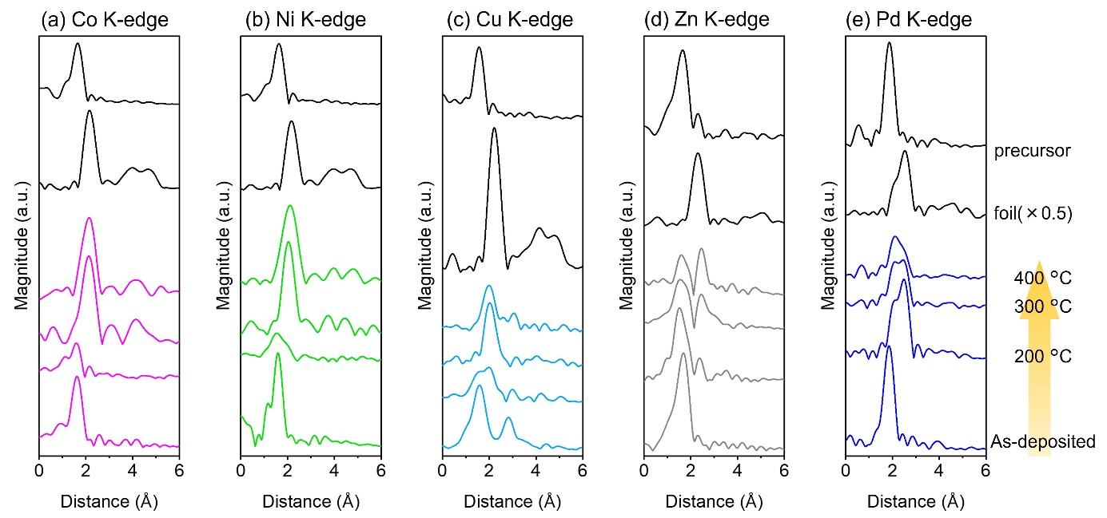

Figure S11. In situ FT-EXAFS spectra at the (a) Co, (b) Ni, (c) Cu, (d) Zn and (e) Pd K-edge of CoNiCuZnPd/CeO₂-NCs under H₂ condition with elevated temperature from room temperature to 400 °C.

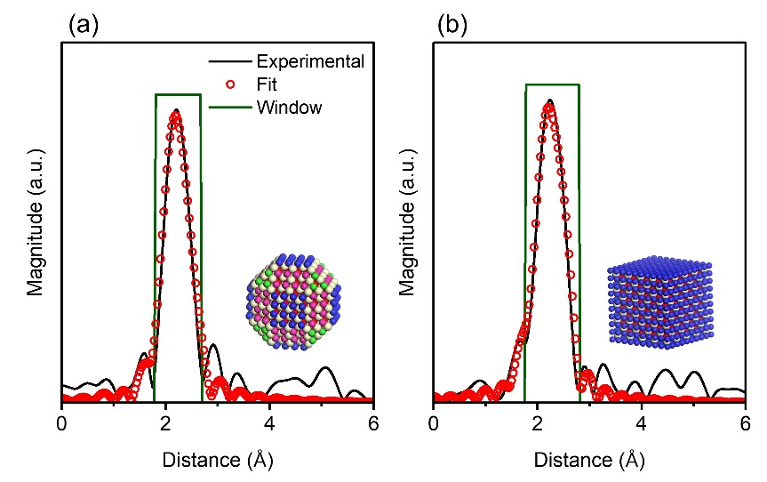

Figure S12. FT-EXAFS spectra of (a) CoNiCuZnPd/CeO₂-NPs and (b) -NCs at Pd K-edge and fit curve.

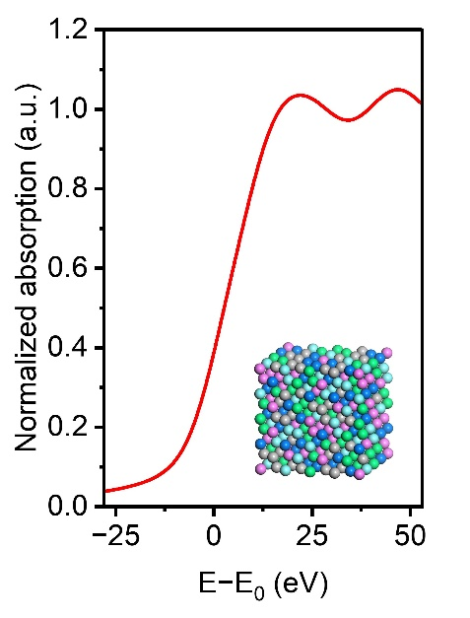

Figure S13. Simulated XANES spectrum of bulk HEA (Co₁₃Ni₁₃Cu₁₂Zn₁₃Pd₁₃).

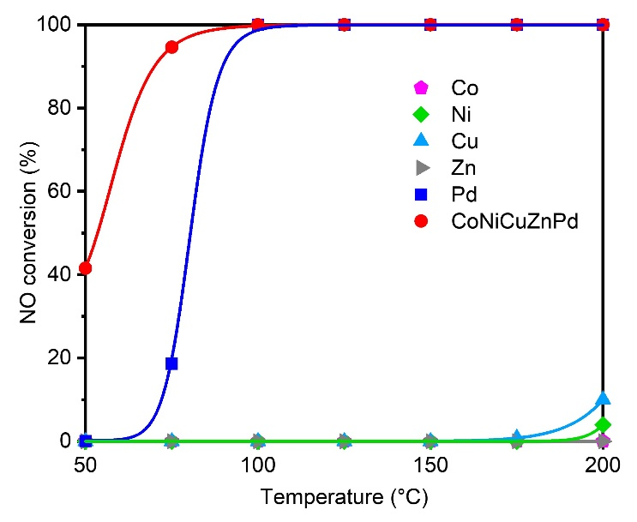

Figure S14. NO reduction activity over CoNiCuZnPd/CeO₂-NRs and monometallic M/CeO₂-NRs (M=Co, Ni, Cu, Zn and Pd).

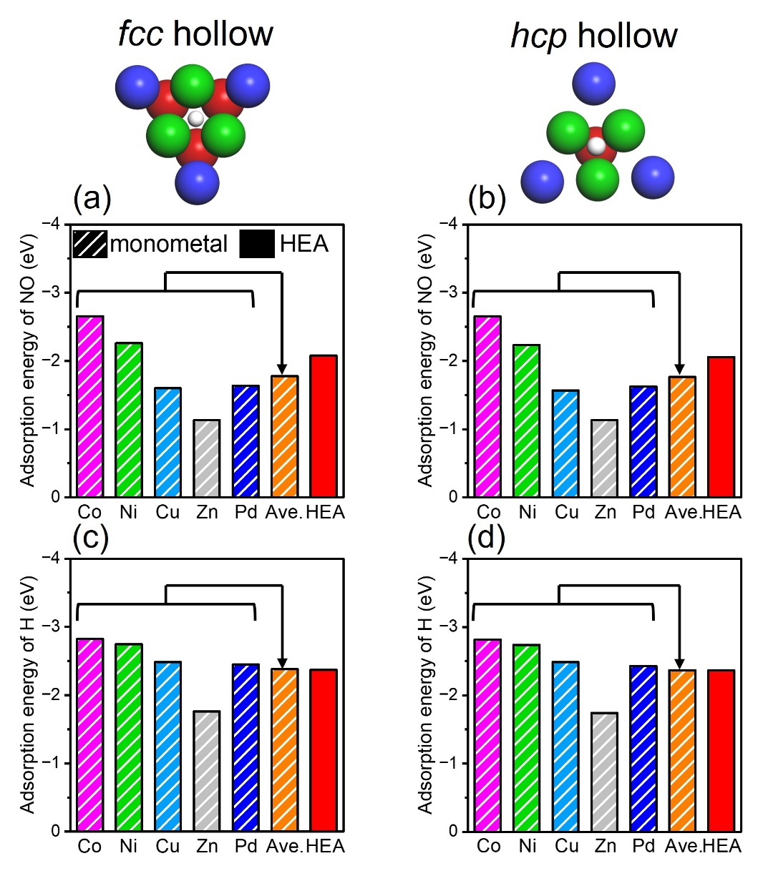

Figure S15. Adsorption energy of (a,b) NO and (c,d) H on fcc and hcp hollow sites for quinary CoNiCuZnPd(111) and monometallic slabs respectively.

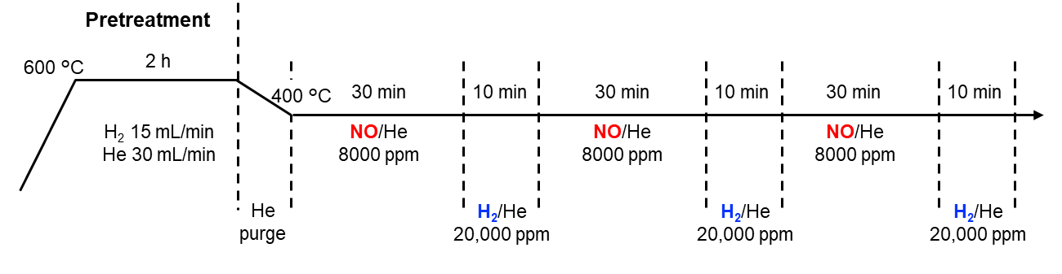

Figure S16. Experimental protocol for in situ XAFS measurement under NO/H₂ conditions

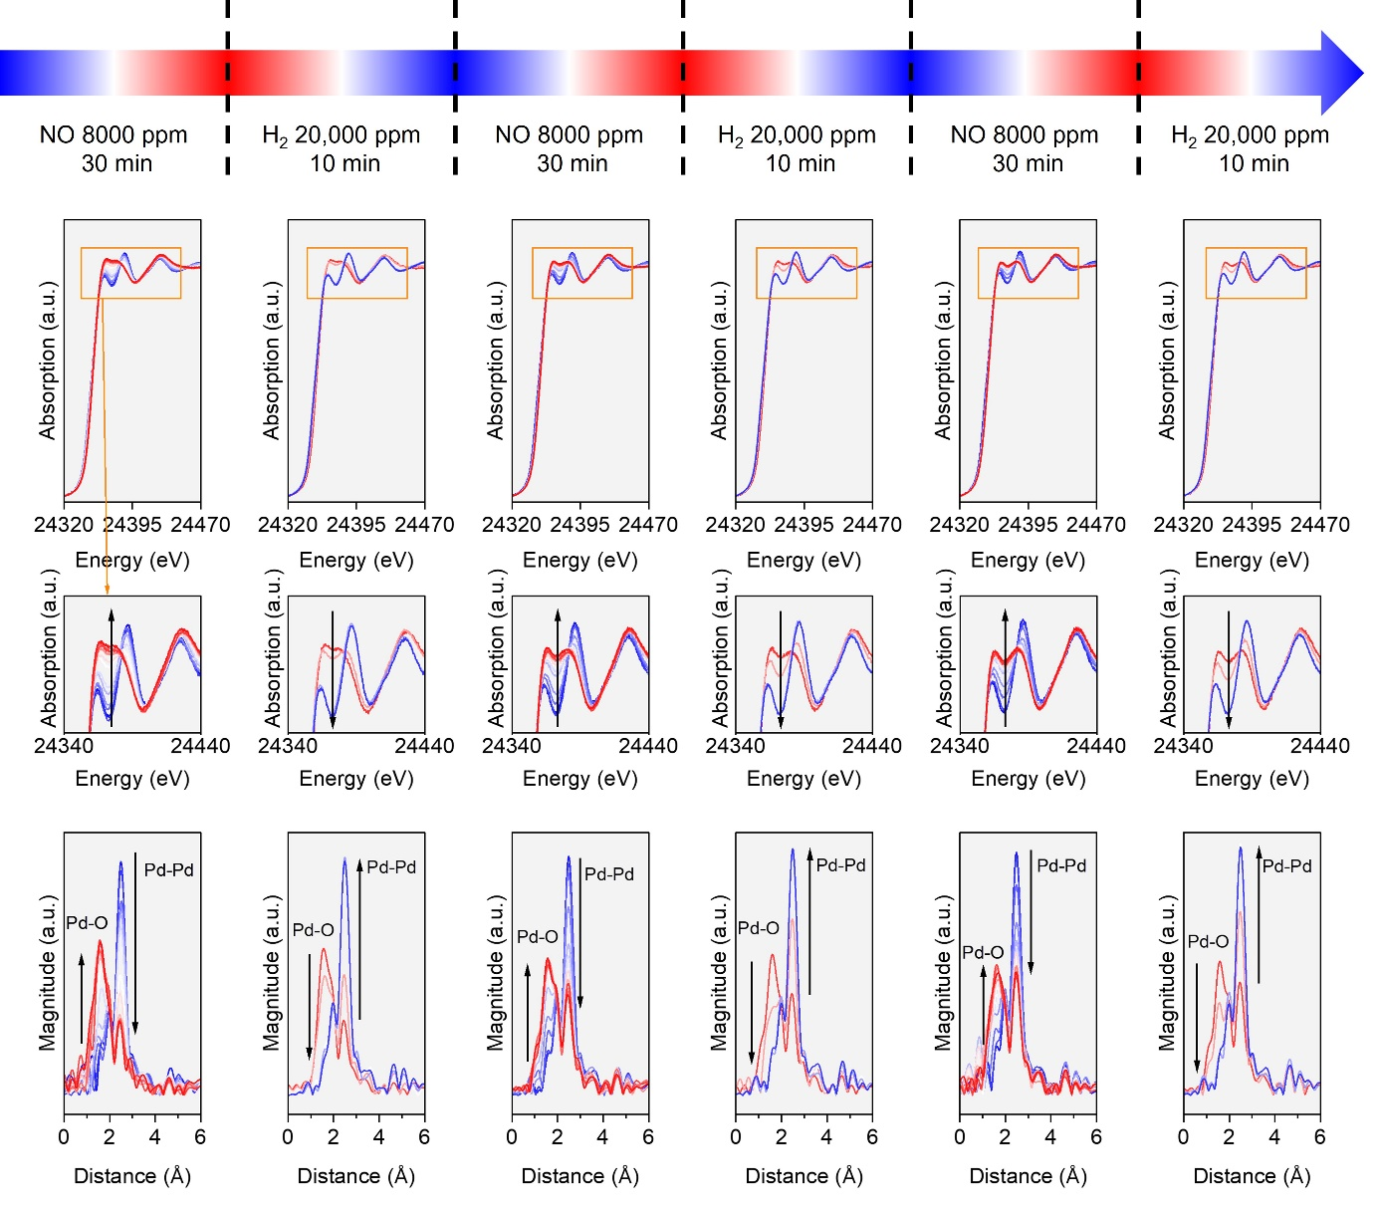

Figure S17. In situ XANES and FT-EXAFS spectra at Pd K-edge for Pd/CeO₂-NRs under cyclic NO/H₂ conditions.

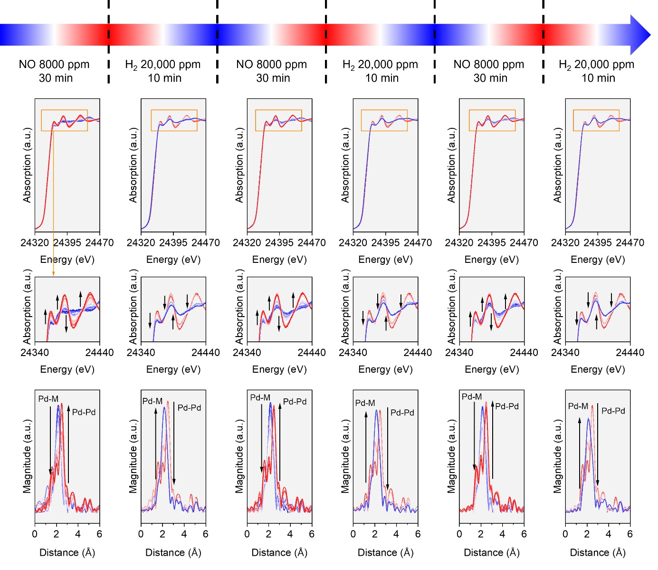

Figure S18. In situ XANES and FT-EXAFS spectra at Pd K-edge for CoNiCuZnPd/CeO₂-NRs under cyclic NO/H₂ conditions

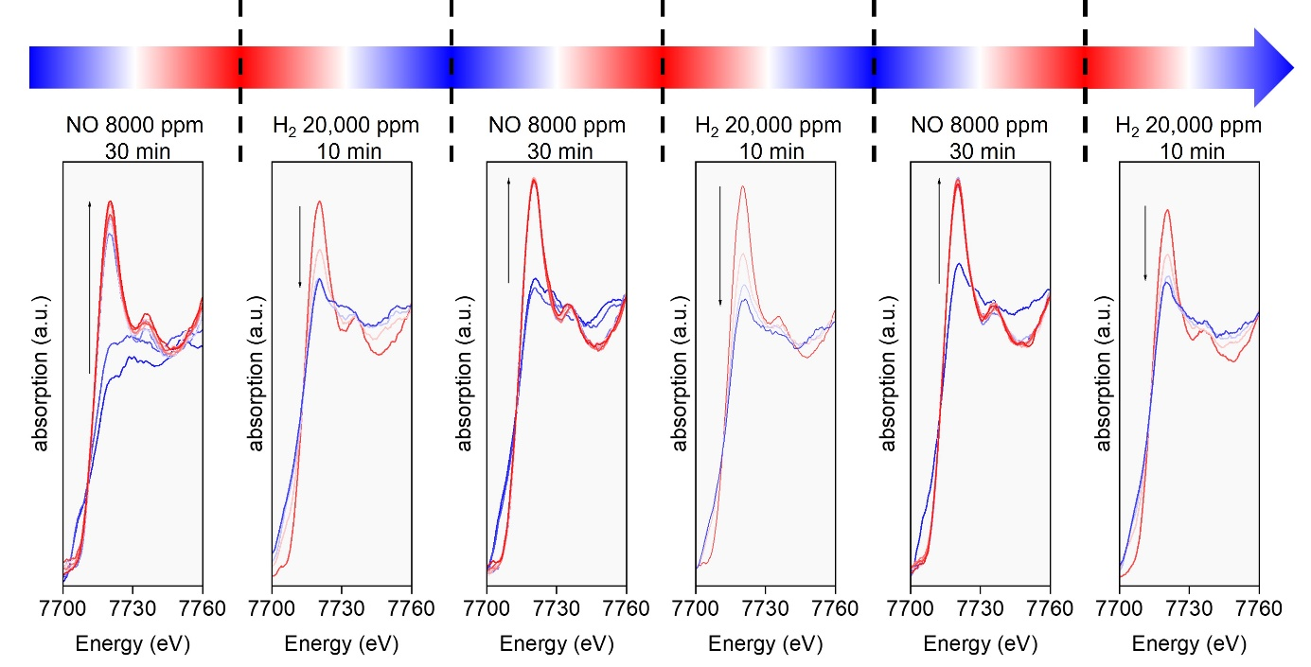

Figure S19. In situ XANES spectra at Co K-edge for CoNiCuZnPd/CeO₂-NRs under cyclic NO/H₂ conditions.

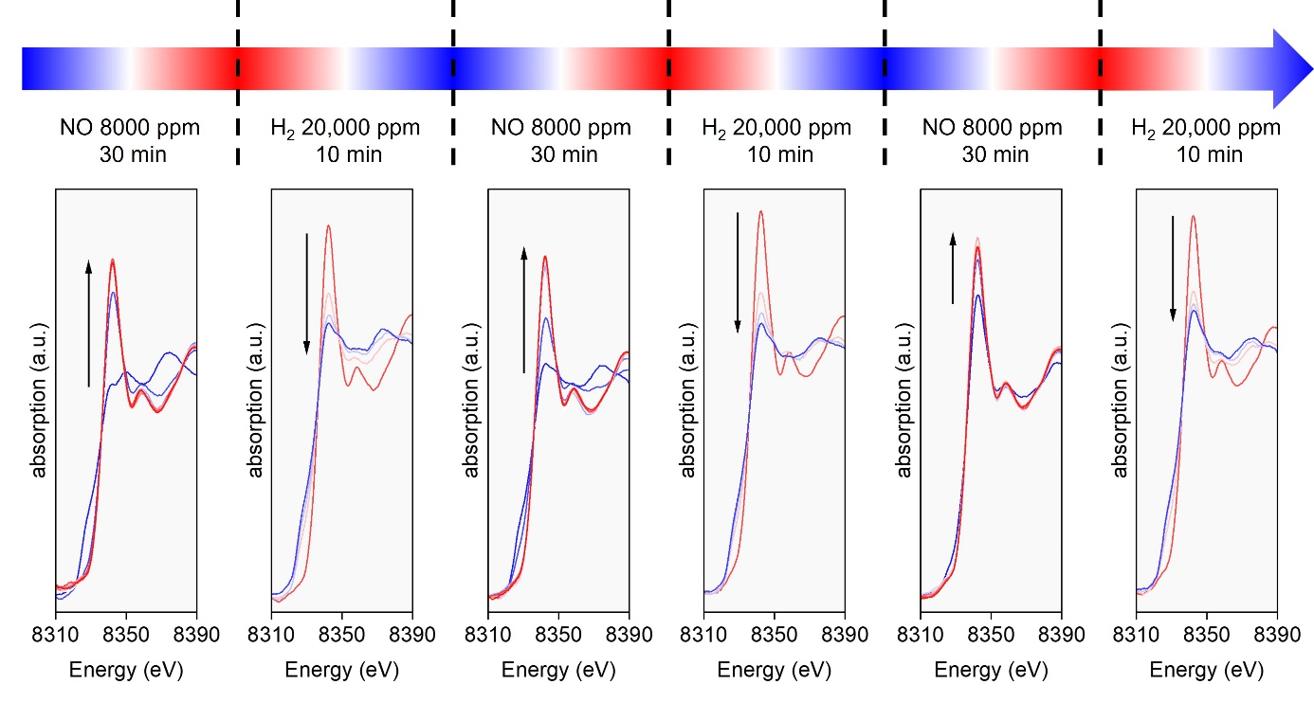

Figure S20. In situ XANES spectra of CoNICuZnPd/CeO₂-NRs at Ni K-edge under cyclic NO/H₂ conditions.

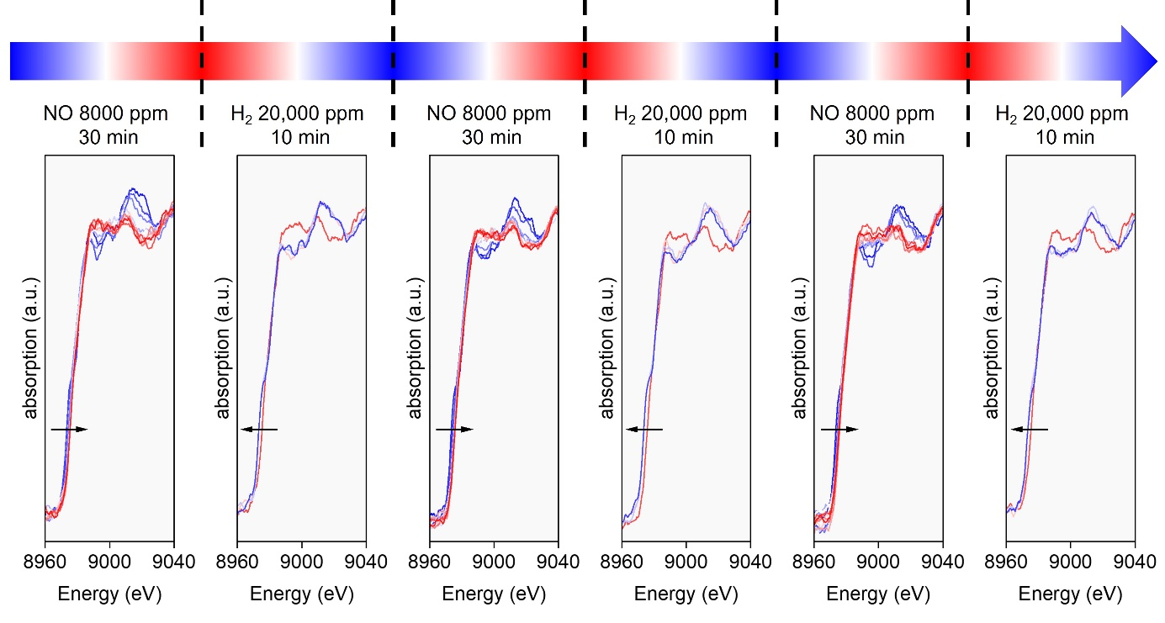

Figure S21. In situ XANES spectra of CoNICuZnPd/CeO₂-NRs at Cu K-edge under cyclic NO/H₂ conditions.

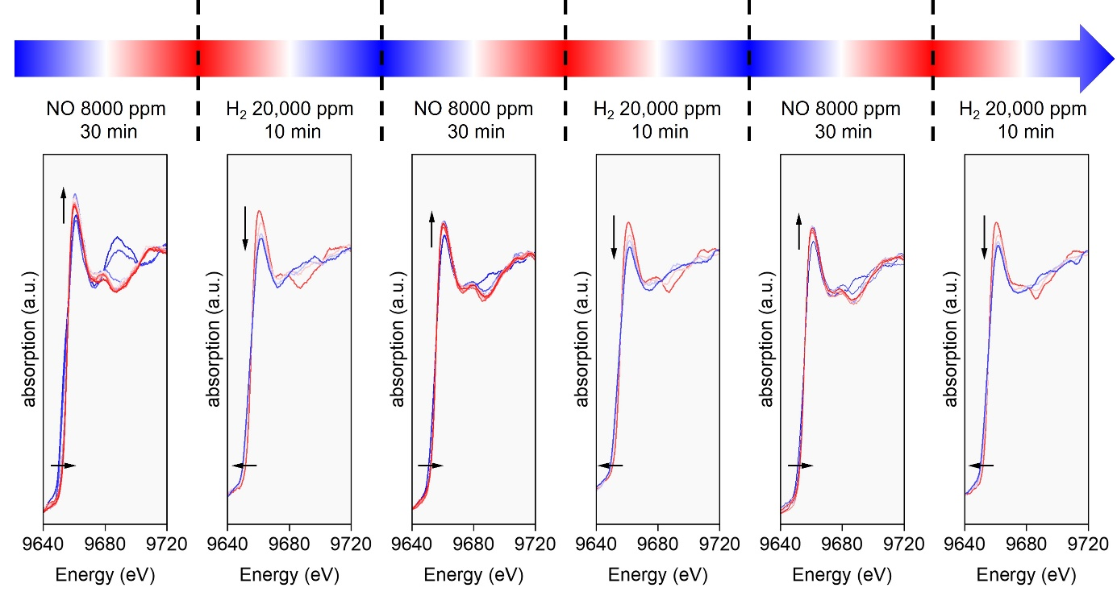

Figure S22. In situ XANES spectra of CoNICuZnPd/CeO₂-NRs at Zn K-edge under cyclic NO/H₂ conditions.

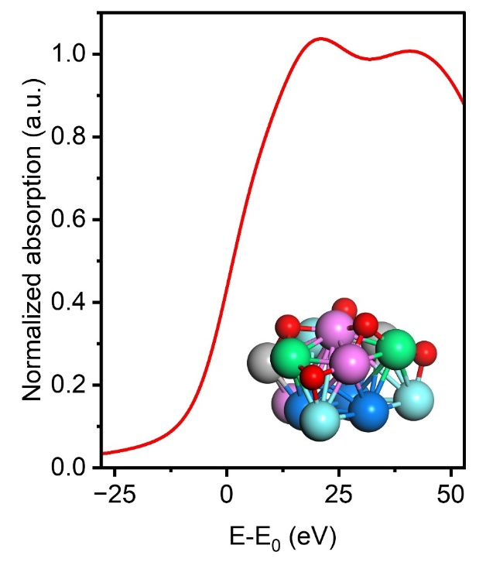

Figure S23. Simulated XANES spectrum at Pd K-edge for oxidized HEA model ((Pd₃@(Co₃Ni₂Cu₃Zn₂)O₆).

Table S1. Curve fitting results at Pd K-edge for CoNiCuZnPd/CeO₂

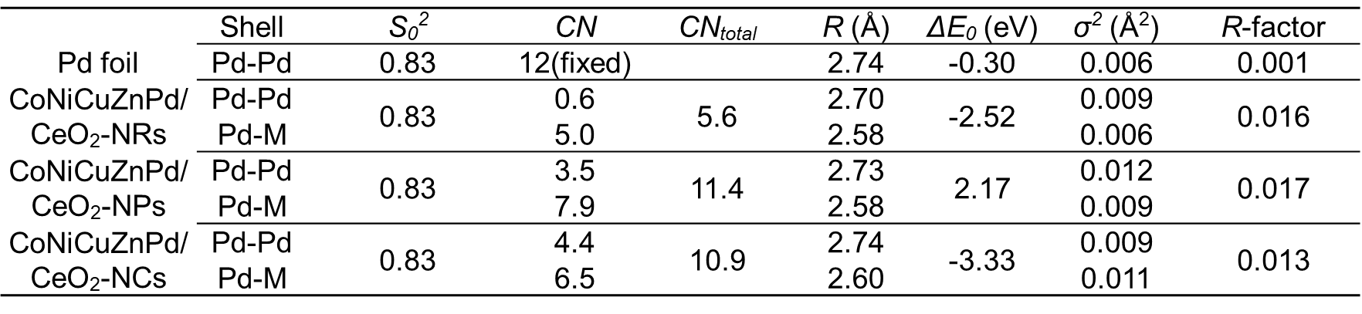

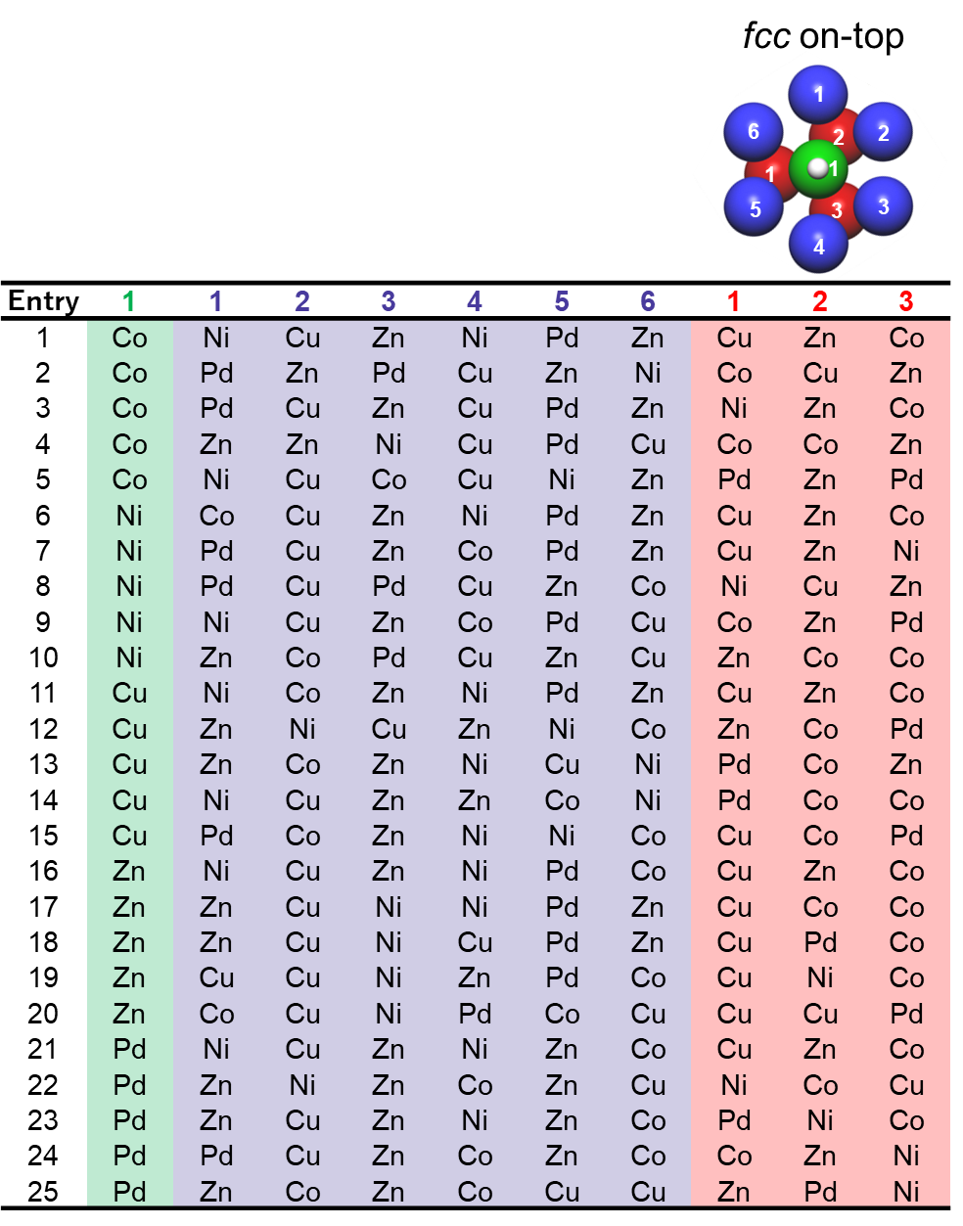
Table S2. The list of employed 25 configuration patterns for the calculation of the adsorption energies of NO and H on fcc on-top

Table S3. The list of employed 30 configuration patterns for the calculation of the adsorption energy of NO and H on fcc hollow.
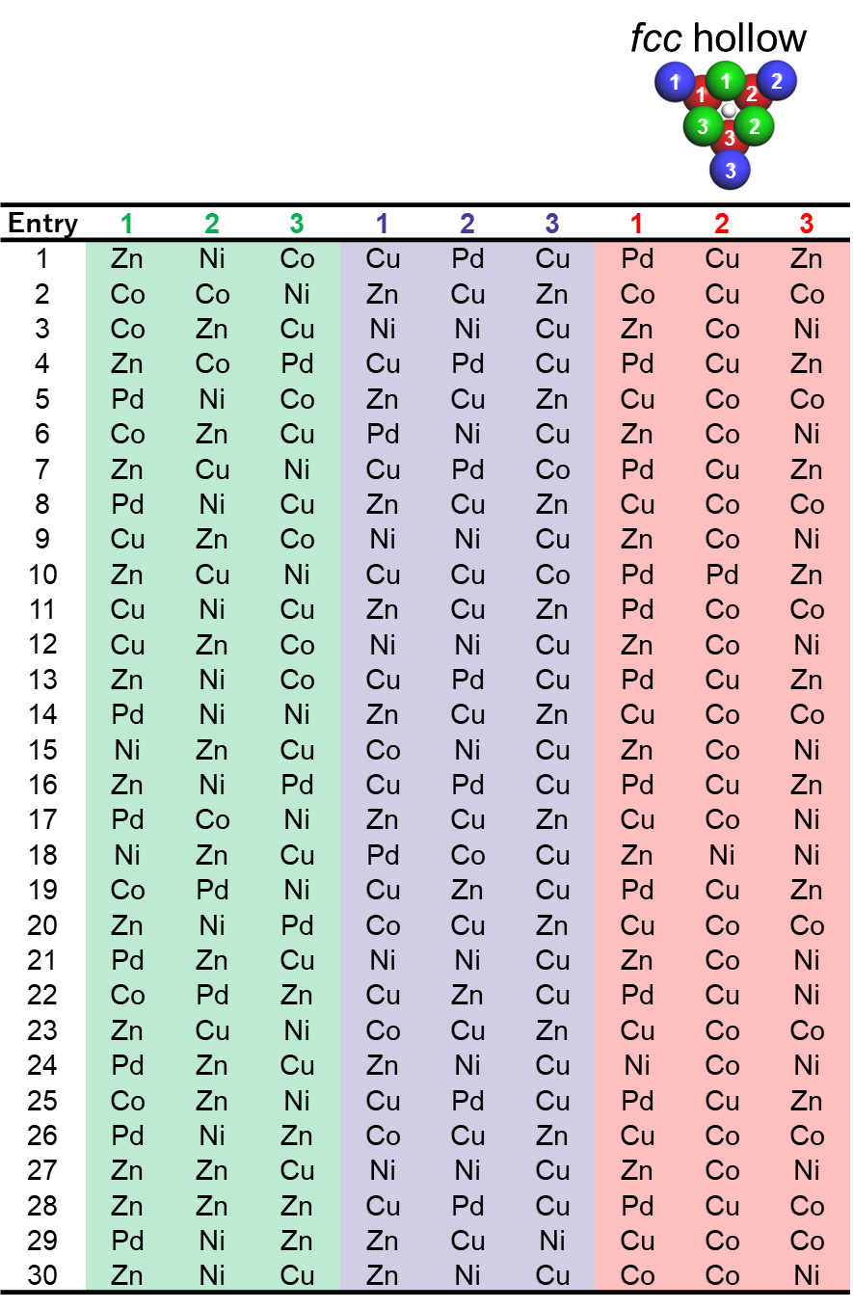

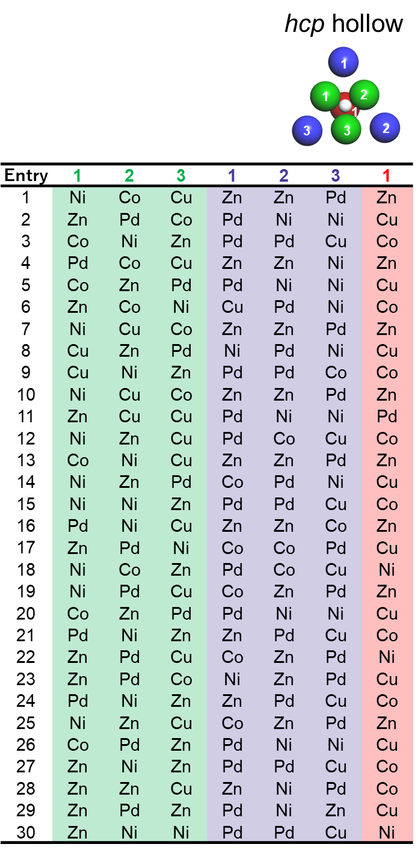
Table S4. The list of employed 30 configuration patterns for the calculation of the adsorption energy of NO and H on hcp hollow.

