Supplementary Table S1. Patterns of disease progression.

 | Sarcopenia | Nonsarcopenia | p-value
Number of patients | 24 (21.1) | 24 (13.0)
Metastatic sites
Lung | 9 (37.5) | 9 (37.5) | 0.448
Liver | 0 | 2 (8.3) | 0.448
Pancreas | 2 (8.3) | 0 | 0.448
Adrenal gland | 0 | 1 (4.2) | 0.448
Kidney | 2 (8.3) | 3 (12.5) | 0.448
Brain | 1 (4.2) | 1 (4.2) | 0.448
Bone | 7 (29.2) | 8 (33.3) | 0.448
Soft tissue | 2 (8.3) | 1 (4.2) | 0.448
Peritoneal/Retroperitoneum | 1 (4.2) | 2 (8.3) | 0.448
Regional lymph node | 3 (12.5) | 0 | 0.448
Extraregional lymph node | 0 | 1 (4.2) | 0.448
Number of metastatic sites
1 | 22 (91.7) | 22 (91.7) | 0.572
2 | 1 (4.2) | 1 (4.2) | 0.572
3 | 1 (4.2) | 0 | 0.572
4 | 0 | 1 (4.2) | 0.572
IMDC risk group
Favorable | 5 (20.8) | 9 (37.5) | 0.324
Intermediate | 16 (66.7) | 14 (58.3) | 0.324
Poor | 1 (4.2) | 0 | 0.324
Unknown | 2 (8.3) | 1 (4.2) | 0.324
IMDC = International Metastatic Renal Cell Carcinoma Database Consortium. Data presented as n (%).

Supplementary Fig. S1. Kaplan–Meier analyses for (a) overall survival, (b) cancer-specific survival, and (c) metastasis-free survival in patients adjusted for age based on the presence or absence of sarcopenia.

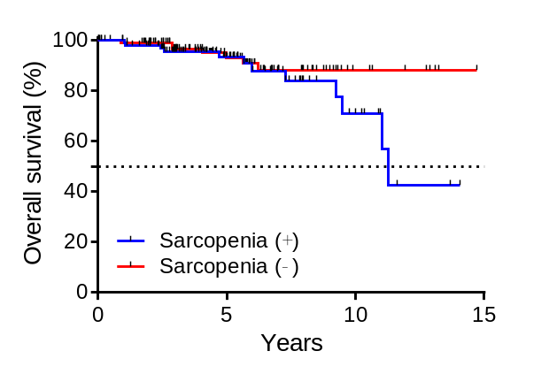
p = 0.161
(a)

Number of patients at risk
sarcopenia (＋) | 102 | 44 | 10 | 0
sarcopenia (－) | 102 | 48 | 9 | 0

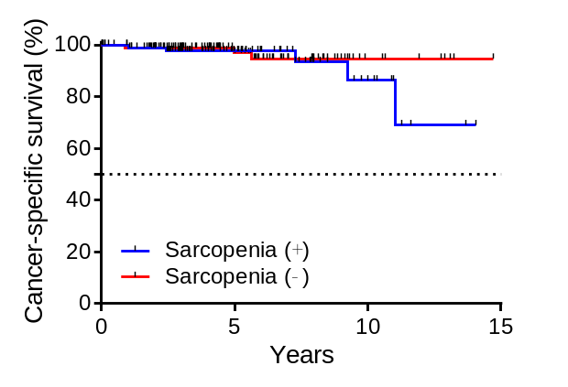
p = 0.398
(b)

Number of patients at risk
sarcopenia (＋) | 102 | 44 | 10 | 0
sarcopenia (－) | 102 | 48 | 9 | 0

Number of patients at risk
sarcopenia (＋) | 102 | 33 | 6 | 0
sarcopenia (－) | 102 | 41 | 6 | 0
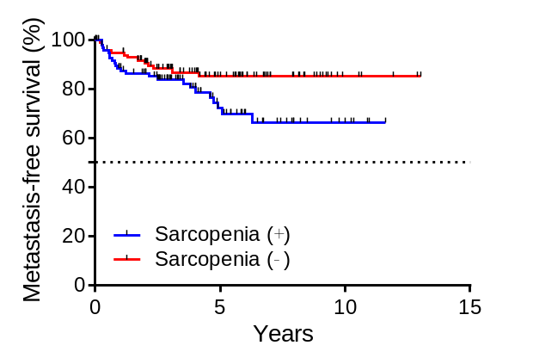
(c)
p = 0.049

