Supplementary data
Table S1. Food recipe for Drosophila diet treatment.
per liter of water | Standard food | High sucrose | High glucose | High fructose | Dietary  restriction
Yeast | 100g | 100g | 100g | 100g | 50g
Sucrose* | 50g | 150g | 150g | 150g | 50g
Agar | 10g | 10g | 10g | 10g | 10g
Propionic acid (dissolved in ddH₂O) | 3g | 3g | 3g | 3g | 3g
Nipagin  (dissolved in ethanol) | 3g | 3g | 3g | 3g | 3g
* For high glucose and high fructose diets, replace sucrose with glucose and fructose, respectively.

Table S2. Diets regulate brain lipogenesis during aging*
Female
 | 5day | 15d | 25d | 35d | 45d
ST vs. DR | ns | *** | **** | **** | ****
ST vs. HG | **** | **** | **** | **** | ns
ST vs. HS | **** | **** | **** | **** | **
ST vs. HF | ns | ns | ns | ns | ns
Male
 | 5day | 15d | 25d | 35d | 45d
ST vs. DR | ns | * | ns | * | ****
ST vs. HG | **** | **** | ns | **** | *
ST vs. HS | ns | **** | * | ** | **
ST vs. HF | ns | *** | ns | *** | ***
* The statistical analysis for Figures 3B (female) and S5A (male).

Table S3. Diets regulate locomotor activity during aging*
Female
 | 5day | 15d | 25d | 35d | 45d
ST vs. DR | ns | ns | **** | **** | ****
ST vs. HG | ns | ns | ** | **** | ns
ST vs. HS | ns | ns | ns | **** | ns
ST vs. HF | ns | ns | ns | * | ns
Male
 | 5day | 15d | 25d | 35d | 45d
ST vs. DR | ns | ns | * | ** | ****
ST vs. HG | ns | ns | * | * | ****
ST vs. HS | ns | ns | ns | ns | ****
ST vs. HF | ns | ns | ns | ns | *
* The statistical analysis for Figures 3C (female) and S5B (male).

Table S4. Diets regulate brain lipolysis during aging*
Female
 | Young |  |  | Old
 | 24h | 48h | 72h | 24h | 48h | 72h
ST vs. DR | ns | ns | ns | ns | ** | ****
ST vs. HG | ns | ** | **** | ns | ns | ns
ST vs. HS | ns | **** | **** | ns | ns | ns
ST vs. HF | ns | * | ns | ns | ns | ns
Male
 | Young |  |  | Old
 | 24h | 48h | 72h | 24h | 48h | 72h
ST vs. DR | ns | ns | * | ns | ns | *
ST vs. HG | ns | ns | ns | ns | ns | ns
ST vs. HS | ns | ns | ns | ns | ns | ns
ST vs. HF | ns | ns | ns | ns | ns | *
* The statistical analysis for Figures 3D (young female), S5E (young male), S3F (old female) and S5G (old male).

Table S5. IIS regulates brain lipolysis during aging*
Female
 | Young |  |  | Old
 | 24h | 48h | 72h | 24h | 48h | 72h
+/+ vs. chico¹/+ | ns | **** | ns | ns | ns | ****
+/+  vs. dfoxo^{Δ94}/dfoxo²⁵ | * | *** | * | ns | ns | ns
+/+  vs. chico¹/+;dfoxo^{Δ94}/dfoxo²⁵ | ns | ns | *** | ns | ns | ns
Male
 | Young |  |  | Old
 | 24h | 48h | 72h | 24h | 48h | 72h
+/+ vs. chico¹/+ | ns | ns | ns | ns | ns | ns
+/+  vs. dfoxo^{Δ94}/dfoxo²⁵ | * | **** | ** | ns | ns | *
+/+  vs. chico¹/+;dfoxo^{Δ94}/dfoxo²⁵ | ns | ns | ns | ns | ns | *
* The statistical analysis for Figures 4F (young female), 4G (young male), S8E (old female) and S8F (old male).

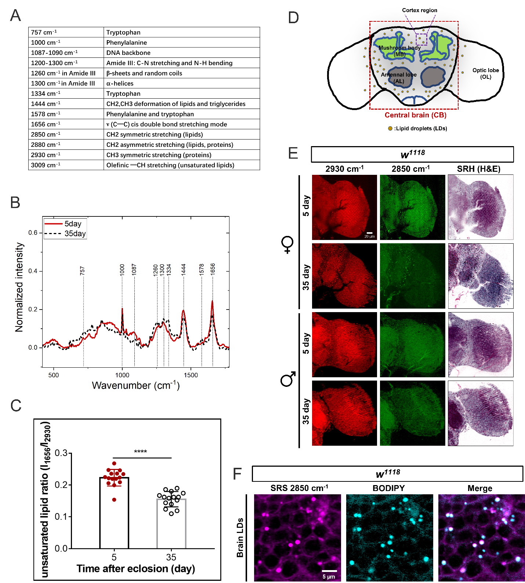
Figure S1. The lipid metabolic changes of Drosophila brain are visualized by SRS microscopy
(A) The Raman peaks in Drosophila brains are assigned to different vibrational modes.
(B) The fingerprint regions of brain Raman spectra from 5-day and 35-day old flies were collected and plotted as Mean ± SD, n =15 brains for each age group.
(C) The ratios of unsaturated lipids (1656cm⁻¹) to proteins (2930 cm⁻¹) level were quantified and plotted as Mean ± SD, n =15 brains for each age group.
(D) A cartoon of Drosophila adult brain depicting the structures of central brain (CB), mushroom body (MB), antennal lobe (AL) and optical lobe (OL) as well as the cortex region.
(E) The optic lobes from 5day and 35day flies were imaged from the proteins (2930 cm⁻¹) and lipids (2850 cm⁻¹) channels, from which signals were color-coded in red and green respectively. The stimulated Raman histology (SRH) H&E were generated from proteins and lipids channels.
(F) The brain LDs imaged at SRS 2850 cm⁻¹ channel are confirmed with BODIPY staining.
Statistical significance was determined by using student’s t-test (C). *, p < 0.05; **, p < 0.01; ***, p < 0.001; ****, p < 0.0001; ns, non-significant difference.

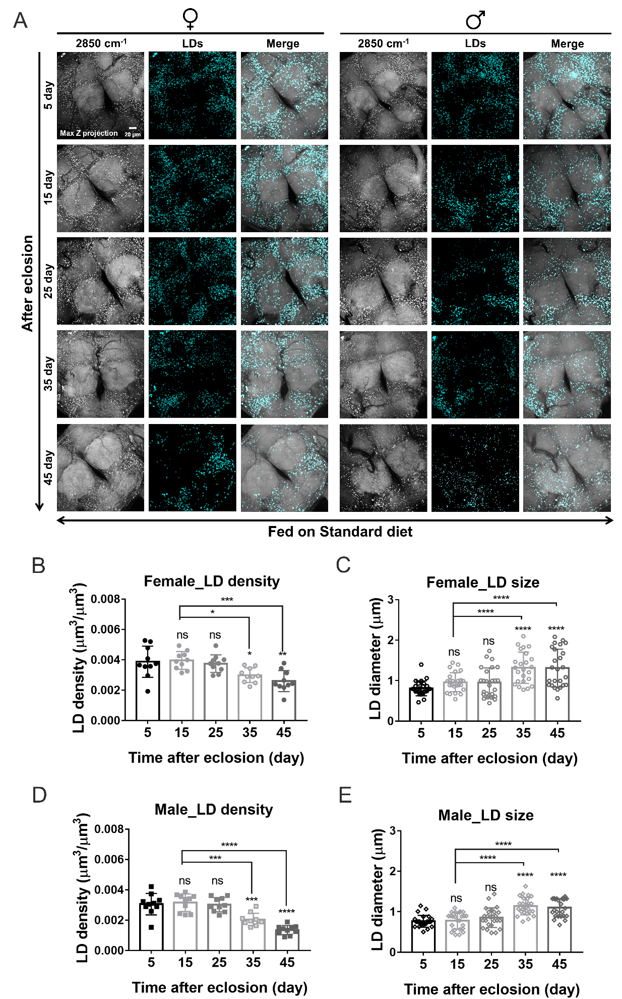
Figure S2. The LD density and size of Drosophila brain are changed during the aging process
(A) Max Z projected images of brain LDs from females and males at different ages were displayed. Scale bar, 10 µm.
(B-E) The LD density (total LD volume to brain cortex volume) and LD size of different aged brains were quantified and presented as Mean ± SD (n = 8~10 brains at each age group).
Statistical significance was determined by using 1-way ANOVA (B-E). *, p < 0.05; **, p < 0.01; ***, p < 0.001; ****, p < 0.0001; ns, non-significant difference.
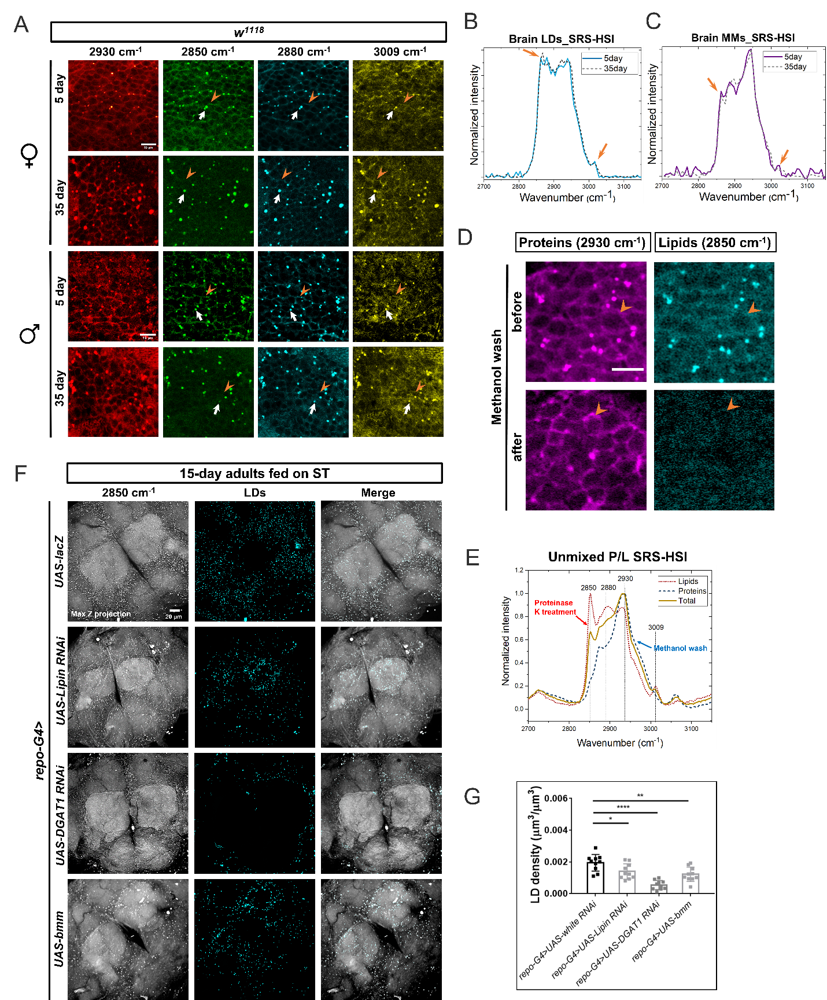

Figure S3. TAGs are the predominant constituent of glial LDs.
(A) The cell body regions from 5-day and 35-day brain cortexes were imaged from different channels: proteins (2930 cm⁻¹), lipids (2850 cm⁻¹), proteins and lipids mixture (2880 cm⁻¹) and unsaturated lipids (3009 cm⁻¹). Signals were color-coded in red, green, cyan and yellow, respectively. White arrows, LDs; orange arrow heads, cell membranes. Scale bar: 10 µm.
(B-C) The SRS-HSI were taken from 5- and 35-day old female brain LDs and membranes, and the spectra of CH regions from LDs (B) and membranes (C) were plotted. Total lipids peak (2850 cm⁻¹) and unsaturated lipids peak (3009 cm⁻¹) were marked by the orange arrows.
(D) The cell body regions from 5-day adult brain were imaged from the proteins (2930 cm⁻¹), lipids (2850 cm⁻¹) channels before and after methanol treatment. Scale bar: 10 µm.
(E) The spectra derived from SRS-HSI of untreated brains (yellow, solid line), proteinase K- treated ones (lipids, red dotted line) and methanol-treated brain membranes (proteins, blue dashed lines) showing the peaks under different conditions.
(F) Max Z projected SRS images of brain LDs in flies with glial-specific gene knockdowns (repo-G4>UAS-RNAi) of TAG synthetic enzymes (Lipin, or DGAT1) or overexpression of TAG lipase (bmm) are compared with the control group (repo-G4>UAS-lacZ).
(G) LD density in (F) was quantified and presented as Mean ± SD (n =5~8 brains). Statistical significance was determined by using Student's t-test (D, E) or 1-way ANOVA (G). *, p < 0.05; **, p < 0.01; ***, p < 0.001; ****, p < 0.0001; ns, non-significant difference.

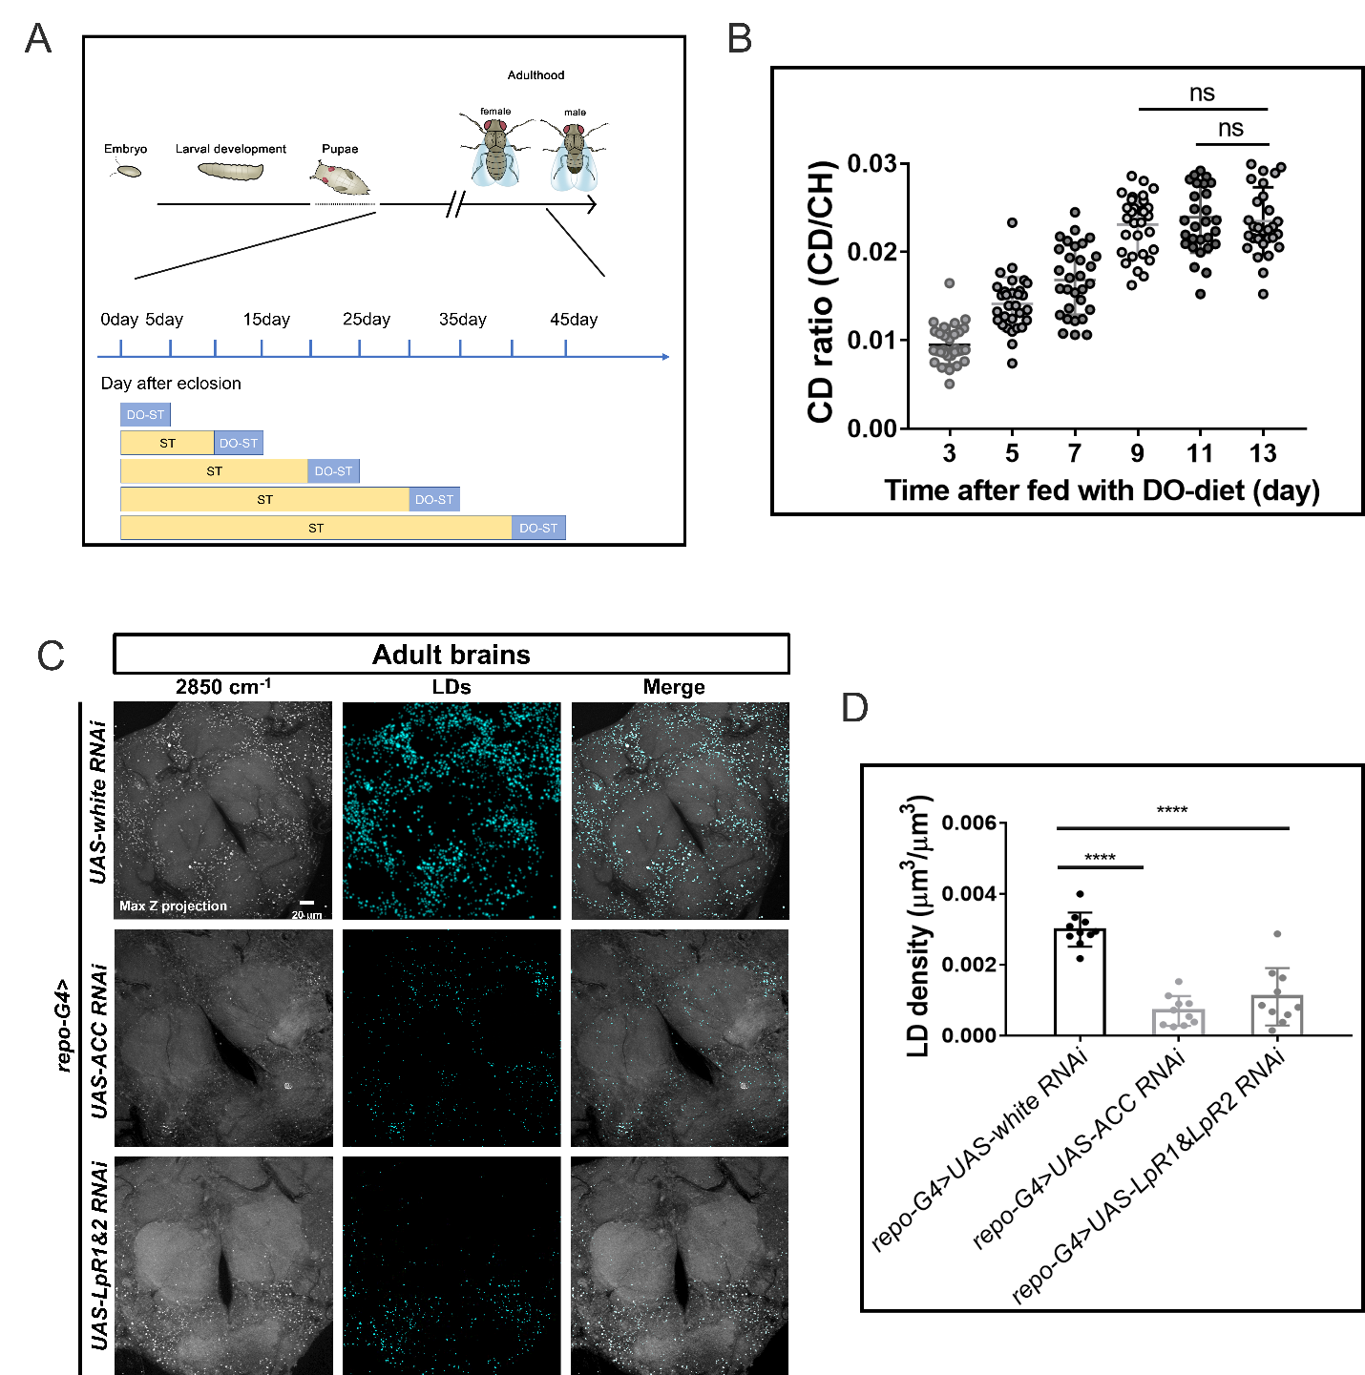
Figure S4. De novo biosynthesis and uptake of lipids both contribute to the brain lipid storage.
(A) A scheme showing D2O diet (DO-ST, D2O labeled standard diet) treatment of adult flies during aging.
(B) Deuterium incorporation into brain LDs reaches saturation after 20% D2O diet treatment for 9-10 days. (n =5 brains at each time point).
(C) Max Z projected SRS images of brain LDs with glial-specific gene knockdowns (repo>RNAi) of fatty acid synthetic gene (ACC) and the genes encoding LDL receptor homologues (LpR1&LpR2) were compared with the control group (repo>UAS-white RNAi).
(D) The LD density ratios (total LD volume to brain cortex volume) of the brains with the designated genotypes in (C) were quantified and presented as Mean ± SD (n =5 brains in each group).
Statistical significance was determined by using 1-way ANOVA. *, p < 0.05; **, p < 0.01; ***, p < 0.001; ****, p < 0.0001; ns, non-significant difference.

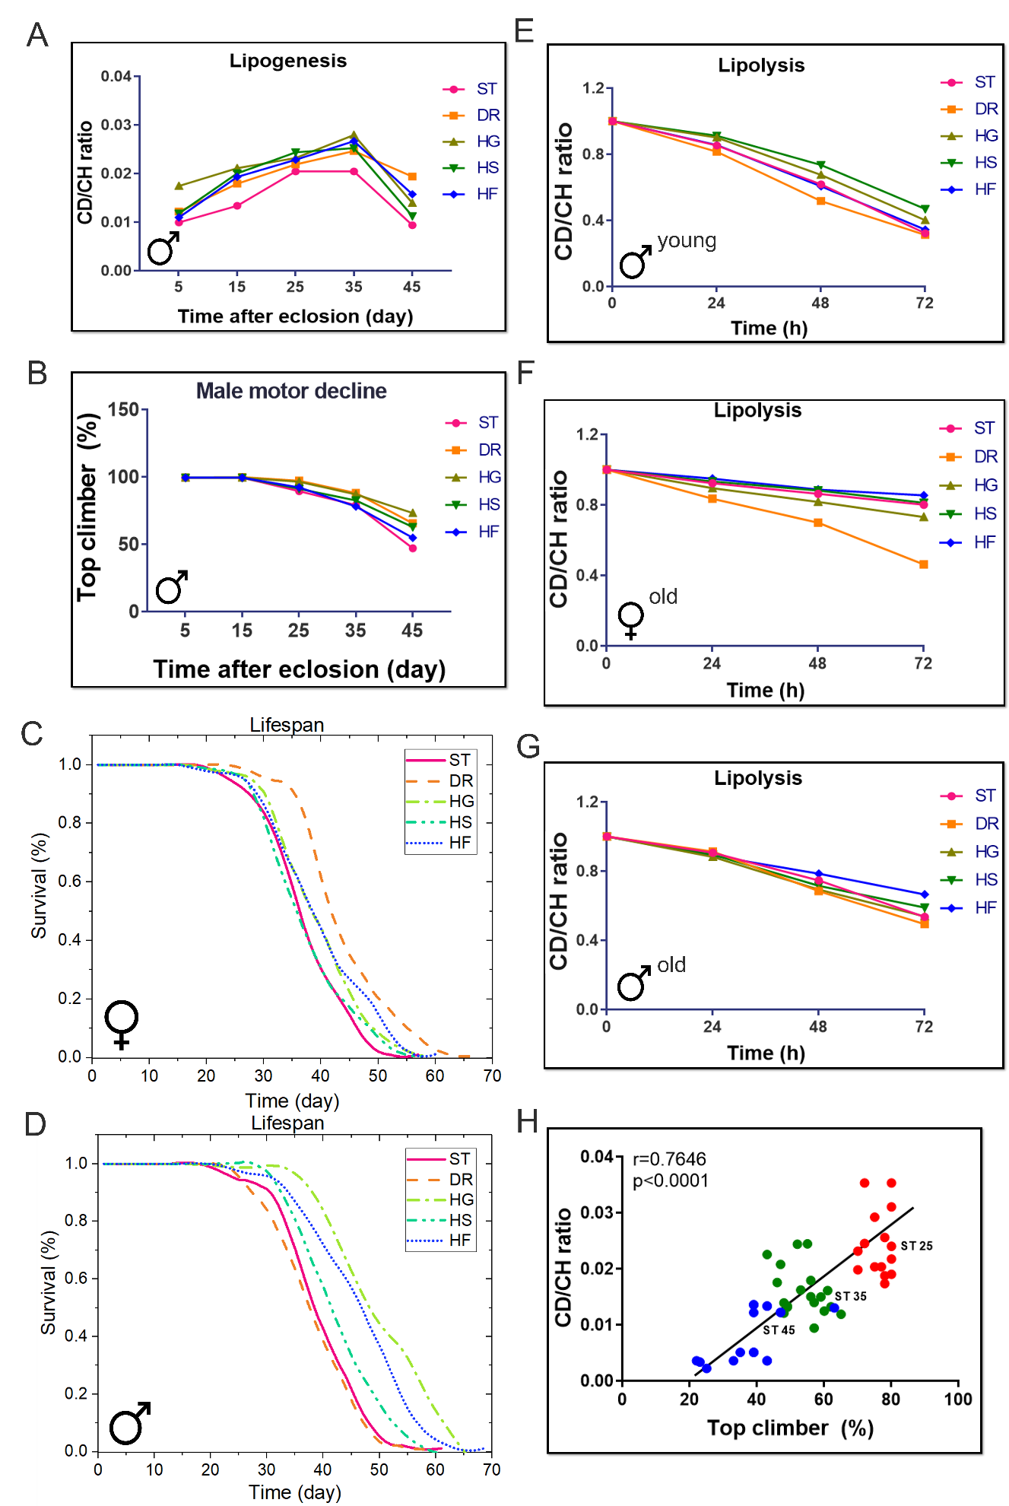
Figure S5. The LD metabolic activity of aging brains under diet treatments are correlated with motor activity and lifespan
(A) The brain LDs from 5, 15, 25, 35 and 45-day old males fed with 20% D2O labeled standard diet (ST), high sugar (glucose, fructose and sucrose) diets (HSDs) and dietary restriction (DR) for 5 days were imaged from the CD lipids (2143 cm⁻¹), CH lipids (2850 cm⁻¹), and the ratio of newly synthesized lipids to total lipids during 5-days’ DO-labeling were quantified as CD ratios (CD/CH) and plotted as Mean ± SD. n =15 ROIs from 5~8 brains.
(B) The motor activities of 5, 15, 25, 35 and 45-day old males fed with standard diet (ST), high sugar (3xglucose, fructose and sucrose) diets (HSDs) were evaluated and plotted as Mean ± SD. n = 40 files per age group.
(C) and (D) The lifespans of flies on standard diet (ST), dietary restriction (DR), high sugar (3xglucose, fructose and sucrose) diets (HSDs). (C), females, and (D), males. (n =120 flies at each group).
(E-G) The time-course changes of CD-lipid mobilization in brain LDs over 72-hour starvation of flies pretreated with different diets. Data are presented as Mean ± SD in (E, young male), (F, old female) and (G, old male). n =15 ROIs from 3~5 brains in each group.
(H) A linear positive correlation between brain lipid synthesis and motor ability during aging process. n = 10~15 for each group, Pearson analysis, r = 0.7646, p < 0.0001.

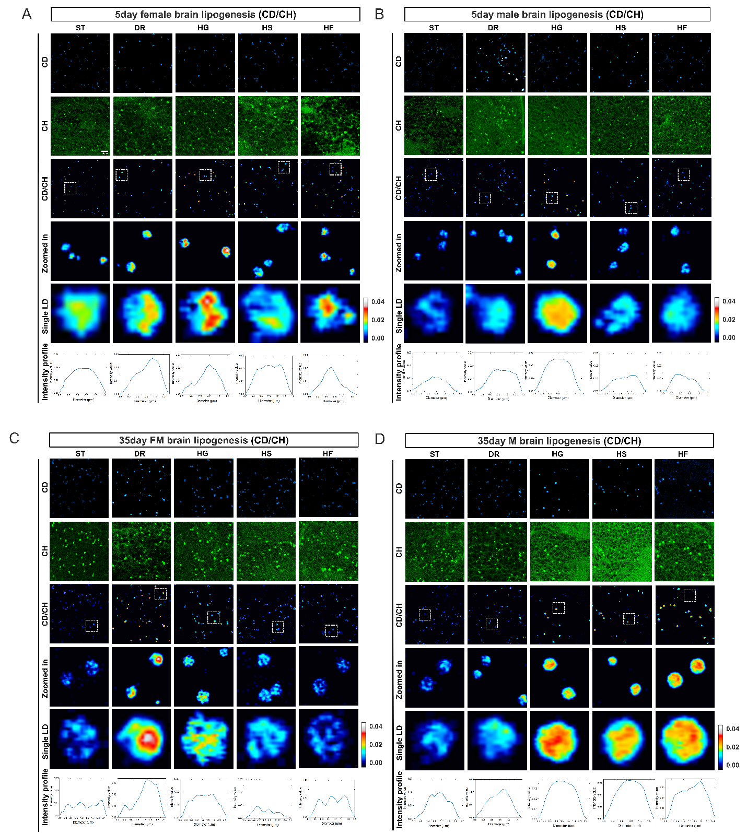
Figure S6. The lipogenic activities of aging brain LDs are modulated by diet treatments
(A-D) The brain LDs from 5, 15, 25, 35 and 45-day old flies fed with 20% D2O labeled standard diet (ST), high sugar (glucose, fructose and sucrose) diets (HSDs) and dietary restriction (DR) for 5 days were imaged from the CD lipids (2143 cm⁻¹), CH lipids (2850 cm⁻¹), and the ratio of newly synthesized lipids to total lipids during 5-days’ DO-labeling were quantified as CD ratios (CD/CH) and displayed in (A, 5-day females), (B, 5-day males), (C, 35-day females), (D, 35-day males), respectively. Scale bar: 2µm.

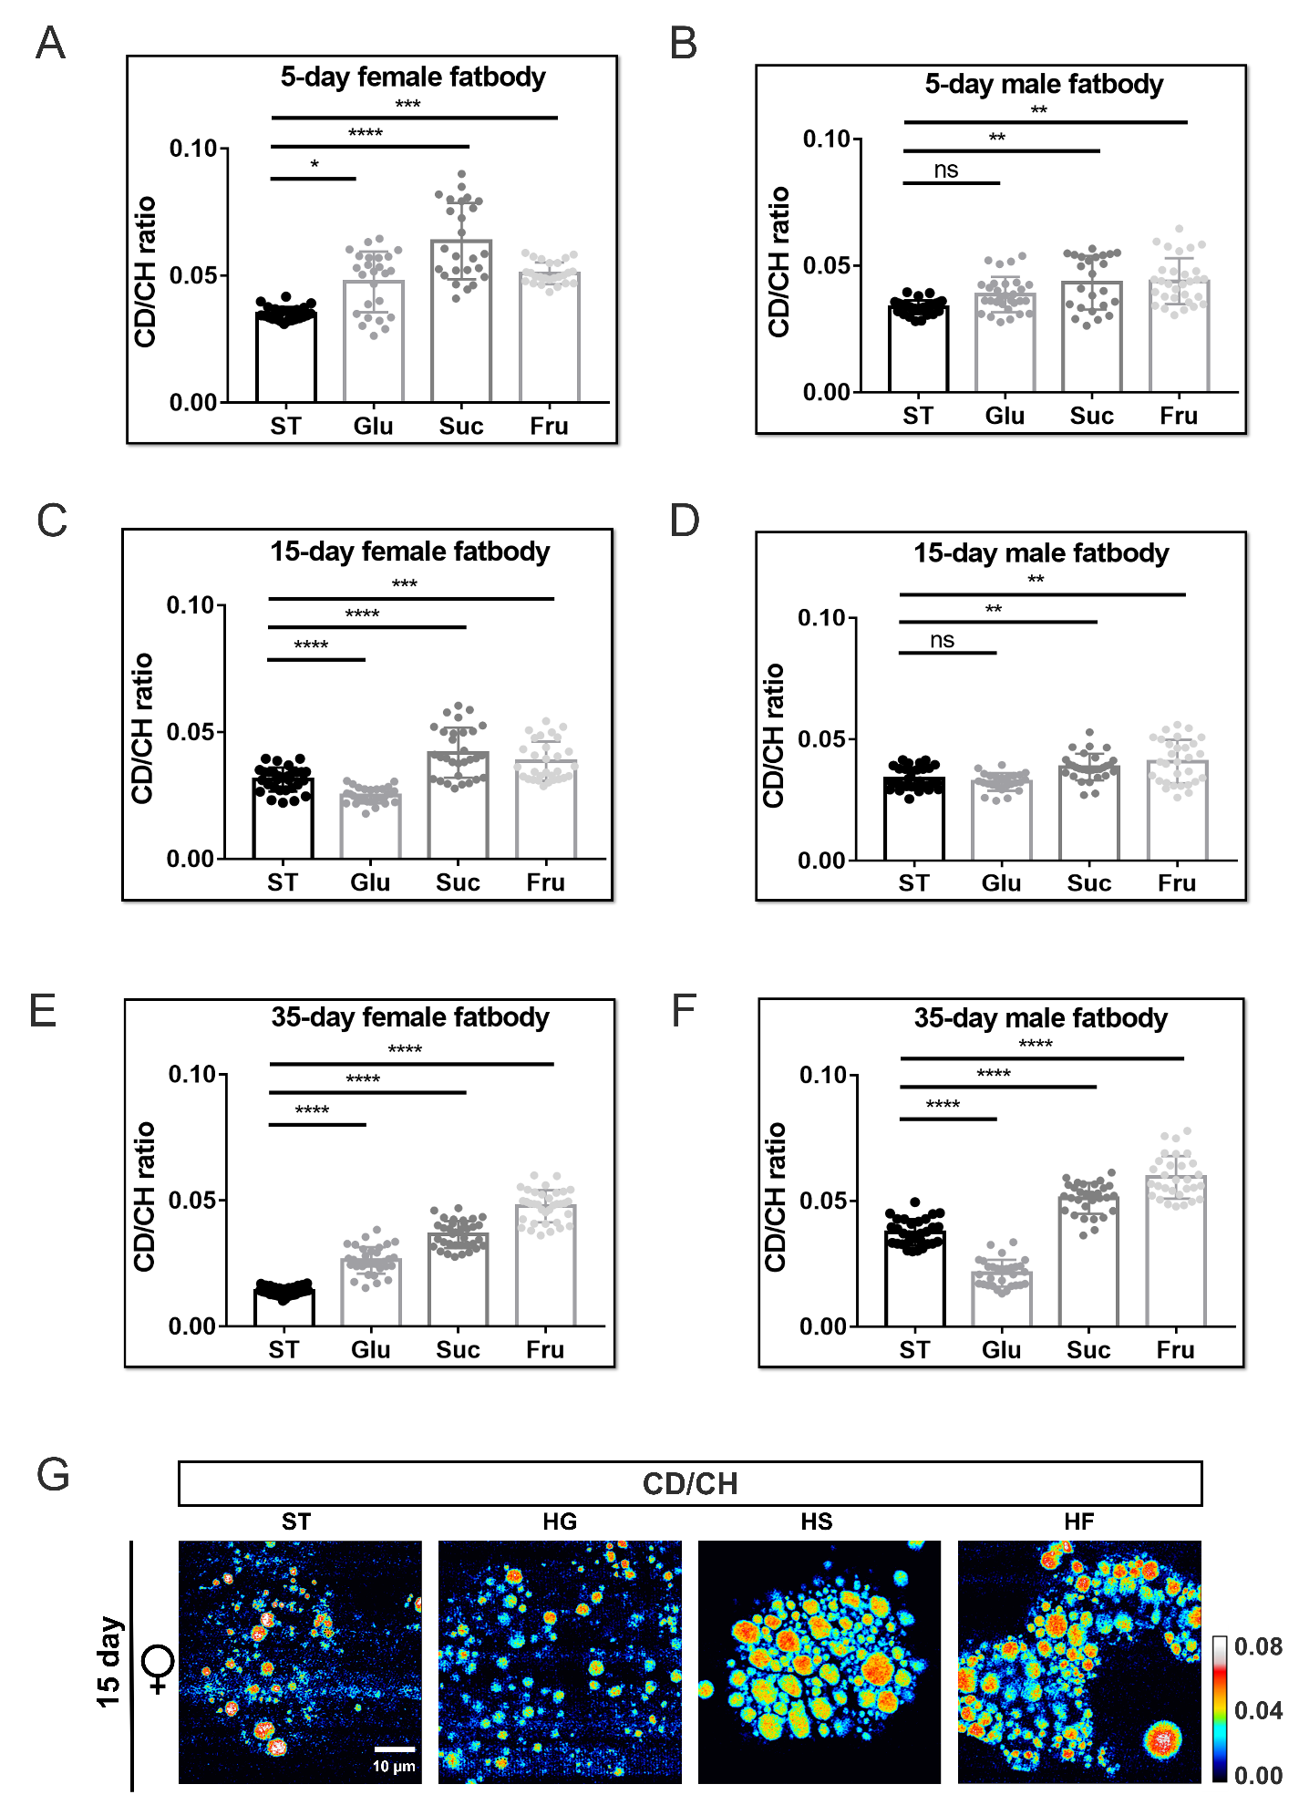
Figure S7. The lipogenic activities of LDs in fat bodies during aging are differently modulated by dietary sugars
(A-D) The LDs from 5, 15, and 35-day old flies fed with 20% D2O labeled standard diet (ST), high sugar (glucose, fructose and sucrose) diets (HSDs) for 5 days were imaged from the CD lipids (2143 cm⁻¹), CH lipids (2850 cm⁻¹), and the ratio of newly synthesized lipids to total lipids during 5-days’ DO-labeling were quantified as CD ratios (CD/CH) and displayed in females (A, C, E,), males (B, D, F) respectively. (n =25 ROIs from 5~8 fat bodies).
The representative radiometric images for lipid biosynthesis of 15-day female fat body LDs were displayed in (G), respectively. Scale bar: 10µm.

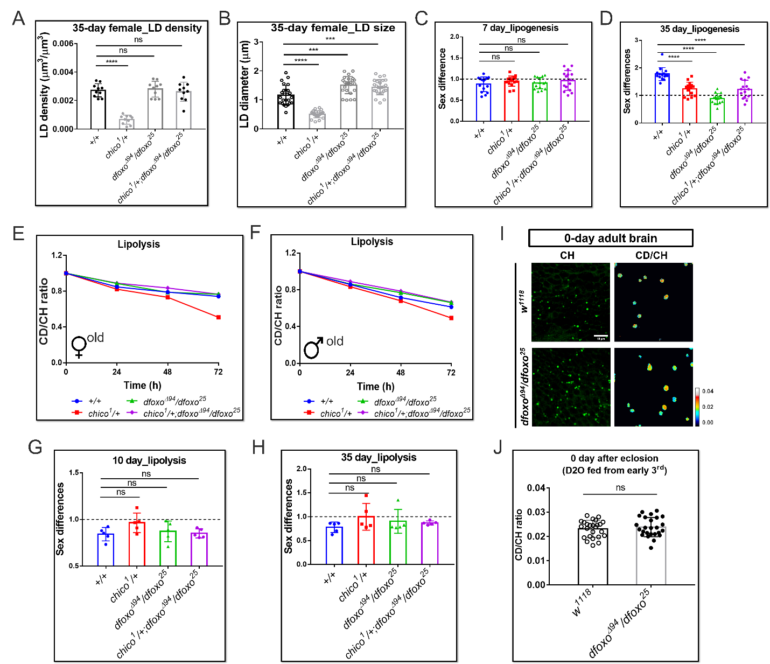

Figure S8. The lipid metabolic changes of genetic mutant brains in IIS pathway
(A-B) The LD density ratios (total LD volume to brain cortex volume) and LD sizes were quantified and presented as Mean ± SD in (A) and (B), respectively. N =5~8 brains for each group.
(C-D) The sex differences of lipogenesis in 7- (C) and 25-day (D) old IIS mutants were determined.
(E-F) The time-course changes of CD-lipid mobilization after 0, 24, 48, 72-hour starvation of old brain LDs. Data are presented as Mean ± SD in (E, old female) and (F, old male), n =15 ROIs from 3~5 brains.
(G-H) Sex differences in lipolysis (decrease in CD/CH ratio after 72h starvation in young flies (Figures 4F and 4G), and old flies (panels E and F)) (arbitrarily defined as the CD/CH ratio in males to that in females, M_{CD/CH}/F_{CD/CH}) were quantified and compared between control and IIS mutant flies.
(I-J) The radiometric images for lipid biosynthesis of 0-day brain LDs from dfoxo^{Δ94}/dfoxo²⁵ and w¹¹¹⁸ were displayed in (F) and quantified in (G). n =15 ROIs from 3~5 brains.

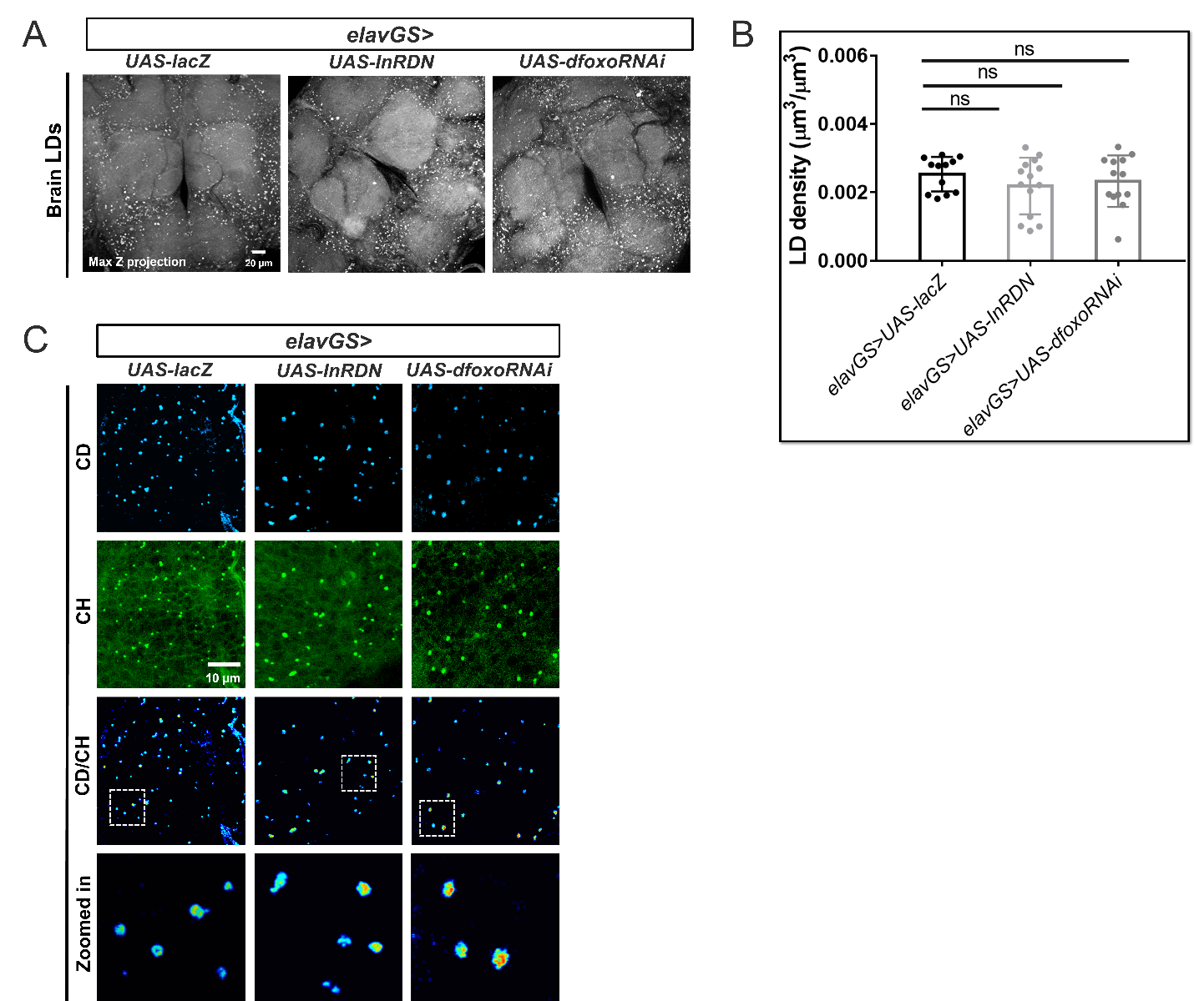
Figure S9. Neuron-specific manipulation of IIS pathway did not significantly affect the brain lipid metabolism
(A) Max Z projected images of brain LDs with neuron-specific expression of InRDN mutant of dfoxoRNAi (elavGS>UAS-InRDN and UAS-dfoxoRNAi) are compared with that of elavGS>UAS-lacZ flies.
(B) LD density (total LD volume to brain cortex volume) in adult brains from the designated genotypes in (A) were quantified and presented as Mean ± SD (n = 5 brains for each group).
(C) DO-SRS images of brain LDs from genetic manipulated IIS flies at 10-day old flies treated with 20% D2O labeled standard diet (ST) for 5 days were displayed as green (CH, total lipids), cyan (CD, newly synthesized lipids), and royal (CD/CH, newly synthesized lipids to total lipids) respectively. The representative LDs inside the dashed box were magnified to show the details, Scale bar: 10µm.

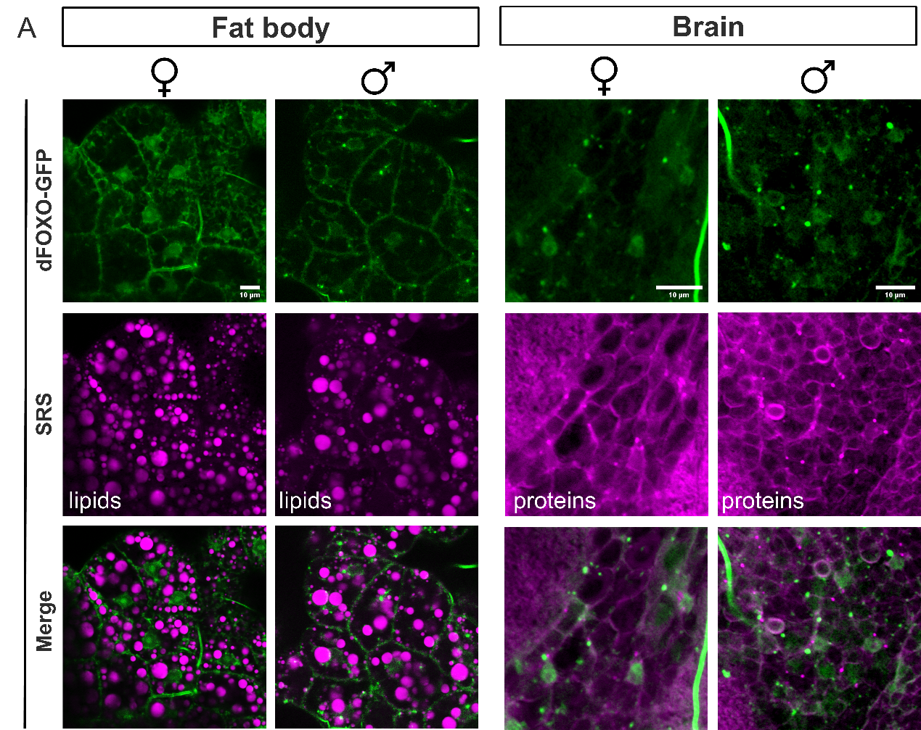

Figure S10. dFOXO-GFP expression shows sexual differences in adult fat bodies but not in brains.
(A) The fluorescent images of dFOXO-GFP expression in fat bodies and brains were taken from 10-day old female and male flies and were displayed as green channel, the SRS lipid signals in fat bodies and protein signals in brains are assigned to magenta, respectively. Superimposed GFP and SRS images are shown. Scale bar: 10µm.

