Online resource 1
Fish-derived Probiotic Improves Growth Performance and Pathogen Resistance of Juvenile Grass Carp (Ctenopharyngodon idella) by Modulating Keystone Taxa and Enhancing Microbial Interactions
Journal: Probiotics and Antimicrobial Proteins

Author: Xiaozhou Qi ª, Mingyang Xue ^{b}, Yong Zhang ª, Gaoxue Wang ª, Fei Ling ª*

ª College of Animal Science and Technology, Northwest A&F University, Xinong Road 22nd, Yangling, Shaanxi 712100, China
^{b} Yangtze River Fisheries Research Institute, Chinese Academy of Fishery Sciences, Wuhan, China

*Corresponding author
E-mail addresses: feiling@nwsuaf.edu.cn (Fei. Ling)

Supplementary figure 1
Fig S1 The impact of P. monteilii JK-1 on immune response and antioxidant enzymes. a Expression of immune related genes in head kidney of grass carp after feeding with base diet (control) and P. monteilii JK-1 supplemented diet (PM-JK1). b Expression of immune related genes in gut of grass carp after feeding with base diet (control) and P. monteilii JK-1 supplemented diet (PM-JK1). c The antioxidant enzymes activity in liver of grass carp fed with different diets. d The antioxidant enzymes activity in gut of grass carp fed with different diets. Data were revealed as mean ± SD. * indicates significant difference (p < 0.05) between different groups.

Supplementary figure 2

Fig S2 Alpha-diversity and beta-diversity of gut bacterial community of grass carp with different diets. a Shannon index comparison among the different groups. b Richness comparison among the different groups. The difference among the four group was constructed with Kruskal-Wallis test, significant differences (p < 0.05) between different groups are indicated with different lowercase letters. c A principal coordinate analysis (PCoA) based on Bray_curtis distance from the different groups (Control, Control-T, PM-JK1 and PM-JK1-T) (adonis p = 0.001). p-values indicate significance of grouping with adonis2 Permutational Multivariate Analysis of Variance Using Distance Matrices test.

Supplementary figure 3

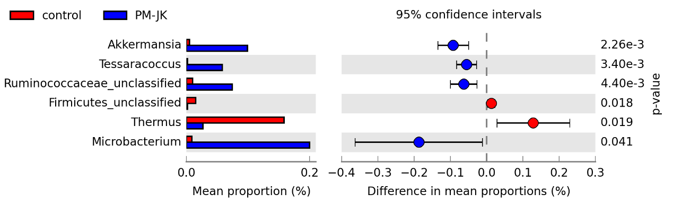
Fig S3 The microbial composition between control and PM-JK1 was explored in terms of the relative abundances at the genus level using STAMP software (White’s non-parametric t-test; p-value < 0.05) to determine statistically significant differences.

Supplementary figure 4

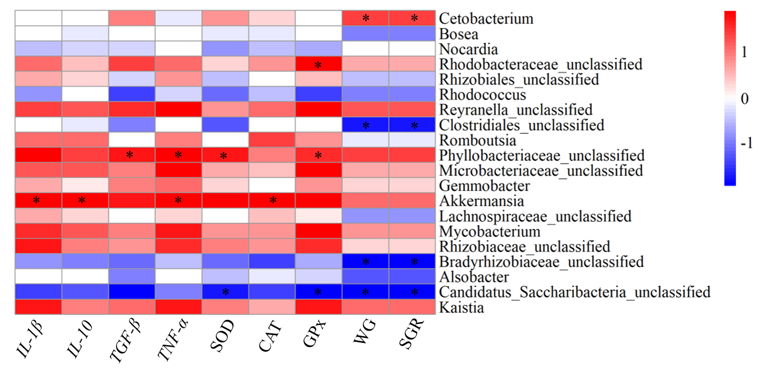
Fig S4 Heatmap of Spearman's correlation between the abundance of gut microbiota (at the genus level) and growth performance and disease resistance. The intensity of the colors represented the degree of association (red, positive correlation; blue, negative correlation). Significant correlations are marked by ∗P < 0.05.

Supplementary table 1

Table S1 Composition and nutrient levels of basal diet (dry matter basis, g/kg).
Item | Content
Ingredients
Fish meal | 120
Soybean meal | 240
Rapeseed meal | 100
Cottonseed meal | 100
Wheat flour | 222
DDGS | 50
Rice bran | 70
Soybean oil | 8
Bentonite | 10
Ca(H₂PO₄)₂ | 20
Microcrystalline cellulose | 40
Vitamin mixture ª | 10
Mineral mixture ^{b} | 10
Proximate composition
Moisture | 134
Crude protein | 300
Crude lipid | 49
Ash | 99
DDGS = distillers dried grains with soluble.
ª Vitamin premix provided per kilogram diet: vitamin A, 3,000 IU; vitamin E, 60 IU; vitamin D, 2,000 IU; vitamin C, 200 mg; thiamine, 5 mg; riboflavin, 10 mg; menadione, 10 mg; pyridoxine HCl, 10 mg; cyanocobalamin, 0.02 mg; biotin, 1 mg; calcium pantothenate, 40 mg; folic acid, 5 mg; niacin, 100 mg; inositol, 200 mg. Cellulose was used as a carrier.
^{b} The mineral mix contained (g/kg of the total mineral): KAl(SO₄)₂·12H₂O, 1.59; CaCO₃, 181.01; Ca(H₂PO₄)₂, 446.01; CoCl₂·6H₂O, 0.70; MgSO₄, 52.16; MnSO₄⋅H₂O, 0.70; KCl, 165.53; KI, 0.14; ZnCO₃, 1.92; NaH₂PO₄, 136.05; Na₂SeO₃, 0.06; CuSO₄⋅5H₂O, 0.75; ferric citrate, 13.38.

Supplementary table 2

Table S2 Primers sequences for the immune-related genes in grass carp
Genes | Primers | T_{m} | Gene Bank
β-actin | F:5’-CCCAAAGCCAACAGGGAAAAGA-3’ | 60°C | M25013
 | R: 5’- GGCAGGGCATAACCCTCGTA-3’
IL-1β | F: 5’-TGTGACGCTGAGAGACGGAAA-3’ | 60°C | JX014320
 | R: 5’-GAGTTTCAGTGACCTCCTTCAA-3’
IL-10 | F: 5’-GTCATGCTTCTGCTTTCTGAAA-3’ | 60 °C | HQ388294
 | R:5’- TGGCATCCATAAGGACTATTGA-3’
TGF-β | F: 5’-CTGACGGAGTTTGTACCGAAAA-3’ | 60°C | EU099588
 | R:5’-TTATGATGCCTATACAGTGCAAGA-3’
TNF-α | F: 5’-CCATCCATTTAACAGGTGCATAC-3’ | 60°C | HQ696609
 | R: 5’-CAGCAGATGTGGAAAGAGACC-3’

Supplementary table 3
Table S3 The top 10 keystone genus in the ecological network in different groups
Control |  | Control-T |  | PM-JK1 |  | PM-JK1-T
Genus | Closeness Centrality | Genus | Closeness Centrality | Genus | Closeness Centrality | Genus | Closeness Centrality
Microbacteriaceae_unclassified | 0.171 | Cetobacterium | 0.154 | Cetobacterium | 0.750 | Gemmobacter | 0.654
Rhizobiaceae_unclassified | 0.171 | Alphaproteobacteria_unclassified | 0.154 | Roseomonas | 0.733 | Cetobacterium | 0.651
Kaistia | 0.171 | Hyphomicrobium | 0.154 | Gemmobacter | 0.733 | Actinomycetales_unclassified | 0.643
Hyphomicrobium | 0.171 | Phyllobacteriaceae_unclassified | 0.154 | Rhizobiales_unclassified | 0.717 | Bosea | 0.643
Bdellovibrio | 0.171 | Shinella | 0.154 | Microbacteriaceae_unclassified | 0.717 | Tessaracoccus | 0.631
Kocuria | 0.171 | Gordonia | 0.153 | Bosea | 0.702 | Hyphomicrobium | 0.621
Cetobacterium | 0.167 | Mycobacterium | 0.153 | Hyphomicrobium | 0.688 | Actinobacteria_unclassified | 0.621
Shinella | 0.167 | Bacillales_unclassified | 0.147 | Clostridiales_unclassified | 0.688 | Bradyrhizobiaceae_unclassified | 0.621
Phreatobacter | 0.167 | Rhizobiales_unclassified | 0.147 | Alphaproteobacteria_unclassified | 0.673 | Mycobacterium | 0.610
Rhodobacter | 0.167 | Bradyrhizobiaceae_unclassified | 0.146 | Rhodobacteraceae_unclassified | 0.673 | Leptotrichiaceae_unclassified | 0.600

