Appendix 1: Kimolohing Average Water Quality Parameter
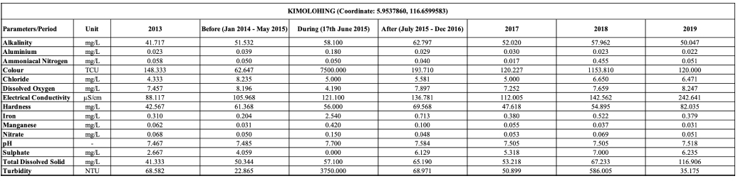
Appendix 2: Bambangan Average Water Quality Parameter
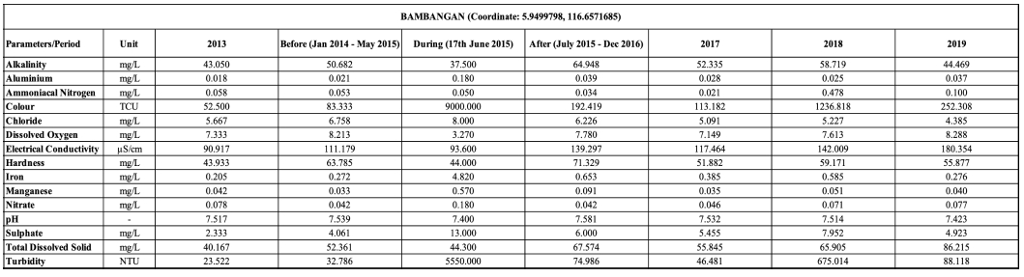

Appendix 3 Average Water Quality for Each Parameters from Kimolohing and Bambangan Station
Parameter  /Data | Average Water Quality Parameter
Aluminum
Colour
Dissolved
Oxygen
Iron
Manganese
Nitrate
Turbidity
Appendix 4. Modelling Data for Each Parameters
Appendix 5. Modelling Data for Each Parameters (cont.)
Appendix 6. Modelling Data for Each Parameters (cont.)
Appendix 7. Modelling Data for Each Parameters (cont.)
Appendix 8. Modelling Data for Each Parameters (cont.)

