Supplementary Information

Supplementary Methods

Overview of quality of life
Quality of life (QOL) has been advocated since the 1930s and has been discussed in various contexts: psychological, healthcare, social sciences, and environmental. The "paradox of affluence," which recognizes that technological progress and economic development do not necessarily improve the well-being of the population, has stimulated the development of indicators that more appropriately reflect overall health and well-being^{1,2}. The complex multifaceted nature of QOL requires diverse insights from other disciplines³. In this study, we first summarize previous discussions on overall QOL and then focus on QOL research related to urban environments.
An early QOL concept was based on the World Health Organization’s definition of “health” as physical, mental, and social well-being, not merely the absence of disease or infirmity⁴. This definition extends the previous definition of “health” as physical health. WHOQOL⁵ is a comprehensive QOL based on the WHO definition of health. Health-related QOL has been applied in practical healthcare systems such as The EuroQol Five-Dimension ⁶, the Short-Form Six-Dimension⁷, and Health Utilities Index Mark 3⁸.
In the policy field, the US presidents Johnson and Nixon adopted the term "quality of life" as a policy slogan in the 1960s⁹. The Nixon administration established a "Quality of Life Committee" to study interrelated QOL variables such as consumer and environmental interests, industrial requirements, and safety aspects. Administrative agencies were encouraged to ensure transparency in their decision-making processes¹⁰.
Nussbaum and Sen¹¹ extended the concept of welfare economics to QOL from a capability perspective. Regarding life as a collection of various functions, they proposed that welfare should create a situation (environment) in which all persons can fulfill their functions. This approach emphasizes the importance of making policies for people with different capabilities.
Thus, QOL is not a one-dimensional concept like health or economics, but has been developed and interpreted differently in various fields. The definitions of QOL highlight the multifaceted richness of human beings and the environment, along with individual and societal needs. QOL domains of individuals have also been extensively researched. Some representative studies on QOL domains are shown in Supplementary Table 2.
QOL domains can be classified into four categories based on the state of the self and its relationship to others and the surrounding environment. The two categories of self-status are a) Physical status and b) Psychological status, which primarily assess the degrees of an individual's physical health (or disability) and psychological health, respectively. Physical status includes the effects of disability, injury, illness, and health conditions on an individual's performance, along with the functional ability to fulfil the individual’s desires. Psychological status includes the effects of a physical condition on an individual's performance and the degree of unfulfilled desire caused by that condition. It also includes an individual’s degree of personhood and self-actualization due to personality and other factors. c) Social interactions (such as economic, family, and community interactions) describe the state, soundness and depth of the relationships between the individual and society. They mainly include the family environment, the economic environment (employment, income, and other monetary factors), and the neighborhood community environment. This category also covers the adequacy of social relationships and the degree of desire fulfillment achieved through these relationships. Finally, d) the surrounding environment indicates the physical and institutional environment surrounding the individual and the condition of that environment. The state and quality of the environment is evaluated in terms of essential living functions such as residential and urban environments. It may also include the institutional environment such as the legal system and administrative structure. Some definitions include religious and spiritual states (spirituality) as a higher element.
These four categories are interrelated and each category affects the other categories. The urban-environment-related QOL can specifically target social relationships and the surrounding environment. Supplementary Table 3 shows the QOL components in previous studies of QOL related to the urban environment.

Distribution of each indicator
Supplementary Table 4 shows the distributions of the indicator data in each metropolitan area. The data of each indicator differ among the regions. Indicators SS1 (flood risk) and SS2 (traffic accident risk) are especially variable. The average rent (EC2) is also sensitive to region and is raised in Tokyo. The commuting time (EC3) tends to be longer in cities with large-scale urbanization (Tokyo, Osaka, and Nagoya) than in other regions, In Nagoya and Fukuoka with relatively low population densities, the access times to shopping (LC1), hospitals (LC2), and other amenities tend to be extended but the large green cover (EF2) is an advantage. The risk of traffic accidents (SS2) is high in Nagoya, where the automobile share is also high.

Results of weight parameter estimation
The weight parameter estimates are listed in Supplementary Tables 6–8. Shown are the weight parameters of the reference attributes and the intersection terms of the dummy variables separating gender and age. All parameters of the reference attributes are positive. Attribute variables with values above and below the reference values are positive and negative, respectively.
Supplementary Table 6 shows the estimated weight parameters of the 15 basic indicators. The parameters of the one-minute access time are shown to differ by purpose, being largest for garbage collection points followed by (in order) railway stations, shopping precincts, and medical clinics. The parameters of the dummy variables depend on life stage and are influenced by age, marriage, and presence of children. Elderly respondents valued offices, hospitals, railway stations, and noise more highly than other participants. However, retired elderly respondents placed less value on offices and railway stations. Married people tended to favor house size, access to shopping, and low flood risk. By income, the higher-income group with money to spare placed higher values on various living environments, possibly because house rent was adopted as the reference indicator.
The estimated weight parameters might also reflect the current lifestyle of each individual. For example, people living in single-family houses might value quiet residences with low flooding risk, whereas regular car users might favor house size over accessibility to railway stations. Additionally, the weighting varies by region. For example, the parameter for railway stations in the intersection term is negative, indicating that citizens in the 23 wards of Tokyo (where the station density is highest) place high value on proximity to a railway station. The values are also region-dependent: access time to railway stations is important to residents in the central part of the Tokyo metropolitan area, whereas flood risk is more valued in the central part of the metropolitan area. In summary, the values depend on life stage, place of residence, and lifestyle.
Supplementary Table 7 shows the estimated weight parameters of other service opportunities (15 facilities). Here, the weight of access time to nearby shopping facilities is set to 1. High weights are assigned to convenience stores, banks, restaurants, and elementary schools. Overall, women tend to value nearby shopping facilities more than men. Large gender differences appear in the values of all 15 facilities, especially those of restaurants and convenience stores. The weighting parameters also show life-stage differences; for example, married couples with children place high value on day-care facilities.
Supplementary Table 8 shows the estimated weight parameters of access times between transport modes. Among the four modes of transport, modes with smaller parameters are more likely to be selected. Reference transport modes with the same travel time were selected in the following order: walking>bicycling>public transportation>cars. Large negative values for the car parameter were given by frequent car users, residents of the Nagoya metropolitan area (which has a high modal share of car), and suburban residents, consistent with the current situation. Transport mode preferences were diverse. Car travel was preferred by households with children, whereas walking was preferred by elderly residents.
As indicated in the above results, the values placed by citizens on their living environments depend on location and lifestyle. Adopting the capability approach of Nussbaum and Sen¹¹, the estimated values may be interpreted as an integrated concept of "functioning" and "needs". In other words, an element (indicator) that cannot enhance the QOL of an individual (either because it cannot benefit the individual or because it is non-QOL enhancing) is assigned a small weight. In contrast, an element that enhances the functionality of all individuals or is necessary for QOL is assigned a high weight.
Note that the values are also influenced by social conditions. For example, Japan has a large gender gap ¹². The active job openings-to-applicants ratio largely favors males. This observation may reflect the situation in Japan; that is, most males enter the workforce while females are mainly responsible for household chores. In future, the gender gap is likely to close and the differences between the values of males and females will reduce. As these values mirror the current social environment, they can monitor the social disparities that are unevenly distributed within each city.
Supplementary Fig. 1 shows the monetary equivalents of the weight parameters, along with those of typical individual attribute subgroups. These results are validated by the commuting time results. For example, suppose that an individual commutes on 240 days each year. A one-minute reduction in commuting time translates into an average saving of 17.4 JPY/min (range 4.6–33.7 JPY/min), In previous studies on transport times in Japan ^{13,14}, the average commute cost ranges from 13.3 to 36.7 JPY/min depending on attribute group (average cost 24.5 JPY/min). Although the present study simultaneously estimates multiple indicators, the estimated results are generally comparable to those of studies of time value alone.
Focusing on the mean and range of each weight parameter, the maximum value is at most twice the mean and the minimum value is extremely low. That is, several elements of the living environment are of little or no interest to some people. The price assignment clearly differs among the typical individual-attribute subgroups, being high in family households (G2 and G4) and especially high in G4 with more time and disposable income. The younger group (G2) assigns higher prices to amusement facilities, day-care centers, elementary schools, and shared offices, indicating differences in households and ages. Group G1, representing young single female individuals, placed high value on security, greenery, and access to workplaces, shops, and railway stations. These results suggest that individuals pursue diverse lifestyles, use various infrastructures with specific attributes, and thus place different values on the effects of urban development. Therefore, the results might indicate who will be affected by heterogeneous urban policies such as road construction, flood control, and land-use conversion.

Supplementary Tables

Table 1| QOL domains of individuals
Source | QOL domains of individuals
WHO (2012)⁵ | Physical, Psychological, Level of independence, Social relationships, Environment, Spirituality/religion/personal beliefs
Spilker (1996)¹⁵ | Physical status and functional abilities, Psychological status and well-being, Social interactions, Economic status and economic factors, Religious and/or spiritual status
Ferrans & Powers (1985)¹⁶ | Physical health and functioning, Socioeconomic status, Family, Standard living etc.
Baker & Intagliata (1982)¹⁷ | Physical & Material Wellbeing, Relations with Other People, Social, Community and Civic Activity, Personal Development and Fulfilment, Recreation
Felce & Perry (1995)¹⁸ | Physical Wellbeing, Material Wellbeing, Social Wellbeing, Development and Activity, Emotional Wellbeing
Schalock et al. (1990)¹⁹ | Self-esteem, social; Self-esteem, beauty; Self-direction (independence); Social relations; Environmental comfort and convenience; Safety and security

Table 2| QOL components related to urban environment in previous studies
Source | QOL domains
HDI (UNDP, 1990)²⁰ | Long and healthy life, Knowledge, A decent standard of living
Better Life Index(OECD, 2011)²¹ | Housing, Income, Jobs, Community, Education, Environment, Civic engagement, Health, Life Satisfaction, Safty, Work-Life Balance
UHI(WHO Kobe Centre et al., 2014)．²² | Health, Environment, Geography, Economics, Sociodemographics
Quality of Life Index included in CPI(UN-Habitat, 2016)²³ | Health, Education, Safety and Security, Public Space
Murgaš & Klobuční (2016)²⁴ | Life, Health, Family, Job
Martín & Mendoza (2013)²⁵ | Health, Education, Personal activities (including commuting and housing), Social connections, Environmental conditions, Personal and economic insecurity
Aroca et al. (2017)²⁶ | Household resorces, Equality/Inequality, House quality, Health, Safety, Perticipattion, Green areas, Clean air, Subjective social wellbeing, Subjective individual welbeing
Mouratidis (2020)²⁷ | Commute, Neibourhood, Housing
(Zhan et al. (2018)²⁸ | Urban security, Convenience of public facilities, Natural environment, Sociocultural environment, Convenient transportation, Environmental health
Ülengin et al. (2001)²⁹ | Physical environment, Social environment, Economic environment, Transportation and Communication
Das (2008)³⁰ | Physical environment, Economic environment, Social environment
Mittal et al. (2021)³¹ | Physical, Social, Economic, Environmental, Mobility, Governance, Psychological

Table 3| Key statistics of the study area
 | TOKYO | OSAKA | NAGOYA | FUKUOKA | SAPPORO
Total Population in 2020 (million) | 38.5 | 19.2 | 10.1 | 5.2 | 2.5
area (km²) | 15,939 | 14,111 | 10,471 | 5,005 | 3,956
Inhabitable area (km²) | 11,021 | 6,158 | 5,140 | 2,795 | 976
Population density (people/km²) | 3,494 | 3,130 | 1,960 | 1,852 | 2,584
Modal share of car (%) | 27.0 | 31.3 | 61.4 | 55.0 | 55.6
Population of Top 5 cities with population over 200,000  (thousands) | Special words of Tokyo  9,733 | Osaka  2,752 | Nagoya  2,332 | Fukuoka  1,612 | Sapporo  1,973
 | Yokohama  3,777 | Kobe  1,525 | Toyota  422 | Kitakyushu  939 | -
 | Kawasaki  1,538 | Kyoto  1,464 | Gifu  403 | Kurume  303 | -
 | Saitama  1,324 | Sakai  826 | Okazaki  385 | - | -
 | Chiba  975 | Himeji  530 | Ichinomiya  380 | - | -
Note: Inhabitable area and population density were calculated based on the number of meshes with population>0.
Table 4| Current measurement data of each indicator
Indicator (Unit) | ALL | TOKYO | OSAKA | NAGOYA | FUKUOKA | SAPPORO
EC1: Active job openings-to-applicants ratio | 1.55  (0.58) | 1.50  (0.54) | 1.60  (0.68) | 1.77  (0.49) | 1.49  (0.56) | 1.14  (0.13)
EC2: House rent (10k JPY per year) | 84.45  (30.34) | 99.70  (32.85) | 72.87  (15.95) | 65.39  (10.99) | 60.06  (13.14) | 57.28  (8.17)
EC3: Commuting time (min) | 38.53  (7.86) | 45.09  (1.35) | 34.58  (4.18) | 28.47  (4.56) | 27.53  (4.86) | 27.58  (3.40)
LC1: Access time to nearest shopping (min) | 9.09  (6.69) | 7.91  (5.94) | 7.95  (5.91) | 13.56  (7.35) | 14.06  (7.80) | 8.09  (5.31)
LC2: Access time to nearest clinic (min) | 5.04  (4.27) | 4.96  (4.25) | 4.52  (4.05) | 6.13  (4.60) | 5.37  (4.39) | 5.01  (3.79)
LC3: Access time to nearest train station (min) | 12.95  (6.53) | 12.89  (6.38) | 12.03  (6.24) | 14.42  (6.88) | 13.85  (6.82) | 13.12  (6.96)
LC4: Access time to other cultural and lifestyle facilities (min) | 13.63  (5.93) | 13.13  (5.71) | 13.33  (5.79) | 15.67  (5.93) | 14.96  (6.02) | 13.05  (5.39)
AM1: Living space (m2 per capita) | 33.67  (3.43) | 32.58  (3.03) | 34.14  (3.69) | 35.65  (2.64) | 35.29  (3.39) | 36.18  (3.26)
AM2: Access time to nearby playground/square (min) | 5.60  (5.29) | 5.44  (5.09) | 5.18  (4.79) | 7.32  (6.08) | 6.23  (6.78) | 3.14  (2.43)
AM3: Noise level (dB) | 53.44  (6.46) | 52.93  (6.46) | 54.07  (6.22) | 54.39  (6.78) | 53.25  (6.55) | 53.42  (5.88)
SS1: Flood depth (m) | 0.49  (0.90) | 0.47  (0.93) | 0.63  (1.00) | 0.50  (0.81) | 0.18  (0.42) | 0.24  (0.45)
SS2: Traffic fatalities per 100,000 population | 0.50  (0.97) | 0.17  (0.15) | 0.19  (0.12) | 2.57  (1.41) | 0.23  (0.15) | 0.14  (0.12)
SS3: Number of criminal offenses per 1,000 population | 7.67  (4.52) | 7.41  (3.36) | 8.59  (6.79) | 7.45  (3.82) | 7.53  (3.35) | 6.02  (2.20)
EF2: Green coverage rate (%) | 15.31  (20.38) | 15.15  (20.70) | 13.79  (18.61) | 18.82  (22.04) | 18.12  (21.82) | 9.66  (14.51)
Note: Upper rows are means, lower rows are S.D.

Table 5| Composition of the questionnaire survey respondents
Category | Composition
Gender | Male: 50% | Female: 50%
Age | 20-29 :12% | 30-39: 21% | 40-49:17% | 50-59: 16% | 60-:33%
Job | Employed: 71% | Unemployed: 12% | Homemaker: 17%
Married | Single: 35% | Married: 65%
Child | With: 60% | Without: 40%
Household income | Less than 2 million yen: 9%｜200-399 million yen: 27%｜400-599 million yen: 26%｜600-799 million yen: 18%｜Over 8 million yen: 19%
Housing | Single-family housing: 52% | Multi-family housing: 48%
Car use | Not less than once a week :42% | Less than once a week :58%
Region | Tokyo center: 5% | Tokyo environs: 15% | Osaka center: 3% | Osaka environs: 17% | Nagoya center: 5% | Nagoya environs: 15% | Fukuoka center: 9% | Fukuoka environs: 11% | Sapporo center: 10% | Sapporo environs: 10%
Sample size | 3,090

Table 6| Estimated weight parameters of the 15 basic indicators
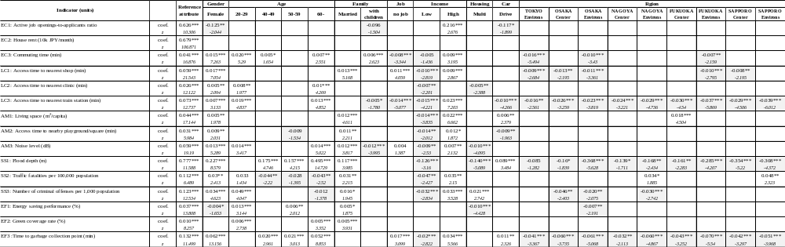
Notes: Initial log-likelihood L0; -49343.1, Maximum log-likelihood LL; -28363.4, ρ^2=(L0-LL)/L0=0.43. Significance codes: ***p < 0.01; **p < 0.05; *p < 0.1.
Reference attribute: Gender; Male, Age; 30 - 39 years old, Family; Single, Job; Employed, Household income; 2-8 million JPY per year, Housing; Single family house, Car use; less than once per week, Region; Tokyo center. A positive (negative) parameter indicates that the weight is greater (smaller) than the reference attribute.

Table 7| Estimated weight parameters of access time to other cultural and lifestyle facilities
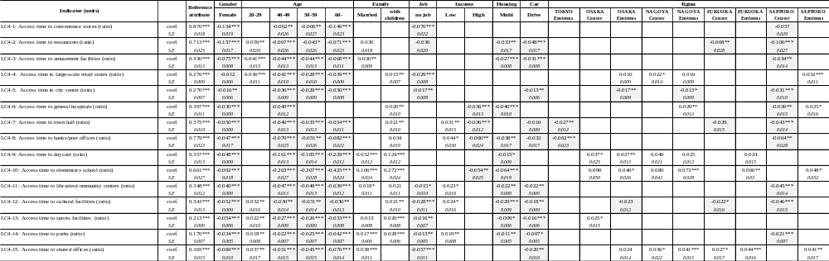
Notes: Significance codes: ***p < 0.01; **p < 0.05; *p < 0.1. Reference attribute: Gender; Male, Age; 30 - 39 years old, Family; Single, Job; Employed, Household income; 2-8 million JPY per year, Housing; Single family house, Car use; less than once per week, Region; Tokyo center. A positive (negative) parameter indicates that the weight is greater (smaller) than the reference attribute.

Table 8| Estimated weight parameters of access time of transport modes
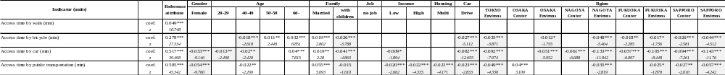
Notes: Initial log-likelihood L0; -32127.37, Maximum log-likelihood LL; -16899.69, ρ^2=(L0-LL)/L0=0.47. Significance codes: ***p < 0.01; **p < 0.05; *p < 0.1.
Reference attribute: Gender; Male, Age; 30 - 39 years old, Family; Single, Job; Employed, Household income; 2-8 million JPY per year, Housing; Single family house, Car use; less than once per week, Region; Tokyo center. A positive (negative) parameter indicates that the weight is greater (smaller) than the reference attribute.

Supplementary Figure
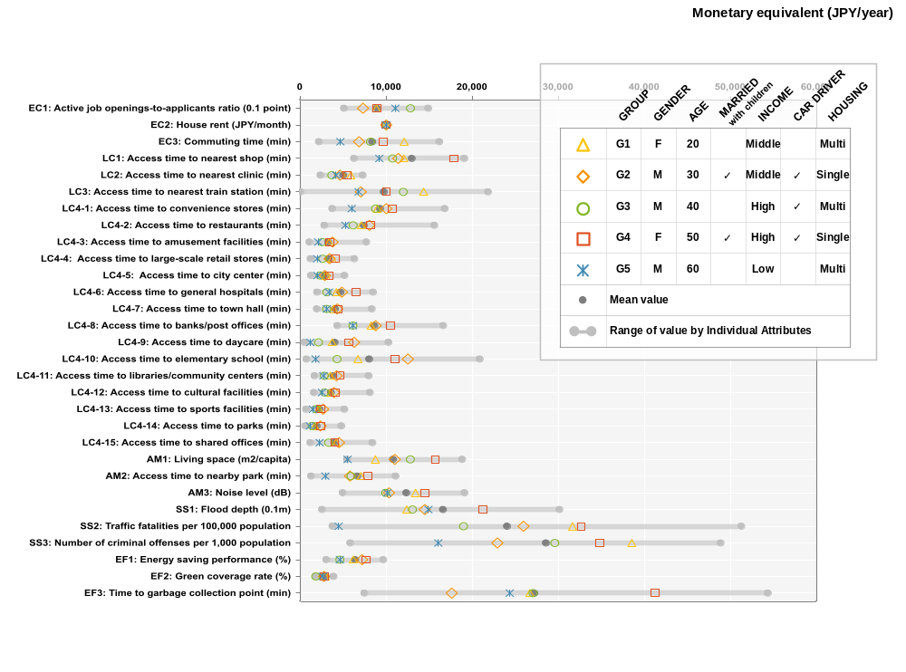
Fig. 1| Monetary equivalents of the weight parameters

Supplementary References

1. Pacione, M. Urban environmental quality and human wellbeing—a social geographical perspective. Landsc. Urban Plan. 65, 19–30 (2003).
2. Lever, J. P. The Development of an Instrument to Measure Quality of Life in Mexico City. Soc. Indic. Res. 50, 187–208 (2000).
3. Diener, E. & Suh, E. MEASURING QUALITY OF LIFE: ECONOMIC, SOCIAL, AND SUBJECTIVE INDICATORS. Soc. Indic. Res. 40, 189–216 (1997).
4. WHO. Constitution in basic documents. (1948).
5. WHO. The World Health Organization Quality of Life (WHOQOL). https://www.who.int/publications/i/item/WHO-HIS-HSI-Rev.2012.03 (2012).
6. EuroQol Group. EuroQol--a new facility for the measurement of health-related quality of life. Health Policy 16, 199–208 (1990).
7. Brazier, J., Roberts, J. & Deverill, M. The estimation of a preference-based measure of health from the SF-36. J. Health Econ. 21, 271–292 (2002).
8. Feeny, D., Furlong, W., Boyle, M. & Torrance, G. W. Multi-attribute health status classification systems. Health Utilities Index. Pharmacoeconomics 7, 490–502 (1995).
9. Calder, J. D. Presidents and Crime Control: Kennedy, Johnson and Nixon and the Influences of Ideology. Pres. Stud. Q. 12, 574–589 (1982).
10. Tozzi, J. J. OIRA’s Formative Years: The Historical Record of Centralized Review Preceding OIRA’s Founding. (2011) doi:10.2139/ssrn.2706279.
11. Nussbaum, M. & Sen, A. The Quality of Life. (Clarendon Press, 1993).
12. WEF. Global Gender Gap Report 2022. https://www.weforum.org/reports/global-gender-gap-report-2022 (2022).
13. Kato, H., Oda, T. & Sakashita, A. Valuation of travel time saving with revealed preference data in Japan: Further analysis. Presented at 13th World Conference on Transport Research (2013).
14. Kato, H., Sakashita, A., Tsuchiya, T., Oda, T. & Tanishita, M. Estimating Value of Travel Time Savings by Using Large-Scale Household Survey Data from Japan. Transp. Res. Rec. 2231, 85–92 (2011).
15. Spilker, B. Taxonomy of quality of life. in Quality of life and pharmacoeconomics in clinical trials (ed. Spilker, B.) 25–31 (Lippincott-Raven, 1996).
16. Ferrans, C. E. & Powers, M. J. Quality of life index: development and psychometric properties. ANS Adv. Nurs. Sci. 8, 15–24 (1985).
17. Baker, F. & Intagliata, J. Quality of life in the evaluation of community support systems. Eval. Program Plann. 5, 69–79 (1982).
18. Felce, D. & Perry, J. Quality of life: its definition and measurement. Res. Dev. Disabil. 16, 51–74 (1995).
19. Schalock, Robert, L. & Ed. Quality of Life: Perspectives and Issues. (American Association on Mental Retardation, 1990).
20. UNDP. Human Development Report 1990. Hum. Dev. Rep. (1990).
21. OECD. How’s Life?: Measuring Well-being. (2011).
22. WHO Kobe Centre et al. The urban health index: a handbook for its calculation and use. (World Health Organization, 2014).
23. UN-Habitat. MEASUREMENT OF CITY PROSPERITY Methodology and Metadata. https://unhabitat.org/sites/default/files/2019/02/CPI-METADATA.2016.pdf (2016).
24. Murgaš, F. & Klobučník, M. Municipalities and Regions as Good Places to Live: Index of Quality of Life in the Czech Republic. Appl. Res. Qual. Life 11, 553–570 (2016).
25. Martín, J. C. & Mendoza, C. A DEA Approach to Measure the Quality-of-Life in the Municipalities of the Canary Islands. Soc. Indic. Res. 113, 335–353 (2013).
26. Aroca, P., Gonzalez, P. A. & Valdebenito, R. The heterogeneous level of life quality across Chilean regions. Habitat Int. 68, 84–98 (2017).
27. Mouratidis, K. Commute satisfaction, neighborhood satisfaction, and housing satisfaction as predictors of subjective well-being and indicators of urban livability. Travel Behaviour and Society 21, 265–278 (2020).
28. Zhan, D. et al. Assessment and determinants of satisfaction with urban livability in China. Cities 79, 92–101 (2018).
29. Ülengin, B., Ülengin, F. & Güvenç, Ü. A multidimensional approach to urban quality of life: The case of Istanbul. Eur. J. Oper. Res. 130, 361–374 (2001).
30. Das, D. Urban Quality of Life: A Case Study of Guwahati. Soc. Indic. Res. 88, 297–310 (2008).
31. Mittal, S., Chadchan, J. & Mishra, S. K. Evaluation of QoL in cities of diverse neighbourhood typologies: A scientific study of New Delhi. International Journal of Urban Sustainable Development 13, 400–419 (2021).

