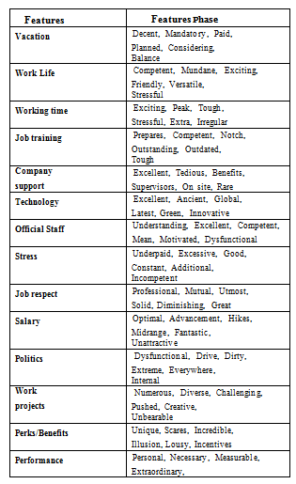
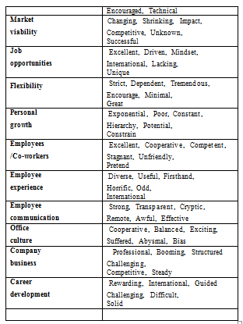

Table 1: Top 24 Features along with their respective features Phase.

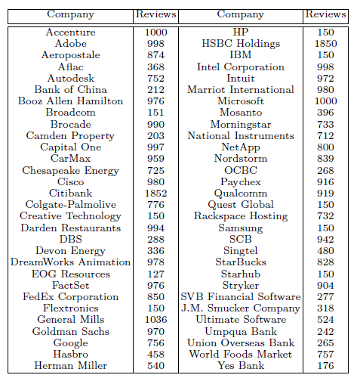

Table 2: The total number of reviews received by each firm [5]

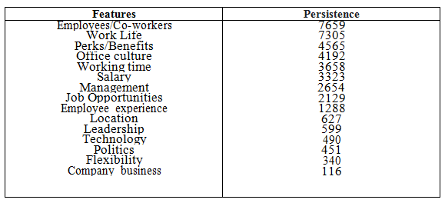
Table 3: Extracted features with their corpus Persistence.

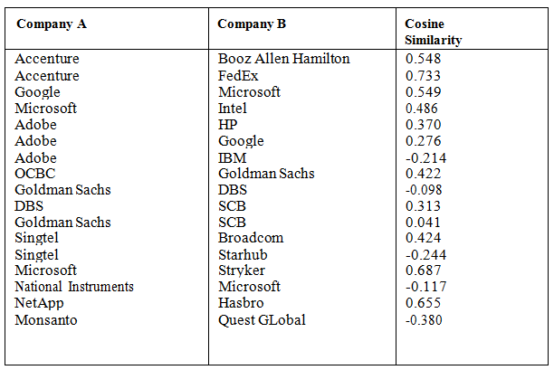
Table 4: Calculated Cosine Similarities between the Companies Using Their Feature-Sentiment Analysis

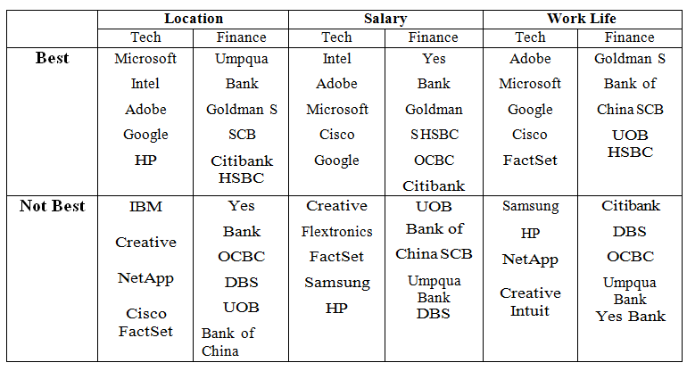

Table 5: In the business worlds of technology and finance, we look at which companies provide the most significant and worst compensation and workplace cultures.

