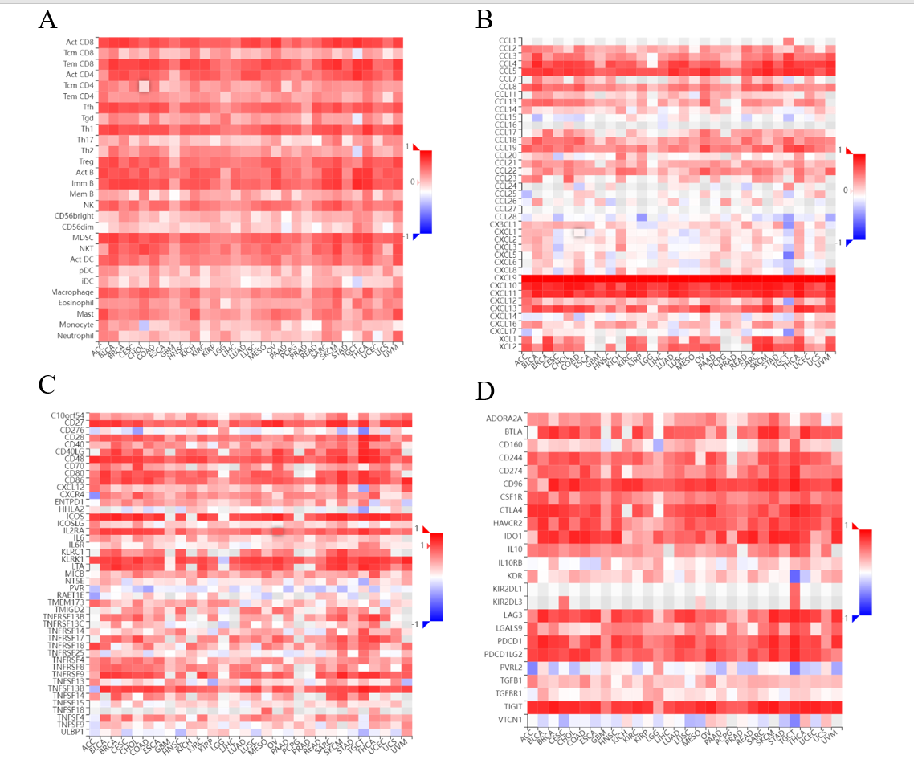
Figure S1. Correlation between CXCL9 and human immune cells (A), chemokines(B), immunostimulators(C) and immunoinhibitors(D)

