Supplementary Table 1. Primers for qRT-PCR
Genes | Primer
lncRNAs
AC156455.1 | Forward | TGTCTCCCTCTAGGATGCCC
AC156455.1 | Reverse | TGCTCTAAACCACCCTTCGG
CCDC18-AS1 | Forward | AAGGGTGTGGCCGTTTTACA
CCDC18-AS1 | Reverse | TTTGGAAGGTCGTCCACTGT
mRNAs
AAK1 | Forward | ATGGGATGAAATGTGCCTTGAA
AAK1 | Reverse | CGCTACTCACGTTGTTGATACT
CCND2 | Forward | GTGCTGGGGAAGTTGAAGTG
CCND2 | Reverse | GACGGTGGGTACATGGCAAA
miRNAs
miR-126-5p |  | GCCATTATTACTTTTGGTACGCG
miR-6835-3p |  | AGGGGGTAGAAAGTGGCTGAAG

Supplementary Table 2. Demographic characteristics of subjects
 |  | MDDgroup | HC group | Statistics | P
 | N | 10 | 10
Discovery  Set | Age (years, mean±SD) | 16.80±2.35 | 17.20±1.93 | t=-0.416 | 0.682
Discovery  Set | Sex (Male/Female) | 4/6 | 4/6 | x²=0.000 | 1.000
Validation  Set | N | 64 | 30
Validation  Set | Age(years, mean±SD) | 15.70±1.79 | 16.00±1.89 | t₁=-0.889 | 0. 093
Validation  Set | Sex (Male/Female) | 14/50 | 9/21 | x²=0.730 | 0.393
Validation  Set | Single-child Family  (yes/no) | 28/36 | 11/19 | x²=0.442 | 0.516
Validation  Set | Public/Private School | 49/15 | 23/17 | x²=0.002 | 0.991
Validation  Set | Family History  (with/without) | 7/57 | 3/27 | x²=0.019 | 0.890
Validation  Set | Response/Non-response | 28/26 | -

* represents P<0.05, ** represents P<0.001.

Supplementary Table 3. Clinical characteristics of subjects in validation set at baseline.
Scales | Scale dimensions | MDD (mean±SD) |  | HC  (mean±SD) | t | P-value
Scales | Scale dimensions | W0 | W8 | HC  (mean±SD) | t | P-value
HAMA |  | 17.867±5.140 | 8.000±5.755 | 2.833±3.018 | t₁=11.706** | P₁<0.001
 |  |  |  |  | t₂=15.075** | P₂<0.001
HAMD₂₄ |  | 25.389±5.360 | 12.556±8.034 | 3.233±3.673 | t₁=11.266** | P₁<0.001
 |  |  |  |  | t₂=19.833** | P₂<0.001
SHAPS |  | 34.327±8.271 | 30.019±9.918 | 19.600±6.137 | t₁=2.984* | P₁=0.004
 |  |  |  |  | t₂=8.446** | P₂<0.001
RBANS | Immediate memory | 78.355±7.437 | 92.000±15.390 | 89.759±19.502 | t₁=-8.415** | P₁<0.001
 |  |  |  |  | t₂=-1.796 | P₂=0.077
RBANS | Visual breadth | 102.774±16.875 | 103.064±10.020 | 103.793±12.105 | t₁=-0.351 | P₁=0.729
 |  |  |  |  | t₂=-0.315 | P₂=0.754
RBANS | Speech function | 77.710±14.487 | 88.774±17.843 | 97.207±13.516 | t₁=-9.521** | P₁<0.001
 |  |  |  |  | t₂=-3.820** | P₂<0.001
RBANS | Attentional function | 106.710±12.445 | 112.484±13.244 | 118.207±11.950 | t₁=-6.167** | P₁<0.001
 |  |  |  |  | t₂=-2.228* | P₂=0.029
RBANS | Delayed memory | 90.419±11.590 | 98.516±11.667 | 98.276±13.810 | t₁=-6.145** | P₁<0.001
 |  |  |  |  | t₂=-2.201* | P₂=0.032
BSI | Suicidal ideation | 12.900±2.717 | 10.517±4.139 | 6.652±3.128 | t₁=4.493** | P₁<0.001
 |  |  |  |  | t₂=8.753** | P₂<0.001
BSI | Suicidal risk | 30.491±7.002 | 24.226±15.614 | 5.348±9.364 | t₁=3.225* | P₁=0.002
 |  |  |  |  | t₂=8.653** | P₂<0.001
MPQ | PRI | 18.256±10.023 | 17.021±1.899 | 1.855±2.889 | t₁=0.584 | P₁=0.652
 |  |  |  |  | t₂=7.782** | P₂<0.001
MPQ | VAS | 3.978±2.532 | 2.990±2.562 | 0.385±1.023 | t₁=2.129* | P₁=0.038
 |  |  |  |  | t₂=5.672** | P₂<0.001
MPQ | PPT | 2.106±1.448 | 1.553±1.486 | 0.115±0.326 | t₁=1.878 | P₁=0.067
 |  |  |  |  | t₂=6.509** | P₂<0.001
t₁ and P₁ represents the statistical value of the comparison before and after treatment in MDD group used Paired t-test. t₂ and P₂ represents the statistical value of the comparison between MDD group and HC group used Student’s t-test. * represents P<0.05, ** represents P<0.001.

Supplementary Table 4. The Top 10 Differentially Expressed lncRNAs and mRNAs
Gene Symbol | Fold Change | P-value | FDR
Upregulated lncRNAs
 | 6.0156583 | 1.0347E-06 | 3.1993E-05
  AC005592.1
HTT | 5.6985957 | 9.7890E-07 | 3.1014E-05
AC156455.1 | 5.4582827 | 7.6841E-07 | 2.7491E-05
AL136982.1 | 5.264142 | 8.7286E-09 | 4.7770E-06
AC005480.1 | 5.0004975 | 5.0286E-07 | 2.2595E-05
G024327 | 4.8106649 | 7.7674E-08 | 1.0899E-05
 | 4.7770627 | 1.5721E-06 | 3.8313E-05
  MIR3681HG
CATG00000110151.1 | 4.6333985 | 1.5009E-07 | 1.3850E-05
 | 4.418489 | 8.6211E-08 | 1.1288E-05
  LINC01735
SOX2-OT | 4.3792263 | 1.5933E-07 | 1.4013E-05
Downregulated
lncRNAs
CCDC148-AS1 | 14.2804497 | 1.8692E-06 | 4.1730E-05
AC024267.5 | 14.0474481 | 7.6158E-05 | 4.9211E-04
G016030 | 9.4612244 | 1.0395E-05 | 1.2237E-04
AC004988.1 | 8.9842792 | 2.0335E-02 | 6.0439E-03
AL512310.10 | 8.5701067 | 7.5981E-06 | 9.8521E-05
AC073525.1 | 7.7523182 | 1.7529E-06 | 4.0469E-05
AC018926.2 | 7.6416159 | 2.0970E-06 | 4.4980E-05
AL512413.1 | 7.3216761 | 6.7038E-07 | 2.6099E-05
CCDC18-AS1 | 7.2093772 | 6.2071E-08 | 1.0249E-05
AL390067.1 | 6.9392245 | 2.0292E-07 | 1.5523E-05
Upregulated
mRNAs
CALCOCO2 | 4.4924556 | 5.6909E-08 | 9.8860E-06
DEFB134 | 4.4182679 | 6.1036E-08 | 1.0084E-05
CDK11A | 4.1969088 | 1.1848E-07 | 1.2833E-05
OXCT2 | 4.0912268 | 1.2069E-07 | 1.2892E-05
THOC5 | 4.0807001 | 2.0332E-07 | 1.6046E-05
WDR89 | 4.0599739 | 3.3373E-07 | 1.8471E-05
MACROD1 | 4.0011509 | 2.9807E-07 | 1.8056E-05
LCE2D | 3.9074442 | 3.4404E-07 | 1.8471E-05
PZP | 3.8283435 | 5.4979E-07 | 2.2633E-05
NFIL3 | 3.6853608 | 4.0822E-05 | 4.0822E-05
Downregulated
mRNAs
PCSK1 | 9.5411289 | 4.9175E-07 | 2.1486E-05
FKTN | 8.582012 | 8.7216E-05 | 5.1000E-04
GUCA1A | 8.3520717 | 1.5175E-07 | 1.4099E-05
FOSL1 | 7.9071378 | 1.7604E-05 | 1.6538E-04
RBMS2 | 7.0303914 | 6.8777E-06 | 8.8130E-05
TDG | 6.8913817 | 2.1499E-06 | 4.3671E-05
CATG00000022646.1 | 6.4841898 | 7.6085E-06 | 9.4089E-05
CATG00000094142.1 | 6.3123225 | 8.6788E-05 | 5.0822E-04
PPTC7 | 6.2476311 | 5.0617E-06 | 7.3066E-05
ODC1 | 6.2258051 | 1.3088E-04 | 7.0021E-04

Supplementary Table 5. The annotation and involved KEGG pathway of mRNAs in Hub-network
Gene Symbol | Annotations |  |  |  | Involved KEGG pathway
Gene Symbol | Description | Associated cell or tissue | Subcellular Localization | Associated Disease Name | Involved KEGG pathway
AAK1 | Adaptor-associated kinase 1 | Middle temporal gyrus | Cytosol; Nucleus; Cytoplasm | - | Map04330 Notch signaling pathway
MAL2 | mal, T cell differentiation protein 2 | amnion | Cytosol;Cytoplasm | - | -
AGAP1 | ArfGAP with GTPase domain, ankyrin repeat and PH domain 1 | Mast cell | Chromatin;Insoluble Fraction;Cell Membrane | Autistic Disorder | hsa04144 Endocytosis
CCND2 | cyclin D2 | neuronal_stem_cell | Ribosome;Cytosol;Insoluble Fraction | Schizophrenia; Cognitive delay; Seizures; Colonic Neoplasms; Diabetes Mellitus, Non-Insulin-Dependent; Fibrosis; Cardiomegaly; Ventricular Septal Defects; Hydrocephalus; Orbital separation excessive; etc. | hsa04068 FoxO signaling pathway
 |  |  |  |  | hsa04110 Cell cycle
 |  |  |  |  | hsa04115 p53 signaling pathway
 |  |  |  |  | hsa04151 PI3K-Akt signaling pathway
 |  |  |  |  | hsa04218 Cellular senescence
 |  |  |  |  | hsa04310 Wnt signaling pathway
 |  |  |  |  | hsa04340 Hedgehog signaling pathway
 |  |  |  |  | hsa04390 Hippo signaling pathway
 |  |  |  |  | hsa04510 Focal adhesion
 |  |  |  |  | hsa04630 JAK-STAT signaling pathway
SEMA5A | semaphorin 5A | Epithelial cell of amnion | Cytosol | Autistic Disorder; Alcoholic Intoxication,Chronic; Cri-du-Chat Syndrome; Fetal Growth Retardation; Orbital separation excessive; Infant, Small for Gestational Age; Round face; Byzanthine arch palate; etc. | hsa04360 Axon guidance

Supplementary Table 6. Parameters of ROC curves.
 | AC156455.1 | AAK1 | CCDC18-AS1 | miR-6835-5p | CCND2
AUC | 0.674 | 0.788 | 0.722 | 0.839 | 0.657
95%CI | 0.537~0.811 | 0.691~0.885 | 0.583~0.862 | 0.734~0.945 | 0.535~0.778
Sensitivity | 0.708 | 1.000 | 0.680 | 0.800 | 1.000
Specificity | 0.667 | 0.561 | 0.731 | 0.904 | 0.442

Supplementary Table 7. The correlation analysis between the changes of gene expression and the changes of clinical characteristics before and after treatment.
 |  |  |  |  | RBANS |  |  |  |  |  | BSI |  | SF-MPQ
 |  | HAMA | HAMD | SHAPS | Immediate  memory | Visual  breadth | Speech  function | Attentional  function | Delayed  memory | Total  score | Suicidal  ideation | Suicidal  risk | PRI | VAS | PPT
CCDC18-AS1 | r | -0.290 | -0.278 | 0.013 | 0.005 | 0.004 | 0.190 | 0.223 | -0.293 | 0.004 | -0.416* | -0.471* | -0.092 | -0.245 | -0.058
CCDC18-AS1 | P-value | 0.056 | 0.078 | 0.938 | 0.983 | 0.986 | 0.437 | 0.360 | 0.223 | 0.986 | 0.006 | 0.008 | 0.599 | 0.156 | 0.740
miR6835 | r | -0.183 | -0.073 | 0.124 | -0.174 | 0.260 | -0.231 | 0.154 | -0.351 | -0.150 | -0.386* | -0.016 | 0.010 | -0.064 | -0.061
miR6835 | P-value | 0.253 | 0.645 | 0.464 | 0.534 | 0.350 | 0.408 | 0.584 | 0.199 | 0.593 | 0.015 | 0.938 | 0.955 | 0.726 | 0.739
CCND2 | r | 0.026 | -0.179 | -0.136 | -0.288 | -0.800** | 0.133 | -0.510* | -0.120 | -0.501* | 0.484** | 0.174 | -0.297 | -0.173 | -0.295
CCND2 | P-value | 0.866 | 0.262 | 0.406 | 0.206 | <0.001 | 0.567 | 0.018 | 0.603 | 0.021 | 0.001 | 0.357 | 0.088 | 0.327 | 0.091
* represents P<0.05, ** represents P<0.001.

Supplementary Figure 1. GO and KEGG pathway analysis among different expressions of mRNAs
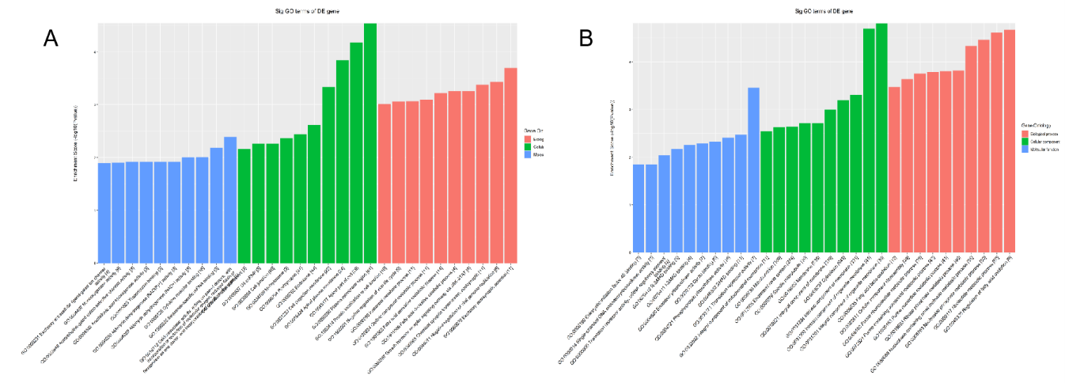
(A) The upregulated mRNAs enriched top 10 GO enrichment;
(B) The downregulated mRNAs enriched top 10 GO enrichment.

Supplementary Figure 2. The venn diagrams of predicting target mRNAs.
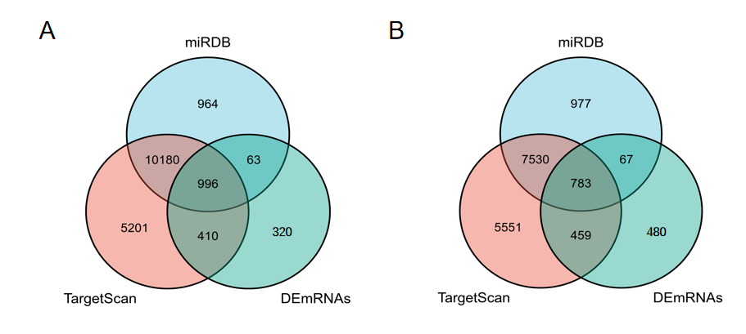
(A) The target mRNAs of upregulated lncRNAs matched-miRNAs. (B) The target mRNAs of downregulated lncRNAs matched-miRNAs.

