Supplementary Table 1. Primers for qRT-PCR
Genes | Primer
lncRNAs
AC156455.1 | Forward | TGTCTCCCTCTAGGATGCCC
AC156455.1 | Reverse | TGCTCTAAACCACCCTTCGG
CCDC18-AS1 | Forward | AAGGGTGTGGCCGTTTTACA
CCDC18-AS1 | Reverse | TTTGGAAGGTCGTCCACTGT
mRNAs
AAK1 | Forward | ATGGGATGAAATGTGCCTTGAA
AAK1 | Reverse | CGCTACTCACGTTGTTGATACT
CCND2 | Forward | GTGCTGGGGAAGTTGAAGTG
CCND2 | Reverse | GACGGTGGGTACATGGCAAA
miRNAs
miR-126-5p |  | GCCATTATTACTTTTGGTACGCG
miR-6835-3p |  | AGGGGGTAGAAAGTGGCTGAAG

Supplementary Table 2. Clinical characteristics of subjects in validation set at baseline.
Scales | Scale dimensions | MDD (mean±SD) |  | HC  (mean±SD) | t | P-value
Scales | Scale dimensions | W0 | W8 | HC  (mean±SD) | t | P-value
HAMA |  | 17.867±5.140 | 8.000±5.755 | 2.833±3.018 | t₁=11.706** | P₁<0.001
 |  |  |  |  | t₂=15.075** | P₂<0.001
HAMD |  | 25.389±5.360 | 12.556±8.034 | 3.233±3.673 | t₁=11.266** | P₁<0.001
 |  |  |  |  | t₂=19.833** | P₂<0.001
SHAPS |  | 34.327±8.271 | 30.019±9.918 | 19.600±6.137 | t₁=2.984* | P₁=0.004
 |  |  |  |  | t₂=8.446** | P₂<0.001
RBANS | Immediate memory | 78.355±7.437 | 92.000±15.390 | 89.759±19.502 | t₁=-8.415** | P₁<0.001
 |  |  |  |  | t₂=-1.796 | P₂=0.077
RBANS | Visual breadth | 102.774±16.875 | 103.064±10.020 | 103.793±12.105 | t₁=-0.351 | P₁=0.729
 |  |  |  |  | t₂=-0.315 | P₂=0.754
RBANS | Speech function | 77.710±14.487 | 88.774±17.843 | 97.207±13.516 | t₁=-9.521** | P₁<0.001
 |  |  |  |  | t₂=-3.820** | P₂<0.001
RBANS | Attentional function | 106.710±12.445 | 112.484±13.244 | 118.207±11.950 | t₁=-6.167** | P₁<0.001
 |  |  |  |  | t₂=-2.228* | P₂=0.029
RBANS | Delayed memory | 90.419±11.590 | 98.516±11.667 | 98.276±13.810 | t₁=-6.145** | P₁<0.001
 |  |  |  |  | t₂=-2.201* | P₂=0.032
BSI | Suicidal ideation | 12.900±2.717 | 10.517±4.139 | 6.652±3.128 | t₁=4.493** | P₁<0.001
 |  |  |  |  | t₂=8.753** | P₂<0.001
BSI | Suicidal risk | 30.491±7.002 | 24.226±15.614 | 5.348±9.364 | t₁=3.225* | P₁=0.002
 |  |  |  |  | t₂=8.653** | P₂<0.001
MPQ | PRI | 18.256±10.023 | 17.021±1.899 | 1.855±2.889 | t₁=0.584 | P₁=0.652
 |  |  |  |  | t₂=7.782** | P₂<0.001
MPQ | VAS | 3.978±2.532 | 2.990±2.562 | 0.385±1.023 | t₁=2.129* | P₁=0.038
 |  |  |  |  | t₂=5.672** | P₂<0.001
MPQ | PPT | 2.106±1.448 | 1.553±1.486 | 0.115±0.326 | t₁=1.878 | P₁=0.067
 |  |  |  |  | t₂=6.509** | P₂<0.001
t₁ and P₁ represents the statistical value of the comparison before and after treatment in MDD group used Paired t-test. t₂ and P₂ represents the statistical value of the comparison between MDD group and HC group used Student’s t-test. * represents P<0.05, ** represents P<0.001.

Supplementary Table 3. The Top 10 Differentially Expressed lncRNAs and mRNAs
Gene Symbol | Fold Change | P-value | FDR
Upregulated lncRNAs
 | 6.0156583 | 1.0347E-06 | 3.1993E-05
  AC005592.1
HTT | 5.6985957 | 9.7890E-07 | 3.1014E-05
AC156455.1 | 5.4582827 | 7.6841E-07 | 2.7491E-05
AL136982.1 | 5.264142 | 8.7286E-09 | 4.7770E-06
AC005480.1 | 5.0004975 | 5.0286E-07 | 2.2595E-05
G024327 | 4.8106649 | 7.7674E-08 | 1.0899E-05
 | 4.7770627 | 1.5721E-06 | 3.8313E-05
  MIR3681HG
CATG00000110151.1 | 4.6333985 | 1.5009E-07 | 1.3850E-05
 | 4.418489 | 8.6211E-08 | 1.1288E-05
  LINC01735
SOX2-OT | 4.3792263 | 1.5933E-07 | 1.4013E-05
Downregulated
lncRNAs
CCDC148-AS1 | 14.2804497 | 1.8692E-06 | 4.1730E-05
AC024267.5 | 14.0474481 | 7.6158E-05 | 4.9211E-04
G016030 | 9.4612244 | 1.0395E-05 | 1.2237E-04
AC004988.1 | 8.9842792 | 2.0335E-02 | 6.0439E-03
AL512310.10 | 8.5701067 | 7.5981E-06 | 9.8521E-05
AC073525.1 | 7.7523182 | 1.7529E-06 | 4.0469E-05
AC018926.2 | 7.6416159 | 2.0970E-06 | 4.4980E-05
AL512413.1 | 7.3216761 | 6.7038E-07 | 2.6099E-05
CCDC18-AS1 | 7.2093772 | 6.2071E-08 | 1.0249E-05
AL390067.1 | 6.9392245 | 2.0292E-07 | 1.5523E-05
Upregulated
mRNAs
CALCOCO2 | 4.4924556 | 5.6909E-08 | 9.8860E-06
DEFB134 | 4.4182679 | 6.1036E-08 | 1.0084E-05
CDK11A | 4.1969088 | 1.1848E-07 | 1.2833E-05
OXCT2 | 4.0912268 | 1.2069E-07 | 1.2892E-05
THOC5 | 4.0807001 | 2.0332E-07 | 1.6046E-05
WDR89 | 4.0599739 | 3.3373E-07 | 1.8471E-05
MACROD1 | 4.0011509 | 2.9807E-07 | 1.8056E-05
LCE2D | 3.9074442 | 3.4404E-07 | 1.8471E-05
PZP | 3.8283435 | 5.4979E-07 | 2.2633E-05
NFIL3 | 3.6853608 | 4.0822E-05 | 4.0822E-05
Downregulated
mRNAs
PCSK1 | 9.5411289 | 4.9175E-07 | 2.1486E-05
FKTN | 8.582012 | 8.7216E-05 | 5.1000E-04
GUCA1A | 8.3520717 | 1.5175E-07 | 1.4099E-05
FOSL1 | 7.9071378 | 1.7604E-05 | 1.6538E-04
RBMS2 | 7.0303914 | 6.8777E-06 | 8.8130E-05
TDG | 6.8913817 | 2.1499E-06 | 4.3671E-05
CATG00000022646.1 | 6.4841898 | 7.6085E-06 | 9.4089E-05
CATG00000094142.1 | 6.3123225 | 8.6788E-05 | 5.0822E-04
PPTC7 | 6.2476311 | 5.0617E-06 | 7.3066E-05
ODC1 | 6.2258051 | 1.3088E-04 | 7.0021E-04

Supplementary Table 4. The enriched KEGG pathway of mRNAs in Hub-network
Gene Symbol | Annotations |  |  |  | Enriched KEGG pathway
Gene Symbol | Description | Associated cell or tissue | Subcellular Localization | Associated Disease Name | Enriched KEGG pathway
AAK1 | Adaptor-associated kinase 1 | Middle temporal gyrus | Cytosol; Nucleus; Cytoplasm | - | Map04330 Notch signaling pathway
MAL2 | mal, T cell differentiation protein 2 | amnion | Cytosol;Cytoplasm | - | -
AGAP1 | ArfGAP with GTPase domain, ankyrin repeat and PH domain 1 | Mast cell | Chromatin;Insoluble Fraction;Cell Membrane | Autistic Disorder | hsa04144 Endocytosis
CCND2 | cyclin D2 | neuronal_stem_cell | Ribosome;Cytosol;Insoluble Fraction | Schizophrenia; Cognitive delay; Seizures; Colonic Neoplasms; Diabetes Mellitus, Non-Insulin-Dependent; Fibrosis; Cardiomegaly; Ventricular Septal Defects; Hydrocephalus; Orbital separation excessive; etc. | hsa04068 FoxO signaling pathway
 |  |  |  |  | hsa04110 Cell cycle
 |  |  |  |  | hsa04115 p53 signaling pathway
 |  |  |  |  | hsa04151 PI3K-Akt signaling pathway
 |  |  |  |  | hsa04218 Cellular senescence
 |  |  |  |  | hsa04310 Wnt signaling pathway
 |  |  |  |  | hsa04340 Hedgehog signaling pathway
 |  |  |  |  | hsa04390 Hippo signaling pathway
 |  |  |  |  | hsa04510 Focal adhesion
 |  |  |  |  | hsa04630 JAK-STAT signaling pathway
SEMA5A | semaphorin 5A | Epithelial cell of amnion | Cytosol | Autistic Disorder; Alcoholic Intoxication,Chronic; Cri-du-Chat Syndrome; Fetal Growth Retardation; Orbital separation excessive; Infant, Small for Gestational Age; Round face; Byzanthine arch palate; etc. | hsa04360 Axon guidance
Supplementary Table 4. Parameters of ROC curves.
 | AC156455.1 | AAK1 | CCDC18-AS1 | miR-6835-5p | CCND2
AUC | 0.674 | 0.788 | 0.722 | 0.839 | 0.657
95%CI | 0.537~0.811 | 0.691~0.885 | 0.583~0.862 | 0.734~0.945 | 0.535~0.778
Sensitivity | 0.708 | 1.000 | 0.680 | 0.800 | 1.000
Specificity | 0.667 | 0.561 | 0.731 | 0.904 | 0.442

Supplementary Figure 1. The flow chat and venn diagram of screening lncRNAs, miRNAs and mRNAs.
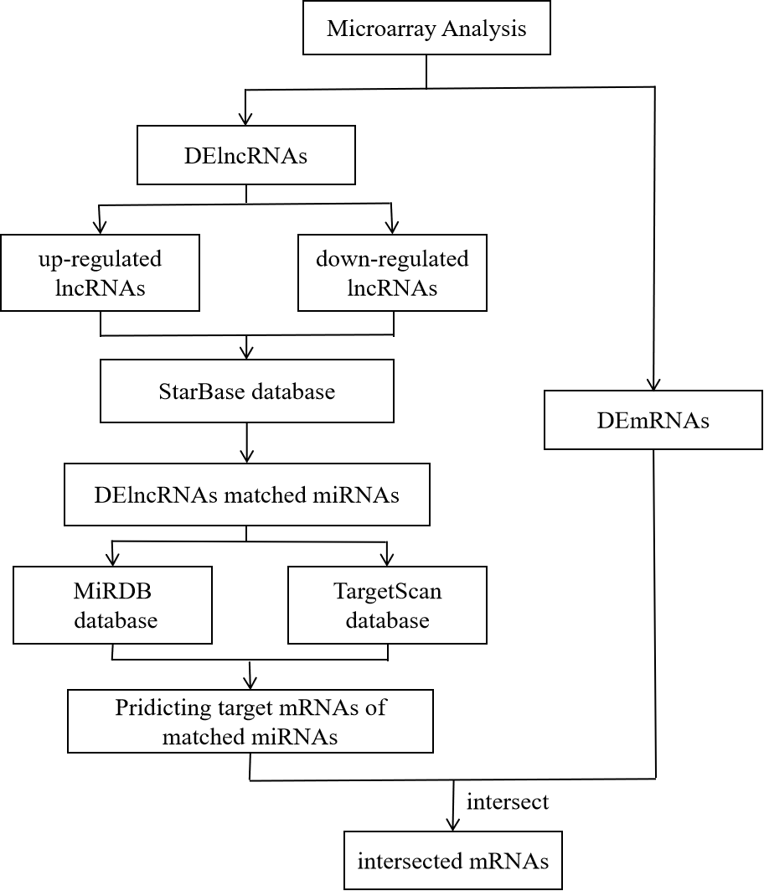

Supplementary Figure 2. GO and KEGG pathway analysis among different expressions of mRNAs
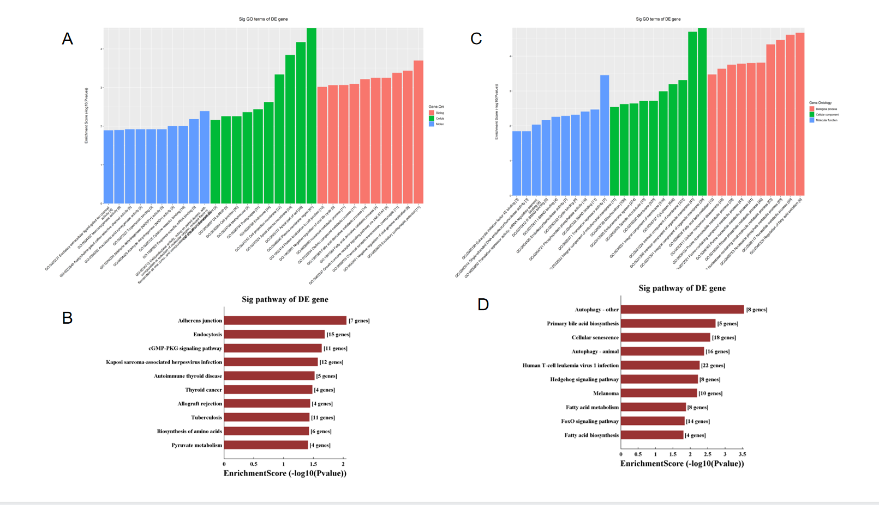
(A) The upregulated mRNAs enriched top 10 GO enrichment; (B) The downregulated mRNAs enriched top 10 GO enrichment; (C) The top 10 enriched KEGG pathway of upregulated mRNAs; (D) The top 10 enriched KEGG pathway of downregulated mRNAs.

Supplementary Figure 3. The venn diagrams of predicting target mRNAs.
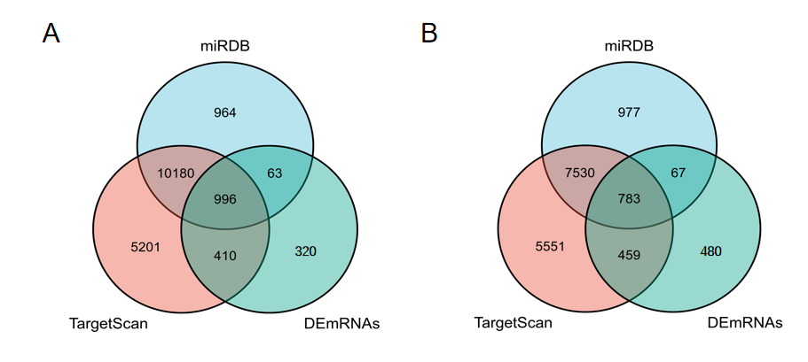
(A) The target mRNAs of upregulated lncRNAs matched-miRNAs. (B) The target mRNAs of downregulated lncRNAs matched-miRNAs.

