Supplementary materials

Supplemental Tables

Table S1. BMP4 and SLC2A1 IHC score results
BMP4 IHC score  Specimen number | HCC | Paracancer | SLC2A1 IHC score  Specimen number | HCC | Paracancer
No.1 | 2 | 4 | No.1 | 2 | 4
No.2 | 4 | 2 | No.2 | 5 | 2
No.3 | 4 | 4 | No.3 | 5 | 4
No.4 | 3 | 1 | No.4 | 4 | 2
No.5 | 4 | 1 | No.5 | 5 | 1
No.6 | 3 | 4 | No.6 | 3 | 3
No.7 | 1 | 1 | No.7 | 3 | 2
No.8 | 1 | 1 | No.8 | 2 | 2
No.9 | 3 | 2 | No.9 | 4 | 3
No.10 | 3 | 3 | No.10 | 4 | 3
No.11 | 4 | 3 | No.11 | 3 | 3
No.12 | 5 | 4 | No.12 | 4 | 4
No.13 | 5 | 2 | No.13 | 4 | 2
No.14 | 1 | 1 | No.14 | 2 | 1
No.15 | 4 | 4 | No.15 | 4 | 3
No.16 | 3 | 1 | No.16 | 3 | 2
No.17 | 1 | 4 | No.17 | 2 | 4
No.18 | 4 | 1 | No.18 | 4 | 1
No.19 | 3 | 3 | No.19 | 3 | 3
No.20 | 4 | 3 | No.20 | 4 | 2
No.21 | 3 | 1 | No.21 | 2 | 1
No.22 | 1 | 4 | No.22 | 1 | 4
No.23 | 4 | 1 | No.23 | 3 | 1
No.24 | 3 | 2 | No.24 | 2 | 2
No.25 | 4 | 4 | No.25 | 4 | 4
No.26 | 4 | 4 | No.26 | 4 | 2
No.27 | 4 | 4 | No.27 | 4 | 3
No.28 | 3 | 4 | No.28 | 3 | 2
No.29 | 3 | 3 | No.29 | 3 | 4
No.30 | 3 | 2 | No.30 | 3 | 2
No.31 | 3 | 2 | No.31 | 3 | 1
No.32 | 2 | 1 | No.32 | 2 | 2
No.33 | 3 | 2 | No.33 | 3 | 3
No.34 | 3 | 1 | No.34 | 3 | 2
No.35 | 1 | 2 | No.35 | 2 | 2
No.36 | 3 | 3 | No.36 | 3 | 3
No.37 | 4 | 3 | No.37 | 4 | 3
No.38 | 1 | 4 | No.38 | 2 | 4
No.39 | 4 | 5 | No.39 | 4 | 3
No.40 | 4 | 1 | No.40 | 4 | 1

Table S2. List of TqPCR primers
Gene | Forward primer | Reverse Primer | Accession No.
Human GAPDH | ACCCAGAAGACTGTGGATGG | CACATTGGGGGTAGGAACAC | NM_008084
Human SLC2A1 | CCAGCAGCTGTCTGGCAT | CGACAGTGAAGGCCGTGT | NM_006516.3
Human SLC2A2 | CTCAGGGGAGCACTTGGC | AAGGATGGCTCGCACACC | NM_000340.2
Human SLC2A3 | GCTTTGGCAGGCGCAATT | AACCTGTGCAGAGTCCGC | NM_006931.3
Human SLC2A4 | CCTGGCCCCATTCCTTGG | CAGCAGGAGGACCGCAAA | NM_001042.3
Human GYS1 | GGACCCAGGTGGAACTGC | GCACGACACAGGCAGAGT | NM_001161587.2
Human GBE1 | TTGAAGCCCTACGCCGTG | AGCACATCTGTGGACGCC | NM_000158.4
Human UGP2 | TCTGGGTGCCACAGTGGA | GTGAGTGTCCCGCCCTTT | NM_001001521.2
Human PYGM | AACCATGACCCGGCAGTG | CCCGTCCATGGTGCCAAT | NM_001164716.1
Human SMAD1 | TGTGTCACCATTCCCCGC | GGCTCTGAAGATCGGGCC | NM_001003688.1
Human SMAD5 | AGCAGCTGCAGCCTCAAA | CCAACATGGGGTGCTGGT | NM_001001419.3
Human SMAD8 | CCTGTGCTCGTGCCAAGA | CACGGAGGCTGCTGGAAA | NM_001127217.3
Table S2. List of TqPCR primers

Table S3. List of PCR primers for ChIP assay

Table S3. List of PCR primers for ChIP assay
Seqeunce | Forward primer | Reverse primer
PCR Frag-1 of SLC2A1 | CTGGTGCCATGAAGAAGGACCGTG | CAAGGCTTCAATTCCTGTGGTCTC
PCR Frag-2 of SLC2A1 | GGATCACGAGGTCAAGAGTTCAAGA | CATTAAGGACATGATAGACCTCG
PCR Frag-3 of SLC2A1 | GAGAACGAGCCGATCGGCAGCC | GCCATTGGCTGGCGACGCCGGTG
PCR Frag-4 of SLC2A1 | GCAGGAGACCAAACGACGGGGGTC | CAGCGCTGCGCTGGTGGCTCTGG

Supplemental Figures

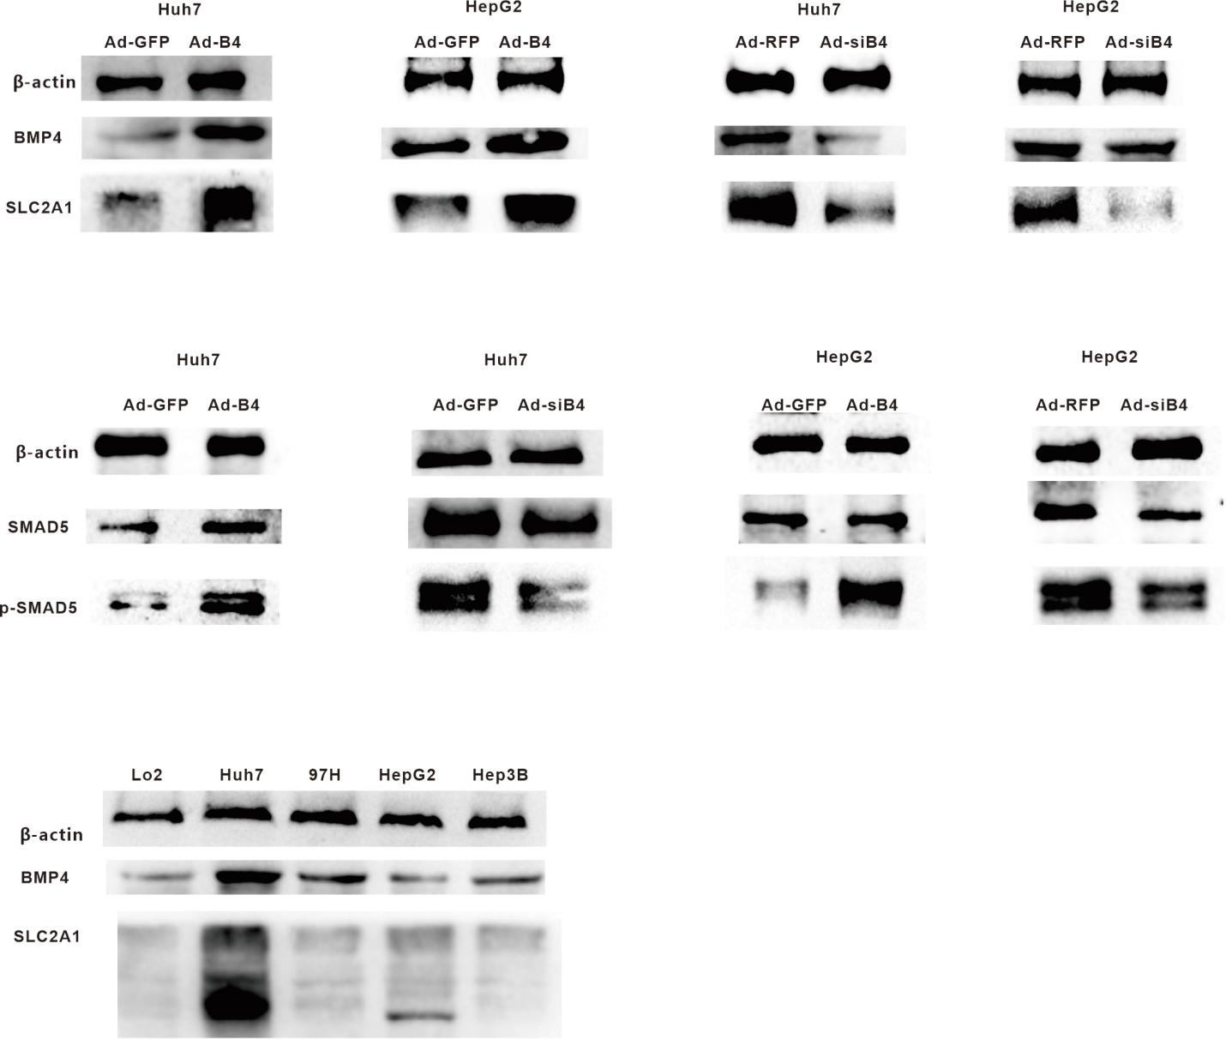
Fig. S1 The original images of WB in figure 3 and 5.

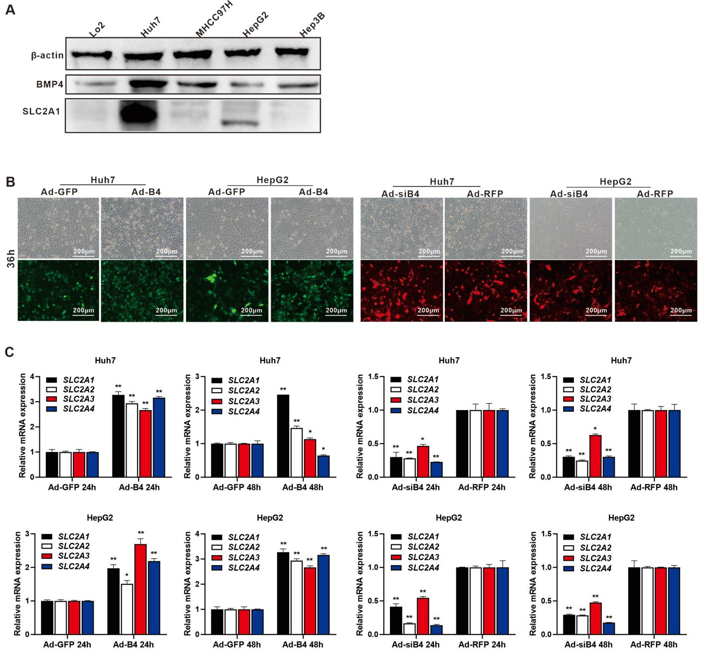Fig. S2 A The expression of BMP4 and SLC2A1 in Lo2, Huh7, MHCC 97H, HepG2 and Hep3B were assessed by Western blotting. B Huh7 and HepG2 were infected with Ad-B4, Ad-GFP, Ad-siB4 or Ad-RFP, respectively, and fluorescence images were taken at 36h. C Huh7 and HepG2 were infected with Ad-B4, Ad-GFP, Ad-siB4 or Ad-RFP respectively, and TqPCR analysis was used to evaluate the expression of SLC2A1, SLC2A2, SLC2A3 and SLC2A4 at 24h and 48h. “**” P < 0.01, “*” P < 0.05, Ad-B4 group vs Ad-GFP group, Ad-siB4 group vs Ad-RFP group.

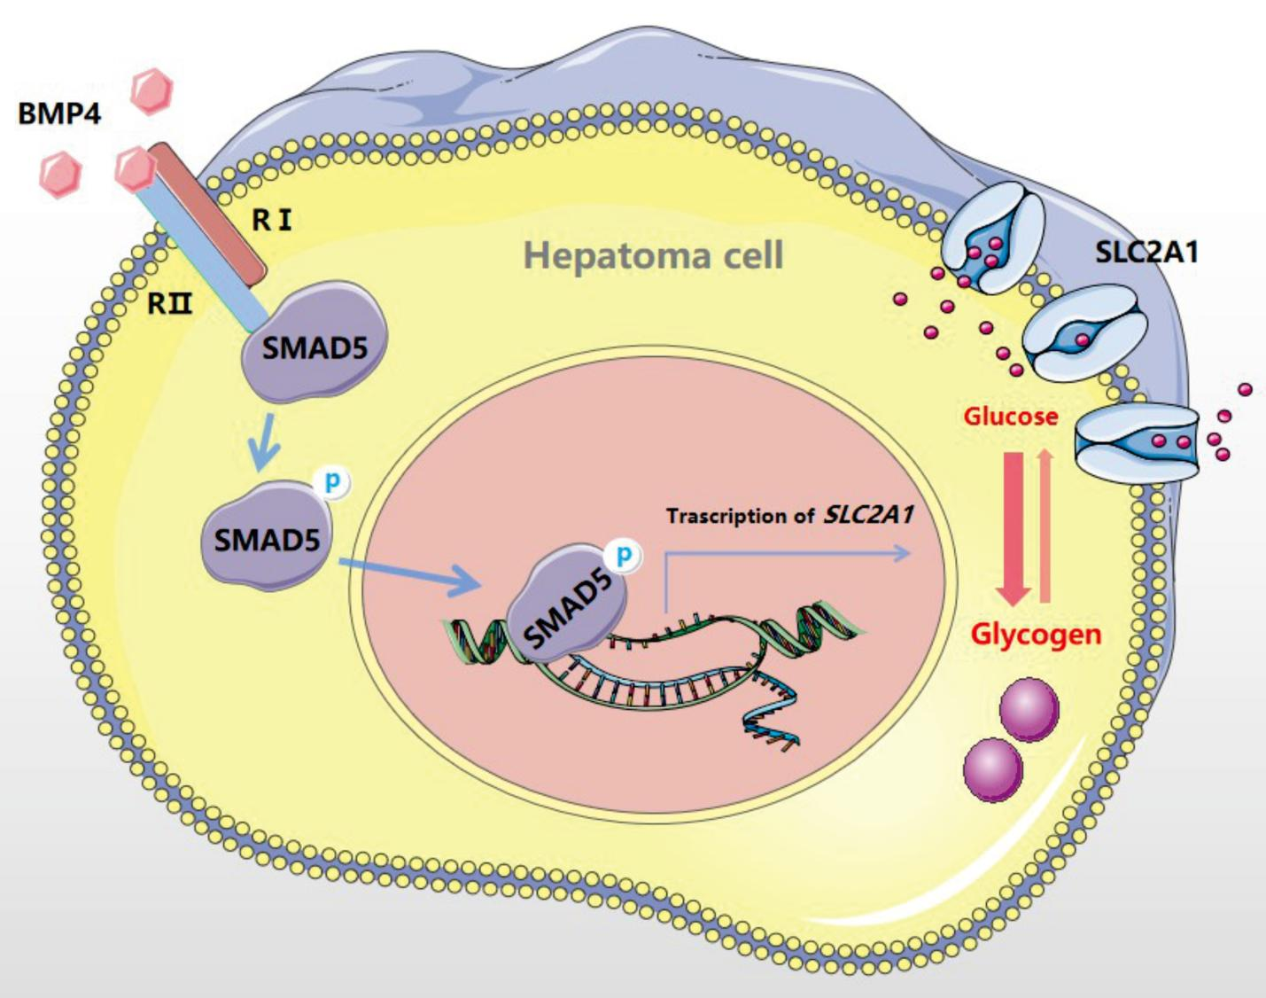Fig. S3 The graphic abstract of this research.

